Name: Rubina Akbur
Student Number: 2118370
Module Code: BMSW4004_BIRM
Module Name: Problem Solving and Decision Making
Assignment Title: Report
Lecturer Name: Zahra Mohammadnazari

Contents Page
Introduction …............................................................................... Page 3
Define the problem Solving …....................................................... Page 3
Scope and the impact …............................................................... Page 3
Analysis of the organisation and problem …................................. Page 4
PESTEL …................................................................................... Page 4
- Political
- Economic
- Social
- Technology
- Environment
- Legal
Fishbone ….................................................................................. Page 6
PMI ….......................................................................................... Page 6
- Possible solutions for Proper Care UK
- Evaluation
Evaluation …................................................................................ Page 7
Plan for Implementation solution ….............................................. Page 8
- Plan
- Monitor
- Review
- Success
Evaluation …................................................................................ Page 8
Conclusion …................................................................................ Page 9
References …................................................................................ Page 10

Introduction
This report will go over how Proper Care (PC) UK are deal with the recent staffing issues and how the staffing issue has impacted health and social care settings. The report will also include various analyses that can be used internally and externally to assist in identifying problems and solutions that can be implemented to improve their organisation.
PESTEL, PMI, and Fishbone concepts will be discussed to gain a broader perspective for targets set to achieve them. Health professionals have stated that staff absences are rapidly increasing, adding to the already serious pressure on hospitals from escalating covid admissions and wider pressure on urgent and emergency services (Lacobucci, G. 2022).
Define the Problem
Staff shortages are a common and universal problem in health care settings such as hospitals and nursing homes. It has been observed that there are not enough nurses, midwives, GPs, doctors, and mental health workers in hospitals. It has been stated by the NHS Support Foundation (2022) that the NHS staff are leaving their jobs because of being displeased with the decisions being made.
However, there is an important level of pressure on the workforce and the issue in staffing continues to have a negative impact on the organisations. It has been recognised that due to the amount of pressure and the staff being over worked, exacerbate and the staff will end up being too exhausted to work. It was said by the NHS Support Foundation (2022) that during the coronavirus pandemic it increased the pressure on frontline nurses, due to extra work being given, the strain being put on the nurses could affect them massively and the staff will be bone tired, The NHS Providers (2022) report demonstrates that the NHS simply is not equipped with enough staff, a difficulty caused by an overburdened and underfinanced social care system. If the health and social care package is not fully funded, it will be exceedingly difficult to hire new employees and keep the ones they already have. Due to the lack of funding, it has had an impact with major cuts and most importantly not enough workforce strategies are being put into place.
Scope and Impact
The scope of the problem is a universal issue in the UK, according to Netten (2003), nursing home closures resulted in a massive loss of 6 percent and 4.9 percent of nursing positions between 2000 and 2001. The nursing homes that were closing had provided a level of care that residents valued and were satisfied with, staff shortages were a common concern and a long-term issue that must be addressed. Staff are affected because they are overworked; this has a negative impact on services and will impede efforts to deal with backlogs or care for residents, as well as the ability to refine access to the services provided. All the issues that have just been raised will have an impact on Proper Care UK, as the NHS Providers (2022) state that by not having the right number of staff, it will have a significant impact on care quality.

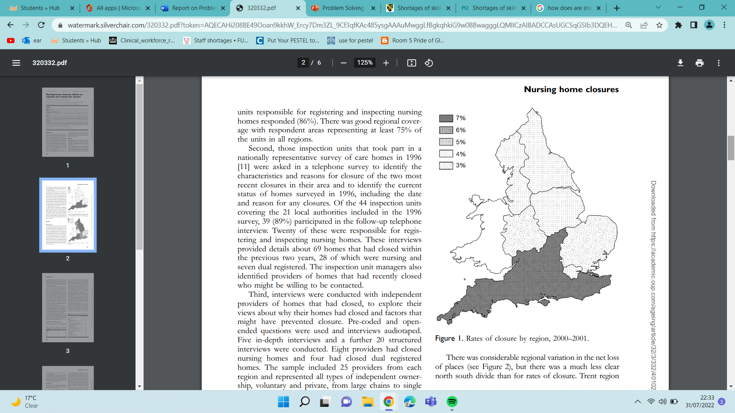
Figure 1: Nursing home closures (2000 – 2001) (Netten, 2003)
There was a high number of staff that were not fully qualified and there was a shortage of managers which were an extra problem. The residents were affected as the duty of care was not met as the quality of care was extremely poor and recruitment was becoming a concern. However, as Netten (2003) also said that the lack of managers was also recognised as an extra problem, and the inspectors that attended the care homes were extremely concerned about capacity of homes where there was should be a quality-of-care while being faced by recruiting staff issues and a high point of residential dependency.
Analysis of the organisation and the problem
Organisations need to find an effective way to analyse what the key issues are at Proper Care UK; this will hopefully broaden their views on what needs to be done about the main issue that has occurred. PC can use PESTEL which is an analysis that generates tools and is identified as a macro force (external force) and Fishbone which generates tools internally. PESTEL
Looks at key areas like political, economic, social, technology environment and legal.

Figure 2: PESTEL Analysis (Cayenne Consultation, 2018)

In proper Care Uk the key areas from PESTEL that were identified as concerns were: -
Political
The Health Care Foundation (2022) have researched that the financial plans generate advanced levels of public spending, its success will be calculated not by the millions spent, but by the end results achieved and the differences that it has made to people's daily lives. It has also been claimed that the funds are ready, ideas are in position and the task is transparent. National Care Foundation (2022) have also stated that it must work because this is not the governments money but the taxpayers money.
Economic
PC UK must examine their financial pressures and the impact they are having on the organisation and their employees. The lack of funding has put a strain on the health-care system, affecting patients as well as the organisation and its employees. The council's budget has been cut, making it difficult for employers to hire, retain, and manage their staff, care cuts could have disastrous consequences (Shearing 2015).
Social
COVID had a significant impact on health and well-being, limiting unplanned and organised physical activity, as well as a lack of assistance from family, friends, and access to health-care services.
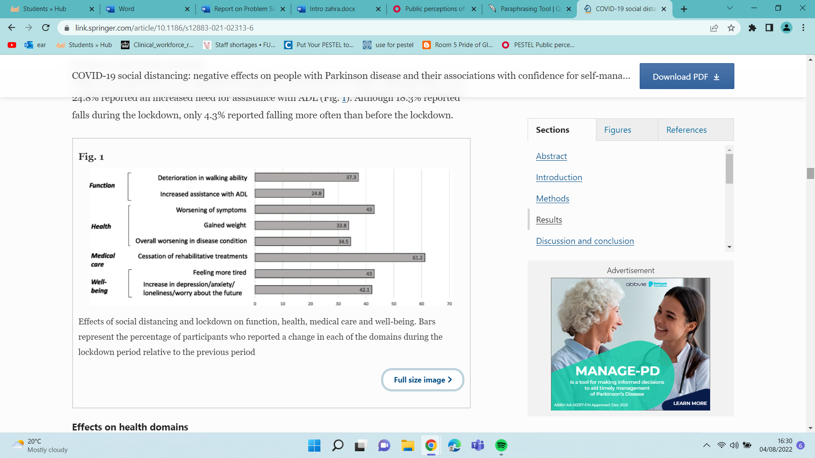
Figure 2: Effects of social distancing and lockdown on function, health, medical care, and well-being (Yogev-Seligmann, G. and Kafri, M., 2021)
Technology
Looking for health information may result in incorrect information, causing harm to the patient’s health. Another disadvantage is a breach of GDPR of the patients’ information. According to Akram and Kumar (2019), the COVID technology was used to see patients and they were given incorrect self-diagnosis as well as potential breach of privacy.
Legal
It has been aimed to recognise the Turnpenny and Hussain (2021) that support evidence is available to contribute migrant workers in home care in the Uk to facilitate results, challenges as Brexit changes immigration laws. Migrant workers play a vital role in meeting the demand for human resources in health and social care.

Environment
If waste is not disposed of properly, it will spread quickly within PC UK and affect everyone in the vicinity. This will then spread throughout the community, into homes, schools, and other workplaces. According to Das et al. (2021), a lack of waste treatment poses significant risks of disease transmission to waste collectors, health care workers, patients, and the rest of society who will encounter infectious bacteria.
Fishbone
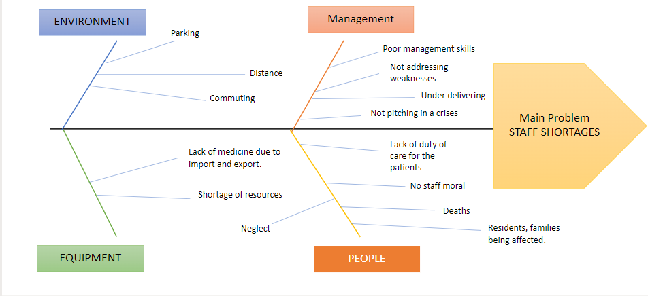

PC UK should conduct a fishbone analysis to determine what issues were arising internally. This will assist them in determining the cause and effect so that they can try to gain control of the situation and address the problem. They will then be able to develop an action plan that relates the internal issues that have resulted in the main issue identified in the analysis. Desai (2015) mentioned that in the Fishbone diagram (Ishikawa) is recognised as a fish skeleton to discover the cause and effect of an internal problem.
PMI
Dr Edward Bono was a critical thinker who put together this analysis so that PMI could be used to generate solutions. The plan of an equivalent application needs to be communicated with others Balaji et al. (2010).
Possible Solution for Proper Care UK
- Provide apprenticeships as the trainees will develop the key attributes needed as well provide a duty of care for the patients. Pay rise is the process through which pay increases achieving a reward system (Armstrong and Brown, 2019).
- Management will need to be hands on and active as this will reflect well on their performance as a manager and employees will feel they are working side by side. It is a legal responsibility of the employer to ensure good working conditions, but you also how to work safely (Unison, 2022).
- Appreciate staff by giving rewards GOV.UK (2022) mentioned that quality work shows health, comfort in people's lives.

Evaluation
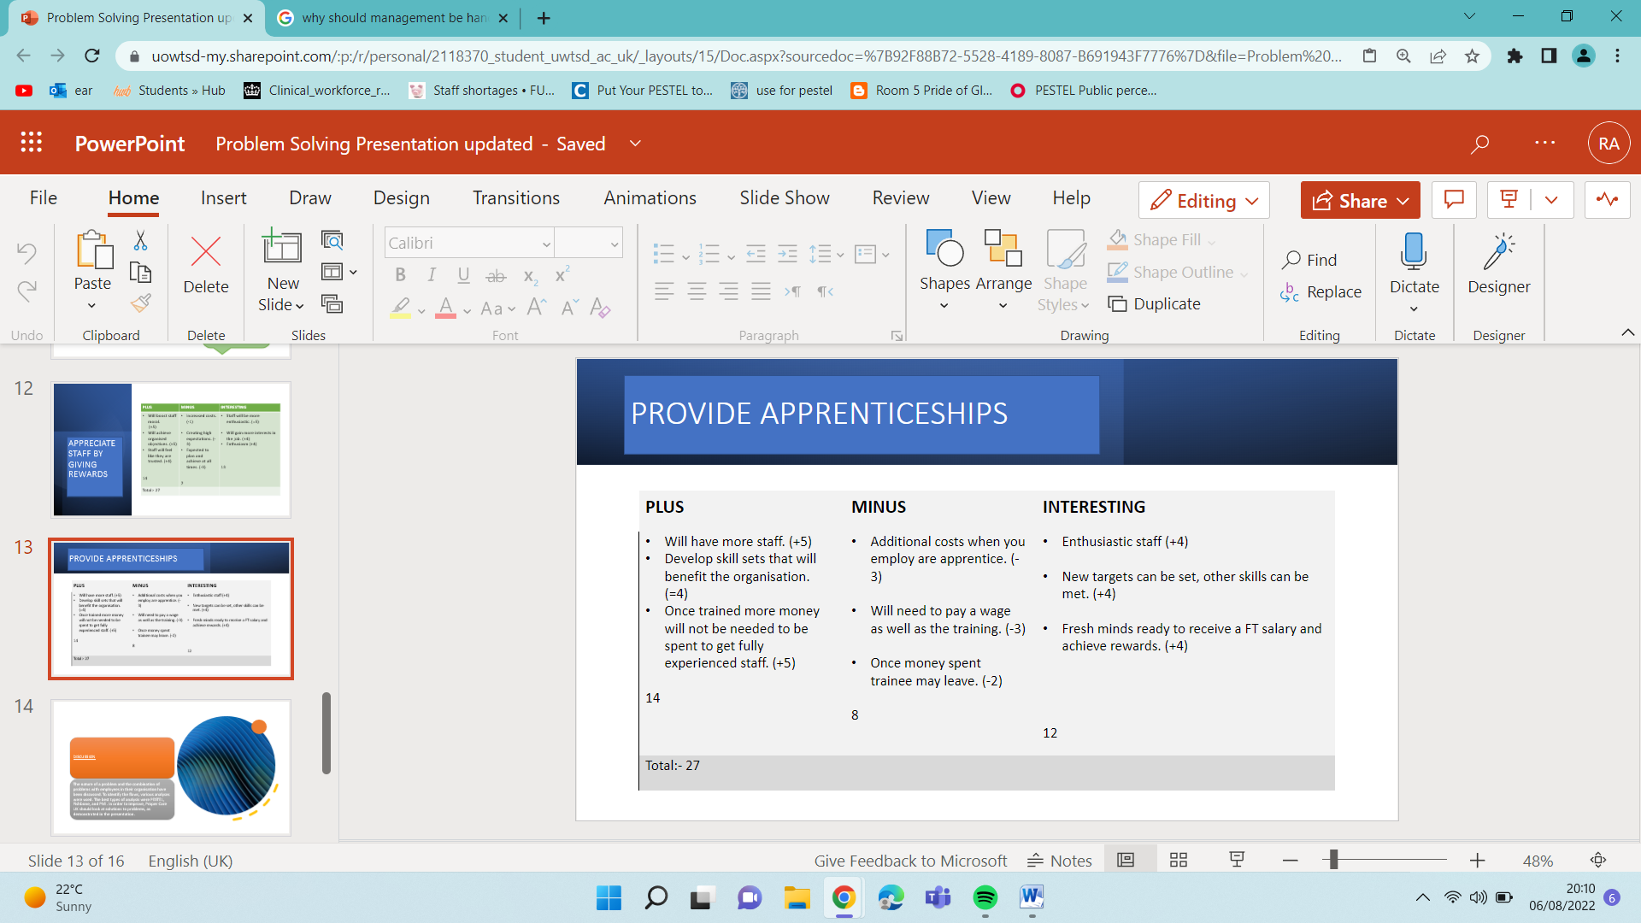
The plus marks for this were 27 but not enough results to put this into practice.
2.
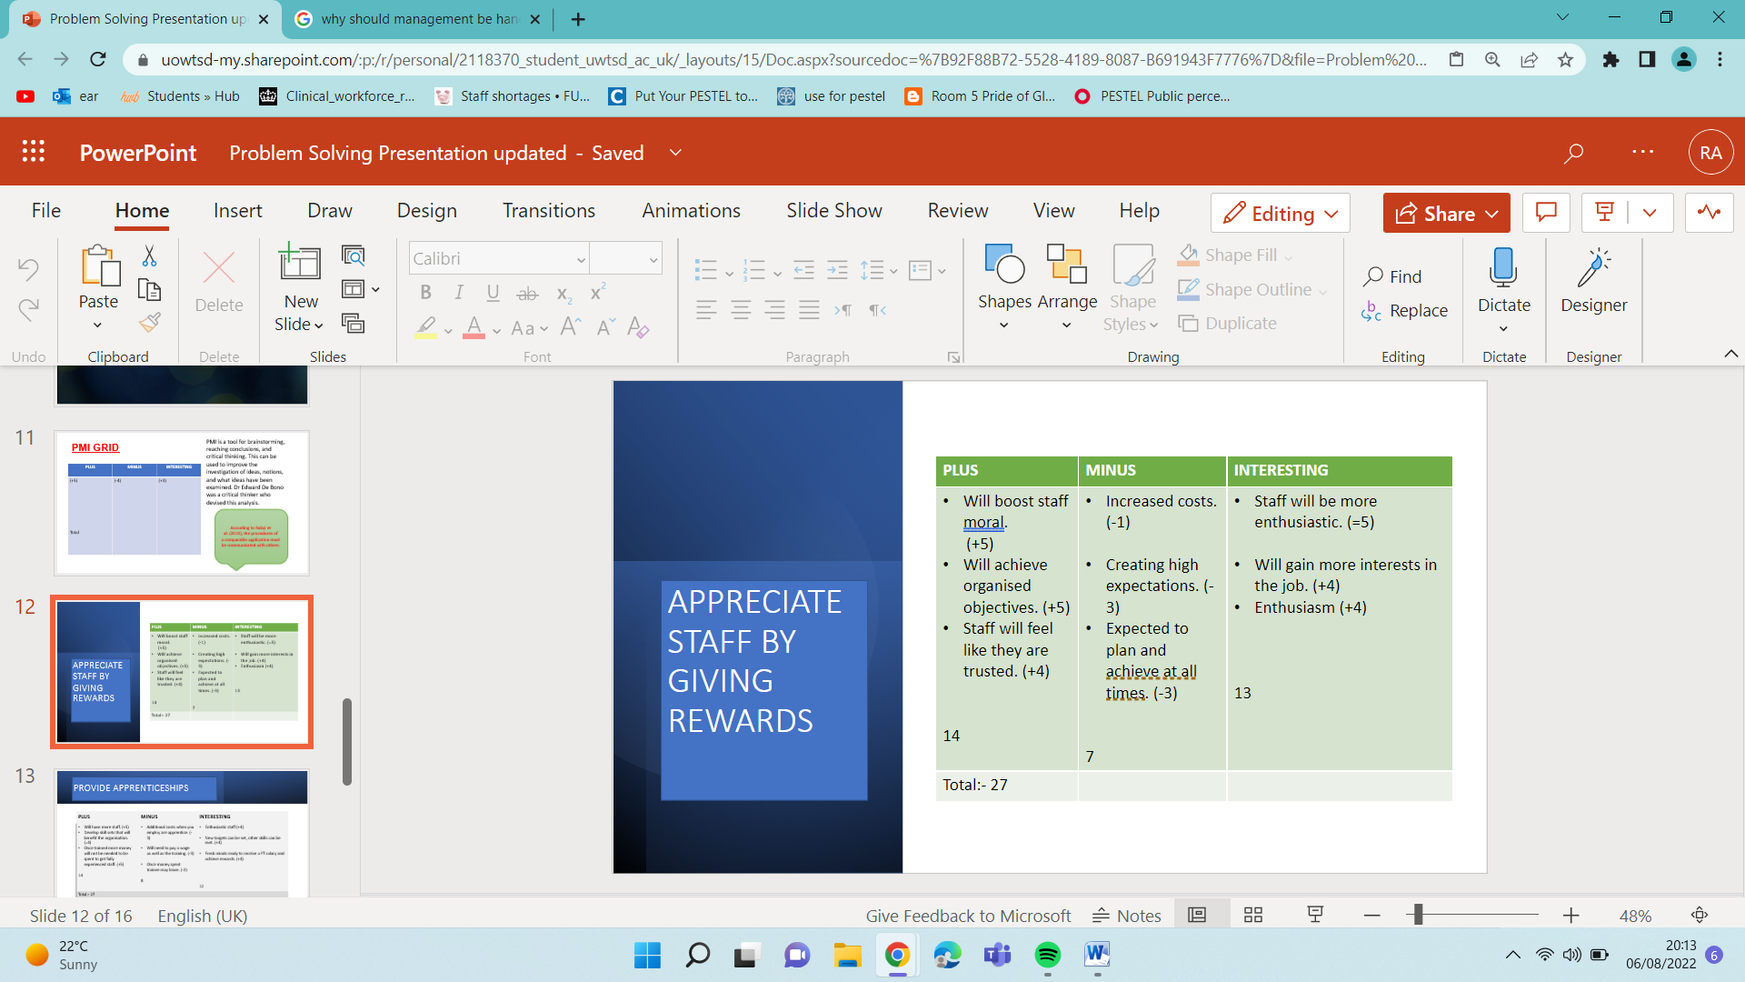
Staff rewards were also 27 marks which was also not enough evidence to show it would be affective.
3.
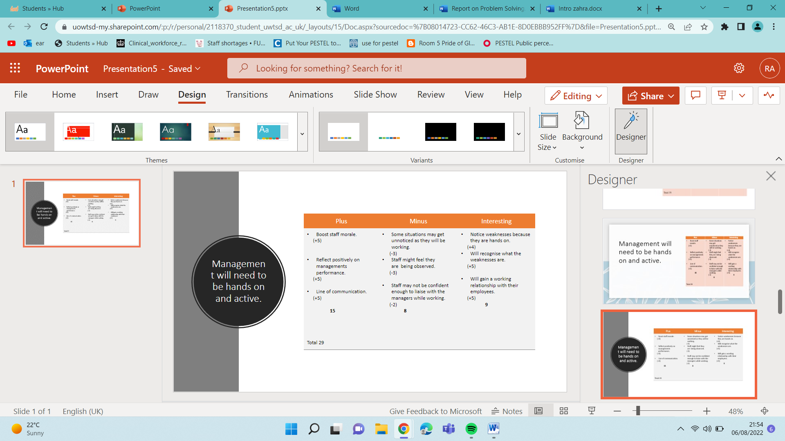
According to the statistics above, this solution will be effective for PC Uk as it has most scores.

Plan for Implementation
PC care should choose the solution where ‘management need to be hands on’ this had the most marks which shows if they put this into place, they will achieve the goals they require.
Plan
PC UK need to ensure that the management team show they are supportive and acknowledge the issues their organisations have. They will also gain respect, and this will give management the time to actively mentor their team and keep watch over the resident's daily care. Finally, this will encourage open lines of communication and actively be part of live feedback so concerns can be raised straight away not when it is to late
Monitor
By actively working alongside the employees, they can monitor the day-to-day care and decision making. This will also give them the opportunity to see the struggles and the strengths within the organisation. However, it is crucial they are protecting and encourage the interests of the patients in their care.
Review
To ensure that the plan is being followed it will be reviewed every 6 months to ensure that all policies and procedures that have been put into place are being followed. Finally, an annual review and update should take place every 12 months.
Success
The success indicators are so that the organisations gain respect, trust, and hope for the residents as well as the staff. This should give the organisation a reputation where the staff are respected and valued. A valued member of staff will feel appreciated, productive and will have a sense of control with their own goals. Once the staff feel appreciated, they will feel motivated and most importantly the workplace will thrive with success on their key performance indicators (KPI). Klipfolio Inc (2022) have suggested that a key performance indicator is a value that can be measured and reveals how effective an organisation is generating their goals.
Evaluation
Once the PMI and solution are implemented, the management team's efforts will aid in raising organisational standards and work ethic. The solution will assist them in identifying how systems work and identifying weaknesses. Effective communication is required because it must be short and clear, free of unnecessary words, and most importantly, consistent. Outstanding managers should be able to identify what their employees' skills and attributes are and what they expect from the work environment. It has been said by ProQuest (2022) effective managers should support their team by giving their all.

Conclusion
Finally, Proper Care Uk will benefit from encouraging their management team to be hands-on to raise the standards of their workforce and solve their staff shortage problem. Employee appreciation occurs when a company's employees are recognised for their exceptional work. Recognizing your employee in the workplace will certainly stimulate certain behaviours or actions that lead to improved performance and profitable business development. Phillips et al. (2017) identified the following motivators as important in the workplace: accomplishment, recognition for achievement, actual work, liability, and growth or development.

References
Armstrong, M. and Brown, D. (2019) Armstrong’s handbook of reward management practice improving performance through reward. 6th ed. London: Kogan Page.
Akram, W. and Kumar, R., 2017. A study on positive and negative effects of social media on society. International Journal of Computer Sciences and Engineering, 5(10), pp.351-354.
Balaji, P., Buntinas, D., Goodell, D., Gropp, W., Krishna, J., Lusk, E. and Thakur, R., 2010, September. PMI: A scalable parallel process-management interface for extreme-scale systems. In European MPI Users' Group Meeting (pp. 31-41). Springer, Berlin, Heidelberg.
Das, A.K., Islam, M.N., Billah, M.M. and Sarker, A., 2021. COVID-19 pandemic and healthcare solid waste management strategy–A mini-review. Science of the Total Environment, 778, p.146220.
Desai, K. J., Desai, M. S. and Ojode, L. (2015) ‘Supply chain risk management framework: a fishbone analysis approach’, S.A.M. advanced management journal (1984). Corpus Christi: Society for the Advancement of Management, 80(3), p. 34–
GOV.UK. 2022. Health matters: health and work. [online] Available at: <https://www.gov.uk/government/publications/health-matters-health-and-work/health-matters-health-and-work> [Accessed 26 March 2022].
Klipfolio (2022) What is a KPI? Available at:https://www.klipfolio.com/resources/articles/what-is-a-key-performance-indicator (Accessed: 7 August 2022).
Lacobucci, G. (2022) ‘Covid-19: NHS trusts declare “critical incidents” because of staff shortages’, BMJ (Online). England: British Medical Journal Publishing Group, 376, pp. o3–o3. doi: 10.1136/bmj.o3.
https://www-proquest-com.ezproxy.uwtsd.ac.uk/docview/2273705993?pq-origsite=primo&accountid=130472
Turnpenny, A. and Hussein, S. (2021) ‘Migrant Home Care Workers in the UK: a Scoping Review of Outcomes and Sustainability and Implications in the Context of Brexit’, Journal of international migration and integration. Dordrecht: Springer Netherlands, 23(1), pp. 23–42. doi: 10.1007/s12134-021-00807-3.
Unison (2022) Working Environment Available at: https://www.unison.org.uk/get-help/knowledge/health-and-safety/working-environment/#:~:text=Cleanliness%3A%20keep%20workplaces%20and%20furnishings,for%20the%20worker%20and%20work (Accessed 6 August 2022).
NHS Support Foundation (2022) Staff Shortages Available at: https://nhsfunding.info/symptoms/10-effects-of-underfunding/staff-shortages/ (Accessed 30th July 2022).
NHS Providers (2022) NHS workforce shortage has “serious and detrimental” impact on services Available at: https://nhsproviders.org/news-blogs/news/nhs-workforce-shortage-has-serious-and-detrimental-impact- (Accessed 4 August 2022).
Netten, A. (2003) ‘Nursing home closures: effects on capacity and reasons for closure’, Age and ageing. [Oxford, England] Oxford University Press, 32(3), pp. 332–337. doi: 10.1093/ageing/32.3.332
The Health Foundation (2022) Public perception of the NHS and social care: performance, policy and expectations https://www.health.org.uk/publications/long-reads/public-perceptions-performance-policy-and-expectations( (Accessed: 5 August 2022).
Shearing, R., 2015. Staffing problems for adult social care firms due to cuts. Nursing And Residential Care, 17(10), pp.585-587.
Yogev-Seligmann, G. and Kafri, M., 2021. COVID-19 social distancing: negative effects on people with Parkinson disease and their associations with confidence for self-management. BMC neurology, 21(1), pp.1-8.

