What helps me learn language and mathematics? : An analysis of a child’s learning in mathematics and language with recommendations for ensuring progress.

Introduction- approximately 300 words

During PTE I was required to gather data using aspects of ‘The Mosaic Approach’. This data, related to a pupil in a small English-medium primary school in South Wales. The child I focused my research on was a 10-year-old girl in a mixed-age Year 5 class. For data protection purposes, the child will be referred to as ‘child A’. The class teacher advised me that child A had some dyslexic tendencies but was currently undiagnosed. Most pupils in the school come from a background, where English is the prevailing language (ESTYN, 2017). It is important to understand the context when undertaking this study to gain an understanding of factors contributing to the child’s education. Data was collected from the pupil using a mosaic approach; a way of understanding that acknowledges children and adults as co-producers of meaning. An intrinsic method that links verbal and visual feedback to understand how the child learns. This methodology was established though work in rural communities, when written feedback was hard to obtain. Communities wanted their own voice and needed a “process of dialogue, reflection and action” to develop their goals (Clark & Moss, 2011). The class teacher was informed of my study and signed a university ethics form (appendix 1). I explained to child A that I was looking to understand how they learn; advising them that they had the right to stop the process at any time. The rapport with the class supported an open and engaging discussion. I conducted an interview to gain an understanding of how they learn and what elements they find difficult. We also took photographs of key areas and resources used to support their language and maths development in the classroom (appendix 2). I will use the A.S.K. model of learning, promoted by Nottingham (2013) to be specific in my collection and presentation of data. The data I have collected includes interviews, photos, copies of work and a pupil-tracking sheet (appendix 15). There is always more than can be collected but within the confines of this assignment, I feel this is sufficient.

Analysis of the Learner in Language

Attitude

Child A is a happy and sociable child with lots of friends in the classroom. Her love of the outdoors was evident during our interview “I like it when it is outdoors”. Her love of the outdoors may be due to the lower levels of noise, research showing how noise contributes to more distractions and less focus (Walker-Gleaves and Waugh, 2017). Child A stated, “In English you use yourself to write, your brain. My brain teaches me things”. Later stating “I like recounts, I don’t like writing stuff I’m told to write but from my own brain.” This suggests child A enjoys leading her own learning, this child-centred approach is supported by theorists such as Rousseau and Dewey who see the key to learning as letting the child learn a subject through a specific topic. Supported by (Barnes, 2011) and Donaldson (2015) who believe through this methodology the child will self-fulfil their potential. This is in contrast to examples where children were viewed as “empty vessels”, unable to learn for themselves, simply waiting to be filled with knowledge by their teachers (Wyse and Jones, 2007). Child A has a positive attitude to learning and collaborates well with others on tasks across the curriculum range. She enjoys completing tasks in the classroom and this is evident in her cover picture for her topic exercise book (appendix 3). Holdaway (1979) and Mercer, Ryan and Williams (2012) both support the idea that excitement is a key psychological factor in how willing a learner feels to communicate in certain situations; they also need to feel secure and have a degree of responsibility before communicating their ideas, and it is this security and enthusiasm which leads to a momentum of learning. Wyse and Jones (2007) affirm that reading should be an enjoyable task above all else. It was therefore good to see child A bring in her own books from home to read before registration and whenever there was free time in the day (appendix 4).

Skills

Communication starts with young children expressing themselves through body and facial gestures and building up to speech. Chomsky believed that by age five, children have developed almost all language, but between five and twelve years old is an important time for more formal language acquisition (Costley and Nelson, 2013). It is the teacher’s job to develop use and range of language in the classroom as a legal requirement in the current curriculum (Welsh Gov, 2016). A large element of learning vocabulary is implicit and done by going to school; talking, listening and reading, although it is every teacher’s responsibility it should be their desire to help their pupils read with an awareness and certainty (Quigley, 2016). A common way to develop these formal language skills is through phonic work; the NAEYC (2019) note that phonic work leads to a child’s awareness that speech is composed of syllables, words, and sounds. Further support comes from the Rose (2006) review in England, which advised that children need phonics to progress. This is different from a ‘whole language’ view, where children learn to read more naturally. The ‘whole language’ theory has been discredited in many circles, although there is still support for this (Adams, Beranek and Newman, 2015). It appears that more research is needed into the positives and negatives of this type of learning. However, it should be noted that understanding how phonics works in early years is also still under some debate (NAEYC, 2019 and Holdaway, 1979). When introducing a subject specific word I would write it on the board getting pupils to repeat the word to me with a whispered and squeaky voice. This fun method of repetition engages the learner and models how the word should be said, segmenting the words to make them easier to understand. The children were further supported through resources in the classroom to help them when writing (appendix 5). However, child A mentioned that “you need a comfortable pen, else it hurts your hand”, highlighting the need for quality, individually assigned apparatus in schools. As language and literacy are so closely linked to experiencing, thinking and expressing, the development of language should be promoted through the arts (Holdaway, 1979). This is supported through Donaldson’s Expressive Arts Area of Learning and Experience, putting emphasis on these subjects and providing space for “thinking, refining and communication of ideas”. The new curriculum will encourage practitioners to include the expressive arts in more lessons (Donaldson, p. 46, 2015).

Knowledge
Child A expressed knowledge in language through a Chinese New Year poetry lesson. Developing higher-order thinking by discussing the senses and sounds when they Think Pair Share. Child A seemed to understand the concept and explained the significance to the others in the class, showing competence in the level 3 skill of “communicating ideas” (Welsh Gov, 2016, p. 14). We then looked at a sample poem ‘The Eagle’, this is a way to model how a poem looks and another way we provide effective learning opportunities for all pupils (Biggs and Moore, 1993). We spoke about the use of metaphor, simile and alliteration to develop subject-specific knowledge. Then the children wrote their draft poems out on whiteboards and I rotated to check for understanding. This covers two elements for writing in the curriculum: organising ideas and information and writing accurately (Welsh Gov, 2016). Poetry writing develops language and oracy and helps them emotionally by talking and writing about feelings. Child A created an exceptional poem (appendix 6) and was one of five who read it to the class. It was disappointing that only girls wanted to read, but their performance of the poems was a great cross-curricular creative lesson. Further promotion of higher order thinking was on the ‘Language of Thinking’ display which promotes questions and deeper thinking (appendix 7). However, I felt the displays are on the walls for show and are not utilised in effective ways. To improve, classrooms need interactive displays that change daily/weekly and by letting the children design and create the displays themselves (Dunn, 2011). In relation to the reading cue system, (appendix 8) child A had a good grasp of semantic skills; she could understand the context and express her ideas well. However, she struggled with grammar aspects when reading. Both these traits carried across to her writing as she had great ideas and insightful writing but sometimes her letters would be in the wrong order (appendix 9). Although child A had neat writing, most of the class had untidy handwriting. Therefore, this was a focus for improvement with teacher-modelled handwriting tasks. Cursive writing has been shown to develop motor skills and especially help children with dyslexia as cursive words appear most distinct than printed words (Concordia University-Portland, 2019). Further support comes from Waugh, Warner and Waugh (2016 p. 92) who note that cursive writing provides “opportunities to practise digraphs as one joined unit and word structures.” While we still use paper, we should encourage handwriting as its own art form and skill.

Future Progress in Language

We discussed the story of St. Dwynwen; the pupils retold the story, using cartoon pictures to develop their understanding before retelling the story through writing. Cooze and Lewis (2019) state that retelling stories builds confidence, develops imagination and extends storytelling into writing, so this would be a methodology I would use when working with child A in the future. I would aim to promote homework which centres around discussion, children love to discuss what they learnt in school and this will engage their learning with their parents and the parents become more engaged providing benefits to all involved with the child and for their future progress (Dunn, 2011). Child A finds spelling tricky, so I would love to see her school use the Toe-by-toe strategy which harnesses a “multi-sensory approach with a memory bonding technique” (Toe-By-Toe, 2019). This would help her decode text and read more fluently. There are also other reading procedures selected as critical for a comprehensive approach to reading, they each develop a different element of reading and are to be used when reading is challenging:
- Reading to students
- Modelled reading
- Language experience
- Shared reading
- Guided reading
- Independent reading
- Book discussion groups
These are influenced by Pearson & Gallagher’s 1983 Gradual Release of Responsibility Model (Fisher and Frey, 2013).
ICT can be used with child A to help her dyslexia; she could improve her academic performance by using laptops, text to speech and voice recognition software (Grigg, 2015). Alongside this, outdoor activities should be promoted as she clearly enjoys outdoor sessions and she is building significant physical skills that will assist her in her learning (Walker-Gleaves and Waugh, 2017). There are some practical, resource based strategies to help child A with her dyslexia, such as:
- Larger font sizing on non-white paper
- Sloped surfaces for writing
- Use of ICT-based speaking programmes
- Use of large egg timers as a visual time scale
(Grigg, 2015. p. 311)
It would be good to see these rolled out in schools. Although, unfortunately a lot of the specific pupil-support relies on funding and although Welsh Government has pledged an additional £100 million for schools (Welsh Gov, 2018) there is still a huge deficit in school budgets, leading to larger classes; ESTYN also warning it could slow the introduction of the new curriculum (BBC, 2019). Linked to this is a need for general resources such as pens and paper, these are provided in school and some children brought their own pencil cases in, however some pupils always ask to borrow writing materials, so there is a strong chance that they don’t have access to these at home and will potentially do less writing at home.
Good literacy skills are vital to ensure children can “communicate effectively and make sense of the world around them” (ESTYN, 2017, p. 18). However, although many children receive books as presents and lots read every day (Literacy Trust, 2019); reading levels in Wales are the lowest in the whole of the UK (BBC, 2016). This could be due to a number of reasons including but not only down to a lack of supportive learning environment in the home (Walker-Gleaves and Waugh, 2017). With these progressions in place, I feel child A would be likely to achieve level 3+ by the end of year 5 and give her a good platform of learning for her future.

Analysis of the Learner in Maths

Attitude

Child A relished taking on daily maths tasks. She put her hand up to give answers; although she did not ask many questions when stuck. Instead, I had to ask her how she was doing, or spot mistakes when circling the class. Tiley-Nunn (2014, p.3) states that there is “less social stigma attached to being ‘bad at maths’ than that of literature”; this links to Gardener’s ‘Multiple Intelligence Theory’ that you may be good at one subject or skill but not multiple ones. This lack of understanding of how to progress in maths sometimes comes when parents have struggled themselves and feel maths is an innate skill, rather than a learned subject, therefore may be less likely to push their children to develop. Small whiteboards were often used in class and are an excellent AFL tool (Dunn, 2011). Used in numerous ways when children wrote six-digit numbers on their boards. Then they showed each other their boards and arrange themselves in order from smallest to largest. This was an engaging way to cover the curriculum “read and write numbers to 1 million” and apply skills in a “variety of contexts” (Welsh Gov, 2016, p. 2-3). Child A would respond positively to the learning objective (appendix 10); I feel this was not always made as explicit as possible. This was a disappointing element of the learning environment as Black et al. (2003) states that when pupils understand their learning, they can take more pleasure from it. We should also consider child A’s grouping; multiple theorists agree that effective grouping of pupils provides opportunities for constructive discussion with peers and team building skills developed through group work (Welsh Gov, 2010; Hallam, Ireson and Davies, 2002 and Powell and Kalina, 2009).
Skills

Child A understood some concepts in maths when given divisions to complete; one sum was 360 ÷ 4. She said, “It’s like a circle in quarters so each quarter is 90 degrees”. This was good as we had been developing the children’s mental arithmetic skills when we “reinforce and extend the application of wider skills” and “promote problem solving, critical and creative thinking” (Donaldson, 2015, p. 66). We applied this in practical ways talking about how the children should work out the answer in the way they felt most comfortable, developing a confidence in giving maths a go and mental strategies for them to use in a wider context. Child A activated prior knowledge during questioning; she also developed her understanding through seeking patterns in maths tasks. She also developed her lateral thinking and reasoning during a lesson on word equations, how to solve these and design her own questions for others to answer (appendix 11). I highlighted that the pupils should Read the question; Note important information; Calculate the answer and then check their Answer (RNCA) we then sang RNCA to the tune of YMCA; doing actions for each letter. This audio, visual and kinaesthetic lesson was great at engaging the class. Supported by Tiley-Nunn (2014) who states that to achieve the best teaching, you need to combine rote with kinaesthetic lessons to engage the learners (Tiley-Nunn, 2014). There seems to be a tendency in Maths to over-compensate in content but not in reasoning. We should be less concerned with correct answers and give greater emphasis on getting kids to be creative with problem solving (Tiley-Nunn, 2014). This has links to Donaldson (2015) who talks of improving levels of problem solving based tasks as these are the kind of skills future employers will desire. However, we need to be careful about how we approach these ideas, teachers should harness children’s innate desire to be problem solvers and build these skills through harder and harder scenarios (Jones, 2013 and Tiley Nunn, 2014).
During a Science/DT lesson we sorted materials into Carroll diagrams, building wider understanding such as recognising patterns (Welsh Gov, 2016 and Welsh Gov, 2015). We also made and fired arrows in this enquiry-based task and input the distance data into a bar graph (appendix 12). This is a way to cover the level 3 skill, using “standard units of length” (Welsh Gov, 2016, p. 13).

Knowledge

The ABACUS textbook (appendix 13) was used for most work as a tool for work across the maths curriculum. “We do the same all week, we learn a new skill at the start of the week then do stuff related to it. Mondays are the hardest because we learn new things.” The Activ Learn website is a support tool for the ABACUS book; teachers use it for planning lessons and it contains online resources, which can be used as a hook for the learning objectives. Child A seemed secure in her knowledge as she rarely asked questions, however when I rotated to check for understanding or marking work, she would often have basic errors in her work. This could be due to confidence in asking for help but could be due to mild dyscalculia; this often occurs in children who have other conditions, such as dyslexia (The Dyslexia Association, 2019). It appeared Child A had some misconceptions when making jumps in tens, hundreds and thousands as shown by (appendix 14). Here in question 11, using a number line, she has jumped from 270 up 30 and got to 1000. Underneath in question 12 she has written 5200 instead of 5300 but has written the correct ‘frog jumps’ so potentially some of the errors could have come from rushing work. Although in question 12 she has written, 9000 + 1 is 9100, so there could be a lack of understanding about jumping on in hundreds from 4-digit numbers. Errors in maths arise from a number of reasons. They may be due to speed of the work, a slight lapse of concentration or a misconception. If the teacher is aware of potential misconceptions, they can plan for them and address these during introductions. A good teacher will understand and unravel the misconceptions for child A’s learning to continue (NECTM, 2019). However, as ESTYN (2017, p. 23) note, there are “shortcomings in the quality of teaching to develop numeracy, often this is because teachers lack the mathematical knowledge and confidence to address pupils’ misunderstandings” (ESTYN, 2017, p. 23).

Future Progress Maths

“I like adding because I get confused with carrying in multiplication” This highlights a lack of confidence in multiplications so I would improve this by adapting teaching methods to individual pupils, differentiating through attainment and look at where the pupil is currently at. This does not give such a fixed mind-set, but provides our aim of delivering a growth mind-set (Dweck, 2012). If I were to work with child A again, I would get her to explain her answers to another child, explaining how she got the answer and use gestures as she does. This would help her have deep and long-lasting procedural mathematical knowledge and a real understanding of the key concepts (NCETM, 2019). My class teacher who stated that ‘to extend the children does not mean giving them more of the same problems, but to challenge them on the concept in a new way’ supported these ideas. In maths, you could extend the range of MAT pupils with questions such as ‘If the answer is 300, what is the question? Find all the ways of drawing a rectangle with a perimeter of 24cm/Tell me number facts about 5/How many different ways do you know to multiply 345x27?’ I did not observe much practical number work, even with the lower ability children. The work should aim to connect different concepts to cement the knowledge. Promoted with counters or counting blocks (cardinal) and using a number line (ordinal) during the same task. I would look to increase this in future work as children learn in multiple ways (Biggs and Moore, 1993). A way to remedy this would be to use maths manipulatives such as counting blocks, unifix cubes and arrow cards to slow the learning down and make it more physical. You could even use Lego blocks and get children to build things using differing numbers of blocks. “Sitting next to a friend helps me and I ask a partner if I get stuck, I ask child B as she’s clever.” This shows that child A does enjoy partner work but lacks a little confidence. I would utilise this and get child A to tell a number story to her partner; listening in and get her to repeat her story to the whole class. This would cement her knowledge and understand the problem in a different way. This child-led learning can also help children who have learning difficulties (Taylor & Francis Online, 2019). There was no fraction wall in the classroom so I would put one up as a fractions wall would support all learners. It would also help to address misconceptions showing relationships between the fractions. Excellent teachers of mathematics should hold a deep knowledge of the concepts of fractions and divisions. Research has shown that if children understand these maths operations by age 10 then there is likely to be a future aptitude in maths (Maddern, 2012). These suggestions should help child A reach level 3+ by the end of year 5.

References

Adams, MJ, Beranek, B and Newman. (2015). Why Not Phonics and Whole Language? International Dyslexia Society. Baltimore.
Available at: http://donpotter.net/pdf/why-not-phonics-and-whole.pdf
(Last accessed 27/03/2019)

Barnes, J. (2011). Cross-curricular learning 3-14. Los Angeles: SAGE.

Biggs, J. and Moore, P. (1993) The Process of Learning. Sydney: Prentice Hall.

British Broadcasting Corporation. (2016). Pisa: Wales still worst in UK in world education tests. BBC. London.
Available at: https://www.bbc.co.uk/news/uk-wales-38208738
(Last Accessed: 27/03/2019)

British Broadcasting Corporation. (2018). 'Quiet crisis' over school funding warning from heads.
Available at: https://www.bbc.co.uk/news/uk-wales-43345395
(Last Accessed: 22/03/2019)

Black, P., Harrison, C., Lee, C., Marshall, B. and Wiliam, D. (2003). Assessment for Learning. Putting it into practice. 1st ed. Maidenhead: Open University Press.

British Educational Research Association [BERA]. (2018). Ethical Guidelines for Educational Research. BERA. Fourth edition: London.
Available at: https://www.bera.ac.uk/researchers-resources/publications/ethicalguidelines-for-educational-research-2018
(Last Accessed 24/03/2019)

Concordia University-Portland. (2019). 5 Reasons why cursive language should be taught in school. Concordia University-Portland. Portland.
Available at: https://education.cu-portland.edu/blog/classroom-resources/5-reasons-cursive-writing-should-be-taught-in-school/
(Last Accessed 22/03/2019)

Cooze, A and Lewis, I. (2019) Notes taken during lectures at UWTSD. Carmarthen.

Costley, KC and Nelson, J. 2013. Avram Noam Chomsky and His Cognitive Development Theory. Arkansas. Arkansas Tech University.
Available at: https://files.eric.ed.gov/fulltext/ED543301.pdf
(Last Accessed 29/03/2019)

Clark, A. and Moss, P. 2011. National Children's Bureau. Listening to Young Children the Mosaic Approach. 2nd ed. London: NBC (National Children's Bureau).

Donaldson, G. (2015). Successful Futures. Cardiff: Crown.

Dunn, D. (2011). How to be an outstanding primary school teacher. London: Bloomsbury Education.

Dweck, C. (2012). Mindset. London: Robinson.

ESTYN, (2017). Annual Report 2016-2017. ESTYN.
Available at: https://www.estyn.gov.wales/sites/default/files/documents/Estyn_Annual%20Report_2018_English_Accessible.pdf
(Last Accessed 26/03/2019)

Frey, N and Fisher, D. (2013). Gradual Release of Responsibility Instructional Framework. Association for Supervision and Curriculum Development.
Available at: https://pdo.ascd.org/lmscourses/pd13oc005/media/formativeassessmentandccswithelaliteracymod_3-reading3.pdf
(Last Accessed 27/03/2019)

Grigg, R. (2015). Becoming an outstanding primary school teacher. Oxon: Routledge.

Holdaway, D. (1979). The foundations of literacy. Sydney: Ashton Scholastic.

Jones, G. (2013). "My guinea pig died with its legs crossed". Aberystwyth: Atebol Cyfyngedig.

Literacy Trust. (2019). What is Literacy? Literacy Trust. London.
Available at: https://literacytrust.org.uk/
(Last Accessed 23/03/2019)

Mercer, S. Ryan, S. and Williams, M. (2012). Psychology for language learning. Basingstoke: Palgrave Macmillan.#

Maddern, K. (2012). Fractions and Divisions Predict Maths Success. London: Times Educational Supplement.

National Association for the Education of Young Children (NAEYC). (2019). Learning to Read and Write: What Research Reveals. Washington.
Available at: http://www.readingrockets.org/article/learning-read-and-write-what-research-reveals
(Last accessed: 29/03/2019)

National Centre for Excellence in the Teaching of Mathematics. (2019). Teaching for Mastery. National Centre for Excellence in the Teaching of Mathematics. Sheffield.
Available at: https://www.ncetm.org.uk/
(Last Accessed 24/03/2019)

Nottingham, J. (2013) Encouraging Learning Oxon: Routledge

Quigley, A. (2016). Closing the vocabulary gap. Abingdon: Routledge.

Rose, J. 2006. Independent review of the teaching of early reading. Nottingham: Department for Education and Skills.
Available at: https://dera.ioe.ac.uk/5551/2/report.pdf
(Last accessed: 30/03/2019)

Taylor & Francis Online. (2016) Child-led and interest-inspired learning, home education, learning differences and the impact of regulation.
Available at: https://www.tandfonline.com/doi/full/10.1080/2331186X.2016.1194734
(Last Accessed 27/03/2019)

Tiley-Nunn, N. (2014). Primary maths - Anyone can feed sweets to sharks. Carmarthen: Crown House Publishing.

The Dyslexia Association. 2019. What is Dyscalculia? Nottingham. The Dyslexia Association.

Available at: https://www.dyslexia.uk.net/specific-learning-difficulties/dyscalculia/

(Last Accessed: 27/03/2019)

Toe-By-Toe. 2019. How Does Toe By Toe Work?

Available at: https://www.toe-by-toe.co.uk/how-does-toe-by-toe-work/

(Last Accessed: 27/03/2019)

Walker-Gleaves, C. and Waugh, D. (2017). LOOKING AFTER LITERACY. London: SAGE PUBLICATIONS.

Waugh, D., Warner, C. and Waugh, R. (2016). Teaching grammar, punctuation and spelling in primary schools. London: SAGE.

Welsh Government. (2010). How to develop thinking and assessment for learning in the classroom. Welsh Government. Cardiff: Crown.

Welsh Government. (2016). Programme of Study for English Key Stages 2–4. Welsh Government. Cardiff: Crown.

Welsh Government. (2016). Programme of Study for Mathematics Key Stages 2–4. Welsh Government.
Cardiff: Crown.

Welsh Government. (2018). School Funding in Wales Research Briefing. Welsh Government.
Available at: http://www.assembly.wales/Research%20Documents/18-047/18-47-Web-English.pdf
(Last Accessed 25/03/2019)

Wyse, D. and Jones, R. (2007). Teaching English, language and literacy. London: Routledge/Falmer.

Appendix

1.
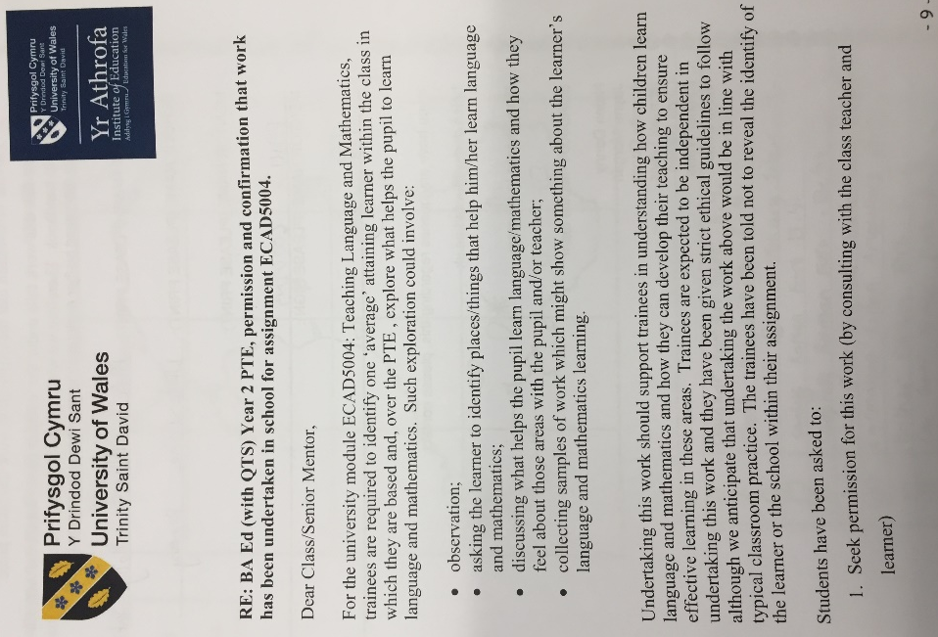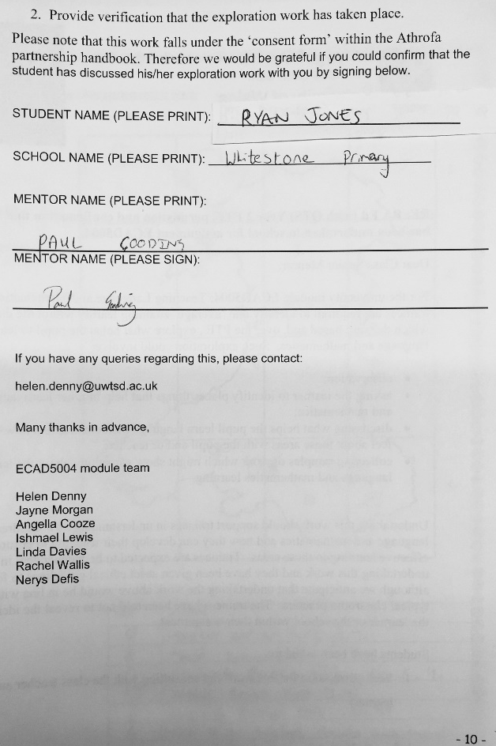
2.
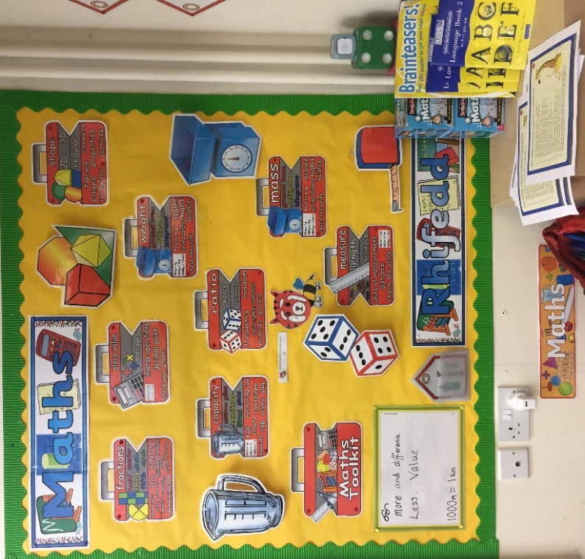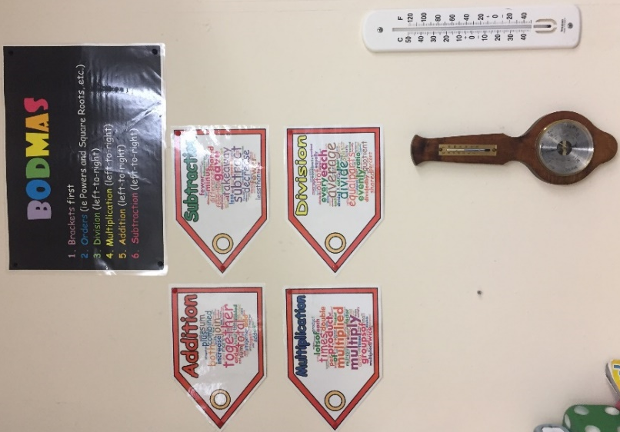

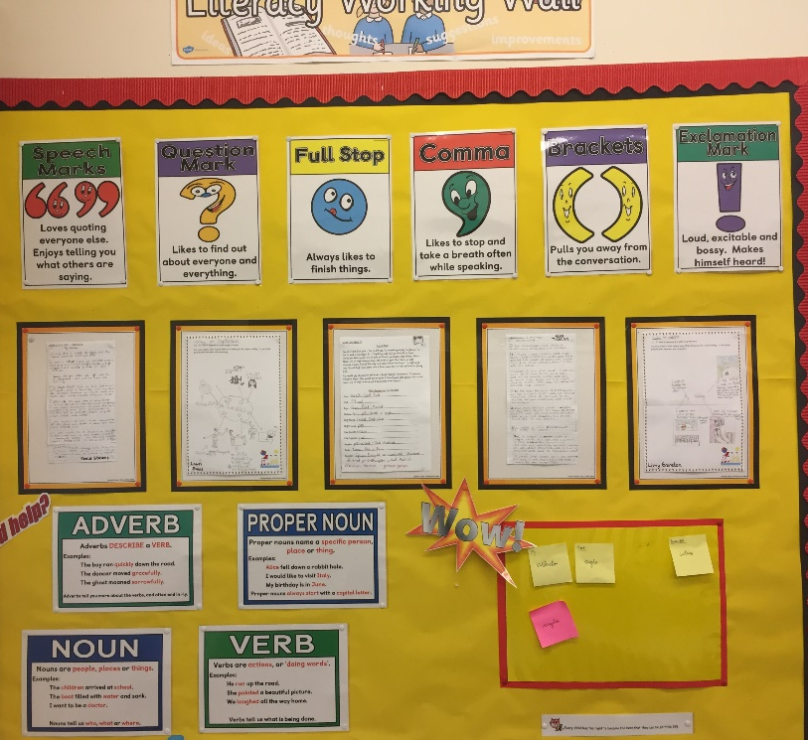

3. 4.
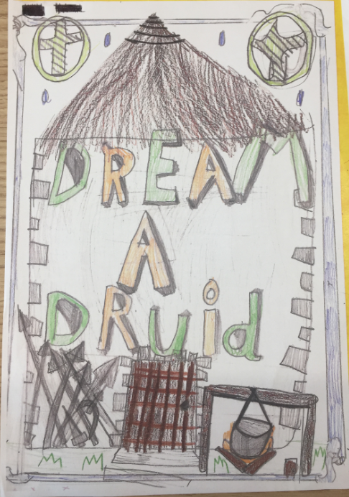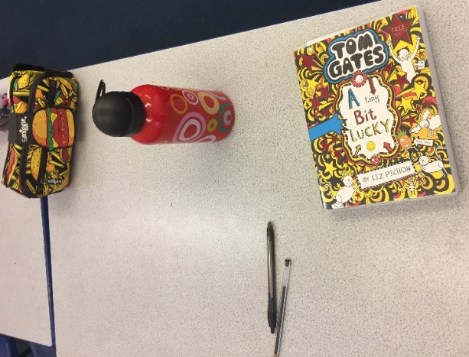

5.
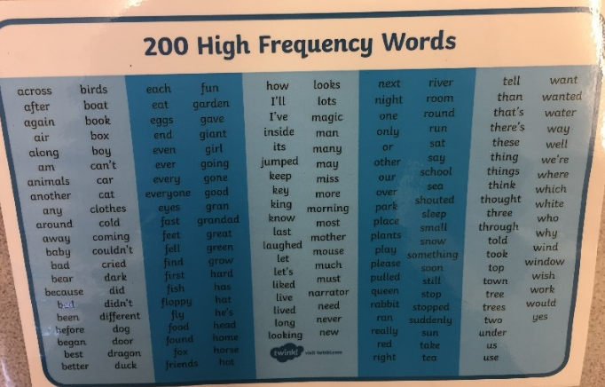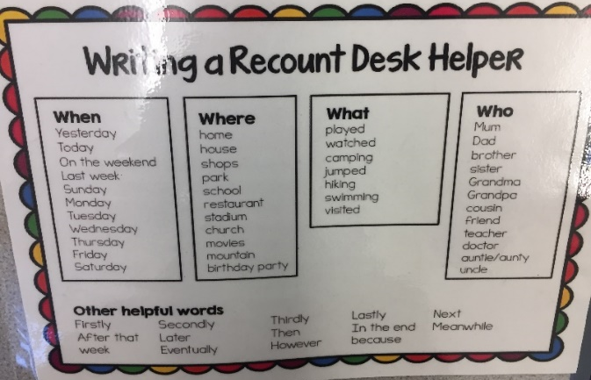

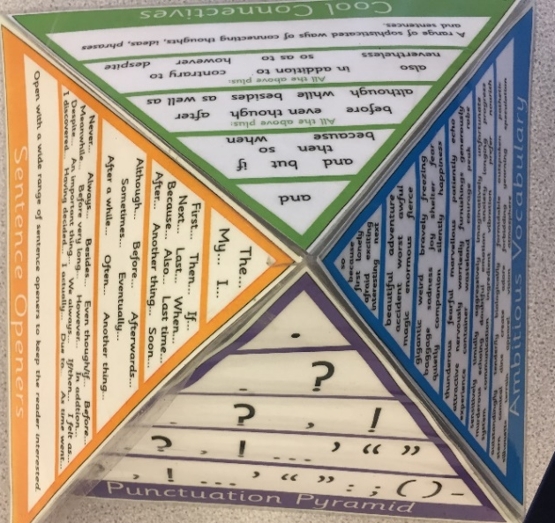

6.
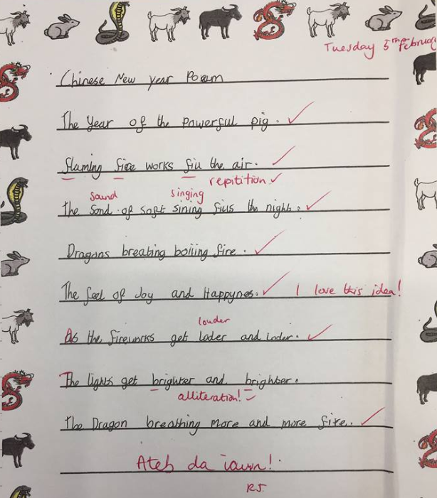

7. 8.
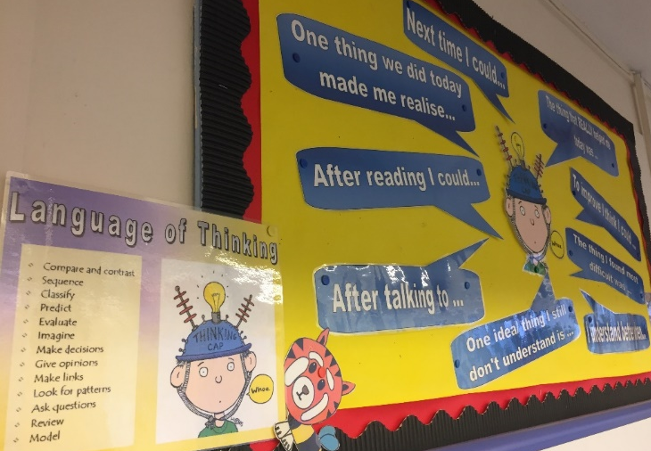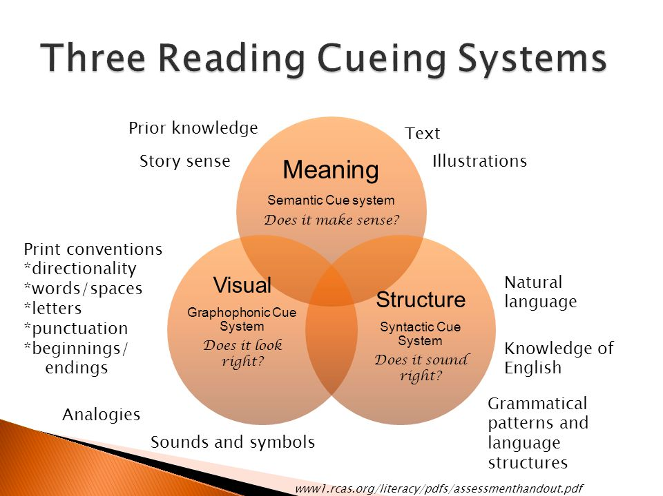
https://slideplayer.com/slide/4364180/
(Accessed: 26/03/19)

9.
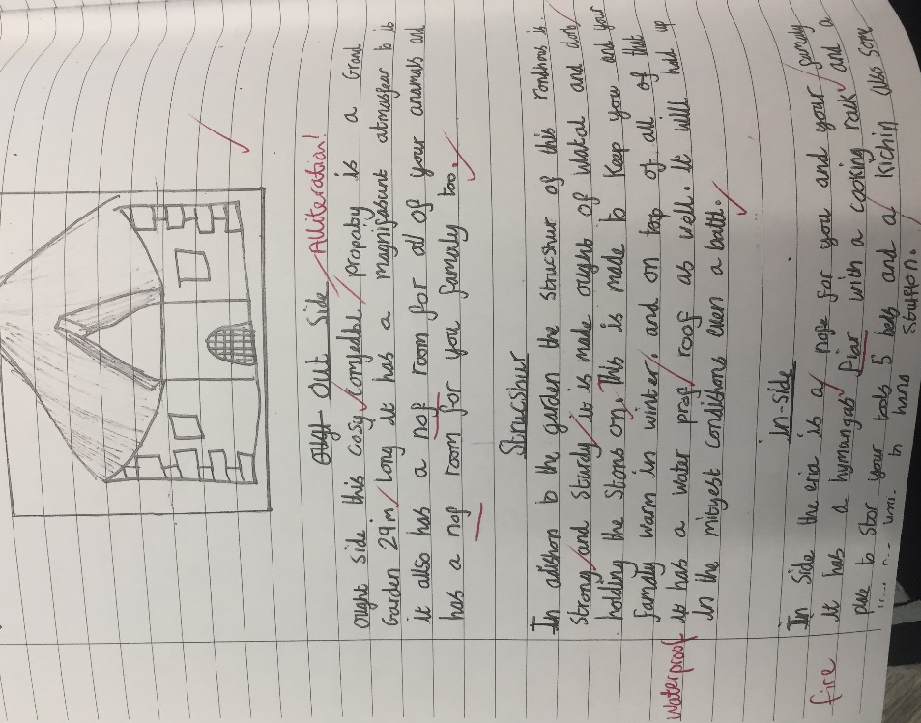
10.
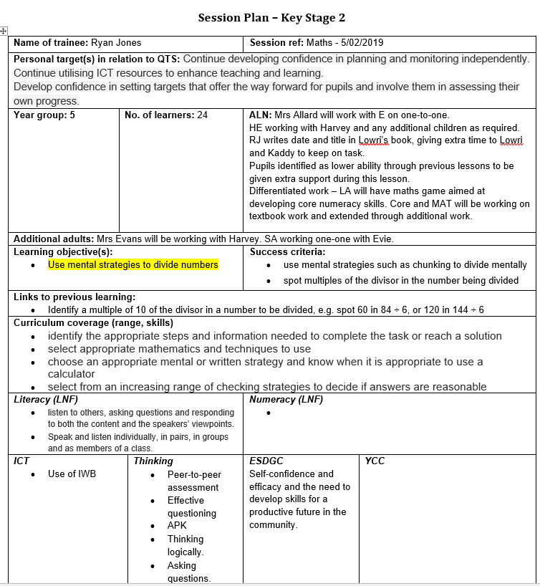
11.
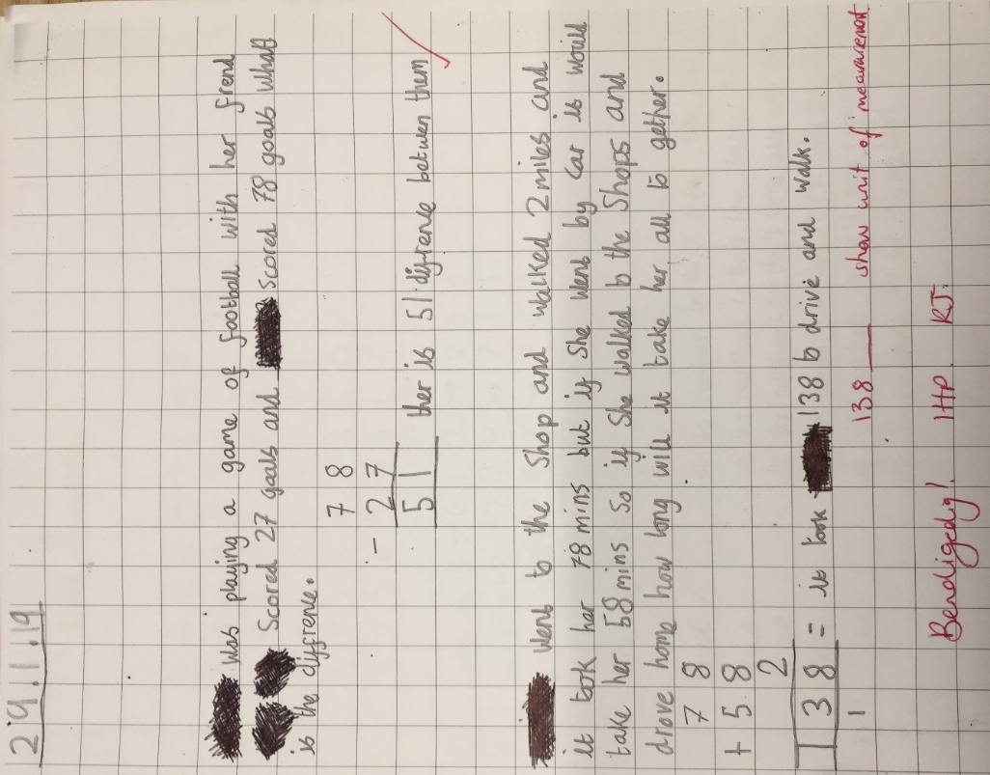

12.
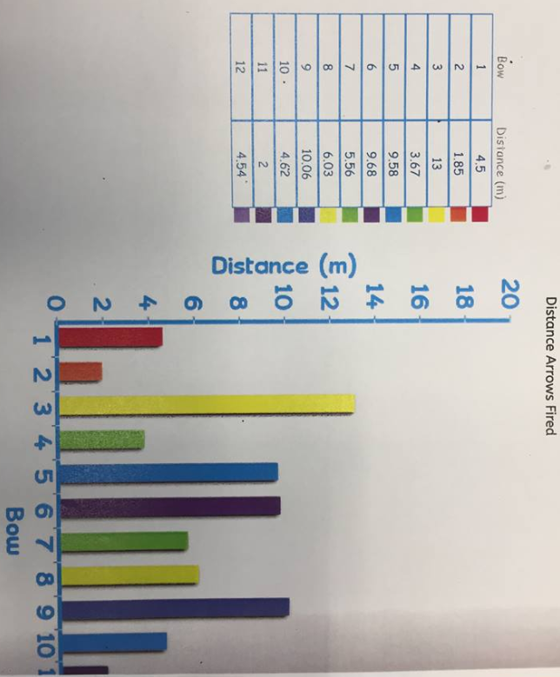

13. 14.
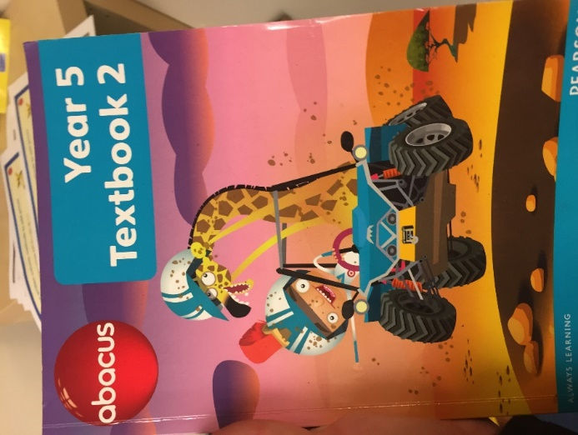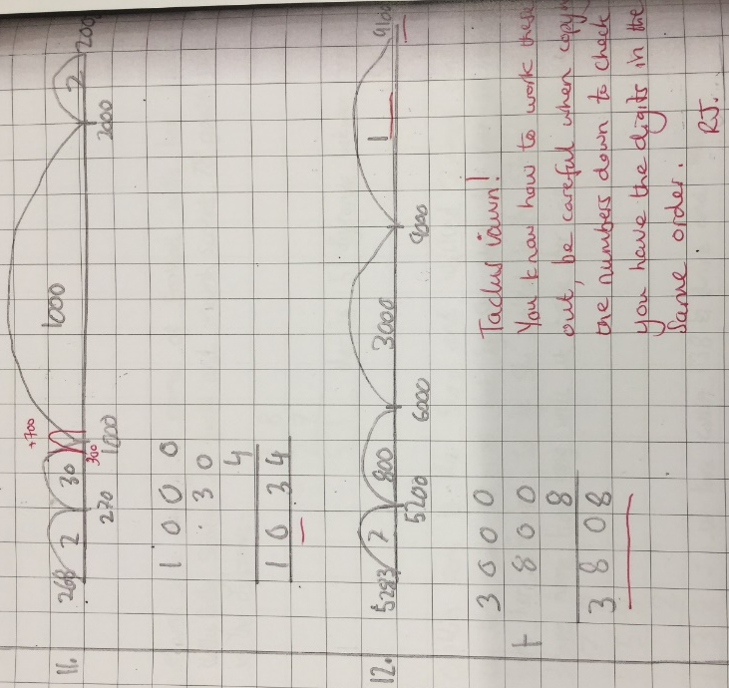

15.



