ASSIGNMENT

Module: Changemakers: Building your Personal Brand for Sustainable Employment
Module Code: BMHP5015
Assignment: Component 1
Online portfolio of exercises
Student Name: Bouchra El Imrani Taidi
Student Number: 2321157



Task 1:
My personal brand represents the professional identity I aim to carry into the health and social care sector which includes being compassionate, reflective, and committed to evidence-based practice. Personal branding helps individuals communicate their strengths, values, and professional direction, which is particularly important in a sector that prioritises trust, empathy, and accountability. As a healthcare professional, I believe providing caring and compassionate approach is extremely important which is one of the key qualities I include in my personal brand. As I continue developing my career, I view my personal brand as a combination of my clinical skills, interpersonal abilities, and the way I present myself within professional spaces. Recent studies indicate that strong personal branding enhances employability, supports clearer career pathways, and builds confidence in professional identity formation (Gamble et al., 2023).
To enhance my job-related skills, I intend to refine my communication skills by building stronger online professional profile, actively engaging in CPD activities, taking on leadership roles and contributing to multidisciplinary learning opportunities.
Additionally, developing emotional intelligence is also important in personal brand, as it supports effective teamwork and improves relationships with both service users and colleagues (Powell et al., 2024). By engaging in reflective practice, learning from feedback, and aligning my behaviours with sector values such as dignity, respect, and inclusion, I can create a strong and authentic professional brand. Ultimately, this will support my progression towards sustainable employment in health and social care.
TASK 2 – Network Map and Rationale
My network is composed of four key dimensions which are career, support, social, and community each contributing to my development within health and social care. To start with first dimension which is career the network will include colleagues, mentors, clinical supervisors, and multidisciplinary professionals who influence my learning and provide professional guidance. The support dimension includes family, close friends, close relatives, and peers, who contribute to emotional stability and resilience. My social network includes friends, neighbours, colleagues, classmates who help maintain balance beyond professional environments. The community dimension includes professional forums, voluntary organisations, gym people and wider health and social care groups that provide opportunities for shared learning.
Employability outcomes are significantly influenced by strong professional networks. According to Granovetter's (1973) theory of weak ties, distant connections frequently offer access to possibilities and new knowledge that might not be available inside intimate networks. More recent research demonstrates how healthcare communities of practice foster lifelong learning, personal growth, and the building of solid professional identities (Louwen et al., 2023).
However, I think this network is lacking in certain research-related fields. I believe my network is strong in emotional and practical support but could be expanded further in areas such as research, leadership, and academic development. Strengthening these connections will enhance my career prospects, increase confidence, and support continuous improvement in my practice.
Task 3
Title: Why Emotional Intelligence Is Becoming Essential in the UK Health and Social Care Workforce
The UK health and social care sector, especially in NHS England continues to face ongoing pressures, including rising service demand, shortage of staff, and increasing levels of stress among staff members. As organisations work toward building a more resilient and compassionate workforce, emotional intelligence (EI) has emerged as a key skill that significantly influences performance, communication, and professional wellbeing.
Emotional intelligence (EI) refers to the ability to recognise, understand, and manage our own emotions while responding effectively to the emotions of others. Recent studies indicate that EI is directly linked to improved teamwork, decreased levels of burnout, and overall better patient experiences (Chaudry et al., 2024). Within healthcare settings, professionals encounter challenging situations daily, such as complex patient needs, poor prognosis, history of abuse, safeguarding issues, and emotionally sensitive conversations. Emotional Intelligence enables staff to navigate through these demands with empathy, patience, and professionalism.
EI is particularly crucial for students, apprentices and practitioners just starting their careers. It helps by developing self-assurance, improving communication with clients, and strengthening bonds within interdisciplinary teams. A psychologically safe workplace where employees feel free to express themselves, think honestly, and grow from their mistakes is another benefit of having strong EI.
An RCT conducted by Oweidat et al., 2024 concluded that professionals with high EI are directly related to more positive outcomes in healthcare. It plays a vital role in recruitment, staffing, promoting, and nurturing employees making it a crucial criterion for achieving excellence in healthcare organizations.
Developing EI is not only beneficial for individual practitioners it also strengthens organisational culture. Health and social care settings that prioritise EI tend to have better staff retention, more effective leadership, and improved quality of care. As the UK continues to restructure services and respond to workforce challenges, emotional intelligence should be recognised as a core professional skill that underpins compassionate, patient-centred practice.
Task 4:
1. What is the primary goal of the NHS Equality, Diversity, and Inclusion Improvement Plan?
The primary goal of NHS EDI is to build an NHS workforce where everyone is treated fairly, feels included, and has equal access to opportunities so the quality of patient care and workforce staff wellbeing improve (Health Education England, no date).
2. How does the NHS EDI Improvement Plan propose to tackle the gender pay gap?
The plan is to manage the gender pay gap by increasing transparency, improving promotion pathways for women and ensuring fair recruitment and career-progression processes for all (NHS England, 2023).
3. What is meant by the term ‘intersectionality’ as used in the NHS EDI Improvement Plan?
Intersectionality means understanding that some people may face more than one type of disadvantage at the same time. It is the framework for understanding how a person's multiple identities for example race, gender, disability, age and sexuality are the combined experiences which need to be recognised and addressed.
4. Why is it important for the NHS to create a psychologically safe work environment?
A psychologically safe workplace is very important because staff needs to feel comfortable in sharing their concerns and speaking up and also asking for help without worrying about being judged.
5. How does the NHS EDI Improvement Plan suggest improving the experience of internationally recruited staff?
The plan supports internationally recruited staff by improving induction, cultural support, fair career development and protection from discrimination. It does this by providing clear pre-arrival communication, comprehensive onboarding programmes, and equal access to training and career progression opportunities (NHS England, 2023).
6. What role does leadership play in advancing EDI objectives according to the NHS Improvement Plan?
Leadership plays a key role in moving EDI forward because it sets the tone and culture of an organisation. Good leaders show accountability, led by example, and make sure EDI values are genuinely put into practice at every level. By modelling inclusive behaviour and holding their teams to the same standard, leaders help ensure that EDI goals are part of everyday decisions, not just words on paper.
7. Identify one way the NHS EDI Improvement Plan aims to reduce health inequalities within the workforce.
One way the NHS EDI Improvement Plan works to reduce health inequalities in the workforce is by looking closely at pay gaps linked to protected characteristics and taking steps to fix them. This helps make sure everyone is paid fairly.
8. Why does the NHS EDI Improvement Plan emphasise the importance of collecting and analysing data on protected characteristics?
The NHS EDI Improvement Plan emphasizes on collecting data on protected characteristics helps the NHS understand where inequalities exist and make changes based on real evidence, not guesswork and address systemic inequalities in both patient care and workforce experience.
9. Explain how flexible working policies can contribute to equality and inclusion in the NHS workforce.
Flexible working supports equality because it helps staff manage their work alongside family, health, or personal commitments, making the workplace more supportive for everyone.
10. What is one strategy mentioned in the NHS EDI Improvement Plan to combat bullying and harassment in the workplace?
One strategy is strengthening reporting systems so staff can safely report bullying or harassment and know action will be taken quickly and fairly.
TASK- 5 Letter to Yourself:
Dear younger me,
You are putting in the work, even when it feels like you are stumbling through everything on your own. Right now, it might feel messy and uncertain, but every challenge you’re facing is quietly shaping the qualities that will one day be your biggest strengths in life and in your career.
You’ll come to understand how crucial emotional intelligence and resilience are especially in a demanding field like health and social care. Emotional intelligence will help you recognise your feelings, manage them and respond instead of reacting. You’ll learn to speak up and ask for support and see situations more clearly. Studies even show that strong emotional intelligence improves decision-making and relationships in caring professions (Alharbi, 2025).
Resilience will build gradually almost without you noticing. Setbacks won’t feel like failures anymore, they will feel like part of the process. You will learn and understand that progress isn’t linear and that it is a part of journey. This resilience you will gain will keep you adaptable, motivated, and patient with yourself during tough moments.
Even if you can’t see it now, these strengths are forming quietly in the background, shaping you into the confident, capable person you’re meant to become. Keep trusting yourself and your determination, focus, and hard work are guiding you exactly where you need to be.
With kindness,
Your future self.
Task- 6 Gantt Chart:
The figure below represents Gantt chart with timeline for future employment goals
- Self-Assessment & Goal Setting-Month 1: I will begin by evaluating interests and skills to proceed in a desired career direction.
- Research Potential Careers- Month 2: I will explore possible roles, sectors, and market relevant to the background.
- Skill Development: Months 2-4: For this, I will start looking for potential courses or training (such as Excel, leadership, or graphic design skills).
- Create/Update CV and Portfolio-Month 3: During this month, the focus will be on designing, proofreading professional CV and compiling a portfolio of relevant work samples.
- Job Search and Networking- Months 3-5: I will start applying for positions, attend industry networking events, and connect with professionals via social media platforms like LinkedIn.
- Interview Preparation- Months 4-5: Research companies, practice interview techniques, and ready application materials.
- Apply for Jobs-Months 4-6: Send job applications, modify cover letters, and send follow up emails to employers.
- Accept Offer and Onboarding-Month 6: The focus will be on reviewing job offers, attending interviews, and prepare for onboarding and adjustment to new role.

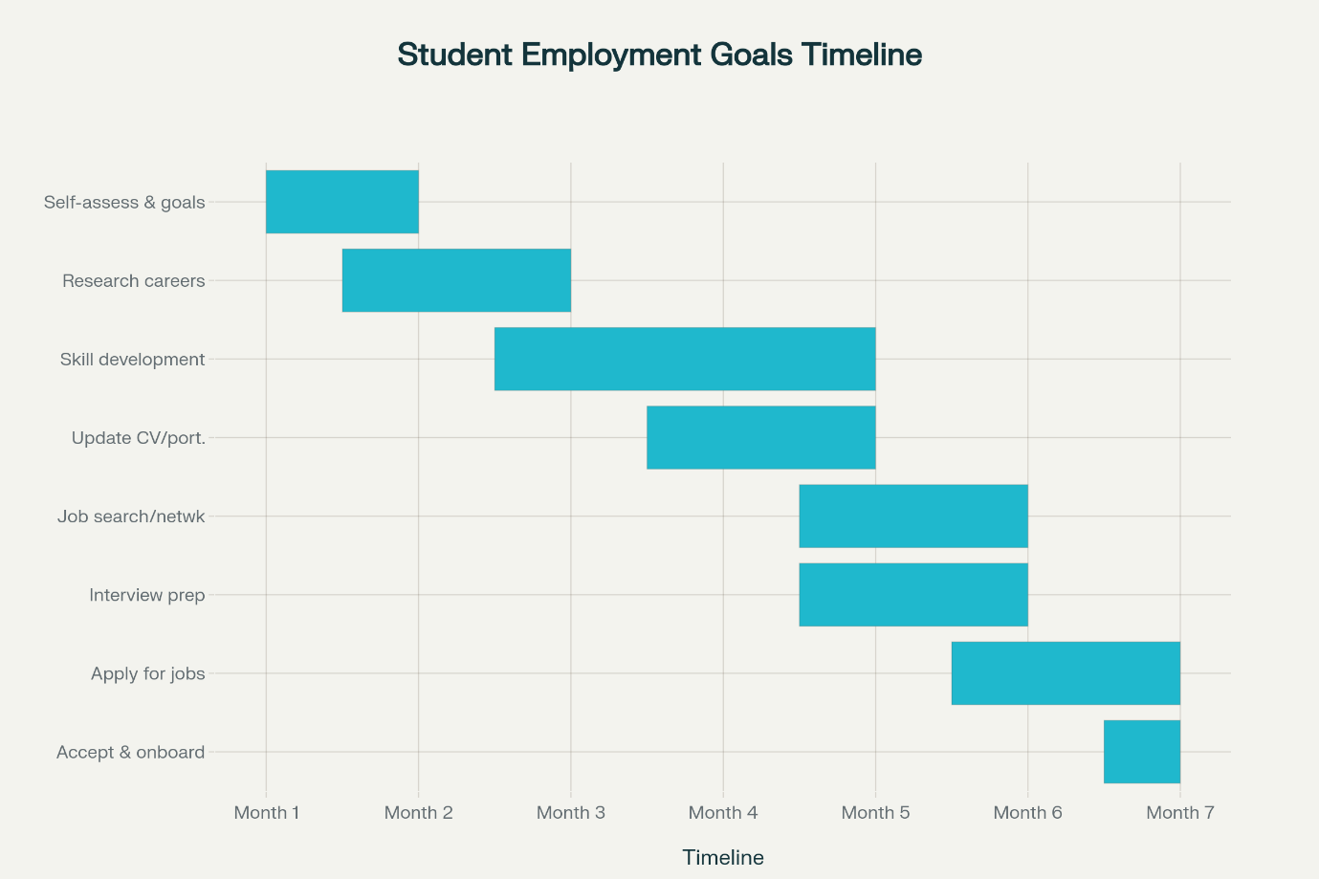

Task 7: Proposed Change: Introducing a Person-Centred Falls Prevention Programme:
As a manager in a care home, I aim to introduce a structured falls-prevention programme to enhance resident safety and reduce fall-related incidents. Falls are one of the significant concern in older adult settings, and evidence suggests that person-centred interventions, staff training, and environmental adjustments can significantly reduce risks (Zhang et al., 2025). To successfully implement this improvement, I will apply Lewin’s Change Model.
The unfreezing stage involves identifying the scale of the problem by reviewing incident reports, conducting MDT meeting and engaging staff in discussions about current challenges. Building awareness helps reduce resistance and prepares the team for change.
Next step is changing stage during which new interventions will be introduced with a focus on comprehensive risk assessments, multiple strength-balance exercise sessions, environmental improvements, and staff training related to safe mobility and observation skills. Effective communication and teamwork are essential to support staff confidence and consistency.
Finally, in the refreeze stage, the new procedures will be embedded into daily routines through regular audits, monitoring, and continued staff development. This ensures long-term sustainability and reinforces a culture of safety.
Potential barriers include staff workload and resistance to new procedures. These will be addressed by involving staff early, providing adequate training, and demonstrating positive outcomes.
TASK 8: Self-Reflection
Using Gibbs reflective cycle (1988), I reflected on my learning throughout this module and how it has contributed to my personal and professional development.
Description: This module explored personal branding, networking, emotional intelligence, employability skills, and reflective practice.
Feelings: Initially, I felt unsure about describing my strengths and creating a professional identity. However, as I progressed in this module and with each class, I became more confident in understanding how my values and abilities align with health and social care roles.
Evaluation: Completing these tasks helped me recognise areas of strength such as communication and compassion. It also helped me identify my weaknesses which includes leadership and digital professionalism.
Analysis: Emotional intelligence emerged as a key theme linked closely to effective teamwork and patient-centred care. Studies show that EI significantly influences clinical performance and resilience in healthcare professionals (Cheraghi et al., 2025). I also gained insight into how networks, personal branding, and self-awareness support long-term career progression.
Conclusion: I now have a clearer understanding of the expectations within health and social care and how to position myself as a confident, employable practitioner.
Action Plan: My action plan is to expand my professional network, maintain reflective practice, develop my digital profile, and engage in further CPD. These steps will help me continue strengthening my employability and personal brand.

References
Gibbs, G.(1998). Learning by doing. Cheraghi, R. et al. (2025). Emotional intelligence and job performance in nurses. BMC Nursing, 24, 130.
Oweidat, I., Alzoubi, M., Shosha, G.A., Ta’an, W.A., Khalifeh, A., Alzoubi, M.M., Al-Mugheed, K., Alabdullah, A.A.S. and Abdelaliem, S.M.F., 2024. Relationship between emotional intelligence and quality of healthcare among nurses. Frontiers in Psychology, 15, p.1423235.
Health Education England. (no date) Equality, Diversity and Inclusion. Available at: https://mhcswtoolkit.hee.nhs.uk/topics/equality-diversity-and-inclusion.html (Accessed: 16 November 2025).
NHS England. (2023) NHS equality, diversity and inclusion (EDI) improvement plan. NHS England, 8 June. Available at: https://www.england.nhs.uk/publication/nhs-edi-improvement-plan/ (Accessed: 16 November 2025).
Gamble, J., Lincoln, M. & Adams, C. (2023). Professional identity formation in early career health professionals. BMC Medical Education, 23(1), 452.
Powell, C., Brown, T. & Yap, Y. (2024). Emotional intelligence training in the healthcare workforce: A systematic review. Frontiers in Psychology, 15, 1437035.
Lewin, K. (1951). Field Theory in Social Science.
Zhang, Y. et al. (2025). Emotional intelligence and work environment impacts on presenteeism. BMC Nursing, 24, 291.
Alharbi, K. (2025). Emotional intelligence and clinical competence in healthcare students. BMC Nursing, 24, 536.
Chaudry, A. et al. (2024). Impact of emotionally intelligent leadership on healthcare performance. International Journal of Environmental Research and Public Health, 21(11), 1531.
Granovetter, M. (1973). The strength of weak ties. American Journal of Sociology, 78(6), 1360–1380.
Louwen, C., Reidlinger, D. & Milne, N. (2023). Profiling health professionals’ behaviour styles and emotional intelligence: A systematic review. BMC Medical Education, 23, 120.

