Assessment
Portfolio Report on Contemporary Software Applications for Business



MODULE NAME: SOFTWARE SOLUTIONS FOR BUSINESS MODULE CODE: ACCA 4026
LECTURER: KOUSHIK MODAK
TRINITY SAINT DAVID UNIVERSITY OF WALES (LONDON

Table of Contents
Introduction 3
Task 1: e-Commerce Website builders/software solutions 4
Task 2: Mind-map of Contemporary Software Applications 5
a. Mind Mapping and the Advantages. 5
b. Mind Map of Modern Software Applications. 6
Task 2: Office Applications for Creating, Storing, Presenting, and Analysing Data 7
a. Explanation of Office Software 7
b. Practical Tasks 10
Task 4: Communication and Collaboration applications 11
a) Analysis of Applications 11
b. Practical Task 13
Conclusion 14
References 16

Introduction
In the modern digital-based business world, organisations are heavily depending on a great number of software applications in order to improve efficiency, communication and decision making. In e-commerce, office productivity applications and teamwork platforms, the software solutions are essential in helping businesses to compete effectively within the local and international markets. The fast rising in technology has contributed towards the creation of modern applications that ease complicated business operations like data analysis, communication and online transactions.
This report examines various types of software applications applied in the contemporary organisations. It will start by discussing the common e-commerce web site builders and then discuss the mind mapping as a way of organising ideas and business processes. The report then proceeds to discuss the office applications in detail like the Microsoft word, excel, PowerPoint and Access, its feature, advantages and disadvantages. Moreover, communication and collaboration tools are discussed in order to reveal the way businesses stay connected and collaborate in dynamic workplaces. Practical activities also will be incorporated to show practical application of features of chosen software.

Task 1: e-Commerce Website builders/software solutions

E-commerce website builders are web-based applications that allow people and companies to create, build and operate online stores without advanced programming or technical skills. These sites have become very relevant in the contemporary business world where organisations are trying to grow their operations into the virtual market. E-commerce builders usually offer various integrated solutions, including ready-made templates, secure payment gateways, inventory management systems, and marketing capabilities, which make online product and service selling easier 4. As a result, they lower the barrier to entry for small businesses and entrepreneurs who need to establish an online presence.
Shopify, Wix, WooCommerce, BigCommerce, and Squarespace are some of the most widely used e-commerce web builders in the world. While these platforms support online business operations, they differ in terms of pricing model, scalability, user-friendliness, and degree of customization. For instance, some providers are fully hosted and manage technical features like security and updates, while others require a certain level of technical expertise to use effectively.
One of the most popular e-commerce platforms is Shopify, which is renowned for its extensive feature set and easy-to-use interface. Shopify is a program that lets users create fully functional, professional online stores using drag-and-drop functionality and custom templates. Additionally, it offers inventory management, safe payment processing, and third-party integration with apps like analytics and marketing. The primary advantage of Shopify is that it is a hosted system, meaning that the provider handles web hosting, software upkeep, and security. This makes it easy to use, especially for people with little technical experience⁶.
WooCommerce, on the contrary, is a less rigid and customizable e-commerce platform. It is a free-of-charge plug-in available in WordPress websites and enables users to convert their existing websites into full-fledged online stores. The high rate of customization is one of the main benefits of WooCommerce as a user can alter the platform with a vast amount of tools and themes. Also, WooCommerce does not have the mandatory subscription charges every month and this makes it an affordable choice by most companies. This leeway, however, comes at a price. The users will be left to do their own hosting, security of their websites, and updates on their systems, which might not be easy to do when the user lacks technical knowledge. Moreover, additional plugins may also complicate and heighten maintenance needs.
To sum up, both Shopify and WooCommerce have beneficial solutions to businesses that need to participate in e-commerce. Whereas Shopify offers convenience and ease of use by means of its hosted platform, WooCommerce offers flexibility and control with its open-source platform. The selection of the two will in the long run be based on the needs of the user, technical capacities, and their financial capacity.

Task 2: Mind-map of Contemporary Software Applications

a. Mind Mapping and the Advantages.

Mind mapping is a visual thinking tool, which is applied to group ideas, concepts, and information in a systematic and hierarchal way. It is the process of having a main idea at the centre of a diagram and then branching out the related ideas by way of extensions into branches, which can consist of keywords, images, symbols, and connections. This method reflects the human brain processing and association of information, and it is simpler to perceive, memorize, and remember more complicated concepts⁸. This has seen the mind mapping technique being embraced in education and business arenas.

Within the business operations, mind mapping is important in the process of brainstorming and idea generation. Mind maps can be used by the teams in meetings or when strategic planning is involved to achieve a quick capture of ideas and a logical arrangement without limiting creativity. This method would promote thinking freely and enables the participants to consider various points of view, and this would result into more creative solutions⁹. Also, mind mapping is used to organize a lot of information into small manageable parts, a factor that enhances clarity and focus in the discussion.

The other important advantage of mind mapping is that it enhances the decision making processes. Decision-makers are able to analyse the available options and assess their possible outcomes better by visually depicting the relationships between various ideas or variables. With this, pattern, connections and priorities can be identified easily unlike in the traditional linear notes where they are sometimes hard to detect. Moreover, mind maps contribute to better communication among teams by creating a clear and simple visual image of ideas that can be understood and eliminate the misunderstanding and ensure that every team member understands what goals are shared¹¹.

Mind mapping is also effective in the enhancement of productivity especially in project management. Multifaceted projects tend to have a number of tasks, schedules, and duties and this may be mesmerizing when it is shown in text format. Through the mind maps, the project managers will be able to subdivide these factors into smaller and interconnected components that will be easy to plan and track progress and allocate resources efficiently. This visual method is time-saving and efficient as it allows retrieving the most important data in a short period of time.

b. Mind Map of Modern Software Applications.

The mind map of modern software applications offers a graphic representation of the various types of tools that are applied in the current business settings. The key idea in the middle of the mind map is the core concept, which is Contemporary Software Applications, which indicates the high diversity of digital tools applied in facilitating organisational processes.
Out of this central node, there will be several key divisions, each of which will be a given type of software. One of its branches is office applications that comprise Microsoft Word, Excel, PowerPoint, and Access. These programs are essential for creating documents, analyzing data, and making presentations. The other important area is communication tools, which include Zoom, Microsoft Teams, and email services. These tools allow organizations to communicate and share information in real time.
Google Drive, OneDrive, and SharePoint are among the collaboration tools that make up the other branch. Collaboration and productivity are encouraged by the tools' ability to allow multiple users to work simultaneously on a single document. Shopify, WooCommerce, and Wix are just a few examples of e-commerce platforms that fall under the category of online business transactions and digital marketing. Organizations use data analysis tools like Excel and Power BI to interpret data and make well-informed decisions, while project management tools like Trello and Asana are used to plan, track, and manage tasks.
In general, the mind map provides an organized and visualized explanation of how different software programs are connected to one another and support routine business operations.
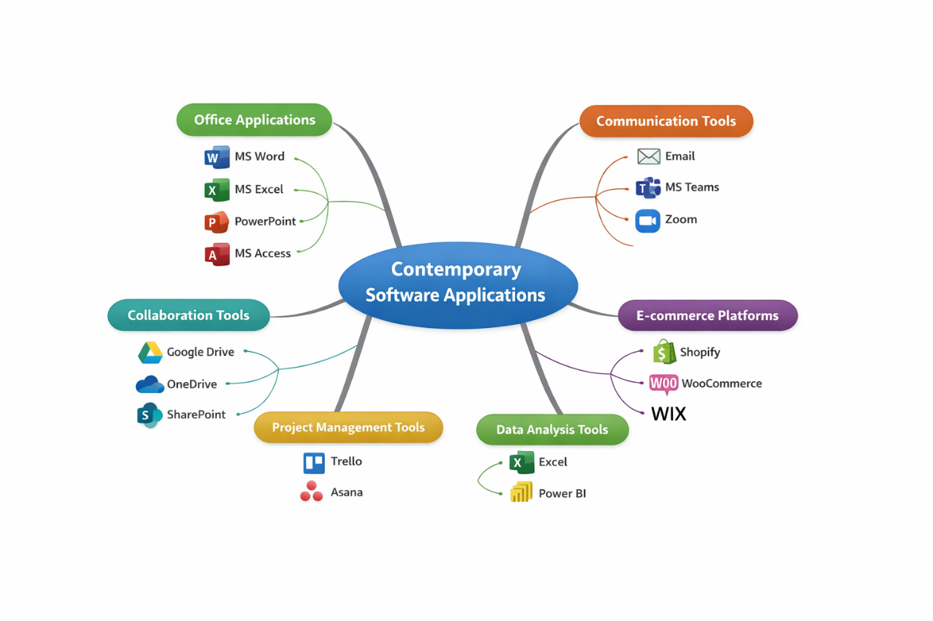
Figure 1: Mind map

Task 2: Office Applications for Creating, Storing, Presenting, and Analysing Data

a. Explanation of Office Software
The office software applications are key in enhancing the business activities in the modern world as they help organisations to generate documents, analyze data, present information, and manage records effectively. The most popular Microsoft Word, Microsoft Excel, Microsoft PowerPoint, and Microsoft Access are among them. These applications are included in the integrated office productivity packages and they are specific to meet various yet complementary business capabilities. Each application has unique characteristics, benefits, and drawbacks that influence how it is used in specific organizational tasks.
One of the most popular word processing applications in the business sector is Microsoft Word. It was made especially to create, edit, format, and distribute written documents such as official reports, letters, reports, and proposals. One of the most important features of Microsoft Word is its advanced formatting capabilities, which allow the user to customize fonts, styles, layouts, and document structures to produce an output that looks professional. Additionally, Word has built-in features like a thesaurus, grammar check, and spell check that enhance the precision and quality of written communication.
The aspect of templates is also important as it enables users to develop standardised templates (resumes, invoices, business letters, etc.) without necessarily begining with a blank sheet¹.
Microsoft word has significant gains in business operations. It enhances communication by allowing organisations to develop transparent, well organised and professional reports. It further improves productivity because the users can edit and revise work quickly without necessarily typing an entire document. Furthermore, Word is capable of working together and can assist in the work of multiple people through such features as track changes and remarks to view and make changes in the documents offered by more than one user. It particularly comes in handy when one is in a team setting where the documents undergo several revisions in order to be finalised⁷. Microsoft word has however had its limitations in spite of the benefits it has brought about. It is not automated to handle gigantic data and perform the intricate data analysis and hence cannot be utilized to handle the tasks that would require use of numbers or statistical analysis. The reason is that at times too complex formatting normally brings about disparity especially in the exchange of documents between different versions of the software.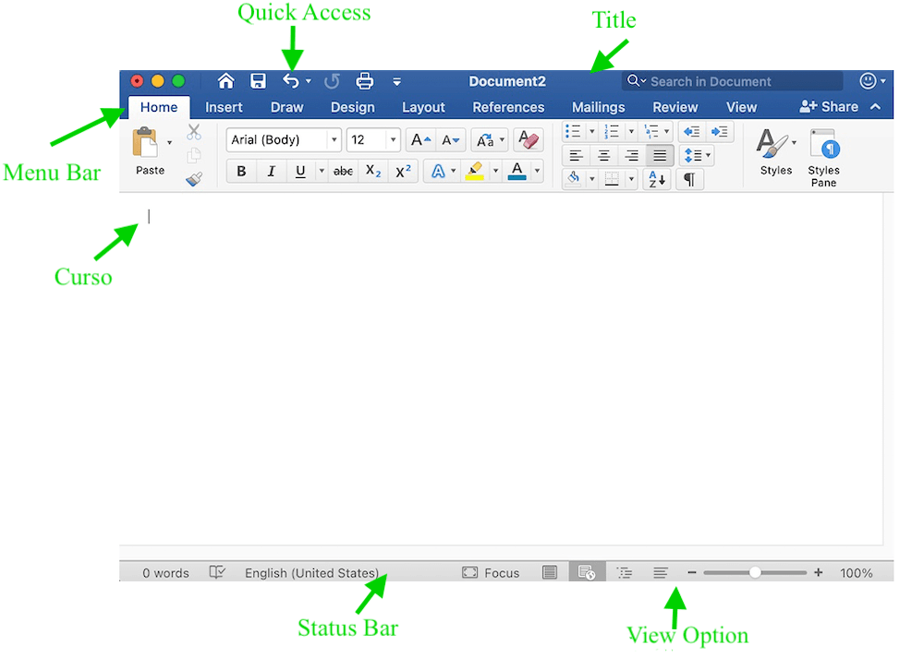
Figure 2: Microsoft word
Microsoft Excel is a spreadsheet application, however, particularly created to carry out data analysis, financial modelling, and numerical computation. The software further enables the user to format data into rows and columns in Excel which makes it simple to make calculations and analyse trends. The use of formulas and functions is one of its most powerful features and allows a user to make a wide variety of calculations, simple arithmetic operations included and highly complex statistical analysis. The IF, VLOOKUP and SUM functions can give the user flexibility in manipulating the data and the pivot table enables the user to fix and analyse small data fastest. Moreover, Excel has charting and data visualisation functionality, which assists in converting raw data to valuable insights using graphs and dashboards¹¹.
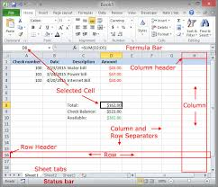
Figure 3: Microsoft excel
Excel has wide advantages in business. It aids in decision-making as it presents precise and timely information analysis required in financial planning, budgeting, and forecasting. Excel also enhances efficiency as it gives an automaticity in repetitive calculations, thus minimizing possibilities of errors when done manually. It is also flexible and hence can be used in different business functions such as accounting, marketing and operations management. Nevertheless, Excel has also its shortcomings. It may be difficult and complicated to the novice, especially with advanced functions and big data. Malfunction of the formula in a formula or in the input of the data can also cause wrong results and this may adversely affect the decision-making process unless the error has been realized and rectified. Also, Excel can be weak with very large data volumes, whereas more robust database systems can be utilized, and it does not offer the same strong data integrity controls as a more specific database application⁷.
Microsoft power point is a presentation software package used to create visual slideshows to communicate. It is common in business to hold meetings, training, marketing pitches and corporate presentations. PowerPoint allows the users to integrate text, images, charts, animation and multimedia in a single presentation. Among the most significant capabilities is the presence of templates and themes of design, which allow the user to make the slides look attractive without having to possess high-level design competency. Furthermore, PowerPoint has an animation and transition feature that helps to engage the audience better as it makes presentations more active and interactive¹.
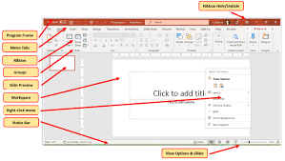
Figure 4: Microsoft powerpoint
The major advantage of PowerPoint is that it has enhanced communication and delivery of information. It enables people to grasp complicated concepts easier because it shows information in graphics than when it is presented through text alone. PowerPoint also allows storytelling in the business world whereby the presenter is able to organize his presentations in a logical and interesting way. Moreover, it improves professionalism since professionally designed slides may impress the client, stakeholders, and coworkers. PowerPoint has a few limitations in spite of these benefits. A presentation can be very effective and such relies on the design and presentation; ineffective slides with too many texts and annoying animation effects may diminish the clarity and interest of the audience. Moreover, excessive use of slides can restrict interaction and critical debate in making presentations that could have an impact on the overall performance of the communication process¹².
Microsoft access is the database management system, which allows organisations to store, handle and retrieve bulk structured data. In contrast to Excel which is mostly utilized in data analysis, Access is designed to deal with relational databases. It enables the user to make tables of storing data, queries of retrieving particular information, data entry forms, and data presentation reports. Access has one of the most important attributes whereby it can create a relationship between various data tables to guarantee data consistency and minimize redundancy. This renders it especially practical in the management of organisational records e.g. customer records, inventory records and employee records¹³.
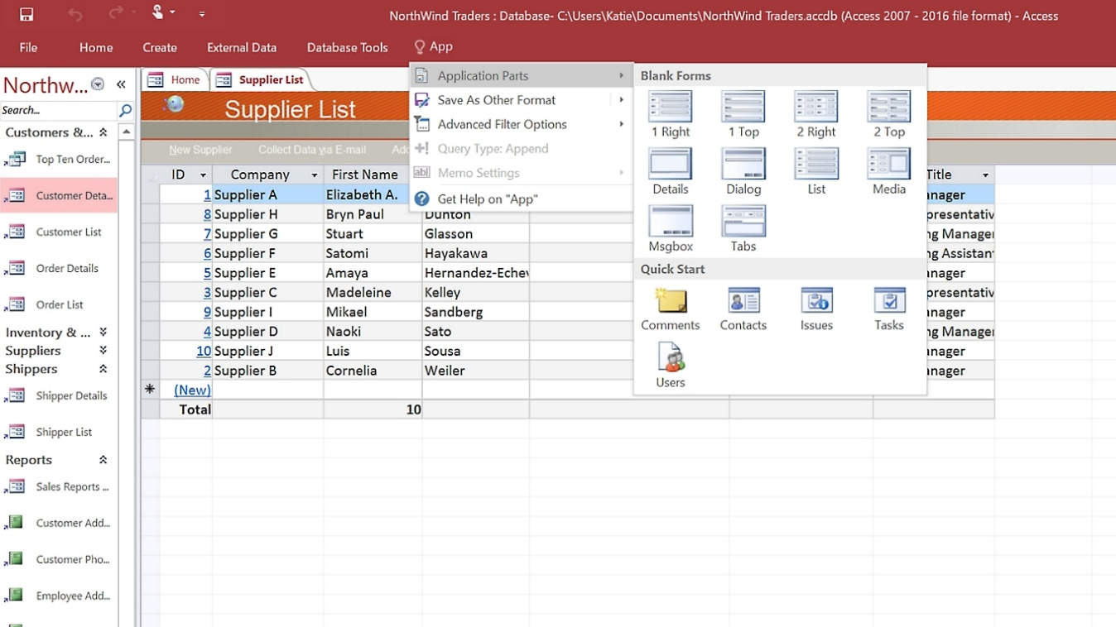
Figure 5: Microsoft access
The advantages of Microsoft Access in business operations are that it enhances better data organisation as well as efficient data retrieval. Access enables storage of data in structured fashion by organizing it into relational tables that allow the storage of information in a systematic manner and easy retrieval when required. It will also improve the accuracy of data using validation rules and constraints, which minimizes the chances of mistakes when entering data. Additionally, Access can be automated using queries and macros, which allow one to carry out repetitive tasks more effectively. Nevertheless, Microsoft Access has shortcomings as well. It is not well adapted to large scale enterprise systems that need a lot of scalability and throughput. More sophisticated database management systems like SQL server or oracle can be in use in such situations. Also, to design and manage databases efficiently, some amount of technical skills is required to use Access, which can be a problem to some users¹³.
To sum up, Microsoft Word, Excel, PowerPoint and Access are useful programs that serve various purposes in business processes. Word is a must to create documents and communicate with the environment, Excel to analyze data and make decisions, PowerPoint to make an effective presentation and communicate; Access to manage the structured data. Although both applications have great advantages, they also have shortcomings that should be taken into account in choosing the right tool to work with particular tasks. These applications combined create an overall package that can improve productivity, efficiency and organisational performance in the business modernisation environment.

b. Practical Tasks

Example 1: Excel – IF Function This is an illustration of the application of the IF function in Excel to automatically compute the student marks and give out the feedback of pass or fail according to a given condition hence making it easy to make a decision and save on the manual calculations.

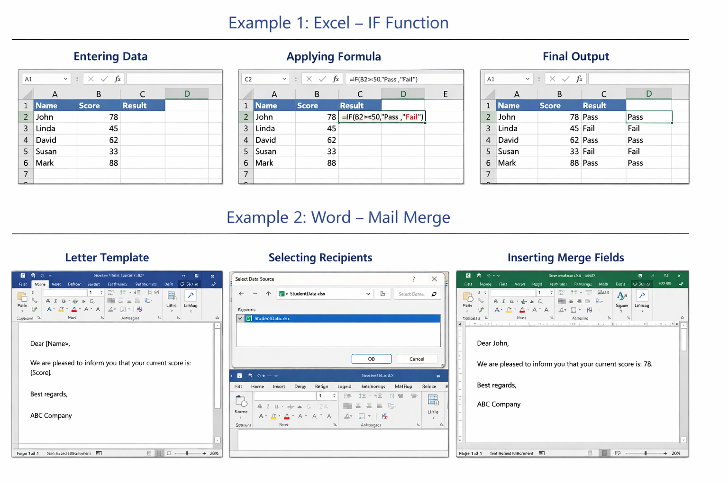
Example 2: Word – Mail Merge The example demonstrates that the Mail Merge option in the Microsoft word application can be utilised to produce personalised letters by integrating a generic template with the data provided in an Excel sheet and thus facilitates effective mass communications in business settings.

Task 4: Communication and Collaboration applications

a) Analysis of Applications
In contemporary business world, communication and cooperation are vital to organisational success, especially in the age of remote work, international collaborations, and digital change. Communication tools facilitate the sharing of information among people and teams whereas collaboration tools facilitate the coordinated efforts in accomplishing tasks and the sharing of common resources. Two examples of the most popular apps in these categories include Microsoft Teams, a communication app, and Google Drive, which is a collaboration app. The flexibility, accessibility, and integration features have made both applications to be a part of business operations every day.
Microsoft Teams is an integrated communication service that enables a team to engage in real-time socialization with each other via messaging, voice calls, and video conferencing. It has a number of major features that include instant messaging, which enables the users to communicate in real time both on an individual basis and within group channels based on projects or departments. Also, Teams allows video meetings and webinars which helps organisations to establish virtual meetings despite their geographical position. The other feature is the ability to share files and integrate with other Microsoft Office versions (Word, Excel and PowerPoint) and enables users to access and edit files within the platform 1.
Microsoft Teams has enormous benefits to the business business processes. It enhances the real-time communication of the employees who are able to answer questions quickly and collaborate in doing tasks. It is also a centralisation stage where all the chats, meetings, and files become centralised in one place whereby several applications are not needed. This improves efficiency and reduces the possibility of loss of information in other channels. In addition, Teams also supports remote work, as it enables the connectivity and engagement of employees regardless of their physical location, which has been more important in the present digital workspace⁷. However, there are weaknesses also associated with Microsoft Teams. It should be connected to the internet and low bandwidth conditions may impair performance. The interface also may appear complex to the novice user as there is a multiplicity of features, and therefore, the novice user may go through the learning curve as he/she uses it initially.
Another tool that is a cloud based collaboration tool is Google drive that enables a person to save his files, share and work on them through the internet. One of its key features is cloud storage that allows users to store documents, spreadsheet, presentation, and other data on external servers safely. Google drive also offers real-time cooperation (as Google Docs, Google Sheets, and Google Slides) in which two or more individuals are able to modify the identical document simultaneously. Any changes made by a single user are instantaneously reflected to other users and this enhances the level of team work and coordination. In addition, Google Drive has file sharing features such that the user can control the accessibility feature, meaning that only authorized individuals can access or make any alterations to some documents³.
The benefits of Google drive are also closely linked to the possibility of access and cooperation. Since it is a cloud-based platform, the users can access their files in any device provided that the device is connected to the internet and thus is highly flexible and convenient to businesses that have scattered workforces. Real time collaboration improves productivity as a person does not have to email numerous versions of one document and thus, does not have to eliminate duplication and confusion. Moreover, the modifications that occur within the Google drive are automatically saved minimizing the risk of losing data. These advantages are matched by certain disadvantages to the platform. Privacy and security of data may be lost particularly to organisations that deal with sensitive data as the data is saved in the external servers. In those instances, the internet addiction is also a disadvantage when the connection is sluggish, or even non-existent⁶.
All in all, Microsoft Teams and Google drive are two significant applications to promote communication and collaboration in business environments today. Google drive is a platform that handles shared work and documents unlike Teams which is specialized to interact and communicate with team members. Their integration promotes organisational efficiency, collaboration and productivity, yet aspects like internet addiction and data protection should be addressed.

b. Practical Task
This screenshot demonstrates how Zoom is used in businesses to conduct virtual meetings. It allows teams to communicate in real-time, especially in remote work environments.
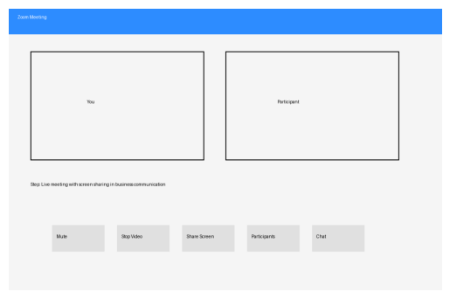
Figure 6: Zoom Meeting Interface
This screenshot shows how Google Docs enables multiple users to work on the same document at the same time, improving productivity and teamwork in organizations.
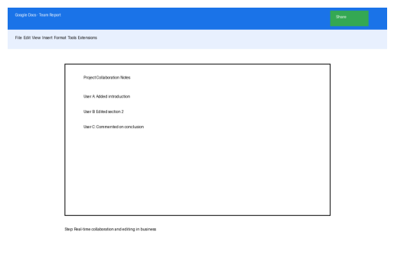
Figure 7: Google Docs Collaboration

Conclusion
To conclude, modern software applications play a key role in the efficient operation of business activities in the current day society because they increase efficiency, ease communication and improve organization and analyses of information. The growing dependency on digital tools is an indication of the increased requirement of organisations to be competitive and flexible in the highly dynamic technological landscape. The use of e-commerce sites has completely changed the business scenario where businesses are able to implement their activities to open up larger and broader markets worldwide and interact with their customer base without the need to be limited by the physical barriers. Meanwhile, some tools like mind mapping applications facilitate the processes of strategic thinking, planning, and creativity by enabling the visualisation of complex ideas and their ordering into a structure.
Moreover, office productivity packages like Word packages, spreadsheet and presentation tools as well as database management packages offer valuable support to daily business operations. These tools allow to create professional documents, analyze the data in detail, and improve the information presentation by using visual means. Besides this, communication and collaboration tools have gained significant roles in aiding work teams, especially in hybrid and remote offices. They enable employees to communicate instantly, share resources and cooperate in doing business tasks without considering geographical location.
The practical exercises completed in this report also underscore the significance of practical experience in learning how these applications work in the real world. This is because using these tools directly equips the users in the implementation of their features in organisational settings. Altogether, with the further integration of digital technologies by businesses, the capacity to employ modern software applications effectively will further be one of the decisive aspects of enhancing productivity, innovation, and long-term organisational success.

References
[1] Microsoft, “Microsoft Teams Overview,” 2024. [Online]. Available: https://www.microsoft.com.
[2] Microsoft, “Microsoft Office Support: Word, Excel, PowerPoint, and Access,” 2024. [Online]. Available: https://support.microsoft.com.
[3] Google, “Google Drive Help Center,” 2024. [Online]. Available: https://support.google.com/drive.
[4] Shopify, “What is Shopify and How Does it Work?,” 2024. [Online]. Available: https://www.shopify.com.
[5] WooCommerce, “WooCommerce Documentation,” 2024. [Online]. Available: https://woocommerce.com.
[6] D. Chaffey, Digital Business and E-Commerce Management, 7th ed. Harlow: Pearson, 2022.
[7] K. C. Laudon and J. P. Laudon, Management Information Systems: Managing the Digital Firm, 16th ed. Harlow: Pearson, 2020.
[8] T. Buzan, The Mind Map Book, London: BBC Active, 2018.
[9] M. J. Eppler, “A comparison between concept maps, mind maps, conceptual diagrams, and visual metaphors,” Information Visualization, vol. 5, no. 3, pp. 202–210, 2006.
[10] M. Davies, “Concept mapping, mind mapping and argument mapping: What are the differences and do they matter?,” Higher Education, vol. 62, no. 3, pp. 279–301, 2011.
[11] J. Walkenbach, Microsoft Excel 2019 Bible, Indianapolis: Wiley, 2019.
[12] B. B. Reynolds, Presentation Zen: Simple Ideas on Presentation Design and Delivery, 2nd ed. Berkeley: New Riders, 2012.
[13] J. A. Hoffer, V. Ramesh and H. Topi, Modern Database Management, 13th ed. Harlow: Pearson, 2020.

