
Design and Implementation of a Relational Database System
AutoPark Management System

Programme: CertHE Computing Skills for Workplace

Module: Introduction to Web and Database Concepts

Module Code: ACCA4023

Student Name: Marwa Jaser
Student ID Number: 2530994
Submission Date: 21 July 2026

Student ID Number: 2530994

Table of Contents

1. Introduction and Scenario Analysis 2
1.1 Scenario Analysis 2
1.2 Main Entities in the System 2
2. Entity-Relationship Diagram (ERD) 3
3. Data Structure Development 4
3.1 Table Design 4
3.2 Relationships and Data Integrity 8
4. Normalisation Compliance 9
4.1 Unnormalized Form (UNF) 9
4.2 First Normal Form (1NF) 10
4.3 Second Normal Form (2NF) 11
4.4 Third Normal Form (3NF) 12
5. Sample Data Population 14
6. Query Development 16
7. Form Development 21
8. Report Development 27
9. Validation and Testing 31
9.1 Phone Number Validation 31
9.2 Referential Integrity Test 34
9.3 Testing Summary 35
10. Design Decisions and Reflection 36
10.1 Reflection 36
11. References 37

Introduction and Scenario Analysis

This report is about designing and creating an Auto Park Management System using Microsoft Access. The purpose of the system is to help manage customers, their vehicles, parking sites, parking spaces, bookings and payments. It can help staff keep the information in one place instead of writing it separately.
In this project, I created six tables: Customers, Vehicles, Parking Sites, Parking Slots, Bookings and Payments. I then linked the tables together so the information can be stored correctly.

Scenario Analysis
The Auto Park Management System is made for a car parking business. The staff need a simple way to record customers and their vehicles. They also need to know which parking site and parking slot is being used. When a vehicle enters the car park, a booking can be created with the entry time, exit time and booking status. The system also keeps payment information for each booking. This makes it easier to find the information when it is needed.

1.2 Main Entities in the System
The main entities I used in the Auto Park Management System are Customers, Vehicles, Parking Sites, Parking Slots, Bookings and Payments. Each table stores a different type of information.
Customers: This table stores customer details. The main fields are CustomerID, FirstName, LastName, Phone Number and Email.
Vehicles: This table stores vehicle details. It includes VehicleID, CustomerID, Registration Number, Make, Model, Colour and Vehicle Type. CustomerID shows which customer owns the vehicle.
Parking Sites: This table stores the details of each car park location. It includes SiteID, Site Name, Location, Total Spaces and Contact Number.
Parking Slots: This table stores the parking spaces inside each parking site. It includes SlotID, SiteID, Slot Number, Slot Type and Status.
Bookings: This table stores the parking bookings. It includes BookingID, VehicleID, SlotID, Entry Time, Exit Time and Booking Status.
Payments: This table stores payment details for each booking. It includes PaymentID, BookingID, Payment Date, Amount, Payment Method and Payment Status.

Entity-Relationship Diagram (ERD)

I created an Entity-Relationship Diagram (ERD) to show the six tables used in the Auto Park Management System and how they are connected. The diagram shows the primary keys (PK), foreign keys (FK) and the relationship type between the tables. There are four one-to-many relationships and one one-to-one relationship. I created the diagram using Lucid chart [1].
Figure 1: Entity-Relationship Diagram (ERD) for the Auto Park Management System.
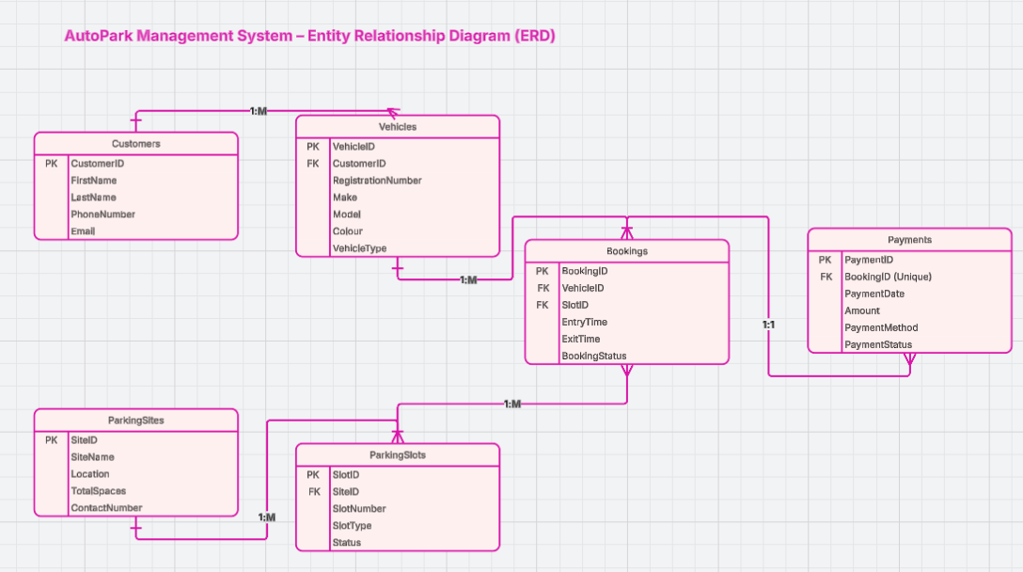

Data Structure Development

After creating the ERD, I created the tables in Microsoft Access. Each table has a primary key to identify each record. Foreign keys were used to link the tables together. I also used relationships to make sure that the data is connected correctly and to reduce mistakes when entering information.

Table Design
The table designs were created in Microsoft Access. Each table has its own primary key. Some tables also have foreign keys to connect them to other tables. The screenshots below show the field names, data types and keys used in each table.

Table 1: Summary of the database tables.
Table | Primary Key | Foreign Key | Purpose
Customers | CustomerID | _ | Stores customer details.
Vehicles | VehicleID | CustomerID | Stores customer vehicles.
Parking Sites | SiteID | _ | Stores parking site details.
Parking Slots | SlotID | SiteID | Stores parking spaces and their status.
Bookings | BookingID | VehicleID, SlotID | Stores booking information.
Payments | PaymentID | BookingID (Unique) | Stores payment information.

Figure 2: Design View of the Customers table.
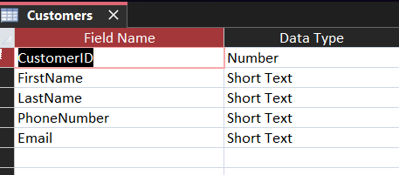

Figure 3: Design View of the Vehicles table.
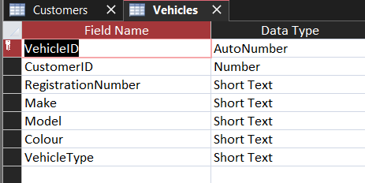

Figure 4: Design View of the Parking Sites table.
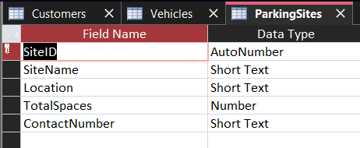

Figure 5: Design View of the Parking Slots table.
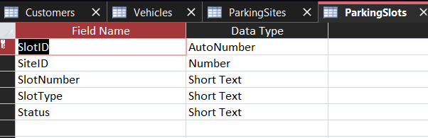

Figure 6: Design View of the Bookings table.
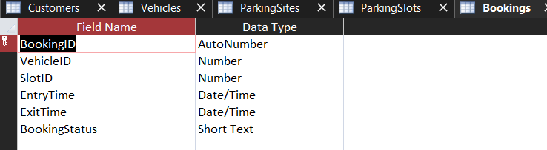

Figure 7: Design View of the Payments table.
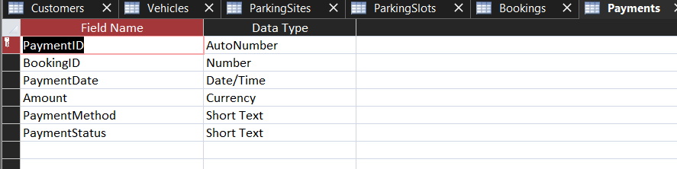

Relationships and Data Integrity
After I finished the table design, I created the relationships in Microsoft Access. I used Enforce Referential Integrity to make sure the tables are linked correctly. This means that Access does not allow a record to use an ID that does not exist in the related table [2].
For example, a payment cannot be saved if its BookingID does not exist in the Bookings table.
I created four one-to-many relationships: Customers to Vehicles, Vehicles to Bookings, ParkingSites to ParkingSlots and ParkingSlots to Bookings. I also created one one-to-one relationship between Bookings and Payments. In the Payments table, BookingID was set to No Duplicates so that one booking can only have one payment.
Figure 8: Relationships created in Microsoft Access.
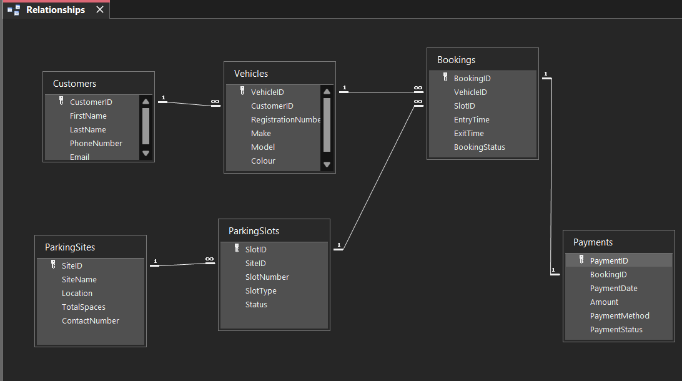

Normalisation Compliance

Normalisation was used to organise the AutoPark data and reduce repeated information. I checked the design from First Normal Form to Third Normal Form before creating the final tables in Microsoft Access [3].

4.1 Unnormalized Form (UNF)
Before normalisation, a parking site could be recorded in one row with more than one parking slot inside the same field.
Table 2: Unnormalized parking site record.
SiteID | SiteName | Location | SlotNumber | SlotType | Status
1 | Broadway Parking | 15 The Broadway, Ealing | A01, A02 | Standard, Standard | Occupied, Available

Problem: More than one parking slot value is stored in the same cell. This is a repeating group, so the table is not in 1NF [3].

4.2 First Normal Form (1NF)

To move the table to 1NF, I placed each parking slot in a separate row. Each cell now contains one value only. In this example, SiteID and SlotNumber together are used to identify each parking slot record [3].
Table 3: Parking site data in First Normal Form (1NF).
SiteID (PK) | SiteName | Location | SlotNumber (PK) | SlotType | Status
1 | Broadway Parking | 15 The Broadway, Ealing | A01 | Standard | Occupied
1 | Broadway Parking | 15 The Broadway, Ealing | A02 | Standard | Available

Solution: A01 and A02 are now stored in separate rows. Each field contains one value only, so the repeating group has been removed. The t [1] [2] [3] [4]able is now in 1NF [3].

Next problem: SiteName and Location are repeated for the same SiteID. This will be solved in the 2NF stage.

4.3 Second Normal Form (2NF)

In the 1NF table, SiteID and SlotNumber are used together as the temporary key. However, SiteName, Location, TotalSpaces and ContactNumber depend only on SiteID, not on both parts of the key. This is a partial dependency, so the table is not in 2NF [3].

Solution after applying 2NF:
Table 4: ParkingSites table after applying 2NF.
SiteID (PK) | SiteName | Location | TotalSpaces | ContactNumber
1 | Broadway Parking | 15 The Broadway, Ealing | 42 | 02085701234

Table 5: ParkingSlots table after applying 2NF.
SlotID (PK) | SiteID (FK) | SlotNumber | SlotType | Status
1 | 1 | A01 | Standard | Occupied
2 | 1 | A02 | Standard | Available

Solution: I created a separate ParkingSites table for information that depends on SiteID. The ParkingSlots table keeps SiteID as a foreign key, so each parking slot is linked to the correct parking site. The repeated site details have been removed. The design is now in 2NF [3].

4.4 Third Normal Form (3NF)

In this example, customer details are stored together with vehicle details. VehicleID is the primary key, but CustomerID determines the customer’s name and phone number. This creates a transitive dependency because the customer details depend on CustomerID, not directly on VehicleID. Therefore, the table is not in 3NF [3].
Table 6: Example of vehicle data before applying 3NF.
VehicleID (PK) | CustomerID | FirstName | LastName | PhoneNumber | RegistrationNumber | Make
1 | 1 | Mona | Salem | 07771122333 | MS12 LDN | Toyota
6 | 1 | Mona | Salem | 07771122333 | MS13 LDN | Toyota

Problem: The customer details are repeated for each vehicle. CustomerID determines the customer details, so these fields should not be stored in the Vehicles table.

Solution after applying 3NF:
Table 7: Customers table after applying 3NF.
CustomerID (PK) | FirstName | LastName | PhoneNumber | Email
1 | Mona | Salem | 07771122333 | m.salem@email.com

Table 8: Vehicles table after applying 3NF.
VehicleID (PK) | CustomerID (FK) | RegistrationNumber | Make | Model | Colour | VehicleType
1 | 1 | MS12 LDN | Toyota | Yaris | Silver | Car
6 | 1 | MS13 LDN | Toyota | Yaris | Silver | Car

Solution: Customer details are stored only once in the Customers table. The Vehicles table contains CustomerID as a foreign key. This links each vehicle to the correct customer and stops the customer details being repeated for every vehicle.

After applying 1NF, 2NF and 3NF, the AutoPark database is divided into separate related tables. This makes the database easier to manage and reduces duplicated information. Each table has a clear purpose, such as storing customer details, vehicle details or booking details. The final database is in 3NF because non-key fields depend on the primary key in their own table, rather than on another non-key field [3].

Sample Data Population

To test the AutoPark Management System, I entered sample data into each table. Each table contains at least five records based on realistic parking situations. The data was added to show how customers, vehicles, parking sites, parking slots, bookings and payments are linked together.
Figure 9: Datasheet View of the Customers table.
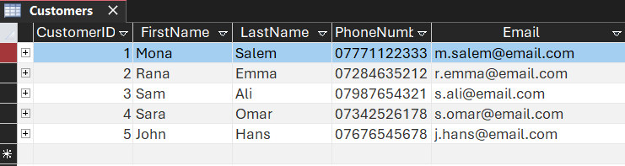

Figure 10: Datasheet View of the Vehicles table.
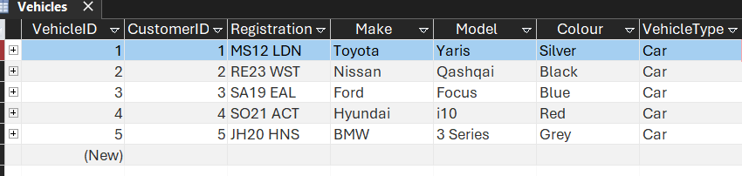

Figure 11: Datasheet View of the ParkingSites table.
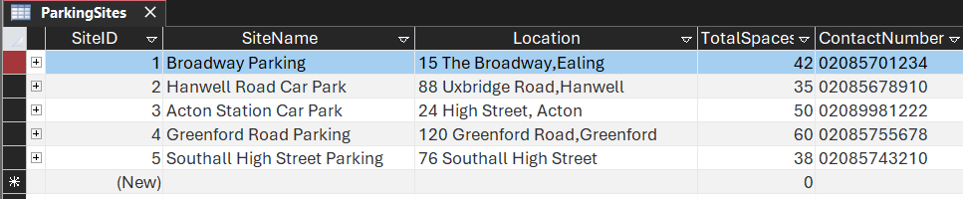

Figure 12: Datasheet View of the ParkingSlots table.
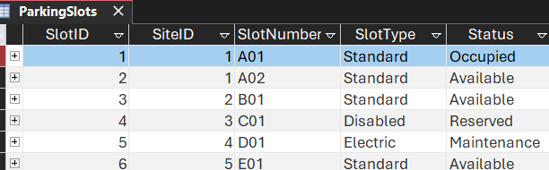

Figure 13: Datasheet View of the Bookings table.
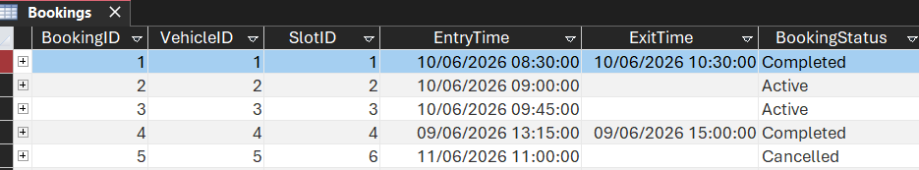

Figure 14: Datasheet View of the Payments table.
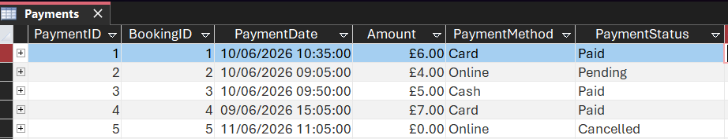

The screenshots show that sample data was entered successfully into all six tables. The records include realistic customer, vehicle, parking, booking and payment information.

Query Development

Q1_AvailableParkingSlots was created to show parking slots where the status is marked as Available. The query shows slots A02, B01 and E01. This can help staff find a free parking slot when creating a new booking.
Figure 15: Query1 Design View
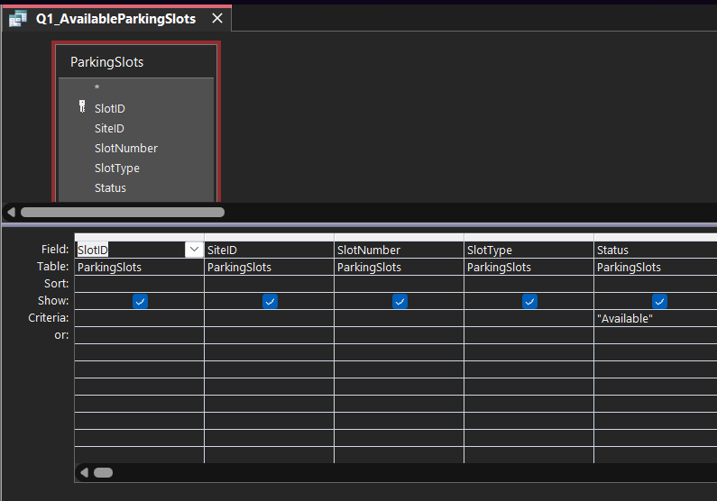

Figure 16: Results of Q1_AvailableParkingSlots showing available parking slots.
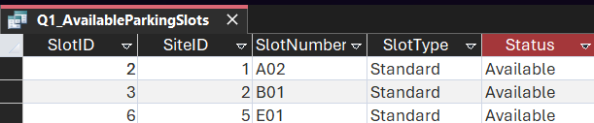

Q2_ActiveBookings was created to show bookings where the BookingStatus is marked as Active. The query shows BookingID 2 and 3 with their vehicle, parking slot and entry time. This helps staff check which vehicles are currently using parking spaces.
Figure 17: Query2 Design View
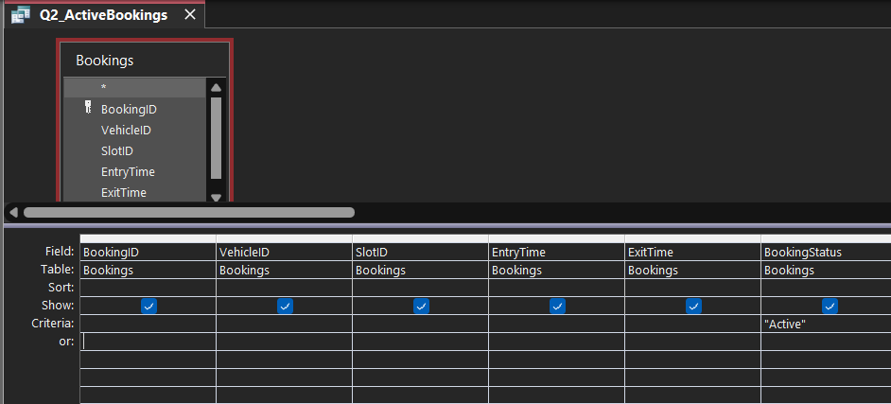

Figure 18: Results of Q2_ActiveBookings showing current active bookings.
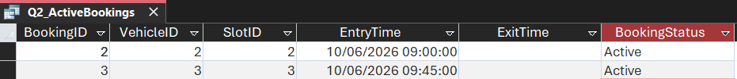

Q3_CustomerBookingDetails was created to show customer, vehicle and booking information together. The query shows the customer’s name, vehicle registration number, parking slot, entry time, exit time and booking status. This helps staff view the full booking details without opening different tables.
Figure 19: Query3 Design View
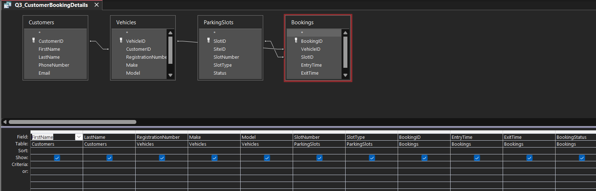

Figure 20: Results of Q3_CustomerBookingDetails showing customer, vehicle and booking information.
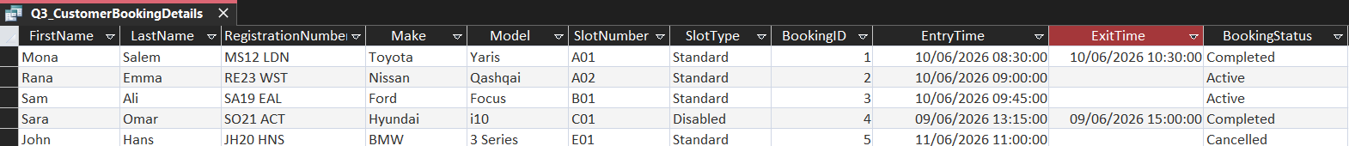

Q4_PaymentsToFollowUp was created to show payments where the Payment Status is marked as Pending or Cancelled. The query shows the payment date, amount and payment method. This helps staff identify payments that may need to be checked or followed up.
Figure 21: Query4 Design View
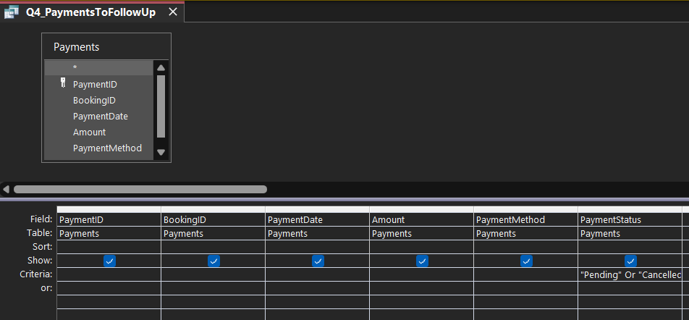

Figure 22: Results of Q4_PaymentsToFollowUp showing payments that need follow-up.
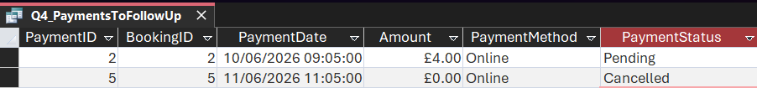

Q5_TotalPaidRevenue was created to calculate the total amount received from paid payments. The result shows that the total paid revenue is £18.00. This helps staff check the amount of money received from completed payments.
Figure 23: Query5 Design View
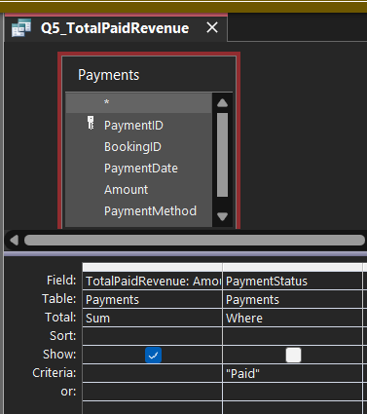

Figure 24: Results of Q5_TotalPaidRevenue showing the total paid revenue.
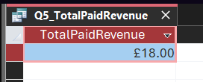

The five queries show how the AutoPark database can be used to check available slots, active bookings, customer booking details, payments that need follow-up and total paid revenue.

Form Development
Three forms were created to make data entry and record viewing easier. The forms were developed for the Bookings, Customers, and Payments tables, allowing users to manage database information more efficiently.
Figure 25: Bookings Form Design View
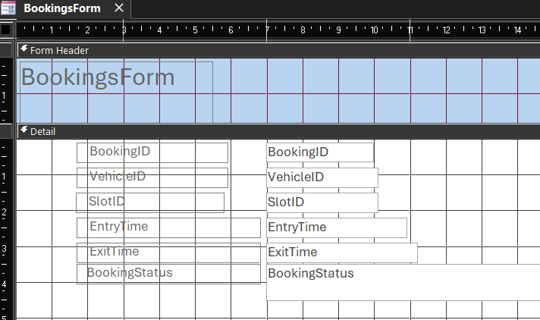
This screenshot shows the design of the Bookings form in Microsoft Access.

Figure 26: Bookings Form View
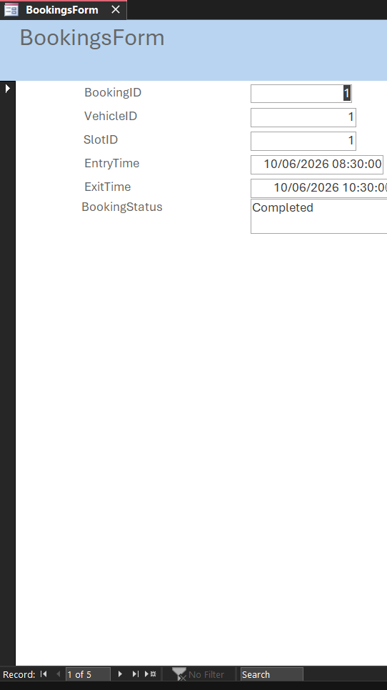
This screenshot shows the completed Bookings form used to view and enter booking records.

Figure 27: Customers Form Design View
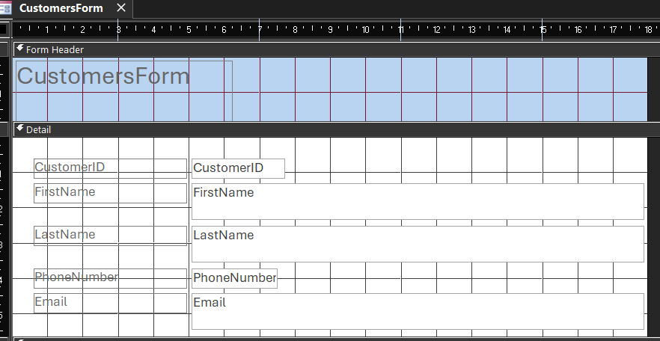
This screenshot shows the design of the Customers form in Microsoft Access.

Figure 28: Customers Form View
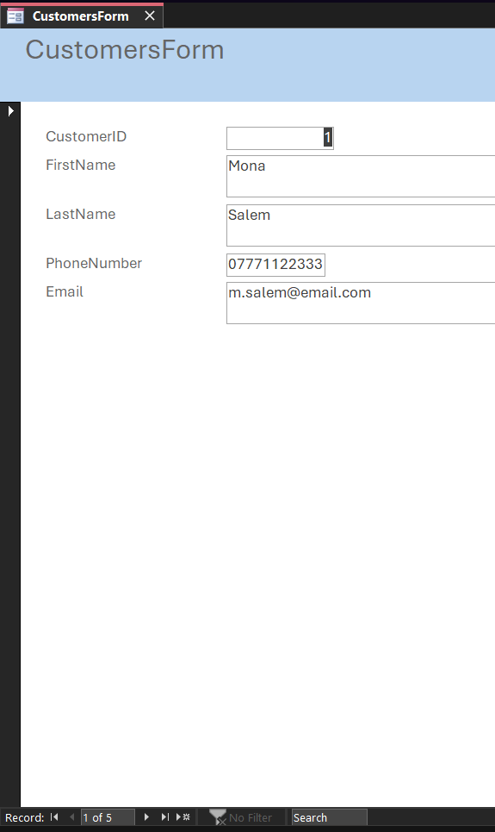
This screenshot shows the completed Customers form used to view and enter customer records.

Figure 29: Payments Form Design View
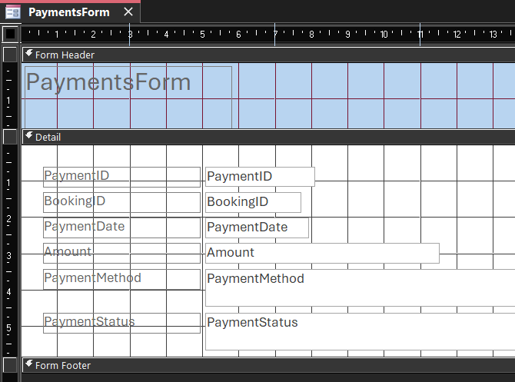
This screenshot shows the design of the Payments form in Microsoft Access.

Figure 30: Payments Form View
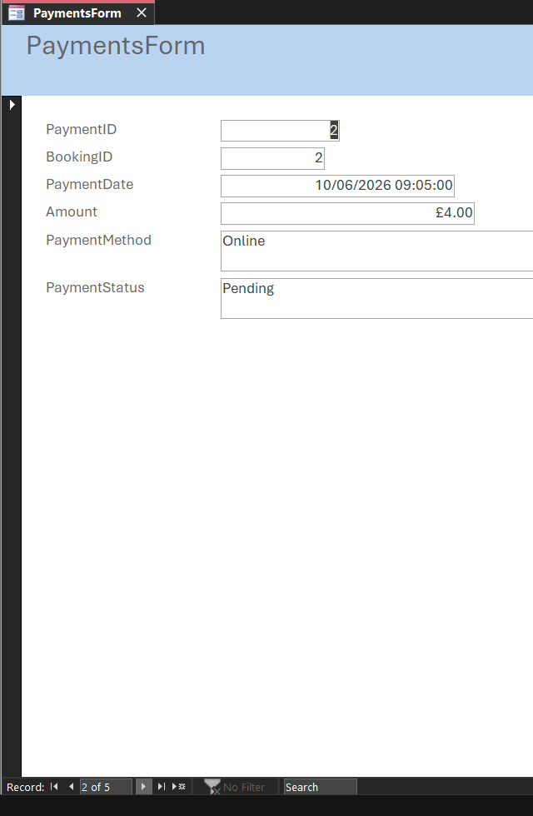
This screenshot shows the completed Payments form used to view and enter payment records.

Report Development
Figure 31: Available Parking Report Design View
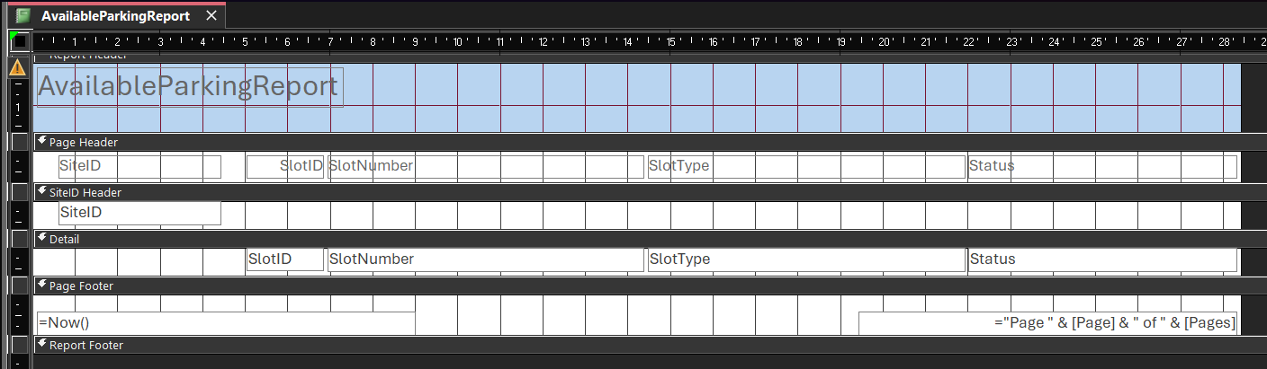This screenshot shows the structure and layout of the Available Parking report in Design View.

Figure 32: Available Parking Report View
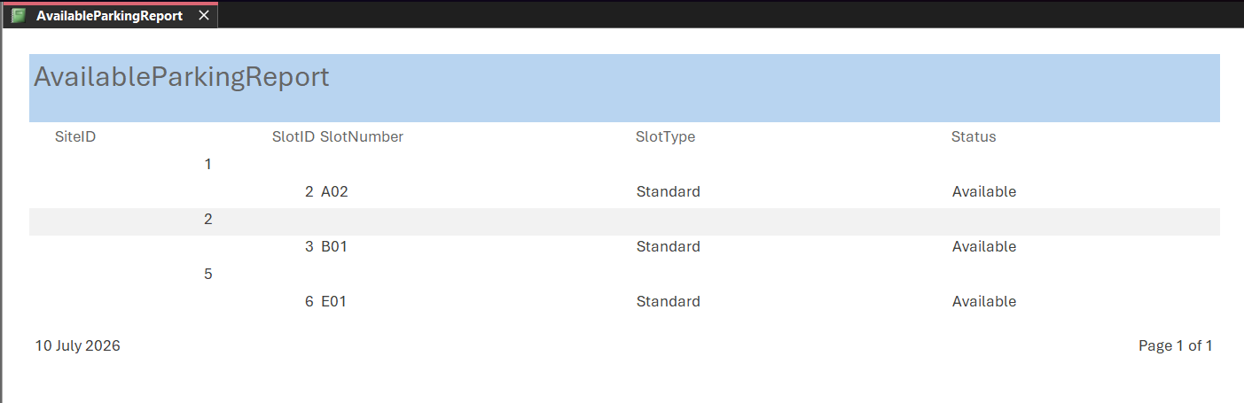This screenshot shows the completed report displaying the available parking spaces

Figure 33: Active Bookings Report Design Vi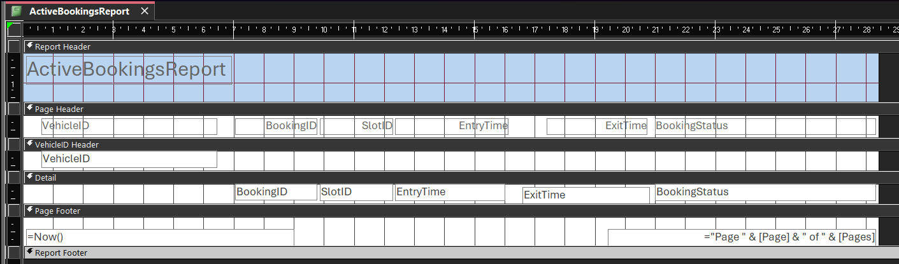This screenshot shows the structure and layout of the Active Bookings report in Design View.

Figure 34: Active Bookings Report View
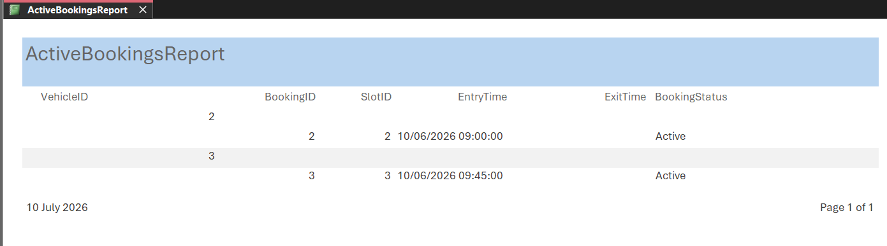This screenshot shows the completed report displaying the current active bookings.
Figure 35: Total Paid Revenue Report Design View
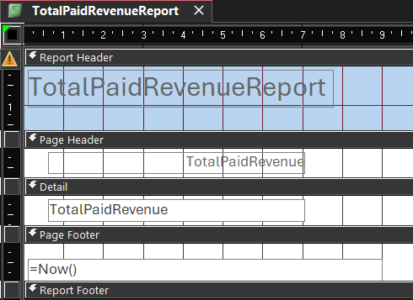
This screenshot shows the structure and layout of the Total Paid Revenue report in Design View.

Figure 36: Total Paid Revenue Report View
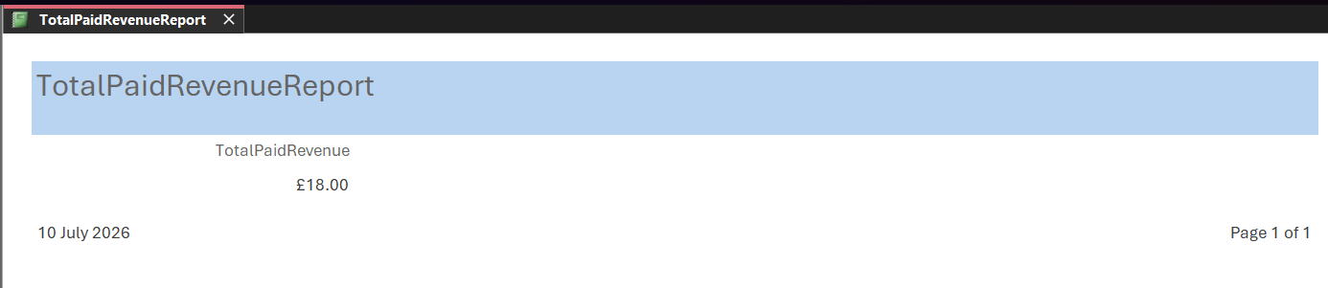 This screenshot shows the completed report displaying the total paid revenue from the database.

Figure 37: Database Objects in Microsoft Access

This screenshot shows the completed database objects, including the tables, queries, forms, and reports created in Microsoft Access.
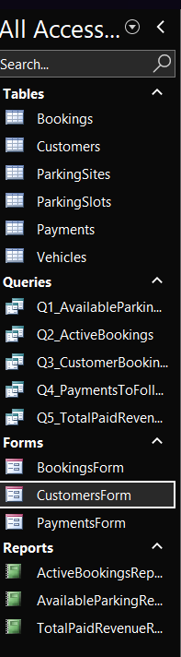

Validation and Testing

Validation and testing were used to check that the AutoPark database accepts correct data and prevents incorrect data from being saved. Two tests were completed. The first test checks that a phone number contains exactly 11 digits. The second test checks that a payment cannot be linked to a booking that does not exist.

9.1 Phone Number Validation

The PhoneNumber field was set as Short Text with a field size of 11. An input mask of 00000000000 was added so that customers must enter an 11-digit phone number. The field was also set as required, so it cannot be left empty [4].

Figure 38: Validation settings for the PhoneNumber field in the Customers table.
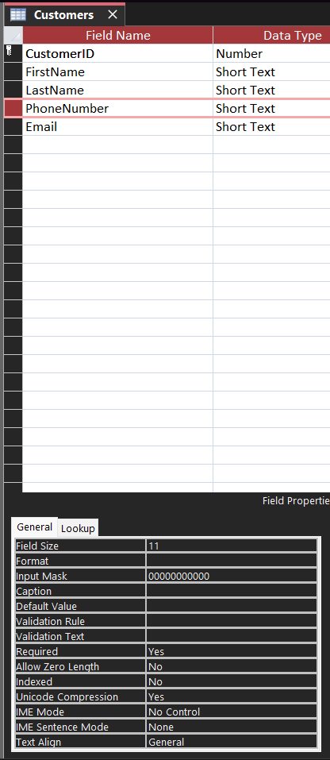

A test phone number with only seven digits was entered. Microsoft Access rejected the value because it did not match the required input mask. This shows that the phone number validation works correctly.
Figure 39: Error message shown when an invalid phone number was entered.
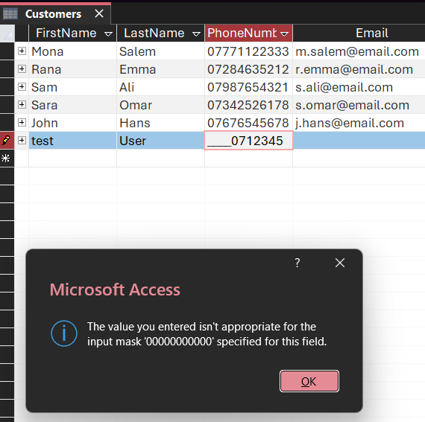

9.2 Referential Integrity Test

The Payments table is linked to the Bookings table using BookingID. Referential integrity was enabled to make sure that each payment is linked to a valid booking [2].
A payment record was tested using BookingID 99. This booking number does not exist in the Bookings table, so Microsoft Access rejected the record. This shows that referential integrity is working correctly and prevents payments from being linked to missing bookings.
Figure 40: Error message shown when an invalid BookingID was entered in the Payments table.
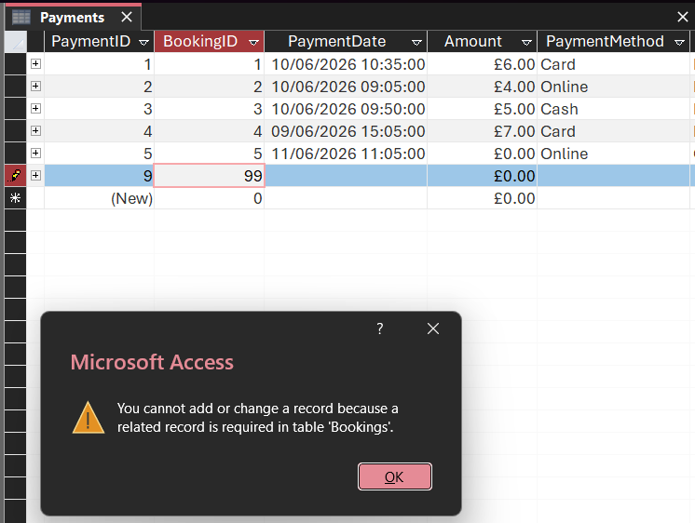

9.3 Testing Summary

Validation and testing results.

Table 9: Validation and testing results.
Test | Test carried out | Expected result | Actual result | Result
Phone number validation | Entered a phone number with seven digits. | Access should reject the phone number. | Access showed an input mask error message. | Pass
Referential integrity | Entered BookingID 99 in the Payments table. | Access should reject the payment because the booking does not exist. | Access showed an error that a related record is required in Bookings. | Pass

Design Decisions and Reflection

The AutoPark Management System was designed using six related tables: Customers, Vehicles, ParkingSites, ParkingSlots, Bookings and Payments. I used primary keys to identify each record and foreign keys to link the tables together. For example, CustomerID links a vehicle to its owner, and BookingID links a payment to a booking.

I decided to separate customer details from vehicle details to avoid repeated information. I also separated parking sites and parking slots because one parking site can have many parking slots. This made the database clearer and helped the system follow 3NF.

10.1 Reflection

While completing this database, I learned how tables, primary keys, foreign keys and relationships work together in Microsoft Access. The part that went well was creating the six tables and using queries to find useful information, such as available parking slots and active bookings.
The most difficult part was understanding the relationships between the tables and making sure the database was in 3NF. I also found validation rules difficult at first, but the phone number test and the BookingID test helped me understand how Access can prevent incorrect data.
In the future, I could improve the system by adding more features, such as booking fees based on parking time, staff accounts and reports showing the busiest parking slots.

References

[1] | Lucid Software, “ER Diagram (ERD): Definition and Overview,” Lucidchart, [Online]. Available: https://lucid.co/diagram/erd/tutorial. [Accessed 5 July 2026].
[2] | Microsoft, “Create, edit or delete a relationship,” Microsoft Support, [Online]. Available: https://support.microsoft.com/en-us/access/create-edit-or-delete-a-relationship. [Accessed 5 July 2026].
[3] | R. Elmasri and S. B. Navathe, Fundamentals of Database Systems, Global Edition, Harlow: Pearson Education Limited, 2016.
[4] | Microsoft, “Restrict data input by using validation rules,” Microsoft Support, [Online]. Available: https://support.microsoft.com/en-us/access/restrict-data-input-by-using-validation-rules. [Accessed 6 July 2026].

