9a(3) Exercises for lists in Python (2)

2a. Using floats

Create an empty list to hold some temperatures.

temps = []

2b. Allow the user to enter 6 temperature readings into your list. Use .append() and a for loop.
Hint: Just do one temperature reading to start – you can add the for loop in afterwards

Sample output:

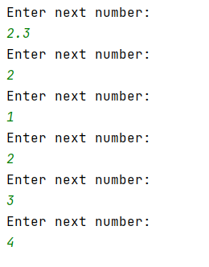

2c. Print out the numbers entered by the user in 2b above – nicely as shown below.

Sample output:

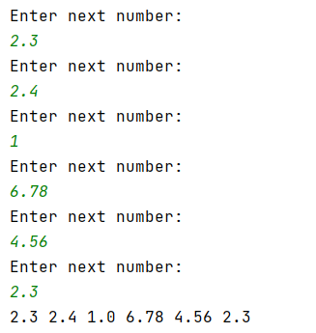

2d Print the item at index 3 of the list on the screen:

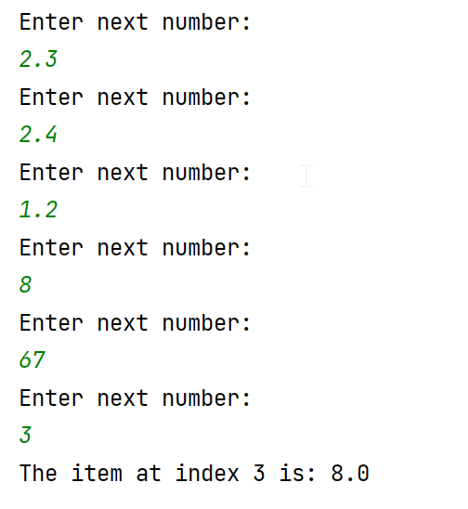

2e. Following on from 2d), this time, allow the user to choose which index they require:

Sample output:

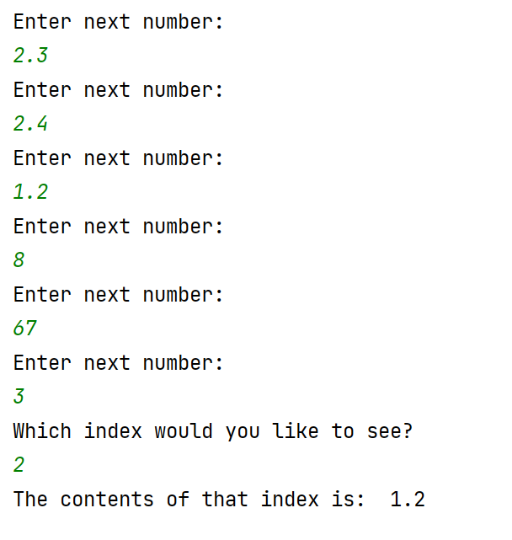

3a Create a program with the following list:

theNumbers = [2, 4, 3, 7, 3, 1, 3, 8, 9]

3b Multiply every list item by 2 and print the result on the screen. Use a for…in range loop to help you:

Sample output:

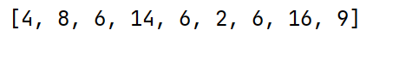

3c (Harder) – Find the average of the following list (ie add the contents of the list – preferably using a loop – and then divide by the number of entries in the list)

Hint: set a variable, total=0, before you start your loop, and then add to total on each iteration of your loop.

theNumbers = [2, 4, 3, 7, 3, 1, 3, 8, 9]

Sample output:

