

Software Development
Daniel Popescu
25.08.2021

A1

Flow of Control
The flow of control on all used functions is processed with three types of control structures:

- Sequential is the default mode.
One line after another means sequential execution of code statement. Like building a house.
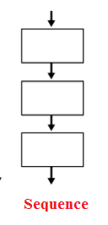
- Selection, is used for decisions – choosing between two or more paths. For example if, if/else, switch

- Repetition, is used for looping. For example repeating part of code many times in a row. These can be: while loop, do/while loop, for loop.
Control structures can be combined in programing. A sequence may be structured from many loops [1]

True and false

From above control structures, selection and repetition statements usually require to take a decision. These decision result as true or false. [1]
Require is also that developer specify on e or mere conditions to be examinate by program in addition with a statement. Statements are executed if condition is true in a way and another way if false. [2]
Phyton programing language has few types of decision making statements.
- If
- If….else
- If…elif..else
- Nested
- Not operator in if
- And operator in if
- In operator in if
For our assessment will exemplify if…elif statement

if statement execute expression inside parenthesis. If expression is true, statements inside the body of if is executed. If it is false, it is skipped. [2]
For example:
x=30
y=20
if x > y :
print (" X is bigger ")
So the output will be: X is bigger.

elif is short for else if
For example:
x=800
if x > 800 :
print(" X is greater than 800 ")
elif x < 800 :
print(" X is less than 800 ")
elif x == 800 :
print(" X is 800 ")
else :
print(" X is not a number ")

The result output: X is 800

A2

Python has two types of Loops.

1 for loop Is an iterator based loop, which steps through the items of iterable objects like lists, tuples, string and executes a piece of code repeatedly for a number of times, based on the number of items in that iterable object.
2 while loop Executes a block of statements repeatedly as long as the condition is TRUE.

The for loop is used to iterate over a sequence (list, tuple, string) or other iteraable objects. Iterating over a sequence is called traversal.

for val in sequence:
loop body

val is the variable that takes the value of the item inside the sequence on each iteration.

Example:
Sum of Numbers stored in a list
# List
numbers = [6, 5, 3, 8, 4, 2, 5, 4, 11]
# variable to store the sum
sum = 0
# iterate over the list
for val in numbers:
sum = sum+val
print("The sum is", sum)

Output:
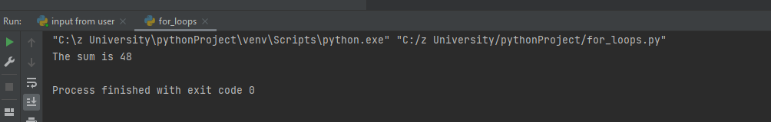

Range Function
We write a sequence of numbers and use range() function.
range(11) will generate the numbers 0 to 10 (11 numbers).
We can also tell where to start, stop and step size as range (start, stop,step_size). step_size defaults to 1 if not provided.
The range object is "lazy" in a sense because it doesn't generate every number that it "contains" when we create it. However, it is not an iterator since it supports in, len and __getitem__ operations.
This function does not store all the values in memory; it would be inefficient. So it remembers the start, stop, step size and generates the next number on the go.
To force this function to output all the items, we can use the function list().

Example:
print(range(11))

print(list(range(11)))

print(list(range(2, 8)))

print(list(range(2, 20, 3)))

Output
range(0, 11)
[0, 1, 2, 3, 4, 5, 6, 7, 8, 9, 10]
[2, 3, 4, 5, 6, 7]
[2, 5, 8, 11, 14, 17]

The range() function is used in for loops to iterate through a sequence of numbers.
Here we use it with the len() function to iterate through a sequence using indexing.

Example: iterate through a list using indexing

genre = ['red', 'blue', 'black']

for i in range(len(genre)):
print("I like", genre[i])

Output
I like red
I like blue
​I like black

for loop with else

A for loop can have an optional else block.
The else part is executed if the items in the sequence used in for loop exhausts.
The break keyword can be used to stop a for loop. In such cases, the else part is ignored.
therefore, a for loop's else part works if no break occurs.
Example below:
- digits = [0, 1, 5]

- for i in digits:
- print(i)
- else:
- print("No items left.")

Output in this case is:
0
- 1
- 5
- No items left.

In this case, for loop Function prints items of the list until the loop exhausts.
When the for loop exhausts, it executes the block of code in the else and prints No items left.
This for...else statement can be used with the break keyword to run the else block only when the break keyword was not executed.

Example to display student marks

- student_name = 'Gigel'

- marks = {'Dan': 90, 'Marean': 55, 'Boby': 77}

- for student in marks:
- if student == student_name:
- print(marks[student])
- break
- else:
- print('No entry with that name found.')

Output
- No entry with that name found.

A3
In Phyton list is a data structure that is a mutable, or changeable, ordered sequence of elements. An item is each element or value that is inside of a list. Like strings are defined as characters between quotes, lists are defined by having values between square brackets [ ]

Lists are one of 4 built-in data types in Python used to store collections of data
Lists are used to store multiple items in a single variable.
Example
thislist = ["lemon", "orange", "apple"]
print(thislist)

Variables can be used for pretty much anything that has to equal something in order for an event to happen.
For example, a variable could be called ‘level’. It controls what goes in each level and when to go to the next level.
Lists are more complex because they hold more values than variables. They can be used for lots of things as well.
For example, you can break down your name into separate letters and hold all the letters in a list to be used for later.
Good projects have variables and lists to regulate everything that goes on in a project.

Python has a great built-in list type named "list". List literals are written within square brackets [ ]. Lists work similarly to strings -- use the len() function and square brackets [ ] to access data, with the first element at index 0. (See the official python.org list docs.)
- colors = ['red', 'blue', 'green']
print colors[0] ## red
print colors[2] ## green
print len(colors) ## 3
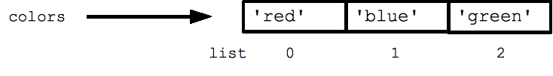

Bibliography

[1] | https://www.cs.fsu.edu/~myers/c++/notes/control1.html, "Control Structures - Intro, Selection," [Online]. Available: https://www.cs.fsu.edu/~myers/c++/notes/control1.html. [Accessed 25 08 2021].
[2] | "Python Conditional Statements," [Online]. Available: http://net-informations.com/python/flow/if.htm. [Accessed 25 08 2021].

