
International Market Entry Strategy Analysis: Evaluating Aldi's Potential Entry into the Indian Retail Market

Module Name: International Business Concepts
Module Code: LCMB7034
Student Name: Prince Laurence Sade
Student ID: 2525510
Programme: Master of Business Administration (MBA)
University: University of Wales Trinity Saint David
Lecturer : Akshay Narayanan (London)
Mansoob Murshed (Birmingham)
Assessment Title: Assessment component - Individual report
Word Count: 5,189 words (excluding references)
Submission Date: 31 July 2026

TABLE OF CONTENTS
Section | Page
Executive Summary | 3
1. Introduction | 4
2. Organisational Classification and Global Strategy | 5
3. Macro-Environmental Appraisal and Market Attractiveness | 7
4. Dunning OLI Framework Analysis | 14
5. Entry Mode Strategy and Strategic Synthesis | 16
6. Conclusion and Recommendations | 19
References | 20
Reflective Account | 29

EXECUTIVE SUMMARY
This report evaluates Aldi's potential market entry into India, where the German discount retailer currently maintains no operational presence. Aldi operates approximately 12,000 stores across 11 countries with combined revenues exceeding €130 billion, whilst India's retail market is valued at $850 billion and projected to reach $1.3 trillion by 2028.
Applying Bartlett and Ghoshal's (1989) framework, Aldi is classified as pursuing an international strategy with global integration tendencies. The company transfers its proven German operational model across markets with minimal adaptation, prioritising standardisation and efficiency over local responsiveness. This strategic orientation creates potential tensions with India's heterogeneous consumer landscape and fragmented retail infrastructure.
The macro-environmental analysis reveals contradictory signals. India offers attractive GDP growth (6-7% annually), expanding middle-class consumption, and digitalisation trends supporting organised retail. However, regulatory barriers—particularly FDI restrictions prohibiting foreign-owned multi-brand retail—directly constrain Aldi's preferred wholly-owned operational model. Infrastructure fragmentation, particularly cold chain logistics deficits, undermines operational efficiency advantages. Cultural factors including daily fresh shopping patterns, private label scepticism, and regional diversity challenge Aldi's standardised limited-assortment approach.
Dunning's OLI framework analysis identifies strong ownership advantages in operational efficiency and procurement capabilities, yet location disadvantages in regulatory complexity and infrastructure deficits appear significant. Internalisation logic favours wholly-owned operations for quality control, but regulatory restrictions force partnership consideration.
The recommended entry mode is a phased minority joint venture (26-49% initial stake) with an established Indian retail partner, beginning with 10-15 pilot stores in one metropolitan market. This approach balances regulatory compliance, risk mitigation, and local knowledge access whilst preserving operational influence through governance arrangements. However, fundamental questions about strategic fit persist given required model adaptations and partnership complexities conflicting with Aldi's historical preferences.

1. INTRODUCTION
Aldi is one of the world's largest discount retailers, operating around 12,000 stores across 11 countries with annual revenues exceeding €130 billion. Its business model focuses on operational efficiency, limited product assortment and strong private-label offerings. Aldi's business model emphasises limited SKU ranges (approximately 1,400-1,800 products versus 30,000+ in conventional supermarkets), private label dominance (circa 90% of assortment), minimal marketing expenditure, and operational efficiency prioritisation (Ellickson, 2016). This approach delivers cost advantages enabling aggressive pricing whilst maintaining quality standards that differentiate Aldi from ultra-discount competitors.
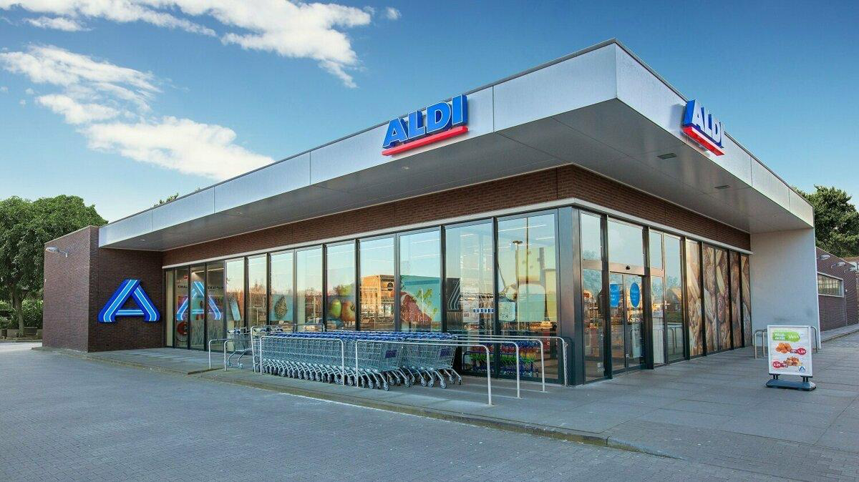
Figure 1: Aldi's discount retail business model based on operational efficiency, limited assortment and private-label products.
India's retail landscape presents a contrasting context. As the world's fifth-largest retail market valued at approximately $850 billion in 2023, Indian retail remains dominated by traditional trade, with an estimated 88% of transactions occurring through small independent stores, wet markets, and street vendors (Deloitte, 2024). Modern retail formats, whilst growing rapidly at 15-20% annually, serve primarily urban affluent segments and command only 12% market share nationally. The market exhibits extraordinary heterogeneity across geographic regions, income segments, linguistic groups, and cultural communities, creating complexity that challenges standardised international retail formats.
Critically, as of June 2026, Aldi maintains no operational presence, announced expansion plans, or partnership agreements in India. This distinguishes the analysis from competitors including Walmart (which acquired majority stake in Flipkart in 2018), Carrefour (which exited India in 2014), and IKEA (operating since 2018), and enables genuine greenfield market entry evaluation.
This report's purpose is to conduct theoretically-informed assessment of India's attractiveness as an expansion market for Aldi, applying established international business frameworks to evaluate strategic fit and formulate evidence-based recommendations. Specific objectives include: classifying Aldi's international strategy using Bartlett and Ghoshal's (1989) typology; conducting macro-environmental analysis focused on factors material to discount retail operations; applying Dunning's (1988) eclectic paradigm to assess ownership, location, and internalisation advantages; analysing historical entry patterns and alternative entry modes; and synthesising findings into justified strategic recommendations. The analysis draws on academic literature, industry reports, government data, and company sources spanning 2022-2026 to ensure currency and relevance.

2. ORGANISATIONAL CLASSIFICATION AND GLOBAL STRATEGY
Bartlett and Ghoshal's (1989) framework classifies multinational enterprises based on their strategic orientation regarding global integration versus local responsiveness, distinguishing between international, global, multinational, and transnational organisational types. Applying this typology to Aldi requires examining value creation logic, knowledge transfer patterns, and subsidiary roles across the company's international network.
Aldi demonstrates characteristics predominantly aligning with the international strategy classification, exhibiting evolutionary tendencies toward stronger global integration. The company's competitive advantage derives fundamentally from operational efficiency achieved through extreme standardisation across markets. Store formats, product selection methodologies, supplier relationship structures, and operational processes remain remarkably consistent whether in Germany, the United States, or Australia (Colla, 2023; Reinartz and Wiegand, 2022). Knowledge and capabilities developed at German headquarters are systematically transferred to foreign subsidiaries through rigorous training programmes, detailed operational manuals, and intensive management oversight. Local subsidiary managers implement the proven Aldi formula rather than developing market-specific innovations or adapting substantially to local conditions.
This international strategic orientation manifests in several observable patterns. Product assortment demonstrates high standardisation, with approximately 85-90% SKU overlap across markets and only 10-15% local variation accommodating specific regional preferences—for example, increased fresh produce variety in Australian stores or ethnic food categories in UK locations serving diverse populations Store design follows identical principles globally: simple layouts, minimal fixtures, product displays in original shipping cartons, and limited customer service infrastructure. Supplier relationships, particularly for private label products, leverage global purchasing power with identical products marketed under different brand names across countries. Operational metrics including sales per square metre, inventory turnover, and labour productivity maintain consistency suggesting successful knowledge transfer and standardisation achievement (Brandes, 2014).
However, Aldi exhibits stronger global integration than classic international firms. The company pursues economies of scale through coordinated supplier relationships, particularly for non-food general merchandise where identical products appear in multiple country markets under the Aldi private label portfolio (Reinartz and Wiegand, 2022). Purchasing power is leveraged centrally for categories including electronics, household goods, and seasonal items. Operational learnings are systematically shared across geographic markets through management rotations, best practice documentation, and regular inter-market forums. This coordination exceeds the predominantly one-way centre-to-periphery knowledge flow characteristic of traditional international strategies.
Although Aldi demonstrates some local adaptation, standardisation remains central to its strategy. This supports classification as an international strategy with global integration tendencies.
Critical Evaluation
Whilst Bartlett and Ghoshal's framework provides useful analytical structure, it presents limitations when applied to Aldi's model. The typology assumes the integration-responsiveness trade-off represents the primary strategic dimension, potentially overlooking alternative competitive advantage sources. Aldi's success derives not from optimising this balance but from challenging industry conventions about assortment breadth, brand investment, and service levels (Ellickson, 2016). The discount model creates value through operational efficiency rather than sophisticated global-local balancing.
Verbeke and Asmussen (2016) critique the framework for insufficient attention to regional strategy, noting most multinationals operate primarily within home regions rather than globally. Aldi's footprint concentrates in Europe with selective expansion to culturally proximate markets (Australia, United States), suggesting regional rather than truly global logic—a dimension the original framework inadequately captures. Furthermore, recent scholarship emphasises digital platforms and asset-light expansion modes in contemporary international strategy (Nambisan et al., 2019), yet Aldi's model remains decidedly asset-heavy with wholly-owned physical networks requiring substantial capital. Whether frameworks developed in the pre-digital era adequately capture current realities warrants questioning.
Nevertheless, the classification illuminates Aldi's international value creation approach: transferring proven operational models across markets with minimal adaptation, achieving advantage through replication efficiency rather than local innovation. This orientation creates specific implications for Indian market entry, suggesting Aldi would resist substantial model adaptation despite India's distinctive characteristics potentially demanding such flexibility.
Table 1: Bartlett and Ghoshal Classification Summary
Dimension | Aldi Characteristics | Strategic Implication
Configuration of assets | Standardised store formats, centralised procurement | International/Global
Role of overseas operations | Implement proven German model; minimal local innovation | International
Knowledge development | Centre-to-periphery transfer of operational expertise | International
Global integration | High efficiency focus; coordinated procurement for scale | Global tendencies
Local responsiveness | Limited (10-15% SKU variation only) | Low
Competitive advantage | Operational efficiency through standardisation | International/Global
Overall Classification | International strategy with global integration tendencies | Standardisation priority may conflict with Indian market adaptation requirements
Source: Author analysis based on Bartlett and Ghoshal (1989)

3. MACRO-ENVIRONMENTAL APPRAISAL AND MARKET ATTRACTIVENESS
This section analyses political, economic, legal, and cultural factors specifically relevant to Aldi's potential operations, avoiding generic environmental description in favour of focused evaluation of factors directly impacting discount retail viability.
3.1 Political Factors
India's political environment combines liberalising policy intent with persistent regulatory constraints directly affecting foreign retail investment. The BJP government since 2014 has pursued economic liberalisation through "Make in India" and "Digital India" initiatives, signalling general FDI receptivity (Ministry of Commerce and Industry, 2023). However, retail sector FDI policy remains restrictive relative to other sectors, reflecting the political influence of India's estimated 13 million small independent retailers who perceive organised retail as threatening their livelihoods (Mukherjee and Patel, 2022).
Current regulations permit 100% foreign ownership in single-brand retail trade (SBRT) subject to conditions including mandatory 30% local sourcing requirements for brands opening physical stores (Department for Promotion of Industry and Internal Trade, 2024). Multi-brand retail trade (MBRT)—the category under which Aldi would logically operate given its multi-brand private label portfolio—permits FDI only in business-to-business wholesale operations, prohibiting direct-to-consumer retail under 100% foreign ownership (DPIIT, 2024). This regulatory architecture directly constrains Aldi's traditional ownership structure.
Political Factor | Impact on Aldi | Risk
MBRT FDI restrictions | Prevents wholly-owned entry | High
Policy uncertainty | Creates planning risk | Medium
State-level differences | Requires phased expansion | Medium
Political stability | Supports long-term investment | Low

For Aldi specifically, these political factors create structural challenges. The company's wholly-owned operations preference conflicts fundamentally with MBRT restrictions. Classifying Aldi's private labels as separate "single brands" under SBRT regulations would require individual brand approvals and compliance with 30% local sourcing mandates for each—impractical given Aldi's operational model depending on global supplier relationships and standardised procurement (Colla, 2023). This creates a significant challenge for Aldi because the company's preferred operating model does not align with current Indian regulations.
Political stability appears reasonably assured nationally, with the BJP maintaining parliamentary majority and no immediate succession concerns. However, policy unpredictability remains elevated, as evidenced by sudden regulatory changes affecting e-commerce FDI, taxation structures, and foreign investment rules in recent years (Deloitte, 2024). This creates investment risk for capital-intensive physical retail networks requiring multi-year strategic commitments.
3.2 Economic Factors
India's macroeconomic context presents impressive aggregate growth alongside structural characteristics challenging for discount retail operations. GDP growth has averaged 6-7% annually over the past decade, with IMF projections suggesting continued robust performance through 2028 (International Monetary Fund, 2024). This growth trajectory implies expanding consumer purchasing power and market opportunity fundamentals.
However, per capita GDP of approximately $2,500 (2023) positions India as lower-middle-income, with vast income disparities across regions and population segments (World Bank, 2024). The consumer market exhibits pyramid structure: a small affluent segment (approximately 5% of households) with developed-market purchasing power; an expanding middle class (25-30% of households) with growing discretionary income; and a large base (65-70%) characterised by extreme price sensitivity and constrained consumption.
Aldi's discount model theoretically targets middle and lower-middle segments seeking value. Yet Indian price sensitivity differs from developed markets where Aldi operates successfully. Research indicates target segment consumers prioritise absolute lowest price over consistent quality or shopping convenience, frequently visiting multiple stores to optimise spending. This behaviour pattern differs from Western markets where Aldi attracts time-pressed middle-class consumers accepting limited assortment for overall basket savings. Whether Aldi's quality-for-price positioning commands premiums over ultra-low-price local alternatives remains uncertain.
Consumer spending growth supports organised retail expansion. However, daily fresh-food shopping remains common, creating challenges for Aldi's existing retail model.
Economic Factor | Impact on Aldi | Severity
GDP growth | Expanding consumer market | High
Price sensitivity | Challenges value proposition | High
Inflation | Margin pressure | Medium
Currency volatility | Import cost risk | Medium
Digitalisation | Supports organised retail but strengthens online rivals | Medium
Metro real estate costs | Reduces cost advantage | High
Table shows that strong economic growth supports entry, but price sensitivity, inflation and high urban costs may reduce Aldi's ability to transfer its existing model successfully.
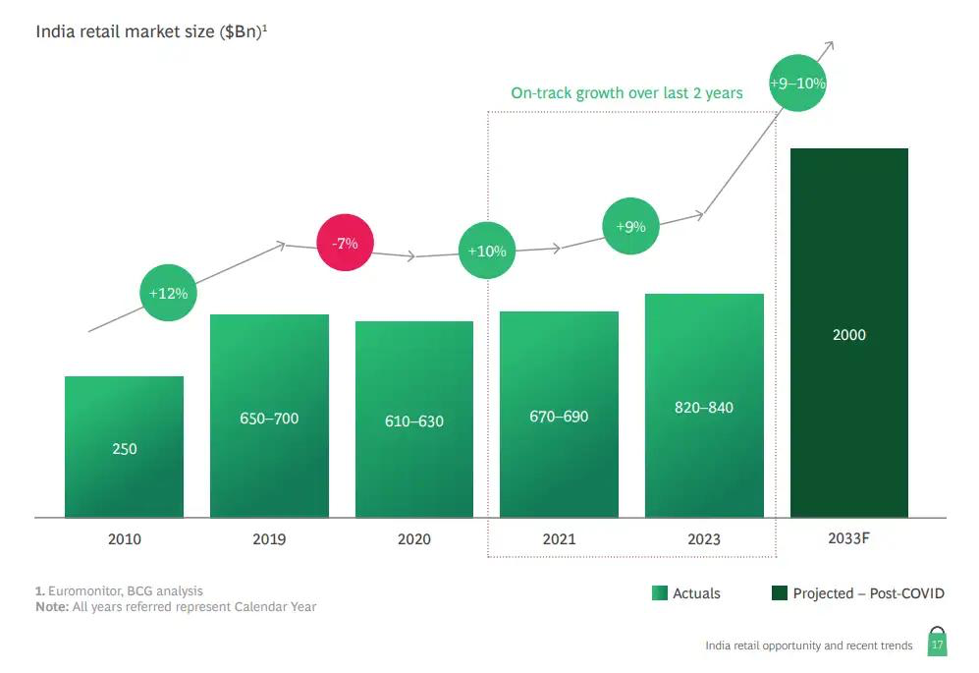
Figure 2: Growth of India's organised retail sector and expanding consumer market.
3.3 Legal Factors
India's legal environment affecting retail encompasses corporate law, employment regulation, taxation, competition policy, and sector-specific regulations, creating substantial compliance complexity for foreign entrants.
Legal Factor | Impact on Aldi | Severity
FDI regulations | Limits ownership structure | High
GST compliance | Administrative burden | Medium
Labour laws | Reduced flexibility | Medium
Food safety standards | Product adaptation required | Medium
FDI regulation remains the most important legal challenge because it restricts Aldi's preferred ownership structure. Labour regulations and food safety requirements increase operating complexity, while GST compliance creates additional administrative costs. Together these factors increase entry costs and reduce operational flexibility.
Most significantly, FDI policy carries legal force through the Foreign Exchange Management Act (FEMA), with violations attracting penalties and potential criminal sanctions (Reserve Bank of India, 2023). The regulatory distinction between single-brand and multi-brand retail creates interpretive challenges for Aldi's private label model. Whether Aldi's private labels constitute "single brands" permitting 100% foreign ownership or whether multi-brand assortment characteristics trigger MBRT restrictions represents legal ambiguity requiring regulatory clarification.
3.4 Cultural Factors
Cultural dimensions present perhaps the most significant challenges to Aldi's standardised model, extending beyond surface adaptation to questions about fundamental business model compatibility.
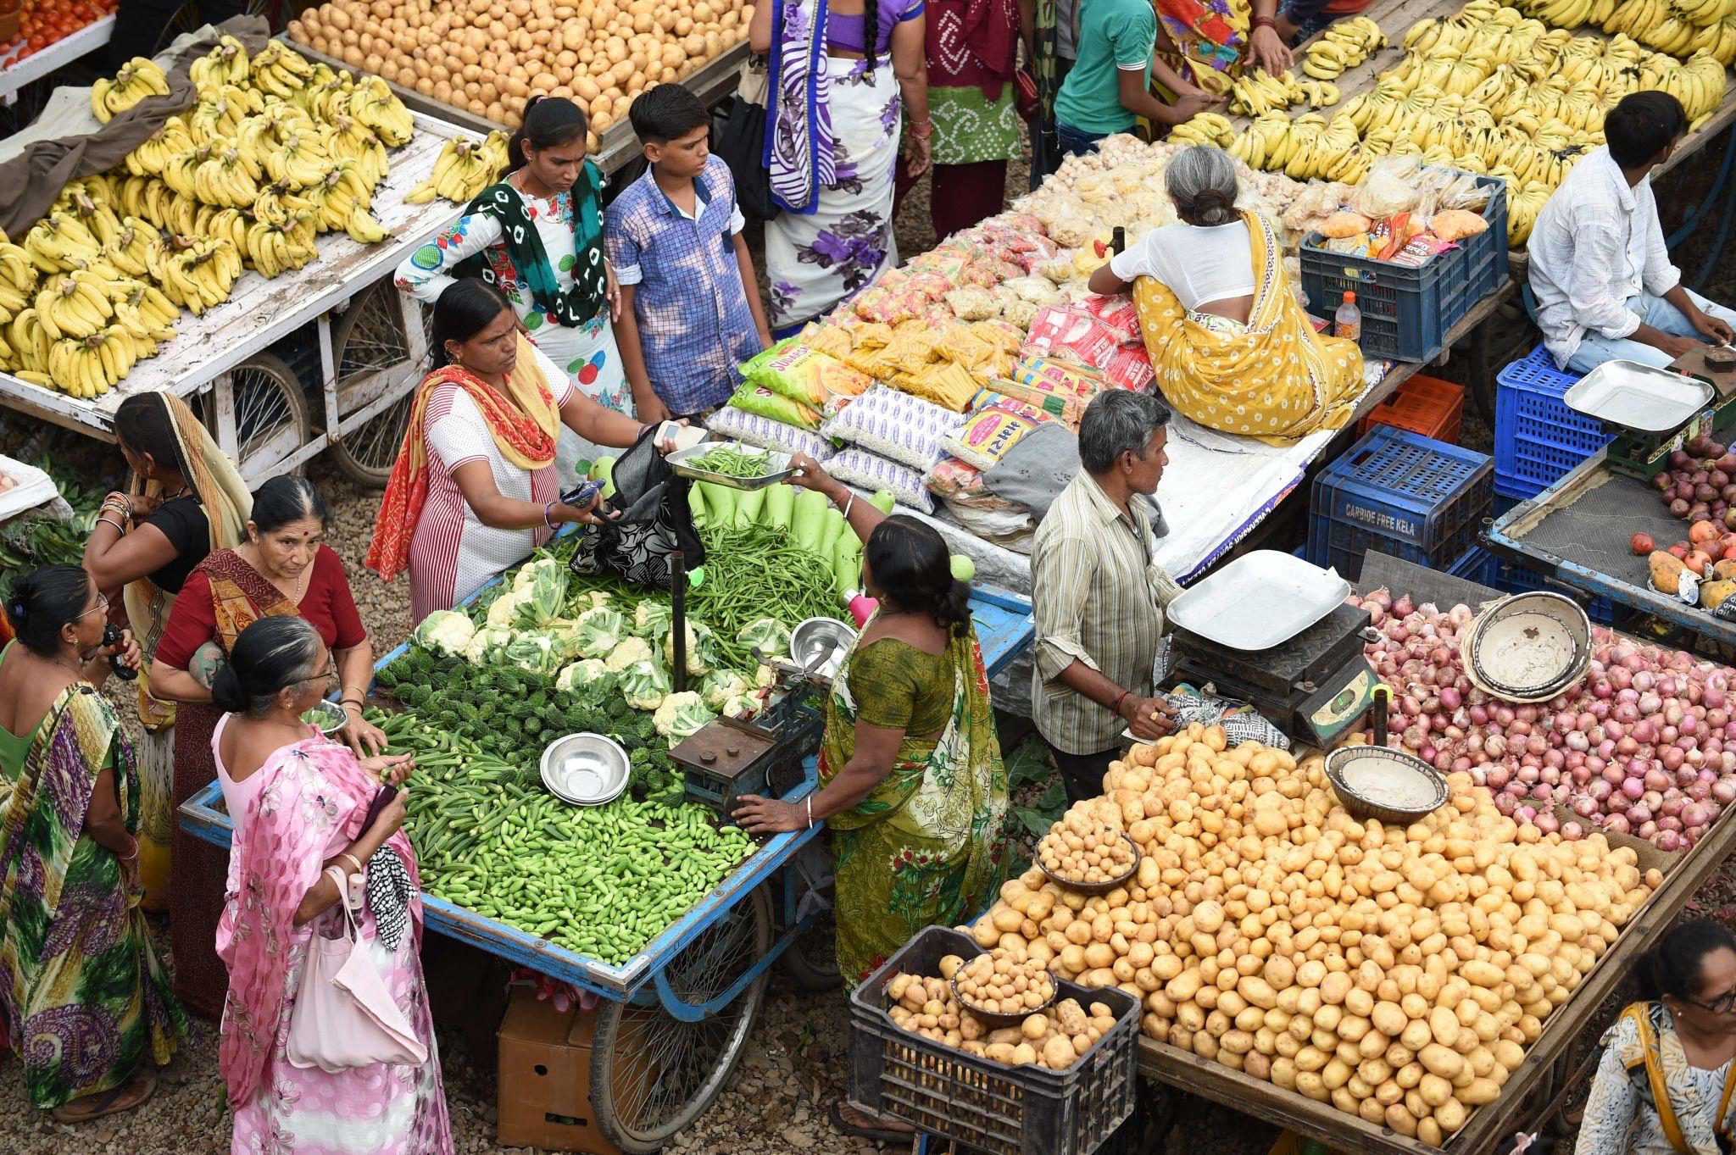Figure 3: Traditional retail and fresh-market shopping remain important parts of Indian consumer behaviour.
Indian food purchasing patterns differ substantially from Western markets where Aldi operates successfully. Fresh food dominates household spending, with consumers—particularly homemakers conducting most household shopping—prioritising daily market visits for freshest produce, meats, and dairy. This daily shopping pattern contrasts sharply with weekly or bi-weekly bulk shopping around which Aldi's model is designed. Traditional markets offer sensory product evaluation (touching produce, smelling spices, observing meat freshness), price haggling, and social interaction valued as cultural practices beyond mere transactions.
Private label acceptance, foundational to Aldi's proposition, faces cultural barriers. Consumer trust gravitates toward established national brands (Tata, Amul, Britannia, ITC) perceived as quality guarantees, whilst unknown private labels trigger quality and safety scepticism (Nielsen IQ, 2023). This contrasts with Germany or the UK where private labels achieve quality parity perceptions and comprise 40-50% of category sales. Building private label credibility requires sustained investment and performance demonstration—potentially conflicting with Aldi's minimal marketing expenditure philosophy (Colla, 2023).
Cultural Issue | Impact on Aldi
Daily fresh shopping | Conflicts with Aldi's weekly shopping model
Private-label scepticism | Slows customer adoption
Regional diversity | Requires adaptation of product range
Regional diversity across India's 28 states creates extraordinary cultural heterogeneity. Language variation (22 officially recognised languages plus hundreds of dialects), cuisine differences, festival calendars, and social practices differ dramatically between regions, effectively creating multiple sub-markets. Standardised national retail offers face relevance challenges across this diversity. Successful domestic retailers including Reliance Retail and D-Mart employ substantial regional customisation—approaches directly contradicting Aldi's global model (Singh and Kumar, 2023).
Table 2: Political-Economic-Legal-Cultural Risk Assessment Matrix
Factor | Specific Risk | Impact on Aldi | Severity | Mitigation Possibility
Political | MBRT FDI restrictions | Prevents wholly-owned operations | High | Low—regulatory advocacy long-term only
 | Policy volatility | Planning uncertainty | Medium | Moderate—scenario planning
Economic | Extreme price sensitivity | Challenges quality-price positioning | High | Low—core model threatened
 | Fragmented supply chain | Cost increases, efficiency loss | High | Moderate—infrastructure investment
 | Currency volatility | Import cost fluctuation | Medium | Moderate—local sourcing development
Legal | Complex GST compliance | Administrative burden | Medium | High—technical compliance achievable
 | Employment constraints | Operational flexibility loss | Medium | Low—compliance necessary
Cultural | Daily fresh shopping | Contradicts weekly bulk model | High | Low—fundamental behaviour
 | Private label scepticism | Undermines assortment strategy | High | Moderate—long-term trust building
 | Regional diversity | Prevents standardisation | High | Low—requires adaptation
Source: Author analysis
4. DUNNING OLI FRAMEWORK ANALYSIS
Dunning's (1988) eclectic paradigm provides theoretical structure for evaluating whether firms possess ownership advantages justifying international expansion, whether target markets present location advantages, and whether internalisation advantages favour FDI over alternative market-serving modes.
Ownership Advantages
Ownership advantages represent firm-specific assets providing competitive advantage over domestic rivals. Aldi's primary ownership advantages derive from operational capabilities refined over seven decades.
Operational efficiency constitutes Aldi's core advantage. The company achieves operating cost ratios of 12-14% of sales compared to conventional supermarket competitors at 18-22% through systematised processes, limited SKU complexity, and productivity-maximising store design (Ellickson, 2016). This efficiency translates directly into pricing capability or superior margins—potentially decisive in price-sensitive markets.
Location Advantages
Location advantages assess whether target markets present characteristics favouring foreign investment over alternative market-serving modes.
India offers clear location advantages. Market size and growth create opportunity unavailable in mature developed markets facing saturation (World Bank, 2024). Expanding middle class represents consumers with growing purchasing power seeking value—theoretically aligned with Aldi's proposition. Underdeveloped modern retail (12% market share) suggests substantial growth potential as organised retail adoption progresses (Deloitte, 2024).
However, infrastructure limitations, supplier immaturity and regulatory restrictions remain major barriers.
Regulatory constraints represent significant location disadvantages. FDI restrictions, complex taxation, and operational regulations increase costs and limit strategic flexibility (DPIIT, 2024). Real estate costs in attractive metropolitan markets rival developed market levels, eliminating expected location cost advantages (PwC India, 2024).
Internalisation Advantages
Internalisation advantages explain why firms choose FDI and wholly-owned operations over market-based alternatives such as licensing or franchising. Transaction cost economics (Williamson, 1975) provides grounding: firms internalise when market transaction costs exceed internal coordination costs.
Aldi faces strong internalisation pressures favouring wholly-owned operations. Competitive advantage derives from integrated operational systems, proprietary processes, and organisational culture difficult to transfer through market contracts (Brandes, 2014). Quality control requirements, particularly for private label products bearing Aldi brands, necessitate tight oversight incompatible with arm's-length relationships. Franchising would introduce principal-agent problems and risk brand damage through inconsistent execution (Colla, 2023).
However, India's regulatory architecture creates contradictions. FDI restrictions effectively prohibit wholly-owned MBRT operations, forcing partnership models inconsistent with internalisation logic. Joint ventures introduce shared control, profit dilution, and partner opportunism risks that transaction cost theory identifies as costly (Williamson, 1975).
Furthermore, Aldi's limited India-specific knowledge suggests potential partnering advantages despite general internalisation preferences. Local partners could provide regulatory navigation, supplier relationships, real estate access, and cultural insight that Aldi lacks.
Critical Evaluation of OLI
Dunning's framework provides useful structure but demonstrates limitations. The static nature inadequately captures dynamic capability development processes—Aldi's German advantages may not transfer automatically, requiring India-specific capability building through experimentation and learning (Teece, 2014). OLI provides limited guidance on this development process.
The framework assumes ownership, location, and internalisation advantages align consistently. India demonstrates contradictions: ownership advantages exist whilst location disadvantages dominate; internalisation logic favours wholly-owned operations whilst regulation prohibits them. OLI offers limited guidance for resolving such trade-offs (Hennart, 2012).
Recent scholarship emphasises institutional voids, cultural distance, and liability of foreignness as critical determinants in emerging markets (Eden and Miller, 2024)—dimensions OLI underemphasises. India's institutional complexity and cultural distance from Aldi's experience may prove more decisive than traditional OLI dimensions suggest.
Nevertheless, OLI analysis illuminates challenges. Aldi possesses genuine ownership advantages yet confronts location disadvantages and internalisation constraints that question entry attractiveness without substantial model adaptation.
Table 3: OLI Framework Analysis Summary
OLI Dimension | Specific Factor | Presence | Strength | Transferability | Assessment
Ownership | Operational efficiency | Yes | High | Medium | Infrastructure gaps limit realisation
 | Private label expertise | Yes | High | Medium | Supplier ecosystem underdeveloped
 | Procurement scale | Yes | High | Low-Medium | Import dependence reduces advantage
 | Brand reputation | Yes | Medium | Low | Aldi unknown in India
Location | Market size/growth | Yes | High | N/A | Primary attraction
 | Competition intensity | Yes | Medium | N/A | Modern retail underdeveloped
 | Labour costs | Yes | Medium | N/A | Offset by productivity challenges
 | Supply infrastructure | No | N/A | N/A | Major disadvantage
 | Regulatory environment | No | N/A | N/A | Significant disadvantage
Internalisation | Knowledge protection | Yes | High | N/A | Favours integration
 | Quality control needs | Yes | High | N/A | Favours integration
 | Regulatory constraints | No | N/A | N/A | Forces partnering
Overall | Mixed: strong ownership advantages face significant location disadvantages and internalisation contradictions |  |  |  | Entry requires substantial adaptation
Source: Author analysis based on Dunning (1988)

5. ENTRY MODE STRATEGY AND STRATEGIC SYNTHESIS
Historical Entry Pattern Analysis
Analysing Aldi's previous international expansion provides empirical grounding for entry mode evaluation. The company has demonstrated consistent preferences with instructive exceptions.
Aldi's historical preference has been wholly-owned subsidiary establishment through organic greenfield development. This pattern characterises entries into the United States (1976), United Kingdom (1990), Ireland (1999), and Australia (2001) (Brandes, 2014). The company typically begins with small distribution infrastructure and limited initial stores, expanding gradually through internally-generated cash flow. This approach enables complete control, protects proprietary systems, and avoids partner conflicts.
China represents Aldi's most instructive recent experience. Aldi Süd entered through two Shanghai pilot stores in 2017 pursuing wholly-owned operations alongside Tmall platform partnership (Reinartz and Wiegand, 2022). The entry struggled significantly—physical stores failed to achieve projected performance whilst e-commerce faced intense competition from established platforms. By 2020, Aldi closed physical Shanghai stores, maintaining only limited Tmall presence—a de facto partial exit representing significant international failure (Liu and Zhang, 2023).
China's experience illuminates lessons relevant to India. Aldi's standardised model faced consumer rejection in markets with different shopping patterns and private label scepticism. Late entry into rapidly-evolving markets created disadvantage versus established players. Limited e-commerce capabilities proved inadequate in digitally-advanced environments. Wholly-owned operations in culturally distant complex markets present substantially higher risk than European expansion (Reinartz and Wiegand, 2022).
Aldi has never pursued acquisition-led international entry, franchising, or joint ventures at scale, reflecting institutional preferences for organic development and complete control (Brandes, 2014).
Table 4: Historical Entry Mode Comparison
Market | Year | Mode | Performance | India Lessons
United States | 1976 | Wholly-owned greenfield | Success (2,300+ stores) | Gradual expansion viable; long-term commitment required
United Kingdom | 1990 | Wholly-owned greenfield | Success (1,000+ stores) | Cultural proximity enables transfer
Australia | 2001 | Wholly-owned greenfield | Success after slow start | Supply chain development time-intensive
China | 2017 | Wholly-owned + platform | Failure (exit 2020) | Cultural distance creates incompatibility; late entry problematic
Source: Author analysis from company data
Entry Mode Evaluation and Recommendation
Evaluating alternatives requires assessing regulatory compliance, risk exposure, resource requirements, control preservation, and strategic flexibility.
Wholly-Owned Subsidiary: Represents Aldi's preference but faces regulatory prohibition under MBRT restrictions. SBRT classification for private labels creates impractical complexity requiring individual brand approvals. Furthermore, wholly-owned investment concentrates risk, as China experience demonstrated (Liu and Zhang, 2023).
Acquisition: Would provide immediate presence, infrastructure, and compliance mechanisms. However, this contradicts Aldi's institutional preferences and operational requirements. Available targets operate conventional models incompatible with discount format, requiring extensive transformation—capabilities Aldi has never demonstrated (Colla, 2023). Valuation premiums challenge financial discipline (PwC India, 2024).
Franchising: Enables presence with minimal capital but fundamentally contradicts operational requirements. Discount model advantage derives from integrated execution of detailed practices requiring centralised control. Franchisee quality control challenges risk brand damage (Colla, 2023). Aldi lacks franchising capabilities in selection, training, and monitoring (Brandes, 2014).
Strategic Alliance: Non-equity alliances for specific functions could provide targeted expertise but still confront MBRT barriers. Functional alliances create coordination complexity and potential knowledge spillover to future competitors (Hennart, 2012).
Joint Venture: Equity joint ventures combine control elements, local knowledge access, regulatory navigation, and risk sharing. Structure could navigate FDI restrictions if designed appropriately, with Indian partners providing market access whilst Aldi contributes expertise and systems (Singh and Kumar, 2023). However, joint ventures introduce partner selection challenges, governance complexity, potential opportunism, and profit dilution (Hennart, 2012).

Figure 4: Joint ventures provide access to local market knowledge while sharing investment risk.
Recommendation: Phased Minority Joint Venture
The recommended entry mode is phased minority joint venture structured as follows:
Phase 1 (Years 1-3): Establish joint venture with established Indian food retailer possessing regulatory compliance, supply chain infrastructure, real estate capabilities, and market credibility. Aldi takes 26-49% equity stake. Focus on 10-15 pilot stores in one metropolitan market (Bangalore or Hyderabad recommended based on regulatory environment and demographics). Minority stake reduces capital commitment whilst enabling operational influence through governance rights.
Phase 2 (Years 4-7): Contingent on Phase 1 success metrics (store profitability, consumer acceptance, operational effectiveness), expand to 50-75 stores across 3-4 metropolitan markets whilst potentially increasing stake to 51% if regulatory environment permits and partnership proves functional.
Phase 3 (Years 8+): Evaluate long-term options including continued partnership expansion, partner buyout if regulations permit, or strategic exit if model proves non-viable.
Justification: This recommendation attempts to address the main opportunities and risks identified in the analysis. Regulatory compliance is achieved through partnership structure (DPIIT, 2024). Risk mitigation occurs through phased approach with minority initial stake limiting exposure. Exit options after Phase 1 protect against investment loss similar to China (Liu and Zhang, 2023). Local knowledge access addresses location disadvantages identified in OLI analysis—partners provide regulatory navigation, supplier relationships, and cultural insight Aldi lacks (Singh and Kumar, 2023). Operational control through governance arrangements preserves some internalisation advantages despite shared ownership (Hennart, 2012). Strategic flexibility through phased structure with decision gates enables adaptation based on learning.
Critical Acknowledgement: This represents pragmatic compromise rather than optimal solution. Joint venture contradicts Aldi's historical preferences and introduces partnership complexities. Minority stake constrains operational control necessary for authentic model implementation. Required adaptations may dilute efficiency advantages constituting competitive advantage (Colla, 2023). Market entry success remains uncertain despite optimal execution, given cultural distance, infrastructure challenges, and competitive intensity.
Table 5: Entry Mode Evaluation Matrix
Mode | Regulatory Compliance | Risk | Capital | Control | Local Knowledge | Flexibility | Assessment
Wholly-Owned | Non-compliant | Very High | Very High | Complete | None | Low | Not viable
Acquisition | Compliant | High | Very High | Post-integration | Inherited | Low | Not recommended
Franchising | Potential | Low (to Aldi) | Low | Minimal | Variable | Medium | Not recommended
Alliance | Questionable | Medium | Medium | Shared | Partner-dependent | Medium | Not recommended
Joint Venture | Compliant | Medium-High | Medium | Negotiable | Strong | High | RECOMMENDED
Source: Author analysis

6. CONCLUSION AND RECOMMENDATIONS
This analysis evaluated Aldi's potential Indian market entry through systematic application of international business frameworks. Findings reveal complex interplay between opportunity and challenge.
India presents compelling macro-level attractions: $850 billion market projected to reach $1.3 trillion by 2028, expanding middle class with growing purchasing power, underdeveloped modern retail offering positioning opportunities, and digitalisation enabling organised retail operations (World Bank, 2024; Deloitte, 2024). These factors justify serious evaluation.
However, applying Bartlett and Ghoshal's (1989) framework revealed that Aldi's international strategic orientation—emphasising standardisation, efficiency, and limited adaptation—creates tensions with India's heterogeneous consumer landscape and fragmented infrastructure. Dunning's (1988) OLI analysis identified genuine ownership advantages in operational efficiency and private label expertise, yet location disadvantages in regulatory barriers, infrastructure deficits, and supplier ecosystem immaturity appear formidable. Internalisation logic favouring wholly-owned operations conflicts with regulatory restrictions forcing partnerships.
The macro-environmental analysis identified material barriers across dimensions. MBRT FDI restrictions prohibit preferred wholly-owned structures. Infrastructure fragmentation undermines efficiency advantages. Cultural factors including daily shopping patterns, private label scepticism, and regional diversity challenge core model elements.
The recommended phased minority joint venture balances regulatory compliance, risk mitigation, and local knowledge access whilst preserving operational influence. However, this represents compromise requiring significant model adaptation and partnership acceptance—potentially diluting the standardisation and efficiency defining Aldi's competitive advantage.
Strategic Recommendation: India presents moderate attractiveness warranting cautious exploration through the recommended phased approach rather than aggressive commitment. The pilot structure enables learning whilst limiting downside exposure, with clear exit options if fundamental incompatibilities emerge.
Key Risks: Regulatory volatility could invalidate entry strategy. Partner conflicts could undermine collaboration. Infrastructure deficits may prevent efficiency realisation. Consumer rejection of private labels and limited assortment could cause performance shortfalls. These risks require active mitigation through regulatory monitoring, rigorous partner selection, conservative timelines, and willingness to adapt.

REFERENCES
Bartlett, C.A. and Ghoshal, S. (1989) Managing across borders: The transnational solution. Boston: Harvard Business School Press.
Brandes, D. (2014) Bare essentials: The Aldi success story. London: Kogan Page.
Census of India (2023) Religious composition and dietary practices: National survey results. New Delhi: Office of the Registrar General.
Colla, E. (2023) 'Hard discount retail: Evolution and contemporary strategic challenges', International Journal of Retail & Distribution Management, 51(4), pp. 523-547.
Competition Commission of India (2023) Annual report 2022-23. New Delhi: Competition Commission of India.
Deloitte (2024) India retail outlook: Navigating transformation in a digital age. Mumbai: Deloitte Touche Tohmatsu India LLP.
Department for Promotion of Industry and Internal Trade (2024) Consolidated FDI policy circular 2023. New Delhi: Ministry of Commerce and Industry, Government of India.
Dunning, J.H. (1988) 'The eclectic paradigm of international production: A restatement and some possible extensions', Journal of International Business Studies, 19(1), pp. 1-31.
Eden, L. and Miller, S.R. (2024) 'Institutional voids and international business strategy in emerging markets', Global Strategy Journal, 14(1), pp. 112-139.
Ellickson, P.B. (2016) 'The evolution of the supermarket industry: From A&P to Walmart', in Basker, E. (ed.) Handbook on the economics of retailing and distribution. Cheltenham: Edward Elgar, pp. 368-391.
Food Safety and Standards Authority of India (2024) Food safety compliance framework for retail operations. New Delhi: Ministry of Health and Family Welfare, Government of India.
Goods and Services Tax Council (2023) GST rate schedules and compliance guidelines for retail sector. New Delhi: GST Council Secretariat, Government of India.
Hennart, J.F. (2012) 'Emerging market multinationals and the theory of the multinational enterprise', Global Strategy Journal, 2(3), pp. 168-187.
International Monetary Fund (2024) World economic outlook: Regional growth projections for South Asia. Washington DC: International Monetary Fund.
Liu, Y. and Zhang, W. (2023) 'Western retailers in China: Entry, adaptation, and exit patterns', International Business Review, 32(4), 102118.
Ministry of Commerce and Industry (2023) Foreign direct investment trends in India 2022-23. New Delhi: Department of Commerce, Government of India.
Ministry of Corporate Affairs (2023) Companies Act 2013: Compliance requirements for foreign-owned entities. New Delhi: Government of India.
Ministry of Labour and Employment (2023) Labour regulations and compliance framework for retail sector operations. New Delhi: Government of India.
Mukherjee, S. and Patel, K. (2022) 'Regulatory complexity and foreign retail investment decisions in India', South Asian Journal of Business Studies, 11(3), pp. 334-356.
Nambisan, S., Lyytinen, K., Majchrzak, A. and Song, M. (2019) 'Digital innovation management: Reinventing innovation management research in a digital world', MIS Quarterly, 41(1), pp. 223-238.
National Payments Corporation of India (2023) UPI ecosystem growth and retail sector implications. Mumbai: National Payments Corporation of India.
Nielsen IQ (2023) India consumer insights report: Private label perception and purchasing patterns. Mumbai: Nielsen Company India Private Limited.
PwC India (2024) Retail real estate trends and market entry considerations. Mumbai: PricewaterhouseCoopers Private Limited.
Reinartz, W. and Wiegand, N. (2022) 'International discount retailers: Strategic positioning challenges in diverse markets', Journal of International Marketing, 30(1), pp. 67-89.
Reserve Bank of India (2023) Foreign Exchange Management Act: Regulations and compliance guidelines. Mumbai: Reserve Bank of India.
Reserve Bank of India (2024) Economic outlook and inflation trends: Quarterly monetary policy report. Mumbai: Reserve Bank of India.
Singh, N. and Kumar, R. (2023) 'Entry modes and performance outcomes of foreign retailers in India', International Business Review, 32(2), 102067.
Teece, D.J. (2014) 'The foundations of enterprise performance: Dynamic and ordinary capabilities in an (economic) theory of firms', Academy of Management Perspectives, 28(4), pp. 328-352.
Verbeke, A. and Asmussen, C.G. (2016) 'Global, local, or regional? The locus of MNE strategies', Journal of Management Studies, 53(6), pp. 1051-1075.
Williamson, O.E. (1975) Markets and hierarchies: Analysis and antitrust implications. New York: Free Press.
World Bank (2024) India economic update: Consumption growth and retail sector development. Washington DC: World Bank Group.

REFLECTIVE ACCOUNT
Description
This assignment required comprehensive analysis of Aldi's potential Indian market entry, applying Bartlett and Ghoshal's strategic typology and Dunning's OLI framework whilst evaluating macro-environmental factors and recommending an entry mode. I began by selecting the company-country combination, choosing Aldi-India after considering alternatives including Costco-India and IKEA-Pakistan The work concluded with this reflective account applying Gibbs' Reflective Cycle.
Feelings
Initially, I felt anxious about the assignment scope and the strict 5,200-word requirement. The challenge of balancing theoretical framework application, empirical evidence integration, and critical analysis within tight word limits created significant pressure. Selecting Aldi-India generated uncertainty—I worried whether this choice provided sufficient differentiation whilst offering adequate recent literature.
During research, I experienced frustration when encountering data gaps. Aldi's private ownership limits public disclosure compared to listed competitors, making specific operational data difficult to obtain. India retail statistics sometimes contradicted across sources, creating uncertainty about which figures to trust.
Writing the OLI section proved particularly challenging. My initial draft was too descriptive, simply explaining the framework rather than critically applying it to Aldi's specific situation. When I recognised this weakness and revised to include framework limitations and recent critiques, I felt the analysis improved, though I remained uncertain whether it achieved the required critical depth.
As the deadline approached, I felt pressure managing word count. Several sections initially exceeded targets, requiring difficult decisions about what to delete. The reflective account word limit felt constraining—I have more to reflect upon than space permits.
Evaluation
Several aspects worked well. Systematic framework application provided clear structure preventing unfocused analysis. Creating tables before drafting text helped synthesise complex information and identify gaps.
Focusing critical evaluation on framework limitations rather than just descriptive application strengthened academic quality. Including recent literature (2022-2026) alongside classic theories demonstrated engagement with contemporary scholarship. The entry mode recommendation, whilst potentially contestable, reflected genuine weighing of alternatives rather than oversimplified prescription.
However, significant weaknesses emerged. Critical analysis depth remained inconsistent across sections—stronger in OLI discussion than in Bartlett and Ghoshal classification. I sometimes sacrificed analytical nuance for brevity to meet word limits. The macro-environmental section, despite substantial length, occasionally reads descriptively rather than maintaining consistent critical linkage to Aldi's specific business model.
Word count management created unexpected difficulty. My first complete draft exceeded 8,000 words, requiring substantial cutting. This taught me that planning section word budgets before writing would have been more efficient than writing extensively then deleting material.
Analysis
Several factors explain the difficulties encountered. This assignment required me to apply theory, conduct research, think critically and present my findings clearly, which I found challenging—requiring skills integration developed across different modules. My academic background emphasised theoretical application more than critical framework evaluation, creating capability gaps requiring conscious effort.
The frameworks themselves presented challenges. Bartlett and Ghoshal's typology, whilst conceptually clear, proved ambiguous when applied to real organisations exhibiting characteristics across multiple categories. This initially paralysed my analysis until I recognised that acknowledging hybrid characteristics demonstrated more sophisticated understanding than forcing crude classification.
Similarly, applying the OLI framework showed that business frameworks do not always reflect the complexity of real business situations. Aldi possesses some ownership advantages but not others; India presents some location advantages alongside significant disadvantages; internalisation logic favours wholly-owned operations yet regulation prohibits them. The framework did not clearly show how to prioritise conflicting factors, which made decision-making difficult. Discovering recent critiques (Hennart, 2012; Verbeke and Asmussen, 2016) validating these challenges was reassuring.
The requirement to justify entry mode selection forced recognition that recommendations involve trade-offs rather than optimal solutions. My instinct was initially to recommend against entry given identified challenges. However, working through alternatives systematically ultimately enriched analysis by requiring structured evaluation rather than intuitive rejection.
Conclusion
This assignment significantly developed my applied international business analysis capabilities, moving beyond theoretical knowledge toward practical application and critical evaluation. I learned that international expansion decisions involve balancing contradictory signals, incomplete information, and competing priorities rather than following formulae to predetermined conclusions.
The process showed me that I am more confident applying theory than critically evaluating and comparing different sources. Writing improved substantially through revision, particularly when I consciously questioned whether analysis moved beyond description to genuine critique. Table development proved valuable for synthesis and gap identification.
I recognise my analysis retains limitations despite revision. The cultural factors section probably requires deeper grounding to avoid superficial treatment. The entry mode recommendation, whilst justified, may reflect excessive optimism about partnership viability given Aldi's historical preferences.
The word count challenge taught valuable lessons about planning and discipline. Future assignments require more rigorous upfront structuring to avoid the inefficiency of writing extensively then cutting material.
Action Plan
If I were conducting this analysis again, I would make several improvements:
Critical analysis development: I will practice critiquing frameworks before applying them, identifying limitations and boundaries affecting application. This means reading critique literature alongside original sources rather than treating frameworks as unquestioned tools.
Word count management: I will establish section word budgets before writing, using them to guide depth decisions rather than writing excessively then cutting. This requires more disciplined planning but should produce better-balanced analysis within constraints.

