

RESEARCH REVOLUTION
Group Project for CertHE
DIGITAL SKILLS
Supervisor: Mark Huntly

GABRIELA CIUBA
1806307

‘This project is submitted in partial fulfilment of the requirements for the Certificate of Higher Education:
Digital Skills, University of Wales Trinity Saint David’

31 July 2024

DECLARATION

‘I have read and understood the University Regulations concerning plagiarism and I undertake:
• That all material presented for examination is my own work and has not been written for me, in whole or in part by any other person(s).
• That any quotation or paraphrase from the published or unpublished work of another person has been duly acknowledged in the project.

FORM OF CONSENT
I Gabriela Ciuba hereby consent that my Project, submitted in candidature for the Certificate of Higher Education: Level 4 degree, if successful, may be made available for inter-library loan or photocopying (subject to the law of copyright), and that the title and abstract may be made available to outside organizations.

Table of contents
Introduction 4
The aim 4
SMART Objectives 4
Specific 5
Measurable 5
Achievable 5
Relevant 5
Time-Bound 6
Project Initiation 6
Project Management 8
Project Lifecycle 9
Risk Assessment 10
Delivery of the project 11
Conclusion 11
References 13

Introduction
Marketing is defined as an interaction that benefits the individual (consumer) as well as the seller (organization). Sometimes, marketing is mistaken for merely selling, wherein the company persuades the customer to buy something they don't need or want.
According to the definition, a company should only offer goods that help it achieve its objectives. As a result, the company has a goal and a strategic plan, and marketing helps the company achieve both goals while also satisfying client needs.
As a result, marketing encompasses much more than merely product promotion. If the field were a circle, the consumer would be at the center, surrounded by the product, place, price, and promotion. The customer must receive a desired or necessary product from all four of these marketing elements at a reasonable price, in a suitable location, and with efficient promotion. But to do this, the company must first pay attention to the demands and desires of the client. [1]
The project will be an excellent tool for potential business owners who intend to start a business in specific areas, giving them access to data and insights about the most sought-after products on the market.

The aim
The project's goal is to establish an environment where businesses and services are customized to meet the needs of individual communities, where no one's demands are disregarded, and where everyone's voice is valued. Building a website for local market marketing research. The website enables you to interview project participants and closely examine their answers. Finding out what services or businesses locals require is the main objective.
The aim is to start by carrying out research focusing on the people of Port Talbot. The primary goal of this study is to understand the unique needs of these residents for businesses and services. The plan is to identify existing gaps in the market and explore potential prospects for introducing new services or businesses that could help improve the quality of life in Port Talbot.

SMART Objectives

SMART goals are designed to cover every significant task associated with your project. Goals are meant to help you successfully accomplish your priorities by concentrating attention and resources on what matters most. Day-to-day project goals are known as SMART goals. [2]
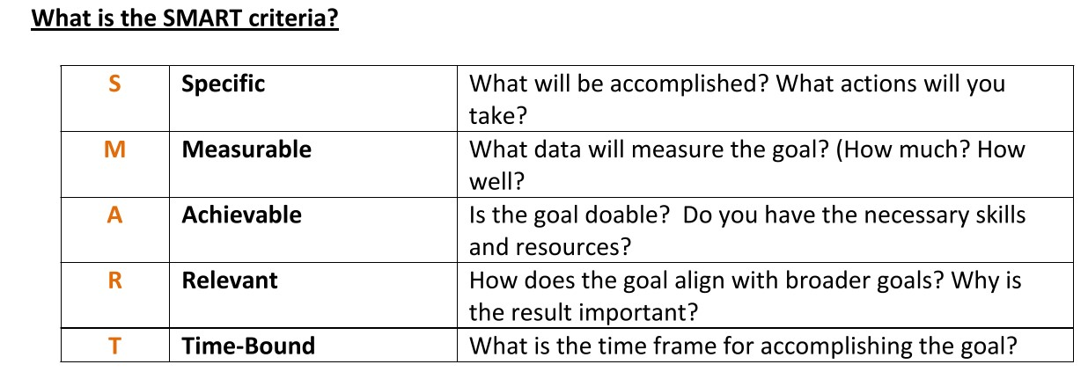
Figurek 1 SMART criteria [2]

Specific
Finding out what services or enterprises Port Talbot residents require is the major objective. Understanding these residents' particular demands for services and companies is the aim of this study. Determine the market gaps that currently exist and investigate the possibility of launching new businesses or services that could enhance Port Talbot's quality of life. Surveys and questionnaires will be used to collect data from a larger group of people.

Measurable
The data obtained from the study are intended to be useful because they can give ideas and help people who are thinking about self-employment or starting (adapting) a small business.
Survey responses can be automatically verified and stored in databases using web-based surveys. [3]

Achievable
Surveys and questionnaires to collect data from a larger group of people will be constructed from open (qualitative) and closed (quantitative) questions. This will collect both qualitative and quantitative data, and by focusing efforts on the residents of Port Talbot, it is hoped to gain an in-depth understanding of the unique needs and preferences of this community.

Relevant
The results will benefit more than just those launching new ventures. Additionally, by being aware of and adapting to people's demands and new trends, these discoveries can assist established firms. In addition to improving the quality of life, the project will increase employment, improve services, and boost the local economy. The initiative combines market research, public discussions, and support for business owners.

Time-Bound
The target delivery date of the project is set for July 31, 2024. By then, a website and basic questionnaires will be created. However, after this time it will only gain momentum because the collected and analyzed data will allow the creation of a larger number of more specific questionnaires and further development of the project.

Project Initiation
Building a highly productive project team is thought to result in superior project outputs that surpass expectations and raise overall productivity. Conflict has been shown to be minimized in highly effective teams, resulting in positive working relationships and potentially better performance. Thanks to this, the idea of ​​teamwork and combining knowledge and experience guarantees that the project will meet current and future requirements. [4]
The project was started by using The Nine Belbin Team Roles. People's strengths can be better understood through the use of Belbin reports, which improves team communication. This permits managers to fabricate extraordinary groups, increment the exhibition of existing groups and guarantee that everybody feels they are having an effect in the work environment. [5]
The project group consisted of 5 members.
Gabriela Ciuba - Project Manager, Specialist
Helen Jones - Shaper, Implementor
Silviu Tobescu - Resource Investigator, Planter
Kathy Clanford - Resource Investigator, Planter
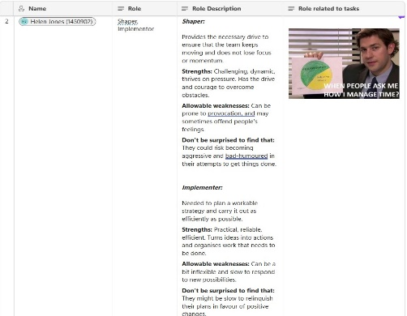
Wioletta Kaprol - Monitor Evaluator, Compliter-Finisher
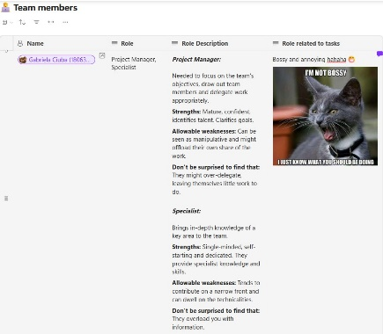

Figure 3 Shaper, Implementor
Figure 2 Project Manager, Specialist
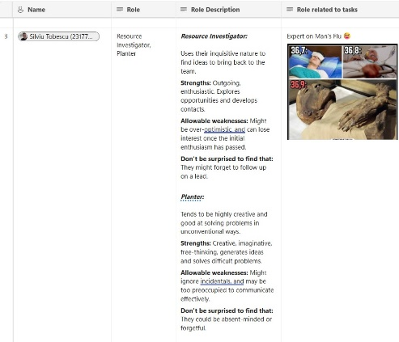
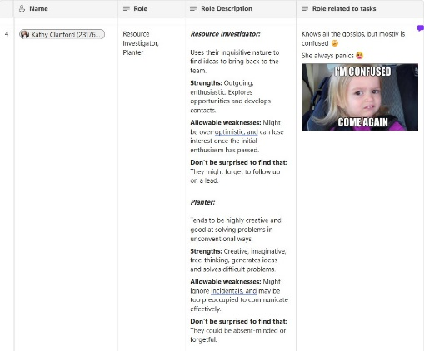
Figure 4 Resource Investigator, Planter
Figure 5 Resource Investigator, Planter

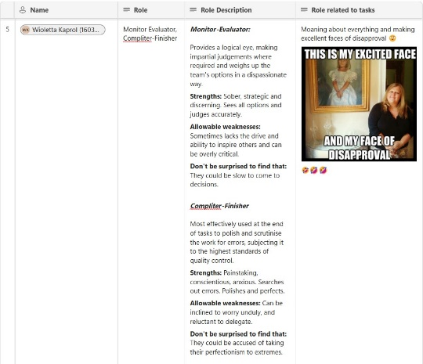
Figure 6 Monitor Evaluator, Compliter-Finisher

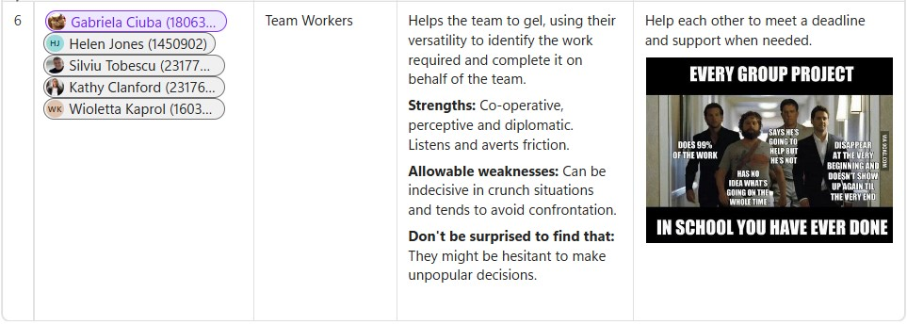
Figure 7 Team Workers

Initiation refers to the activities that need to be done to start the main content of the project. When working on a group project, it is important to assign tasks and organize other members of the project team. It is really necessary to establish some guidelines and methodology for the future work. When the project is underway, it is necessary to monitor as it progresses. [6]

For this purpose, a Project Initiation Document was created.
Figure 9 PID
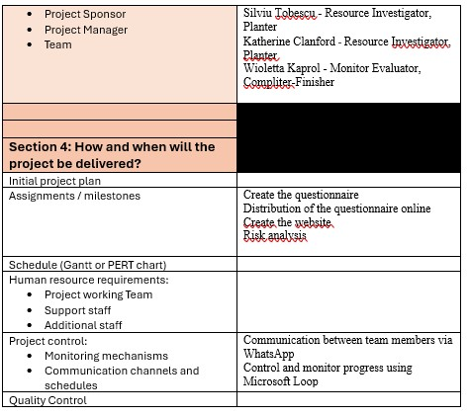
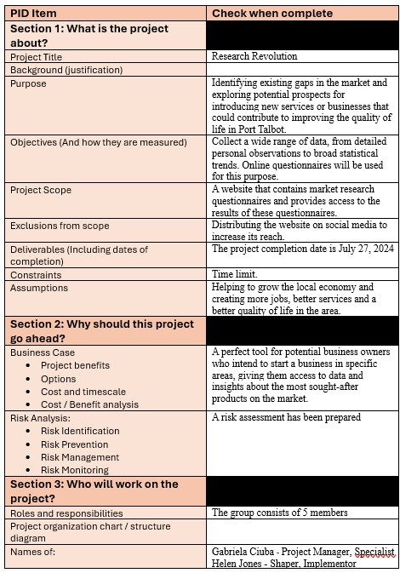

Figure 8 PID

The Project Initiation Document outlines the project's direction and scope and serves as the agreement between the Project Manager and Project Board. The Project Initiation Document remains dynamic as it must continuously mirror the project's up-to-date status, strategies, and management. The deliverables must be revised and re-established at the end of each stage to accurately represent the status of its components. [7]

Project Management
Project management is a set of activities performed to achieve the set main and intermediate goals within a finite time. It includes, among others, planning, scheduling, implementation, control and accounting of tasks that make up the implementation of the project goals.
Agile approaches are applied and utilized globally on a large scale. There are more than 20 distinct agile approaches, each with its own variations. The kind of project and the people involved determine which approach to use and how to modify it. The traits, relationships, and drive of team members are some of the factors that can have a significant impact on how well the methodology is implemented. [8] Agile is a project management methodology that breaks down a project into phases and places an emphasis on ongoing improvement and collaboration. Teams work in cycles of planning, carrying out, and assessing. Scrum is the most widely used agile methodology for software product development among the other methodologies. Scrum is essentially a lean, agile framework with processes for managing and controlling the development of software and products. Scrum provides a tailored approach to working on various projects with a range of requirements. Its benefits include no set procedures to follow and flexible requirement selection for sprints. [9]
The project's work style was typical of the Agile method because it showed adaptability, frequent communication, and use of appropriate tools. Short sprint planning, team collaboration, and a supportive leadership style were the aspects of the work style that were most in line with the Scrum methodology. A strategy for achieving the sprint goals in the short term was developed during each sprint. Regular communication, progress sharing, and obstacle resolution. The group was able to quickly and effectively implement changes to the plans because the project manager made quick and appropriate decisions.

Project Lifecycle
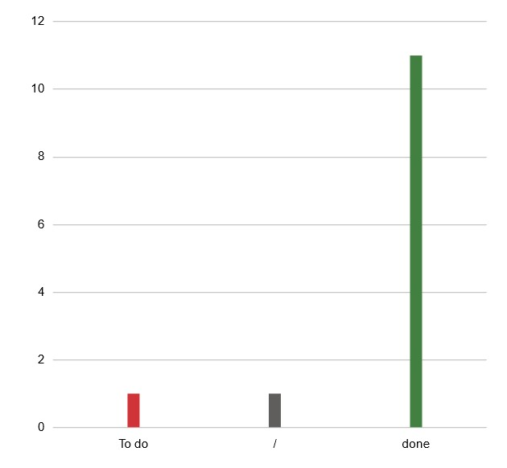
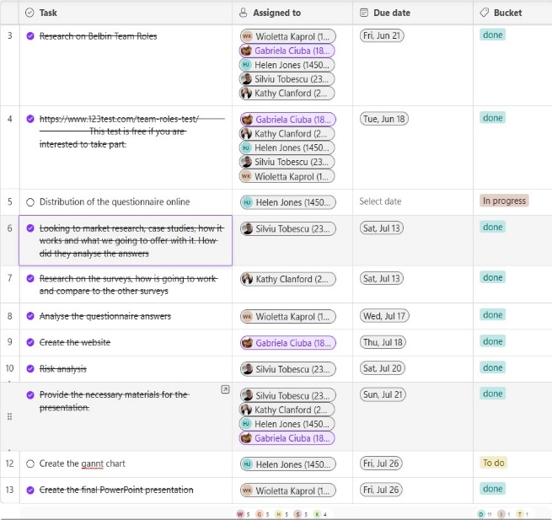
Each task goes through various progressive phases. These stages change contingent upon the sort of task. The venture life cycle likewise relies upon the procedure utilized. Projects have an obviously characterized objective that should be accomplished inside a predefined time and at a predetermined expense. The project will end with predetermined products. Items are planned for the venture client and are made by the task group under the oversight of the task manager. [10] After defining the project steps and creating a draft plan, the necessary actions were presented to achieve the main goal. At the same time, effective communication channels were established between team members and selected applications to facilitate collaboration during the project. Considering that all team members had unlimited access to Microsoft Office applications, these solid project management tools were used. In particular, task lists were compiled, a task table with time constraints was created, a shared calendar was used and the collected information was jointly modified. As a result, individual tasks were assigned to each team member, supporting effective coordination. During the gathering project work, successful correspondence was guaranteed between colleagues by: as often as possible examining progress, sharing updates, and settling any issues that were experienced. Utilizing joint effort apparatuses, for example, Microsoft Loop [11] and WhatsApp [12] that consider discussion, sharing outcomes, and teaming up progressively. during discussions, actively listening to others' ideas and concerns.
Figure 10 Microsoft Loop
Figure 11 Tasks Chart

Risk Assessment
Risk Assessment expects to distinguish and evaluate the dangers that compromise the accomplishment of undertaking goals and to make a move to stay away from, decrease or even acknowledge those dangers. It ought to be seen as a fundamental piece of undertaking the executives, not similarly as a bunch of devices or strategies. [13] Developing a website for market research purposes involves a number of potential risks that the project team must assess and prepare for.
Technical Risks:
Potential Threats: Site failures, software flaws, or technical difficulties that could cause disruptions to research activities.
Mitigation: Hiring reputable hosting services, engaging skilled developers, and conducting comprehensive testing (including functionality, usability, and security assessments) before deploying the site. Ensuring a comprehensive backup and disaster recovery strategy is in place.
Lack of user adoption: On the off chance that clients are not drawing in or sharing their inclinations, the site won't offer significant experiences. This can be cured by empowering client investment yet adding helpful realities about the area of premium or customized ideas.
Data Accuracy and Bias: When it comes to user preferences, they may not always represent everyone. To address this, we can make sure that we regularly review and update data. Additionally, including a diverse range of demographics can be beneficial to avoid bias.
Privacy concerns:
When we collect user preferences, we are dealing with personal data. To comply with privacy rules (such as GDPR), we need to make sure that our privacy policy is clearly explained and that we obtain user consent.
The team’s research has highlighted the potential risks when creating preference-based websites, but it has also shown how to proactively approach those risks.

Delivery of the project
In the context of projects, delivery simply refers to carrying out the project's objectives and completing them. The job of the venture director is consequently to convey the task. [10]
Wix was chosen for the website to deliver the group project because it offers an intuitive website builder that allows you to create professional-looking sites without having to know how to code. Additionally, Wix offers a generous free plan and an extensive library of customizable templates, making it easy to choose a style that fits your chosen market research goals, expectations, and budget. [14]
The link to the website is below:
https://ciubagabriela83.wixsite.com/researchrevolution
In the future, it will be possible to monitor and improve a website over time by performing detailed analysis of the website's audience. Analyze user traffic on the website. In this way, it will be possible to understand what interests them the most, as well as define the weak points of the website and therefore what is worth working on.

Conclusion
Market research gives one of a kind experiences that can't be gotten through different means, for example, web-based entertainment or client audits, a profound comprehension of client needs, wants and ways of behaving that can't be gotten through shallow strategies. Companies can enhance the customer experience by gaining an understanding of the needs and preferences of their customers through market research. The project research is tailored to the Port Talbot community, with a range of questions and feedback to allow each member to provide their own unique perspective. The project group took care to personalise it and ask questions that no one else had asked. The focus on the Port Talbot community was narrowed to reach a specific audience. The group agreed that project research is a quick and efficient method for obtaining immediate feedback and making decisions. With online questionnaires, analyzing research information, and giving fast and simple insights is simple. It tends to be utilized to screen improvement and assess the outcome of promoting drives by observing outcomes. Online surveys enable automated verification and capture of survey responses in databases. [3] Regular use of the survey made it possible to monitor changes in the attitudes, opinions, and behaviors of respondents over time. The team concluded that the survey made it easier to examine the findings and made it possible to collect and analyze data more quickly. They discovered that the survey was less expensive, had a higher response rate than surveys that were printed on paper, and allowed for faster analysis to speed up decision-making. Organizations can acquire significant data that will assist them with outflanking their rivals and work on their labor and products by decisively utilizing statistical surveying and online studies.

References
[1] B. Kolb, Marketing research: A practial approach, vol. 3, no. April. 2008.
[2] U. of California, “SMART Goals : A How to Guide,” Smart Goals A How to Guid., pp. 1–13, 2017.
[3] M. G. de Jong and U. Böckenholt, “Marketing research,” Handb. Item Response Theory, vol. 3, no. February, pp. 365–385, 2017.
[4] E. Kim, D. Adams, I. Hentzel, S. Song, and S. Willson, “Program of Study Committee,” Citeseer, 2010, [Online]. Available: http://citeseerx.ist.psu.edu/viewdoc/summary?doi=10.1.1.146.4675 [Accessed: July, 2, 2024]
[5] “Belbin-Team-Roles @ Www.Belbin.Com.” [Online]. Available: https://www.belbin.com/about/belbin-team-roles [Accessed: July, 27, 2024]
[6] C. W. Dawson, Projects in computing and information systems: a student’s guide. Pearson Education, 2005.
[7] G. Bayliss, “Contributors Isle of Wight Fire & Rescue Service Senior Officers Hampshire Fire & Rescue Service Senior Officers”.
[8] A. Rasnacis and S. Berzisa, “Method for Adaptation and Implementation of Agile Project Management Methodology,” Procedia Comput. Sci., vol. 104, no. December 2016, pp. 43–50, 2016, doi: 10.1016/j.procs.2017.01.055.
[9] A. Srivastava, S. Bhardwaj, and S. Saraswat, “SCRUM model for agile methodology,” Proceeding - IEEE Int. Conf. Comput. Commun. Autom. ICCCA 2017, vol. 2017-Janua, pp. 864–869, 2017, doi: 10.1109/CCAA.2017.8229928.
[10] R. Newton, Project Management: Step by Step: How to Plan and Manage a Highly Successful Project. Pearson UK, 2016.
[11] “microsoft-loop @ www.microsoft.com.” [Online]. Available: https://www.microsoft.com/en-us/microsoft-loop [Accessed: July, 5, 2024]
[12] “Index @ Www.Whatsapp.Com.” [Online]. Available: https://www.whatsapp.com/ [Accessed: July, 5, 2024]
[13] APM, “Project risk analysis and management mini-guide,” Assoc. Proj. Manag., no. January, pp. 1–20, 2018, [Online]. Available: http://m.isaca.org/chapters11/Malta/Documents/Events/210416 - Mark_Debono - Understanding_Risk_in_the_Field_of_Project_Management.pdf [Accessed: July, 3, 2024]
[14] “index @ www.wix.com.” [Online]. Available: https://www.wix.com/ [Accessed: July, 3, 2024]

