
Figure 1
SKILLS AND CHARACTERISTICS
FOR EQUITABLE LIFE
Organisations Performance

Vasile Stan (1912877)

SKILLS AND CHARACTERISTICS FOR EQUITABLE LIFE

Skills and characteristics sought by employers:

- Soft skills sought by employers
- Results orientation
- Communication skills
- Flexibility, adaptability
- Problem solving

RESULT-ORIENTED

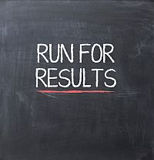

The comes about introduction suggests expecting duties and continually making an exertion to attain the proposed results.
Those who are results-oriented and continually endeavor to reach the set target will be much acknowledged by the group and bosses, and are moreover considered essential individuals.
They set in intellect an result they need to reach and look for the quickest and most proficient way. To effortlessly create this aptitude, you must set short-term goals. After you do them, you'll remunerate yourself with little breaks and things you enjoy.

COMUNICATION SKILLS



Among the foremost looked for after and acknowledged by managers are communication skills. Communication is the act of exchanging data from one put to another (from one individual to another), verbally, composing (utilizing books, magazines, mail, site, etc.), outwardly (utilizing tables, logos, illustrations). etc.) or non-verbal (utilizing body dialect, signals, tone and voice intensity). This suggests the capacity to intentioned pass on exact and clear data, suitable in terms of fashion and substance, to the gathering of people to whom it is tended to. Successful communication involves the capacity to specific thoughts clearly, concisely and with confidence.

PROBLEM SOLVING

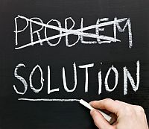
Those who have this capacity, construct consistent approaches to fathom issues, to oversee quick openings or circumstances, based on their claim preparing and information, but moreover seeking out for other references or resources.
Regardless of the nature of the issues, a really vital part of the part of an representative is to illuminate it; Therefore, in case you've got this capacity and you appear it with certainty, you'll develop within the eyes of the employer.
There are 4 essential steps in the process of solving a problem:
• Defining the problem;
• Generating alternatives;
• Evaluation and selection of alternatives;
• Implementation of solutions.
When characterizing issues, it is exceptionally imperative to create beyond any doubt that you simply are confronting the issue and not its symptoms. For illustration, if the execution of his group is underneath the specified measures, he should figure out on the off chance that the group individuals are to fault or there's a need of basic aptitudes (in this case, the group needs training).
Define the problem
•What happened?
• What are the specific symptoms?
Collect data:
• What evidence does this problem have?
• How long has this problem been?
• What were the factors that allowed this problem to occur?
• What other problems were there when that discussion started?
Recommend and implement solutions:
• What can you do to prevent this problem from recurring?
• How will the solutions be implemented?
• Who will be responsible for their implementation?
• What are the risks of their implementation?

FLEXIBILITY OR ADAPTABILITY
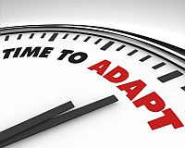

A individual characterized by adaptability and versatility changes the working strategy or approach when essential, in arrange to realize a objective or to fulfill a task Therefore, they require, in their turn, candidates who adjust effortlessly to outside weights and work needs, who effortlessly grasp modern thoughts, are business visionaries and clever and rise to the level of any challenge.
Flexibility includes 5 characteristics merely must expect: self-confidence (self-esteem), tolerance (open and tuning in to the suppositions of others), compassion (tolerating the sentiments of those around you), positive thinking (driving to positive occasions), regard (for those around him).

