Changemakers Value and Creation

Assignment 2
Contents Page:

Task A 3 - 4
Task B 5
Task C 6 – 9
References 10
Task 1

The aquatics industry is dominated by only a few giants in the equipment industry; Speedo, TYR and Arena when it comes to mid to high range equipment (Swim Outlet, 2024), who consistently outperform other brands in unique innovation and represent the pinnacle of swimwear and training equipment in the aquatics sector. From developing revolutionary tech suits to streamlined goggles used by Olympians from every country, Speedo, TYR and Arena go head-to-head in every aspect of the sport, in turn, making each innovation greater than the last. However, despite their significant advancements in swimwear material, hydrodynamics and training equipment (Solomon and Trusty, 2024), there is a clear and distinct gap in the market regarding the integration of artificial intelligence (AI) into the aquatics industry. While the big three have their eyes focused on enhancing the physical aspects of swimming like drag reduction in swimwear or swimmer's comfortability, both brands have a severe lack of interest in the development of the technology surrounding the sport of aquatics. Other sports have begun to introduce technological advancements in recent years, such as VAR, GPS Trackers and Live Replay Capabilities, but swimming is unfortunately, one of the few sports that is not keeping up to date with the ongoing march of technology, despite it having the potential to change the sport forever. Artificial Intelligence, if used correctly, can revolutionize the sport, through improved health and safety, advanced training modules and programs and even on the go coaching guidance from the poolside.

Swimmers face several difficult challenges to overcome during their careers including maintaining a proper technique without the luxury of immediate feedback from a coach, efficiently pacing themselves without an external guide and tracking their performance in real time. Unlike cyclists or runners, swimmers can't easily communicate with officials or coaches midsession or mid competition, so training often relies on a delayed coaching feedback, making real time corrections a great challenges which can hinder performance improvement and development.

Swimmers face several challenges, including maintaining proper technique without immediate feedback, pacing efficiently without external guidance, and tracking performance in real-time. Unlike runners or cyclists, swimmers can't easily check a smartwatch mid-session. Training often relies on delayed coach feedback, making real-time corrections difficult, which can hinder performance improvements.

The core premise of this innovative idea is to develop a pair of swimming goggles with a strong focus on AI integration. However, they will not only feature AI integration, but also have a built-in speedometer, waterproof earphones and dual cameras at the side of each lens. The lenses will also have small projectors on them, so videos and overlays can be displayed in front of the swimmers' eyes while they are in the water. These goggles will be multifunctional and would suit a wide variety of swimmers from a wide variety of backgrounds, abilities and environments. From Competitive swimmers using it to identify their fastest speed at a specific point, to club swimmers using the in ear headphones to listen to their coaches on the go guidance. Every single aspect of these goggles has been thoroughly thought out with the swimmer in mind.

The principle of these goggles is fantastic, however, there are some logistical difficulties attached to them. One such disadvantage is the cost per unit of the goggles as on average, a pair of Speedo Fastskin goggles sell for £57 at full price (Speedo, N.D), which is already above budget for many casual and beginner swimmers, so considering the markup price due to the integrated technology, there is a threat that nobody will be able to afford the product. Another logistical factor is the risk that FINA, ‘Fédération internationale de natation’ which is the international swimming federation, may reject such goggles as a form of cheating or unfair advantage. If this were to happen, then the only use for the goggles would be in training sessions, and they could never be used in a competition that was either hosted by FINA or hosted by the National Swimming Federation.

However, despite these risks, there are many positive factors that influence the likelihood of success for a product like this. The first benefit is increased accessibility for swimmers, especially those in remote areas who do not have access to top tier and quality training. Another benefit is the instant feedback that either the AI integrated scanners or the coach can give to you through the in ear waterproof headphones. The lense projectors can also be used to display training videos, emulate and replicate both fictional, upcoming and real previous competitions to compare your performance to competitive swimmers, as well as logging all progress to an account, so as long as you have a set of the goggles, you can pick up and go anywhere, anytime.

Finally, on the topic of the AI capabilities, the AI systems would be able to analyze the swimmer’s performance in real time, detecting inefficiencies in their strokes, breathing patterns, and overall movement. The system could provide feedback on improving form, energy conservation, and technique. Then with personalized data, swimmers would get a better understanding of their body’s performance, injury risks, and muscle development, optimizing training schedules and rest periods.

Overall, there is a strong need for a product like this, and this type of goggle could easily revolutionize the swimming world forever, however, they are not only useful for in the moment but moving forward. The potential to continue to develop this technology could go so much further. Integrating AI technology into kickboards, swim caps, swimming costumes, to measure various metrics of technique, efficiency and success. Innovation does not happen regularly in swimming to the eye of a regular spectator, but with technology like this, we can prove that swimming is making leaps towards the new future of swimming, where AI and technology is at the core.

Task B
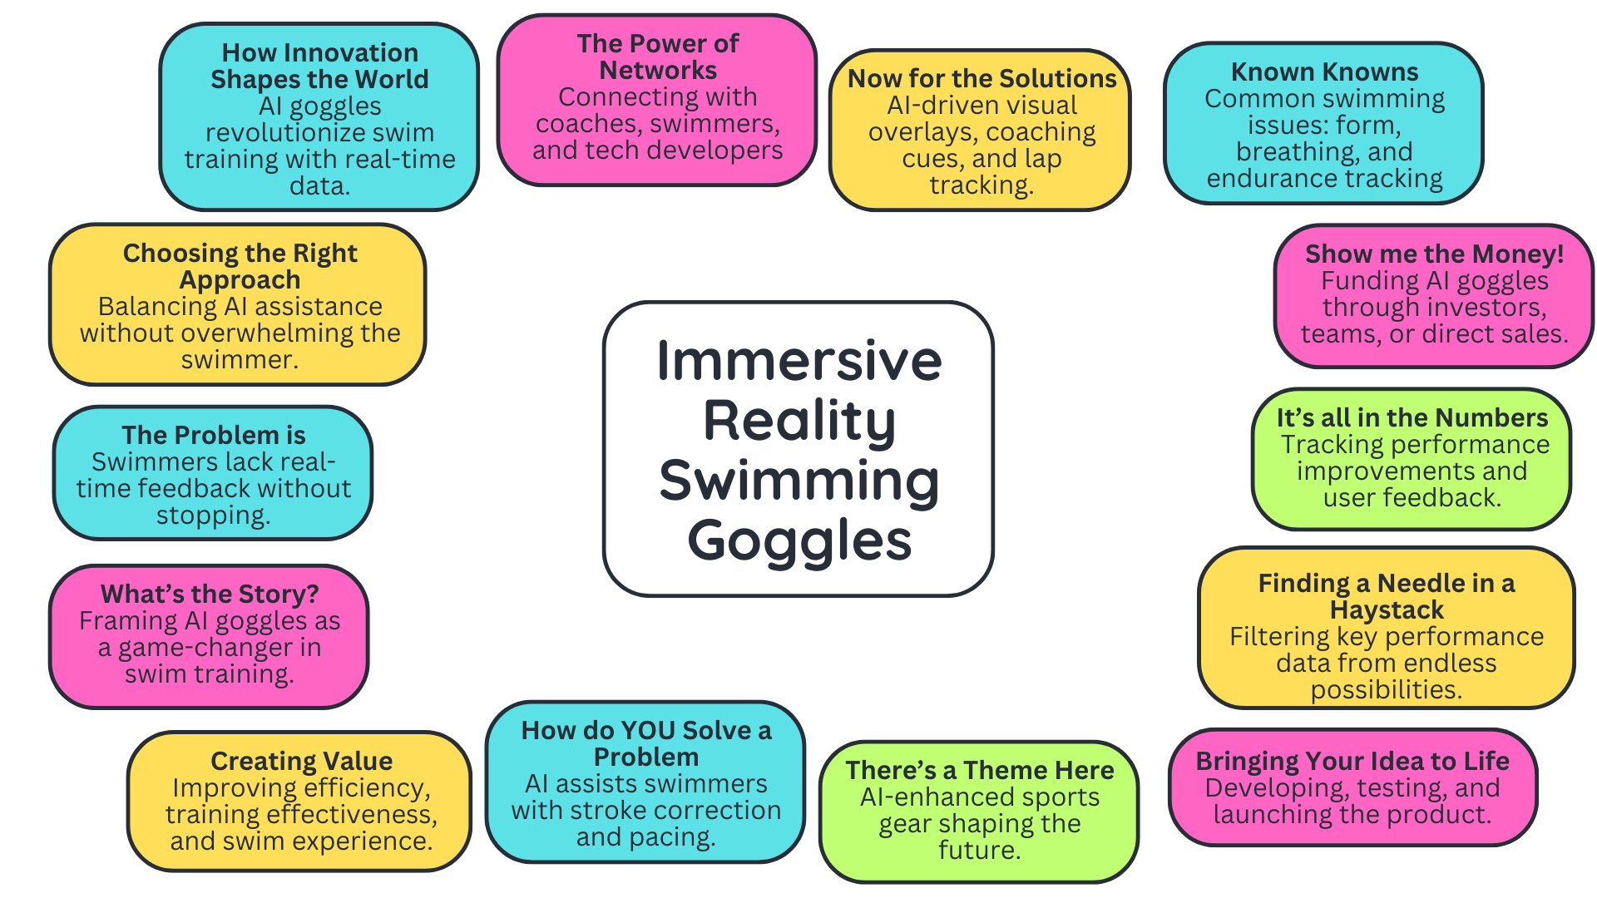

Task C – Next Page
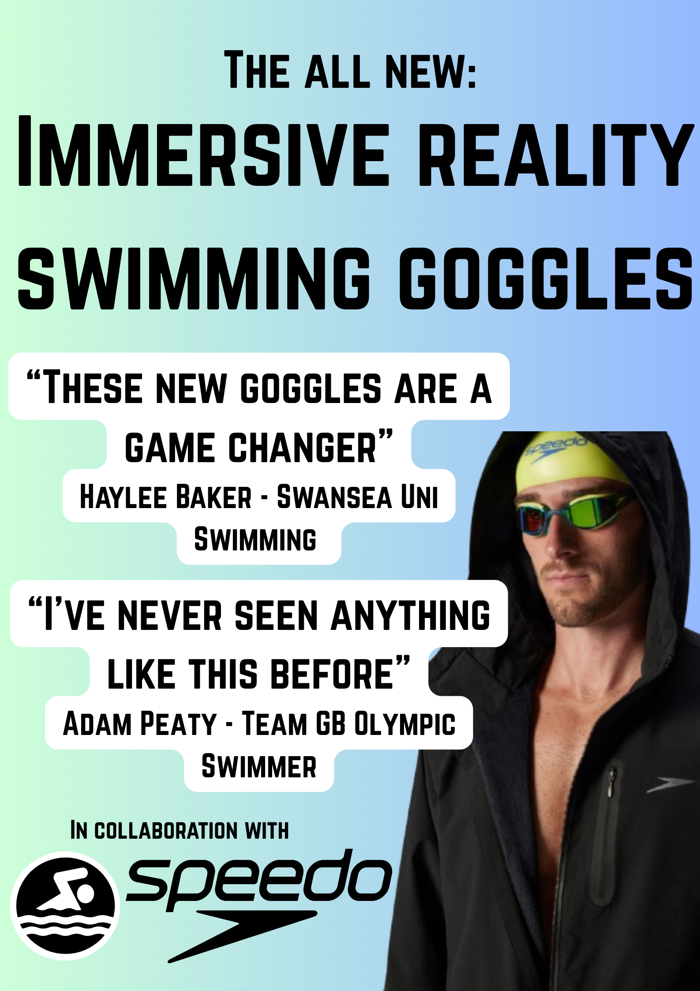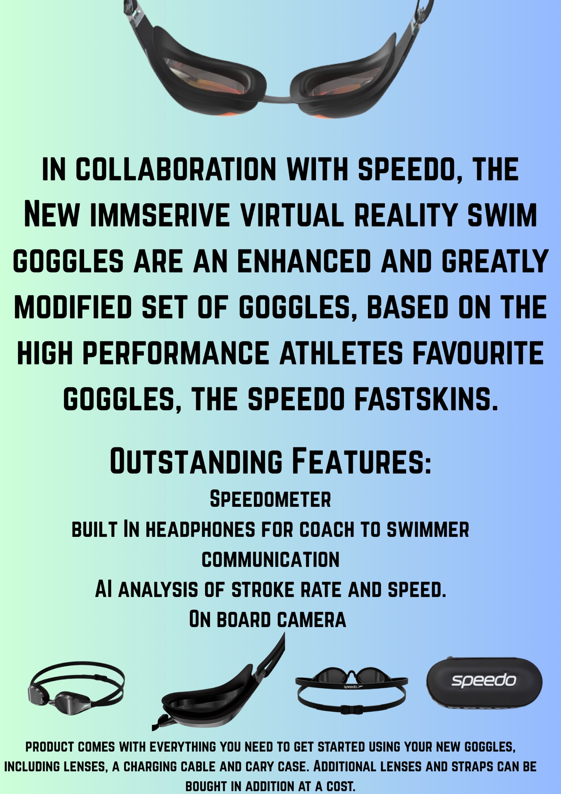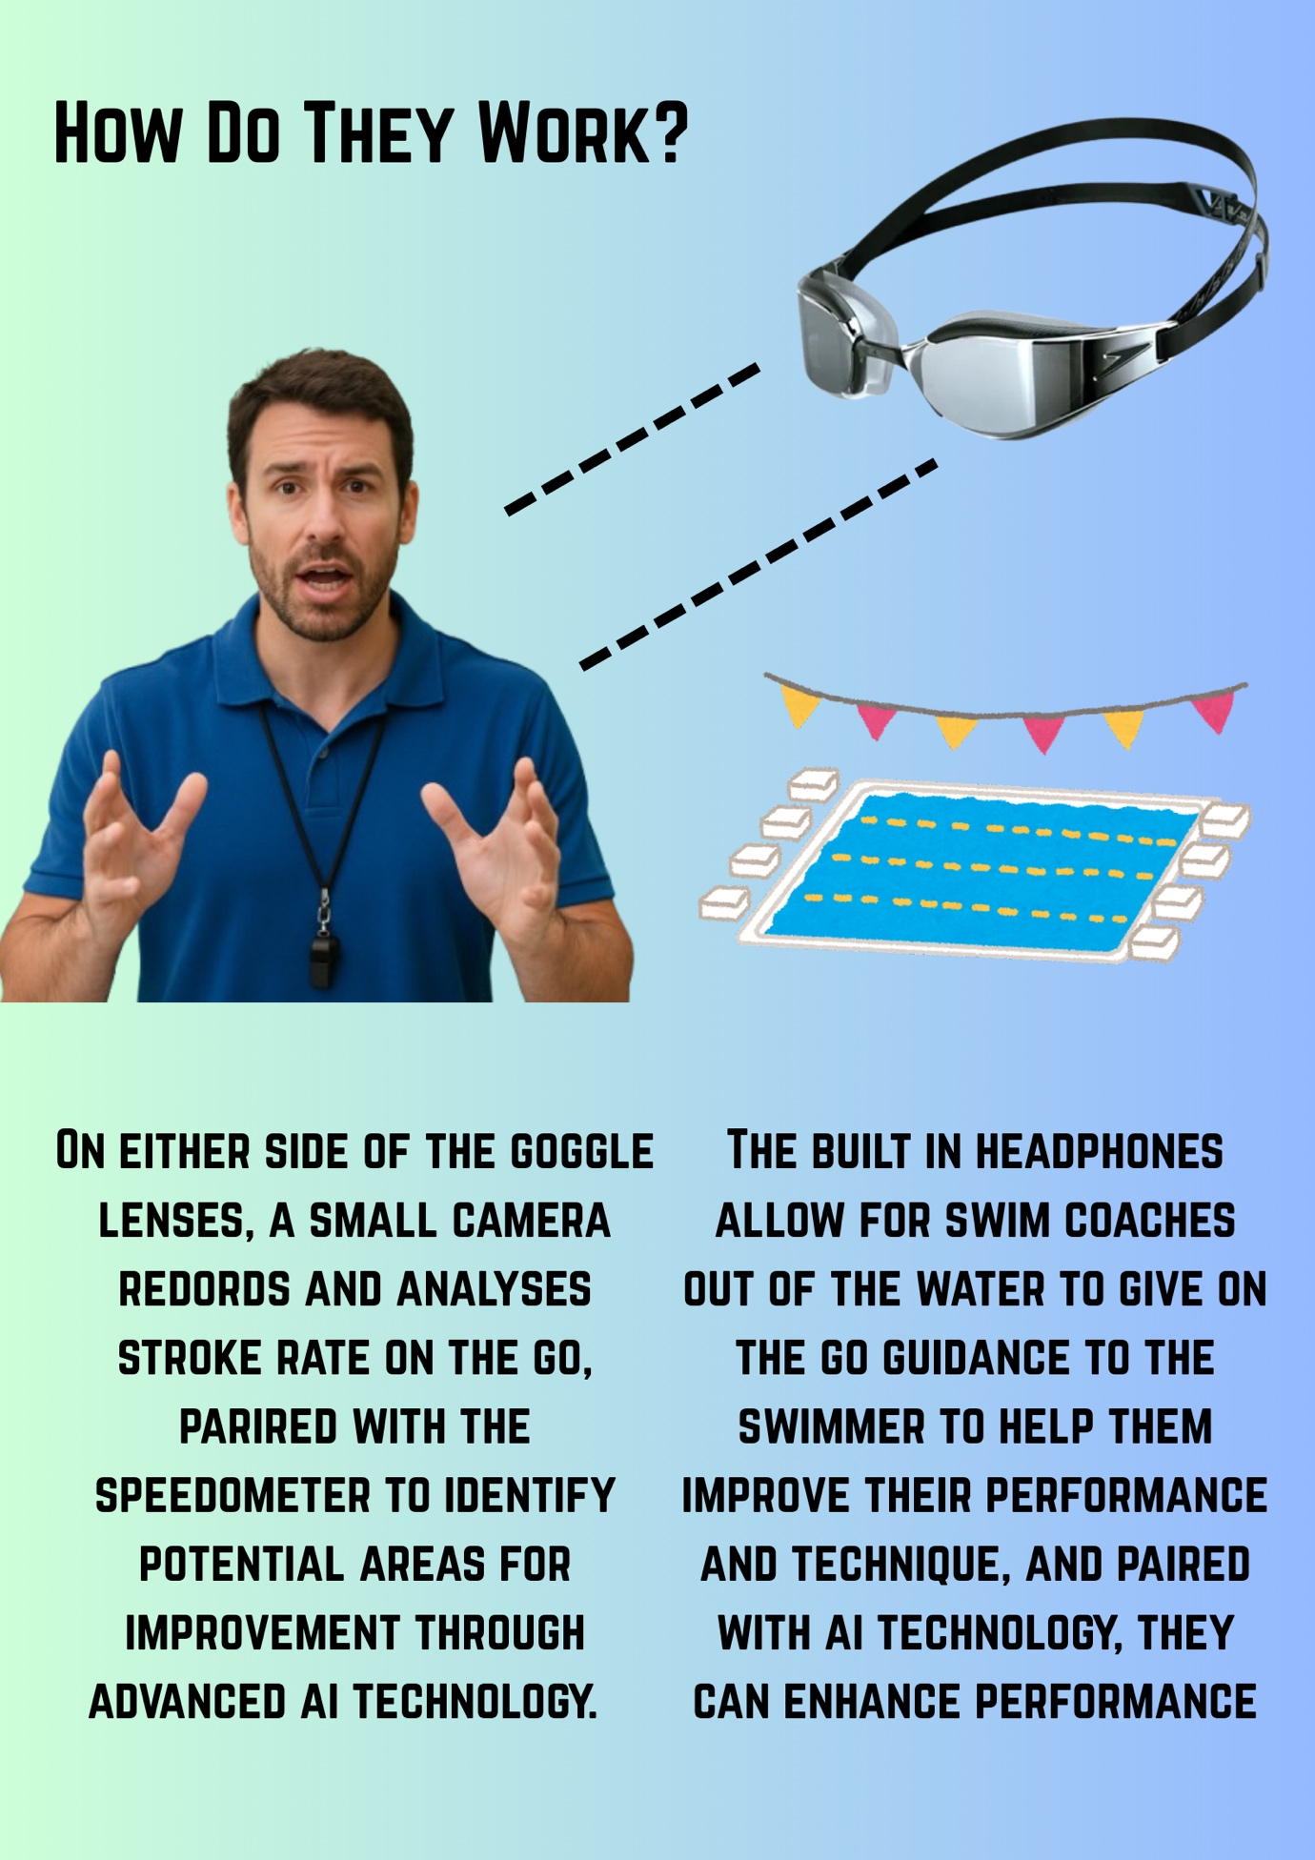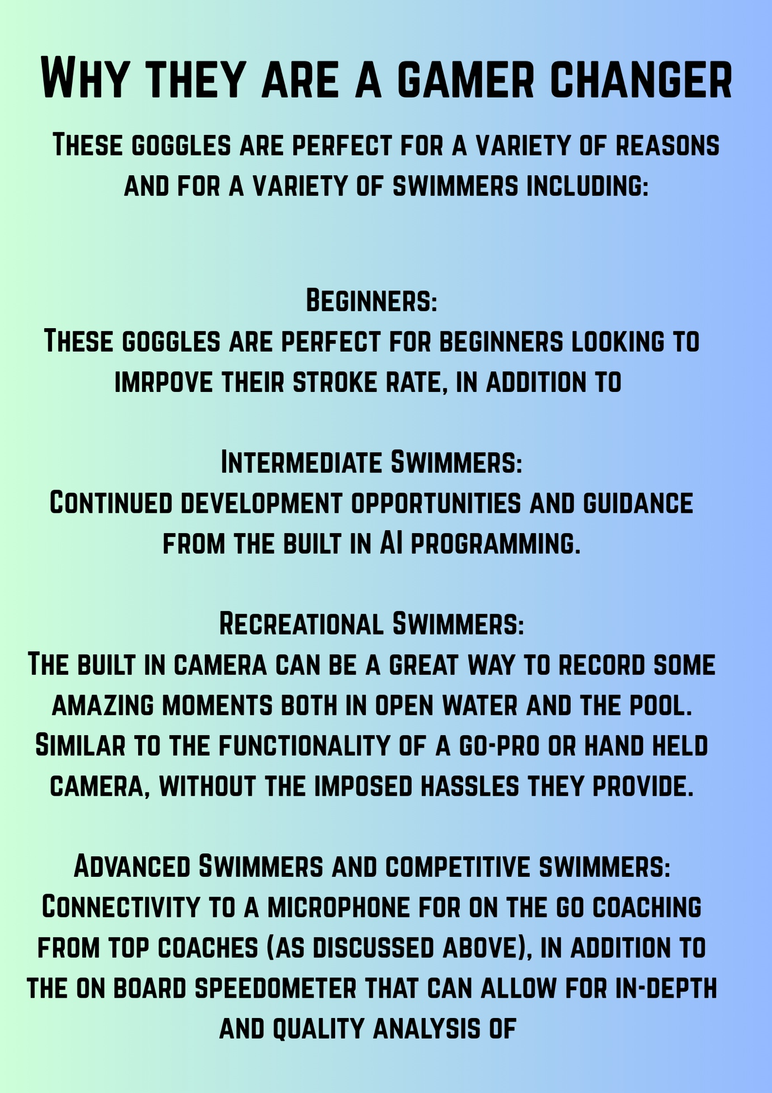

References

Speedo (N.D) FastSkin Men’s Goggles. Available at: https://www.speedo.com/adult-fastskin-hyper-elite-mirror-goggles-black/13102228.html?autocomplete=productsuggestion&search=fastskin (Accessed 28.3.25)

Solomon, G. and Trusty, T. (2024) Beyond the Podium: Technology & Fashion in Swimming. Available at: https://www.foley.com/insights/publications/2024/08/beyond-the-podium-technology-fashion-swimming/ (Accessed 28.3.25)

Swim Outlet (2024) The Best Athletic Swimwear Brands. Available at:
https://www.swimoutlet.com/blogs/guides/best-athletic-swimwear-brands (Accessed 28.3.25)

