Politics of desire
The Non-Verbal Communication of Identity and Status Through Fashion
Kelly Jones 1804366 MA Textiles
Coexistent Perspectives (ADCD7001)

Table of Contents
Introduction 2
Non-Verbal Communication of Fashion 4
Identity of a Designer 8
Catwalk to Commercial 10
Luxury Handbags 12
Conclusion 15
Bibliography 16
Reference List 16
List of Figures 19

Introduction
It was once considered irrelevant and capricious to investigate clothing as an academic line of study, those that did saw themselves, and were considered by others, to be “at the fringe of academic respectability” (Guy, et al. 2001:237). How much of this is because fashion was seen as a women’s ‘playground’, rather than a serious subject of discourse, can be argued at length. However, over time, this has changed, as many now see the role fashion has to play within many discussions, least of all postmodern and feminist rhetoric. Certainly, the historical context of textiles, how they were used and produced has to be acknowledged, as “it is primarily women who are involved in the production of textiles, implications of this challenge reach outside the strict confines of textiles dialogue, as they reflect attitudes of women and towards women and their activities” (Bachman & Scheuing, 1998: 202).

For the purposes of this exploration, there must be clear definitions of ‘fashion’, ‘status’ and ‘identity’. Chief among those expressions, identity is hard to pinpoint, as for every unique person it is an individual, progressing discourse of self. “It is fundamentally about issues of belonging, expression, performance, identification and communication with other” (Hetherington, 1998: 62). Therefore, in the context of this investigation, identity is to mean the persona of self that a person is wanting to indicate to others.

Status is intrinsic to our understanding of identity, and status motivation has long been researched and philosophised on. The results seem to be unchanging over time, as there are “common assumptions about which motives drive us to seek high status” (de Botton, 2014: 11). While it does not appear to be common for consumers to actively reflect their purchases or the items chosen to dress their bodies, the communication of status (among other things) is ever-present. This will be expanded on in the first part of the essay.

Through both identity and status, the definition of fashion within this discussion is born. A word developed in the Medieval period; it was first used to describe a process of making an object, but “became increasingly associated with clothing and the constant shifts and changes in personal adornment” (Cumming et al, 2010: 79). Throughout this essay, fashion will be used to both discuss and describe how one styles themselves for the world to interpret, to design a language of one’s own. This is to separate the idea of personal fashion language from the semantics of fashion and media held by Roland Barthes. Through Barthes’ theory of fashion, we know there are semantic codes in clothes and how they are styled, a language we are conditioned to understand by our societies to know the hidden meanings, through advertising and media, without having to actively learn the interpretations (2010).

Considering these definitions and theories, how the identity or celebrity of a designer can translate to their couture and commercial collections will be examined. How this then transfers to the consumer and their own expression of identity and status through fashion will also be investigated. In particular, the design of luxury handbags will be considered, due to the use of signifiers which are not brand logos, to reveal high-end luxury status, this seems to feed Baudrillard’s theory of a post-modern consumerist society, one where “commodities are reduced to mere signs” (Friedman, 2004: 7), and will be scrutinized further.

Non-Verbal Communication of Fashion
An almost unparalleled amount of data is accrued through one’s fashion choices, and we have “an amazing capacity to make sense of a substantial amount of detail in a very short time” (Damhorst, 2005: 67), even when we do not know that we are doing it. What colours you choose to pair, how you style your hair, and your choice of footwear are all fashion choices that have something to say about who you are and who you see yourself as. Both conscious and unconscious choices tell our audience, intended and otherwise, tell those around us things we want them to know – or not know – about ourselves. Did you take the time to iron your shirt this morning, or was the one from yesterday fine for who you are expected to be today? For the majority of people, “dress helps us define social situations” (Damhorst, 2005: 74), thus getting ready for any occasion, however important, helps us set the tone for how we expect to be perceived.
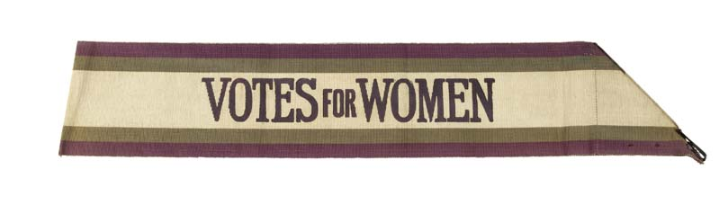
For many women, style and fashion choices were the only ‘voice’ they had in the public arena, which followed the social conformities of the time. In the mid-nineteenth century this started to change in the West, with it being documented in the United States of America where “women wore men’s clothing to fight against gender norms” (Yangzom, 2016: 623). This was followed in the early twentieth century in the United Kingdom, where Suffragettes wore sashes emblazoned with their slogan, wrapped in their now iconic colours. The colours were of course chosen with specific meanings in mind; “purple stood for loyalty and dignity, white for purity and green for hope.” (Chertsymuseum.org). The purple, green and white colours are still used today to signify women’s suffrage and is used by those who want to show support for the movement. However, in recent years, more women are choosing the hot pink of the ‘pussy hats’, first adopted during the Women’s March of 2017, shown in Figure 2 (overleaf). The pink is visually loud and shocking, and aligns the wearer with a modern, intersectional feminism.
Fig. 1, Suffragette Sash, 1908-1910.

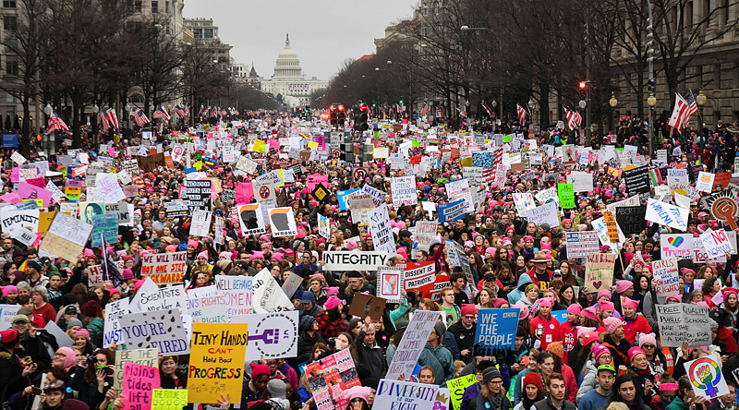
Fig. 2, Women’s March, 2017. (Woolston, 2017)
However, in a postmodernist age, we are overwhelmed by the daily choices we have to make when readying ourselves. This has been covered time and again, with the well-trodden joke of a woman exclaiming ‘I have nothing to wear!’ in front of overflowing dressers and drawers, however, what is often meant is “there’s nothing for who I’m supposed to be today” (Moran, 2012: 211). Indeed, fashion and style are not constant or linear, we adjust what we wear to suit the social situation we are expecting to encounter, therefore through changing we can use it to differentiate who we are and who we need to be, a form of codeswitching which has long been explored by linguists, but less so by those who study fashion and textiles. “In changing incessantly, is differentiates one time from another and one social stratum from another” (Simmel, 1957: 541). Yet, generally, our fashion does remain the same during most interactions, and therefore in that snapshot it can “communicate stable characteristics of the wearer” (McCracken, 1986). We do need to keep in mind the context of the situation, what one wears to a job interview may not correlate to what they would choose for a relaxed social engagement.

Our clothes do a lot of talking for us, and when selecting our ensembles, it can become a process that is flipped on its head. Rather than saying ‘who do I want to be seen as today’, it can easily become a question of who I am not, “constructing and reconstructing appearance and, in part, identity, becomes a process of figuring out how we ‘fit’ in and ‘depart’” (Kaiser, 2005: 89). This can also translate to when we are purchasing objects, it can often be easier to reject the objects that do not confirm our identity, instead negotiating our consumerism of identity and appearance by asking “how we strive not to look” (Freitas et al., 1997: 323). By doing this we are engaging in a “kind of postmodern reflexivity” (Kaiser, 2005: 89) of self-examination and reflection. Through this we are not only rejecting what is not, but being more conscious of advertising ourselves and consuming the work of others, wherein the “body is both an intimate and social object” (Entwistle, 2011: 139), therefore identity is a visual metaphor for intimacy and social forces and pressures are shaping the outcome of our fashion.

This can be clearly seen and analysed through our fiber consumption as a global population. Since 1900 the world’s consumption of fiber has exploded. Although the population has expanded, this does not account for the volume of fiber consumed, as outlined below.

“In 1900 the world’s population of around 1.7 billion people each consumed about 5lb [2.3kg] of fiber per year giving the annual world fiber market of around 3.4 million tons [18,144kg] (around 75 per cent cotton and 25 per cent wool – all of it natural fibre!) (European Textile Network). A century later, the world’s population is 6.6 billion, each using around 20lb [9kg] of fiber per year (nonwoven.co.uk, 2007)”
(Bide, 2011: 577)

This brings the annual fibre market of 2000 to 66 million US tons [nearly 60 million tonnes]. By 2020, when the world’s population was 7.8 billion, the “total volume accounted for 120 million tonnes, which translates into an average consumption of almost 16kg per capita” (Englehardt, 2020).

The other statistic to account for is the mix of fibers. Technological advances and globalisation do mean that we have more access to more fibers than ever before, by 2020 natural fibers only accounted for 32 million tonnes, with cotton output “falling faster to 26 million tonnes” (Englehardt, 2020). The choice of fibers will be examined further later, but it is worth bearing in mind now.

An increasing population cannot count for this alone, especially with the meteoric rise of online shopping, which has “transformed the model of consumption and is the perfect medium for the disposable mode of ‘fast-fashion’ consumption” (Fung, 2007, p. 6). It is hard to see how this accelerated consumption is going to be able to control itself with the access that advertising now has to us, how it feeds into our anxiety status and perpetuates the capitalist consumerism model our society is in.

Through the social forces and pressures fashion can become a process, by which “the taste of a mass of people is collectively redefined” (Land & Lang, 2011, p. 131). When the pioneers and influencers of fashion first endorse a new style or fashion, they can then “identify themselves as members of an elite group apart from the rest of the world” (Land & Lang, 2011, p. 131). It is not dissimilar, in today’s global society, to the way the status quo has always been set. In the one hundred years running up to the mid-twentieth century “Parisian couturiers had held sway as leaders of fashion” (Black, 2011, p. 8), albeit the fashion, and communication of changes, had been at a slower pace than that of today. In today’s social media society, it is those with the largest number of followers who seem to hold most sway. One doesn’t have to look much further than the post-feminist clan of the Kardashian-Jenner women. They present themselves as hyperfeminine, and who are all “financially and culturally powerful women” (Monteverde, 2016: 160), who have each made financial gains selling the promise of a lifestyle through the purchase of their products and endorsements. In this metaphor, the Kardashian-Jenner fashion is one of both consumer and designer of consumerism.

Identity of a Designer
Founded in 1921, Gucci has had many public and private issues. These have been picked apart by press and media time and again, and the humble beginnings of the brand often forgotten. It was not until 1937 that the first handbags were launched, designed, and made in-house by local leather artisans. During this time the infamous double ‘G’ logo and iconic green and red canvas striping were developed, and later the instantly recognisable metal horse-bit was incorporated into the Gucci loafer in 1953. After having a successful reception, the horse-bit was then added to the luxury handbag line.

Initially the company started by making leather handbags, but during World War II the leather artisans were drafted to create much-needed items for the Italian Forces (Forden, 2001; Gucci, 2016). At that point the company started using cotton canvas and included their logo in the canvas design.

The mid 1980s to the mid-1990s was a tumultuous time for the brand, which concluded in a Bahraini investment company acquiring total control of the historically family-run company (Tungate, 2008). Tom Ford, a designer from Texas, who had been at the fashion house for five years, was then appointed the role of creative director and thus reinvented the brand in such a manner that “’doing a Gucci’ has become a stock phrase” (Tungate, 2008: 163). After Ford’s appointment, Gucci went public on the stock exchange in 1995 and in 2001 Kering – previously Pinault-Printemps-Redoute (PPR) – bought the brand outright. With this new injection of cash, the Gucci Group, as it was now known, began “acquiring other luxury brands” (niood.com, 2008), amongst which was the fashion house Alexander McQueen. As the group accrued more brands “they’ve been keen to market them. Their system is to buy a luxury or fashion business, improve the product, and then tell lots of people about it very quickly” (Tungate, 2008: 133). The changing designs, availability, and ‘street cred’ of the brand is reflected in the constant change in ownership and creative direction. Since Ford’s involvement the brand has cemented its identity and withdrawn its availability to the public.

By comparison the fashion house Alexander McQueen is a very young competitor. Founded in 1992, following Lee Alexander McQueen’s MA graduate collection, and with the help of fashion editor Isabella Blow (Bethune, 2015), McQueen quickly made a name for himself as the “bad boy of British fashion” (Frankel, 2001: 16). Every subsequent collection McQueen released was met with delight and shock of “not only the press and the public but also the supposedly shock-proof fashion industry” (Frankel, 2001: 16). After a career disrupting the fashion industry, including a stint at Kering-owned Givenchy as creative director, McQueen took his own life in February 2010. A short but prolific career, where McQueen created a “design aesthetic so fully submerged in his vision, has eclipsed the designer’s own imagination and become a kind of fashion religion itself” (Knox, 2010: 123).

McQueen and Ford are both fashion designers and creative directors whose allure to the public has transcended their own identity, both are exemplars of designers “whose personal image has helped to transform brands” (Tungate, 2008: 57). In interviews they both discussed status, money, identity and heritage, and on paper, seem to be diametrically opposed in nearly every way.

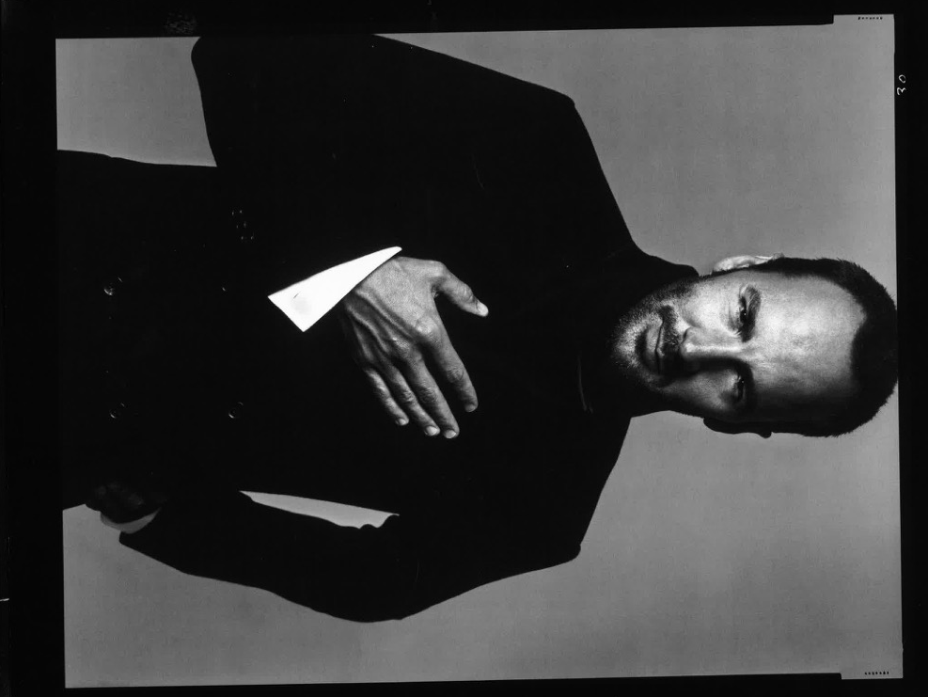
For Ford, status was everything. Always dressed in his own designs, and when queried about it responded, “Of course… Gucci everything!” (Frankel, 2001: 130). Known for wearing all back all of the time, seen in Figure 3, and in this instance, all Gucci, the branding was still visible to the trained eye, with his jeans turned up just so, “to reveal that tell-tale famous red and green Gucci stripe running alongside the inside seam” (Frankel, 2001: 130). Ford wasn’t just a designer as Gucci, he was a consumer of the products since age 12, when he has his first pair of the classic loafers. Hailing from Texas, he acknowledged that “wearing anything Gucci was just totally status” (Frankel, 2001: 132). Playing both roles of creator and consumer, Ford has become a simulation of his own design.
Fig. 3, Portrait of Ford (Avedon, 2002: 4)

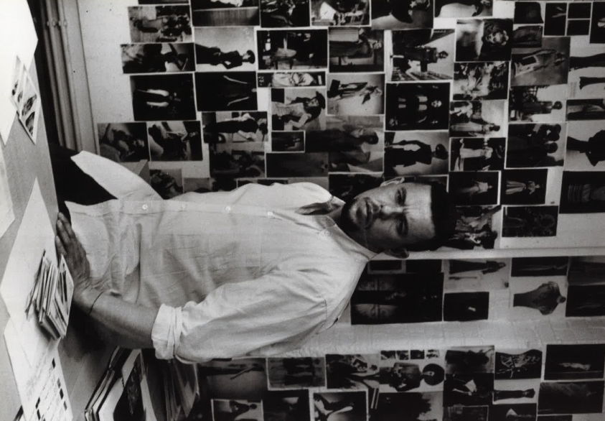
By stark contrast, McQueen did not have the slick, monochromatic designer look that Ford favours. Rarely caught in anything other than jeans, usually ripped, and a plain t-shirt, McQueen was open and proud of his working-class background, seen in Figure 4. Preferring the inconspicuous look of the masses, he let his catwalk designs do the talking. However, as much as McQueen tried to blend in, the press could not let that happen, “the temptation to reduce him to any number of stereotypes has proved too great to resist… suffice to say, this was the only way the press could deal with him” (Frankel, 2001: 16). As previously explored here, this chosen ‘lack’ of precision and choice in personal fashion may have been a direct response or rejection of high fashion. In opposition to his personal fashion, McQueen’s catwalk fashion was full of intention and embedded with his identity and status. McQueen’s graduate show was titled ‘Jack the Ripper Stalks His Victims’, referring to “an ancestor who purportedly rented a room to one of the Ripper’s victims” (Gleason, 2012: 9). Although many publications omit this collection from retrospectives, possibly because it was a graduate show and Alexander McQueen the fashion house had not yet been founded, it cannot be ignored as it is where he me Blow, who would become his “patron, muse and unofficial PR” (Frankel, 2001: 20). Without Blow championing, financing, and encouraging McQueen to be true to himself, it is hard to say if he would have been able to stick to his identity as a designer.
Fig. 4, Portrait of McQueen (McCullin, 2008: 284)

Catwalk to Commercial
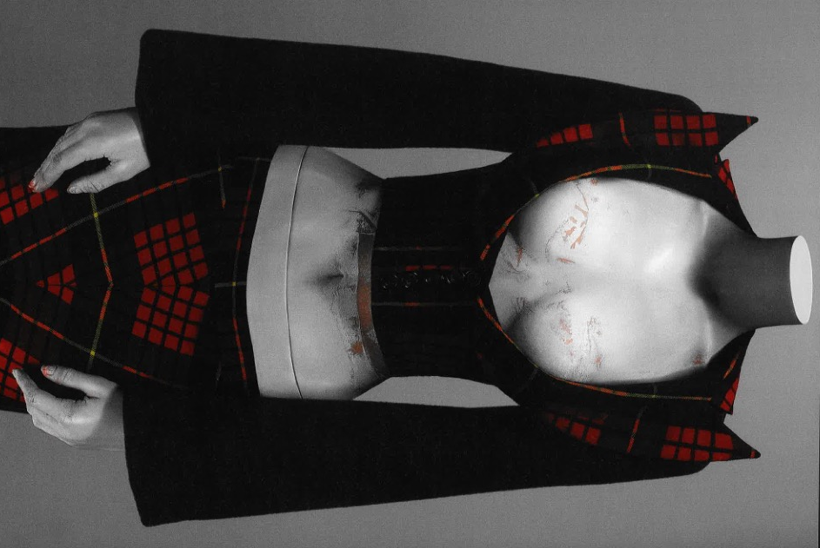
Certainly, in McQueen’s Autumn/Winter 1995 collection, ‘Highland Rape’, identity is imbued in the very bones of the collection. His mother was a genealogist, and this collection was a commentary on how the English treated the Scottish Highlands and being of Scottish descent, McQueen felt very strongly on the topic. In an interview “I have no respect for what the English did there… What the British did there was nothing short of genocide” (Frankel, 2001: 19). The generational trauma cannot be departed from McQueen’s ‘whole’ identity, in the way he presented himself and in his work, it was moored in every aspect. Although McQueen rejected the romanticisation of Scotland, he embraced the MacQueen tartan, but in a new and aggressively unapologetic way, and through this “signalled the importance of personal biography and contrasted starkly with the more profligate use of tartan by other British fashion designers” (Wood, 2015: 51). Through these choices of fashion, McQueen controlled the narrative of his identity and how the world perceived him.
Fig. 5, Suit from ‘Highland Rape’ Collection (Bolton, 2011: 126)

Ford’s inspiration comes from a similar place – he had often recognised his mother and grandmother’s personal fashions in the Seventies as major influences. However, where McQueen’s catwalks were art installations, with staging and theatrics fit for the West End, and the clothes more sculptural in design, and therefore not commercially viable, Ford is a self-proclaimed “commercial designer… I have never wanted to be anything else” (Foley, 2004: 21). In his first collection for Gucci, Ford shocked audiences with a Seventies revival, but it was not just a reproduction of the Seventies, Ford brought the Seventies into the present day and created “the most blatantly sexy thing that had been seen at the international collections for seasons” (Frankel, 2001: 133). Ford’s identity, personal fashion, and collections all echo sex appeal and commercial viability. Ford’s image is increasingly public and is one that cannot be “divorced from his designs” (Tungate, 2008: 57).

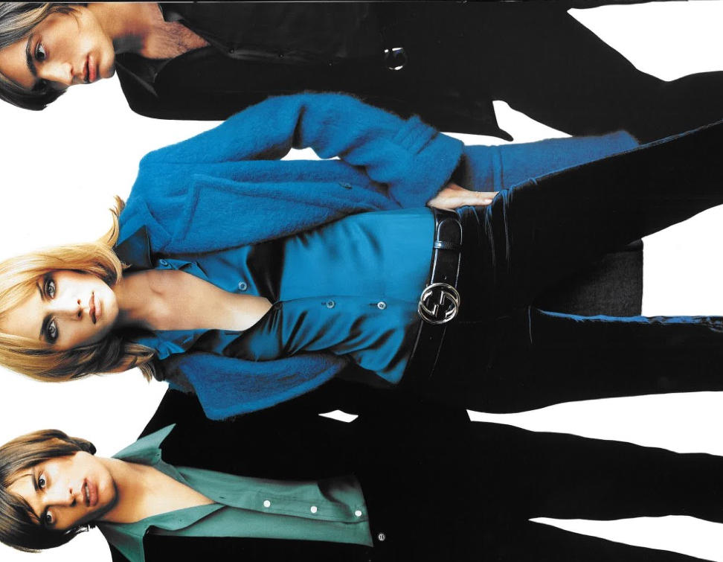
When Ford arrived at Gucci, the branding was “ludicrously ostentatious” (Frankel, 2001: 130) and “anything but super sexy” (Turco-Williams, 2015). Since Ford’s appointment the fashion house went for a quieter branding, everything quickly became slicker and sexier, which re-enforced to the consumer that this was the ‘new’ Gucci, with the distinct symbol, service, and identity (Adams, Moricka & Stone, 2006), but with less brash flashiness about it.

Fig. 6, Gucci advertising campaign (Foley, 2004: 41)

Luxury Handbags
Both Ford and McQueen had their first touch of celebrity during the 1990s, when handbags, among other accessories, became more popular for high-end fashion houses during this time, “fashion designers featured more and more accessories at the catwalk shows… supplying the fizz, and the sales, for many collections” (Wilcox, 1999: 114). This is how the fashion houses became accessible to the mass market, although the price tag was still high, it was now more achievable for the average consumer. Following this booming trend, where “the loudest noise in our industry’s recent history has been the whisper and tight snap of a handbag clasp” (Storey, 1996: 163), the fashion houses then had to meet demand for elite versions of their products, where they would be recognised through classic shapes and colours, not tacky logos. This could be pointed to as the ‘birth’ of the no-logo revolution. For many a “good bag becomes an intimate extension of the body” (Johnson, 2002: xii), others might describe luxury handbags as “vital indicators of style because of their ability to transmute more quickly” (Wilcox, 1999: 11), they can evolve an ensemble, especially one that nods towards luxury status rather than shout about it.

For many the lack of logos can say more about the items they are choosing, “customers of no-logo brands are more concerned with quality and design that with the need for logo display (Singh, 2020: 27). Ford tapped into this way of thinking and raised Gucci’s perceived status within the fashion world, and for consumers, by using it to its full effect, using discreet branding that, instead of shouting its name, whispered it quietly to those in the know.

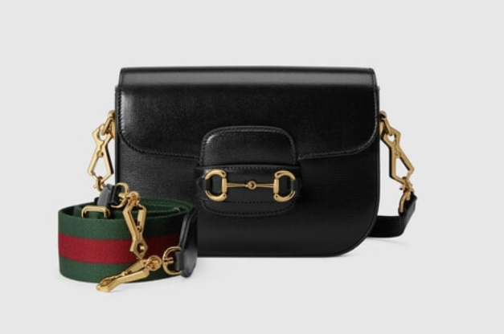
The Gucci ‘Horse-bit 1955’ handbag – of which there are multiple size and finish variations – embodied this message, with all logos being removed for the highest price tag. Although the option to buy a slightly cheaper version, with a cotton canvas finish instead of leather, the cotton canvas is woven with the interlocking ‘G’ design. In the leather edition shown in Figure 7 the branding is still there, albeit quieter in its delivery. The iconic horse-bit sits centrally on the bag, no matter the size or style, and the instantly recognisable green and red stripe of the strap tells you the brand without screaming it. In this case it is absolutely the extrinsic features which embody the “intrinsic meaning of what the business would like to portray” (Singh, 2020: 23).
Fig. 7, Gucci Horse-bit 1955 mini bag, (Gucci.com, 2021)

On top of the no-logo signalling, the red, green, and gold of the strap and horse-bit are all deep and luxurious colours, matching the fine tan of the leather, from which the consumer can understand the implied meaning that the product, and by extension them owning it, is rich, luxurious, high-status and affluent. It is recognisable without its logo, which tells the viewer of the wearer that they “place more emphasis on quality, craftsmanship, and timelessness” (Singh, 2020: 27).

Similarly, in Alexander McQueen’s commercial endeavours, the logos of the fashion house are minimal, instead it is the cut or the shape of a product which is instantly recognisable. To stay with handbags, in recent years the Alexander McQueen fashion house has revamped the “iconic Skull Four Ring long box clutch designed by the brand’s founder Lee McQueen in 2009” (Grazia, 2022).

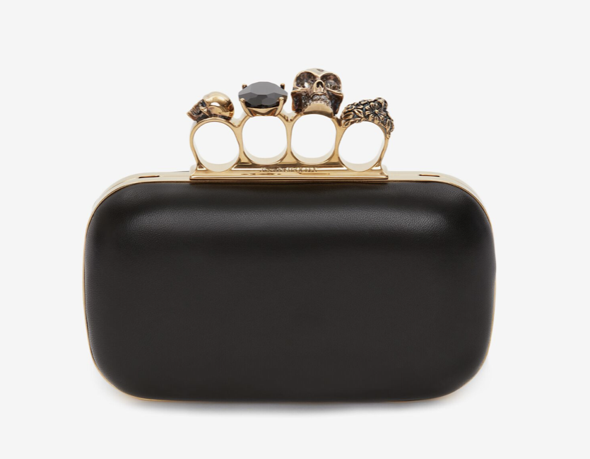
The latest rendition of the clutch is now part of the ‘Knuckle’ collection, referencing the trademark knuckle-duster clasp along the top line of the bag, shown in Figure 8. The punk aesthetic of the bag is embedded with McQueen’s oft-referenced influences of art, religion, nature, and death. In itself the object is now a style of memento mori of the designer, I distinct difference to Gucci’s ‘Horse-bit 1955’ bag. “McQueen often contrasted fashion’s glamour with darkness and death” (Victoria and Albert Museum, 2015). McQueen adopted the human skull in his work and as his signifier, which translated from the catwalk designs into the commercial pieces, lending “symbolic meaning, mission [and] philosophy” (Singh, 2020: 21) to the consumers of the products.
Fig. 8, Knuckle clutch, (alexandermcqueen.com, 2023)

The overall shapes of both brand’s signifiers, or non-logos, have remained largely unchanged over time, despite the products themselves being available in various finishes and at various price points. The “memorable and recognisable” (Singh, 2020: 21) elements of both non-logos act as gestures to those ‘in the know’, whilst still being able to exist in the no-logo arena of luxury products, giving the consumer “low in need for status… pay a premium for quiet goods only they recognise” (Han, Nunes & Dreze, 2010: 15).

Conclusion
Through this investigation of the two case studies, Tom Ford at Gucci & Lee Alexander McQueen at Alexander McQueen, it has been shown that fashion, in personal terms which were laid out at the opening, is indeed a communication of identity and status. Rational behaviour cannot always be applied to the desires of the consumer, but nevertheless the purchases we make, and indeed how we choose to wear them, both directly and indirectly communicate status and identity to others. It sometimes, in elite circles of consumerism, even goes so far as to remove common signifiers of status for preference of quality and craftsmanship.

It can also be said that for many high-end fashion houses and brands, not just the two cases studies discussed, it is often the identity and celebrity of the creative directors/ designers which captures the attention of the consumer. However, the designer still “depends on the consumer to supply the final act of association and effect the meaning transfer from world to object” (McCracken, 1986: 71). This pertains to accessories such as handbags especially, as they can “embody luxury, be a practical friend or an expressive social tool, a crafted object or highly fashionable status symbol” (Wilcox, 1999: 11).

To wear any item with either a logo brand or no-logo aligns the consumer with the brand’s values and ethos, “at a time when exclusivity is the holy grail… design provides the means to pinpoint, differentiate and communicate a unique identity” (Fung, 2007: 4). Although logo’s have long “been considered a key status symbol” (Kiapour & Piramuthu, 2018: 1), the lack of a logo, instead replaced with signifiers, can also communicate identity and status. “Some high-end brands have reached a point where they can be recognised without logos” (Singh, 2020: 26), instead being recognised for by trademarks colours or signifiers unique to that brand.

Through this Barthes’ theory of semantic fashion codes (2010) are still in operating in today’s consumer identity and fashion, alongside status signalling from Baudrillard’s theory of post-modern society, where “objects and material goods are not in fact the object of consumption – they are object merely of needs and the satisfaction of needs” (1996: 199). It does, therefore, appear that Miuccia Prada was correct when declaring “fashion is instant language” (Galloni, 2007).

Bibliography

Reference List

Dress & the Suffragettes (Mar 16 2023) [Online] Available: https://chertseymuseum.org/suffragette_dress (Accessed: 15 April 2023).

The Indelible Impact of Tom Ford on Gucci: A Retrospective (March 16 2023). [Online]. Available: https://niood.com/the-indelible-impact-of-tom-ford-on-gucci-a-retrospective/ (Accessed: 15 April 2023).

BACHMANN, I. and SCHEUING, R., (2002) Material Matters: the art and culture of contemporary textiles. Toronto: YYZ Books.

BARTHES, R. (2010) The fashion system. London: Vintage.

BAUDRILLARD, J. (1996) The system of objects. London: Verso.

BIDE, M., (2011) Fiber Sustainability: Green is not black + white. In: L. WELTERS and A. LILLETHUN, eds, The Fashion Reader. Oxford: Berg.

BLACK, S., (2011) Eco-chic: the fashion paradox. London: Black Dog Pub.

CUMMING, V., CUNNINGTON, P.E. and CUNNINGTON, C.W., 2010. The dictionary of fashion history. Oxford: Berg.

DAMHORST, M.L., (2005) Dress as non-verbal communication. In: M.L. DAMHORST, K.A. MILLER SPILLMAN and S.O. MICHELMAN, eds, The Meanings of Dress. New York, NY.: Fairchild Publications.

DE BOTTON, A., (2014) Status Anxiety. 15th Ed. London: Penguin Books.

ENTWISTLE, J., (2011) The Dressed Body. In: L. WELTERS and A. LILLETHUN, eds, The Fashion Reader. Oxford: Berg.

FOLEY, B., (2004) Tom Ford. London: Thames & Hudson.

FORDEN, S.G., (2000) House of Gucci. New York: Morrow.

FRANKEL, S., (2001) Visionaries: interviews with fashion designers. London: V&A Publications.

FREITAS, A., KAISER, S., JOAN CHANDLER, D., CAROL HALL, D., KIM, J. and HAMMIDI, T., (1997) ‘Appearance Management as Border Construction: Least Favorite Clothing, Group Distancing, and Identity Not.’ Sociological inquiry, 67(3), pp. 323-335.

FRIEDMAN, J. (2004) Consumption and identity. London: Routledge.

FUNG, A. Y. T., (2007) Fashion Unfolding: uncover the power of graphics in fashion. Hong Kong: Victionary.

GALLONI, A., (2007), Interview: 'Fashion Is How You Present Yourself to the World.'. Available: https://www.wsj.com/articles/SB116907065754279376 [26 Apr, 2023].

GLEASON, K., (2012) Alexander McQueen: evolution. New York: Race Point.

GRAZIA (2022) Alexander McQueen Releases New Jewelled Satchel Designs Available: https://graziamagazine.com/us/articles/alexander-mcqueen-jewelled-satchel-bag/ (Accessed: 14th April 2023).

GUCCI, P., (2016) In the Name of Gucci: A Memoir. Austin: Crown Archetype.

GUY, A., GREEN, E. and BANIM, M., (2001) Through the wardrobe: women's relationships with their clothes. Oxford: Berg.

HAN, Y.J., NUNES, J.C. and DRÈZE, X., (2010) ‘Signalling Status with Luxury Goods: The Role of Brand Prominence.’ Journal of Marketing, 74(4), pp. 15-30.

HETHERINGTON, K. (1998) Expressions of identity: space, performance, politics. London: SAGE.

JOHNSON, A. (2002) Handbags: the power of the purse. New York: Workman.

JONES, J.M., (2020) The Fiber Year 2020. Available: https://www.fiberjournal.com/the-fiber-year-2020-deceleration-along-the-textile-chain/ (Accessed: 15 April 2023).

KAISER, S.B., (2005) ‘Identity, Postmodernity, and the Global Apparel Marketplace.’ In: M.L. DAMHORST, K.A. MILLER-SPILLMAN and S.O. MICHELMAN, The Meanings of Dress. New York, NY.: Fairchild Publications.

KIAPOUR, M.H. and PIRAMUTHU, R. (2018) ‘Brand > Logo: Visual Analysis of Fashion Brands’. Available at: https://doi.org/10.48550/arxiv.1810.09941.

KNOX, K., (2010) Alexander McQueen: genius of a generation. London: A&C Black.

LAND, K. and LANG, G.E., 2011. The Power of Fashion. In: L. WELTERS and A. LILLETHUN, eds, The Fashion Reader. Oxford: Berg.

MANSUROGLU, A., (2021) Gucci Horsebit 1955 mini bag Available: https://www.gucci.com/uk/en_gb/pr/women/handbags/shoulder-bags-for-women/gucci-horsebit-1955-mini-bag-p-65857418YSG1060 (Accessed: 21 April 2023).

MCCRACKEN, G., (1986) ‘Culture and consumption: a theoretical account of the structure and movement of the cultural meaning of consumer goods.’ The Journal of consumer research, 13(1), pp. 71-84.

MILLER-SPILLMAN, K., MICHELMAN, S.O. and DAMHORST, M.L., (2005) The Meanings of Dress. 2nd Ed, New York, N.Y: Fairchild Publications.

MONTEVERDE, G., (2016) ‘Kardashian Komplicity: Performing post-feminist beauty.’ Critical studies in fashion & beauty, 7(2), pp. 153-172.

MORAN, C., (2012) How to be a woman. London: Ebury Press.

SCHEMING, R., (2002) ‘The Unravelling on History: Penelope & Other Stories.’ In: I. BACHMAN and R. SCHEUING, eds, Material Matters: The art and culture of contemporary textiles. Toronto: YYZ Books.

SEAN ADAMS, NOREEN MORIOKA, TERRY STONE, (2006) Logo Design Workbook. Osceola: Rockport Publishers.

SIMMEL, G., (1957) Fashion. The American journal of sociology, 62(6), pp. 541-558.

SINGH, S., (2020) Luxury and Fashion Marketing. Milton: Taylor and Francis.

STOREY, H., (1996) Fighting Fashion. London: Faber and Faber.

TUNGATE, M., (2008) Fashion Brands: branding style from Armani to Zara. 2nd Ed. London: Kogan Page.

TURCO-WILLIAMS, N., (2015) ‘Tom Ford opens up about his landmark Gucci AW95 collection.’ Available: https://www.dazeddigital.com/fashion/article/24492/1/tom-ford-opens-up-about-his-landmark-gucci-aw95-collection (Accessed: 14th April, 2023).

VICTORIA & ALBERT MUSEUM, (2015) Memento Mori. Available: https://www.vam.ac.uk/museumofsavagebeauty/memento-mori/#read_more_1 (Accessed: 14 April 2023).

WELTERS, L. and LILLETHUN, A., (2011) The Fashion Reader. 2nd Ed. Oxford: Berg.
YANGZOM, D., (2016) ‘Clothing and social movements: Tibet and the politics of dress.’ Social movement studies, 15(6), pp. 622-633.

WILCOX, C. (1999) Bags. London: V&A.

List of Figures

Figure 1 Maker unknown, (1908-1910) Suffragette’s Sash, [textile] Museum of London: People’s City: Suffragettes, London. Available at: https://collections.museumoflondon.org.uk/online/object/87737.html (Accessed 15 April 2023).

Figure 2 Woolston, B. (2017) Crowds of marchers on Pennsylvania Avenue, Washington, D.C., January 21, 2017, [photograph] Available at: https://americanhistory.si.edu/creating-icons/women’s-march-2017 (Accessed 21 April 2023)

Figure 3 Avedon, R. (2002) Portrait of Tom Ford [photograph] in Foley, B. (2004) Tom Ford. London: Thames & Hudson.

Figure 4 McCullin, D. (2008) Alexander McQueen in his London studio [photograph] in McQueen, A. and Wilcox, C. (2015) Alexander McQueen. London: V&A Publishing.

Figure 5 Bolton, A. et al. (2011) Alexander McQueen: savage beauty. New York: Metropolitan Museum of Art.

Figure 6 Foley, B. (2004) Tom Ford. London: Thames & Hudson.

Figure 7 Gucci. (2021). Gucci Horsebit 1955 mini bag. Available at: https://www.gucci.com/uk/en_gb/pr/women/handbags/shoulder-bags-for-women/gucci-horsebit-1955-mini-bag-p-65857418YSG1060 (Accessed 21 April 2023)

Figure 8 McQueen, A. (2023). Women’s Knuckle Clutch with Chain in Black. Available at: https://www.alexandermcqueen.com/en-gb/knuckle-clutch-with-chain-6762561AAJD1000.html (Accessed 21 April 2023)

