

Assessment 1 – Reading Task Template
PART 1: Upload your photo of your A3 in-class notes here:
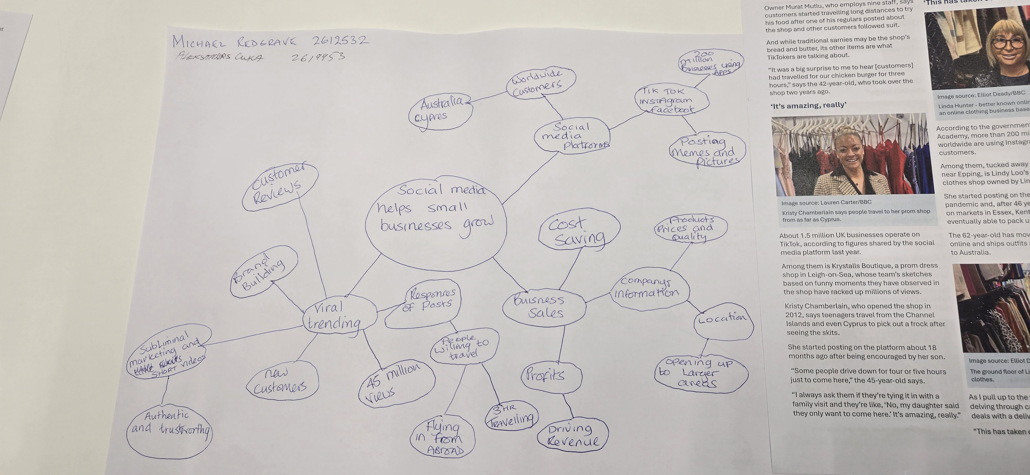

PART 2:
- Answer every question below in 1-3 full sentences.
- Use your own words. Do not use generative AI to answer these questions.
- Include a specific detail from the text when asked.
REMINDER
- The main idea is the overall message of the whole text.
- A key point helps to explain the main idea.
- A specific detail or example from the text shows that the key point is true.

- What is the main idea of the whole text?
Social media platforms like TikTok and Instagram give small businesses a powerful way to reach huge audiences , helping them grow significantly when their content goes viral.

- What is one key point that supports the main idea, and which specific example from the text shows this?
One key point is that authentic, relatable content sometimes can work better than traditional advertising. as text shows with Little Love’s Pamper Bus, shared videos of their parties reached 45 million views in under a year, turning a weekend hustle into a full-time business.

- What is a different key point that supports the main idea, and which specific example from the text shows this?

Another key point is that social media can attract customers from much further away than a business would normally reach. For example, Murat Mutlu’s sandwich shop in Basildon had customers travelling three hours just to try his chicken burger after people posted about it on TikTok.

- Which part of the text do you think is most important, and why?
I think the most important part is that social media can help small businesses, helping them to reach people all over the world without costing much money.

Reflection:
- What did you find difficult in this task (including in-class components), and why was it difficult?
Everything was pretty straight forward once I read through the text. The easiest part was seeing how social media helped each business, and the rest just came together naturally.

- What helped you with this difficulty, and how did it help you?
Making the mind map and discussing it with my classmate in class really helped. Talking through together made it much easier to understand and write things on my own.

