University of Wales Trinity Saint David
Wales Institute of Science and Art


Circuit Testing & Applications

Vehicle Electronics: ACHA4031

Harri Brown
2420832
19/04/2026
Contents
1 Task 3 1
1.1 Scope Time Division Calculations (6) 1
1.2 Function Generator output square wave (6) 1
1.3 Capacitor charge and discharge wave marked at correct points. (6) 1
1.4 Basic Capacitor Calculations (6) 1
1.5 Capacitor discharge table (5) 2
1.6 Plot log(V) Gradient (5) 2
1.7 Gradient Calculations and Compare (8) 2
1.7.1 Gradient Calculations 2
1.7.2 Comparison table 3
1.8 Capacitor Uses (5) 3
1.9 Inaccuracies Question (4) 4
1.10 Risk Question (10) 4
2 References 4

Task 3

Scope Time Division Calculations (6)
The time constant for an RC circuit is defined as:
$$τ=RC$$
To display a full waveform, approximately 5τ is required. The oscilloscope was set to 500 µs/div, with 10 divisions across the screen, giving a total time of:
$$Total time=500μs×10=0.005s$$
This allows the full charge and discharge cycle of the capacitor to be observed clearly within the display window.

Function Generator output square wave (6)
The function generator produced a square wave signal, as shown in the oscilloscope trace. The waveform alternates between high and low voltage levels, providing the necessary step input for charging and discharging the capacitor.

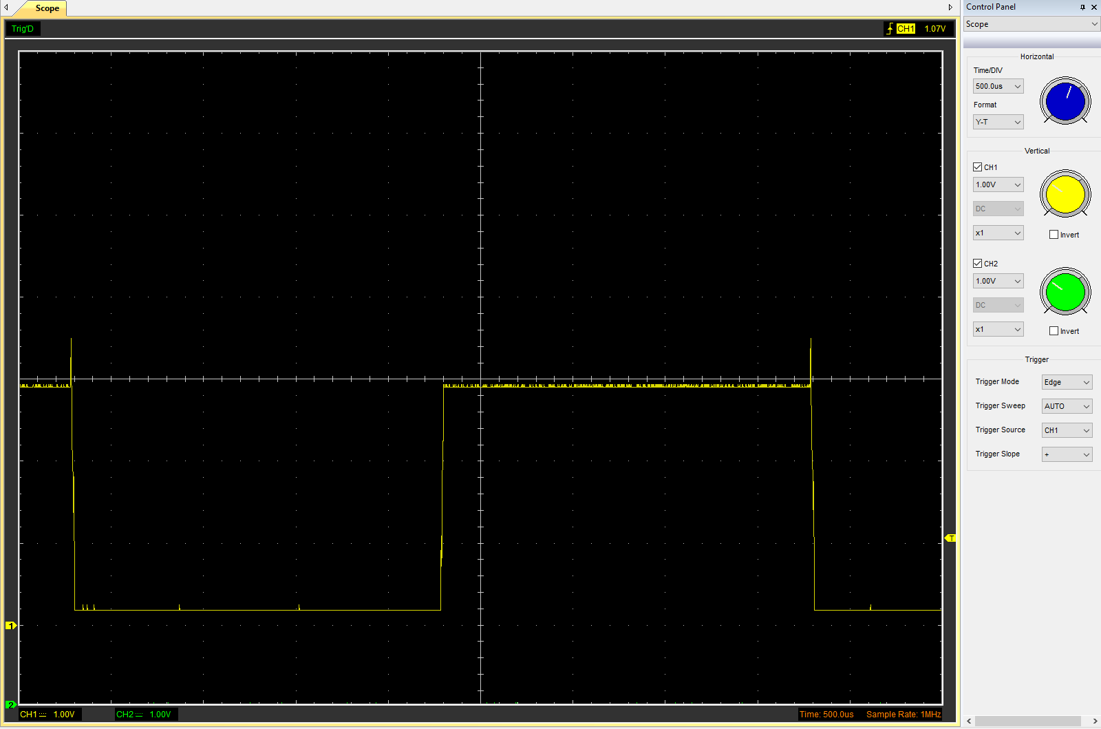
Figure 1 - square wave output from function generator

The square wave demonstrates a rapid transition between voltage levels, which is essential for analysing transient behaviour in RC circuits. The constant amplitude ensures consistent charging and discharging cycles.

Capacitor charge and discharge wave marked at correct points. (6)
The capacitor waveform shows an exponential charge and discharge curve. During charging, the voltage rises asymptotically towards the supply voltage. During discharging, the voltage decreases exponentially towards zero.

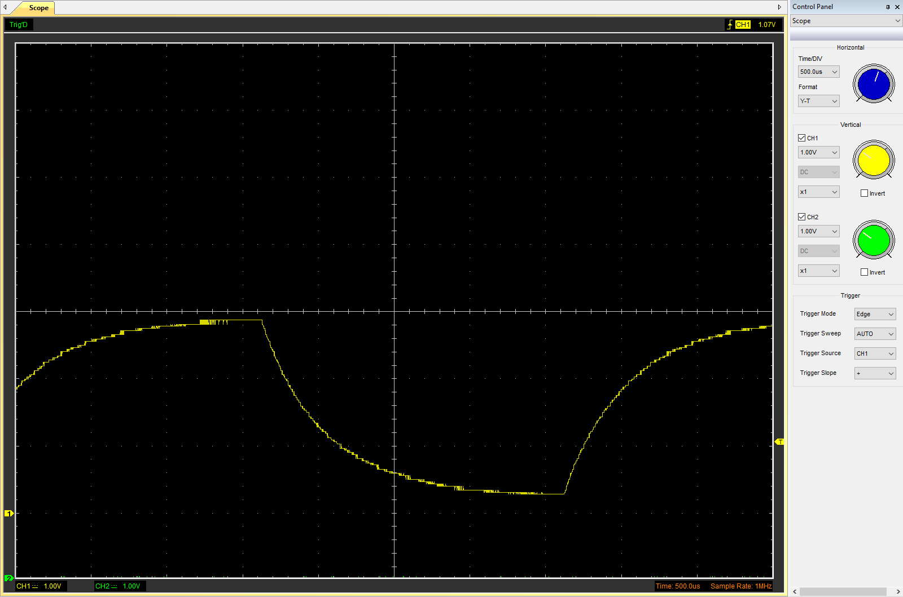
Figure 2 - wave output after including capacitor with function generator

At one time constant (τ), the capacitor reaches approximately 63% of its maximum voltage, which is a key point used for capacitance calculations. The waveform confirms the expected theoretical behaviour of an RC circuit.

Basic Capacitor Calculations (6)
Capacitance was calculated using the time constant relationship:
$$C=\frac{t}{R}$$
From the oscilloscope:
Time at 63% is 0.0025s, Resistance is 100Ω
$$C=\frac{0.0025}{100}=25μF$$

Capacitor discharge table (5)
Time (s) | Voltage (V) | ln (V) | dy = y2 – y1  dy = ln(V)2-ln(V)1 | dx = x2- x1  dx = Time2 – Time1 | dy/dx
0.004 | 2.4157 | 0.8819891 | x | x | x
0.004072 | 2.0392 | 0.712557574 | -0.169431526 | 0.000072 | -2353.21564
0.004144 | 1.7569 | 0.563550892 | -0.318438208 | 0.000144 | -2211.376443
0.004216 | 1.5059 | 0.409390726 | -0.472598374 | 0.000216 | -2187.955435
0.004288 | 1.2863 | 0.25176988 | -0.63021922 | 0.000288 | -2188.261181
0.00436 | 1.1294 | 0.121686518 | -0.760302582 | 0.00036 | -2111.951616
0.004432 | 1.0353 | 0.03469124 | -0.84729786 | 0.000432 | -1961.33764
0.004504 | 0.9098 | -0.094530484 | -0.976519584 | 0.000504 | -1937.538857
0.004576 | 0.8157 | -0.203708639 | -1.085697739 | 0.000576 | -1884.891908
0.004648 | 0.7529 | -0.283822862 | -1.165811962 | 0.000648 | -1799.092534

Plot log(V) Gradient (5)

Figure 3 - graph of Ln (V) against time

Gradient Calculations and Compare (8)

Gradient Calculations
The discharge equation is:
$$\ln\left(V\right)=\ln{(V_{0}})-t/RC$$
The gradient of the graph is:
$$m= -\left(\frac{1}{RC}\right)$$
From the data, the gradient values are approximately between -1800 and -2350.
An average gradient is taken:
$$m ≈ -2100$$
Capacitance:
$$C= -\left(\frac{1}{R}×m\right)= -\left(\frac{1}{100}×\left(-2100\right)\right)=4.76μF$$

Comparison table
 | Capacitance | Delta | Percentage difference
Actual | 1 µF | x | X
Marker Calculation | 25μF | 24μF | 2400%
Gradient Calculation | 4.76μF | 3.76μF | 376%
The comparison of results shows a significant deviation between the calculated capacitance values and the actual capacitor value of 1 µF. The marker method produced a capacitance of 25 µF, resulting in a very large percentage difference of 2400%. This suggests that the time constant was overestimated when identifying the 63% voltage point on the oscilloscope, which is highly sensitive to reading accuracy and resolution limitations. The gradient method produced a capacitance value of 4.76 µF, which is closer to the actual value but still shows a considerable percentage difference of 376%. This method is generally more reliable because it uses multiple data points from the discharge curve, reducing the influence of random measurement errors. However, inaccuracies remain due to limitations in the precision of the recorded data, potential noise in the signal, and the use of approximate gradient values rather than a precise best-fit calculation. The large discrepancies also indicate that the experimental setup or time scaling may not have been optimally configured for measuring a capacitor of 1 µF.

Capacitor Uses (5)
Capacitors are widely used in electrical and automotive systems due to their ability to store and release electrical energy efficiently. One of their primary applications is in power supply smoothing, where they reduce voltage fluctuations and provide a stable DC output (Hughes, 2016). In automotive systems, capacitors are essential in engine control units (ECUs), where they help filter electrical noise and stabilise signals to ensure reliable operation of sensors and control systems. They are also used in timing circuits, where the charge and discharge rate determine time delays in electronic functions. In addition, capacitors play a key role in noise filtering and signal coupling, allowing AC signals to pass while blocking DC components, which is critical in communication and audio systems (Horowitz and Hill, 2015). Furthermore, capacitors are used in ignition systems to store and rapidly discharge energy to create a spark. In safety-critical applications such as airbag deployment systems, capacitors ensure that sufficient energy is available even if the main power supply is interrupted. They are also used for energy storage in hybrid and electric vehicles, contributing to power management and efficiency. Overall, capacitors are fundamental components that improve performance, reliability, and stability across a wide range of electrical and automotive applications.

Inaccuracies Question (4)
There are a number of reasons why measured and actual capacitance values may differ. Resistors and capacitors may not have the precise values shown on the label due to component tolerances. When interpreting oscilloscope values, especially when locating the 63% voltage point, measurement mistakes can happen. Inaccuracies may also be introduced by the oscilloscope's resolution and sampling rate. The oscilloscopes themselves weren't the best. These combined factors contribute to discrepancies between theoretical and measured values.

Risk Question (10)
Electronic control units (oecus) in modern cars can communicate with one another thanks to Controller Area Network (CAN) bus systems. However, because infotainment systems and wireless connections are examples of weak entry points, cybersecurity concerns are introduced by this connectivity. An organised framework for handling cybersecurity threats in automotive systems is offered by ISO/SAE 21434:2021. Throughout the vehicle’s lifespan, it places a strong emphasis on risk assessment, threat analysis, and secure system design. Implementing message authentication to stop spoofing attacks, encrypting communication channels, and employing intrusion detection systems to spot unusual network activity are examples of mitigation techniques. In order to lessen the impact of a prospective attack, network segmentation can also be used to divide important systems from non-critical ones. System security is further improved by secure coding techniques and frequent software updates. Cryptographic keys can be safely stored, and critical actions can be safeguarded with hardware security modules (HSMs). Manufacturers can greatly lower cybersecurity risks and enhance the general safety and dependability of vehicle electronic systems by using these mitigating techniques in accordance with ISO/SAE 21434.

References

Hughes, E. (2016) Electrical and Electronic Technology. 12th edn. Harlow: Pearson.
Horowitz, P. and Hill, W. (2015) The Art of Electronics. 3rd edn. Cambridge: Cambridge University Press.
ISO (2021) ISO/SAE 21434 Road Vehicles – Cybersecurity Engineering. Geneva: International Organization for Standardization.

