DSP & COMMS
BAE Systems | UWTSD
Simulation of Digital Modulation Techniques
Joshua Martin | 1810346
2020
Contents
1 Introduction 3
1.1 Circuit creation 3
1.1.1 Random Signal Generator 3
1.1.2 Modulator 3
1.1.3 Noisy Channel 3
1.1.4 Demodulator 3
1.1.5 BER Calculation 4
2 Background information 4
2.1 Digital Modulation 4
2.1.1 ASK 4
2.1.2 PSK 4
2.1.3 QPSK 5
2.1.4 QAM 5
3 Simulation models 6
3.1 ASK 6
3.2 PSK 6
3.3 QPSK 6
3.4 QAM 6
4 Results 7
4.1 ASK 7
4.2 PSK 9
4.3 QPSK 10
4.4 QAM 11
5 Discussion 12
6 Conclusion 12
7 References 14

Figure 1: Circuit template [3] 3
Figure 2: ASK Carrier Wave [7] 4
Figure 3: PSK Carrier Wave [8] 4
Figure 4 Left: QPSK Constellation diagram [9] 5
Figure 5 Right: QPSK Carrier Wave [10] 5
Figure 6: (Left) 16-QAM (Right) 64-QAM [13] 5
Figure 7: ASK circuit created in SIMULINK, scope removed 6
Figure 8: PSK circuit created in SIMULINK, scope removed 6
Figure 9: QPSK circuit create in SIMULINK, scope removed 6
Figure 10: QAM circuit created in SIMULINK, scope removed 6
Figure 11: ASK 0 to -5 SNR values 7
Figure 12: ASK 0 to -50 SNR values 8
Figure 13: ASK 0 to -50 SNR Graph 8
Figure 14: PSK 0 to -50 SNR values 9
Figure 15: PSK 0 to -50 SNR graph 9
Figure 16: QPSK 0 to -50 Values 10
Figure 17: QPSK 0 to -50 SNR graph 10
Figure 18: QAM 0 to -50 values 11
Figure 19: QAM 0 to -50 SNR graph 11
Figure 20: ASK vs PSK vs QPSK vs QAM 12

Introduction
This report is going to investigate different types of digital modulation for use in a digital communication system. In a digital system, the variations of the carrier wave are restricted by the discrete information being transmitted, as opposed to analogue, where there are continuous variations in the frequency or amplitude of the carrier wave [1]. Communication systems have never been more crucial to the world as they are now, with ever increasing requirements in the information age, along with the particular effects of the Covid-19 pandemic. There is currently a heavy reliance on digital communication for both personal and professional use as people are unable to socialise in person, and are working from home where possible. To successfully communicate through a digital platform, there should be as little noise as possible. Electronic noise in this context, is an unwanted signal tending to obscure or interfere with the required signal [2]. Noise could come in the form of unwanted feedback or unclear audio while communicating, in a world of digital communication, a large amount of noise could significantly slow down and make operating a business difficult in particular. This report will investigate the effectiveness of communicating utilising different types of digital modulation, and evaluate their performance using a bit error rate calculation.

Circuit creation
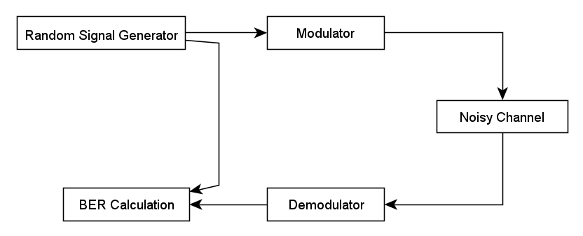
Figure 1: Circuit template [3]

Random Signal Generator
For the ASK and PSK circuits in this report, the random signal generator being used will be a Bernoulli Binary block. This generates a completely random data bit using a Bernoulli distribution to simulate digital communication systems [4]. Due to it being a binary signal, there will be no need for integer to bit converters in the simulation.

Modulator
Modulation in a digital communication system takes the transmitted signal, mixes with another sinusoid and makes the encoded message suitable for transmission through the channel. [5]

Noisy Channel
The channel in this simulation will be an additive white Gaussian noise block. This will allow noise to be added and taken away from the simulations, allowing a full analysis of how the modems perform at different levels of the signal to noise ratio.

Demodulator
The demodulator works in opposite effect to the modulator, it will read the carrier wave signal that has been received, and decode it back to what the transmitted signal originally was. This is where the bit error rate can be calculated, as if there is noise and interference in the system, the demodulator may decode incorrectly. [5]

BER Calculation
BER stands for Bit Error Rate, this block in SIMULINK takes two inputs, one from the transmitted signal and the other from the received signal. The transmitted signal comes straight from the Random Signal Generator to the Tx port, in the case of this report, a Bernoulli Binary block. The received signal travels through the entire system, through the modulator, channel, filter and demodulator and into the Rx port. The BER calculator block outputs to a display, this will show the percentage of errors picked up, the number of errors, and the number of bits that were sent within the sample time. The calculation is shown below.
$$BER=\frac{Number of bits with error}{Number of bits sent}$$

Background information

Digital Modulation
Due to the increased demand of digital communication, there also needs to be improvements in quality of the communication. One way of doing this is using digital modulation schemes, digital modulation contributes to the improvements in quality, speed and capacity through the wireless network [6]. There are three parameters of the carrier wave to vary, and this results in there being three basic types of digital modulation within a communication [5]. Amplitude Shift Keying (ASK), Phase Shift Keying (PSK) and Frequency Shift Keying (FSK).

ASK
ASK modulation represents the binary input data in the form of variations in the amplitude of a carrier wave, the variation in amplitude will be between (usually two) discrete levels. In the simulations of this report, when the binary signal is a 1, the carrier wave will have a set amplitude. When the binary signal is a 0, then the wave will have no amplitude at all, as shown by figure 2. This is also known as binary amplitude shift keying (BASK) or on-off keying (OOK) [5].
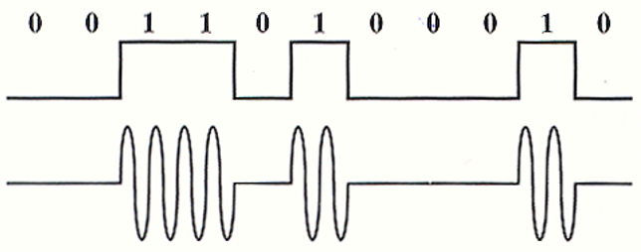
Figure 2: ASK Carrier Wave [7]

PSK
Phase shift keying represents the binary input data as variations in the phase of the carrier wave. Once the binary data changes from a 0 to 1 or vice versa, the phase shifts 180º and will create the ‘w’ and ‘m’ shapes seen in figure 3 below. [5]
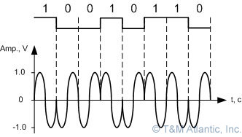
Figure 3: PSK Carrier Wave [8]

QPSK
QPSK stands for Quadrature Phase Shift Keying. It is a more advanced method of digital modulation that allows for a higher data rate. This is due to it having two bits per symbol, as opposed to one like ASK and PSK. The data bits are represented by a double digit such as 00, 01, 10, and 11. While ASK changes the amplitude between on and off, PSK changes the phase 180º and QPSK can change the phase at four different points, 45º, 135º, 225º and 315º. Best compared against a PSK/BPSK modulation scheme that can transfer one bit of data per symbol, QPSK works with two bits in a symbol while working at the same baseband signal of the same frequency. This increases the bandwidth efficiency by a factor of two. [1]
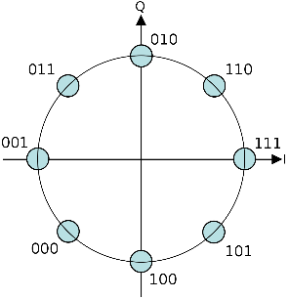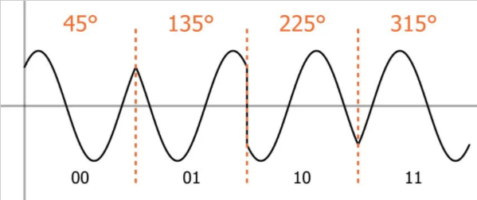
Figure 4 Left: QPSK Constellation diagram [9]
Figure 5 Right: QPSK Carrier Wave [10]

QAM
QAM stands for Quadrature Amplitude Modulation, in this technique, the amplitude is able to vary with the phase and it can be seen as a combination of ASK and PSK digital modulation [11]. There are four bits per symbol in 16-QAM modulation, so it is once again increasing the data rate by a factor of two against QPSK, and four against ASK and PSK [12].
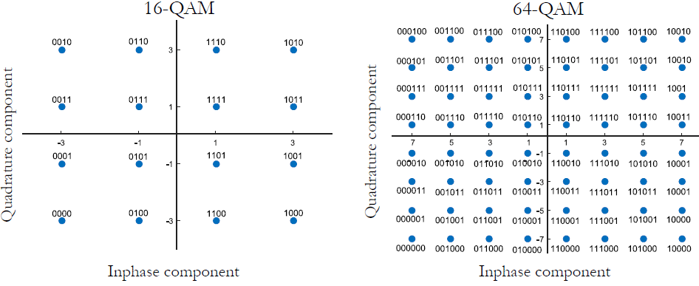
Figure 6: (Left) 16-QAM (Right) 64-QAM [13]
Figure 6 shows how QAM modulation is represented. Phase and amplitude are modulated as such that the points lie on a square grid [12]. In the 16-QAM image, each point represents a symbol containing 4 bits. In the 64-QAM image, each symbol contains 6 bits. While this increases the amount of data that is able to be transferred, it means the distance between the points has been decreased. This results in the system being more susceptible to noise and interference [14].

Simulation models

ASK
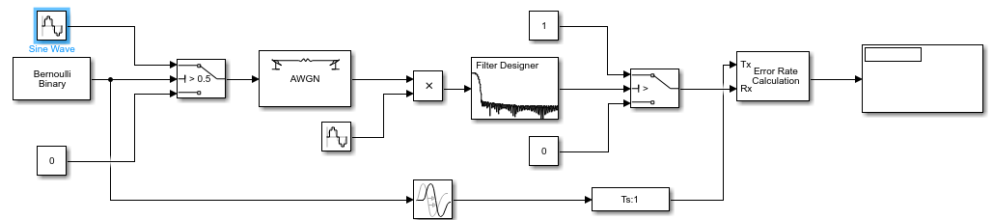
Figure 7: ASK circuit created in SIMULINK, scope removed

PSK
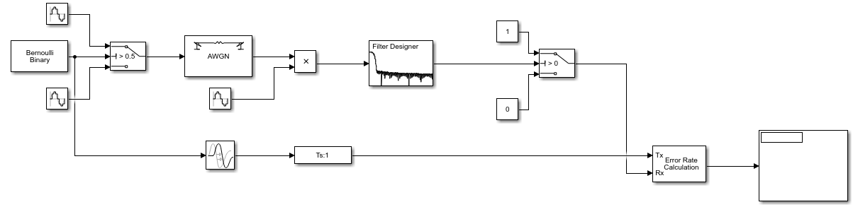
Figure 8: PSK circuit created in SIMULINK, scope removed

QPSK
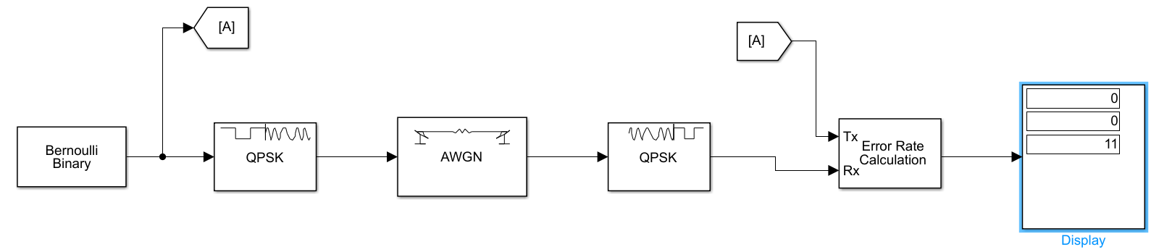
Figure 9: QPSK circuit create in SIMULINK, scope removed

QAM
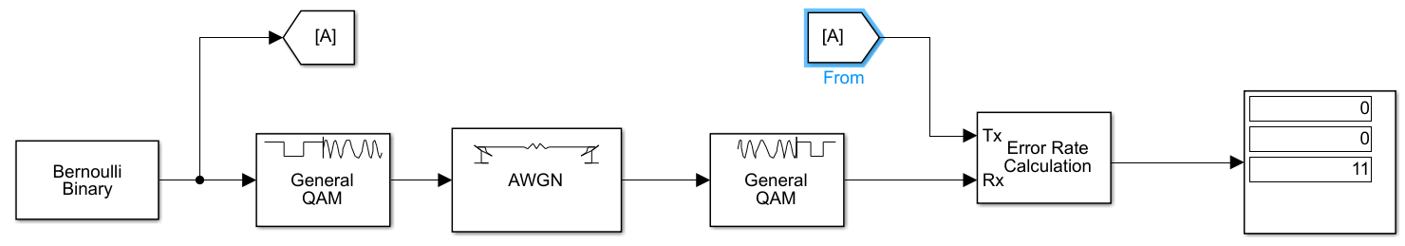
Figure 10: QAM circuit created in SIMULINK, scope removed

Results

ASK
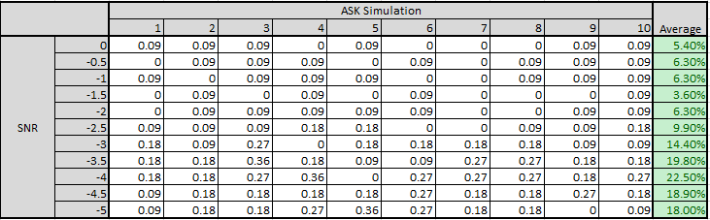
Figure 11: ASK 0 to -5 SNR values
To begin understanding the effectiveness of the amplitude shift keying approach, the SNR (Signal to Noise Ratio) is changed. To change this, it must be done through the properties of the AWGN block. To start, as there is no prior assumption at what point it will fail, an increment of 0.5 was used to see how the error rate changed when more noise was added to the signal. The results in figure 11 show that an average was taking after five simulation runs at each SNR value. The maximum error percentage was 22.5%, although this is almost a quarter of the signal, for this purpose, anything at 50% or over will be considered a failure. Due to the lack of a detected failure using these SNR values, further analysing can be shown in figure 12.

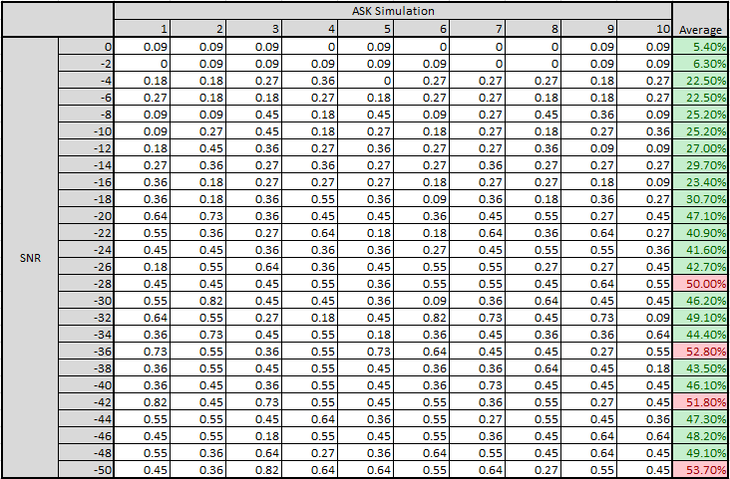
Figure 12: ASK 0 to -50 SNR values
Due to the lack of failures from 0 to -5, the range was increased to investigate what happens up to an SNR value of -50. It can be seen that the first failure was detected at an SNR value of -28, however, it then dropped below 50%. Additional simulations were run to see if there was a point that every simulation was considered a failure past a certain SNR value. Down to an SNR of -50, there were four failed simulation averages.
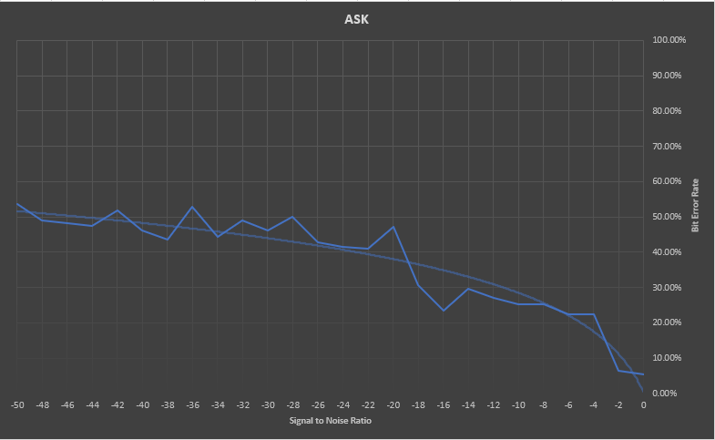
Figure 13: ASK 0 to -50 SNR Graph
The graph in figure 13 shows the data from figure 4. It can be seen that although the error rate does increase the closer you get to the -50 value, it isn’t increasing along the same projection. The error rate flattens off slightly at -24, and the point on the logarithmic trend line that crosses a 50% failure would be the SNR value of -45.

PSK
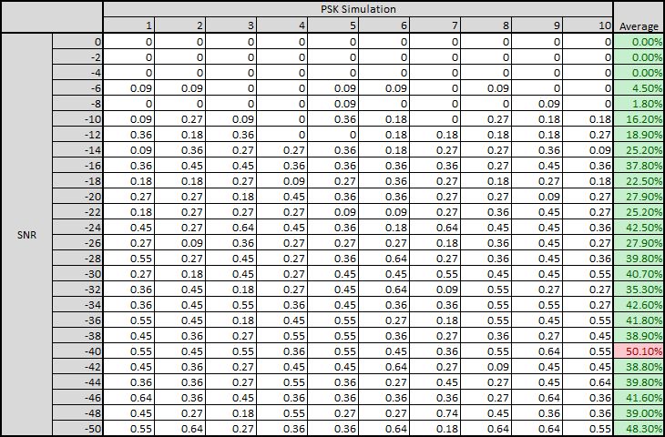
Figure 14: PSK 0 to -50 SNR values
As the 0 to -5 SNR values of the ASK simulations didn’t hit the 50% failure mark, an assumption was made that the same would go for PSK (Phase Shift Keying). 0 to -50 was chosen as the scale to create the most reliable comparison against ASK. To start off, no error was detected until the SNR reached -6. It then increased in similar fashion to the ASK system. It reached system failure at an SNR of -40 and even going further to -50, it did not reach system failure again.
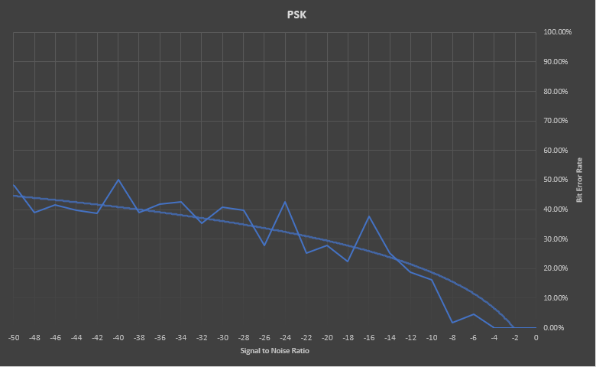
Figure 15: PSK 0 to -50 SNR graph
The graph in figure 15 represents the data from figure 14. The main point to note is that the trend line never hits the 50% failure mark, although the individual simulation averages result in a system failure at an SNR value of -40.

QPSK
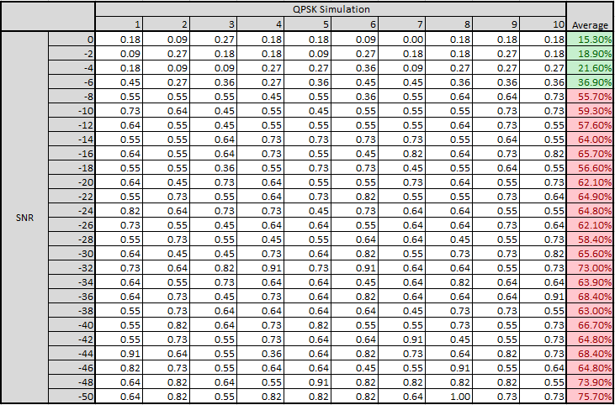
Figure 16: QPSK 0 to -50 Values
The bit error rate calculator detected many more errors throughout the SNR values, it reached its first complete failure at an SNR value of -8 and continued that trend consistently down to -50.
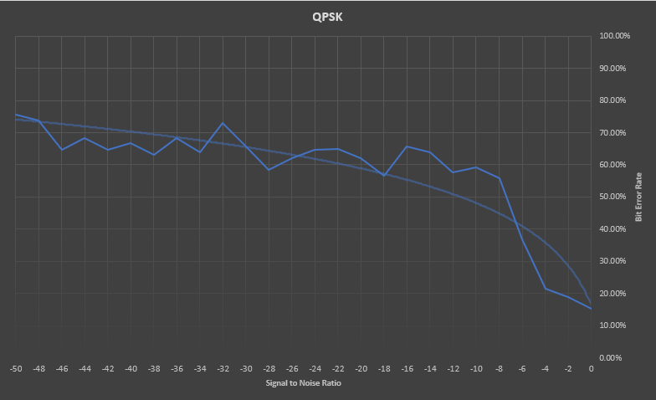
Figure 17: QPSK 0 to -50 SNR graph
The graph in figure 17 shows a much quicker increase in errors than previous modulation techniques, and the trend line reaches the failure of 50% at an SNR value of -11.

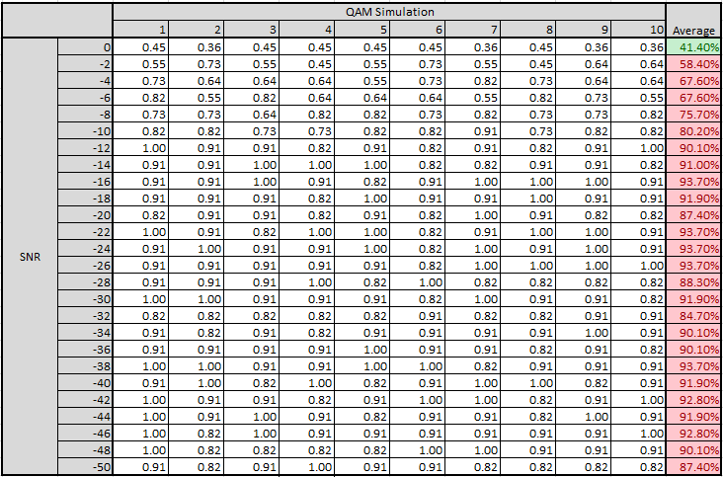
QAM
Figure 18: QAM 0 to -50 values
Figure 18 makes it clear that almost immediately once noise is introduced to the system, it causes high error rates, it reaches the 50% failure at the -2 SNR value and stays above 50% to the end of the tests. 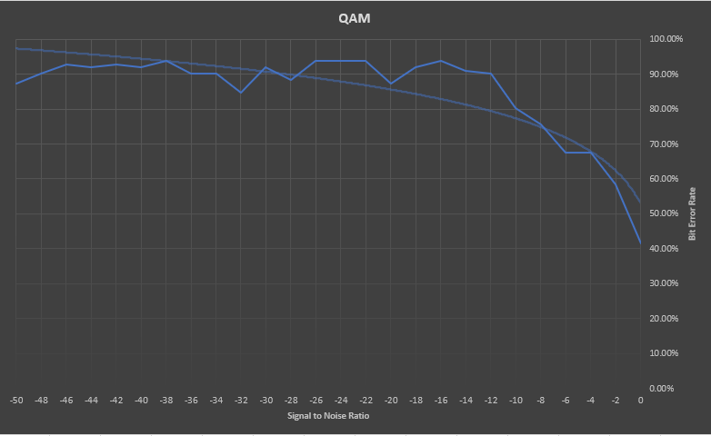
Figure 19: QAM 0 to -50 SNR graph
The graph in figure 19 immediately starts with the trend line above the 50% failure limit at an SNR value of 0, this confirms that the QAM system is very susceptible to noise.

Discussion
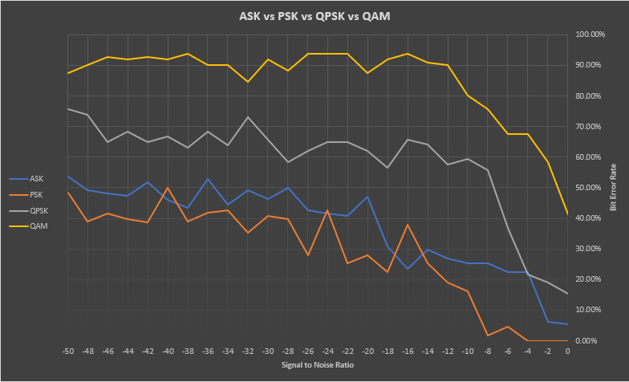
Figure 20: ASK vs PSK vs QPSK vs QAM
Figure 20 shows a comparative graph of the bit error rate for all four digital modulation techniques discussed in this report. The Phase Shift Keying method is the most effective when it comes to the error rate, and despite the occasional spike above the error rate of the ASK system, it is generally a better performing system. The occasional spikes are due to the Bernoulli binary block producing a completely random signal and it just so happens to be higher in that series of simulations, the trend line of PSK in figure 15 clearly shows a better performance than ASK in figure 13. As both ASK and PSK have only one bit per symbol, PSK is the better choice between the two for a digital communication system. QPSK does have a higher BER than PSK when noise is introduced into the system, however, due to its ability to transfer two bits per signal, it is a more efficient use of bandwidth. QAM allows the largest data transfer and most efficient use of bandwidth. However, the more points you have on the QAM diagram going through 16, 64, 256-QAM and beyond, the distance between the points is greatly reduced, therefore the possibility for interference and noise is significantly increased. The QPSK constellation diagram allows for much more space between the points, meaning the system is more protected against noise.

Conclusion
In conclusion, for smaller data transfers, a PSK system is more suitable against an ASK system. However, in modern times where there are huge amounts of data flowing through digital communication mediums all across the world, the QPSK system will be most useful. It can transfer twice as much as data, or use half the bandwidth for the same amount of data with a lower BER than QAM. While QAM could be used for much larger data transfers using the same bandwidth, it does come with a much higher BER. More research on QAM systems would be needed to justifiably comment on the feasibility of a low noise QAM system that can provide the ability of a large data transfer, while ensuring the BER is kept to a minimum. Due to time restrictions and detrimental factors against this report due to the Covid-19 pandemic, it is unfair to make a comment on which digital modulation scheme is currently the best performing, as they each are useful for certain applications. They were also created differently in SIMULINK. ASK and PSK were built by creating the modulator and demodulators using separate blocks, however in the QPSK and QAM circuits, they were made using the standard SIMULINK modulator and demodulator blocks. This makes for a possibly unfair comparison, as they may develop different properties in the system. After more research into building QAM and QPSK circuits to reflect the method used for ASK and PSK, a more detailed conclusion could be made.

References

[1] | R. Keim, “Understanding Quadrature Phase Shift Keying (QPSK) Modulation,” allaboutcircuits, [Online]. Available: https://www.allaboutcircuits.com/technical-articles/quadrature-phase-shift-keying-qpsk-modulation/. [Accessed 01 12 2020].
[2] | P. J. Fish, Electronic Noise and Low Noise Design, Hampshire: The Macmillan Press LTD, 1993.
[3] | S. Mosey, ACDA5008 sem1 CW1 2020 21, Swansea: UWTSD, 2020.
[4] | MathWorks, “Bernoulli Binary Generator,” MatLab, [Online]. Available: https://www.mathworks.com/help/comm/ref/bernoullibinarygenerator.html. [Accessed 09 12 2020].
[5] | S. Mosey, “Digital Modulation,” UWTSD, Swansea, 2020.
[6] | G. Sadeque, Bit Error Rate (BER) Comparison of AWGN Channels for Different Type’s Digital Modulation Using MATLAB Simulink, Global Society of Scientific Research and Researchers , 2015.
[7] | tmatlantic, “ASK - Amplitude Shift Keying,” [Online]. Available: https://www.tmatlantic.com/encyclopedia/index.php?ELEMENT_ID=10420. [Accessed 03 12 2020].
[8] | tmatlantic, “PSK - Phase Shift Keying,” [Online]. Available: https://www.tmatlantic.com/encyclopedia/index.php?ELEMENT_ID=10478. [Accessed 03 12 2020].
[9] | Wikipedia, “Constellation Diagram,” [Online]. Available: https://en.wikipedia.org/wiki/Constellation_diagram. [Accessed 03 12 2020].
[10] | All About Circuits, Practical guide to radio frequency analysis and design, EETech Media, 2020.
[11] | M. Barnela, Digital Modulation Schemes Employed in, International Journal of Wired and Wireless Communications, 2014.
[12] | S. Mosey, “Advanced Modulation,” UWTSD, Swansea, 2020.
[13] | N. Mathura, “QAM modulation in Matlab and Python,” Gaussian waves, [Online]. Available: https://www.gaussianwaves.com/2012/10/qam-modulation-simulation-matlab-python/. [Accessed 05 12 2020].
[14] | I. Wells, “Advanced Modulation,” UWTSD, Swansea, 2020.

