Feeling Beautiful Forever Plan

Module name: Managing Enterprise (BMSW4011)
Student Name: Jana Sliskova
Student Number: 2421920
Lecture Name: Melanie Squire

Table of Contents
Part 1: Business Plan: Feeling Beautiful Forever 2
1. Product and service proposition and company name 3
2. Story behind the idea 3
3. Business ownership, rationale, pros and cons 4
4. Mission, aim, SMART objectives and USP 4
5. Physical location and rationale 4
6. Human resources strategy 5
7. Marketing activities and PR initiatives 5
8. Market research and how it was used 7
9. Financial resources and cash flow 8
10. SWOT and PESTLE analysis 8
Part 2: Reflection 8
1) Skills I have exercised and developed 9
2) An entrepreneurial trait I need to develop (and how) 9
3) Feasibility of my business proposition 9
References 10

Part 1: Business Plan: Feeling Beautiful Forever

1. Product and service proposition and company name
Feeling Beautiful Forever is a small beauty and hair studio planned for Cardiff city centre. It will offer quick, hygienic treatments for nails, brows, lashes, basic facials, and simple hair styling, such as blow-dries and tidy trims. Services are sold in clear bundles with fixed prices and timings, so clients know what they are buying before they book (Desai, 2021; Reshitco, 2024). Most appointments last thirty to forty-five minutes and can be booked online, by phone or in person.

Figure 1: Logo of the brand Feeling Beautiful Forever.

2. Story behind the idea
The idea came from my own salon experiences and from a short questionnaire with classmates and local women about their beauty routines. Many people said they struggled to find a salon that felt clean, was honest about prices, and was easy to book at short notice. They also wanted one studio where they could sort nails, brows, skin and hair before events without luxury spa prices. I already provide treatments for friends and built a website for Feeling Beautiful Forever, so this plan turns that work into a focused local business. The promise is “express glow you can trust”: visible hygiene, straightforward prices and timings you can rely on.
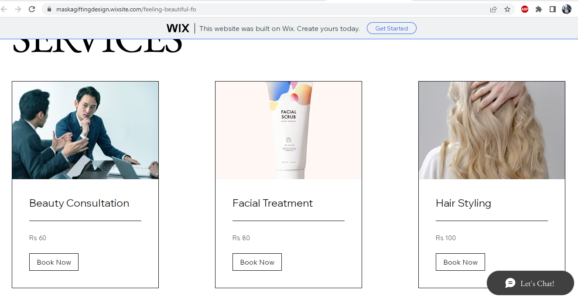
Figure 2: Website for booking salon services in Cardiff city.

3. Business ownership, rationale, pros and cons
In the first year, Feeling Beautiful Forever will trade as a sole trader. This keeps start-up costs low, keeps decisions simple and makes cash flow easier to control because there are no staff wages (Oasmaa, 2024; Nikitina, 2021). The weaknesses are unlimited liability and dependence on me if I am ill or need time away. Insurance, careful health and safety practices, and a small emergency fund will reduce this risk. When cash flow is stable, the plan is to add part-time staff and later consider a limited company.

4. Mission, aim, SMART objectives and USP
The mission is to help clients feel beautiful for everyday life through quick, hygienic beauty and hair services in central Cardiff. The first year aims to reach a steady monthly income that covers costs, pays a modest wage, and allows small savings for growth. SMART targets are to reach about 250 paid treatments per month by month twelve, gain an average Google review score of 4.7 out of 5, and reach 40% repeat clients. The unique selling point is the mix of express nail, skin, hair, and lash services, with clear prices and an easy online booking process (Atherton, 2023).

5. Physical location and rationale
The studio will be in a small ground-floor unit in the CF10 postcode, Queen Street, close to Cardiff station. This area has steady footfall from office workers, students and shoppers who want quick appointments before and after work. A compact unit keeps rent and utility costs lower while still providing a safe, professional environment (Heinze and Cano, 2024). Figure 1 in the final document will show a Google Maps image of the chosen street so the reader can see transport links and nearby businesses.
Figure 3: Proposed location of Feeling Beautiful Forever in Cardiff city centre (CF10).

6. Human resources strategy
During year one, I will be the only regular worker and will cover nails, brows, basic facials and simple hair styling. This protects early cash flow because there are no fixed wages or rotas to manage (Resitco, 2024). During busy periods such as Christmas, New Year, and wedding seasons, I will book insured freelance technicians on agreed day rates. In year two, if demand grows as planned, the aim is to hire at least one part-time nail and hair stylist to extend opening hours and add more colours and styles (En, Vistro and Abidin, 2021).

7. Marketing activities and PR initiatives
The brand colours are soft blush pink, warm beige and touches of gold, matching the logo and website. These shades will appear across décor, price lists, and online channels, so the brand feels calm and easy to recognise. Business cards will be simple, with the logo on one side and a QR code to the booking page on the other. The launch promotion will use A6 flyers near the station, plus Facebook and Instagram posts featuring real nails, hair, and skin photos, and a first-visit discount. Ongoing marketing will use regular social posts, Google Business updates, a loyalty card and referral offers (Grandhi, Patwa, and Saleem, 2021; Google, 2025). Each month, I will review the numbers and change course where needed, using evidence from search queries, post-performance, ratings and repeat-visit data so the budget backs the tactics that deliver bookings (British Beauty Council, 2025).
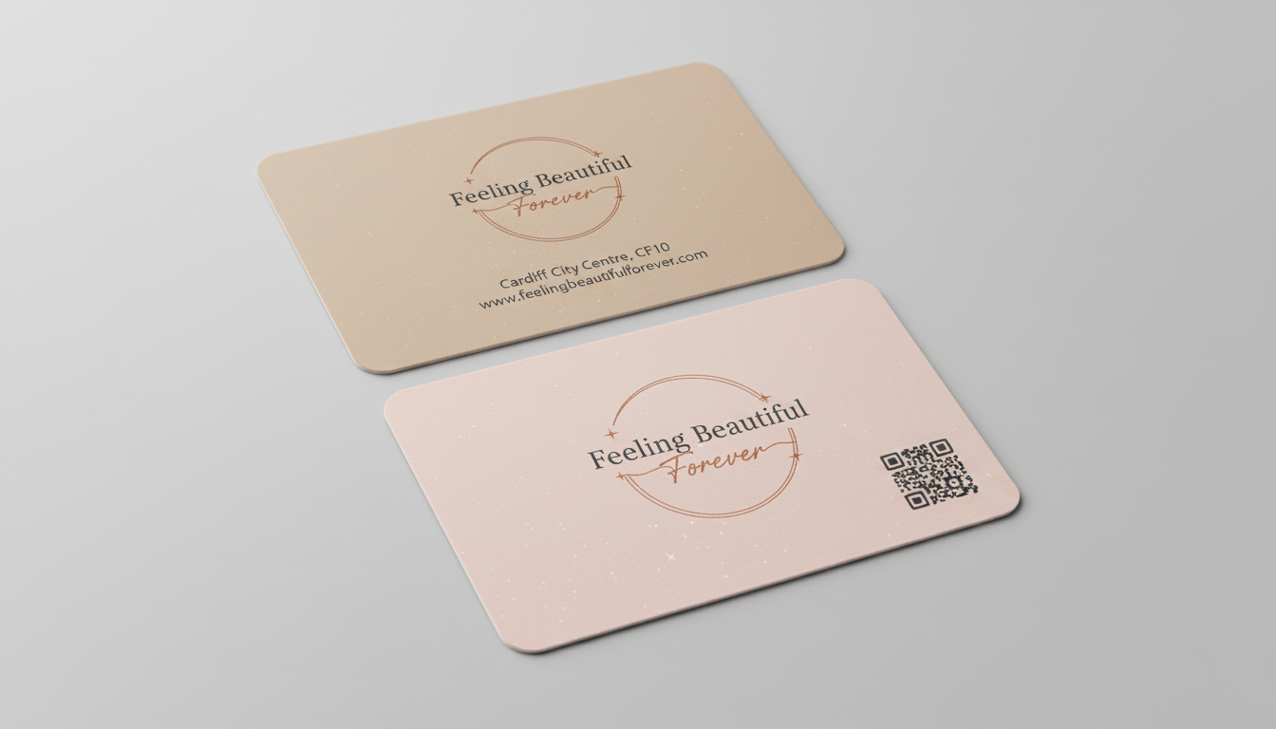
Figure 4: Business Cards with a QR code
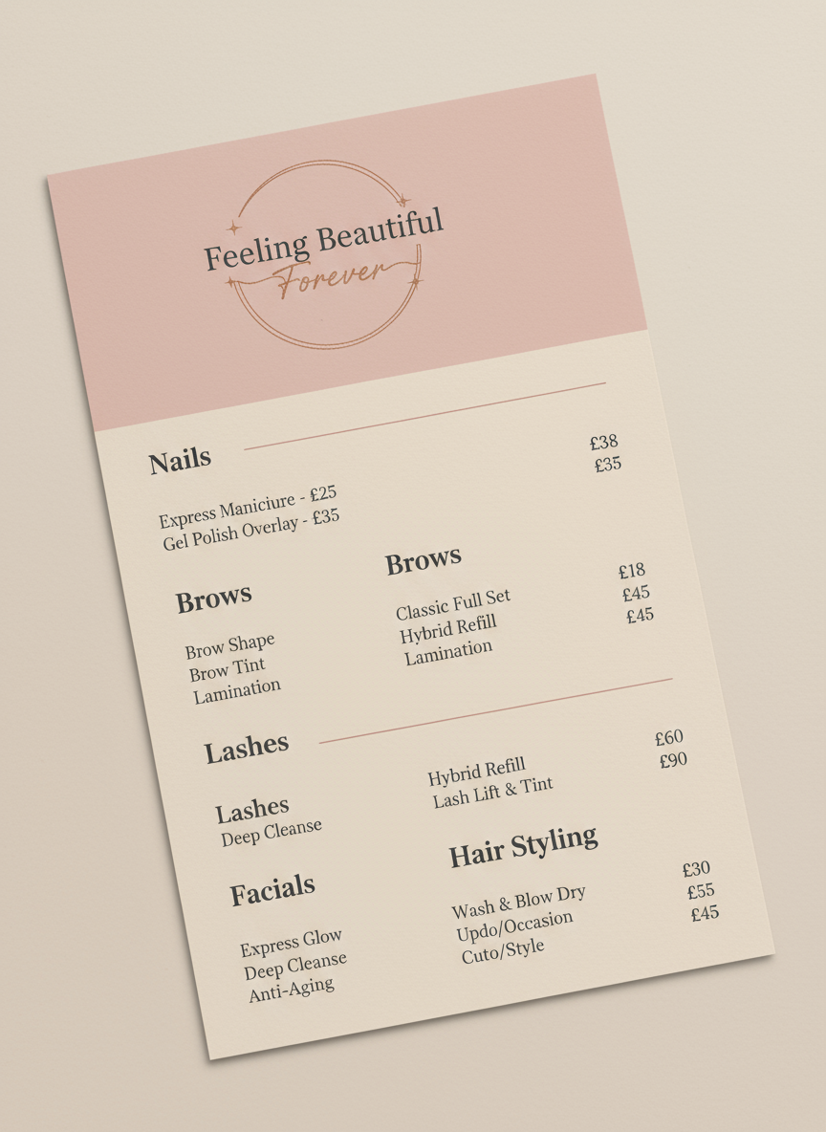
Figure 5: A6 flyers.

8. Market research and how it was used
Primary research for a previous project used a short online questionnaire with potential clients. Most respondents said they visit a salon weekly or monthly, and that pedicures, skincare, and hair styling are their favourite services, with online booking important but phone and face-to-face services still valued (Tatikonda et al., 2024). These findings shaped the service menu and confirmed the need to include hair, nails, and skin. Secondary research from beauty industry reports and salon case studies showed that clients consult reviews and social media before making a choice. Hence, the plan focuses on Google reviews, Instagram content, and a clear, transparent website with prices (Salonist, 2024).

9. Financial resources and cash flow
Start-up costs will cover a deposit and first month rent, basic decoration and furniture, treatment equipment, stock, licences, insurance and the booking system, plus branding and printing. Funding will come mainly from personal savings with possible support from a small family loan. The twelve-month cash flow forecast assumes an average treatment price of twenty-two pounds and growth from about one hundred sixty treatments in month one to around three hundred in month twelve. It shows small losses at first but profit once monthly treatments pass roughly two hundred thirty, so tight control of costs and stock is vital (Heinze and Cano, 2024).

10. SWOT and PESTLE analysis
Strengths are the central location, clear express menu, modern branding and flexible booking choices. Weaknesses are limited capacity with one worker and reliance on one income, while opportunities include rising demand for quick beauty and hair services and scope to add staff. Threats are new competitors, higher costs and changes in social media reach (Ofcom, 2024). Legally the salon must follow licences, health and safety rules and data and consumer protection. Economic conditions affect spending, but social interest in self-care and online images supports demand (Singh and Ahmed, 2025). Booking and payment technology must be secure. Environmental issues such as waste and energy use will be managed by choosing reusable tools where safe and recycling packaging.

Part 2: Reflection

1) Skills I have exercised and developed
This project has helped me turn a loose idea into a clearer small business. I have learned how to describe my offer in simple language and link it to a target customer. Writing the plan for Feeling Beautiful Forever made me think about how nails, skin and hair services can fit together in one studio and how to price them in a realistic way.
I also developed basic financial skills. Putting together a twelve-month cash flow forced me to list every cost, from rent and licences to small items like cotton pads. I had to estimate how many treatments I could do each week and what that meant for income. This made me more careful about promises. I now see that a nice brand is not enough if the numbers do not work.
The work improved my marketing skills too. I created ideas for flyers, social posts and review cards that match the brand colours and logo. I practised writing short, clear messages that tell clients what to book and how. I also learned the importance of Google Business, maps and local search when people look for a salon near them. Finally, the plan made me pay more attention to legal and hygiene issues such as insurance, licences and standard procedures.

2) An entrepreneurial trait I need to develop (and how)
The main trait I need to develop is consistent time management. I often try to do everything at once and then feel rushed. For a sole trader this is risky because I am the only person who can bring money into the business.
To improve this, I plan to keep a simple weekly timetable. I will set aside specific hours for appointments. I will set aside a little block each day for cleaning and stock checks. I will also set aside a short block for messages and social media. I shall also evaluate the week every Friday and write down important figures like number of bookings, average spend and main source of clients. This will show me if my time is going to the right tasks. Moreover, I hope to speak with one local salon owner about how they plan their diary. Gaining knowledge from a person who has effectively practised it should help me.

3) Feasibility of my business proposition
Working on the plan has made me more realistic about Feeling Beautiful Forever. The idea is small on purpose. It is one compact studio in Cardiff city centre, run by me as a sole trader in the first year. I now understand that my capacity and health are big limits, so I must manage bookings and prices carefully.
The cash flow shows that if I reach around 230-250 treatments a month at an average price of about £22, the business can cover costs and pay me a modest wage. This is demanding but possible if I build busy evenings and weekends and keep waste low. There are risks such as illness, higher rent or weaker demand, but I can reduce them with a small emergency fund, good insurance and support from trusted freelancers in peak times.
Overall, I now see the business as viable at a modest scale, as long as I stick to the plan, review the figures often and grow staff only when the cash flow is strong enough.

References
Atherton, J., (2023). Social media strategy: A practical guide to social media marketing and customer engagement. Kogan Page Publishers. https://www.koganpage.com/marketing-communications/social-media-strategy-9781398609990
Desai, D., (2021). Website personalisation: Strategy for user experience design & development. Turkish Journal of Computer and Mathematics Education, 12(12), pp.3516-3523. https://doi.org/10.17762/turcomat.v12i12.8092
En, E.W.T., Vistro, D.M. and Abidin, A.Z.Z., (2021), December. Online Media Management Booking System. In 2021 14th International Conference on Developments in ESystems Engineering (DeSE) (pp. 27-32). IEEE. https://doi.org/10.1109/DeSE54285.2021.9719493
Grandhi, B., Patwa, N. and Saleem, K., (2021). Data-driven marketing for growth and profitability. Euromed Journal of Business, 16(4), pp.381-398. https://www.econbiz.de/Record/data-driven-marketing-for-growth-and-profitability-grandhi-balakrishna/10012411489
Heinze, A. and Cano, M., (2024). SEO strategy for a digital presence. In Digital and Social Media Marketing (pp. 229-249). Routledge. https://www.taylorfrancis.com/chapters/edit/10.4324/9781003372189-13/seo-strategy-digital-presence-aleksej-heinze-montserrat-cano
Nikitina, S., (2021). Marketing Strategy Proposal for the Selected Beauty Salon. https://digilib.k.utb.cz/bitstream/handle/10563/46720/nikitina_2021_dp.pdf?sequence=1&isAllowed=y
Oasmaa, S., (2024). Elevating sales and customer experience in a beauty salon’s new web store. https://www.theseus.fi/bitstream/handle/10024/864693/Oasmaa_Suvi.pdf?sequence=2&isAllowed=y
Reshitco, A., (2024). Creating a landing page for a beauty salon. In Sesiune națională cu participare internațională de comunicări științifice studențești (pp. 82-84). https://ibn.idsi.md/ro/vizualizare_articol/215232/datacite
Singh, J. and Ahmed, S., (2025). CONSUMER PREFERENCES. Phoenix: International Multidisciplinary Research Journal (Peer reviewed High Impact Journal),1, p.86-93. https://pimrj.org/index.php/pimrj/article/view/58
Tatikonda, R., Ponnala, J., Thatikonda, R., Yendluri, D.K., Kempanna, M. and Ananthan, B., (2024), March. Optimising digital marketing strategies Through search engine optimisation. In 2024 IEEE international conference on contemporary computing and communications (InC4), 1, pp. 1-6). IEEE. https://doi.org/10.1109/InC460750.2024.10649088
British Beauty Council (2025) Value of Beauty 2025. British Beauty Council. https://britishbeautycouncil.com/value-of-beauty-2025/
Google (2025) Tips to improve your local ranking on Google. Google Business Profile Help. https://support.google.com/business/answer/7091?hl=en
GOV.UK (2025) Set up as a sole trader. https://www.gov.uk/set-up-as-sole-trader
Ofcom (2024) Online Nation 2024 report. Ofcom. https://www.ofcom.org.uk/siteassets/resources/documents/research-and-data/online-research/online-nation/2024/online-nation-2024-report.pdf
Salonist (2024) The powerful impact of an online booking system in salons. Salonist Blog. https://blog.salonist.io/online-booking-system/

