Name: Lorine Aikpaojie
Student Number: 2532537
Module Code: LCHS7009
Module Title: Population Health and Digital Health Promotion
Lecturer Name: Dr Ping Wu
Assignment Title: Component 1 (2 blogs)

Blog 1: Can mobile health apps truly make diabetes prevention accessible to everyone?
Non-communicable diseases (NCDs) account for more than 70% of deaths globally and are conditions primarily driven by modifiable behavioural risk factors such as unhealthy diets, physical inactivity, high consumption of alcohol and tobacco use (Zhu et al., 2025). Type 2 diabetes mellitus is a major NCD, and one closely associated with sedentary lifestyles and living with overweight or obesity (National Institute of Diabetes and Digestive and Kidney Diseases (NIDDK), 2022). The rise in obesity and physical inactivity worldwide necessitates developing scalable and cost-effective solutions. Mobile health (mHealth) applications have been increasingly seen as a promising tool in supporting healthier behaviours, since they have 24/7 accessibility, offer personalised interventions, and possess capabilities for real-time monitoring (Almohammadi, 2026).
Mobile health apps can be seen to address this public health issue by taking evidence-based interventions, such as the National Health Service Diabetes Prevention Program (NHS DPP), and translating them into digital formats (Barron et al., 2022). They offer support similar to the face-to-face programme but in a digitised way since the apps allow users to access online peer support groups, health coaches, electronically setting and monitoring goals, and accommodating wearable technologies that monitor levels of exercise (Barron et al., 2022). The study by Almohammadi (2026) shows that mobile health interventions show consistent glycaemic improvements, with HbA1c reductions of -0.49% (95% CI: -0.65% to -0.32%) seen in comparison to standard care. The systematic review by Mladin et al. (2024) also confirmed that mobile health apps can empower patients living with chronic conditions like diabetes by providing personalised tools for accessing educational resources, tracking health behaviours, and linking them with supportive communities.
The impact of these technologies is however not felt uniformly. Digital interventions are often seen to serve the more privileged and affluent users better than populations which are less privileged – this phenomenon is referred to as the digital health divide (Western et al., 2025). Meanwhile, the latter are often the group which is usually at the highest risk of developing NCDs, such as diabetes. Individuals with higher digital literacy and harbour more positive attitudes towards e-services are more likely to engage with digital health interventions (Ruotsalainen et al., 2025). To address this shortfall, a shift towards promoting equity through the design of interventions is needed (Bitomsky, Nißen and Kowatsch, 2025). The approach involves co-designing interventions alongside the target populations to make sure they are user-friendly, linguistically accessible, and are culturally appropriate. It requires the development of multi-level strategies, including targeted digital literacy training, user-centred design, and supporting infrastructure in communities that have been historically underserved (Almohammadi, 2026).
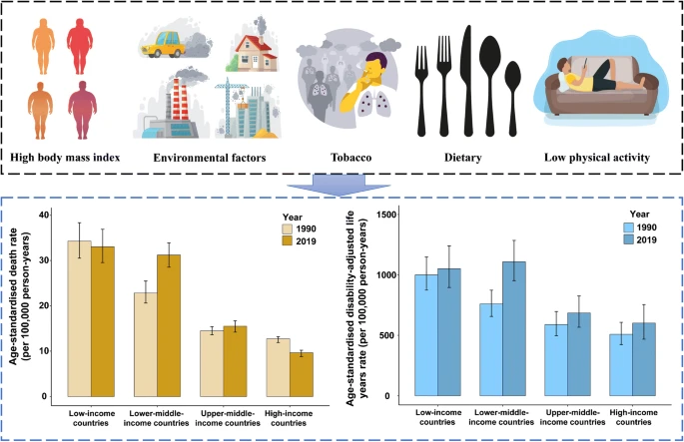
Fig. 1: Low- and middle-income countries and growth of type 2 diabetes 1990-2019 (Liu et al., 2022)

Blog 2: The ‘HealthConnect’ community hub and designing for inclusion
As seen in the study by Western et al. (2025), the digital divide in health is a significant and persistent challenge and aligns with the broader trend where the adoption of technology is skewed towards groups that are more educated, more digitally literate, and have higher incomes. Despite their vast potential, mHealth apps are often taken up following the existing social stratification, and risks leaving the most vulnerable people behind (Bitomsky, Nißen and Kowatsch, 2025). Therefore, to address this divide a new approach is required, one that goes beyond addressing the individual user behaviour to building community capacity and establishing/widening digital infrastructure. This blog introduces ‘HealthConnect’, a community-based digital health hub.
HealthConnect is not an app, but a system that has been designed for the purpose of bridging the digital health gap. It is a physical community hub that has been equipped with tablet kiosks (iOS and/or Android) that offer educational materials, risk assessments, and linkages to local health services. The hub’s staff would be trained digital health navigators – they would be peers from the community who provide one-on-one support. Their presence helps address the situation where individuals with lower digital competence and those with high data security concerns vis-à-vis their data are seen to be less likely to adopt digital health tools (Ruotsalainen et al., 2025). HealthConnect, through providing a safe, supportive environment and merging technology functionality within the current social infrastructure, aims to bypass the barriers of mistrust of digital systems and low digital literacy.
HealthConnect’s expected impact is notable. It is designed to empower communities and being the digital confidence of the population therein. Studies such as Seo (2024) and Ombech et al. (2025) show that integrating digital health interventions into community settings is effective in improving population health outcomes, as well as, making sure their design is user-centred and participatory. This strategy also has the potential of fostering enhanced social support and connection, both of which are needed to sustain changes in behaviour and often lack in digital-only interventions.
A potential shortfall is the anticipated operational cost and how sustainable maintaining physical hubs and training staff is. Besides this, scalability in rural areas could also present a challenge. A hybrid model could be considered to address this. This would take the form of kiosks being complemented by a simplified, data-light mobile version to be able to serve those who have old or basic smartphones, or an SMS service (Aljohi et al., 2024). Additionally, partnerships with local governments and non-governmental organisations (NGOs) could be leveraged to secure long-term funding to facilitate the embedment of these hubs in existing community centres, making the hubs a sustainable community asset.
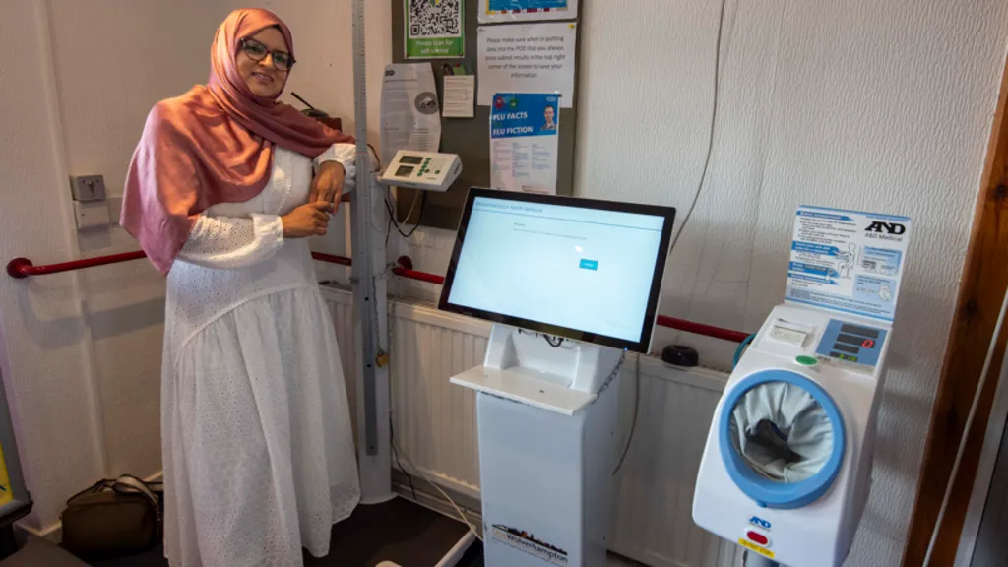
Fig. 2: Councillor Obaida Ahmed and a self-service health kiosk (Gall, 2025)
References
Aljohi, A. S. et al. (2024) ‘Navigating the Divide: Digital Kiosks and Mobile Apps as Complementary Human-Centered Self-Service Technologies’, RAiSE-2023. Available at: https://doi.org/10.3390/engproc2023059162
Almohammadi, A. A. (2026) ‘Digital Health Technologies for Chronic Disease Prevention: A Narrative Review’, Current Medical Issues, 24(2), pp. 223–229. Available at: https://doi.org/10.4103/cmi.cmi_227_25
Barron, E. et al. (2022) ‘Effectiveness of digital and remote provision of the Healthier You: NHS Diabetes Prevention Programme during the COVID ‐19 pandemic’, Diabetic Medicine, (16 December). Available at: https://doi.org/10.1111/dme.15028
Bitomsky, L., Nißen, M. and Kowatsch, T. (2025) ‘Equity by design principles for digital health interventions’, International Journal for Equity in Health, 24(1). Available at: https://doi.org/10.1186/s12939-025-02645-6
Gall, C. (2025) Self-service health kiosks set up at GP surgeries. Available at: https://www.bbc.com/news/articles/cvg9qn175qpo (Accessed: 9 July 2026).
Liu, J. et al. (2022) ‘Low- and middle-income countries demonstrate rapid growth of type 2 diabetes: an analysis based on Global Burden of Disease 1990–2019 data’, Diabetologia, (19 May). Available at: https://doi.org/10.1007/s00125-022-05713-6
Mladin, O. A. et al. (2024) ‘The transformative power of mHealth apps: empowering patients with obesity and diabetes – a narrative review’, Journal of Medicine and Life, 17(12), pp. 1030–1035. Available at: https://doi.org/10.25122/jml-2024-0340
National Institute of Diabetes and Digestive and Kidney Diseases (NIDDK) (2022) Risk Factors for Type 2 Diabetes. Available at: https://www.niddk.nih.gov/health-information/diabetes/overview/risk-factors-type-2-diabetes (Accessed: 9 July 2026).
Ombech, E. A. et al. (2025) ‘Effectiveness of an integrated community and hospital digital health information system for maternal and newborn healthcare in Northern Kenya: a nonrandomized before-after evaluation’, Frontiers in Digital Health, 7(17 December). Available at: https://doi.org/10.3389/fdgth.2025.1584733
Ruotsalainen, I. et al. (2025) ‘Unraveling the Factors Associated With Digital Health Intervention Uptake: Cross-Sectional Study’, JMIR mHealth and uHealth, 13(9 December), p. e63896. Available at: https://doi.org/10.2196/63896
Seo, J. (2024) ‘Designing Public Healthcare Platform for Rapidly Aging Population in South Korea: Mixed-Method Study Based on Design Thinking Approach (Preprint)’, JMIR Research Protocols, (8 July). Available at: https://doi.org/10.2196/63094
Western, M. J. et al. (2025) ‘Bridging the digital health divide: a narrative review of the causes, implications, and solutions for digital health inequalities’, Health Psychology and Behavioral Medicine, 13(1). Available at: https://doi.org/10.1080/21642850.2025.2493139
Zhu, M. et al. (2025) ‘Global burden of non-communicable diseases attributable to behavioral factors’, Science Bulletin, (August). Available at: https://doi.org/10.1016/j.scib.2025.08.037

