Charlene Morgan
1906685

Date: 25th June 2021
Managing projects in a workplace Working Minds Matter

Table of contents

Executive Summary………………………………………………………… Pg. 2

Introduction……………………………………………………………………. Pg. 3

Main Findings…………………………………………………………………. Pg. 4

Life Cycle……………………………………………………………….. Pg. 4

Quad Chart……………………………………………………………. Pg. 6

Stakeholders Analysis ……………………………………………. Pg. 7

Execution Phase……………………………………………………………… Pg. 10

Working Breakdown Structure……………………………….. Pg. 10

Gannt Chart……………………………………………………………. Pg. 12

Network Diagram……………………………………………………. Pg. 13

Monitoring and Evaluation………………………………………………. Pg. 14

Risk Analysis……………………………………………………………. Pg. 14

SWOT………………………………………………………………………. Pg. 15

PESTLE…………………………………………………………………….. Pg. 16

The Iron Triangle…………………………………………………….. Pg. 17

Evaluation………………………………………………………………………… Pg. 18

Conclusion………………………………………………………………………… Pg. 19

Recommendations……………………………………………………………. Pg. 20

References………………………………………………………………………….Pg. 21

Executive Summary

Project Management highlights the best and most challenging of outcomes, when presented with an exciting new project there came uncertainties and questionable methods of how to apply the right information to the varies tools which were given.
A solid team can provide the right frame of mind and support one another in the most surprising of ways. All tools and frameworks combined can show a side of creativity, assist in the delegated roles given, passion and flair.
With learning each step comes in, an extensive range of knowledge, stumbles along the way and a chance to reflect the future decisions of the project.
Only time will tell if this project made it or failed it.

Introduction
This report has been requested by Shehla Khan by 25th June 2021. It will involve using a variety of tools and techniques to help with the project in question, involving working with a community organisation, making a difference to volunteers and clients to work towards employability by supporting and encouraging in work look abilities, CV composing and planning for interviews.
2020 Business Insight Ltd (2021) claim the word project means to have a defined beginning and a conclusion in a certain amount of time which can characterize scope and resources. It can comprise of a group of people who may not necessarily have worked together before, these people may come from different organisations, but all must be able to deliver the project on time, keep in line with budget costs, learning and integration which organisations require. Every project needs to be managed therefore certain skills, knowledge and techniques go hand in hand before the 5 processes can commence, these include initiating, planning, executing, monitoring and controlling and closing (2020 Business Insight Ltd, 2021)
Teamwork plays a very important role, it needs to consist of different individuals who all want to succeed in the project with the same outcomes. Considering that teamwork can be challenging at times, the creation of this group consisted of 4 individual women who all have thought- provoking opinions, vocally challenged and are direct, this may seem a put off, but equally it shows, compassion, leadership and overall will ultimately get the job done. ‘Working Minds Matter’ was a name that came instantly to the team, it incorporated everything what the project was striving for, it involved vulnerable adults, employment issues, language barriers, confidence fears, apprehension returning to work or education.
In this report there will be several tools and techniques which will be explored, it shall include The Life Cycle, which will run through the whole of the report, followed by a Quad Chart, Stakeholders Analysis, Work Breakdown Structure (WBS), Gantt Chart and lastly a network Diagram. These tools will eventually decide if the project is a success or a failure. An evaluation will be drawn up to analyse the Risk Analysis (against a SWOT & PESTLE) and the Iron Triangle which will give a great deal of insight to the project as the triangle needs to be balanced for it to work.
Main Findings
2020 Project Management (2021) says there are many variations of the project life cycle, it will always include a beginning and an end, but it is what passes through the project which becomes the life cycle using its phases. Each stage allows the team to deliver on time, carefully budget and produce quality of work. (2020 Project Management, 2021).
Brown (2019) suggest the life cycle consists of many tasks throughout and must demonstrate comprehensive knowledge on stakeholders, risk analysis and client’s needs. When breaking the project down into bitesize pieces it will help with a more organised, planned and calm approach. (Brown, 2019).
Bringing in the Life Cycle tool into this project helped benefit in numerous ways, firstly communication was key, it gave a chance, to share ideas, explore potential clients, expand advertising, delegated roles within the team. The benefits that were taken away from the life cycle were the interaction and growth that was established with one another, an honest and committed approach helped enormously and a desire to work together on an even keel helped with keeping a level head. But with benefits comes limitations and without one another there would not have been an opportunity to identify any risks, time management issues and creativity to be put on hold.
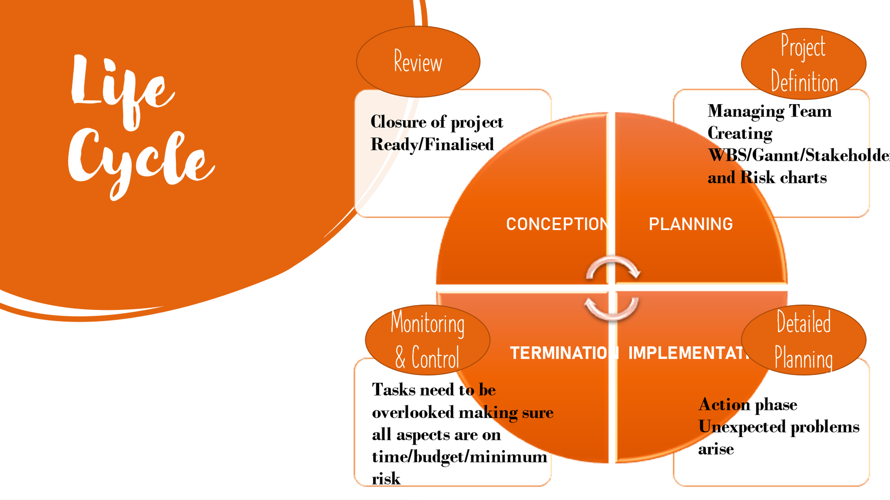
Fig. 1 Morgan, C. (2021) Working Minds Matter – Life Cycle.

Forming a group can be a daunting experience Harper (2019) expresses questions which create uncertainty while working with others will the team be successful? Will the people ‘click’? Will the team make it? or will there be a fall at the first hurdle? There is an element of using Tuckmans theory while creating a group formation, as the 5 stages will take away the nasty surprises, and only aim for the best chance of team collaboration. (Harper 2019).
Belbin (2021) undertake the initiation phase of the Life Cycle, a team meeting was held and discussions were undertaken to decide the best way to move forward. Taking a Belbin test would determine what strengths everyone could contribute to the team and learn a greater self-understanding of themselves. (Belbin 2021).
Mind Tools Team (2021) allowed such pleasing results it uncovered a few areas of the Belbins model and with everyone being a different personality trait, it felt confident to delegate the roles very quickly. Belbin recommends that, by understanding your part inside a specific role, you will create your qualities and oversee your shortcomings as a group, and so progress how you contribute to the team. Team managers often utilize the Belbin model to assist making way for a more well-balanced team. (Mind Tools Team 2021).

Define Quad Chart
Audiopedia (2018) claims a quad chart is a form of technical documentation used to briefly describe an invention or other innovation through writing or illustration or photographs. It is formed into four main sections and is used as a visual aid so it can show a quick overview of the project. (The Audiopedia 2018).
When studying the Quad chart, it became clear that box one, wanted an apparent understanding of a purpose within the project, its aims and objectives were required and with these certain questions were raised.
These aims are to help and support vulnerable adults who lack confidence but are yearning to get back into employment, education or volunteering.
Objectives shall help clients with confidence issues, stresses and worries. Build C.Vs, learn interviewing skills, provide virtual online support and develop extra employability skills both theory and social.
Box two takes on the stakeholders. One huge question must be asked before filling this box in. who is being impacted? All internal and external stakeholders play an enormous part at this stage and it needs to be clear on who can advise, who may help with guidance and who potentially be a strong influence.
Desired results will be to help each client with a shadowing approach of producing a C.V, interviewing techniques which will have a role play feel and give the individual a better clarity to create certain skills to start employment or education. Every part of these results covers a measurable tactic, the other side of this is the unmeasurable desire which focuses on emotional support. This is highly likely in this project because the whole project wants to support vulnerable adults who have concerns, worries and predicaments.
Finally, the last box holds the measure of success, Pickell (2021) defines the difference between Quantitative data which can be counted, measured, and communicated using numbers. While Qualitative data is clear and conceptual. This can be based on traits and characteristics. (Pickell 2021). To relay this to the project every client that received support, had a chance to feel more confident and satisfied with the service and be job ready for potential work. A completed C.V followed by a physical appearance and awareness of the job interviews are the qualitative goals in mind. Survey feedback from clients is vitally important, it will show Working Minds Matter if the service which has been provided, has been positive experience or a discouraging turn of events. No matter the result, there will be continuous help and support, so no one feels they are not feeling their worth.
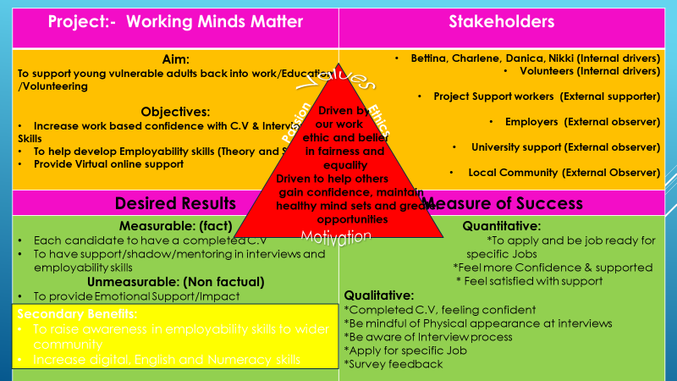
Fig. 2 Bennett, N. (2021) Working Minds Matter – Quad Chart.

Looking back at the planning phase of the life cycle the team created a written strategy of where best to start with defying the project deliverables, the time schedule and creativity can begin. A certain level of guidance is needed here, even though the task has been provided, the goals and objectives need to be discussed, therefore using a Quad Chart and a stakeholder analysis quickly makes way for a clearer insight to what the project needs.

Stakeholder Analysis
Crosby (1991) clearly states that the principle of a stakeholder analysis is to imply whose interests should be considered when making a decision. At the same time, the analysis ought to reveal why those interests should be considered. (Crosby, 1991).
Project Management (2020) say these stakeholders play a crucial part within the project, when being actively involved it requires one’s support and knowledge to ultimately require a productive result. Stakeholders can range from individuals within the project, individuals from different departments within the organisation and looking beyond familiar faces to external contributors (e.g. Customers, consumers etc) which can similarly have a huge impact on the project. The advantages that remain important for stakeholders and can help the project identify are that the team can be inspired to take control of different parts of the project, can find ways of reducing the negative impacts that stakeholders may cause and key people for information distribution during executing phase. (Project Management, 2020).
Ultimately when working on the stakeholder analysis, the team needed to establish who would potentially influence the project using a high to low priority level, following the perspective and what plan of action would be taken. To make this work for the project, the highest priorities were the team and the clients, perspectives raised were subject to making this venture a success and making sure all clients participate assisting in the project and having that desired result to make an impact on future life decisions. Action taken would be the team constantly keeping in contact and communicating to be a continuously flowing, with emails, video calling, and phone calls, this would also comply to the clients, but more on an emotional and skill basis. Likewise, the medium priorities come under our project supporter and employers, perspectives here are providing the clients, whilst waiting on the results of the clients and how it may have an impression on that person’s job. With employers these are potential recruiters for prospective job opportunities. The action taken here again shall be communication and regularly giving feedback to the project supporter about any progress being made, with the employers the same action applies. Lastly low priorities were university and the local community, by no means are these less important, but it does not fully impact the project, it may be beneficial further down the line, and shall always remain monitored. The views are still a guidance and can help with upgrading employability skills, this in turn will support the clients for extra information, bringing in further education, student finance and learning/gaining new perspectives. Local community shall always provide feedback of supportive networks, the job centre, job fayres and workshops, with immediate effect, the group can actively understand if there is a sense of belonging, start to build confidence and finally give that client a fundamental starting ground to gain skills in the workplace.
Using this tool has had its limitations, it does not help on an emotional level whatsoever, it regularly needs updating as changes can be made at any time, stakeholders can pull out and conflict can occur.

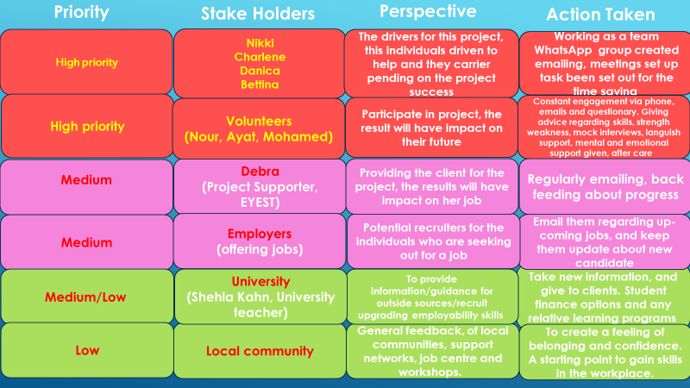
Fig. 3 Silsby, B. (2021) Working Minds Matter – Stakeholders Analysis.

Execution Phase

The execution phase of the life cycle sees three different project management tools come to life, these are:
- Work Breakdown Structure (WBS)
- Gantt Chart
- Network Diagram

Work Breakdown Structure

Harned (2019) expresses that the WBS is a method that breaks a project down into a hierarchy of deliverables, tasks, and subtasks. It is a valuable tool that defines a thorough cost or time estimate and offers guidance for schedule development and control. It will demonstrate how the scope of the project can be managed in smaller bite size pieces by using an organised approach. (Harned, 2019).
Project Manager (2021) recognises just why WBS should be used in a project. the structure gives an orderly plan of action, it can help to achieve goals and the objectives. One venture may incorporate a few stages, or smaller sub-projects and indeed those sub-projects can be broken down into deliverables, sub-deliverables and work bundles. In doing so, it can pick up clarity into the subtle elements required to achieve each perspective of the venture. (Project Management 2021).
The aim was clear from the off, to return young vulnerable adults back to work or education. Shifting to the next boxes which are the deliverables of the chart it links to the desired results from the Quad chart this covered the clients having the employability skills and having the encouragement to have a work-based confidence and to create C.V skills. Moving on to sub-deliverables which is breaking the task down further to have a well-defined understanding. Working further down the chart is the activity boxes here tasks are required to achieve the deliverables. With this stage complete, each member of the team can take away a task and be supported by the following tools and resources. The final part shows the end results. Leading this from a bottom up approach the team brainstormed by writing the tasks down and delegating them to the appropriate individual. Clarizen (2020) state that the bottom-up approach is gaining in popularity particularly in industries where projects tend to involve new encounters that require innovative results. The benefits of this are employee engagement which in turn can enhance morale and accountability it will also have a lower risk of any issues that may occur. The only drawback maybe the time has project managers need to include contribution from many stakeholders into the project plan. (Clarizen, 2020).

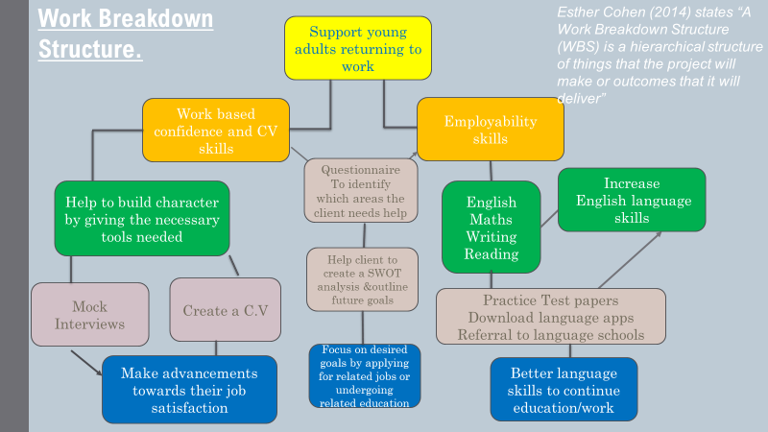

Fig. 4 Dickson, D. (2021) Working Minds Matter – Work Breakdown Structure.

Gantt Chart
Freeman (2021) suggests that the Gantt chart can visualize information and dependency of project tasks. Each bar on the timeline signifies a task and demonstrates the start and finish date as well as the progress naturally. It will show comprehensive information of each task and the overall project, which benefits project managers in project planning. (Freeman, 2021).
This was a favourable chart for the team as it gave a start and end date and a time scale of four weeks, so the deadline was tight. It was an effective way for the team to follow a visual aid and allow each other to stay on track.

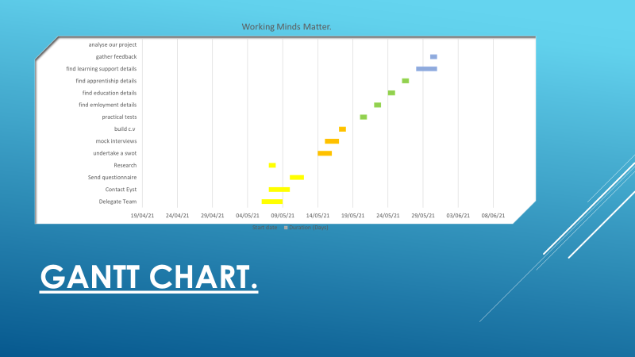
Fig. 5 Dickson, D. (2021) Working Minds Matter – Gantt Chart.

Network Diagram
(Verma 2021) defines a network diagram has a graphical interpretation of the project which is composed of a series of connected arrows and boxes to describe the connection between the activities involved in the project. There is a start and an end to the visual graph and all other activities must fall into place between the two. (Verma, 2021). The network diagram on the team’s project displays the time scale, if this does not tie in with all other tools which have been used, then it can lead to a chain of events which will not work for the activities on the graph. Here communication is yet again a key area to which can lead to a better approach and hopefully reach the end goal.

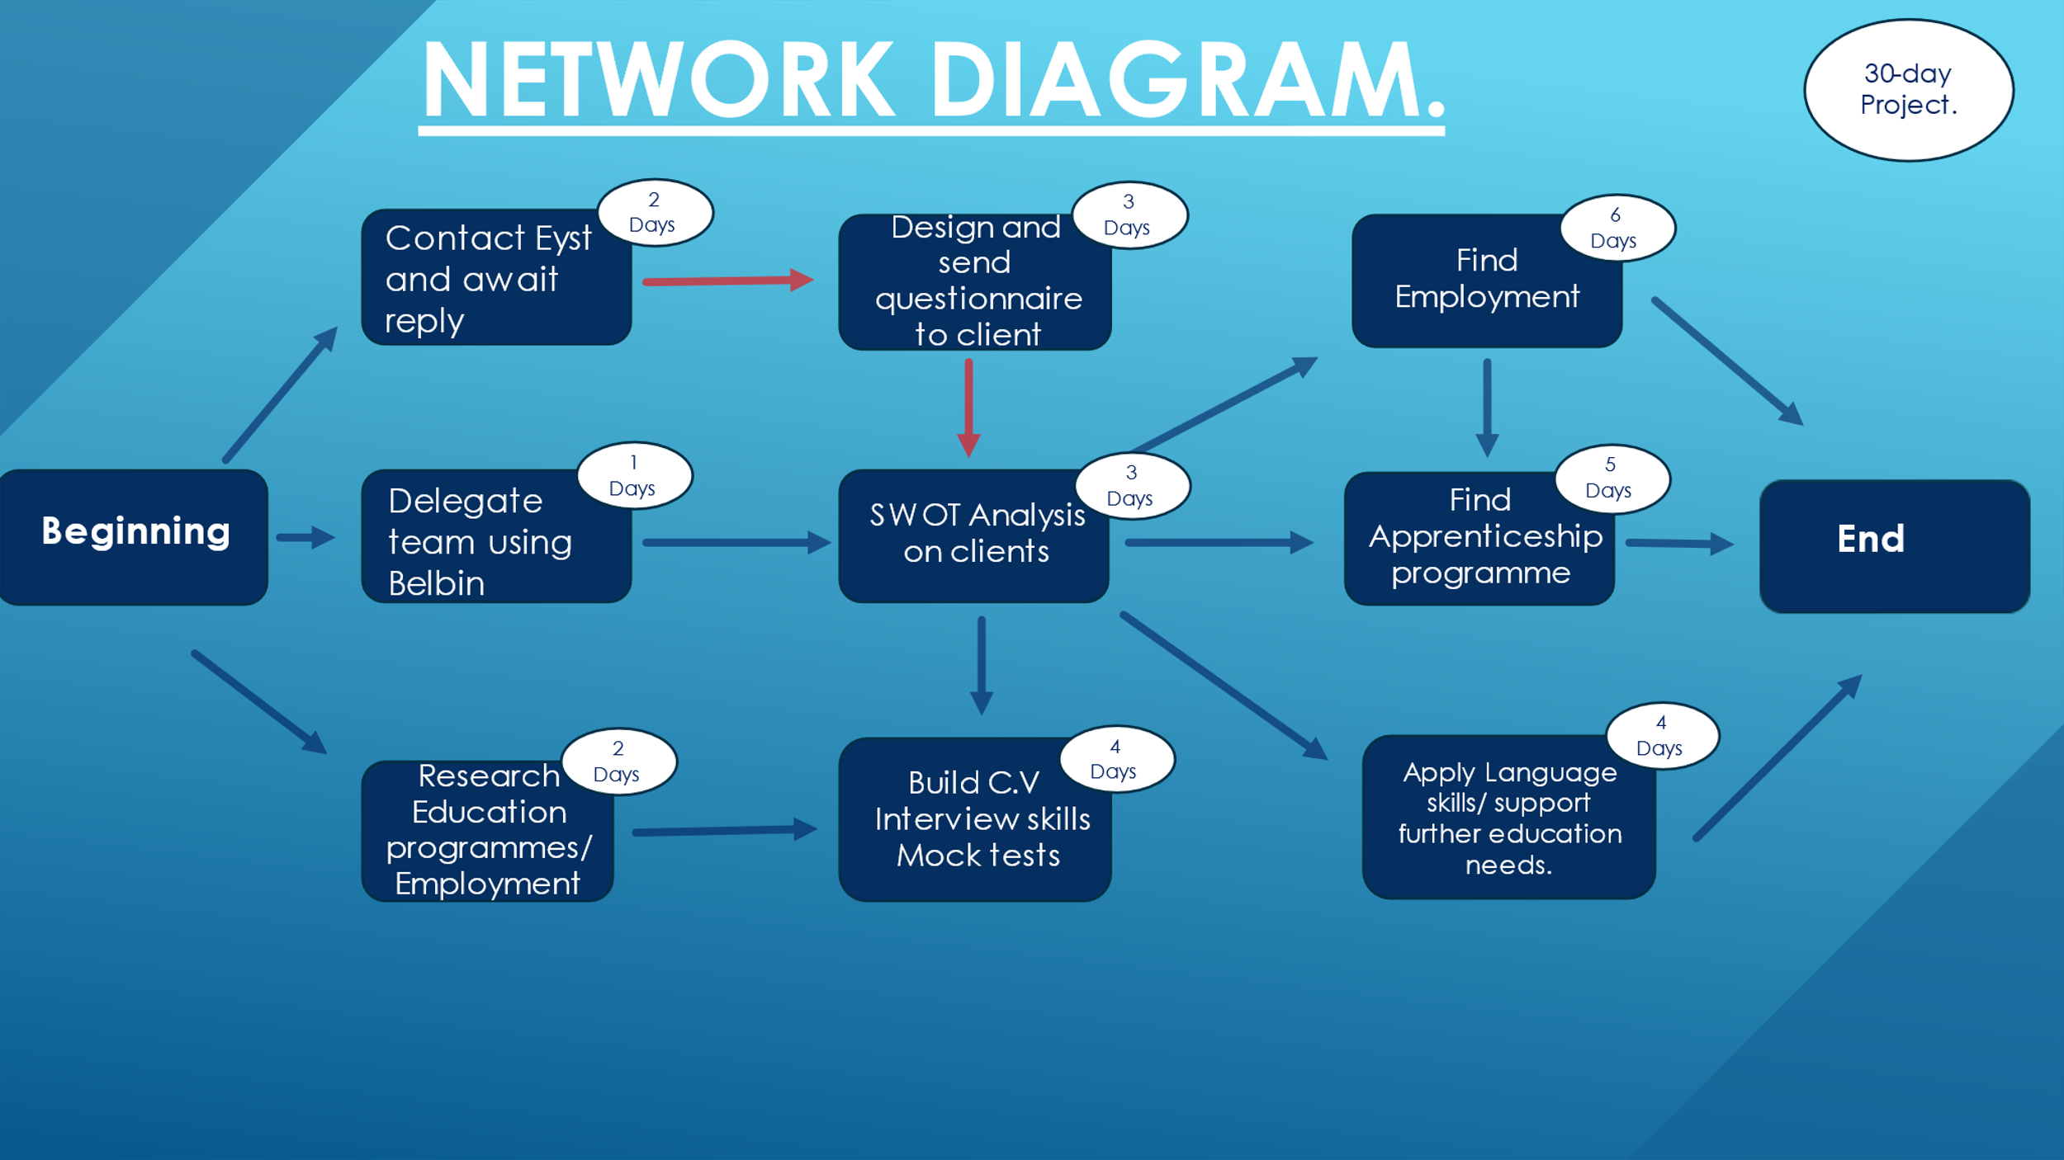
Fig. 6 Dickson, D. (2021) Working Minds Matter – Network Diagram.

Monitoring & Evaluation

Risk Anaysis

Rosencrance (2020) reveals a Risk analysis is the process of recognising and analyzing potential concerns that could negatively impact the businesses initiatives or projects. This process is done in order to help organizations avoid or alleviate those risks. (Rosencrance, 2020).

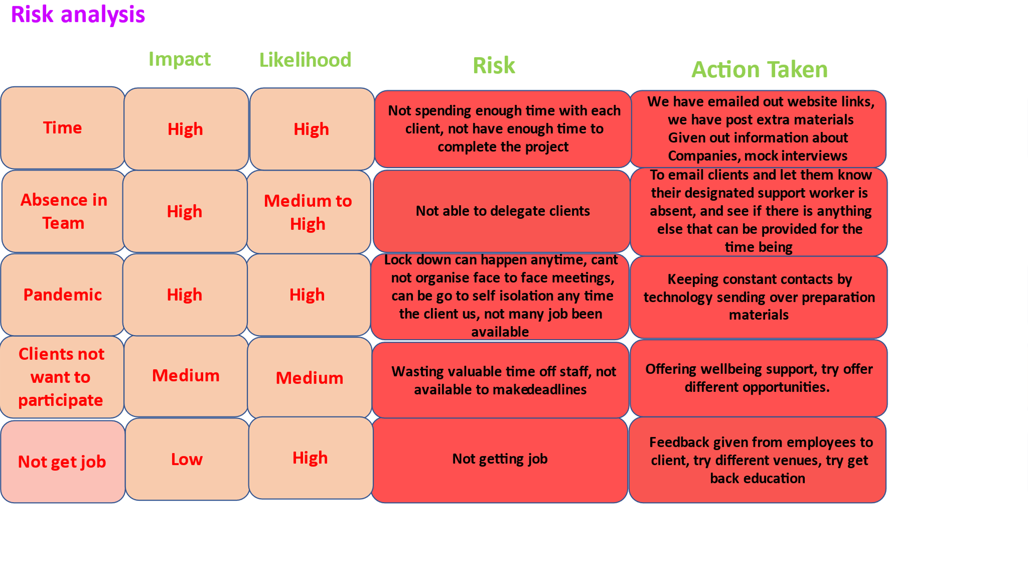

Fig. 7 Silsby, B. (2021) Working Minds Matter – Risk Analysis.

SWOT
Hall (2021) suggests conducting a swot analysis can get project managers or other facilitators to use this formidable tool to identify strengths and weaknesses. Furthermore, strengths may provide opportunities and weaknesses may lead to threats. The best way to start a SWOT is to brainstorm, analyse and combine, prioritise the greatest strength, follow this with the next three boxes, find the risks and define them. (Hall, 2021).
N Task (2018) proposes by clarity, risk identification is the procedure of defining risks that could potentially block the project, or investment from achieving its objectives. (N Task, 2018).
By exploring the risk analysis with the SWOT, it breaks it down, so there is time to focus on each main point and establish any changes, if potentially any threats do occur, then the working minds matter team will confront these head on and seek out any competitiveness, sickness, cost etc and evaluate the SWOT against the risk analysis and make the necessary actions and changes.

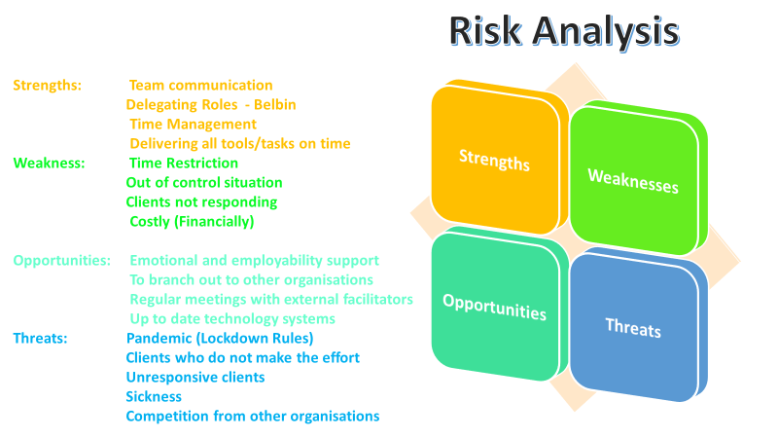
Fig. 8 Morgan, C. (2021) Working Minds Matter – SWOT Analysis.

PESTLE
One of the key issues that was raised in the risk analysis, was Covid 19 and how it has impacted the project. Using a PESTLE the team unpicked several elements to have a better comprehension of this particular choice of risk. Bush (2020) explains that the coronavirus has disturbed the world in many negative ways, causing change, lack of uncertainty and more prominently distress through mental health. The positive from this pestle is the technical side, as there has been a steady rise in medical technology, with the potential of working from home for the foreseeable. (Bush, 2020).

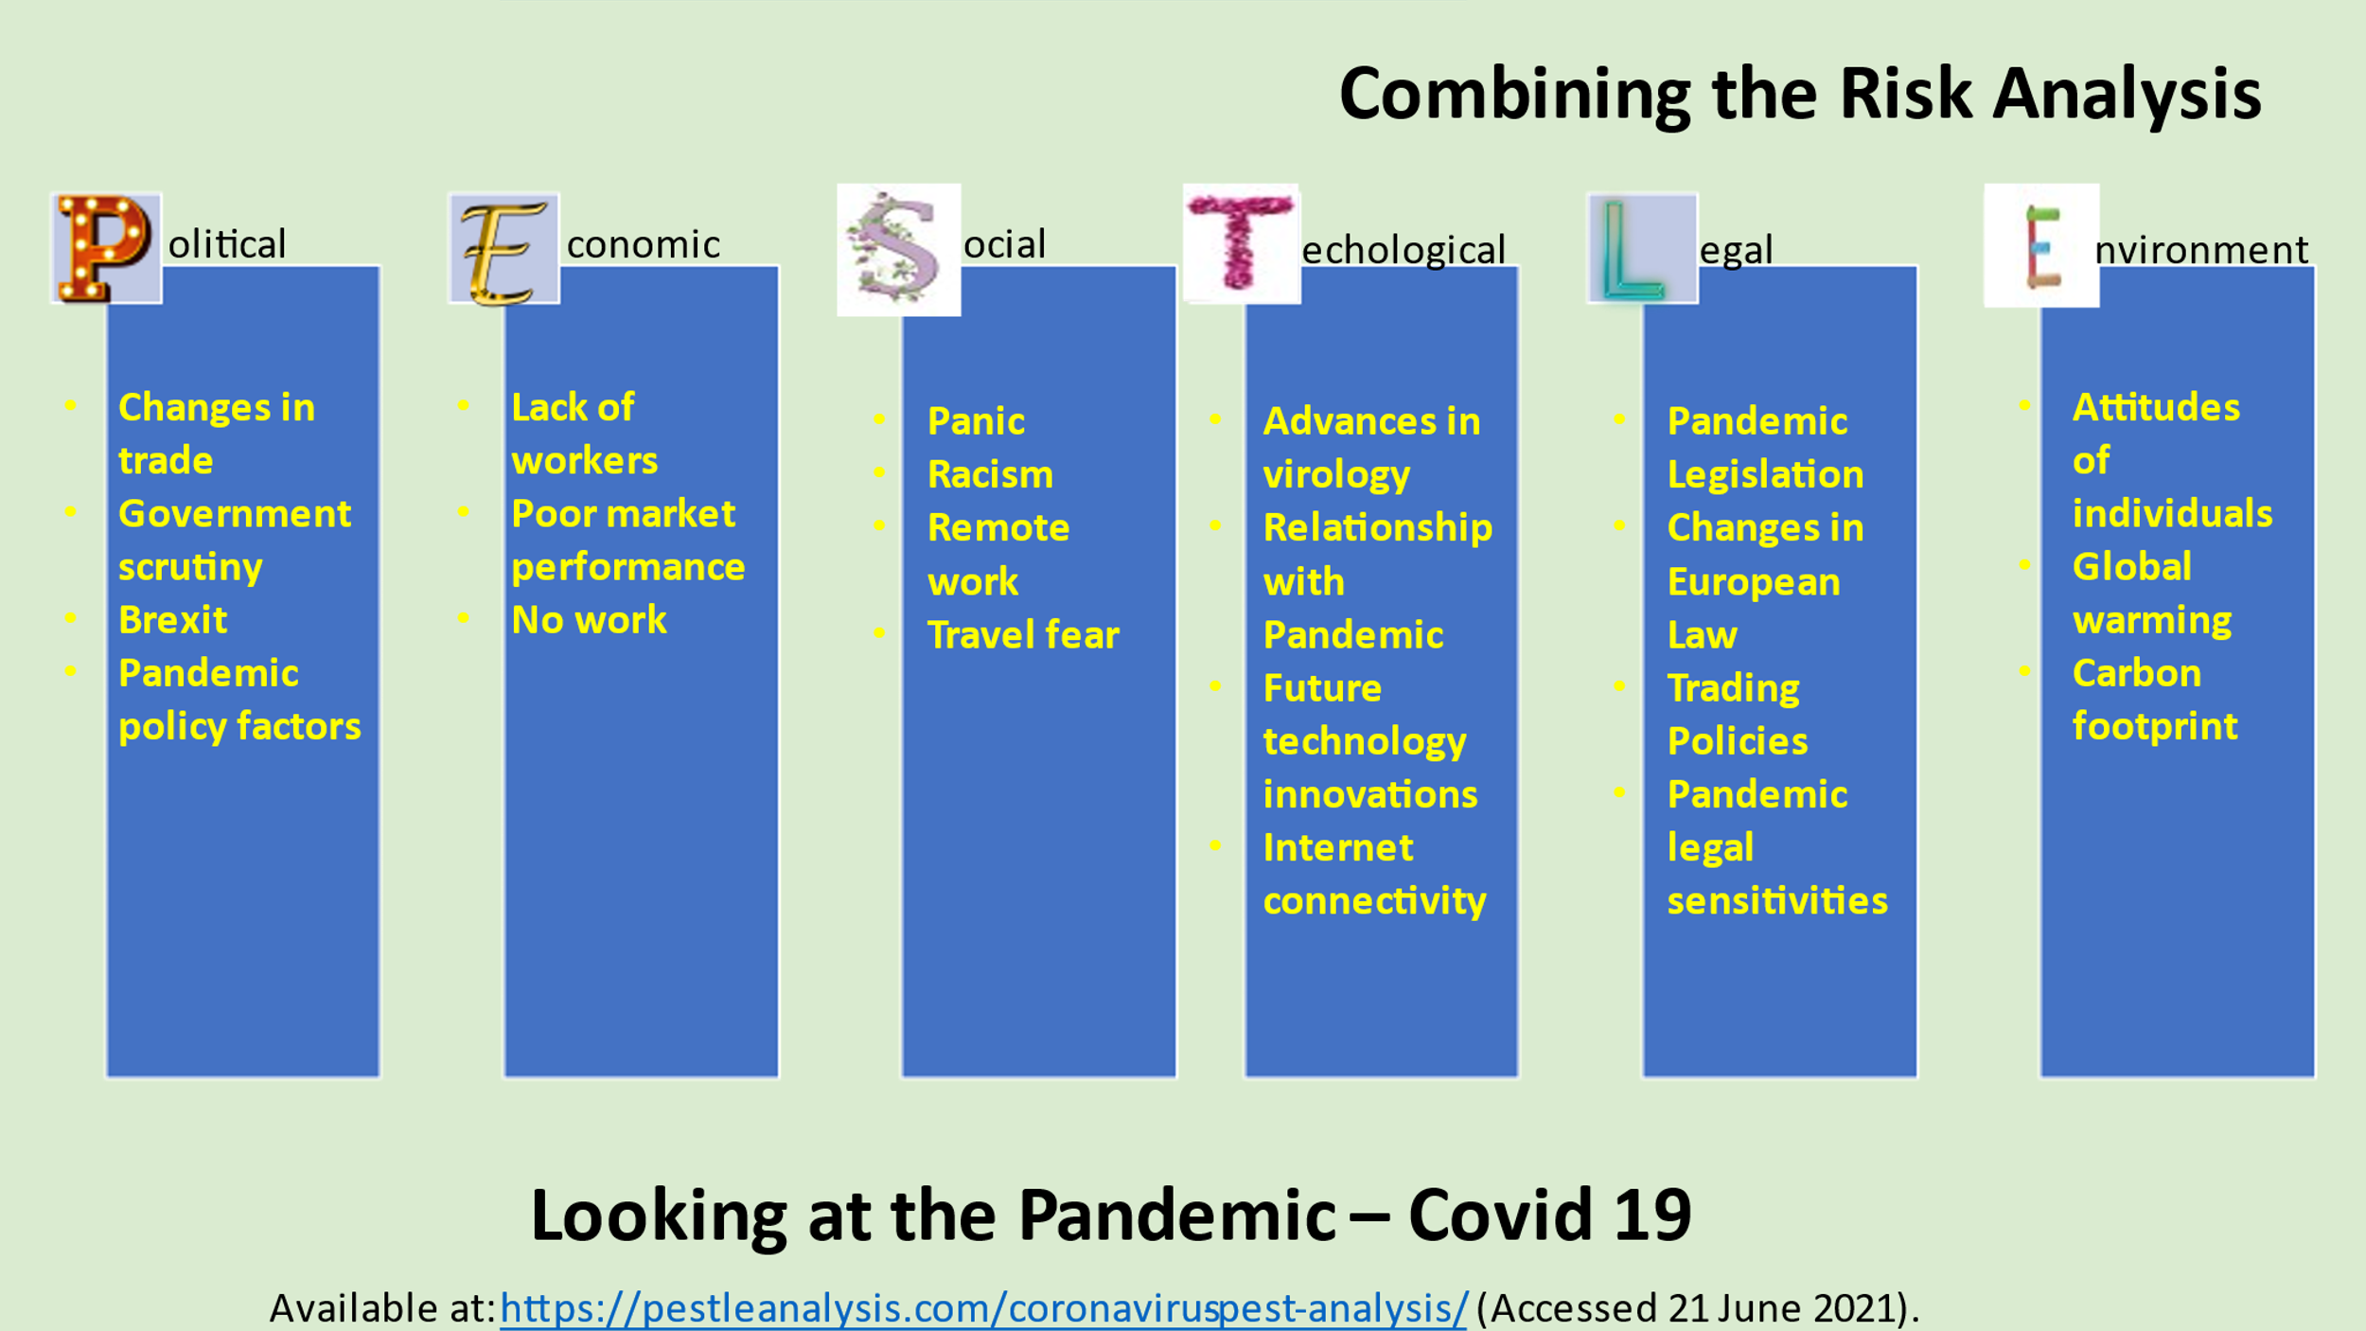
Fig. 9 Morgan, C. (2021) Working Minds Matter – PESTLE Analysis.

Iron Triangle
The Iron Triangle offers a valuable insight into project management, it helps by supporting clear decisions. Clayton (2017) says it compromises of three different sections which helps to produce the best it can be ‘quality’ in a quick ‘time’ frame under the minimum ‘cost’, allowing an overall scope. With each corner produced, the team can secure the ultimate iron triangle. (Clayton, 2017)
Madsen (2013) implies that even though the Iron Triangle is indeed a useful tool, it may not be ready to disregard it at all, but instead add to it (impact, relevance and sustainability). If the team can create an ethos throughout then the project is ultimately going on to achieve a bigger scheme of things and the entire team will do well to acknowledge it. Madsen, 2013).
Working Minds Matter wanted to create a quality of service which captured the performance, planning and functionality as a team. Time had become a big issue, which fundamentally did not help in the implementation stage of the life cycle, nevertheless all charts, questionaries, feedback forms, emails, face to face contact were created, it was the responses which took time. Cost was not included in this project a focus on human resources were involved instead.
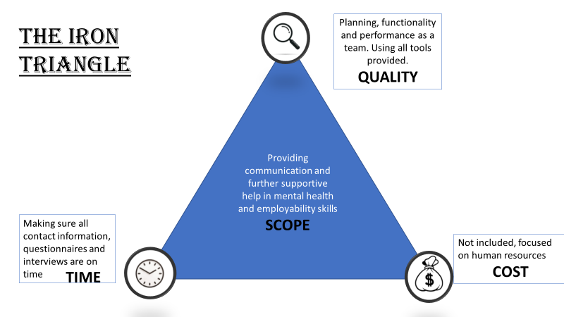
Fig. 10 Dickson, D. Working Minds Matter – The Iron Triangle.

Evaluation
When Working Minds Matter entered the conceptional plan of the life cycle, the team had to review and evaluate everything that had ever been discussed, created or developed. Kuezk and Rist (2004) suggest evaluation is a systematic and objective assessment of an on going or completed project it includes the following design, implementation and results. The point is to decide the pertinence and satisfaction of targets, improvement in productivity, adequacy, impact and sustainability. It ought to give data that's solid and valuable, so lessons can be learned within the choice making method. (Kuezk and Rist 2004).
There are two ways to evaluate, subjectively – which can support a quick and straightforward review, agreeing by accepting personal preferences and opinions. Additionally, there is a more time consuming leading to more relevant data which is best known as objectively, this requires further quantifiable evidence.
After studying the hard factors, Working Minds Matter received one outcome with the chance of that client looking to go into education. The soft effect is an emotional approach which the feedback can be positive and support is at hand. Illuminative was a slight negative has there were restrictions were put in place because of the pandemic, so no face to face and role playing could be considered at this point, to improve this more interaction with Microsoft Teams, or Skype could make this slightly more bearable. But to elevate the soft outcome behaviours, regular information and providing the right tools to help with confidence , interview and language skills and external links could surpass an emotionally draining feeling into something helpful.
Working Minds Matter, worked very well as a team, all tools and charts, were filled out thoroughly, communication was exceptional as was the commitment. The experience as has been an eye opener, and with carefully evaluating all tools it will make way for any necessary changes. Throughout the whole of the life cycle phases the team has clarified the roles and responsibilities, run effective meetings, dealt with any problematic forthcomings and finally reviewed the whole project for the end results.
As a project manager Charlene created the teams email address, The Life Cycle, introduced the Belbin Test, made active responses to clients and worked through the questions for the questionnaire, She has managed to take her teamwork and specialist results and amalgamate them to the teams preferences, of ideas and skills. Dedication has proved to be her biggest strength, along with showing a desire to not create any friction in the group. Everyone had a chance to talk, and Charlene made headway to listen whilst being co-operative through the process.

Conclusion
As a final observation, the Working Minds Matter team, used every tool and technique that was offered within this project, it provided a unique and different way of how to run a project, how to excel as a group and how to measure all the uncertainties, flaws and prospects which could arise. Regrettably, this project was not a success, it became more delicate than the team thought. The time restriction weighed heavily on the teams minds, it added pressure on clients responses which never came and the pandemic causing uncertainty hindered face to face meetings. All these off-putting results were covered in the Risk Analysis, so the team were equipped for these risks, yet not necessarily able to be in control of.
Nonetheless, the team were exceptional covering all aspects of communication, commitment and creativity. Certain tools worked well for example the Quad Chart gave real focus, detailed aims, and objectives to understand and clarify the project in hand, likewise the Network Diagram gave the same definition in terms off a beginning and an end, the flow helped with the connectivity through the association between the actions included within the venture. Just because this project did not give the best outcome does not mean there is not a chance to succeed in another way.

"Remember the two benefits of failure. First, if you do fail, you learn what doesn't work; and second, the failure gives you the opportunity to try a new approach." - Roger Von Oech

Recommendations
There are many ways in which Working Minds Matter can make this project more successful looking back at the Risk Analysis and Network Diagram the team needs a lot more time to receive the responses from the clients, to help with supporting the emotional concerns and getting clients to give feedback where necessary. Once covid restrictions lift there could be an opportunity to seek premises which could elevate the isolation most clients have been experiencing.

References
2020 Business Insight Ltd (2020). What is the Project Life Cycle? Available at: https://2020projectmanagement.com/resources/project-lifecycle-and-methodology/what-is-the-project-life-cycle (Accessed: 13 June 2021).
Belbin, M. (2021) What’s Belbin all about? Available at: https://www.belbin.com/ (Accessed: on 14 June 2021).

Brown, L. (2019). Learning What is Project Management Life cycle & Its Phases? Available at: https://www.invensislearning.com/blog/5-phases-project-management-lifecycle/#:~:text=A%20project%20life%20cycle%20is,its%20initiation%20to%20its%20closure.&text=The%20project%20lifecycle%20can%20be,and%20aspects%20of%20the%20organization. (Accessed: 13 June 2021).

Bush, T. (2020) PEST Analysis of Coronavirus: Pandemic’s 9 Impacts to World Available at: https://pestleanalysis.com/coronavirus-pest-analysis/ (Accessed: 21 June 2021).

Clarizen (2020). Top-Down vs. Bottom-Up Approaches: Which is Right for You? Available at: https://www.clarizen.com/top-down-vs-bottom-up-approaches-which-is-right-for-you/?cn-reloaded=1 (Accessed: 18 June 2021).

Clayton, M. (2017) Online PM Courses What is the Iron Triangle? Project Management in Under 5. Available at: https://www.youtube.com/watch?v=JHSHOAfV-uw (Accessed: 21 June 2021).

Crosby, B. (1991) Stakeholder Analysis: A Vital Tool for Strategic Managers. Available at: https://moodle.uwtsd.ac.uk/pluginfile.php/496919/mod_resource/content/1/stakeholders%20analysis%202.pdf (Accessed: 18 June 2021).
Fig. 1 Morgan, C. (2021) Working Minds Matter-Project Life Cycle. [PowerPoint presentation slide] Wales: Students own collection.
Fig. 10 Dickson, D. (2021) Working Minds Matter-The Iron Triangle. [PowerPoint Presentation] Wales: students on collection.
Fig. 2 Bennett, N. (2021) Working Minds Matter-Quad chart Analysis. [PowerPoint Presentation Slide] Wales: students own collection.
Fig. 3 Silsby, B. (2021) Working Minds Matter-Stakeholder Analysis. [PowerPoint presentation] Wales: students own collection.
Fig. 4 Dickson, D. (2021) Working Minds Matter-Work Breakdown Structure. [PowerPoint Presentation] Wales: students own collection.
Fig. 5 Dickson, D. (2021) Working Minds Matter-Gantt Chart. [PowerPoint Presentation] Wales: students own collection.
Fig. 6 Dickson, D. (2021) Working Minds Matter-Network Diagram. [PowerPoint Presentation] Wales: students own collection.
Fig. 7 Silsby, B. (2021) Working Minds Matter-Risk Analysis. [PowerPoint Presentation] Wales: students own collection.
Fig. 8 Morgan, C. (2021) Working Minds Matter-SWOT Analysis. [PowerPoint Presentation] Wales: students own collection.
Fig. 9 Morgan, C. (2021) Working Minds Matter-PESTLE Analysis. [PowerPoint Presentation] Wales: students own collection.
Freeman, J. (2021) Gantt Charts' Advantages and Disadvantages for Project Management Available at: https://www.edrawsoft.com/project/advantages-disadvantages-gantt-chart.html (Accessed: 18 June 2021).

Hall, H. (2020) Project risk coach How to Perform a SWOT Analysis Available at: https://projectriskcoach.com/how-to-perform-a-swot-analysis/ (Accessed: 21 June 2021).

Harned, B. (2019) What Is a Work Breakdown Structure? Available at: https://www.teamgantt.com/blog/how-to-estimate-projects-accurately-using-a-work-breakdown-structure (Accessed 18 June 2021).
Harper, H. (2019) The Stages of Group Formation, and how they Aid Your Teams Success. Available at: https://www.workstyle.io/stages-of-team-development (Accessed 22 June 2021).

Kuezk, J, Z. and Rist, R. (2004) Ten Steps to a Results-based Monitoring and Evaluation System. Washington: World Bank.

Masden, S. (2013) Is the Iron Triangle outdated? Available at: https://www.susannemadsen.co.uk/blog/the-iron-triangle-and-the-tripleconstraintsare-outdated (Accessed: 21 June 2021).

Mind Tools Team (2021) Belbins Team Roles. Available at: https://www.mindtools.com/pages/article/newLDR_83.htm (Accessed: 14 June 2021).

N Task (2018) How to do a SWOT Analysis for Risk Identification and Risk Management Available at: https://www.ntaskmanager.com/blog/how-to-do-a-swot-analysis-for-risk-identification/ (Accessed: 21 June 2021).

Pickell, D. (2021) Qualitative vs Quantitative Data – What’s the Difference?. Available at: https://www.g2.com/articles/qualitative-vs-quantitative-data Accessed 22 June 2021).

Project Management (2020) What is Stakeholder Analysis? Available at: https://project-management.com/what-is-stakeholder-analysis/ (Accessed: 18 June 2021).

Project Management (2021) The Ultimate Guide to… Work Breakdown Structure (WBS) Available at: https://www.projectmanager.com/work-breakdown-structure (Accessed 18 June 2021).
Project Management Institute (2021). What is Project Management? Available at: https://www.pmi.org/about/learn-about-pmi/what-is-project-management (Accessed: 3 June 2021).

Rosencrance, L. (2020) risk analysis Available at: https://searchsecurity.techtarget.com/definition/risk-analysis (Accessed: 19 June 2021).

The Audiopedia (2018) What is QUAD CHART? What does QUAD CHART mean? QUAD CHART meaning, definition & explanation. Available at: https://www.youtube.com/watch?v=TkRyzUVWtm0 (Accessed: 14 June 2021).

Tran, L. (2016) The 62 Most Inspiring Project Management Quotes. Available at: https://www.inloox.com/company/blog/articles/the-62-most-inspiring-project-management-quotes/ (Accessed: 22 June 2021).

Verma, E. (2021) Network Diagram: An Important Tool for Effective Time Management Available at: https://www.simplilearn.com/network-diagram-as-an-effective-time-management-tool-rar224-article (Accessed on: 19 June 2021).

