Name: Cristina Marin
Student Id: 2213202
Module: Data Handling & Business Intelligence
Module Id: LCBB5000

Section 1
Part A.
1. What is the mean value for coffee consumption (in cups) per day?
2.What is the median value for coffee consumption (in cups) per day?
3.What is the mode of the coffee consumption (in cups) per day?
4.What is the standard deviation for effects on the human body (based on a health index score)?
5.Which one of the two variables has a larger variance?
6.Which one of the two variables has a larger standard deviation?
7.Can you interpret the last three outcomes?
Part B.if function
Part c.SPSS
Section 2.
Introduction
SPSS
Advantages
Disadvantages
Microsoft Excel
Advantages
Disadvantages
Tableau
Advantages
Disadvantages
Data Mining Cycle
Conclusion
Reference list

Section 1
"Coffee_Consumption_and_Effects_2024", a research study is a comprehensive investigation into the daily coffee consumption habits over a selected group of individuals conducted by our research center. As a data analyst intern, a pivotal role in a project involves delving into the rich data set that has been collected over an extended period.
In this study have been gathered detailed data on individuals’ daily coffee intake, categorizes by the number of cups consumed, along with corresponding health indices and diagnostic results .By leveraging the power MS Excel and the recently acquired SPSS data mining statistical software ,this paper aim is to conduct a thorough and insightful analysis between coffee consumption and its effects on human health .
Part A.
1.Mean value is the average of a given set of values; to calculate it we use a formula :
We start by calling the function , typing =average and it explains what this function means and how it returns then open a left brackets and type the first needed cell or simply click and drag through the second cell ,through is given by the sign colon (:) namely =average(nr1:nr2) and then close the brackets or press enter.

In our study the mean value is given like this =average(b2:b41)
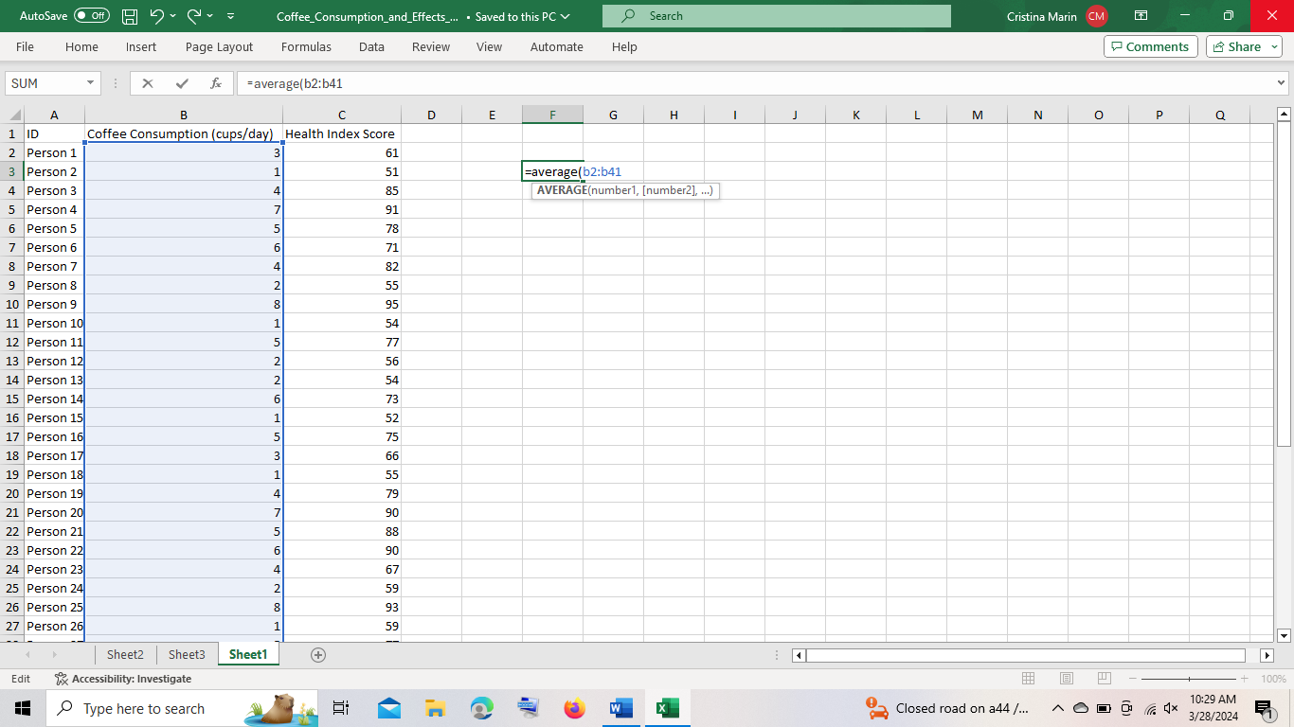
The result given is 3,625 ,the average coffee consumption in cups per day.

- 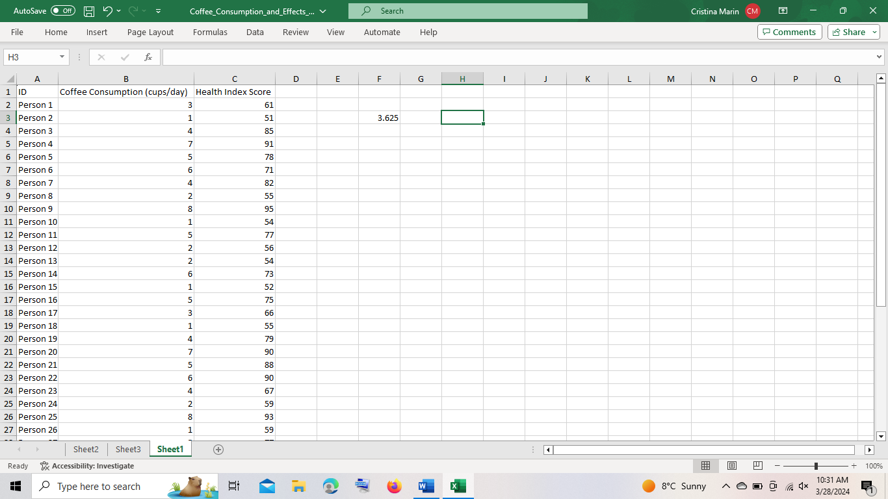
2. Median is given by the middle number from a certain set of values

To find out a median value for coffee consumption we use the same formula as above ,for instance ,starting to call the function =this time type median, open a bracket start with first cell through the second cell you wish to use : =median(b2:b41 close the brackets or click enter tab.
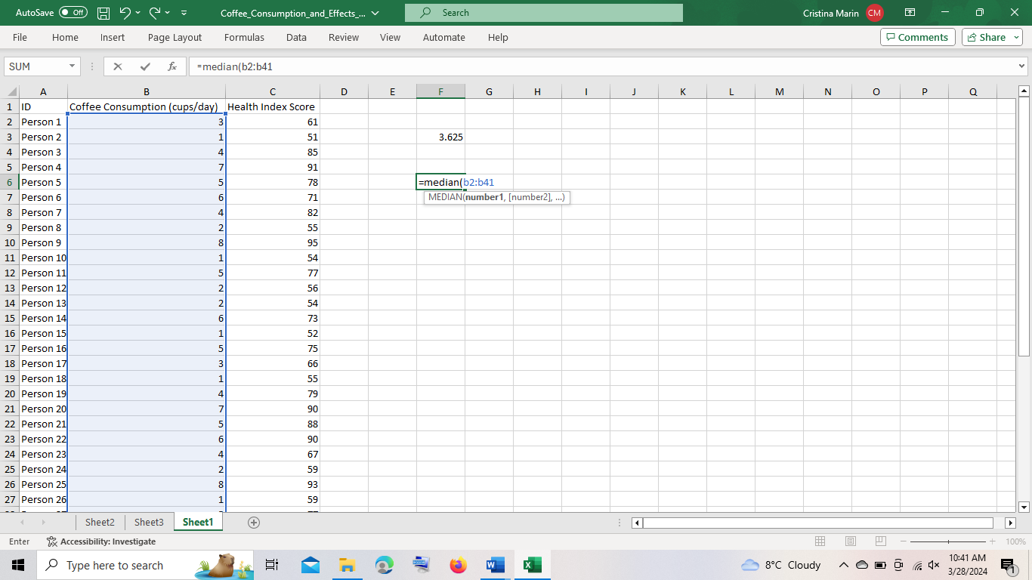
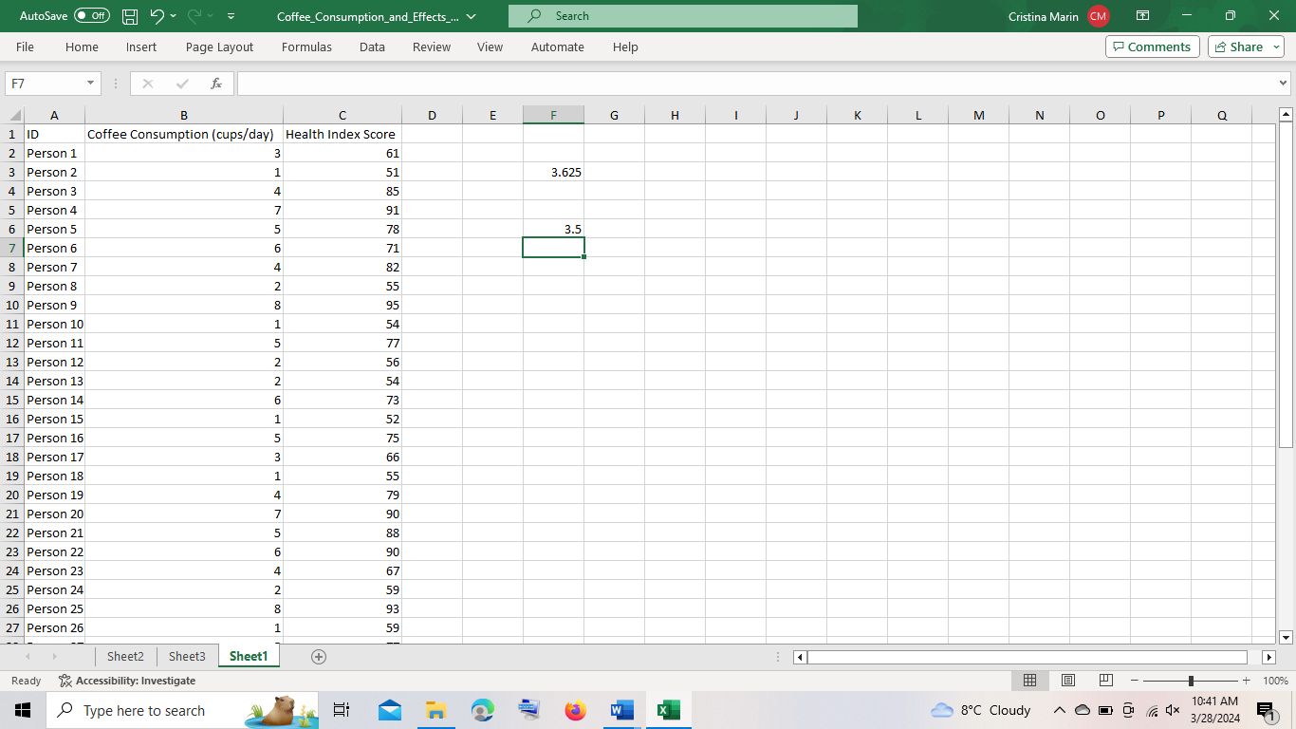
The median value of coffee consumption in cups per day is 3.5.
3. Mode is a repetitive value in a range of data as it is explained in Microsoft Excel.
To do that we call the function entering = then mode, open a bracket ,first cell needed through the second cell(=b2:b41) ,close the bracket press enter.
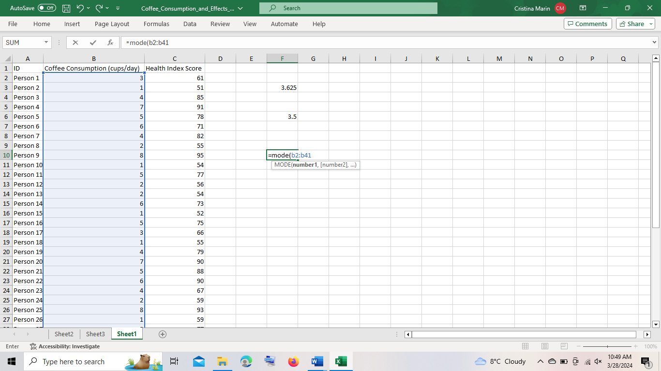
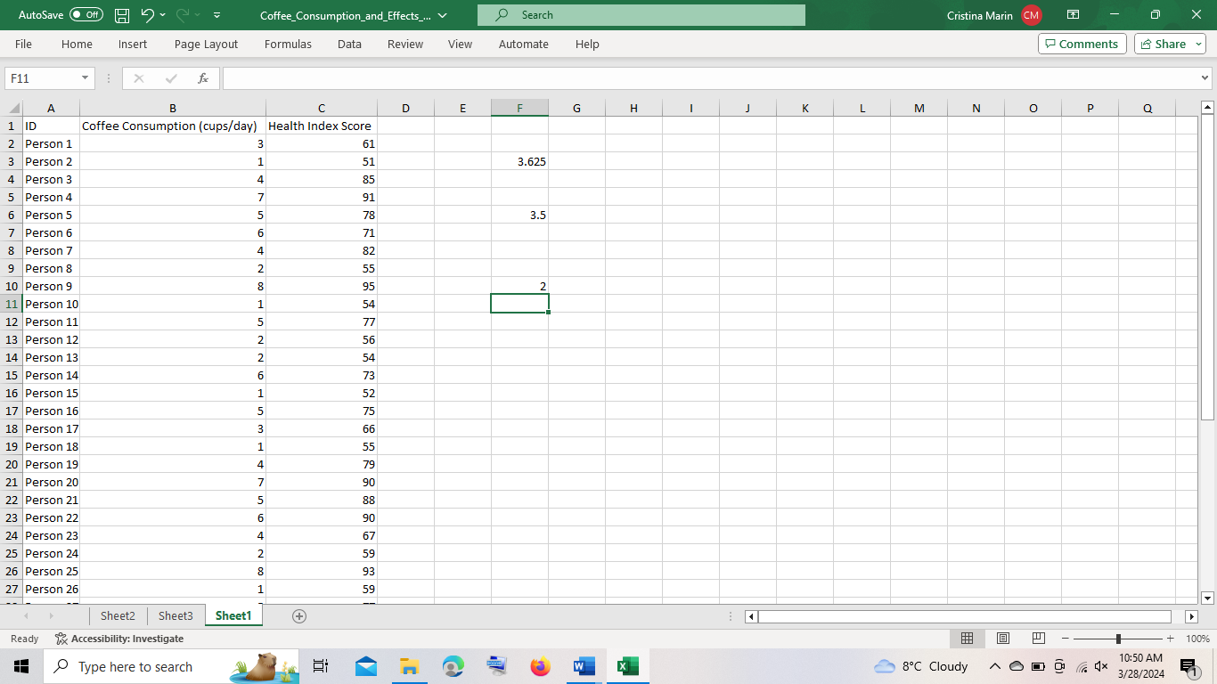

Our given answer for coffee served in cups per day is 2.
4. Standard deviation is the average sum of flexibility in a data set, it returns a normalized value from a division illustrated by a mean and standard deviation.
Call the function,= write stdev, it will give a list to choose from ,each one is vaguely different from which you can get almost the same results ,we selected STDEV.S double click on it and carry on in the same way , open a bracket type first cell needed through the second one (c2:c41)
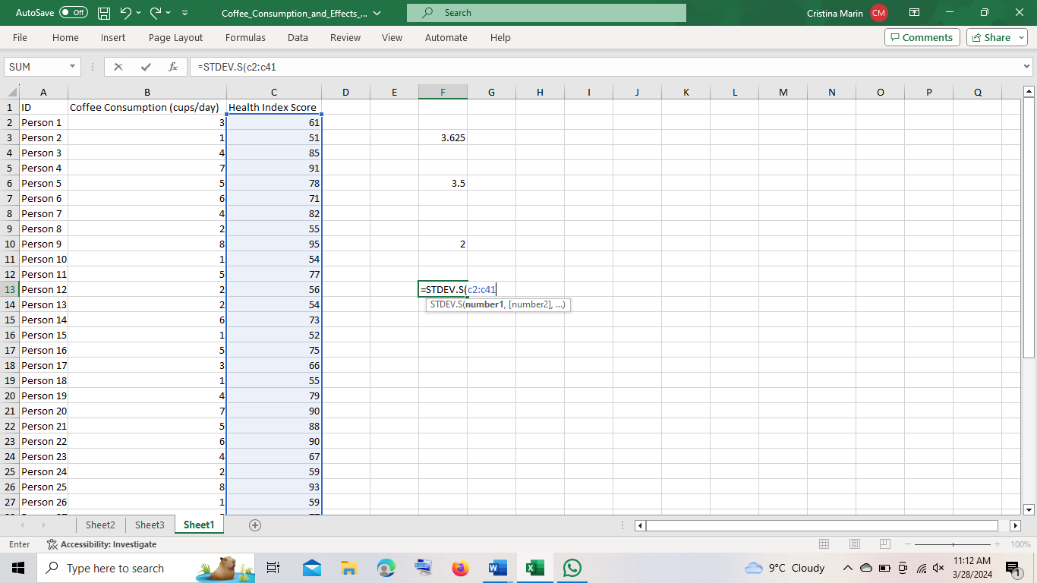
Tap enter and our answer is 13.41237
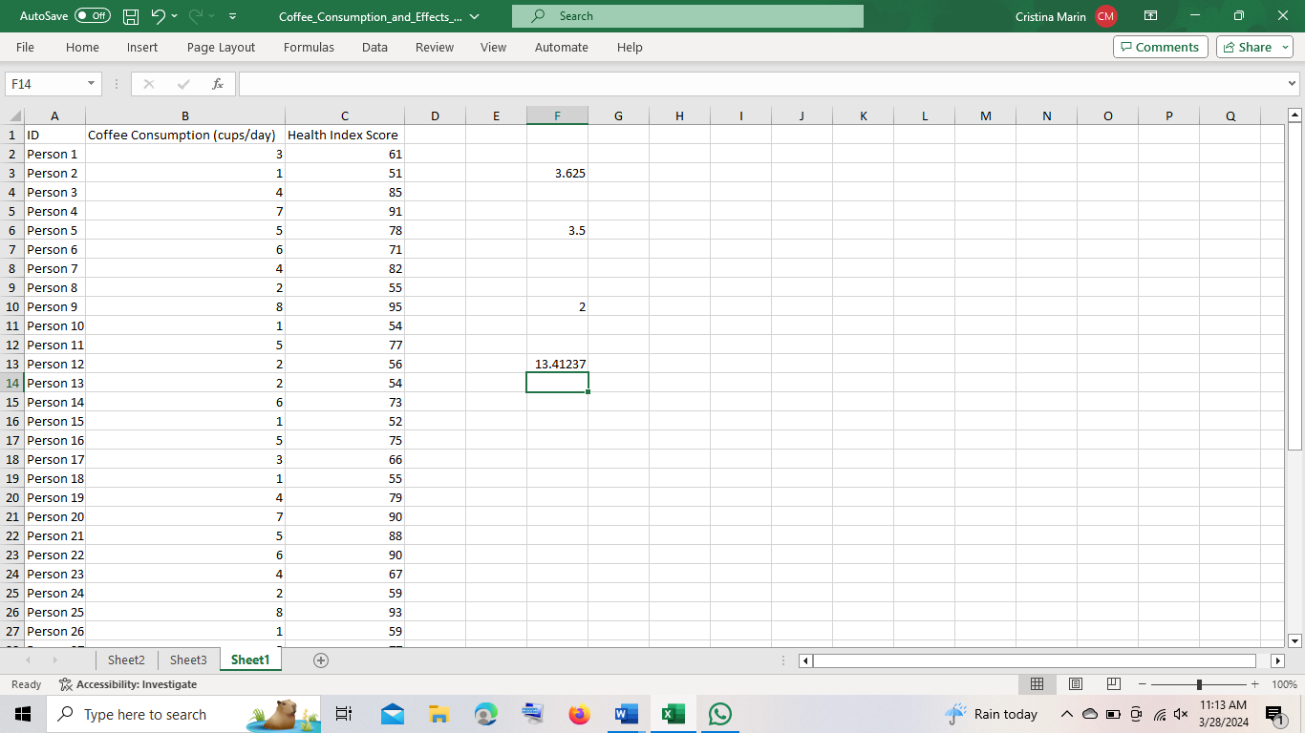
5.Variance is a measure of variability between numbers in a data set. The more spread the data, the larger the value is in relation to the mean .Starting by finding which are the variances: first one will be variance over coffee consumption: call the function “=” tap var and select by double click on var.s open brackets type the needed cells ,nr1 :nr 2 press enter(=var.s(b1:b41))
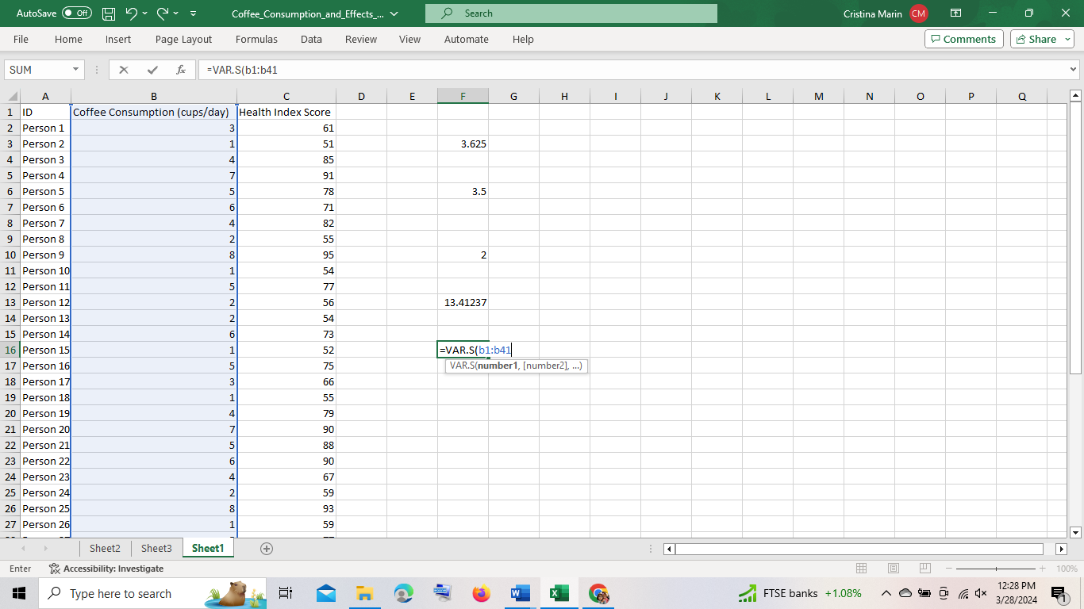
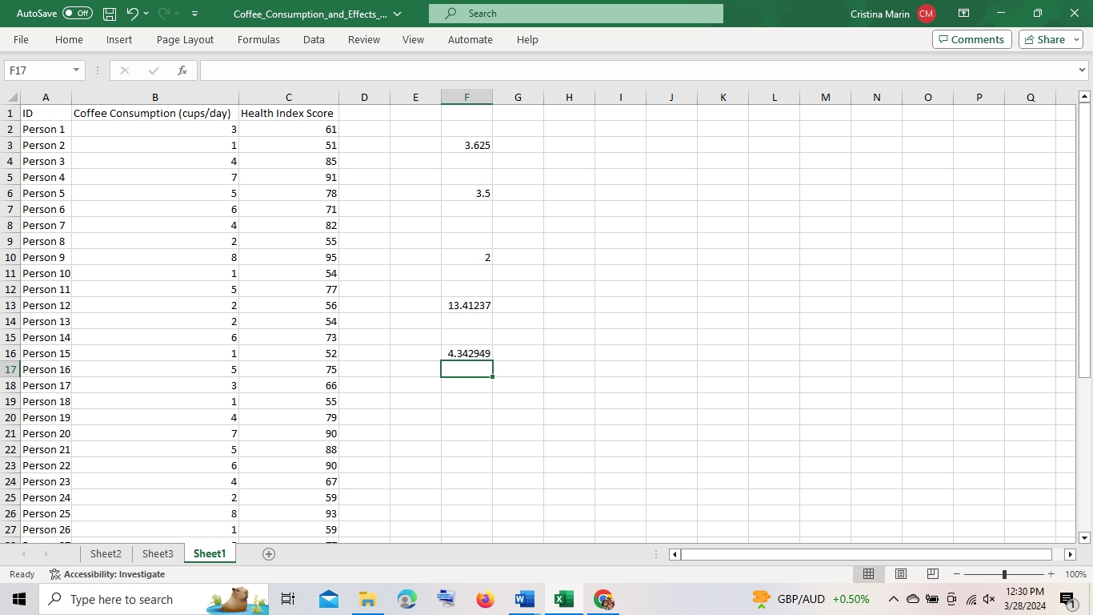
4.342949
Health index variance :=var.s(c2:c41)
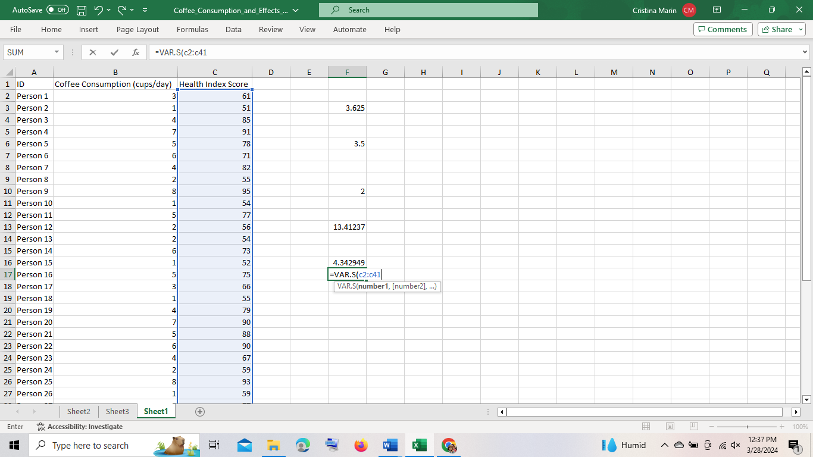
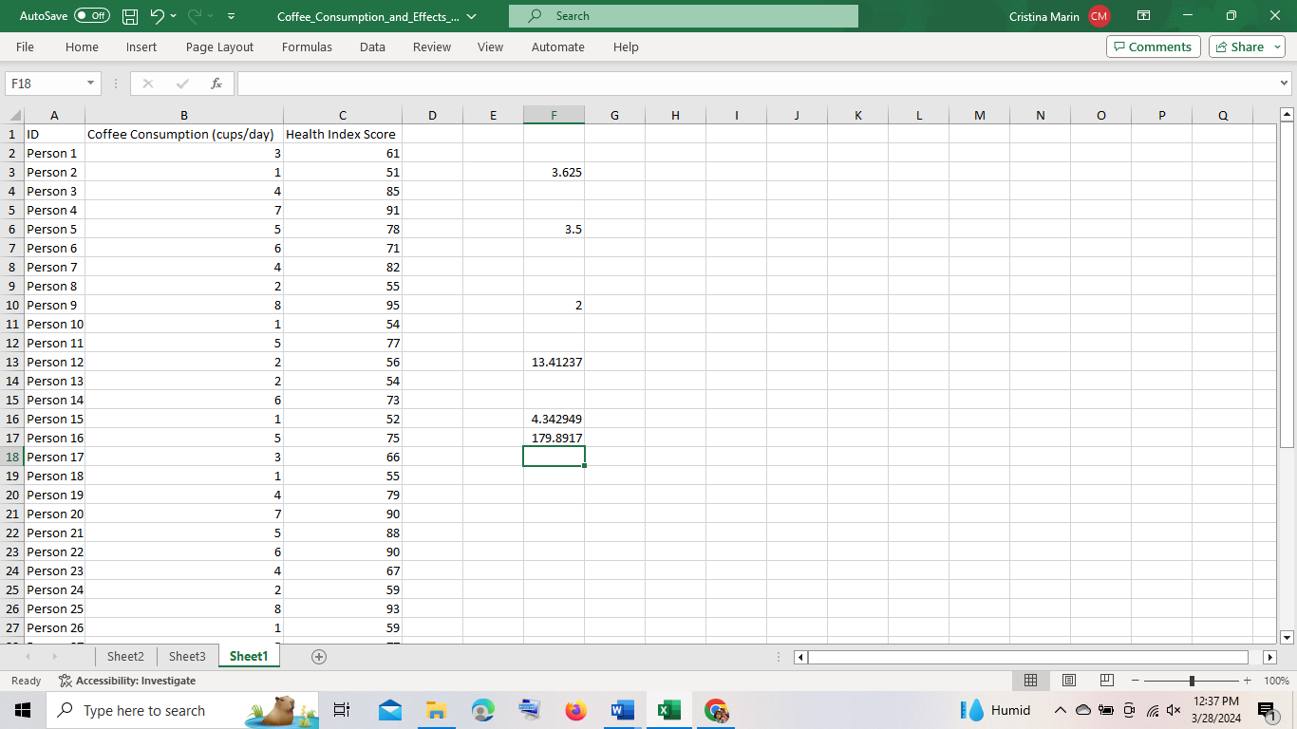
179.8917.
6.Standard deviation for Coffee Consumption:2.083974
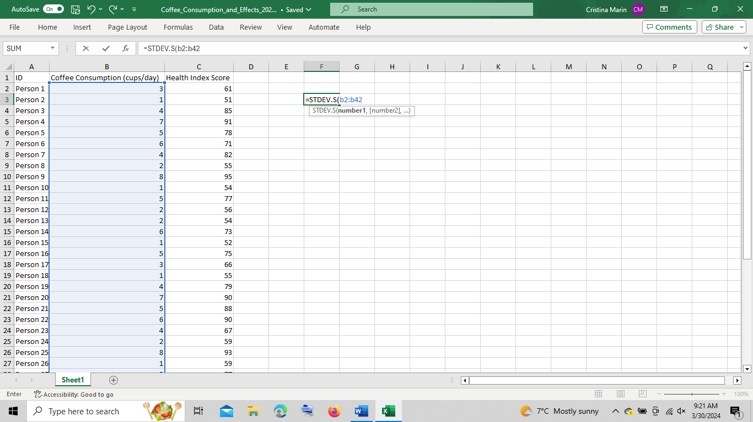
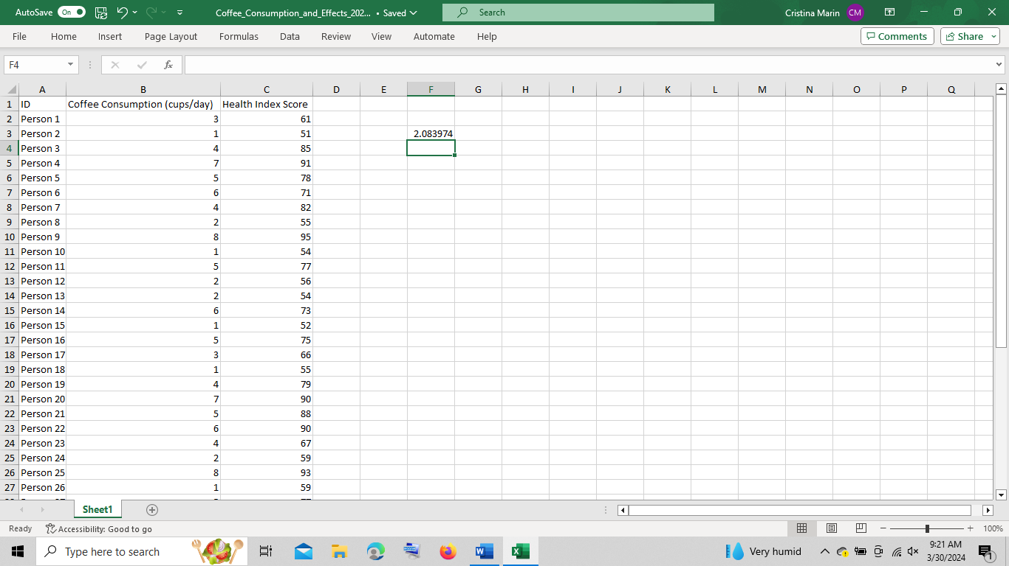
Standard deviation for the Health Index Score:13.41237

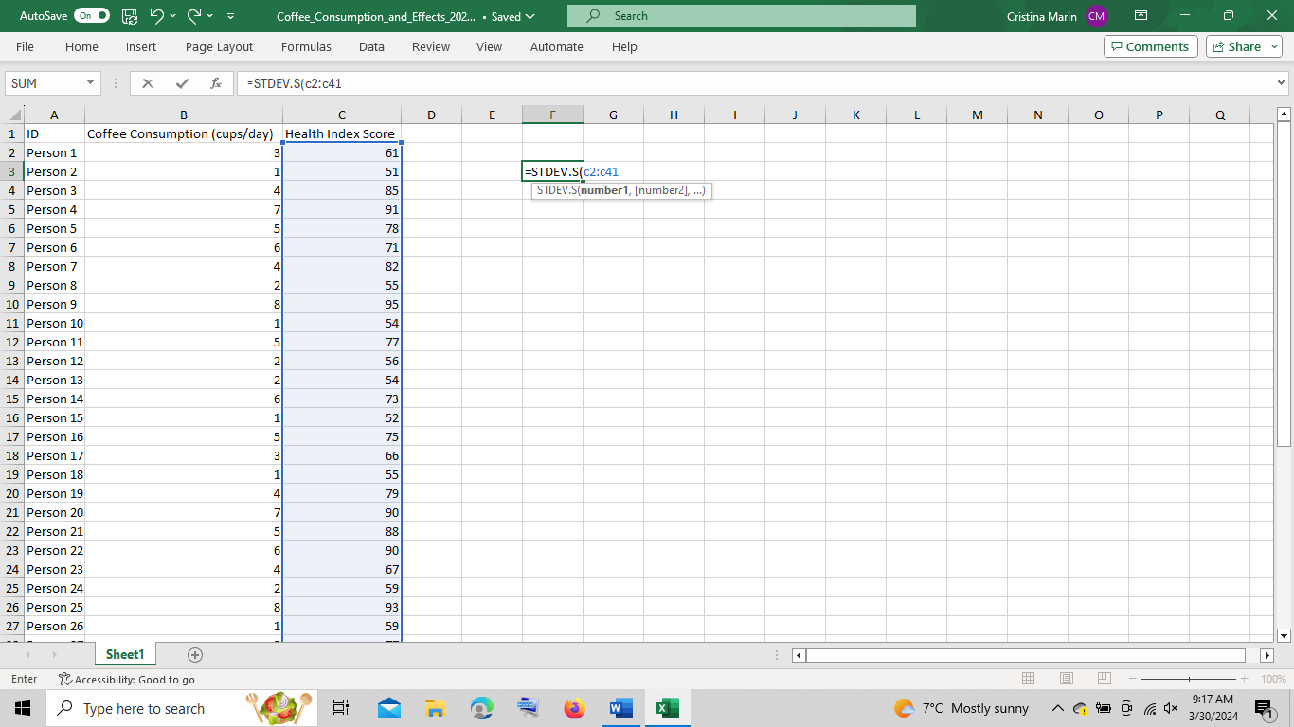
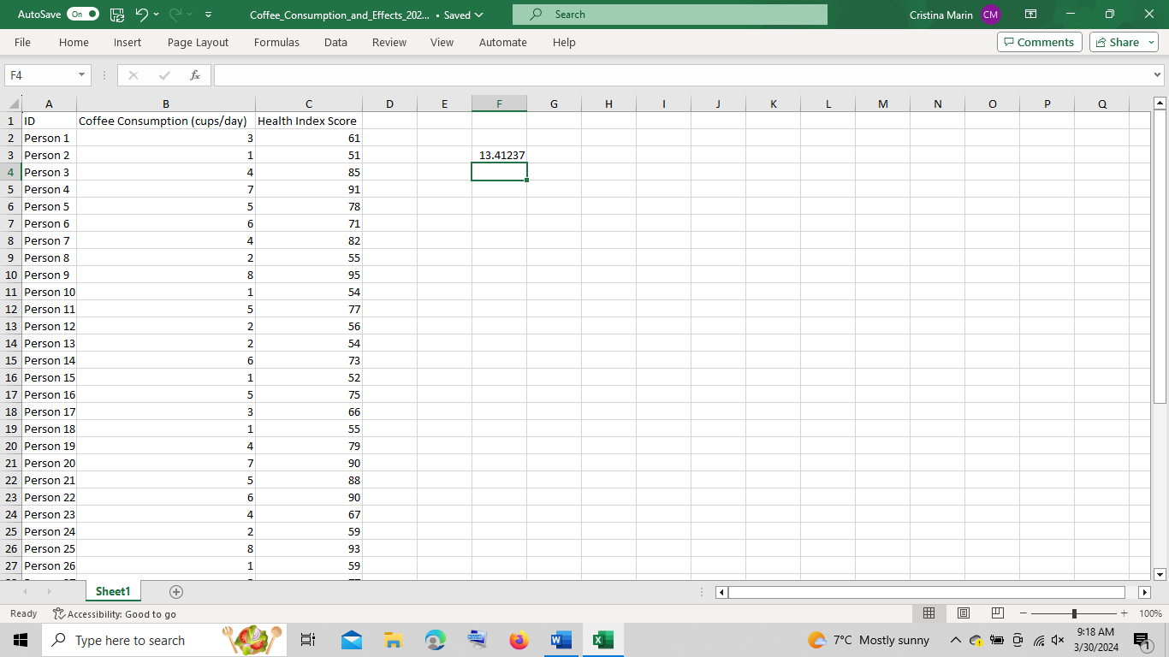

The standard deviation for "Coffee Consumption (cups/day)" is approximately 2.08, while the standard deviation for "Health Index Score" is approximately 13.41. This means the "Health Index Score" variable has a larger standard deviation compared to the "Coffee Consumption (cups/day)" variable.
7.Interpret the last three outcomes:
- Person 38 consumed 3 cups of coffee per day and had a Health Index Score of 73.
- Person 39 consumed 4 cups of coffee per day and had a Health Index Score of 86.
- Person 40 consumed 2 cups of coffee per day and had a Health Index Score of 59.
These outcomes suggest a variety of coffee consumption patterns and associated health index scores, which might indicate the relationship between coffee consumption and the perceived health outcomes for these individuals.
Part B.
If function.
IF function allows you to make a logical comparison between a value and what you expect by testing for a condition and returning a result if that condition is True or False (Microsoft, 2021). To understand the numbers of coffee cups served in a day and the impact over Health Index Score we use the following:
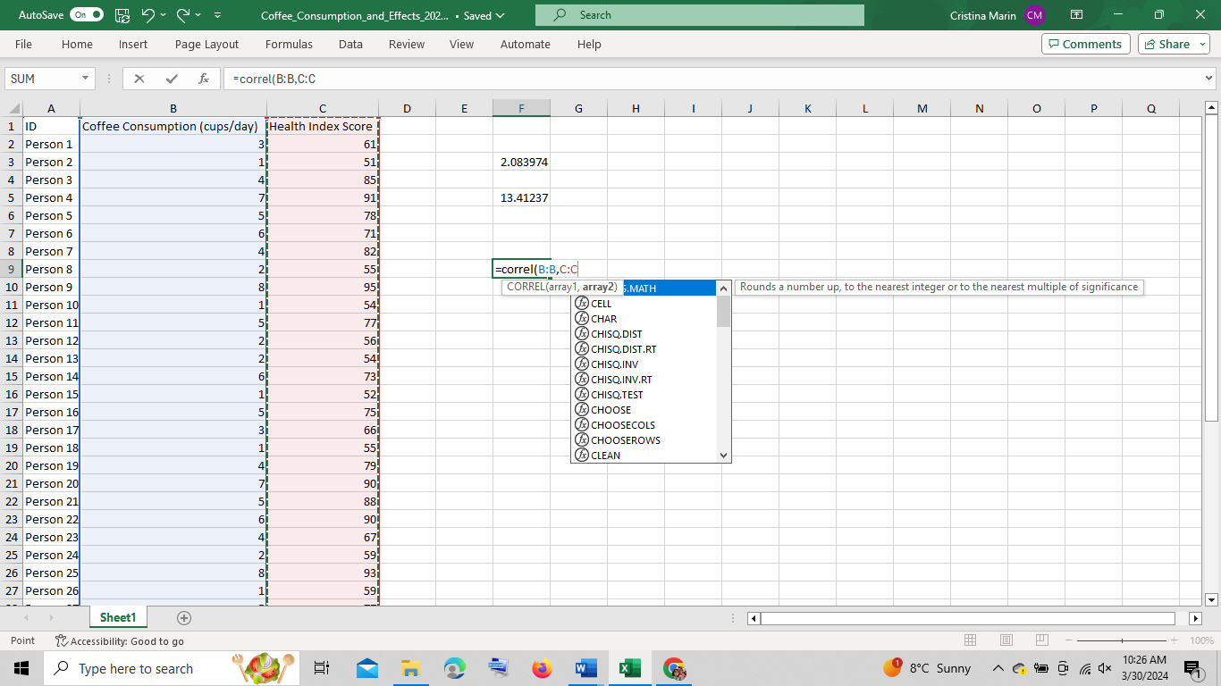
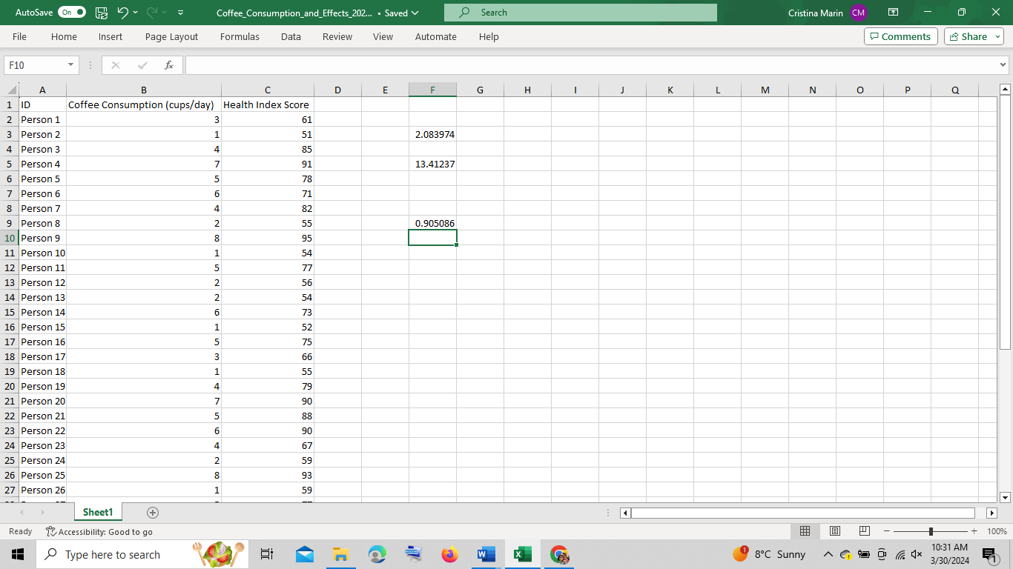
A correlation value closer to 1 signifies a strong association between the variables. A correlation coefficient of 0.90 indicates a close dependency between the number of cups consumed per day and the Health Index Score. Any increase of coffee intake is likely to affect the Health Index.
In conclusion our analysis of coffee consumption has provided valuable insight into daily coffee intake and human health. Utilizing Microsoft Excel have been covered several significant findings .These findings emphasize the importance of moderation in coffee consumption and recommendations based on individual health profiles.
Part C.
SPSS.
Beside Microsoft Excel there are other options of data processing one of them is SPSS and in our data, this will help in finding the correlation between coffee consumption and health index score, as follows :
a. Import the needed data onto SPSS
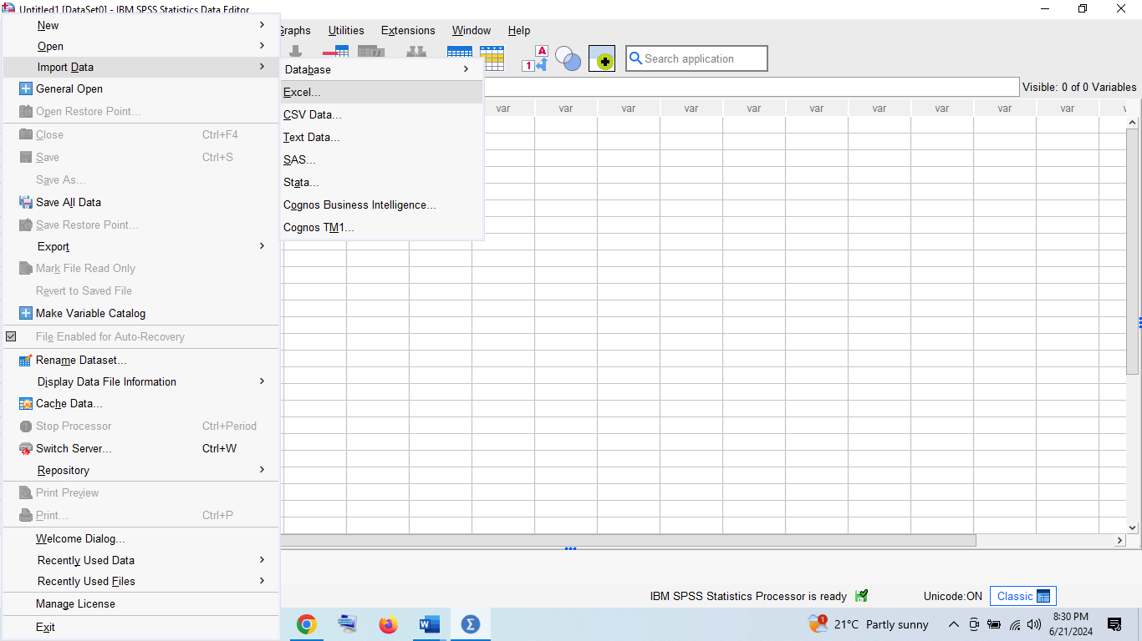
Ok to confirm,
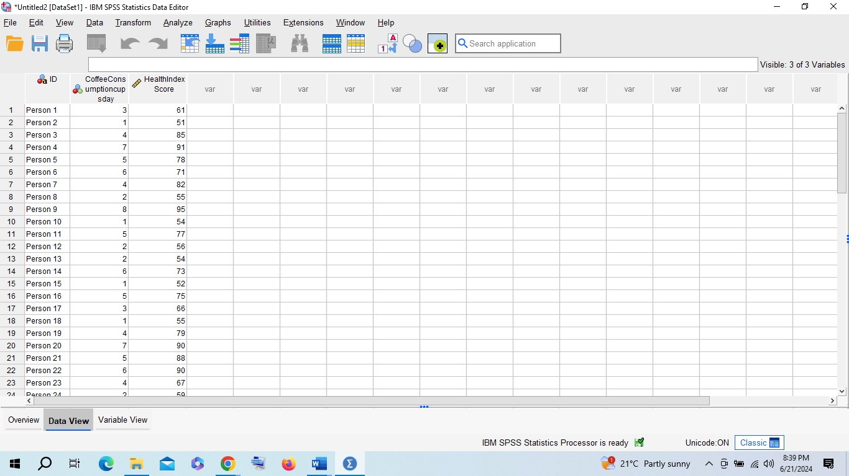
b. Click on “analyze” section from there “correlate” and choose “bivariate”:
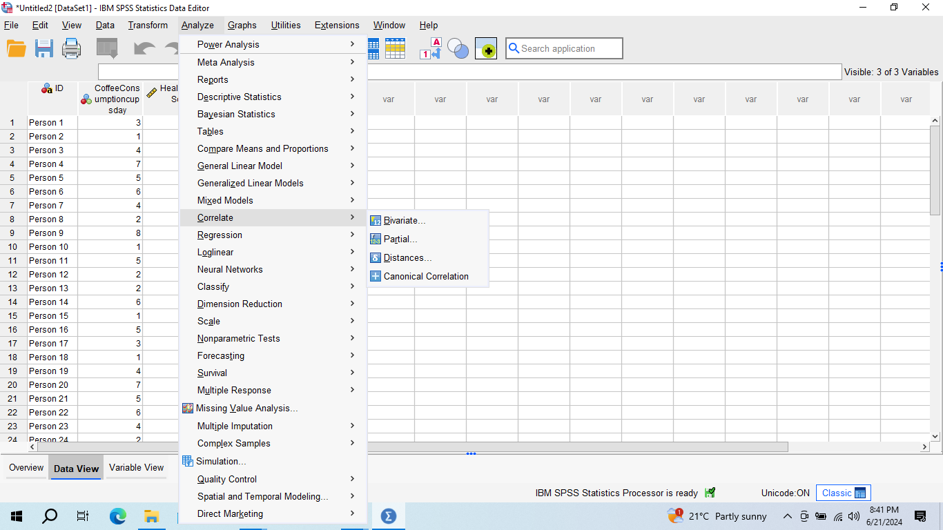
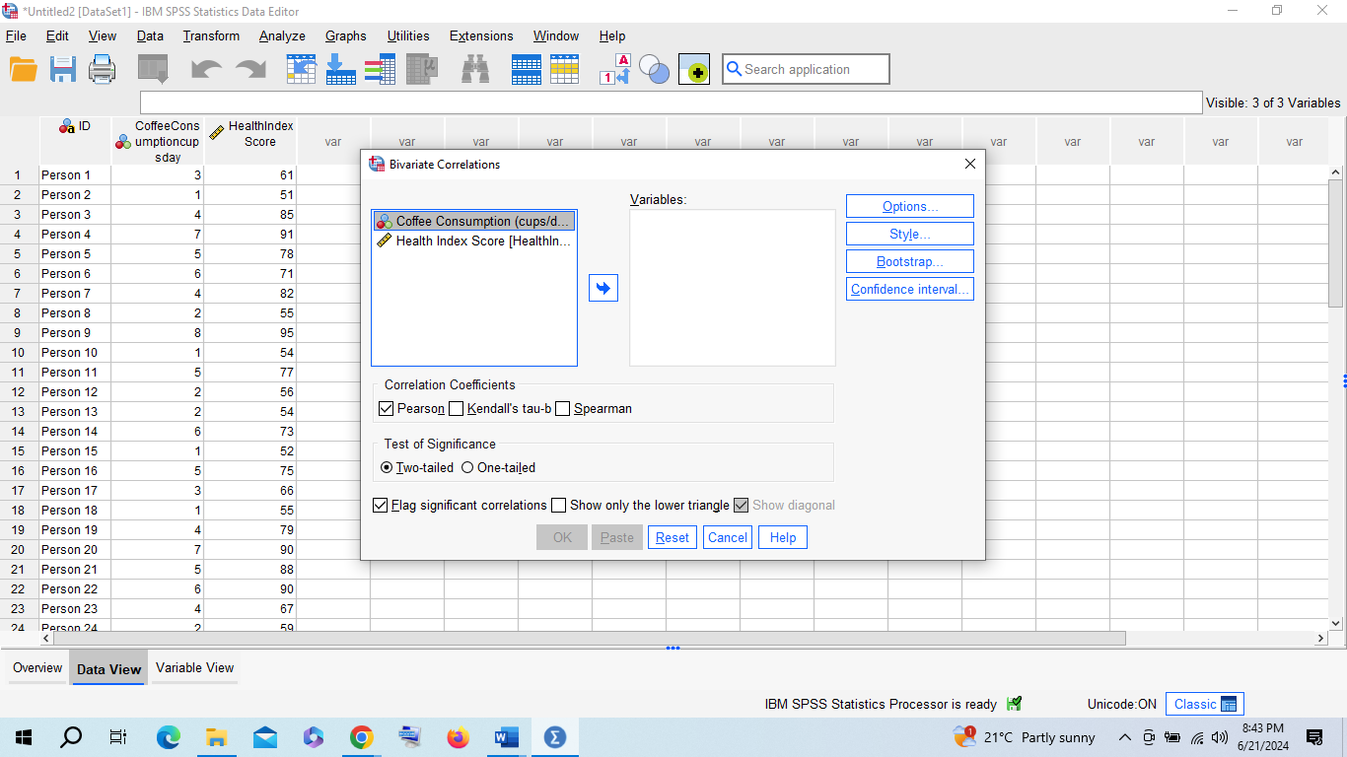
c. Drag the variables on the empty box, where variables are then click options and if you press “means and standard deviations “
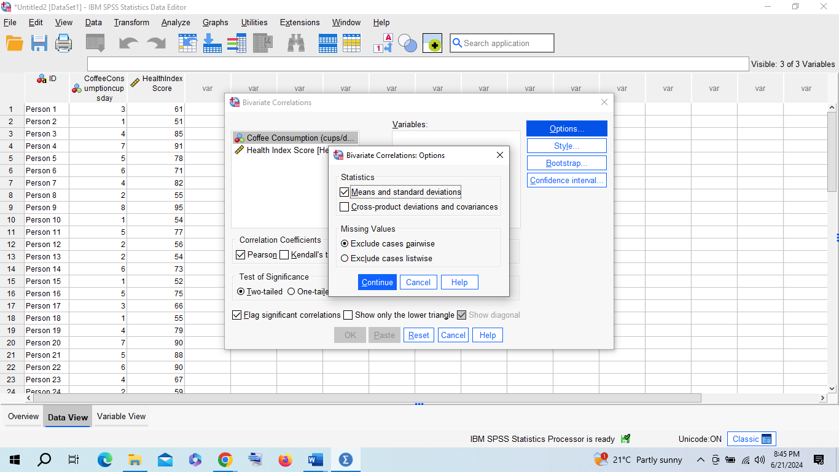
followed by continue than ok ,the result will be the one below:
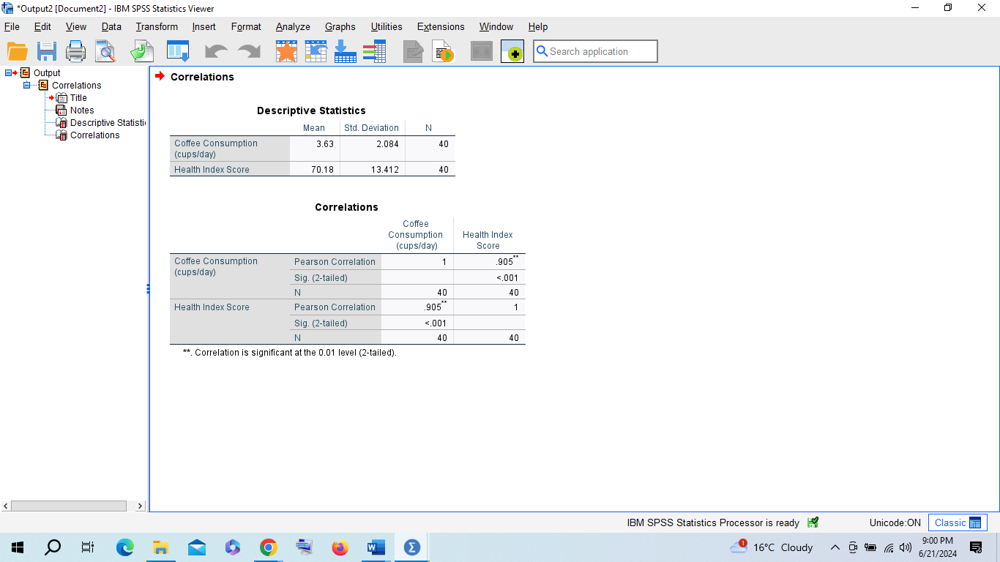

The result of the table format can be interpreted :the correlation of each variable is 1 whilst the correlation between both is 0.90, meaning that the 2 variables are correlated between them.
Scatterplot using SPSS:
We begin by choosing from “graphs”
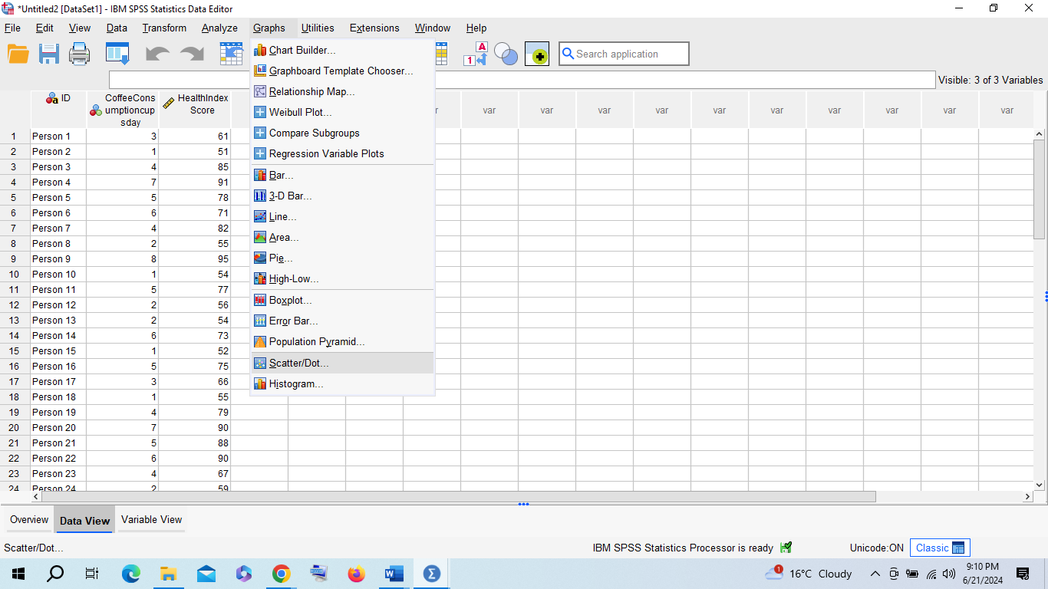
Then click on “scatter/dot
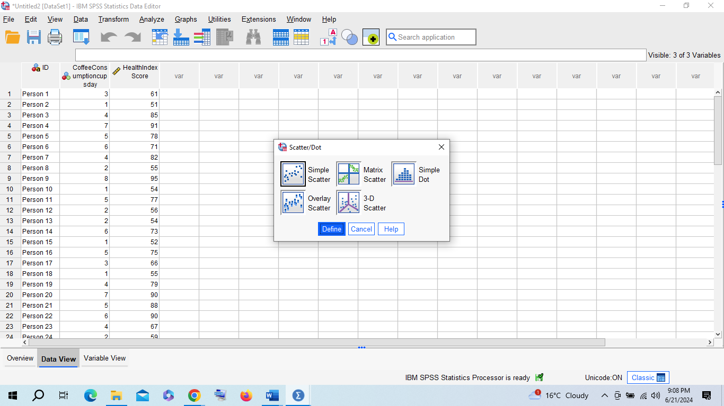
Tap define, drag the variables into the needed section( “y” and “x”) :
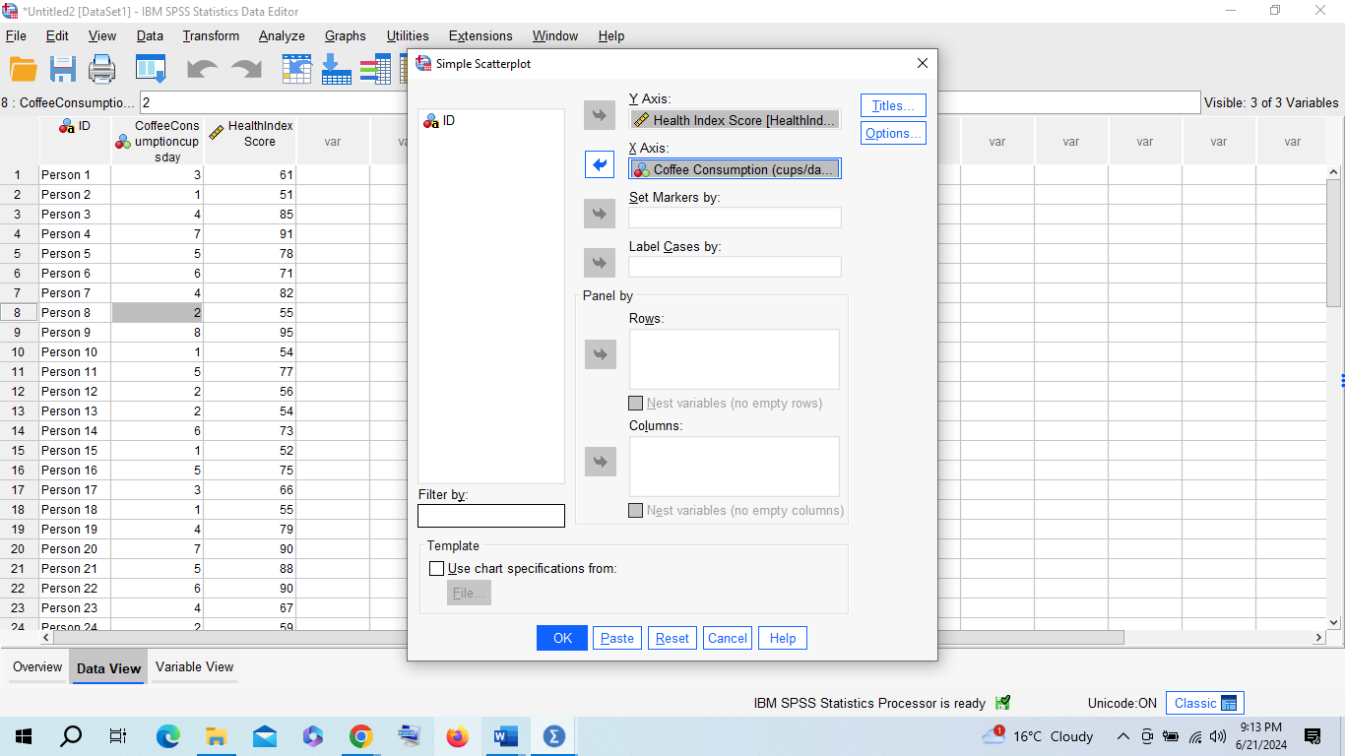

Click ok:
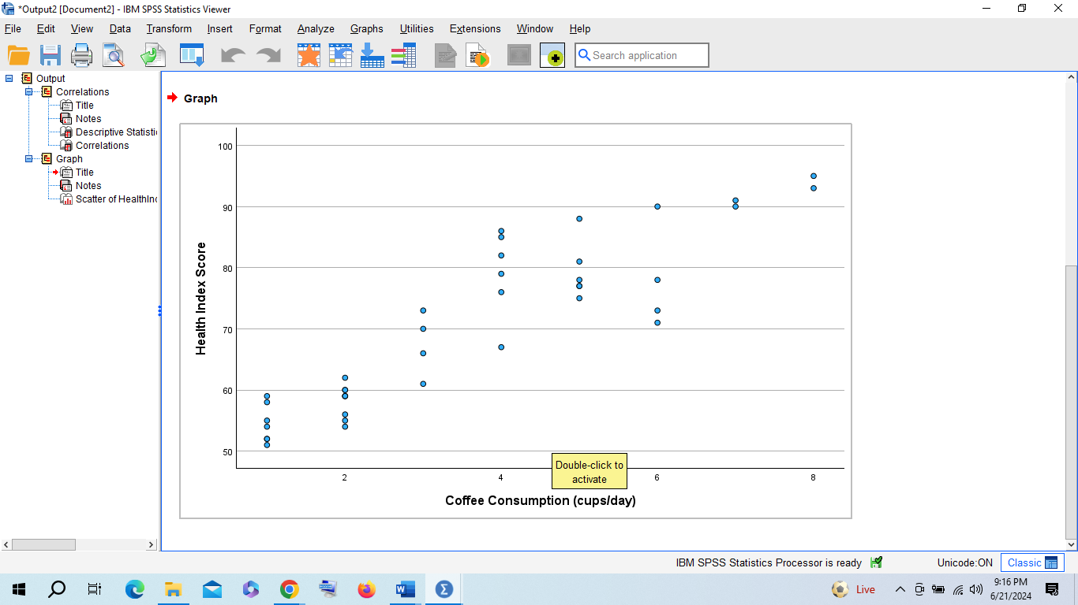
From SPSS software we can notice the same result as on “if” function .The health index score value remains 0.90 and the interdependency between those variables is evident, considering that if the numbers of cups consumed by an individual per day increases so performs the health index score.

Section 2.

Introduction
In today's data-driven world, extracting insights from information is crucial for informed decision-making. This paper explores three key tools for data analysis: statistical software (SPSS), spreadsheets (Excel), and data visualization software (Tableau). Each of these tools offers unique advantages and disadvantages, which will be examined through practical examples of their functionalities. Statistical software like SPSS is notorious for its vigorous analytical capabilities, making it a preferred choice for complex statistical analysis and hypothesis testing. Spreadsheets such as Excel are highly adaptable, widely accessible, and ideal for managing and manipulating large datasets, performing basic statistical operations, and creating pivot tables. Data visualization software like Tableau excels in transforming raw data into intuitive and interactive visualizations, helping users to quickly identify trends and patterns.
In addition to looking at these tools, this essay will explore the concept of the Data Mining Cycle, an essential framework for systematically extracting valuable insights from large datasets.

SPSS
According to Contributor(2018), SPSS, which stands for Statistical Package for the Social Sciences, is a commonly used software for statistical analysis in social science. It is particularly popular among researchers for its ability to handle large datasets and perform complex statistical analyses. One of the key advantages of SPSS is its user-friendly interface, which includes a menu-driven command interface and an option to run analyses through a simple, intuitive graphical user interface. For instance, researchers can use SPSS to conduct various types of regression analyses, ANOVA, and factor analysis with no difficulty, allowing them to focus more on interpreting results rather than the complexities of coding (IBM, 2021) .

Advantages:
SPSS is designed for complex statistical analysis, particularly in the social sciences. Its user-friendly interface with menu-driven commands makes it accessible for users with varying levels of statistical expertise. Regular updates ensure that the software incorporates the latest statistical techniques, constantly improving its functionality and effectiveness for researchers. For example: ANOVA (Analysis of Variance) is a statistical method used to compare the means of three or more groups to see if there are significant differences among them. It helps determine if the observed variations between group means are due to actual differences or simply random chance. For example, in a study examining the effect of different diets on weight loss, researchers might divide participants into three groups, each following a different diet (Diet A, Diet B, and Diet C). After a certain period, they measure the weight loss for each participant. Using ANOVA, they can analyze the data to determine if there are significant differences in the mean weight loss among the three diet groups. If the analysis shows significant differences, researchers can conclude that the type of diet impacts weight loss (IBM, 2021).

Disadvantages
Despite its advantages, SPSS is associated with a high cost, which makes it less available for individuals and small institutions. Additionally, it is less flexible in advanced statistical modeling compared to more flexible software like R or Python. Moreover, SPSS can be potentially inefficient when handling very large data sets, limiting its utility in data-intensive research scenarios. SPSS's limitations can be seen in a small nonprofit organization conducting a large-scale survey to evaluate community health needs. Due to the high cost of SPSS licenses, the organization may struggle to afford the software, making it less accessible for their project. Furthermore, it lacks the flexibility in advanced statistical modeling offered by software like R or Python. This limitation becomes evident when the organization attempts to implement complex machine learning algorithms or custom statistical models, which are more easily handled by R or Python. Additionally, when dealing with a very large dataset from their extensive survey, SPSS might become inefficient and slow, complicating the data analysis process and hindering timely decision-making (IBM, 2021).

Microsoft Excel
According to Microsoft (2021), Excel stands as a leading spreadsheet software widely utilized across various sectors including business, academia, and by individual users for an array of data processing and analysis tasks. Recognized for its user-friendly interface, Excel offers a comprehensive suite of intuitive tools that facilitate efficient data management and analysis. Among these tools, pivot tables are particularly notable for their ability to summarize large datasets, allowing users to quickly extract meaningful insights. The formula functions in Excel cover a broad spectrum, ranging from basic arithmetic operations to complex statistical analyses, thereby accommodating the needs of both novice users and advanced data analysts. As well, Excel's vigorous data visualization options, such as charts and graphs, empower users to present their data in a visually appealing and easily interpretable manner. This combination of powerful features and ease of use makes Excel a versatile tool that is accessible to users regardless of their level of expertise in data analysis. The software's widespread adoption and continued evolution underscore its significance as an indispensable tool in the range of data processing and analysis (Microsoft, 2021).

Advantages
It is highly useful, making it suitable for a range of tasks such as data entry, budgeting, and statistical analysis. Its user-friendly design includes features like pivot tables and various data visualization options, enhancing its functionality and ease of use. As a part of the Microsoft Office suite, Excel is also widely accessible to users. For instance, a local bookstore can use Excel to manage inventory by keeping track of stock levels and sales data. With pivot tables, the store owner can easily summarize monthly sales by category, identifying bestsellers and slow-moving items. The various data visualization options in Excel, such as bar charts and line graphs, authorize the owner to create visual reports that track sales trends and seasonal variations, allowing him to efficiently handle these tasks without requiring advanced technical skills (Microsoft, 2021).

Disadvantages
The software faces challenges when handling very large datasets and is limited in advanced statistical capabilities compared to specialized software. Additionally, the reliance on manual processes for data management and analysis increases the risk of errors. A practical example of Excel's limitations can be seen in the financial industry, where large datasets are common. For instance, an investment firm managing extensive portfolios might struggle with Excel when processing millions of rows of transaction data due to performance issues. Moreover, while Excel can perform basic statistical analyses, it falls short compared to specialized software like R or SAS, which offer more sophisticated statistical modeling capabilities. This limitation can lead to inefficiencies and inaccuracies in financial forecasting and risk assessment. Additionally, manual data entry and formula creation in Excel can introduce errors, such as the infamous 2012 JPMorgan Chase trading loss, where a spreadsheet error contributed to a $6 billion trading loss (Tom Groenfeldt, 2013).

Tableau
Tableau is a powerful data visualization tool widely used in the field of business intelligence and data analytics. One of its key advantages is its ability to connect to a wide range of data sources, including large and complex datasets, and transform this data into visually appealing and interactive dashboards and reports. Tableau's manageable interface is particularly significant, as it allows users with little to no coding skills to create complex and insightful visualizations. This accessibility democratizes data exploration and analysis, enabling a broader range of users, not just data scientists, to engage with and understand the data. By providing drag-and-drop functionality and an intuitive design, Tableau empowers business professionals, analysts, and decision-makers to derive actionable insights from data without requiring extensive technical knowledge. This capability makes it an invaluable tool for organizations aiming to foster a data-driven culture and improve their decision-making processes.

Advantages
Tableau excels in data visualization and business intelligence, offering robust tools for connecting to a wide range of data sources, including those that are large and complex. Its capacity to transform raw data into visually appealing and interactive dashboards and reports is one of its defining strengths. Notably, Tableau's interface is designed to be highly accessible, allowing users without any coding skills to create sophisticated and insightful visualizations. This ease of use ensures that a broad spectrum of individuals, from business professionals to analysts, can effectively engage with data. By simplifying the process of data analysis, Tableau enables organizations to foster a data-driven culture and make more informed decisions based on the insights derived from their data, namely a large retail company's marketing department. The team uses Tableau to connect to diverse data sources like sales databases and social media metrics, transforming this raw data into interactive dashboards. These visualizations highlight key performance indicators and customer trends, promoting professionals without coding skills to create these visual reports, enabling quick identification of successful strategies and areas for improvement. This fosters a data-driven culture and supports informed decision-making within the organization (Tableau, n.d.).

Disadvantages
The software can be quite expensive, which might make it challenging for small businesses and individual users to afford it. It doesn't have as many advanced analytical features compared to dedicated statistical software. Before using it, you'll likely need to store and prepare your data separately. Tableau's limitations can be observed in a small startup trying to analyze its customer data. Due to Tableau's high cost, the startup struggles to justify the expense, making it difficult for them to afford the software. Additionally, while Tableau excels in data visualization, it lacks the advanced analytical features found in dedicated statistical software like SPSS or R, limiting the startup's ability to perform complex data analyses. Before using Tableau, the startup's team also needs to spend significant time storing and preparing their data in separate tools, which adds to their workload and delays the data analysis process (Holistics, 2021).

Data Mining Cycle
Data mining refers to the process of discovering patterns, correlations, anomalies, and insights within large datasets through computational algorithms. It involves extracting meaningful information from raw data to uncover hidden patterns and relationships that can be used to make informed decisions and predictions. Data mining techniques typically include statistical analysis, machine learning algorithms, and visualization tools to sift through large volumes of data and derive valuable insights that may not be immediately apparent through traditional analysis methods (Alexandra Twin, 2024).
The Data Mining Cycle encompasses various stages, including data collection, preprocessing, analysis, and interpretation, which collectively ensure a comprehensive approach to data analysis. By understanding and utilizing these tools and frameworks, individuals and organizations can significantly enhance their ability to make informed, data-driven decisions.
This cycle begins with “Business Understanding“ phase, where the objectives and requirements of the project are defined from a business perspective.
This is followed by the “Data Understanding” phase, where initial data collection and exploration take place to become familiar with the data, identify data quality issues, and discover initial insights.
Next is the “Data Preparation” stage, which involves cleaning and transforming the raw data into a suitable format for analysis. This may include handling missing values, identifying and removing outliers, and selecting the relevant subset of data.
After data preparation, the “Modeling” phase commences. In this stage, various modeling techniques are applied to the data to identify patterns and relationships. This might involve techniques like clustering, classification, regression, or association rule learning, depending on the nature of the problem.
The 'Evaluation' stage follows, where the results of the modeling are assessed against the business objectives set in the first phase. This step ensures that the model adequately achieves the intended goals and provides valuable insights.
Finally, the 'Deployment' phase involves applying the model to the business environment. This can include integrating the model into business processes, presenting the results to stakeholders, or making strategic decisions based on the insights gained. (IBM, n.d.)
In the retail industry, the data mining cycle is applied to enhance sales by understanding customer purchasing patterns. Initially, in the Business Understanding stage, the retail company identifies the goal of increasing sales through insights into customer behavior.
During the Data Understanding phase, the company collects diverse data encompassing customer purchases, demographics, and browsing history. This data is then meticulously prepared in the Data Preparation phase, ensuring it's cleaned and organized for thorough analysis.
Moving to the Modeling phase, the company utilizes techniques like clustering to categorize customers into segments based on their purchasing behaviors. These segments are then evaluated in the next stage to determine their effectiveness in enabling targeted marketing strategies.
Finally, in the Deployment phase, the insights gained from the data mining process are applied practically. The retail company implements tailored marketing strategies for each customer segment, aiming to optimize sales and enhance customer satisfaction based on the analyzed data (Victoria Shakerpeare, n.d.).

Conclusion
In conclusion, the data mining cycle is a comprehensive process that contains a series of systematic steps, starting from understanding the business problem to deploying actionable insights. Each phase plays an important role in ensuring that the data mining process is both effective and aligned with specific business objectives. By following a structured approach, organizations can extract meaningful patterns and insights from large datasets, leading to informed decision-making and strategic advantages.

References:
Alexandra Twin, 2024. Investopedia. [Online]
Available at: https://www.investopedia.com/terms/d/datamining.asp
[Accessed 2024].
Holistics, 2021. Holistics. [Online]
Available at: https://www.holistics.io/blog/tableau-limitations-and-top-alternatives
[Accessed 2024].
IBM, 2021. IBM. [Online]
Available at: https://www.ibm.com/products/spss-statistics
[Accessed 2024].
IBM, n.d. IBM. [Online]
Available at: https://www.ibm.com/docs/en/db2/11.1?topic=studio-data-preparation-in-mining-process
[Accessed 2024].
Microsoft, 2021. [Online]
Available at: https://support.microsoft.com/en-gb/office/using-if-with-and-or-and-not-functions-in-excel-d895f58c-b36c-419e-b1f2-5c193a236d97
[Accessed 26 06 2024].
Tableau, n.d. Tableau. [Online]
Available at: https://www.tableau.com/en-gb/solutions/marketing-analytics#:~:text=Tableau%20helps%20marketers%20see%20and,matters%20most%2C%20in%20real%20time.
[Accessed 2024].
TechTarget contributor, 2018. TechTarget. [Online]
Available at: https://www.techtarget.com/whatis/definition/SPSS-Statistical-Package-for-the-Social-Sciences#:~:text=SPSS%20(Statistical%20Package%20for%20the%20Social%20Sciences)%2C%20also%
[Accessed 2024].
Tom Groenfeldt, 2013. Forbes. [Online]
Available at: https://www.forbes.com/sites/tomgroenfeldt/2013/02/19/solutions-to-spreadsheet-risk-post-jpms-london-whale/
[Accessed 2024].
Victoria Shakerpeare, n.d. Fuelcycle. [Online]
Available at: https://fuelcycle.com/blog/data-mining-market-research/#:~:text=Data%20mining%20can%20also%20provide,in%20addition%20to%20that%20product.
[Accessed 2024].

