University of Wales Trinity Saint David
Wales Institute of Science

Electrical Control Systems
ACHA4010

Cara Williams
2401134
06/04/09

Contents
1 Task 3 1
1.1 Scope Time Division Calculations (3) 1
1.2 Function Generator output square wave (3) 1
1.3 Capacitor charge and discharge wave marked at correct points. (3) 1
1.4 Basic Capacitor Calculations (3) 2
1.5 Capacitor discharge table (2) 2
1.6 Plot log(V) Gradient (2) 3
1.7 Gradient Calculations and Compare (4) 3
1.7.1 Gradient Calculations 3
1.7.2 Comparison table 4
1.8 Capacitor Uses (5) 4
1.9 Inaccuracies Question (4) 4
2 References 5

Task 3

Scope Time Division Calculations (3)
Frequency if wave = 250Hz
T/div = T/10divisions = 4ms/10div = 0.4
T = 1/freq = 1/250 = 0.004 = 4ms
Time /div = 0.4 ms = 400 µs
The student sets the time/DIV to 500 µs because 500 is closest to 400 µs.

Function Generator output square wave (3)

Capacitor charge and discharge wave marked at correct points. (3)
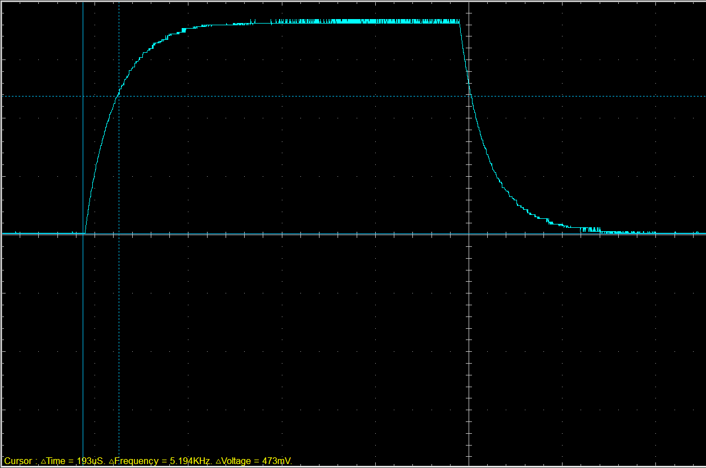Charge 63.2% of peak voltage
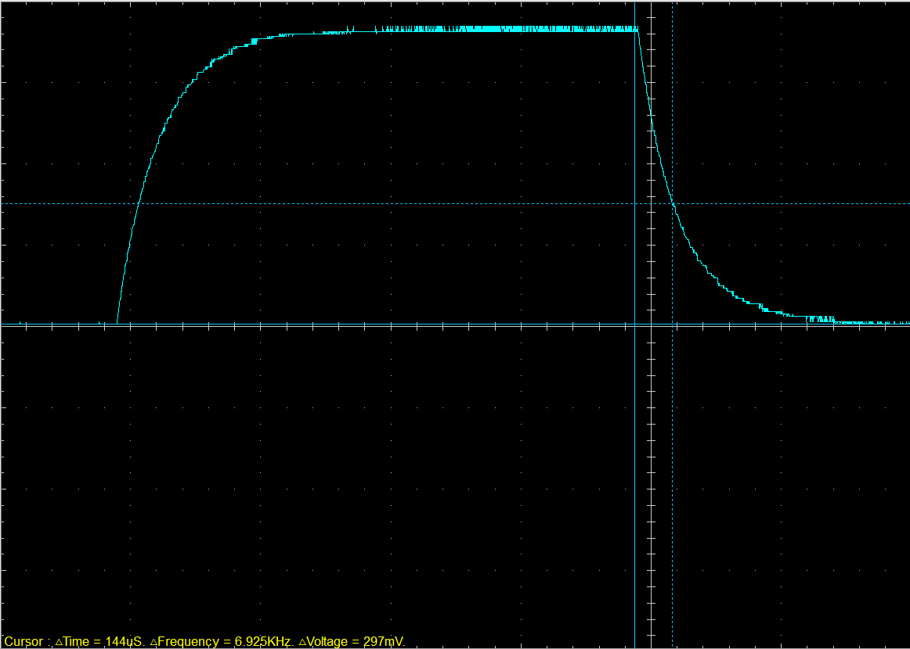Discharge 36.8% of peak voltage

Basic Capacitor Calculations (3)
T = RC
193x10⁻⁶ = 1.93x10⁻⁶ x 100
193x10⁻⁶ / 100 = 1.93x10⁻⁶ = 1.93 µF

Capacitor discharge table (2)
Time (s) | Voltage (V) | ln (V) | dy = y2 – y1  dy = ln(V)2-ln(V)1 | dx = x2- x1  dx = Time2 – Time1 | dy/dx
0.002172 | 0.822 | -0.196014884 | x | x | x
0.00219 | 0.7404 | -0.300564698 | -0.10455 | 0.000018 | -5808.32
0.002208 | 0.6776 | -0.389198136 | -0.08863 | 0.000018 | -4924.08
0.002226 | 0.6149 | -0.486295626 | -0.0971 | 0.000018 | -5394.31
0.002244 | 0.5584 | -0.582679728 | -0.09638 | 0.000018 | -5354.67
0.002262 | 0.502 | -0.689155159 | -0.10648 | 0.000018 | -5915.3
0.00228 | 0.458 | -0.780886095 | -0.09173 | 0.000018 | -5096.16
0.002298 | 0.4204 | -0.86654864 | -0.08566 | 0.000018 | -4759.03
0.002316 | 0.389 | -0.944175935 | -0.07763 | 0.000018 | -4312.63
0.002334 | 0.3639 | -1.010876174 | -0.0667 | 0.000018 | -3705.57

Plot log(V) Gradient (2)
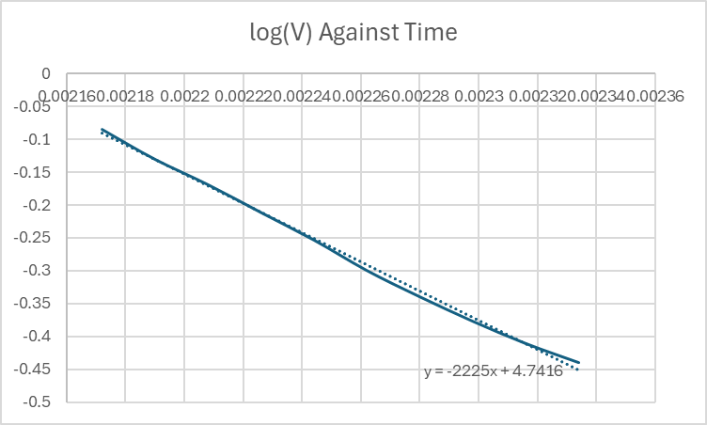
Gradient = -2225

Gradient Calculations and Compare (4)

Gradient Calculations
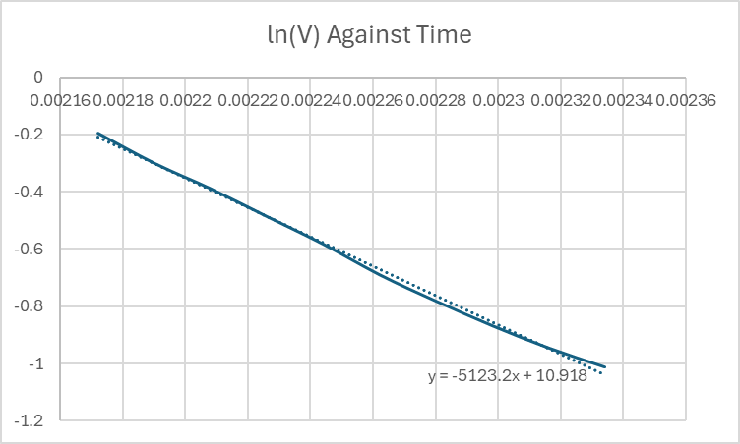
Gradient = -5123.2
Gradient Calculations – (1/5123.2) / 100 = 1.95 x10⁻⁶

Comparison table
 | Capacitance | Delta | Percentage difference
Actual | 1 µF | x | X
Marker Calculation | 1.93 µF | +0.93 µF | +93%
Gradient Calculation | 1.95 µF | +0.95 µF | +95%
Marker calculation – 193x10⁻⁶ / 100 = 1.93x10⁻⁶

Capacitor Uses (5)
Common uses of capacitors consist of:
- Power conditioning; it can be used to filter out spikes or dips in power outputs for example in AC or DC circuits. (Electronics Tutorials, 2021.)

- Energy storage; capacitors store electrical energy this is good for delayed power outputs such as defibrillators where a large discharge of energy is needed. (All About Circuits, 2022.)
- Signal Filtering; Capacitors can block DC while allowing AC signals to pass, used in radio, audio, and TV circuits i.e. High-pass or low-pass filters in audio equipment. (SparkFun, 2014.)
- Coupling and Decoupling; Coupling Allows AC signals to pass between stages of an amplifier while blocking DC and decoupling prevents noise from one part of a circuit affecting another. (Analog Devices, 2008)
- Timing and Wave Shaping; In RC (resistor-capacitor) circuits, capacitors control the timing or shape of electrical signals. For example oscillators and timers. (Electronics Notes, 2012)
- Motor Starters to provide an extra phase shift to help single-phase induction motors start.
- Power Factor Correction; Improves efficiency in AC power systems by compensating for inductive loads. (EE Power, 2015.)
- Snubber circuits: Protect switching devices (like transistors or thyristors) from voltage spikes by absorbing energy used in power electronics, such as motor drives and switching power supplies. (Texas Instruments, 2002)
- Touch sensors; Capacitive touchscreens detect changes in capacitance when a finger touches the surfaces used in Smartphones, tablets, and touch-sensitive buttons. (HowStuffWorks, 2018)
- Resonant circuits: used in LC (inductor-capacitor) circuits to select or reject specific frequencies. Used in Radios, transmitters, and other communication devices. (Electronics Tutorials, 2018.)

Inaccuracies Question (4)
Differences between the calculated and actual capacitance values are quite common and usually caused by measurement issues. The main reason is that resistors and capacitors aren't always exactly the value written on them i.e. they usually have a tolerance of ±5% or more, which can affect the RC time constant.
Another contributing factor is the oscilloscope probe itself. When you connect it to the circuit, it can slightly change the behaviour of the signal by adding a small amount of resistance or capacitance. Additionally, trying to find the exact voltage point, like 63.2% during charging, can be tricky and may lead to small errors.
Other things like electrical noise, temperature changes, or the oscilloscope not triggering at the right time can also affect the measurements. If the oscilloscope’s settings aren’t right, or if it doesn’t take samples quickly enough, the waveform can look slightly wrong.
All these factors add up, so it’s normal for your measured capacitance to be a bit different from the theoretical value.

References
- All About Circuits, n.d. Capacitor Applications. [online] Available at: https://www.allaboutcircuits.com/textbook/direct-current/chpt-13/capacitor-applications/ [Accessed 5 Apr. 2025].
- Analog Devices, 2008. Decoupling Capacitors: An Analytical Approach. [online] Available at: https://www.analog.com/en/analog-dialogue/articles/decoupling-capacitors-an-analytical-approach.html [Accessed 5 Apr. 2025].
- Electrical4U, 2012. Capacitor Start Motors. [online] Available at: https://www.electrical4u.com/capacitor-start-motor/ [Accessed 5 Apr. 2025].
- Electronics Notes, n.d. RC Circuit Basics. [online] Available at: https://www.electronics-notes.com/articles/analogue_circuits/rc-circuit/resistor-capacitor.php [Accessed 5 Apr. 2025].
- Electronics Tutorials, n.d. Capacitor Tutorial. [online] Available at: https://www.electronics-tutorials.ws/capacitor/cap_1.html [Accessed 5 Apr. 2025].
- Electronics Tutorials, n.d. Resonant Circuits. [online] Available at: https://www.electronics-tutorials.ws/resonance/res_1.html [Accessed 5 Apr. 2025].
- EE Power, n.d. Power Factor Correction. [online] Available at: https://eepower.com/capacitor-guide/applications/power-factor-correction/ [Accessed 5 Apr. 2025].
- HowStuffWorks, n.d. How Capacitive Touchscreens Work. [online] Available at: https://electronics.howstuffworks.com/capacitive-touch-screen.htm [Accessed 5 Apr. 2025].
- SparkFun, n.d. Capacitors. [online] Available at: https://learn.sparkfun.com/tutorials/capacitors/all [Accessed 5 Apr. 2025].
- Texas Instruments, 2002. Designing Snubber Circuits. [pdf] Available at: https://www.ti.com/lit/an/slup100/slup100.pdf [Accessed 5 Apr. 2025].

