

Student Name: | Charles Uzor
Student Number: | 1809185
Module No: | LCMB 7003
Module Title: | Strategic Management
Lecturer: | Dr Gladius Kulothungan

Statement of Confirmation of Authenticity
By the act of making this submission, the student declares that this is the work of the student named above. The work has not, in whole or in part, been knowingly presented elsewhere for assessment, or where assessment has been built on a previous assessment, this has been identified. Where materials have been used from other sources it has been properly acknowledged. If this statement is untrue, the student acknowledges that an assessment offence has been committed.
Attention is drawn to the plagiarism and unfair practice policies of both the University and of ILM.

Contents
Introduction: 2
Company Background: 3
Strategy and Strategic Management: 4
Tesla Mission and Strategic Objective 5
Automobile Industry Analysis: 6
Analysis of Tesla’s External Business Environment. 8
Political: 8
Economic: 9
Social. 9
Technology: 9
Environmental: 10
Legal: 10
An Analysis of the Electric Vehicle Auto Industry Competitiveness. 11
Porters Five Forces 11
Barging Power of Suppliers: 11
Bargaining Power of Buyers: 12
Threat of New Entrants: 12
Threat Of Substitutes: 13
Competitive Rivalry 13
Analysis of Tesla’s Resource base and capabilities 14
VIRO Analysis 15
SWOT ANALYSIS 17
Strengths: 17
Weaknesses 18
Opportunities 18
Threats 18
Development of Tesla Strategic Choices 19
Ansoff Matrix: 19
Recommendation: 21
Conclusion: 21
References 23

Introduction:

The world economy has become more integrated in recent times due to increase in technological advancement. This has led to increase in globalisation, as organisation continue their quest to increase business activities both in local and international markets, and in identification of ways in which to gain competitive advantage within their operating markets. In trying to achieve this, organisations must first identify how to differentiate themselves from the competition, be clear of their core competence and develop processes on how best to apply their competences in their business and operating environments, with a view of gaining an edge over the competition. There has been a lot of debate on what constitutes core competence (Prahald, et al., 1990), with the subject becoming more complex due to increased globalisation and growth of the internet, which have opened the world environment to more competition.

Organisations regardless of size are now needing to develop key operational strategies that will support their business activities within their target markets and beyond. This report will seek to analyse key competencies of Tesla group, with a view of identifying their strategic capabilities and direction and make recommendation on potential strategic options based on the findings of the organisation strategic analysis, using key business and environmental scanning models.

Company Background:

Tesla is an electric automobile, solar panel and batteries manufacturing company founded on the mission to manufacture and distribute Electric Vehicles that uses alternative source of energy, that has zero emission impact to the environment. The organisation was founded in 2003 in Palo Alto by Martin Eberhard and Marc Tarpenning and following various funding initiatives, Elon Musk joined the organisation in late 2003, and later took over as CEO of the Organisation 2008. The organisation mission to accelerate the world transition to sustainable energy, have seen them expand their operation from developing luxury electric vehicles, to generation of scalable clean energy and storage products, with factories in Fremont, California, and Gigafactory in Shanghai China (TESLA, 2021). The organisation has a strong employee base, made up of over 99,000 fulltime members of staff globally, providing the organisation a network of highly experienced experts within their industry.

The organisations sustainability program, which is tied into their corporate objectives, has led to them committing to delivering zero emission for every 5million miles by 2030, this it hopes to achieve through increased production and distribution of tesla electric vehicle model and products, aiming to sell over 20millon electric vehicles a year by 2030 (TESLA, 2020). The organisation innovation capabilities permits it to enhance its business performance through sustained research and development, geared at development of new sustainable products, while making improvements to existing products. The organisation has since invested over $1.4B in in research and development which amount to over 11% of its revenue in 2020, focusing on improving its production and manufacturing efficiency, in developing self-driving capabilities, its model 3 and model X, power engineering and energy storage capabilities (Marketline, 2021).

Tesla unveiled its latest Electric vehicle range the Model 3, with added futures and improved mile range in 2016. This led to a massive jump in the organisation’s revenue, as it secured over 500,000 pre-orders of the model by 2018 (Tesla, 2019). However, in last quarter of 2018, saw failure in manufacturing processes coupled with activities of competitors, led to a massive drop in revenue, leading to the organisation recording a loss of over $743 million on a $4billion revenue. This led to analyst questioning the organisation business level strategy, which is mass production of low-cost electric vehicles, as it was projected the organisation may need to considerably increase production in other stand any chance of stopping the losses. The organisation corporate strategy which involved further development of its battery production capabilities to include energy generation for home and business, went someway in mitigating their losses. The ability of a firm to survive and remain profitable, depends on the ability of the leadership to choose, make, and implement good strategies that will generate competitive advantage for the organisation (Barney & Hesterly, 2018).

Strategy and Strategic Management:

Several definitions of the term strategy exist as scholars tried to address this from different viewpoints, all pointing to varied aspects or processes of achieving a goal. Strategy is the direction and scope of an organisation over a long term, which achieves advantage in a changing environment through its configuration of resources and competencies, with the aim of fulfilling stakeholder expectation (Johnson, et al., 2008). The above definition highlights the importance of organisations having a clear vision or business goals and develop a clear plan on how to achieve their goal, while ensuring that they can achieve the goals using the available resource allowed in their operating environment.

The ever-changing business environment means that mangers and businesses must continuously adapt their organisations strategy to the changes in their environment to ensure they remain on course and if necessary, develop new strategies alongside the existing one. This process of managing the changes in organisational business environment is known as strategic management, and is defined as the management of the complexities arising out of ambiguous and non-routing situations with organisation-wide rather than operation-specific issues, and includes an understanding of an organisations strategic position in areas of making choices for the future and strategy implementation. (Johnson, et al., 2008).

Organisation strategic process is known to provide the most challenges in strategy implementation, as it directly influences the way people develop and implement strategy. Process deals with the way actions links together and interacts with each other, as strategy unfolds in an ever-changing business environment, therefore mangers should pay particular attention to processes adopted when implementing strategy. Two main strategic approaches have been identified to aid strategy development with a view of reducing the disruption caused because of differences in interpretation of strategic process. Lynch (2018) identified Prescriptive and Emergent approach as possible ways to mitigate these challenges in strategy development. Prescriptive strategy is process of initially identifying and defining strategic objectives in advance, ensuring all components for the strategy development are in place before strategy can commence. While emergent strategy is one whose final objective is unclear and components are developed as the strategy process is developed (Lynch, 2018). The determinant criteria of an organisation’s choice from the identified approaches, will depend on internal and external factors such as market forces factors and operational decisions based on opportunities available to the organisation.

Tesla Mission and Strategic Objective

An organisation mission is concerned with the overriding purpose for which the organisation was established. It is a general expression of the organisation’s operational intention, that are aligned with its stakeholder’s expectations and values, while defining the scope and boundaries of the organisation’s operations (Johnson, et al., 2008). Many organisations strategic objectives stem from its mission, as the objectives set out important steps by which the mission is to be achieved. Tesla’s mission to accelerate the world transition to sustainable energy, through innovation of environmentally friendly energy sources, and integration of efficient engineering processes, have set it apart from its industry competitors. The organisations drive to achieve competitive edge, has led to development and evolution of its corporate level strategies, such as the decision to vertically integrate all aspect of its manufacturing process, while adopting a more emergent approach in implementation of their business level strategies as situation evolved, allowing it to better manage the various issues it encountered, such as technologies glitches and quality issues within their operations. These steps formed core of the organisations strategic objectives, as it maintained its focus of delivering an enhanced customer experience through its innovation of network of services, that complement its core mission, allowing it to gain sustained competitive edge within the auto manufacturing industry.

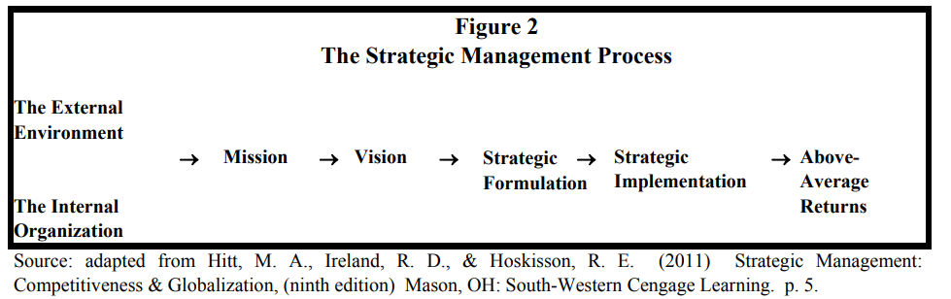
Fig. 1

Automobile Industry Analysis:

The automobile industry is one that attracts high interest from many governments as the industry represents high income value for both the governments and operators. The US Auto industry is worth over $270billion and help prop up the US economy. The Automakers employ over 3million people in the US, with over 7million cars sold in the US in 2016, a figure that was surpassed in 2018 (Marketline, 2021). Over 46% of the automobile industry was controlled by three main players namely General Motors, Ford, and Chrysler, with Telsa only having 0,2% of the market share. The rise in environmental concerns and changes in social trends, led to a surge in demand for electric vehicles, due to the low cost of operating electric vehicles and further led to a race within automakers to develop new models of electric vehicles that will appeal to the customers. The US hybrid and Electric car industry is forecast to hit $33billion by 2025, with estimated sales volume to exceed 800,000 per annum by end of 2020 (Market Line, 2021). Four main areas drove the race in Electric vehicle development, these were Autonomous vehicles (AV’s), Electric vehicles, (EV’s) connected cars, and personal Mobility service. Various new innovations were needed to support the development of these new electric motor technologies and thereby created opportunities within the industry, as suppliers and manufactures raced to build new facilities such as charging stations and battery manufacturing plants.

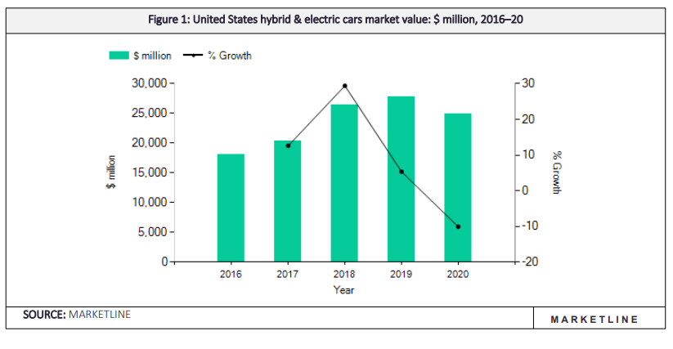
Fig 2 Source (Market Line, 2021).

Competition within the auto industry is shaped by different segments such as extended range electric (EREVs) and standard plug-in and non-plug-in hybrids. Prices and products feature such as range capacity and battery efficiency, as well as supply chain strategies had huge bearings on manufactures operational strategies. Manufactures targeted different segments and established different strategic alliances, in other to gain competitive advantage. Tesla’s always on 3G connectivity gave it an advantage as it represented a reduction in new vehicle recall, with upgrade to its vehicle remotely controlled. (Teeca, 2018). Customers demonstrated little brand loyalty when buying new cars and were prepared to switch brand provided the car brand met their requirements, which centred around affordability and luxury experience. A shift in car ownership trends, led to an increase in number of households who preferred other electric mode of transportation, such as electric scooters and electric shared schemes, all which presented immense revenue opportunity for car manufactures within the United States and beyond.

Analysis of Tesla’s External Business Environment.

Events occurring within an organisation global environment can directly impact how their business operations are managed (Ansoff, et al., 2012). Managers and leaders of organisations must continually review activities within their global environment, in other to ensure that appropriate strategies designed to mitigate or enable their business functions are timely implemented. In developing operational strategies for an organisation with a global presence such as Tesla, an environmental scanning tool PESTEL will be used to analyse various aspects of their external business environment that may directly impact their strategy formulation and direction (Hill, et al., 2008). PESTEL stands for political, Economic, Social, technological, Environmental and Legal considerations, which will be individually analysed to form a global picture of their Macro business environment.

Political:

The Political climate of any business environment plays a considerable role when developing strategic direction for any organisation. This is because government decisions can intentionally or otherwise limit the possibility for an organisation to operate within their business environment (Ward, 2012). Political environments affect the regulatory environment, and a stable political environment can lead to increase economic activity and prosperity. On the contrary the reverse can be the case if political climate is unstable. The US has a very stable political environment over the years, which has resulted in sustained political decisions and regulations that have supported economic and business strategy development. The automotive industry has directly benefited from the stable political statute of the US market, in that government regulations and policies such as the introduction of tax rebates and subsidies to help drive the adoption of Electric vehicle, has help push up the sales of EV. Government rescue or bailout plans have also helped to keep major automotive manufacturer trading, during difficult economic periods as seen in the case of Chrysler in 2008. Stability in international political environments as a wider macro business environment, is also important for successful operation of economic activities. Trade agreements and good foreign relationships are important to boost demand and supply activities, as many automakers such as Telsa depend on international supply chain networks for supply needed for production (Abhijeet , 2017). The political factors can be considered favourable to Tesla business operations.

Economic:

Economic factors play an important role in any business environment and can impact operational viability of organisation within that environment. Factors such as inflation, exchange rate changes and fluctuation in economic cycles, can determine how well a business thrives within an industry (Wheelen & Hunger, 2011). This was collaborated by an assertion by De Kluver and Pearce (2009), which concluded that growth of a business can be judged based on the inflation, economic growth, and other economic factors within its operating environment. Telsa has seen an increase in sales of its EV models, though this appears to have slowed down following the recent covid-19 pandemic. As world economies continue to open and regain momentum and consumer spending confidence returns, sales of the EV are expected to return to original projected figure over 800,000 by 2025. Low interest and borrowing rates have helped boost consumer buying power and continues to drive up the demand for EV globally. Sales in Electric vehicle is forecasted to grow by over 2.3% in US and 6% globally by end of 2025 (Market Line, 2021).

Social.

Social and cultural trends can strongly influence people’s perceptions, which can impact on economic activities such as demand and supply of certain products. Behaviours, values, and the culture of people in a particular environment can affect their acceptance levels of a brand or product (Hofstede, 2018). There has been an increase in demand for sustainable products globally, this is particularly favourable for the manufactures of Electric vehicles, as the trend suggests an increase in social acceptance due the reduced impact it has on the environment. Furthermore, Tesla produces only sustainable products, and this is a major plus point to the brands acceptance, as it focuses on transitioning the world toward a green and more sustainable fuel-efficient future. Though as the world demography changes and the growing number moving to the cities are choosing alternatives modes of transportations and not owning cars, this growing trend is one that can affect Tesla growth plans.

Technology:

Technology advancement is the biggest driving force for business growth globally. Many organisations are investing heavily in new technologies in other to better position their business operations for the future. McGowan et al, (1972), suggests that the current rapid growth in technology industry, has major impact on how business activities are carried out globally (McGowan, et al., 1972). Tesla is heavily dependent on technology and new innovations for its operations. The organisation has invested heavily on new technologies that allows it to completely automate its manufacturing process, while developing software and connected technologies that allows for remote maintenance and update of its EV models. Tesla continued investment into owned rapid charging stations provided added competitive edge for its EV motor range.

Environmental:

Environmental factors are becoming ever more important in developing modern day business strategy. Organisations are mandated by government laws and policies to develop sustainable operational strategies, that will reduce the impact their business operations have on the environment. Incentives in form of tax rebates are offered for organisations that meet their emission reduction targets, and this is heavily tied to acceptance of brand by consumers. Tesla has a good sustainable program and stands in good stead with its environmental program, the organisation as a sustainable driven outfit, strives to be the best in every metric relevant to their mission, to accelerate the worlds transition to sustainable energy. Although Tesla has a good sustainable program, the have encountered a few issues recently as they were issued a notice of violation by the bay area air quality management district (BAAQMD) for their Fremont factory, though this is currently being disputed (TESLA, 2020).

Legal:

Legal factors are important consideration to make when developing a business strategy. Labour and employment laws are examples of legal factors that can impact an organisation Macro business environment. Activities of Unions and environmental activist can disrupt organisational operational activities, though in Tesla’s case, the later may not be applicable. Furthermore, safety operation laws can disrupt sales of Tesla cars if found to be unsafe due to the passenger play functionality, as over 600,000 Tesla cars may be affected. Though an investigation by the National highway traffic Administration is still ongoing, Tesla has committed to stopping in motion play in all its vehicle via a software update.

An Analysis of Tesla’s external business environment suggests that operational conditions are favourable for the organisation, especially as the social trends are driving for increased sustainability and are supported by most global government operational policies, However Tesla may need to pay more attention to the impact of the waste generated from its manufacturing process, especially in its supply chain networks, to ensure this to not have a negative impact on its mission targets.

An Analysis of the Electric Vehicle Auto Industry Competitiveness.

The US electric car market remains concentrated and same can be said for other developed markets. Competition has remained relatively strong as adoption of EV is still low when compared to traditional combustion engine vehicles. The demand for electric vehicle is driven by various buying groups such as end user and car leasing dealerships. Recent pressure by the government for alternative fuel source coupled with the rising cost of fuel, has helped to drive demand in the electric vehicle industry.

Porters Five Forces

To better understand Tesla position and strategic direction within the EV industry, it may be important to analyse the attractiveness of the EV industry using known models. Porters (1979) five force model helps provide an in depth understanding of a firm’s competitive position within a given industry. Although widely used for this purpose, the model is considered to have its short comings, as it combines both external and internal aspects firms use to determine their source of competitive advantage (Pitkethly , 2006)

Barging Power of Suppliers:

Suppliers within the automaker industry, include manufactures of all key components such as fabricated components, steel, aluminium, and other software’s, and sub-systems, such as steering and automatic braking systems. Car manufactures depend heavily on the supplier networks to access important components to complete the manufacturing processes, and with very little difference in the requirements from the various car manufactures, the demand for the supplies remains very high. The shortage of raw material sources such as graphite and Nikel used in battery production and the limited number of manufactures producing this essential component for electric vehicles, has placed more importance on the availability for the required battery sizes for EV from suppliers, pushing up their bargaining power with the players within the EV automakers. Furthermore, developers of charging station networks are considered significant suppliers for Electric vehicle manufactures, and the limited availability of charging points, had a significant effect on the demand for Electric vehicles, as buyers were concerned on were to charge their EV’s if they were out. Tesla had identified earlier-on based on their projected number of productions of new electric vehicles per year, that it would struggle to meet its production targets if they were to depend solely on their supply network. Tesla adopted a backwards integration strategy, building its own battering manufacturing plant in the US and signed a four-year extended supply deal of graphite with an Australian mining company to help it mitigate the strangle hold of this essential component from suppliers. Tesla invested further in its own network of rapid charging stations specifically for Tesla cars across the US and effectively gaining competitive advantage from it (REUTERS, 2021). Overall supplier power is assessed to be moderate to high within the car manufacturing Industry.

Bargaining Power of Buyers:

Buyers in the Auto market vary in size, from independent dealerships, car leasing firms and individual buyers. However, individual buyers make up for the most buyers of Electric vehicles at these early stages of its infancy into the car industry and projected to make up to 17% of new EV sales in US by 2020 (Marketline, 2021). The relative number of buyers increases the bargaining power of the buyers, as more manufactures enter the EV market. As the shift in societal change for more environmentally friendly products continues to grow, and the cost for EV is still high, recent studies have seen a drop in demand for car ownership, and a more pragmatic approach from car owners, who are choosing other modes of transportation, further increasing sales pressures on car manufactures. However, it is expected that these powers will diminish as the demand for EV continues to grow, aided by the government push and availability of car financing options increases. Manufactures are investing heavily on building their brands and offering EV’s that try to meet consumers demands, such as range capacity, top speed, and charging times. Tesla have integrated their service offerings, owning all the processes from manufacturing, sales, charging stations and can remotely update the Tesla EV’s without the need of attending a service station. Overall, the bargaining power of buyer is considered moderate to high.

Threat of New Entrants:

The threat of New Entrant is related to the ability of new competitors to enter a market and considers how easy it is for new entrants to overcome operational factors such as economies of scales, needed to be competitive within the market. Market position strategy is based on a combination of strategic choices, that align an organisations resources and capabilities to its ability to compete in a given market, and usually act as a barrier to entry to a new market (Zhou & Ethiraj, 2019). The threat of new entrant is considered to be very low in the US EV market for various reasons. Brand strength, reputation, and brand loyalty, coupled with the high level of investments and fixed costs needed in areas such as building manufacturing capabilities, developing dealership networks and capital requirements, are serious deterrents for any new entrant. Furthermore, accessibility of raw materials and access to the already overstretched supply chain risks, will be a significant deterrent for any new entrant. However, increase in technology have seen huge technology-based firm such as apple and google invest heavily into the EV car industry and with the growth of mergers and acquisitions, further increases the threat of other player entering the EV car industry. Tesla entered the market by identifying and niche in the SUV market, initially targeting this market by offering cost savings through its Model 3X range and later introduced other models which it intends for mass production. Overall, the threat of new entrants is considered low.

Threat Of Substitutes:

The threat of substitutes deals with the threats posed from alternative options available for a particular product in given market. The threat of substitutes for Electric Vehicles is medium to high, as it is relatively a new range technology with growing acceptability. Consumer still consider standard fuel car most effective and often place higher value for money on them despite being aware of their environment impact. This can be attributed to battery range issues and availability of charging infrastructures. Also, the average cost of EV is still considered 6.3% higher than a standard combustion engine, from figure obtained in 2020 (Marketline, 2021). Price sensitive consumers may prefer to purchase ICE vehicle from now, as the EV infrastructure continue to grow. Furthermore, public transport and the increased use of personal transport such as bicycles for commuting, are a growing trend and cheaper alternatives. Overall, the threat of substitutes is considered very strong in the EV market.

Competitive Rivalry

The Electric vehicle industry in the US is highly concentrated with a few players leading the way. Geneal motors, Toyota, Nissan, and Tesla are the leading manufactures, offering different models of the electric vehicles with varied futures. Other manufactures are also releasing their own models, such as Hybrids targeting identified segments of the market driving consumer demands, such as internal luxury and range. Tesla Motors differentiates itself as an EV only car manufacture and targets a specialised segment with greater innovation capability than it rivals, also producing energy storage, electrical powertrain, and its own charging stations. Overall, the impact of competitive rivalry is considered to be moderate

In analysing the Electric vehicle industry attractiveness, competition within the car industry appears to the differentiated across segments with Tesla dominating the EV segment with is premium sedan and Model 3 and X range, the combined sales of all Tesla models accounts for over 25% of all sales in the US market and 78% of all Electric vehicle sales in the US. Tesla also operates over 1000 supercharging stations across the US further boosting the range capacity for its vehicles. Tesla business model which is centred around building a strong image and brand through investment in innovation and infrastructure, has provided it a strong foundation to operate and grow it operation within and outside of US markets.

Analysis of Tesla’s Resource base and capabilities

To determine an organisations internal strengths and weaknesses, it is important to analyse its resource base and capabilities, to ensure they align and are able to support its value chain strategic directions. An Organisations resource base consist of tangible and intangible assets it controls, that supports the fulfilment of it service offerings. Assets such as firms’ infrastructure, human resources, technology development and procurement, that supports its operational activities towards gaining competitive advantage (Lumpkin, et al., 1995). Fahy and Smithee, (1999), surmised that an organisation can only create a sustained high performance if they have superior resources, with its capabilities protected from migration (Fahy & Smithee, 1999), this was further augmented by Barney (1991), when he stated that multiple resources and capabilities, forms the highest of the competitive entry barriers and helps organisations in sustaining competitive edge (Barney , 1991).

An organisation resource base is critical in developing internal value chain strategies necessary in achieving an organisation operational objective. For an organisation such as Tesla to establish a truly cost or differentiation advantage, it needs to ensure its resources and capability are Valuable, Rare, Imitable, and organised. (VIRO). Applying the VIRO model helps answer key strategic questions on how the identified resources and capabilities helps in achieving efficient operational processes while ensuring organisation strategic direction can be maintained.

Tesla Value Chain Analysis
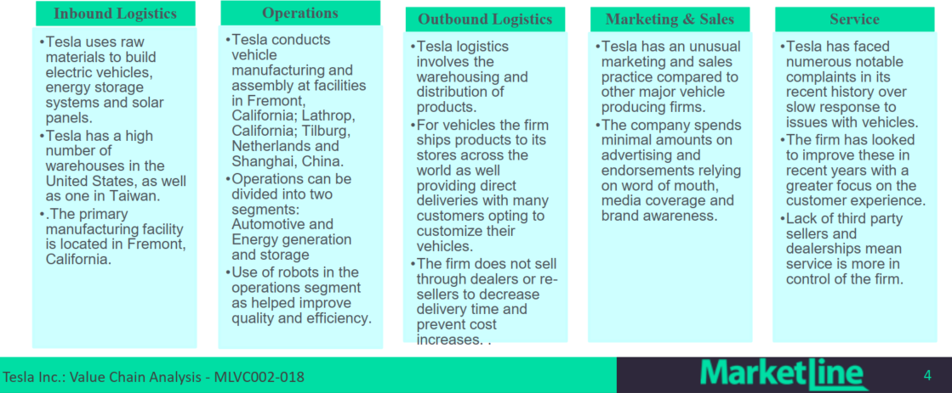
Fig. 3 Source: (Marketline, 2021).

VIRO Analysis

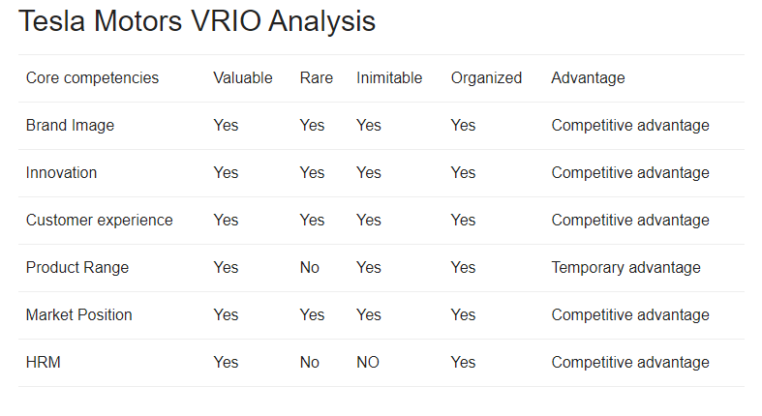
Fig 4 Source: (Prat, 2021).

Tesla operates the largest Electric Vehicle manufacturing plant in the US, with over 1.3 million square feet of space in its Fairmont factory in California. The factory is used to manufacture only its EV models and parts, making it both valuable and rare when compared to its competitors, as it has vertically integrated its manufacturing processes to increase efficiency and maintain competitive edge. Tesla owns and controls its own distribution channels, with dedicated Tesla show rooms, where it encourages its customers to learn more about Tesla product range, providing increase brand value to its customers. This Strategy although rare as Tesla is the Only manufacture that operates 111 stores in 26 states, with salaried staffs, can be imitated but at a very high cost to the competitor.

Tesla owns an operates over 1300 charging stations and nearly 11000 super chargers designed specifically for Tesla Electric Vehicles, with the capability of providing a 170mile range worth of charge in thirty minutes. Tesla recent acquisition of SolarCity in 2016, make it the only Automaker that has come to the market with a complete energy solution for its EV models and household and offices (MarketLine, 2016). This is extremely valuable resource to both Tesla and its customers, as it helps to mitigate the concerns customers have in relation to charging the EV while on a long distant drive and further encourages them to purchase a Tesla Model of EV. Whilst these resources are very rare, it can be however imitated, though at a high cost, as automakers are merging resource in other to remain competitive and suppliers are also investing heavily in research and development to find most efficient ways of improving the Charging network for all electric vehicle users in US market.

Telsa operates over 76 service centres alongside its sales store. Because Tesla EV models have fewer parts compared to a conventional ICE vehicle, there is less need to physical repairs. Most of the repairs can be remotely done via Wi-Fi update and other software updates. Tesla also operates its diver-less cars the Part Deux Model, which can double up as shared mode of transport for all Tesla owners wishing to partake in the scheme. Telsa owners can earn as much as $6900 per year from joining this scheme, providing further value to the Tesla customers. These capabilities are both rare and imitable as Tesla is the only EV manufacturer currently offering these services.

Tesla employs high calibre employees within the engineering and software development space. The organisation currently employees over 34,000 employees worldwide, with 10,000 based in its Fairmont plant in California and another 1000 at its battery plant in Nevada. The organisational structure is made of a nine closely knit colleague with a flat structure that allows for easy communication across all the different arms of the organisation’s operation. The leadership adopt a hand on approach that allows for improved innovation speed, as ideas are implemented quicker. This provides value to the organisation and a difficult process to imitate as tacit knowledge is easily shared within key organisational functions, allowing for increase business agility, and sustained competitive advantage.

The VIRO framework analysis, demonstrates that Tesla resources and capabilities fully supports the organisations prescribed strategy, which is to accelerate the world transition to sustainable energy, through innovation of environmentally friendly energy sources, and integration of efficient engineering processes, and other emergent strategies such as the acquisition of solar city to further the organisations value offering and gain further competitive advantage. The identified resource and capabilities answer the questions posed and provides scope to exploit opportunities and neutralise threats within their macro and micro environment. However, Tesla must consistently review these and stay on course with its innovation strategies, to ensure its strategic direction continues to provide value to its customers and not easily imitated by the competition.

SWOT ANALYSIS

Following the analysis of Tesla’s external and internal business environments, the SWOT tool is used to provide an overview of important factors necessary to consider in further development of an organisation’s strategic direction. It provides organisations a technique that allows for a systematic approach in analysing aspects of their industry and firm, that contributes to gaining competitive advantage, or may negatively impact their operations, and also help identify future opportunities and threats within the macro and micro business environments (Martinette, et al., 2013). A major criticism to this tool is that it tends to encourage brainstormed list of opportunities, rather than a strategically generated overview of important factors that can help a firm achieve its objectives. Therefore, care should be taken when analysing findings from using this tool, and where possible swot should be used in conjunction of other strategic analysis tools.

Strengths:
- Market leader in the Electric vehicle manufacturing sector, with a huge capital base of over $400 billion as of 2020, which is highest in the automobile brands globally
- High market valuation with fastest share price increase in 2020, making Tesla the seventh largest US base company ahead of its competitors.
- Tesla has enjoyed a sharp rise in demand and sales of Tesla Electric vehicles, with a 30% increase in sale from 2019-2020. Tesla EV models offer almost double the range of any commercially available electric vehicle, with a proprietary on-board charging system, allowing for easy charging of it EV’s from practically anyway.
- Tesla have increase revenue growth from 2019 to 2020 by over 30% which has aided improvements in business operations.
- High innovation capabilities with huge scope on research and development, spending over $1.4billion in 2020. Its vehicles are considered high end with good quality designs and loaded with advanced technology such as remote update and maintenance via Wi-Fi connection, with very little maintenance costs.
- Tesla vehicle and power train engineering coupled with its energy storage innovation, and improved manufacturing processes, helps the organisation focus on new product development.
- Tesla owns and operates its own super charging stations specifically designed for Tesla vehicles
- Tesla vertically integrated manufacturing process, allows it to maintain controls of all aspect of its operation, allowing for high business agility and operational efficiency.

Weaknesses
- Tesla has very high debt liabilities and low liquidity. This may impact the organisations’ ability to meet their short-term objectives.
- High debt may impact the organisations’ ability to raise further finances it needs for future developments.
- Limited Customer base due to lack of support infrastructure for electric vehicle globally.
- Tesla has a few ongoing investigations on the impact of the organisations manufacturing processes on its local environment. If findings are negative, it may adversely affect brand image

Opportunities
- The demand for Electric vehicle is set to rise globally, and Tesla is well positioned to benefit from this, being a leader in the EV manufacturing industry.
- Tesla can benefit from the growth in energy storage market, which is expected to reach 22,2GW by 2023, representing a value of over $13billion (Market Line Advantage, 2022).
- Growing Charing and manufacturing networks within emerging markets such as Brazil and India provide new target markets for Tesla

Threats
- High level of competition within the alternative fuel vehicle market. Manufactures are pulling resources together in other to bridge the gap within the market, as the demand for EV vehicle grows globally. This could considerably reduce Tesla’s dominance in the market.
- The continued rise in alternative mode of transportation especially in urban areas may impact on sales of electric vehicles. The development of driverless cars and customers choosing to buy miles rather than owing EV’s may affect future sales revenue.
- Fluctuation in sales due to seasonal demand may affect the organisations’ ability to raise funds needed for its operations, as majority of the accumulated expenditure are based on projected sales income.
- Obtaining the required regulatory certifications across the global markets will be Tesla biggest challenge. This may seriously limit the organisations’ ability to sell its EV’s into certain markets.

The above summary provides information which may aid Tesla in further development of their strategic options and direction. Identified opportunities within its macro environment can be used to improve their operational strategic direction, to include new strategies that considers positives changes within their business environments, that may provide new source of competitive advantage. Internal value chain capabilities can be deployed when developing these new strategies, ensuring new strategic directions, address any weakness concerns identified and further strengthen their ability to manage the external threats.

Development of Tesla Strategic Choices

Organisation strategic choices are derived from information gained from an analysis of their strategic content, which are usually developed from comparing value chain capabilities to the opportunities within their operating environment. Depending on the organisations business activities, changes in strategic direction maybe required based on the finding or developments within its operational environments. This may be in form of changes made to product offering or shift in direction for services offered, venturing into new markets, or expanding activities within it current markets. These strategic options are commonly cited in two key approaches known as cost leadership or differentiation (Porter, 1980). To help determine the most suitable strategic option, Ansoff analysis Matrix will applied to the summary finding of their current strategic analysis.

Ansoff Matrix:

This Analysis model was developed my Igor Ansoff (1957), with the focus that business activities are concerned with gaining competitive advantage within two main realms, Product or Market and the interrelationship between these two elements, determines an organisations strategic direction, that best suits their resource capabilities (Taylor, 2012). Four areas of focus are explored, Market penetration, market development, product Development diversification, with emphasis or existing products or new product development.
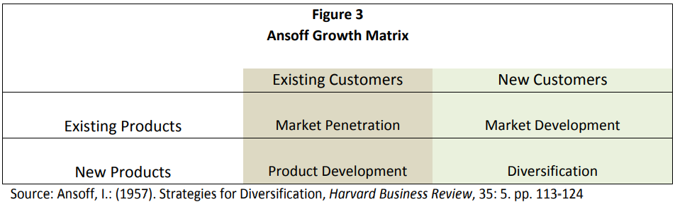
Fig 5.

Market Penetration:
Considered a growth strategy where core competencies of existing value chain, are used to develop new strategic choice (Porter, 1985). This Strategy may suit organisations with an established market base or products and is considered low risk as operational parameters are known.
Market development:
This Strategy is concerned with expansion of operational remits with existing products or services. A low-medium risk strategy with a big potential for growth opportunities. However, may become capital intensive depending on size of operation.
Product development:
Concerned with focusing on increasing business activities with existing customer base, through introduction of new products or enhancing existing one. It is important to have good knowledge of customer base if this strategy is to be adopted.
Diversification:
This strategy involves a complete shift in strategic direction. Changing existing business concepts or ideas or venturing into new industries. This can be either related diversification, in which case can complement existing product strategy or unrelated diversification, where a totally new concept is pursued.

Tesla market position provides it with several strategic options based on the Ansoff model. The organisations main business activity is production of alternative fuel and energy source and electric vehicles. The organisation currently has three leading models of EV’s in the market currently outselling other EV models from its competitors. The organisation has also invested heavily into EV batteries which is a key component that drives demand of EV’s currently, controls all its sales processes and owns its own charging station. The vertical integrated strategy currently offers increase competitive edge within the EV market. However, activities of the competition suggests that this advantage will diminish in the near future, if Tesla does not continue to develop their strategic direction.

Tesla May consider diversification as an option in developing its strategic direction. The organisation may increase its investment in growing its energy storage products and aim to target wider markets outside the EV market. Also, as part of its diversification strategy, Tesla may look to further develop its innovation on software application, as more EV cars are expected to become more connected in the future, with the projection being that over 100,000 software engineers will be required in the US market alone. Tesla can spear head this as related diversification strategy, as this will provide it first mover advantage and help it maintain its competitive advantage.

Tesla may also consider market development as a new strategic direction to further its dominance of the EV market. Markets like Brazil, Australia and India are primed for expansion of sales of its existing EV models. Provided the organisation can secure all operational regulatory clearances, it may look to invest in expanding its infrastructure base such as the charging stations within these markets in other to increase demand for the Tesla EV’s.

Recommendation:

Analysis of Tesla Marco environments highlights a growing trend in demand for alternative environmentally friendly mode of transportation, especially in the urban areas, this may affect sales and growth revenue in the future, therefore Tesla must pay close attention to these trends and ensures they implement strategies such as development of their own-share scheme and driverless cars to help mitigate the effects of these changes. Tesla may also consider a strategic alliance with another OEM manufacture to help reduce the financial burden on the organisation, this will provide several opportunities such as economics of scale and easy expansion into new markets, without the worries of dealing with barriers to entry into the new markets.

Conclusion:

Strategy can be considered a science of continual innovation, where a combination of business activities, are merged with resources with a primary aim of gaining a competitive advantage (Lynch, 2018). Organisations such as Tesla, must consistently review the key strategic drivers within their macro and micro business environments, to ensure they attain a strategic fit between their chosen strategy, resource availability and intended operational markets. Analysis shows that Tesla is currently in a Leading position within the EV market sector and have vast amount of resources at their disposal, however, the high level of exposure to financial liability can cause an imbalance to its ability to achieve a strategic fit for its future operations. Therefore, efforts must be made to continue evolving the organisation strategic direction with a view of maintaining their competitive advantage.

References

Abhijeet , P., 2017. Tesla Busness Analysis PESTEL. [Online]
Available at: https://notesmatic.com/tesla-pestelpestle-analysis/
[Accessed 15th April 2022].

Ansoff, H., Kipley, D., Helm-Stevens, A. O. & Ansoff, R., 2012. Implanting Startegy Managment, s.l.: Springer.

Barney , J., 1991. Firms Resources and Sustained Competitive Advantage. Journal of Management, Volume 17, pp. 99-120.

Barney , J. & Hesterly, W., 2018. Strategic Management and Competitive advantage; Concepts and cases; Ebook, , Harlow : Pearson.

Fahy, J. & Smithee, A., 1999. Strategic Marketing and Resource Base View of The Firm, s.l.: s.n.
Hill, C., Schilling, M. & Jones, G., 2008. Strategic Management.

Hofstede, 2018. How does company culture support Business Strategy,

Johnson, G., Scholes, K. & Whittington, R., 2008. Exploring corporate strategy. 8th ed. Harlow: Pearson Education.

Lumpkin, G., Mckelvie, A. & Gras, D., 1995. Is Strategy Different for very small and new firms. Journal Of Small Business Strategy, 21(2), pp. 10-11.

Lynch, R., 2018. Strategic Management. 8th ed. Harlow: Pearson.

Market Line Advantage, 2022. Tesla Inc SWOT Analysis. [Online]
Available at: https://advantage-marketline-com.ezproxy.uwtsd.ac.uk/Company/Profile/tesla-motors-inc?swot#S0
[Accessed 22nd April 2022].

Market Line, 2021. United States Hybrid & Electric Cars. [Online]
Available at: https://advantage-marketline-com.ezproxy.uwtsd.ac.uk/Analysis/ViewasPDF/united-states-hybrid-electric-cars-140339
[Accessed 14th April 2022].

MarketLine, 2016. Tesla buys SolarCity. [Online]
Available at: https://advantage-marketline-com.ezproxy.uwtsd.ac.uk/Analysis/ViewasPDF/tesla-buys-solarcity-teslas-is-now-the-first-company-to-come-to-market-with-a-complete-energy-solution-41195
[Accessed 20th April 2022].
Marketline, 2021. New Cars : Global Industry Data. [Online]
Available at: https://advantage-marketline-com.ezproxy.uwtsd.ac.uk/Analysis/FullReport/new-cars-32534
[Accessed 14th April 2022].

Marketline, 2021. Tesla Inc. [Online]
Available at: https://advantage-marketline-com.ezproxy.uwtsd.ac.uk/Company/Profile/tesla-motors-inc?swot
[Accessed 14th April 20211].

Martinette, L., Franklin, A. & Srivastava, M., 2013. Building A Sustainable Competitive advantage. Joournal of technology Management and Innovation, 8(2), pp. 47-59.

McGowan, B., Hakins, W. & Garcia, j., 1972. Limbec lesion and control of Internal and External environment. Behavioual Biology, 7(6), pp. 841-852.

Pitkethly , R., 2006. Oxford handbook for strategy-environmental analysis, s.l.: Academia.edu.
Porter, M., 1980. Competitive Strategy, New York: Free Press.

Porter, M., 1985. Competitive Advantage; Creating and sustaining superior advantage, New York: Free Press.

Prahald, C. K., Hamel, G. & Aaker, D., 1990. The Core Competence of the Corporation. Havard Business Review, Volume 3, pp. 71-79.

Prat, A., 2021. Viro Analysis Tesla Motors, Harlow:

Pratap, A., 2021. Notesmatic. [Online]
Available at: https://notesmatic.com/a-pestpestlepestel-analysis-of-pepsico/
[Accessed 12th March 2022].

REUTERS, 2021. REUTERS, Australia's Syrah Resources soars on graphite supply deal with Tesla. [Online]
Available at: https://www.reuters.com/markets/deals/australias-syrah-resources-soars-graphite-supply-deal-with-tesla-2021-12-22/
[Accessed 19th April 2022].

Taylor, E., 2012. Competitive Improvement Planing; Using Ansoff's Matrix with Abell Model to Inform the Strategic Management Process. Academy of Strategic Management, 11(1), pp. 21-27.

Teeca, D., 2018. Tesla and the reshaping of the auto Industry. [Online]
Available at: https://www.cambridge.org/core/journals/management-and-organisation-renew/article/tesla-and-the-reshaping-of-the-auto-industy/5E551257839D5E430F61CB93AFA62
[Accessed 14th April 2022].

Tesla (2019) MIT Management Slaon School.
TESLA, 2020. Impact Report 20202. [Online]
Available at: https://www.tesla.com/ns_videos/2020-tesla-impact-report.pdf
[Accessed 13th April 2022].

TESLA, 2021. About Tesla. [Online]
Available at: https://www.tesla.com/about#:~:text=Tesla's%20mission%20is%20to%20accelerate,to%20drive%20than%20gasoline%20cars.
[Accessed 13th April 2022].

Ward, K., 2012. Strategic Management Accounting.

Wheelen, T. & Hunger, J., 2011. Concept Instrategic management and business Policy, India: Pearson Education.

Zhou, Y. M. & Ethiraj, S., 2019. Fight or Flight? Market positions, Submarket interdependencies and strategic responses to entry threats. Strategic managment journal, 40(10), pp. 1545-1569.

