

Name : Kanika Kanika
Student ID : 2229261
Programme: MSc Public Health and Social Care in Practice
Module: Population Health and Digital Health Promotion
Module code: LCHS7007
Assignment Title: Assessment Component 1
Professor : Diola Bijlhout

Part A- Blog
Part B- Poster design

Table of Contents
TASK 1 – Blogs 2 entries 3
Blog 1 – The impact of an existing digital technology currently used for a digital health promotion intervention 4
Introduction 4
Public Health Problem 4
Chosen Digital Technology 6
Evidence 7
Impact of Chosen Digital Technology 7
Addressing shortfall 8
Conclusion 8
Blog 2- The impact of a digital technology that is being designed for a digital health promotion intervention 9
Introduction 9
Public Health Problem 9
Design 10
Use of the technology 11
Impact of the technology 11
Addressing shortfalls 12
Conclusion 12
References 13
TASK 2- Poster design 15

TASK 1 – Blogs 2 entries

Blog 1 – The impact of an existing digital technology currently used for a digital health promotion intervention

Introduction
The analysis delves into the impact of mHealth applications in health promotion. It examines both the advantages of accessibility and personalized support and the challenges related to limited reach, information accuracy, dependency concerns, and data security, aiming to provide a comprehensive assessment of this digital technology's role in public health.

Public Health Problem
A serious public health issue with broad worldwide ramifications is “Childhood obesity”. The World Health Organisation (WHO) estimates that over 41 million obese children are suffering from overweight all over the world. "CDC (the Centres for Disease Control and Prevention)" has also reported a fourfold increase in obesity among children in the United States aged 2 to 19, impacting approximately 18.5% of kids (Venturelli et al., 2019). Childhood obesity significantly raises the chances of developing type 2 diabetes, cardiovascular disease, and mental health conditions. As a result, comprehensive therapies are critically needed to combat this expanding epidemic.
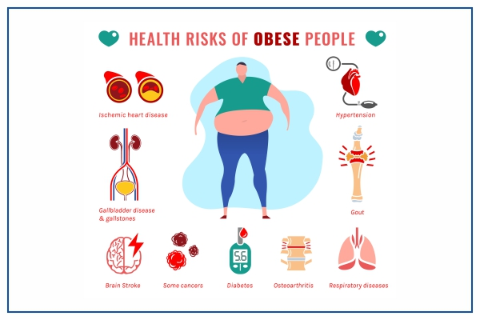
Figure: Issues related to Obese
(Source: Venturelli et al., 2019)
Table: Childhood Obesity Statistics in the United States
Age Group (Years) | Prevalence of Obesity (%)
- 3 – 5 | - 13.9
- 6-11 | - 18.4
- 12-19 | - 20.6

Sources:
- World Health Organization (WHO)
- Centres for Disease Control and Prevention (CDC)
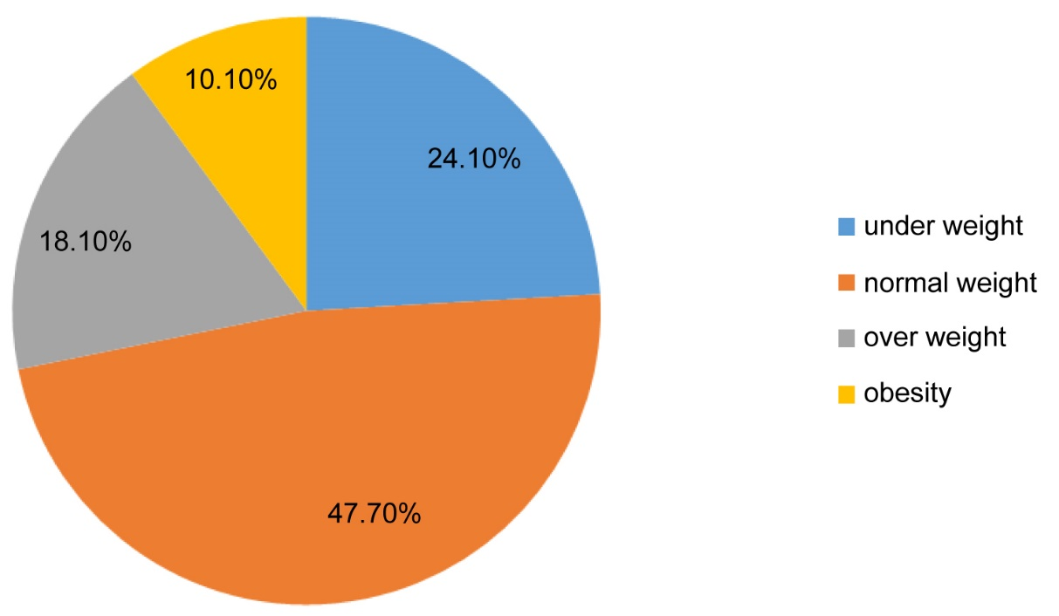
Figure: Statistics
(Source: Venturelli et al., 2019)

Chosen Digital Technology
The chosen digital technology, “mobile health (mHealth) applications”, is utilized in health promotion by providing educational resources, personalized diet and exercise plans, and behaviour-tracking tools (Mathews et al., 2019). These apps help address childhood obesity by empowering parents and children to make healthier lifestyle choices, monitor progress, and access support networks, promoting long-term behaviour changes.

Figure: mHealth App Development
(Source: Mathews et al., 2019)

Evidence
Numerous studies have demonstrated the effectiveness of mHealth applications in promoting health. For instance, a systematic review published in the Journal of Medical Internet Research found that mHealth interventions significantly improved weight management outcomes, including reducing body weight and Body Mass Index (BMI) in individuals with obesity (Powell, 2019). Another study published in Obesity Reviews showed that mobile health apps can enhance physical activity levels and dietary habits, contributing to overall health improvement.
Study | Outcome | Statistics
Journal of Medical Internet Research | - Improved weight management outcomes | - Significant reduction in body weight and BMI
Obesity Reviews | - Enhanced physical activity levels  - Improved dietary habits | - Increased number of steps per day  - Higher consumption of fruits and vegetables

Impact of Chosen Digital Technology
Since mHealth applications give people easy-to-use, personalised tools for behaviour modification, they have a substantial influence on health promotion as they encourage a culture of self-management and prevention.
Advantages | Disadvantages
- Accessibility and user convenience.  - Successful in encouraging behaviour change (Paschou and Sakkopoulos, 2019).  - Encourages empowerment and self-monitoring. | - Limited accessibility for underprivileged groups.  - Information's correctness and quality might differ.  - Data handling privacy and security problems (Rossmaier, 2022).

Addressing shortfall
Efforts should concentrate on enhancing digital literacy in marginalised groups, assuring content trustworthiness and accuracy, encouraging a balanced attitude to technology usage, and putting in place strong data protection mechanisms to overcome shortcomings (Naslund et al., 2020).

Conclusion
The applications of “mhealth” offer valuable opportunities in health promotion, providing accessible support and encouraging behaviour change. However, addressing the identified challenges is crucial to maximize their potential impact on public health.

Blog 2- The impact of a digital technology that is being designed for a digital health promotion intervention

Introduction
The research highlights public health issues, such as sedentary lifestyles as they have a direct influence on people's and communities' well-being. One can learn more about the prevalence, implications, and influence of the issue at hand by looking at recent data from literature and statistics.
Digital technology has changed healthcare, especially strategies for health promotion. The influence of current digital technology used for health promotion is critically examined in this blog post with an emphasis on its benefits, drawbacks, and possible weaknesses (Park et al., 2020).

Public Health Problem
Lack of exercise leads to sedentary lives and related health problems. Sedentary behaviour is associated with a higher risk of obesity, cardiovascular disease, and mental health issues, according to the available data source: WHO, CDC (Thompson et al., 2020).
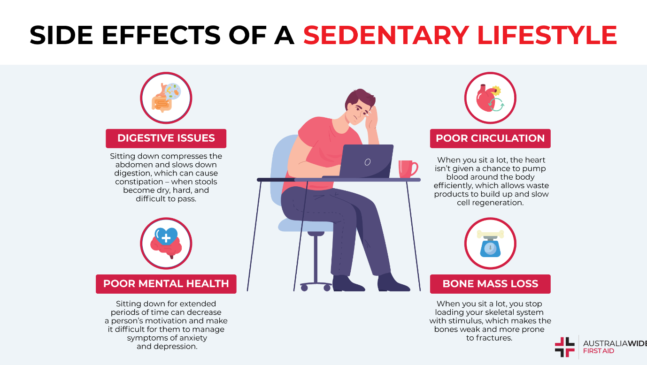
Figure: Related Health Problems related to Sedentary Lifestyle
(Source: Thompson et al., 2020)
Table: Sedentary Statistics in the United States
Health Problem | Age Group | Percentage | Source
Obesity | All age groups | Approx. 15-20% higher risk of obesity | WHO, CDC
Cardiovascular Disease | Adults (18 years and above | Approx. 25-30% higher risk of heart disease | WHO, CDC
Mental Health Issues | All age groups | Approx. 25-30% higher risk of mental health issues | WHO, CDC

Design
The digital technology I have designed is a mobile application called "ActiveLife." It uses gamification elements and personalized activity tracking to motivate and guide individuals towards adopting and maintaining a physically active lifestyle (Marín-Marín et al., 2020).

Figure: Development of Mobile Application ActiveLife
(Source: Marín-Marín et al., 2020)

Use of the technology
In order to combat sedentary behaviour and foster a better lifestyle, the "ActiveLife" mobile application will motivate users to partake in regular physical exercise by presenting personalised activity recommendations, monitoring progress, and awarding prizes (Trilar et al., 2019).
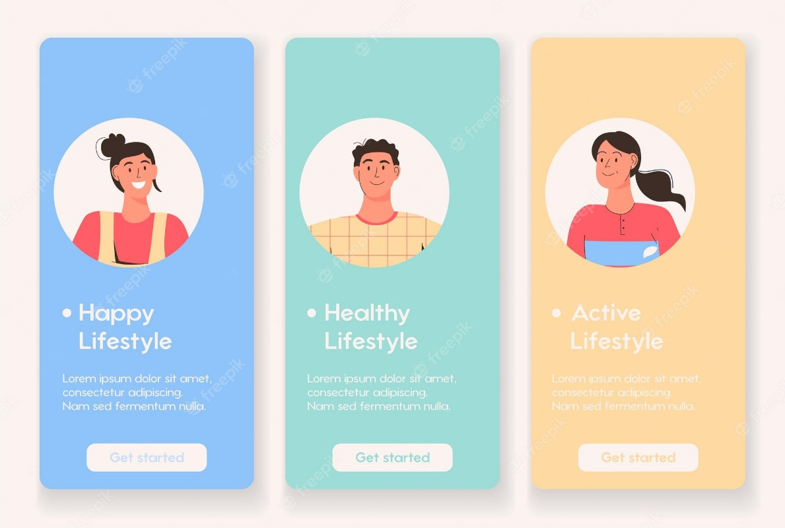
Figure: Personalised Activity Recommendations
(Source: Trilar et al., 2019)

Impact of the technology
Advantages
- The "Active Life’s” gamification features and personalised tracking can increase user motivation, resulting in more involvement in physical activity.
- The mobile app makes it easy for people with hectic schedules to access materials for health promotion whenever and wherever they are (Hamid et al., 2022).
Disadvantages
- Users who depend too much on the app may miss their intrinsic drive for exercise, which might hinder long-term behaviour change.
- Digital interventions might not be acceptable or accessible for people with poor digital literacy, those without smartphones, or those without consistent internet connectivity (Hernandez-Ramos et al., 2021).

Addressing shortfalls
Efforts need to be made to promote the value of intrinsic motivation alongside technology use and to offer alternative support channels for people with restricted digital access to alleviate the aforementioned shortcoming (Vollbrecht et al., 2020).

Conclusion
By boosting accessibility and incentive, the created digital technology, "Active Life," has the potential to have a significant influence on health promotion. However, it should be taken into account to combat the overuse of technology and guarantee inclusion for all groups.

References
Hamid, K.H.A.L.I.D., waseem Iqbal, M., Nazir, Z.A.E.E.M., Muhammad, H. and Fuzail, Z.U.B.A.I.R., (2022). Usability empowered by user's adaptive features in smartphones: The RSM approach. Tianjin DaxueXuebao (ZiranKexueyuGongchengJishu Ban)/Journal of Tianjin University Science and Technology, 55, pp.285-304.

Marín-Marín, J.A., Soler-Costa, R., Moreno-Guerrero, A.J. and López-Belmonte, J., (2020). Effectiveness of diet habits and active life in vocational training for the higher technician in dietetics: the contrast between the traditional method and the digital resources. Nutrients, 12(11), p.3475.

Mathews, S.C., McShea, M.J., Hanley, C.L., Ravitz, A., Labrique, A.B. and Cohen, A.B., (2019). Digital health: a path to validation. NPJ digital medicine, 2(1), p.38.

Naslund, J.A., Bondre, A., Torous, J. and Aschbrenner, K.A., (2020). Social media and mental health: benefits, risks, and opportunities for research and practice. Journal of Technology in behavioural science, 5, pp.245-257.

Park, J.H., Moon, J.H., Kim, H.J., Kong, M.H. and Oh, Y.H., (2020). Sedentary lifestyle: an overview of updated evidence of potential health risks. Korean Journal of family medicine, 41(6), p.365.

Paschou, M. and Sakkopoulos, E., (2019), July. Personalized assistant apps in healthcare: a Systematic Review. In 2019 10th International Conference on Information, Intelligence, Systems and Applications (IISA) (pp. 1-8). IEEE.

Powell, D., (2019). Schools, corporations, and the war on childhood obesity: How corporate philanthropy shapes public health and education. Routledge.

Rossmaier, L.W., (2022). commercial mHealth apps and unjust Value trade-offs: a Public Health Perspective. Public Health Ethics, 15(3), pp.277-288.
Thompson, W.R., Sallis, R., Joy, E., Jaworski, C.A., Stuhr, R.M. and Trilk, J.L., (2020). Exercise is medicine. American Journal of lifestyle medicine, 14(5), pp.511-523.

Trilar, J., Zavratnik, V., Čermelj, V., Hrast, B., Kos, A. and Stojmenova Duh, E., (2019). Rethinking family-centred design approach towards creating digital products and services. Sensors, 19(5), p.1232.

Venturelli, F., Ferrari, F., Broccoli, S., Bonvicini, L., Mancuso, P., Bargellini, A. and Giorgi Rossi, P., 2019. The effect of Public Health/Pediatric Obesity interventions on socioeconomic inequalities in childhood obesity: A scoping review. Obesity Reviews, 20(12), pp.1720-1739.

Vollbrecht, H., Arora, V., Otero, S., Carey, K., Meltzer, D. and Press, V.G., (2020). Evaluating the need to address digital literacy among hospitalized patients: a cross-sectional observational study. Journal of Medical Internet Research, 22(6), p.e17519.

TASK 2- Poster design



