BMMB7004 Environmental Sustainability in the Hospitality Industry
Portfolio

ALEXANDER SEBASTIAN
2211049

LECTURE: DR JAYNE GRIFFITH – PARRY
Table of content
Portfolio 1: Essay
How to enhance brand image of hospitality companies using social and digital media tools …………………………………………………………………………………………………3
Portfolio 2: Report
A Report on staff awareness on innovations in hospitality sector to create sustainable development……………………………………………………………………..……………5

Portfolio 3: Essay

How brands in the hospitality sector implement a circular economy for sustainability.....8

Portfolio 4:

Reflection How could the government promote sustainability in hospitality sector? …..10

Portfolio 5: Essay

improving Guest Experience in Hospitality Sector……………………………………….12

Portfolio 6:

Reflection How green environmental practices in hospitality sector improves environmental experience of customers……………………………………………………13

Portfolio 7:

Essay How Regulatory affairs in the UK improves the sustainability of the hospitality sector………………………………………………………………………………………16

Portfolio 8: Report

Fiscal and economic incentives for brands promoting sustainability…………………….18

References …………………………………………………………………………………...21

Portfolio 1: Essay

How to enhance brand image of hospitality companies using social and digital media tools
Brand image is the general perception of the consumers about the brand. Customers connect the brand with a variety of relations. These connections serve as the foundation for brand image. According to Gaber and Wright (2014), based on the consumers' subjective opinions of the brand's association bundle, a picture of the brand is shaped. The concept beneath brand image entails that when a consumer buys a product or service, they are also buying the image that goes along with it. Brand images ought to be favorable, distinctive, and immediate. Brand communications such as packaging, word-of-mouth publicity, advertising, and other marketing programs, etc. can help to strengthen brand perceptions. Customers buy the goods and their reputation at the same time. Consumers' mental and objective reactions to a brand when they buy a product are known as brand image. surpassing the expectations of the consumer is a positive brand image. A strong brand image improves an organization's reputation and brand value. Social media is being used by a large number of companies, both large and small, to advertise their brands and engage with their audiences (Wingrove and Urban 2017). Social media allows for direct client interaction and input for industries. People often turn to social media as their first stop when exploring new companies for numerous businesses. Social media is thus the ideal channel for both lead generation and building a positive business image. Customers can engage with brands more actively on social media. Conversely, brands are also freer to communicate with one another. Radesky et al., (2020) point out that businesses can set up studies, contests, and referral programs using the features of different social media to engage with audiences, draw in new ones, and get feedback. Social media is a fantastic site for these events due to its widespread use. Many brands have used social media tools to showcase their sustainability aspects such as Digitize Building-Material Waste which is used to construct new building for circularity (Kingsnorth, 2022). There are many leading companies which have promoted social media and digital marketing for triggering the brand image in the market. The below section has provided a list company which has attained high revenue in the hospitality sector.
Social media has made it possible for fast food chains to showcase their creativity while also establishing their brands. Business is significantly impacted by social media. The reliance of marketers on radio, television, newspapers, and direct mail as a means of marketing has diminished as a result of social media. Singh and Pattanayak (2016) comment that the impact of marketing using social media have a greater impact than traditional methods since
social media platforms allow for direct screening. Additionally, because building relationships with clients on social media is not an easy process, it may take longer to see the full benefit. Hospitality companies with sarcastic reputations aids in propelling the revenue. Their tweets can be enjoyed by both individuals who are interested in food and people who are not, and both groups may end up retweeting and promoting them on other media.
There are various digital tools used to increase the brand image of a company other than social media like email marketing, content marketing, PPC advertising, search engine optimization, website and landing page builders, etc Hussain (2018). But social media is the biggest platform that allows hospitality companies to engage with customers and build a strong brand image. Through social media image of the brand can get negatively or positively influenced by social circumstances and consumer demands prevailing at the time. The challenges faced by the world’s largest hospitality company Marriott International is an example of the phenomenon. The companies such as Marriott International used alluring social media advertisements for encouraging the travelers and visitors to book hotel quickly (Bragg et al., 2020). Ireland, France the UK, the Nordic nations, and other nations have already taken the initiative by enacting rules, taxes, and laws for controlling social media ads. According to Zahoor (2022), the business changed its course to be more healthful in response to criticism. Marriott International introduced thrlling and much more natural aesthetics in response to the growing interest for making green world. The company has also provided food packages where menu was expanded to include salads, fruits, and carrot sticks in addition to premium coffee and healthy beverages. The corporation has implemented smaller portion sizes in an effort to address the needs of customers and improve the brand's image. The business also revised its kid-targeted advertising approach. To encourage leading an active lifestyle, a commercial featuring ads and cartoon fruits and vegetable dancing was released in the hospitality sector.

Portfolio 2: Report

A Report on staff awareness on innovations in hospitality sector to create sustainable development:
Introduction:
According to Golubovskaya et al. (2017) the hospitality sector, particularly encompasses hotel, foodservice business, event management, entertainment venues, tourism and travel which has become a significant subset of the service sector that further includes accommodations, travel businesses, food outlets, and clubs are all included. Furthermore the journal published by Bilgihan and Nejad (2015) emphasises upon this use of innovation in the tourism and hospitality sector, providing an insight concerning studies in the areas of services marketing. It can be understood that the hospitality and travel sectors have undergone a transformation because of the emergence of newer technologies as well as innovative business strategies and thus it is indeed crucial that employees are made aware of advancements in the hospitality business.
Main Body:
From the observation of studies on service development, it has progressed from a holistic standpoint to a boundary viewpoint, depicting this as what should be distinct from innovative products, and actually turning into a formulation aspect (Minh et al. 2015). Additionally, the integrative perspective highlights the need for an unified approach to development that takes all these technical and non-technological factors into account for leveraging sustainability in this sector. However, in order to enact such an adaptive framework, it is vital to consider the newest marketing strategies, product promotion, process improvement, customer relationship management, provision of services, channels of distribution, research technologies and most prominently the moulding up the employee knowledge of recent advancements in these fields (Dzhandzhugazova et al. 2015).
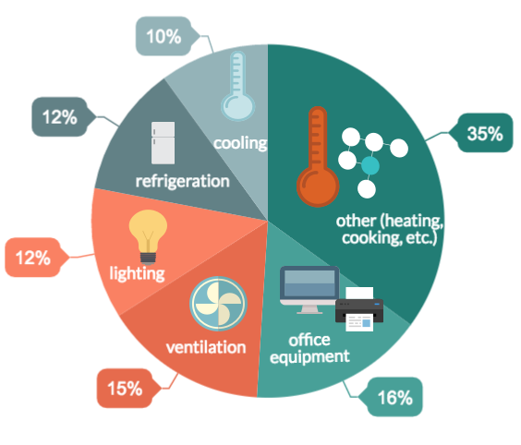
Figure 2: Energy conservation in hospitality sector
Source: AlFaris et al. (2016)

Consequently, these changing ecosystems inspire service providers to keep innovating and reinvent their solutions in addition to offering businesses abundant opportunities for creativity. Furthermore Bruns-Smith et al. (2015) demonstrates how intellectual team resources are essential to attain new innovative technologies and business results. Confirming the concept in plenty of other hospitality enterprises would be pertinent given that the hospitality sector is made up of organisations with a variety of diverse attributes. According to the viewpoint of Nieves and Segarra-Ciprés 2015 hospitality businesses can work more effectively if companies concentrate in training staff members and, more importantly, in fostering a greater degree of broad sweeping accumulated understanding about the globalised economy which means the ability to learn is very important for obtaining success in the hospitality sector.

.
Conclusion:
As has been demonstrated the report intended to identify how hospitality training and development programmes are a significant indicator of staff service innovativeness. The research examines two primary concerns: initially, by what means the trainings at hospitality industry are associated with workers' competence in hospitality innovation; subsequently, whether performance and adaptability in the changing innovative globe are significant determinants of this association. Furthermore, Chen (2017) shows how business orientation affects service employee engagement in the hospitality sector, which could perhaps contribute to a greater understanding of organisational employees' awareness.

Portfolio 3: Essay

How brands in the hospitality sector implement a circular economy for sustainability?
The third-largest industry in terms of CO2 emissions, tourism accounts for at least 5% of global emissions. Restaurants and hotels, in particular, produce large-scale waste. This waste includes food waste, electricity, water usage, wastewater, and dangerous materials and chemicals. Some large hotels currently handle these problems and tempt tourists to connect their tactics with their efforts to reduce environmental effects (Manniche et al., 2021). Florido et al. (2019) commented that implementing a cutting-edge and sustainable company model is necessary to move toward a circular economy approach. The application of sustainable innovation primarily depends on four business model tenets: value proposition, supply chain, consumer interface, and finance model. Along with functioning with environmentally conscious and inventive suppliers, sustainable innovation prioritises new finance techniques.
The supply chain should be made up of networks and activities that integrate innovative and environmentally friendly engagements throughout the entire production process, including the audit of waste management through suitable systems and technologies, given that it is the primary driver of progress toward sustainability. The circular economy in the hospitality industry can be well understood using the Triple Bottom Line theory (Rashidi et al., 2020). The triple bottom line is a framework for change that industries and other organization can use to transform themselves in the direction of a more sustainable and regenerative future. The triple bottom line includes several tools to measure, benchmark, establish targets, develop, and eventually move toward more sustainable organizations and models (Pan et al., 2021). For example, the triple bottom line shows that if a company prioritizes turnover while ignoring the needs of public and the environment, it will not be successful over the long term because it will not be able to cover all of its costs.
High operational expenses resulting from the need for consumable products used in the hospitality sector's restrooms, laundry, and cleaning supplies have contributed to sustainable practices. Hotels have been pushing visitors to be more aware of unwanted linen drinks and substituting small quantities of shampoo and soap bars with disposable packaging for a long time. This situation can be significantly improved if sustainable products are more extensively used. Moreover, customers frequently choose less ethically when ordering food and beverages. Even though many hotels and restaurants have started composting biodegradable garbage, newer, more effective practices and methods must be used. For instance, a lot of the trash generated by the hotel sector, including food waste, can be used to create renewable energy like biogas (Mercade Mele et al., 2019).
Portfolio 4: Reflection

How could the government promote sustainability in hospitality sector?
Rodríguez-Antón and Alonso-Almeida (2019) articulated that the hospitality industry contributes 20% of the overall carbon emissions from the tourism industry, uses 5% of the water used globally, and emits 1% of the world's greenhouse gas emissions. Yet, private entities in the hospitality industry frequently prioritise growth-centric business models while paying little regard to how their actions affect destinations' natural and social carrying capacity. As a result, the circular economy idea is gaining popularity among business leaders and decision-makers worldwide. However, the Circular Economy's relevance and applicability to sectors like hospitality that rely heavily on services are poorly understood and understudied.
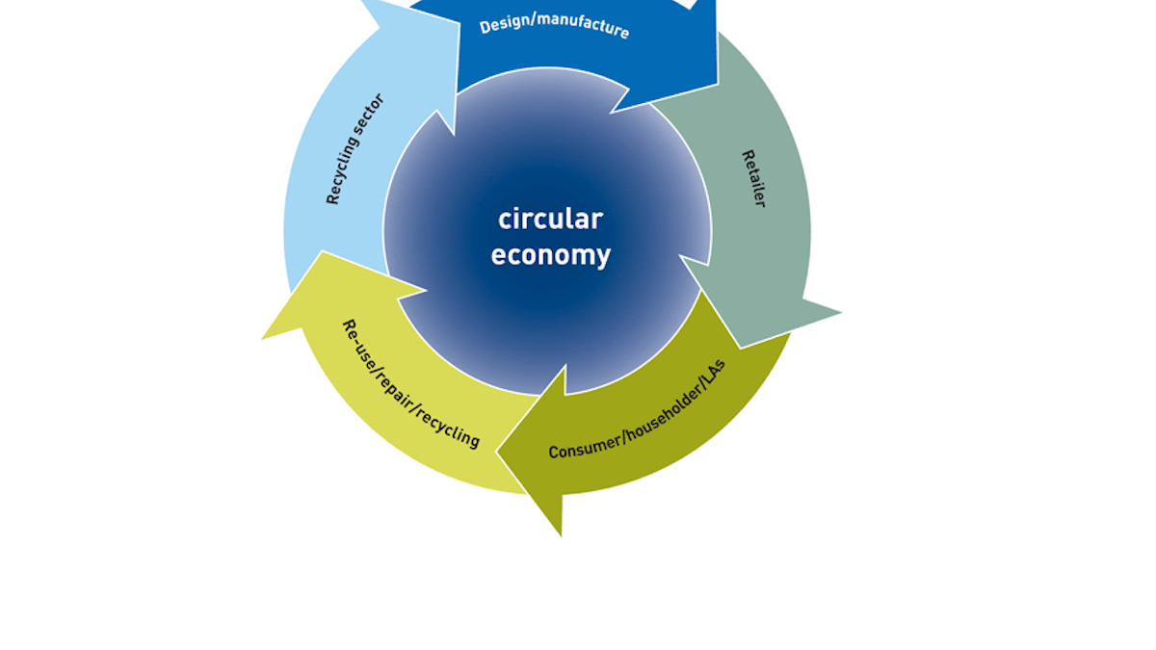Figure 4: Circular economy concept
Source: Rodríguez-Antón and Alonso-Almeida (2019)
Even though the prospect of disruption is a compelling reason to act, leaders also understand that carefully thought-out circular products and business models may foster growth, reduce costs, and foster resilience while putting the company in position for a low-carbon future. For example, hospitality properties must make significant financial investments in infrastructure, furnishings, and machinery (Legrand, 2022). In a linear economy, which encourages frequent and aggressive renovations, frequently for financial reasons like tax deductions, these have a finite lifespan. Instead, these expenditures should go toward materials and goods made in a circular economy for long-term sustainability.
.

Portfolio 5: Essay

Improving Guest Experience in Hospitality Sector
According to ( Manhas and Tukamushaba 2015) enhancing the guest experience by offering high-quality factors of production is an important competitive need for firms involved in the hospitality and tourism industries to improve their brand recognition which is fundamental for a business's goals and for sustaining long-term progress and in addition customers can interact with companies using it as well. Nevertheless Nobar et al. (2018) promotional activities with a recurring concept helps to build a brand's reputation throughout years, and the experiences of actual customers serve to validate it. Thus a logo must be straightforward and able to deliver the intended audience in order to ensure a smooth market position. Likewise, studies suggest that to attract and retain customers, travel and tourism providers should build their clients with high-quality offerings that make a huge impact (Bharwani and Jauhari 2017).
How ever,the hunt for innovative strategies and aspects of good execution to improve guest experience is fuelled by the hospitality industry's environment of fierce competition. Subsequently the making and use of technical innovations and fresh components that can act as a potent catalyst for the development of the hotel business to amplify visitor satisfaction represents one of the key advancements in this field ( Dzhandzhugazova et al. 2016). In the opinion of Kandampully et al. (2018) exceptional guest experiences are critical to win over customers and attempt to obtain a competitive edge in the modern hotel sector.

Portfolio 6: Reflection

How green environmental practices in hospitality sector improves environmental experience of customers
Introduction:
I've concocted and digested many ideas on how the hospitality sector is highly dependent on achieving sustainable development, which is actually the careful utilisation of a source to prevent depletion or deterioration (Bani et al. 2022). Moreover the preservation of the scenic and historical features that draw visitors to a location is essential to the success of hospitality enterprises. Subsequently I came across the advantages of using green techniques in the recent studies of Kuo et al. (2022) that one can lower your environmental impact and the amount of pollutants discharged into the ecosystem by making modifications. The benefits of cleaner atmosphere, reduced wastes, and thus more sources of renewable energy end up benefiting subsequent generations. My next step would be reflecting more on how environmentally friendly activities in the hotel industry enhance the clients' ambient perception and I’m quite excited to go ahead with my learnings.

General Analysis:
The most significant element I realised was, the hotels that practise environmental responsibility increases customer satisfaction while simultaneously it can cut waste by 55% to 77%, benefiting the hospitality industry thousands of dollars in dumping expenses. Because once applied to the whole sector, adopting green energies can indeed lower cost of operations by 10%, resulting in cost avoidance of 8.5 kilowatts. Furthermore, as being one of the sustainable sources of oxygen and inhaling, greener environments not only provide a lovely aesthetic space but also minimise pollutants, attempting to keep us energetic and paving a pleasant feel for the guest to admire the beauty of nature. Since we benefit from breathable air, less contamination, and other factors, it is really important to maintain our ecosystem especially in the hospitality industries.

Evaluation:
Modica et al. (2020) propounds the importance of how client contentment, commitment, and readiness to pay more for goods and services are characterised by economic, ethical, and ecological sustainability policies of businesses in the hospitality distribution chain. Modica’s concept provides insight into my own experience of a content feel when I got to see a restaurant with a blissful greenery environment and increased my willingness to see the same environment all around me which in further raised my interest in enhancing landscaped gardens in my own space. However there are also few research that pinpoints the concept of concerns about using sustainable and green techniques in the hotel sector. This concept is typical of what Prakash et al. (2020) had mentioned in his article which further broadens the topic on how hotel business needs to embrace a green strategy while maintaining better sustainable management growth. There are many studies which indicates on certain maintenance practices in the building of hospitality sector such as sustainable cooling heating, sustainable domestic/restroom, sustainable laundry, pool etc. have high importance in the consumer market.
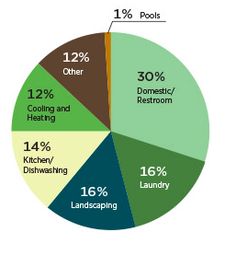
Figure 5: Building Maintenance
Source: Prakash et al. (2020)

Conclusion:
Having read around this issue I now realise that there are several advantages to just using sustainability in the hospitality industry. In addition to bringing in more clients and appropriately addressing what many see as a patriotic obligation in context of the current environmental collapse, green initiatives provide incentives for hospitality firms and a lot more additional benefits. Furthermore, I have developed my understanding of how important it is to develop green environment implementations in the service sector in order to enhance the guest experience as well.

Portfolio 7: Essay

How Regulatory affairs in the UK improves the sustainability of the hospitality sector:
Introduction
It was noted by Jones et al. (2016) that in attempt to display a meaningful and long-lasting sustainability efforts, the hospitality sector might have to revaluate how it distinguishes sustainable development, expand its conservation tracking to include subject matter and peripheral confirmation, and fix the concerns of green development and continued population increase. According to the viewpoint of Martínez et al. (2019) the professionals who can offer data and insights that helps the organisation to efficiently handle aspects of sustainability are known as expertise agents, out of the angle of a hotel, which is seen as the most significant wheel in the mechanism of the hospitality business.Alternatively, research results suggest that the function of expertise agents is important for the effectiveness of an organisation's environmental base of knowledge in the hotel industry. Therefore in the observation of Lieske et al. (2019) realising a sustainable environment through adequate regulatory surveillance is crucial for addressing future economic and environmental crises.
Main Body
Extensive research on many studies showcases that the UK has had remarkable success in the hospitality and tourism business. Based on the various studies, tourism was the third-largest service exported from the UK, stimulating trade and economic growth while also generating jobs nationwide and contributing significantly to the nation's exceptional cultural diplomacy position. According to Bowie et al. (2016) the greatest of Britain is essentially showcased to the globe through tourism. The UK government cannot implement legal and regulatory framework on its own. Every governing party in the globe has a responsibility to participate in development policies, whether it is through infrastructure development, taxing, deciding how to explore the opportunities through borders and visa procedures, or advertising through various tourism organisations ( MacKenzie et al. 2019). However, the significant proportion of the interactions, travel options, and lodging used by tourists are inevitably provided by the private industry, thus this plan will need to be implemented in collaboration with industry. To put this strategy into place, the UK government has been committed to collaborating with other authorities as well as the private industry.

Conclusion
Furthermore, the UK Policy and regulations aims to include an expanding, vibrant, and sustainable tourist economy realising its complete capacity and strengthening the economy in each of the UK's nations and regions. Additionally in order to achieve the state's larger Worldwide Britain, levelling-up, and growth of the economy, tourism has a critical role to play. González-Torres et al. 2021 states that the UK government has been committed to doing everything in its power to support the tourism sector's quick Covid-19 recovery and to enhance itself after the outbreak by making it much more sustainable, affordable, adaptable, competitive, and inventive.

Portfolio 8: Report

Fiscal and economic incentives for brands promoting sustainability
Introduction
Many practices have been undertaken in each country for reforming the environmental sustainability. The hospitality sector is becoming highly popular in the market especially after the post-pandemic period. Many people have started to travel again which have consecutively leveraged the worth and value in the hospitality segment. The present section will focus on how the hospitality brands accomplish fiscal and economic incentives by promoting sustainability concept.

Main body
Nowadays the customers are highly conscious of making the right choices especially when it comes to hospitality sector as most of the consumers wants best service at an affordable range. As the global tourism sector elevates considerable higher it consecutively gives scope for the overall development of hospitality sector. Baum and Hai (2020) studied that even though there was a dip in 2020 due to pandemic crisis, the tourism sector again raised which is gown through the below figure.
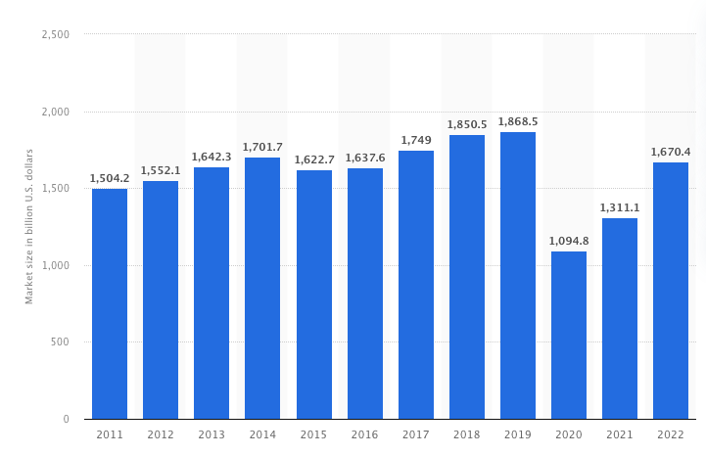
Figure 6: Hospitality sector
Source: Statista (2022a)
The hospitality companies which are now promoting green and sustainable oriented practices are becoming highly popular and also gains high publicity in the market. The companies are highly benefitted by these practices because the customers are highly likely to consider these hospitality companies over others in the market. The customer awareness on the green sustainability practices have leveraged unprecedently and undoubtedly which delivers better scope for all the hospitality companies which promotes it appropriately. Elkhwesky et al. (2022) studied that the companies obtained economic and fiscal incentives with the support of adequate green marketing practices. In addition to this, the companies which align with the sustainability practices into their current operations have better advantage of customer support which also rewards them monetarily. On the other hand, the government support for the companies which are promoting environmental sustainability practices is also higher which provides better growth and development platform for the firms (Elkhwesky et al., 2022). The leadership is also an important aspect for earning positive economic and fiscal incentives for hospitality companies. In addition to this, Energy Management Programs and energy usage evaluating techniques are used by the hospitality companies for reducing their environmental impact is a boon for the society and companies (Zhong et al., 2021). The government have promoted embracing renewable energy concept amid the companies for not only improving the country’s sustainability but also contributing for long-term longevity of the society and environment. On the other hand, sustainable strategies including energy-efficient programs should be deployed in the company as it is appreciated by consumers and government. Henceforth, the sustainability of the hospitality sector is inevitable not only to achieve economic incentives but also to sustain the name and fame in the market.
Conclusion
The conclusion of the report is that the hospitality sector should focus on innovating and improving their sustainability aspects for accruing better results in the market. At the same time, the global hospitality sector is becoming highly challenging which requires better support of economic incentives through customer adherence. The green strategies need to be deployed for accomplishing better achievements in the company. The green sustainability practices not only improves the company’s performance but there will be also support and baking from the governmental side. The company could eliminate any unnecessary lawsuits and issues.

References
AlFaris, F., Abu-Hijleh, B. and Abdul-Ameer, A. (2016) Using integrated control methodology to optimize energy performance for the guest rooms in UAE hospitality sector. Applied Thermal Engineering,
Bani-Melhem, S., Al-Hawari, M.A. and Mohd. Shamsudin, F., 2022. Green innovation performance: A multi-level analysis in the hotel sector. Journal of Sustainable Tourism,
Baum, T. and Hai, N.T.T. (2020) Hospitality, tourism, human rights and the impact of COVID-19. International Journal of Contemporary Hospitality Management,
Bharwani, S. and Jauhari, V., 2017. An exploratory study of competencies required to cocreate memorable customer experiences in the hospitality industry. In Hospitality marketing and consumer behavior. Apple Academic Press.
Bilgihan, A. and Nejad, M., 2015. Innovation in hospitality and tourism industries. Journal of hospitality and Tourism Technology.
Bowie, D., Buttle, F., Brookes, M. and Mariussen, A., 2016. Hospitality marketing. Routledge.
Bragg, M.A., Pageot, Y.K., Amico, A., Miller, A.N., Gasbarre, A., Rummo, P.E. and Elbel, B., (2020). Fast food, beverage, and snack brands on social media in the United States: An examination of marketing techniques utilized in 2000 brand posts. Pediatric obesity,
Chen, B.T., 2017. Service innovation performance in the hospitality industry: the role of organizational training, personal-job fit and work schedule flexibility. Journal of Hospitality Marketing & Management,
Christou, P., Avloniti, A. and Farmaki, A., 2019. Guests’ perceptions of emotionally expressive and non-expressive service providers within the hospitality context. International Journal of Hospitality Management,
Dzhandzhugazova, E.A., Blinova, E.A., Orlova, L.N. and Romanova, M.M., 2016. Innovations in hospitality industry. International Journal of Environmental and Science Education,
Dzhandzhugazova, E.A., Blinova, E.A., Orlova, L.N. and Romanova, M.M., 2016. Innovations in hospitality industry. International Journal of Environmental and Science Education,
Elkhwesky, Z., El Manzani, Y. and Elbayoumi Salem, I. (2022) Driving hospitality and tourism to foster sustainable innovation: A systematic review of COVID-19-related studies and practical implications in the digital era. Tourism and Hospitality Research,
Florido, C., Jacob, M. and Payeras, M. (2019) How to carry out the transition towards a more circular tourist activity in the hotel sector. The role of innovation. Administrative Sciences
Gaber, H.R. and Wright, L.T., (2014). Fast-food advertising in social media. A case study on Facebook in Egypt. Journal of business and retail management research,
Golubovskaya, M., Robinson, R.N. and Solnet, D., 2017. The meaning of hospitality: do employees understand?. International Journal of Contemporary Hospitality Management.
Hussain, K., Konar, R. and Ali, F., 2016. Measuring service innovation performance through team culture and knowledge sharing behaviour in hotel services: a PLS approach. Procedia-Social and Behavioral Sciences,
Jones, P., Hillier, D. and Comfort, D., 2016. Sustainability in the hospitality industry: Some personal reflections on corporate challenges and research agendas. International Journal of Contemporary Hospitality Management.
Kandampully, J., Zhang, T.C. and Jaakkola, E., 2018. Customer experience management in hospitality: A literature synthesis, new understanding and research agenda. International Journal of Contemporary Hospitality Management.
Kingsnorth, S. (2022) Digital marketing strategy: an integrated approach to online marketing. London: Kogan Page Publishers.
Kuo, F.I., Fang, W.T. and LePage, B.A., 2022. Proactive environmental strategies in the hotel industry: eco-innovation, green competitive advantage, and green core competence. Journal of Sustainable Tourism,
Legrand, W. (2022) Circularity: The sustainable hospitality frontier? Available at: https://www.hospitalitynet.org/viewpoint/125000162.html (Accessed: 2 December, 2022).
Lieske, M.C., Lieske, D.M. and Tamm, M., 2019. Product Regulatory Affairs. Ann Arbor,
MacKenzie, N. and Gannon, M.J., 2019. Exploring the antecedents of sustainable tourism development. International Journal of Contemporary Hospitality Management.
Manhas, P.S. and Tukamushaba, E.K., 2015. Understanding service experience and its impact on brand image in hospitality sector. International Journal of Hospitality Management, 45
Manniche, J., Larsen, K.T. and Broegaard, R.B. (2021) The circular economy in tourism: transition perspectives for business and research. Scandinavian Journal of Hospitality and Tourism,
Martínez-Martínez, A., Cegarra-Navarro, J.G., Garcia-Perez, A. and Wensley, A., 2019. Knowledge agents as drivers of environmental sustainability and business performance in the hospitality sector. Tourism Management,
Martínez, P., 2015. Customer loyalty: Exploring its antecedents from a green marketing perspective. International Journal of Contemporary Hospitality Management.
Mercade Mele, P., Molina Gomez, J. and Garay, L. (2019) To green or not to green: The influence of green marketing on consumer behaviour in the hotel industry. Sustainability,
Minh, N.H., Ha, N.T., Anh, P.C. and Matsui, Y., 2015. Service quality and customer satisfaction: A case study of hotel industry in Vietnam. Asian Social Science, 11(10)
Modica, P.D., Altinay, L., Farmaki, A., Gursoy, D. and Zenga, M., 2020. Consumer perceptions towards sustainable supply chain practices in the hospitality industry. Current Issues in Tourism,
Nieves, J. and Segarra-Ciprés, M., 2015. Management innovation in the hotel industry. Tourism Management,
Nobar, H.B.K. and Rostamzadeh, R., 2018. The impact of customer satisfaction, customer experience and customer loyalty on brand power: empirical evidence from hotel industry. Journal of Business Economics and Management,
Pan, X., Sinha, P. and Chen, X. (2021) Corporate social responsibility and eco‐innovation: The triple bottom line perspective. Corporate Social Responsibility and Environmental Management,
Prakash, S., Sharma, V.P., Singh, R. and Vijayvargy, L., 2022. Adopting green and sustainable practices in the hotel industry operations-an analysis of critical performance indicators for improved environmental quality. Management of Environmental Quality: An International Journal,
Radesky, J., Chassiakos, Y.L.R., Ameenuddin, N. and Navsaria, D., (2020). Digital advertising to children. Pediatrics, 146(1).
Rashidi, K., Noorizadeh, A., Kannan, D. and Cullinane, K. (2020) Applying the triple bottom line in sustainable supplier selection: A meta-review of the state-of-the-art. Journal of Cleaner Production, 269,
Rodríguez-Antón, J.M. and Alonso-Almeida, M.D.M. (2019) The circular economy strategy in hospitality: A multicase approach. Sustainability, 11(20),
Singh, P.K. and Pattanayak, J.K., (2016). Study of the relationship among the factors of brand equity: A study on fast-food brands. Global Business Review, 17(5)

Wingrove, C.A. and Urban, B., (2017). Franchised fast food brands: An empirical study of factors influencing growth. Acta Commercii,
Zahoor, S.Z., (2022). Analysing the Effect of Social Media on Customer Equity: A Study of Fast-food Restaurants. Vision,
Zhong, Y., Busser, J., Shapoval, V. and Murphy, K. (2021) Hospitality and tourism student engagement and hope during the COVID-19 pandemic. Journal of hospitality & tourism education, 33(3),

