Module nr: LCBB6003
Lecturer’s name: Dr. Laila Maazouz
Leadership and management, theory and practice

Contents
Introduction 2
Task 1 3
Examples from the business world 5
Task 2 6
Management skills 6
Leadership skills 8
Skill development 9
Conclusion 10
References 11

Introduction
In organizations management is the main focus body of the company which focuses on the operational tasks of the company and provides a brief path to the employees of the company. The promoter of the company is not capable of managing all the required activities in the company especially when the company is too big and has thousands of employees. To manage the managerial tasks and work management is needed for the company which manages all the policy establishments for the company, decision-making activities in the company manage the efficiency levels of the employees, motivate employees, and manage all the resources of the company efficiently. The shareholders of the company are completely reliant on the management for the growth aspect of the company and its smooth operations and to fulfil those expectations the management needs to have a defensive approach in the business.

Task 1
The management of the company has a very wide working responsibility for the company and to combine all these activities the end goal of the manager is to achieve sustainable growth for the company (Garvey, Garvey and Stokes, 2021). The statement is agreed upon because leaders and managers have very thin differences but this creates a huge potential for both in terms of business and its operations. Generally, in organizations managers are responsible for the daily tasks of the company with no failure. Maintaining the available resources of the company and their efficient use for making revenues for the company is one of the tasks of the managers but on the other hand, the leader has tasks to manage the team in the company and motivate them for their efficiency levels and try to achieve new highs of their potential (Garvey, Garvey and Stokes, 2021). Usually, leaders are considered to be high-risk takers with their team and try new things in their daily tasks to complete their goals but on the other hand, managers need to adopt a defensive approach for the company which needs to protect the company from financial losses and negative cash flows (Garvey, Garvey and Stokes, 2021).
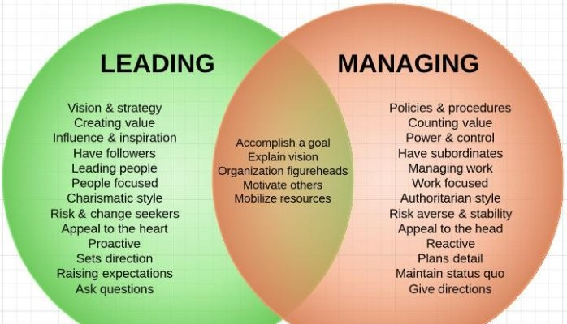
Figure 1: Difference between leadership vs management
Source: (Grote et al., 2019)
In the above image, the leadership and managing qualities are mansions with the common approaches of both managers and leaders. Leaders have a vision and strategy for their operational activities, and value-creating methods, influence their teams, and many more related qualities (Grote et al., 2019). On the other hand, managers have procedures and policies for their operating activities, control and power of the operations, and the authorization facilities of the company (Grote et al., 2019). Due to this difference, the management of the company has to have these qualities to maintain the sustainability aspect of the company.
The selection process of the managers is indulged by the shareholders and founders of the company. The leaders in the company are selected by the management of the company. Therefore, the management has more responsibilities in the company. The lead command of the company is always be to the managers and the individual command of the company will be preferable to the leaders (Grote et al., 2019). From this kind of approach, the company can manage their operations well and do well in the related industry. Higher management of the company prefers those people who can follow given commands and work according to them but in some instances, the leaders do not fulfil those qualities and differ from the managerial approach (Grote et al., 2019).
The statement is too short to make a brief decision of agreed or disagreed because in big organizations the company has thousands of employees and their brand visibility to their clients is perfect for those companies (McCauley and Palus, 2021). But in small organizations where the working population is too short like below hundreds this approach cannot work properly because initially, the company needs those leaders who have an aggressive approach to the business and have a new approach to operational tasks instead of a manager who has a defensive approach for the business (McCauley and Palus, 2021). Therefore, it all depends on the organisation's goals and its size for the managerial approach.

Examples from the business world
Steve Jobs was a great leader at Apple and revolutionised the tech industry through its initiatives and efforts. The person is very inspiring for their team which is the ideal quality of the leader (Weiss, Tappen and Grimley, 2019). Steve showed that the world needs innovative things and changes in traditional technologies. If Steve Jobs had adopted the managerial approach for the company, then they would never have achieved that landmark for the company and for itself (Weiss, Tappen and Grimley, 2019). And the company has never grown at the level it has today.
Jack Welch, CEO of General Electric was considered to be a transformative manager for the company who implemented some important changes in the company such as reducing the cost of manufacturing vehicles, boosting revenues and profits of the company, managing operations of the company in a streamline and focuses on accounting, the performance of the employees and results of the company (Bachkirova, Jackson and Clutterbuck, 2021).
Indra Nooyi who was the former CEO of PepsiCo is considered to be a strategic leader who expanded the global reach of the company and diversified the range of products of the company. The sustainability practices of the company were increased in Indra’s term (Weiss, Tappen and Grimley, 2019). This is the example of the perfect leader because before the company was not doing well and if the management had adopted a managerial approach for the company, then this would not worked and the company would never have grown at that time.
Reed Hastings, CEO and Co-founder of Netflix has been considered to be an innovative leader in the media industry. Hastings disrupted the media industry with its innovative subscription-based idea where people can watch new movies and TV series on their IoT devices and not need to buy DVDs for that (Weiss, Tappen and Grimley, 2019). To implement these kinds of revolutionary ideas the company needs a leader who has different thinking.
Task 2
It is very typical to decide what approach is best for an organization such as leadership or managerial. However, the company has provided several data facts such as the company has a high return on investment on their sales which shows that the company has pricing power, and the company has significant growth in its sales which is another positive factor for the company and the company is debt-free. If any company fulfils these criteria points them the command of that company will be in a managerial approach to maintain their growth and sales forecast. Management focuses on maintaining the existing operating activities of the company and if there are any loopholes reflected in that approach then rectify that and provide a suitable approach for the company. The managerial approach provides a brief security to the company where the main motive of the management is to survive the company in the competitive environment and maintain the interest of all the stakeholders in the company such as employees, consumers, suppliers and shareholders.
In another scenario, the company has bad cashflows, negative working inventory, negative working capital, reduced workforce and declining market share in the industry in this kind of situation an innovative and critical leader will be required. An innovative leader has all the skillsets to manage this kind of company and can give them a path to success. The leadership approach provides a different perspective to the employees of the company here they see another chance to grow in the business and gain the previous potential again. The leadership approach gives another chance to compete and turn around its financials. The higher management chooses this way only if the general requirements are not fulfilled by the management and needs a different approach for the operation tasks.

Management skills
To manage the operational tasks of the company the management needs specific skillsets which help them to maintain their work. These skillsets are required to manage their work-life balance for the long-term which gives another potential to their working methods. Some of the main skills are described in the following section of this document:
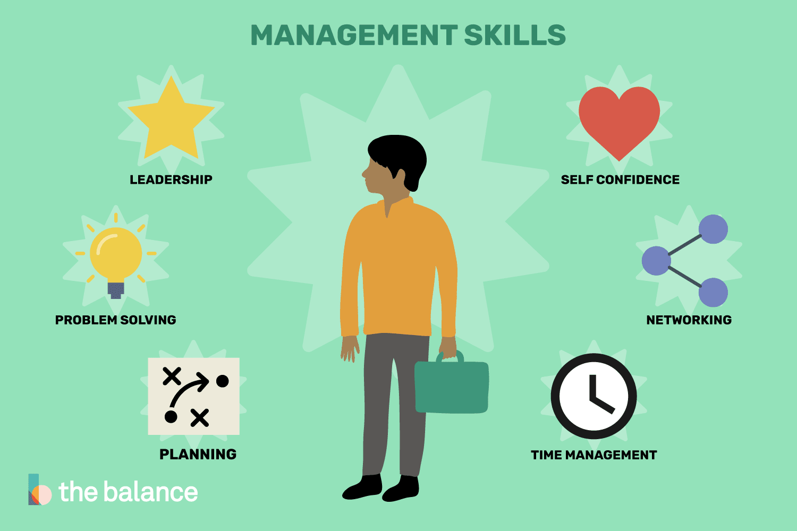
Figure 2: Management skills
Source: (Doyle, 2023)
Leadership: Leadership is the key skill which should have in any manager to lead his workforce. Management of the company Should have a visionary approach and long-term strategy for the company so that the company can achieve sustainability in the long run (McCauley and Palus, 2021).
Problem-Solving Skills: Managers should have problem-solving skills because in the worst situations where the workforce and company do have not any solution for the current scenarios then the management will be responsible for resolving that issue.
Planning: For the long-term success of the company and to maintain its competitive advantage the management should have long-term planning where they have all the aspects of the operation tasks in the company (Garvey, Garvey and Stokes, 2021). Without planning the management cannot run the company and faces negative consequences of their operational activities.
Time management: As a manager of the company, the person needs to manage their time because it will give extra potential for their work. With this approach, the manager can fulfil all the tasks of the company within the required timeline (Clegg, Pitsis and Mount, 2021).
Networking: In today’s competitive era where companies are facing a lot of efforts to make profits and revenues with proper growth in their top line the managers can give an edge with their networks in the industry and provide a supportive environment to the company (Garvey, Garvey and Stokes, 2021).
Self-confidence: Self-confidence is another key skill for managers because if they lack confidence then they cannot maintain proper leadership in the company and feel a lack of confidence to make necessary decisions such as firing those employees who have a lack of integrity.

Leadership skills
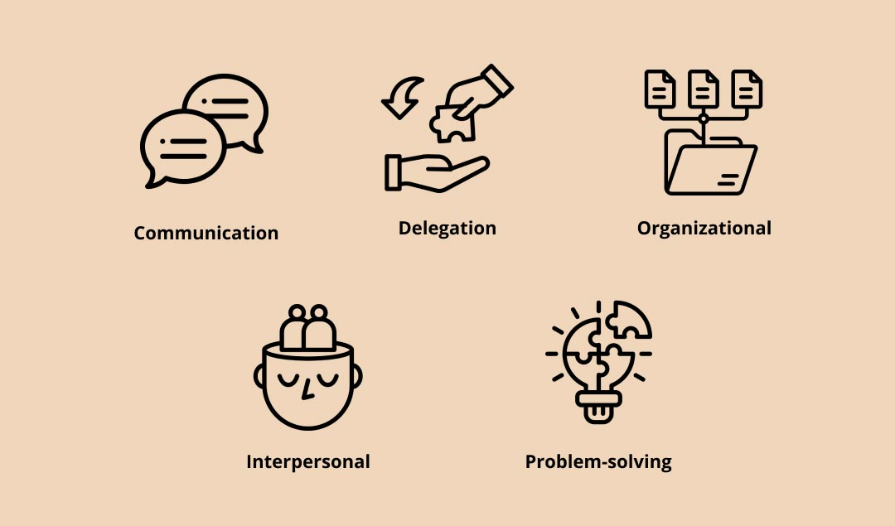
Figure 3: Leadership skills
Source: (McCauley and Palus, 2021)
Communication: Good communication skills are very important for a leader to communicate their thoughts to their team and manage proper relations with them.
Delegation: To diversify the specific tasks among the team equally should be necessary for the leader and make them better leaders (Grote et al., 2019).
Organizational: Organizational tasks which are required to be fulfilled daily have to be accomplished by the leaders.
Interpersonal: Leaders should be aware of the conflicts between their team leaders and have the skills to resolve them (Clegg, Pitsis and Mount, 2021).
Problem-solving: Problem-solving skills are very helpful for the leader in any company to manage their work and resolve problems in the workplace.

Skill development
Developing managerial and leadership skills is a very important criterion for the person who has the desire to work as a manager in any company. Usually, these kinds of skills are learned in academic places such as universities and some students join an internship program in companies where they learn about the business and its aspects (Clegg, Pitsis and Mount, 2021). To analyse the management skillsets students must follow the professional CEOs and founders of the company who built their business from scratch and currently have significant brand value. Companies can provide specific training to their employees to gain these skillsets which can be the ideal way to develop these skillsets.

Conclusion
The work practices of the managers and leaders may differ and have different basic approaches to their work. The main goal of the managers is that the organization should be run smoothly with no complications in the business. Maintain the operating profit margin when the cost of production or cost of doing business should be lesser which helps the company to fulfil its monetary requirements such as giving dividends to its shareholders. Whereas the leaders are inspired by the changeset policies and bring the company to new highs in this approach, the company can see any ups and downs in the operational activities and also in cashflows in the company which is not preferred by the higher management of the company.

References
Bachkirova, T., Jackson, P. and Clutterbuck, D. (2021). Coaching and Mentoring Supervision: Theory and Practice, 2e. [online] Google Books. McGraw-Hill Education (UK). Available at: https://books.google.com/books?hl=en&lr=&id=6lA3EAAAQBAJ&oi=fnd&pg=PA3&dq=Leadership+and+management [Accessed 2 Dec. 2023].
Clegg, S.R., Pitsis, T.S. and Mount, M. (2021). Managing and Organizations: An Introduction to Theory and Practice. [online] Google Books. SAGE. Available at: https://books.google.com/books?hl=en&lr=&id=eiQxEAAAQBAJ&oi=fnd&pg=PP8&dq=Leadership+and+management [Accessed 2 Dec. 2023].
Doyle, A. (2023). Redirect Notice. [online] Google.com. Available at: https://www.google.com/url?sa=i&url=https%3A%2F%2Fwww.thebalancemoney.com%2Fmanagement-skills-list-2062427&psig=AOvVaw0eg60WGQyzw0DDB2BScH-B&ust=1701602657450000&source=images&cd=vfe&opi=89978449&ved=0CBIQjRxqFwoTCIDGnYHS8IIDFQAAAAAdAAAAABAJ [Accessed 2 Dec. 2023].
Garvey, B., Garvey, R. and Stokes, P. (2021). Coaching and Mentoring: Theory and Practice. [online] Google Books. SAGE Publications. Available at: https://books.google.com/books?hl=en&lr=&id=OsxAEAAAQBAJ&oi=fnd&pg=PP1&dq=Leadership+and+management [Accessed 2 Dec. 2023].
Grote, H., Smith, J., Little, J. and Horridge, M. (2019). Clinical leadership fellow schemes for junior doctors: a brief overview of available schemes and how to apply. Future Healthcare Journal, 6(3), pp.172–176. doi:https://doi.org/10.7861/fhj.2019-0030.
McCauley, C.D. and Palus, C.J. (2021). Developing the theory and practice of leadership development: A relational view. The Leadership Quarterly, 32(5), p.101456. doi:https://doi.org/10.1016/j.leaqua.2020.101456.
Northouse, P.G. (2021). Leadership: Theory and Practice. [online] Google Books. SAGE Publications. Available at: https://books.google.com/books?hl=en&lr=&id=6qYLEAAAQBAJ&oi=fnd&pg=PT14&dq=Leadership+and+management [Accessed 2 Dec. 2023].
Todnem, R. (2021). Leadership: In Pursuit of Purpose. Journal of Change Management, 21(1), pp.1–15. doi:https://doi.org/10.1080/14697017.2021.1861698.
Tourish, D. (2020). Introduction to the special issue: Why the coronavirus crisis is also a crisis of leadership. Leadership, 16(3), p.174271502092924. doi:https://doi.org/10.1177/1742715020929242.
Weiss, S.A., Tappen, R.M. and Grimley, K. (2019). Essentials of Nursing Leadership & Management. [online] Google Books. F.A. Davis. Available at: https://books.google.com/books?hl=en&lr=&id=i5SODwAAQBAJ&oi=fnd&pg=PR1&dq=Leadership+and+management [Accessed 2 Dec. 2023].

