An assignment focussing on:

Client letter and draft BIM Execution Plan


(Module: BIM (ACBA5010)

Prepared for:
G. Traylor

Created by:
Natalie Jopling
1911296

Date completed:
27th March 2022

Table of Contents
Page Numbers

- Letter to client 3 - 5

- BIM Execution plan 6 - 11

- References 12

- Client Letter

City and County of Swansea
Civic Centre
Oystermouth Road
Swansea
SA1 3SN

Welsh Structures LTD
9 New Dock Road
Llanelli
Carmarthenshire
SA15 8TP

27th March 2022

RE: BIM Maturity Requirements for Ysgol Bae Abertawe

Dear Ms Thomas

I am writing to you with regards to the ‘state of the art’ Infant School ‘Ysgol Bae Abertawe’, which is a joint funded project with the Welsh Government. As promised, I am writing to inform you about the measures that will be taken to show that the teams within the project are following the guidance that BIM maturity requires.
Firstly, Building Information Modeling (also known as BIM), is a digital process used to create and manage information for a specific project. It includes 3D models and data which relates to the models (Hamil, Hamil and Sharman, 2022). There are a variety of different levels of BIM, but the level we will be using on this project will be level 2, which is also known as BIM maturity. BIM maturity or BIM compliance is a more collaborative way of

working. It is more specific by allowing each party involved in the project to access related files (McPartland, McPartland and Sharman, 2022). When using a collaborative working database’s, it does not matter what specific data is use for the project. What is highly important is that all parties have the correct information at the start of the project, such as the co-ordination points of the project.
To begin, we would respond to what is known as an EIR (employer’s information requirements). We are yet to receive this document but when we do, we will forward it on to you. The EIR is broken into three sections which cover the technical, commercial and management areas. The Technical Department will cover the file information and formats, as well as the levels of definition which include graphical and non-graphical information (Levels of definition explained, 2022). This department will use various software packages such as CAD, REVIT or Revisto. These packages design the building and provide detailed information, such as a certain type of material being used as part of the build. The Commercial Department will include the client’s purpose, as well as the tender information for the project. This department tends to use certain software that provides all the information which would be needed at tender stage, such as site drawings, measurements, specifications and quantities. The Management Department will include the standards, responsibilities as well as the security for the data (B1M 2022).
Throughout the project, members of each department will be able to store, exchange and manage information by using a Common Data Environment (CDE). The CDE is used by members of the design team such as architect, contractor, project manager and client which will provide certain information needed throughout the project.
CDE is a workflow which is used to manage the collection of all information which is relevant to the project. There are 4 sections to a CDE that I have noted below:-
- Section 1. WIP (Work in progress) – This is used to store unprocessed information and data. Once the information has been approved, it will then move into the 2nd phase
- Section 2. Shared – This section allows dependent members of the design team to view the approved information. This allows specific people to make a start on the design work which can then be approved and moved onto the next phase
- Section 3. Published – This section includes information that will be shared amongst the whole project team. At this part, all work should be accurate and validated as it will be the information construction will follow during the project
- Section 4. Archive – This section allows all project members to access all information relating to the entire project. This will include information such as orders and transactions (Zutec | Blog | 4 Phases Of CDE In Construction, 2022)

With collaboration involved and so many departments and members of the team who have access to the data of the project, measures will need to be put in place to manage security risks. We will be following the PAS 1192-5 specification which applies the appropriate processes to follow. The PAS 1192-5 will assist members within the project to reduce the risk of disclosure of the information provided. The specification covers all possibly avenues such as a sensitive build asset, which is a security minded approach to make sure protection measures are in place, to prevent interests of threat such as fraudulent or criminal behaviour.
The other processes includes risk assessments to assess possible threats, security policies, processes and procedures to emphasis to the team the measures that need to be adhered to regarding possible security risks.
Please find enclosed a copy of the BIM Execution Plan (or known as BEP). The BIM Execution Plan is a breakdown which describes how a construction model will be applied and explains the processes along the way. It provides a better understanding of the roles and responsibilities of the people involved in the project and each goal that needs to be achieved regarding the BIM maturity requirements. One of the important parts of the BIM Execution Plan is having a good understanding of the projects goals. Everyone involved in the project benefits from the plan and it is imperative that it provides good skills which can make it easier to access certain software’s.

I hope this letter has provided you with a better understanding of the BIM requirements.
If you require any more information or have any queries, please do not hesitate to contact me.

Yours sincerely

Natalie Jopling

- BIM Execution Plan

Project Name: Ysgol Bae Abertawe
Project number: 5010

Pre-contract BIM Execution Plan

Contents

- 1.0 Project Information

- 2.0 Management

- 3.0 Planning and Documentation

3.1 Common Data Environment (CDE) stages

3.2 Project Implementation Plan

3.3 Team Collaboration

3.4 Documents

3.5 Task Information Delivery Plan

- 4.0 Standards, Methods and Procedures

4.1 Drawing sheet

- 5.0 IT Solutions

- 6.0 References

BIM Execution Plan (BEP)
Project Number: 5010 – Project Name: Ysgol Bae Abertawe

- Project Information

Project name: | Ysgol Bae Abertawe
Project number: | 5010
Project Description: | One form entry infant school for 90 pupils with 48 PT Nursery Provision
Site Location: | Slipway Road, Maritime Quarter, Swansea, SA1 1YB
Project Duration: | March 2023 – May 2024

- Management

- Responsibility | - Company | - Name | - Email | - Phone
Lead Consultant | Welsh Structures LTD | Natalie Jopling | N.Jopling@welshstructuresltd.co.uk | 01792 292851
Design Architect | Design Architects | John Thomas | John.Thomas@designarchitects.co.uk | 01269 456789
Structural Engineer | Roger Casey Associates | Phil Jones | Office@RCA.co.uk | 01267 222645
Quantity Surveyor | David Morgan | David Morgan | David.morgan@gmail.co,uk | 07866 2456976
Contracts Manager | Steven Windsor | Steven Windsor | Steven.Windsor@yahoo.co.uk | 07845 123654
Site Manager | James Smith | James Smith | James.smith@live.com | 07546 321984
Project Manager | Thomas James | Thomas James | Thomas.James@hotmail.co.uk | 07555 465812
Buying | AJH procurement | Amanda Hughes | Admin@ajhprocurement,com | 01792 458761

BIM Execution Plan (BEP)
Project Number: 5010 – Project Name: Ysgol Bae Abertawe

- Planning and documentation
The planning for the project will follow the RIBA plan of work 2020 which provides a work frame to clarify the different stages of the project.

Project stage | Estimated start date | Estimated completion date
0 – Strategic Definition | N/A | N/A
1 – Preparation & Briefing | N/A | N/A
2 – Concept Design | February 2022 | May 2022
3 – Spatial Co-ordination | June 2022 | September 2022
4 – Technical Design | October 2022 | February 2023
5 – Manufacturing & construction | March 2023 | March 2024
6 - Handover | N/A | May 2024

3.1 Common Data Environment (CDE) stages
Sections | Stage | Information
1 | Work in progress | To store unprocessed information and data. Once the information has been approved, it will move onto the next stage
2 | Shared | Allows dependent members of the team to view the information. This allows specific people to make a start on the design, which can then need approval to move onto the next stage.
3 | Published | This includes accurate and validated information that will be shared amongst the whole project team.
4 | Archive | This section allows all project members access to all information relating to the entire project, such as orders and transactions.

BIM Execution Plan (BEP)
Project Number: 5010 – Project Name: Ysgol Bae Abertawe

3.2 Project Implementation Plan
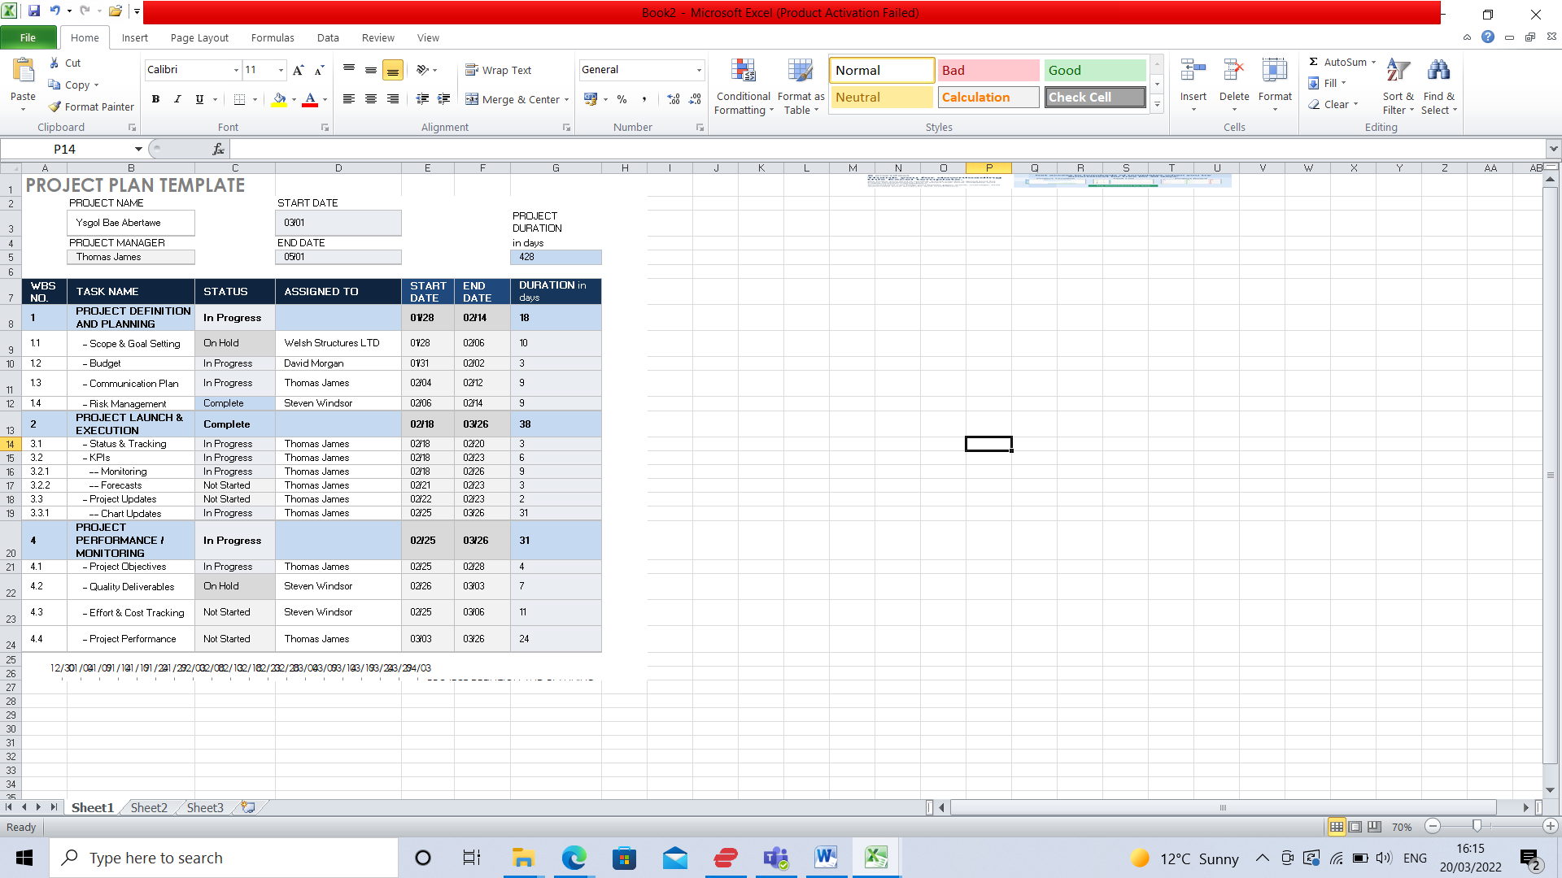
3.3 Team Collaboration

All information documents for the project will be stored on the project cloud network. This is an easier way for all parties involved to gain access.

Following the section of a Common Data Environment, once project information has been approved (section 1), all information from section 2 onwards will be shared for the design team. They will have certain access to files found within the cloud network.
The Architects will use various software programs. They will be REVIT, CAD, and REVIZTO. Relating to REVIZTO, the design team will have access to a shared file where they can access, amend and add information to the 3D design from REVIT.

From sections 3 onwards, if there are any changes made the documents found within the cloud, all parties will be informed and will have access to see the amendments.

The files will be available in PDF formats as it will be the easier option to view the documents for everyone involved.

More information will be provided once the EIR is sent.

The PAS 1191-5 specification will be put in place to prevent any security risks.

BIM Execution Plan (BEP)
Project Number: 5010 – Project Name: Ysgol Bae Abertawe

3.4 Documents
The following documents can be found within the cloud network:-

- Plans
- Elevation plans
- Sections
- Engineering plans
- Specifications
- Terms and conditions
- RAMS

3.5 Tasks Information Delivery Plan

FILE IDENTIFIER
PROJECT | ORIGINATOR | FUNCTIONAL BREAKDOWN | SPATIAL BREAKDOWN | FORM | DISCIPLINE | NUMBER
5010 | Welsh Structure LTD | XX | 00 | D | Q | 0

4.0 Standards, Methods and Procedures
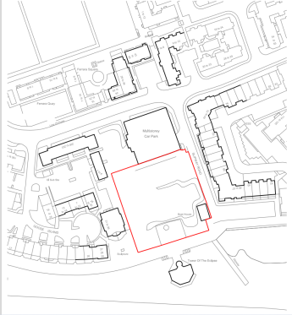
All standards for the project are noted below

The location plan for the project is found to the right

The project base point for the project will be 0,0 and the location point from Google maps is also shown in the table below:-

- Reference | - Position
Ground Floor | 0 (mm)
Project base point | 192364.7N, 265976.9E (mm)
Location point | 51°36’51°N 3°56’11°W

BIM Execution Plan (BEP)
Project Number: 5010 – Project Name: Ysgol Bae Abertawe

4.1 Drawing sheet
All drawings produced and found in the cloud network will have certain information on the title sheet. This information is noted below:-

Project | 5010
Originator | Welsh Structure LTD
Functional breakdown | XX
Spatial breakdown | 00
Form | D
Discipline | Q
Number | 0
Description | GA Plan
Status | SO
Revision | A

5.0 IT Solutions
A list of the specific software packages used for the designs within this project is found below:-

- Company | - Purpose | - Software | - Version
Autodesk | 2D modeling | AutoCAD | 2022
Autodesk | 3D Modeling & creating drawings | REVIT | 2022
Vizerra | Collaboration software platform | REVIZTO | 5

6.0 References

2022. [online] Available at: <https://www.theb1m.com/video/what-are-employers-information-requirements>

Hamil, D., Hamil, D. and Sharman, J., 2022. What is BIM?. [online] NBS. Available at: <https://www.thenbs.com/knowledge/what-is-building-information-modelling-bim>

McPartland, R., McPartland, R. and Sharman, J., 2022. BIM Levels explained. [online] NBS. Available at: <https://www.thenbs.com/knowledge/bim-levels-explained>

Zutec. 2022. Zutec | Blog | 4 Phases Of CDE In Construction. [online] Available at: https://www.zutec.com/4-phases-of-cde-workflow-management/

