
Applied Leadership and Management in the Workplace
Module Assignment Submission
Student Name: | Rosemarie Bennett
Student Number: | 2310781
Module No: | BMSK4013
Module Title: | Management Communication

Statement of Confirmation of Authenticity
By the act of making this submission, the student declares that this is the work of the student named above. The work has not, in whole or in part, been knowingly presented elsewhere for assessment, or where assessment has been built on a previous assessment, this has been identified. Where materials have been used from other sources it has been properly acknowledged. If this statement is untrue, the student acknowledges that an assessment offence has been committed.
Attention is drawn to the plagiarism and unfair practice policies of both the University and of ILM.

Contents
Section 1: Communication 2
• 1.1 Explain the relevance of the communication cycle for effective communication in management 3
Effectiveness of this model 5
1.2 Explain, with examples, the importance of selecting an appropriate tone, language, and level of formality in management communications 6
Definition on tone 6
Definition on language 6
What is formality 6
1.3 Assess the effectiveness of a range of verbal and written communication methods within your area of the organisation 7
Written Communication 7
Verbal Communication 7
Section 2: Motivation 9
2.1 Evaluate theories of motivation relevant to your workplace 9
2.2 Evaluate the principal factors that may affect performance and motivation in the workplace 11
2.3 Select a theory of motivation - apply it to your workplace – evaluate the impact 12
Select one of the theories from above and you have to apply this theory to you 12
2.4 Develop appropriate criteria to evaluate own ability to communicate effectively 12
2.5 Collect and analyse feedback on own verbal and written communication skills 13
2.6 Evaluate own communication skills as a manager, identifying strengths and areas for improvement……then Produce a PDP to address these 14
SWOT analysis based on questionnaire. 14
My PDP based on data results. 14
References 16

Section 1: Communication
Communication is defined as the sharing information between one or more people using a ‘medium of language disseminated through its formal (making public) and informal (signs, symbols, verbal, writing, e-mail, pre-prints, etc.) channels’ (Rao, 2018), and is said to be "the creation and exchange of meaning" (Nordquist, 2019), through a variety of channels. Key to success is using the right language and the right channel, whilst gaining feedback s to ensure the message has been received correctly.
Managers and leaders need strong communication skills because it helps them perform their jobs effectively, (Oratory CDC, 2023) and they can communicate effectively to their team. This leads to better understanding, improved performance and increased motivation and trust, which are important for effective management.

1.1 Explain the relevance of the communication cycle for effective communication in management
The communication cycle demonstrates the exchange of information between a sender and a receiver. Effective communication is a vital component for an organisation to accomplish its purpose, goals and objectives and can improve management of the team, build confidence and strengthen the team by creating constructive feedback loops (Lee & Kim, 2018). The communication cycle shows evidence of this feedback, together with the other stages which includes:
SENDER – the person who formulates the message. Thought is needed at this stage to consider what message is being sent, the best language and level of formality to use as this will help ensure clarity and understanding.
MESSAGE – as well as considering what they want to say the sender will also consider the most appropriate channel of communication for the message to be sent. The channel can be very important but often in the workplace e-mail is used and has led to the term ‘e-mail overload’ which refers to employees ‘receiving and sending more e-mails than they can handle and/or process effectively (Wood & Krasowski, 2020). When this happens some e-mails can be missed which means communication has not been effective.
RECEIVER – needs to decode the message, so it has to be clear, in the right language, the right level of formality and through the right channel. If a quick response is needed then there is little point sending a letter, considering the e-mail overload issue means the most appropriate channel might be a telephone call, which gives direct access and immediate response. The receiver can decode the message and ask for feedback during the phonecall.
FEEDBACK – How the message is communicated and how it is understood are two different things (Mulder, 2022), to check if the other person has understood you can repeat what has been said to clarify and avoid misunderstandings (BBC,2024) however the communication cycle does not actively show the checking required to ensure the message has been understood correctly. The recipient tries to ‘crack’ the sender’s message through decoding, which means they interpret what they are seeing and hearing and translate it into thoughts (Mulder, 2022). If the message contains a lot of jargon or abbreviations then it can be difficult for a the receiver to decode the message. This is something that happens often within the NHS where a lot of jargon and abbreviations are used in meetings and it is assumed that everyone knows what is being discussed, but this is not always the case and some people leave meetings with a vague understanding at best. If unsure about the message the decoder can ask for more information or for clarity. More information might be needed and therefore feedback is asked for, which then re-starts the cycle.
The more clearly the sender has encoded the message, the more accurately the recipient can decode it, minimising the chance of misunderstandings (Mulder, 2022). When communicating a message the information must be transmitted to the receiver without misunderstanding or confusion, otherwise, “the message which is understood by the receiver can be different from what the sender intended to send” (Lee & Kim, 2018) and when communication is ineffective and those involved are unable to understand the information being sent this can lead to uncertainty and mistrust and sometimes to conflict within the teams

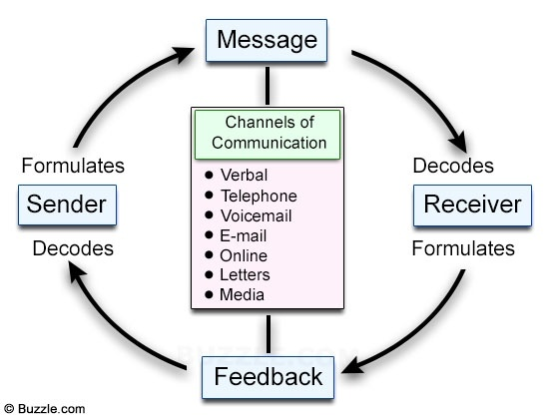

The Shannon & Weaver Communication Cycle model is “a linear model of communication that provides a schematic representation of the relation between sender, message, medium/ media and recipient”.(Mulder, 2022) The model includes ‘noise’ which can affect the transmission of the message, e.g. the lawn being mowed outside a classroom, other people talking and whispering while in a meeting and internal noise such as feeling unwell or worrying about a job that is not being done while you are in a meeting. If a manager recognises that noise plays a part in the receiving of a message then they should make conscious efforts to reduce the ‘noise.

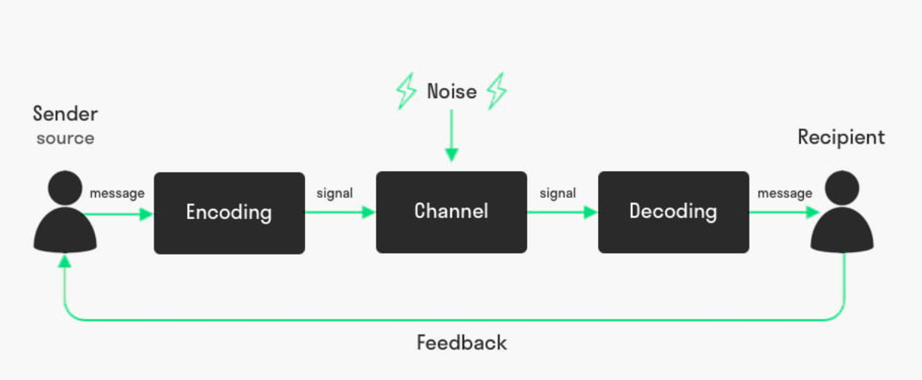
Shannon & Weaver Communication Cycle
Source: Mulder, 2022

In the Shannon & Weaver model both the sender and the recipient can respond to each other, with the sender and recipient alternating roles. This leads to a cyclical process (Mulder, 2022), and the inclusion of feedback within the loop shows that there is some effort to find out whether the message has been understood but again the recipient seems to have the responsibility for checking understanding.

Effectiveness of this model
The effectiveness of this model is that there is a clear understandable structured process to follow to make sure that instructions or information is passed on to the person its for effectively. This model gives a step by step structure and this can be used for many forms of communication, for example, email, face to face conversation, or even a simple text. However critics claim that it is more of a model of the flow of information rather than a communication model, and is now quite old, there is also a suggestion that the model is incomplete (Al-Fedaghi, 2012).

1.2 Explain, with examples, the importance of selecting an appropriate tone, language, and level of formality in management communications

Definition on tone
The tone of voice used in communication crucial. Whatever the content of the things we say, it's the tone we use to communicate that can add impact to the message. Our tone tells the truth even when our words don't (Lickerman, 2010).

The tone of voice used should be pleasant and the right pace and pitch will encourage interest in what is being said. It is essential to listen attentively to get an accurate understanding of customer requests (BBC, 2024). The tone sets out the formality (or informality) of the message being shared.
Brower (2023) found that tone has a significant bearing on how well people work together, stating that if communication has a positive tone,
- 62% respond more quickly
- 57% are more responsive to future requests
- 48% address the concern or do the work at a higher quality
- And 59% perceive the sender more positively

These statistics show how important the tone of voice can be in the workplace and using a positive tone can have a significant impact on the workforce.

Definition of language
Language is an essential tool for communication and using simple language leaves little opportunity for confusion (Wallace, 2017). When communicating it is important to be as clear as possible, with the minimum waffle, technical language and jargon as this means that most team members will understand what is being said. To be effective “both the sender and the receiver(s) need to be well-aware in terms of common language and they need to work diligently to up-grade their language skills on a continuous basis” (Kapur, 2020), otherwise errors will keep happening. Unfortunately there are many organisations who continue to use abbreviations and jargon, (Wallace, 2017), even though it generally causes problems in communication. In the NHS Doctors in particular use jargon when talking in meetings making it difficult to concentrate and understand what is being said.

What is formality
Formal communication is exchanging official information between two or more people within the same organization, by following predefined rules and using official channels of communication. Mostly, it is done in written form but can also be seen in meetings where structure and tone can set the level of formality. Formality is controlled and flows through a hierarchical structure and chain of command in the organizational structure (fisic, 2022). In the workplace there is a need to decide on the correct level of formality, for example if facing a disciplinary meeting then the severity of the situation would not be helped by friendly, jocular conversation and informal friendly discussion, this situation has to adopt formal tone and language.

1.3 Assess the effectiveness of a range of verbal and written communication methods within your area of the organisation

The effectiveness of verbal and written communication varies, depending on who the message is intended for and their ability to take on new information. While verbal communication is fitting for most people, because you get to engage with the individual and explain the process, some people may prefer an email as they have that as a reference to look back on. I have worked in an organisation where we used both forms of communication beginning with a brief verbal of what is required followed by an email with additional information, this would allow us to ask additional questions and have something to relate back to at a future date.

Written Communication
- E-mails
In my organisation Emailed communication can be informal and formal. Informal e-mails include requests for leaving gifts, Christmas Dinner organisation. Formal E-mails include requests for information, updates on projects, external requests, sending of invoices and requests for payment.
- Posters
In my organisation the use of poster communication is a great way to attract attention. A well-constructed Poster can convey essential information in an informal way but they do need to include all of the necessary information to be effective and this information needs to be well presented and not too cluttered. Good colour and graphics can help draw attention to the poster and get the message across to the audience.

Verbal Communication
- Formal meeting
Formal meetings should have a clear communication flow through proper and pre-defined channels. The formal communication adopted in meetings is rational, structured, and goal oriented and this is controlled by an agenda and controlled by the Chairperson, who needs to ensure that the formal approach does not deprive organizational groups of their voice or filter out critical information (Gomez & Dailey, 2017). Having attended formal meetings it is clear that some chairpersons are good at ensuring everyone who wants to voice opinions are heard but there are other meetings where I have seen people being shut down because there is ‘not enough time to discuss that’, or we have ‘run out of time on this for now’. This has a bad effect on people who stop engaging in the meetings.
- Informal Meetings
These are often staff meetings where the team bring in a drink, the agenda may be less formal and there may be some note taking but maybe not formal minutes. Whilst there is still some structure the tone and language is less formal, and can be quite chatty and conversational. In my experience people are happier and willing to speak up in these meetings because they feel comfortable.
- Online meeting
Online meetings using a tool such as Zoom or Teams are now very popular within work placements since the COVID 19 pandemic, however it can be challenging because some people may switch their camera off and you are unable to see if they are paying attention or understanding what is being asked of them, or even if they are there. Some people say that having the camera on affects their IT (Internet connection and IT issues) so it is hard to argue with that, because they then lose connection (intentionally or unintentionally is hard to determine). These meetings can be formal or informal depending on who is attending.

Section 2: Motivation

The term motivation describes why a person does something. It is the driving force behind human actions. “High levels of motivation are intrinsically linked with high levels of employee engagement” (Schooley, 2024) which is why managers place importance on motivation of their team.
Motivation is important within the workplace because it is used to encourage employees to perform well and enable the business to meet and exceed their goals. A demotivated workforce means companies could struggle to deliver their promises, fail to complete daily tasks, and fail to capitalise of future opportunities (Galindo, 2023). It also means an unhappy workforce who are not engaged and not performing to the best of their abilities.
Motivation is not straightforward, it is very individual, we are not all motivated by the same things therefore a one size fits all approach cannot be implemented.

2.1 Evaluate theories of motivation relevant to your workplace

The theories relevant to my workplace include:
Maslow
Human beings are motivated by goal accomplishment. Achieving goals allows humans to meet their individual wants and needs. Needs are mentally prioritized in order of importance (Maslow, 1943).

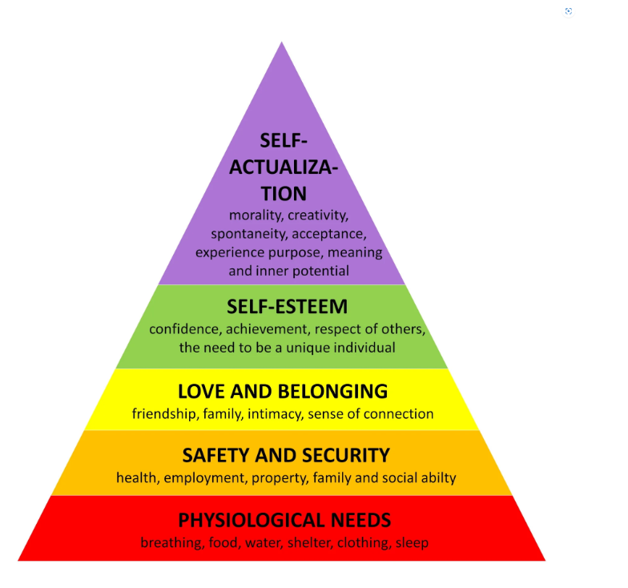 (www.simplepsychology.org, 2024)

Maslow suggested that there is a general pattern of needs recognition and satisfaction that people follow, generally adopting the same sequence (Gawel, 2019). His motivational theory comprises of a five-tier model of human needs, often depicted as hierarchical levels within a pyramid (McLeod, 2018) which he initially claimed was followed in sequence but later clarified that satisfaction of a need is not an “all-or-none” phenomenon, admitting that his earlier statements may have given “the false impression that a need must be satisfied 100 percent before the next need emerges” (McLeod, 2018)

Starting at the bottom of the pyramid, physiological needs are the first priority and must be satisfied first. These needs include nourishment, sleep, clothing, and shelter. These basic needs should be met in order to focus on anything else. If a person is hungry, they will ignore any other wants or wishes to focus on satisfying their hunger (Serhart, 2020) .

Hertzberg

Herzberg (1959) constructed a two-factor theory around issues affecting people's attitudes about work. It was believed that one factor can demotivate and these can often be related to matters other than the work itself, whilst the other set of factors, called motivators, can lead to greater satisfaction and greater motivation leading to increased performance. The main concept of this theory is the difference between motivation factors and hygiene factors (Alshemari et al, 2017). Motivators were elements that enriched a person's job; there are five factors in particular that are strong determiners of job satisfaction: achievement, recognition, the work itself, responsibility, and advancement. It is useful to note that there are some items that Hertzberg sees as hygiene factors which may not motivate but could actually demotivate if not there, others see as motivators.

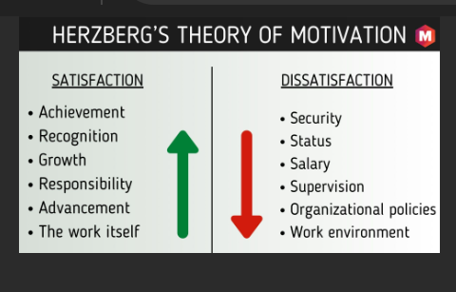

McClelland

The Three Needs Theory, seeks to understand human nature and develop tools to measure how people make choices. McClelland’s Theory of Three Needs is based on the premise that each person is motivated by power, affiliation, or achievement. One trait is usually more dominant, but the others are present in an individual as well. (kurt s. , 2021).

If a person is motivated by power then they will want to have control and influence over their environment, if they are motivated by achievements then they enjoy challenges and want to solve problems, and a person motivated by affiliation want acceptance and productive working relationships (Tanner , 2024)

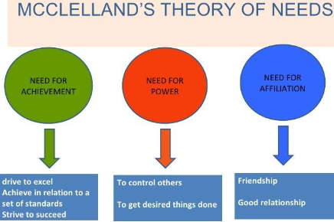

Mc Gregor

McGregor’s X and Y Theories challenged the long standing autocratic approach to leadership (Sutton, 2024). Theory X is the negative theory (Mohammad, 2022) that focuses on supervision and is “associated with the more traditional and autocratic style of management” (Sutton, 2024). Theory Y is the positive theory that focuses on rewards and recognition (Mohammad, 2022) and recognises that we accept and seek out responsibility and are ready and willing to engage our imagination (Sutton, 2024). There are some employees who will flourish under leaders who adopt either approach but there are employees who will not be motivated by either approach.

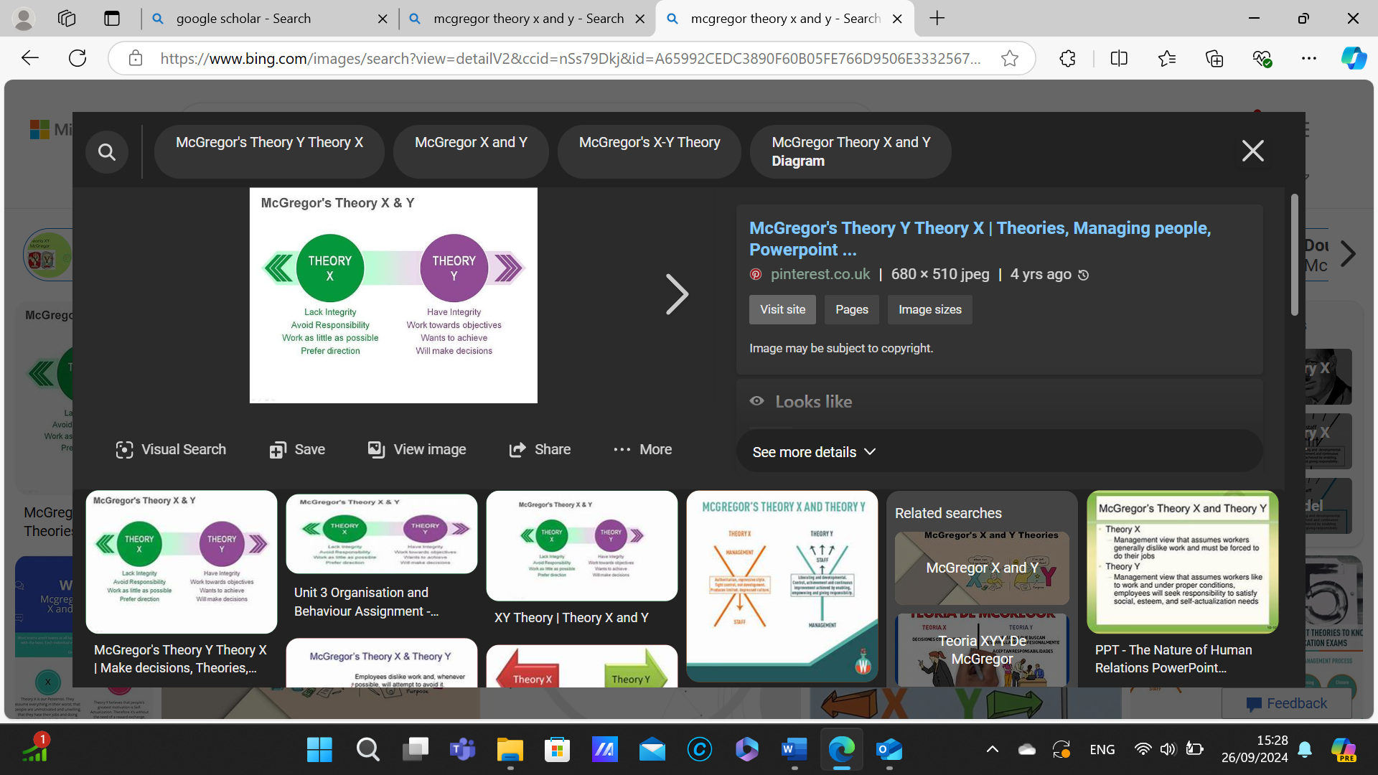

2.2 Evaluate the principal factors that may affect performance and motivation in the workplace

(Recognize, 2024) identified the top 8 factors that affected employee motivation, which included:

- Reward and recognition – praising employees, or thanking them if they have done a good piece of work. Extra effort, over and above expectations could require more than praise to motivate staff and reward could be considered
- Opportunities for Growth and Development – giving staff opportunities to attend training that will enhance their prospects. Many employees would like to be considered for promotion and are motivated to learn so that they can achieve their personal goals
- Financial Benefits – could include a raise or bonus linked to performance but this can be demotivational for other employees who don’t get the chance to get the bonus. Paid time off is a bonus many appreciate and links well to work/life balance.
- Non-monetary benefits – a spa day, meal out, paying for lunch to thank an employee who has gone over and above to complete a piece of work to a high standard is motivational
- Work-life balance – Making sure that employees have a proper work-life balance. Making it clear that employees are not expected to be working in the evening or at weekends, unless that suits them. Offering flexibility in working hours and trusting staff to complete their work is a motivator
- Work Environment - The relationship between people and their work environment affects motivation to work and perform. The work environment includes the organizational culture, management style, goals and values, job demands and support, incentives and rewards.
- Relation with Colleagues – A good working relationship within the team is important to motivation. Conflict should be dealt with quickly so that it does not damage motivation (see conflict management strategy Appendix 1). If managers do not manage conflict well then they can frustrate employees and damage relationship. Conflicts can sabotage alliances and relationships, but effectively managed conflict vitalizes partnerships and invigorates interpersonal bonds. Conflict challenges leaders and teammates and engages them in the full range of experiences that organizations offer. (Dean Tjosvold, 2019)
- Leadership and relation with leaders – leader should be inspirational and approachable. They should also be honest and trustworthy because once trust is damaged then motivation is affected.

2.3 Select a theory of motivation - apply it to your workplace – evaluate the impact

The model I have chosen to apply to my workplace in McClelland, and personally I feel that they key need is the need for achievement
E,g, if you use McClelland and apply it to your job ironing then you can say
- When I am ironing, I have the drive to excel and make sure that every garment is perfect before it leaves my business, this is not just for the tablecloths I iron for local businesses but for any and every garment that comes through my business.
- I have set myself a standard that I strive to achieve, and if a garment does not meet my high standards, then I will re-do the work and make sure that I do meet the standard. I believe in ensuring I provide a quality service, and I am not willing to allow the standard to slip just to get more work done and more money into the business.
- I do strive to succeed; I want to make the ironing business my main source of income and to do that I feel I have to build my reputation for excellent service through my high standards.
- I do enjoy taking on garments that are challenging and have very specific and specialist requirements and I am happy to spend time working out how to solve the problem of how to iron the garment in the best way.
- I will change my ironing method if it is not meeting my needs and allowing me to achieve my high standards.
- One of the reasons I like working in my own business is because I do not like working in groups because they do not like having limited control over the outcome. I like the responsibility for providing a high quality service and doing this myself, not relying on someone else and worrying whether they are meeting my standards.
- The area where I struggle is receiving recognition for any success. I do find it hard to accept compliments and this is unusual for those with a need for achievement. I am also someone who does not like to take risks and those with achievement needs ‘seek out situations where they can take moderate risks’ ( (Fripp, 2024). I am someone who avoids risk which is why my business is growing so slowly.

2.4 Develop appropriate criteria to evaluate own ability to communicate effectively

Having conducted some research and considered some of the skills required to be an effective manager I identified the skills that I thought were important which were:
- empathy,
- approachability,
- Listening and active listening skills,
- tone of voice
- positive
- trustworthiness
These were the skills criteria I used to evaluate my own ability to communicate effectively and used to ask others what they felt my skills were like.

2.5 Collect and analyse feedback on own verbal and written communication skills

 | person 1 | person 2 | person 3
empathy | 4 | 3 | 4
approachable | 5 | 5 | 4
listening & active | 3 | 3 | 4
tone of voice | 2 | 5 | 3
positive & trust | 5 | 4 | 3

I have used this information to identify my strengths and weaknesses and what areas I need to improve on. The chart and data comes from a questionnaire I asked 3 people. With a scale of 1 -5, 1 being poor and 5 being excellent, I asked them what they thought of my, empathy, how approachable I am, what are my listening and active skills like, how my tone of voice come across and how positive and trustworthy am I. The results suggest I need to improve my listening and my tone of voice I will use this knowledge in my PDP.

2.6 Evaluate own communication skills as a manager, identifying strengths and areas for improvement……then Produce a PDP to address these

SWOT analysis based on questionnaire.

Strengths | Weaknesses
According to my data findings I am a very positive person and trustworthy | The results of my data show that my tone of voice is my weakness
Opportunities | Threats
With these results my opportunities within the workplace could be very postie as I am shown to be trusting and positive therefore this will help grown moral | My tone of voice could be my threat as information or general conversation may come across as shouting or degrading.

My PDP based on data results.
What do I want to learn? | What do I have to do? | What support and resources will I need? | How will I measure success? | Target Date for Review
How to ensure my tone of voice stays at an appropriate level | Ensure I think about how I’m speaking to people | Feedback from management | Conduct this questionnaire in a few months’ time | October 2024
Ensure my positive attitude stays. | Keep up positive moral in the workplace | Management and colleges | Colleagues will still be happy at work | ongoing

Personal Objectives

Short Term Goals (next 12 months)
To improve on all my weaknesses in my PDP
Pass Level 4 Cert HE in Applied Leadership & Management in the Workplace

Medium Term Goals (2-3 years)
To be able to use computers comfortably
To complete L5 Applied Leadership & Management in the Workplace

Long Term Goals (3-5 years)
Complete my degree to a high level

References

Al-Fedaghi, S. (2012). A Conceptual Foundation for the Shannon-Weaver Model of Communication. International Journal of Soft Computing, 12-19.
Dean Tjosvold. (2019, august 28). Managing Conflict for Effective Leadership and Organizations.
Durant, I. (2023, october 5). https://peepstrategy.com/understanding-tone-of-voice-in-communication-definition-and-examples/#:~:text=The%20tone%20of%20voice%20is%20an%20important%20factor,gestures%2C%20should%20also%20be%20considered%20for%20effective%20communication.
fisic, j. (2022, feburary 8). https://pumble.com/blog/formal-communication/.
Fripp, G. (2024, October 23). McClelland’s Theory of Needs. Retrieved from My Organisational Behaviour: https://www.myorganisationalbehaviour.com/understanding-mcclellands-theory-of-needs/#:~:text=McClelland%E2%80%99s%20theory%20proposes%20that%20an%20individual%E2%80%99s%20needs%20are,their%20success%20in%20both%20personal%20and%20professional%20spheres.
Galindo, P. C. (2023, april 18).
Hakim, A. (2018, JUNE 25). https://englishfinders.com/definition-of-language-by-scholars/?utm_content=cmp-true.
https://www.managementstudyguide.com/herzbergs-theory-motivation.htm. (n.d.).
Kendra Cherry, M. (2023). https://www.verywellmind.com/what-is-motivation-2795378.
kurt, s. (2020, febuary 6).
kurt, s. (2021, may 23).
managementstudy. (n.d.). Retrieved from https://www.managementstudyguide.com/herzbergs-theory-motivation.htm
Mohammad. (2022, may 22). Retrieved from https://parsadi.com/mcgregors-x-and-y-theories/
Nordquist, R. (2019, september 19). https://www.thoughtco.com/what-is-communication-1689877.
PhD, B. M. (2015, May 15). Retrieved from https://onlinelibrary.wiley.com/doi/abs/10.1002/pfi.21481#:~:text=The%20relationship%20between%20people%20and%20their%20work%20environment,contextual%20level%20and%20interact%20at%20the%20situational%20level.
rahmanjmc. (2015, febuary 9). https://rahmanjmc.wordpress.com/2015/02/09/berlos-smcr-model-of-communication/.
Rao, Y. S. (2018). Scholarly Communication Cycle: SWOT Analysis . Proceedings of International Conference on Scholarly Communication, , 50-68.
Recognize. (2024, May 28). Top 8 Factors that Affect Employee Motivation in 2022. Retrieved from Recognize: recognizeapp.com/cms/articles/factors-that-affect-employee-motivation
Schooley, S. (2024, 28 5). Benefits of Highly Motivated employees. Retrieved from www.business.com: www.business.com/articles/the-benfits-of-highly-motivated-employees/
Sutton, J. (2024, May 28). Theory X and Theory Y (&Z): Employee Motivation Explained. Retrieved from Positive Psychology.com: positivepsychology.com/theory-x-and-theory-y/
Tanner , R. (2024, May 28). Motivation, As simple as the Three Needs Theory. Retrieved from Managementisajourney.com: managementisajourbey.com/motivation-as-simple-as-the-three-needs-theory/
Theories, M. (n.d.). Retrieved from https://www.knowledgehut.com/tutorials/project-management/motivation-theories
Wood, K. E., & Krasowski, M. D. (2020). Academic E-mailoverload and the Burden of Academic Spam. Academic Pathology, 7.
www.simplepsychology.org. (2024, October 21). Maslows Hierarchy of needs. Retrieved from www.simplepsychology.org: https://www.simplypsychology.org/maslow.html

Appendix 1
Conflict Management Strategy

- Acknowledge the problem.
Whether you think the dispute is trivial or serious you must remember to deal with it in the same way. Listen to the complainant and make sure that they feel heard. Decide what you need to do about the situation
- Gather the necessary information.
Investigate all sides of the issue, and make sure you take time to understand what has been said, this helps when finding the best resolution
- Set guidelines.
Set out how the meeting will go, what is acceptable and what is not acceptable. Participants should be clam, listen and try and understand others point of view. Be clear that if anyone does not follow the guidelines then the meeting will end at that point and may resume at a later date when emotions may not be so high
- Keep emotion out of the discussion.
Stay calm throughout, being angry or emotional is not helpful
- Be decisive.
Once you have found the best approach implement the solution and do not sway from your decision.
- Review
Set out a review meeting as this allows you to review whether the approach is working and if not you can get the parties together again and find a new solution

