Software development – Programming in C
Module tutor: Mike Dacey
By Rhys Davies 1803152
Submission date: 5th April 2019

Contents
Exercise 1 – Higher or Lower 2
Planning 2
Written Notes 2
Flowcharts 3
Coding (Development and Patterns) 4
Testing 7
Problems and problem solving 12
Test No #013a 12
Test No #019 12
Test No #019a, Test No #019b 12
Exercise 2 – Hidden Treasure 13
Planning 13
Coding (Development and Patterns) 15
Testing 20
Problems and problem solving 27
Test No #006 27
Appendix 28
Exercise 1 code 28
Exercise 2 code 31

Exercise 1 – Higher or Lower

Planning

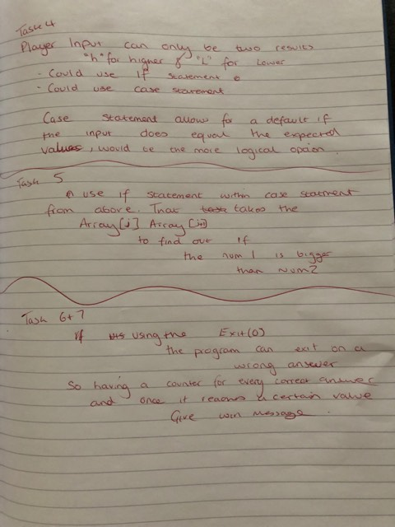
Written Notes
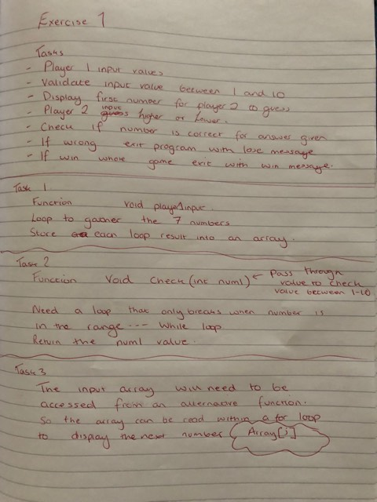
Here are my initial notes I made for the task. I first wrote down all the tasks I thought I needed to complete, any further tasks after this could be written and thought about if and when needed. I took each task and wrote how I thought I would do them. From function type, the patterns needed and how to store and retrieve the data. As the tasks were labelled, if tasks were similar such as player 1 and player 2 input, I could refer between them.
Task 4 shows the two methods in which I was going to tackle the inputting of player 2s input. The two methods were to use either a case statement that ahs the h or l value passed in or to use a nested if function.
Task 5 shows the method of thought behind getting the program to recognise what the current and previous number was.
This helped a lot during the coding stage as it gave me the skeleton of what I needed to build and could make changes from there as needed.

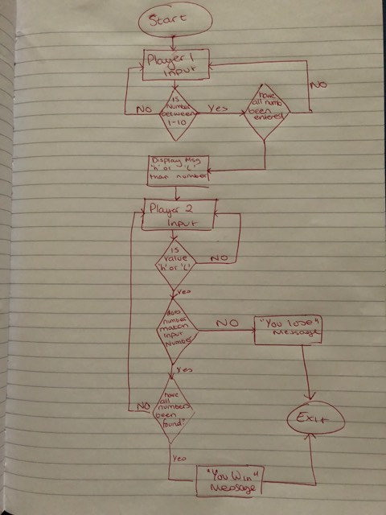
Flowcharts
This is the flow diagram I drew after the notes above so that I could understand which way the program was meant to work. It follows systematic steps and decisions that allow the program to go to the next stage or not, this makes it much simpler to code as you can see the way in which the program should process the data and how it should be set up.

Coding (Development and Patterns)

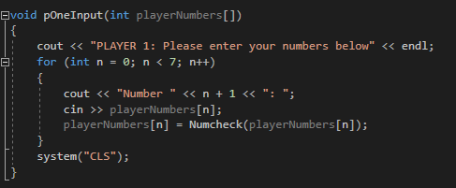

Void pOneInput(int playerNumbers[])
This is my player one input function. It is a void as it will not be returning a value, the parameters list has an int array in it as I will be calling the function later on and needing to have the array be passed through to another function.
The first line is an output to instruct the player that they are to enter numbers below.
The following FOR loop is counting to 7 as that is the number of numbers required in the array. For every loop it is outputting the word “Number” followed by the number of the loop +1 that it is on, this is because the loop starts at 0 and having a number 0 isn’t logical for the scenario. The CIN command is then taking an input and adding it to the array of the number of the loop.
There is then an additional function which checks the number entered to ensure it is between 1 and 10. The return value is then stored within the array under the number of the array.
The console then clears not to show player 2 the answers.

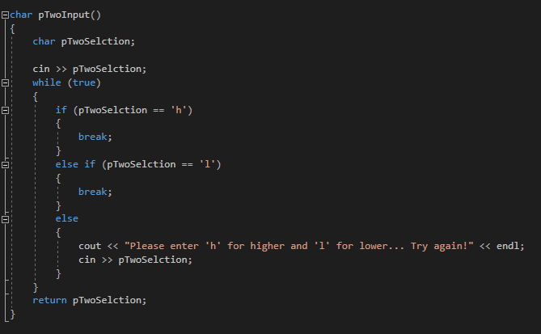
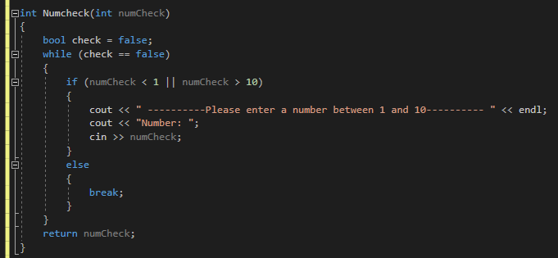
int Numcheck(int numCheck)
This is the Numcheck function, this is where the number entered in the player array function above is checked to ensure the value is between 1 and 10. The loop makes use of a WHILE loop where when the value is passed through in it will go into IF statement and won’t leave until the criteria is met. If the criteria are met the ELSE will then break the loop and return the number back to the function it was called from.
char pTwoInput()
This is player 2 input functions. As the higher and lower aspect of the game requires text the easier way to implement this was to use CHAR function and return the result. Having the player type out higher or lower would be inefficient and cause issues with spelling and capitalisation so I went with CHAR (L) (H). The variable to hold the input is CHAR pTwoSelection. The following while loop is a check to ensure that the character entered is either an ‘L’ or a ‘H’. If it doesn’t equal either of the expected characters then the ELSE statement will ask for it to be re-entered and the input will then be entered into the variable. This will go on until the expected input is inputted. The variable is then return to be used in another function.

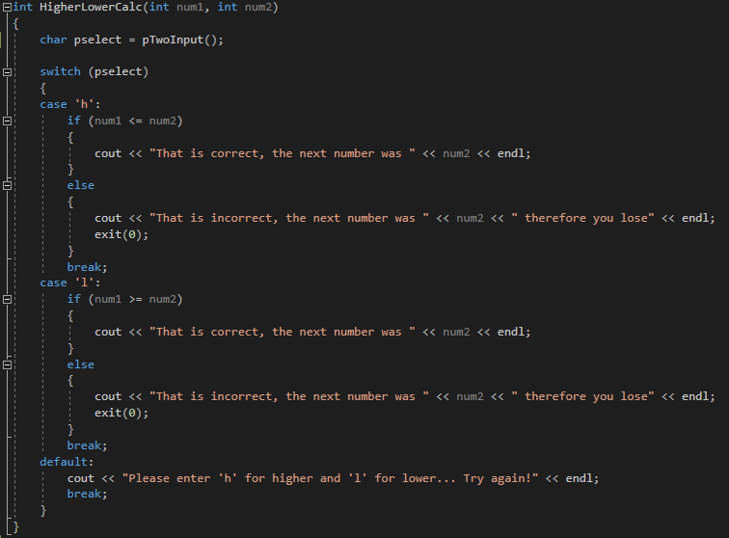
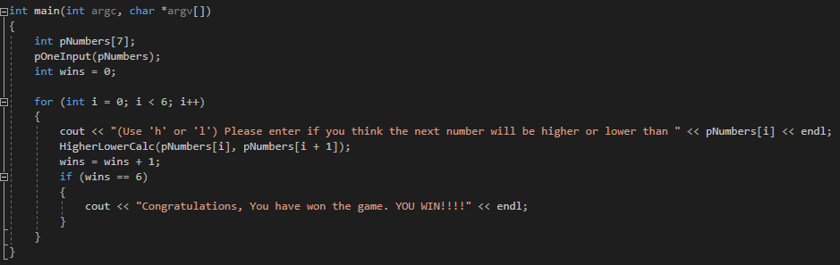
Int main (int argc, char *argv[])
The main function is the function is in conjunction with the HigherLowerCalc function and between the two they bring everything else together to work. The array pNumbers[7] is there to store the input from the pOneInput function, the function is then called in the main and the data returned is stored in main array. The int wins variable is to monitor how many the player gets correct and based off that a winner can be given. The for loop counts to six and every loop there is an output asking the user to enter h or l than, and then the array followed by the number the loop is on. The HigherLowerCalc function is called and takes 2 arguments, the two arguments given is the array[loop number], this is the number that the second player is guessing higher and lower against. The second argument is the array[loop number] +1 as you need the following number to decide on if the input matches the result. The following line is to keep track on the amount of correct answers given. This method works as after the function is called the wins score goes up by one, I don’t have to worry about the if its a lose as the HigherLowerCalc function exits after a loss therefore it is irrelevant. When the counter reaches 6 then there is an output message saying you have won and the programme exits.

Int HigherLowerCalc (int num1, int num2)
This is where we determine a winner in the HigherLowerCalc function. The player two input function is called and the value that is being returned in that function is being stored in a new variable for this function called pSelect. The switch statement then uses that input to determine what case to use. The case statements have nested IF functions in them and takes the passed through values from the main, and compares them. Then if the result is equal to the guess, an output displays saying its correct and move onto the next one. However, if the answer is wrong a message is displayed saying you lose and the program exits.

Testing
Test No. | Test Description | Input | Expected result | Actual result | Result Expected? | Comments
Void pOneInput(int playerNumbers[])
001 | Does program ask for player one to enter numbers? | N/A | Displays message | 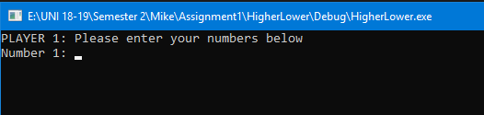 | Yes | Displays correctly.
002 | Does program display “number #” followed by correct number (#) | N/A | Display Number 1 |  | Yes | Displays correctly.
003 | Does program allow for input? (1/7) | 5 | Take input and move onto next number | 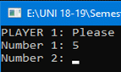 | Yes | Displays correctly.
004 | Does program allow for input? (2/7) | 2 | Take input and move onto next number | 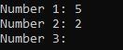 | Yes | Displays correctly.
005 | Does program allow for input? (3/7) | 3 | Take input and move onto next number | 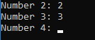 | Yes | Displays correctly.
006 | Does program allow for input? (4/7) | 6 | Take input and move onto next number | 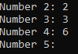 | Yes | Displays correctly.
007 | Does program allow for input? (5/7) | 1 | Take input and move onto next number | 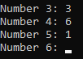 | Yes | Displays correctly.
008 | Does program allow for input? (6/7) | 5 | Take input and move onto next number | 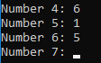 | Yes | Displays correctly.
009 | Does program allow for input? (7/7) | 9 | Take input. Move onto player 2 function. |  | Yes | Displays correctly.
Int Numcheck(int numCheck)
010 | Testing numbers the program should reject (1/4) | 0 | Should reject and continue to ask for a number between 1 and 10 until a number within those parentheses are entered | 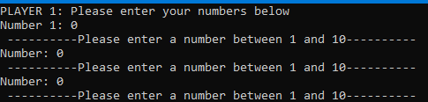 | Yes | Displays correctly.
011 | Testing numbers the program should reject (2/4) | -10 | Should reject and continue to ask for a number between 1 and 10 until a number within those parentheses are entered | 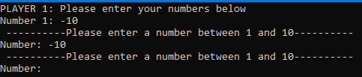 | Yes | Displays correctly.
012 | Testing numbers the program should reject (3/4) | 11 | Should reject and continue to ask for a number between 1 and 10 until a number within those parentheses are entered | 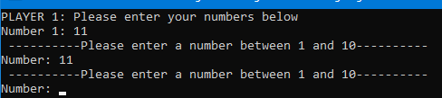 | Yes | Displays correctly.
013 | Testing numbers the program should reject (4/4) | 100 | Should reject and continue to ask for a number between 1 and 10 until a number within those parentheses are entered | 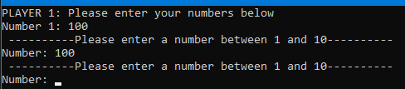 | Yes | Displays correctly.
013a | Testing decimal places | 10.5 | Should reject as it isn’t an int | 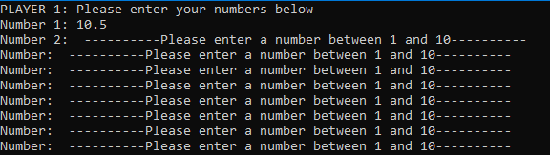 | No | See here
013b | Testing if program accepts characters | z | Should reject as it isn’t an int | 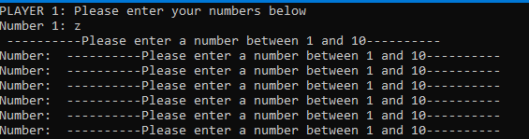 | No | Same issue as above.
Char pTwoInput()
014 | Testing player 2 input with accepted character | h | Should accept and display if the answer was correct |  | Yes | Displays correctly.
015 | Testing player 2 input with accepted character | l | Should accept and display if the answer was correct |  | Yes | Displays correctly.
016 | Testing player 2 input with rejected character | z | Should reject and ask user to re-enter if it was higher or lower |  | Yes | Displays correctly.
017 | Testing player 2 input with rejected character | 4 | Should reject and ask user to re-enter if it was higher or lower |  | Yes | Displays correctly.
018 | Testing player 2 input with rejected character | > | Should reject and ask user to re-enter if it was higher or lower |  | Yes | Displays correctly.
019 | Testing player 2 input with 2 accepted characters | hl | Should reject and ask user to re-enter if it was higher or lower | 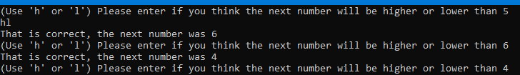 | No | See here.
019a | Testing if it accepts capitalisation of the accepted letters. | H | Should reject and ask to re-enter. |  | Yes | Fix Here.
019b | Testing if it accepts capitalisation of the accepted letters. | L | Should reject and ask to re-enter. | 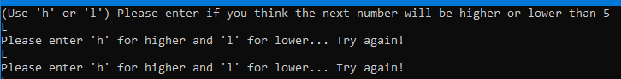 | Yes | Fix Here.
Int HigherLowerCalc (int num1, int num2)
020 | Does pTwoInput function return value into pselect variable? | h | Will take the return value and put it into case statement and return either a correct or incorrect message | 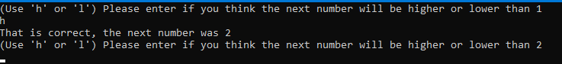 | Yes | Displays correctly.
021 | Accepts case statement ‘h’ | h | Should display the correct or incorrect message based on IF statement. |  | Yes | Displays correctly.
022 | Accepts case statement ‘l’ | l | Should display the correct or incorrect message based on IF statement. |  | Yes | Displays correctly.
023 | If statement should read input numbers and display a message based on if 2 is a bigger number than 1 | 1, 2 (h) | Should output the "That is correct, the next number was " message |  | Yes | Displays correctly.
024 | If statement should read input numbers and display a message based on if 5 is a smaller number than 4 | 5, 4 (l) | Should output the "That is correct, the next number was " message |  | Yes | Displays correctly.
025 | If statement should read input numbers and display a message based on if 3 is a bigger number than 4 | 4, 3 (h) | Should output the “That is incorrect, the next number was # therefore you lose" message |  | Yes | Displays correctly.
026 | If statement should read input numbers and display a message based on if 8 is a smaller number than 7 | 7, 8(l) | Should output the “That is incorrect, the next number was # therefore you lose" message |  | Yes | Displays correctly.
int main (int argc, char *argv[])
027 | Does pOneInput function transfer contents of array into the array in main? | 1 | Should output message …” higher or lower than 1” |  | Yes | Displays correctly.
028 | Does wins +1 after every correct answer? | N/A | The wins variable should plus 1 each time. | 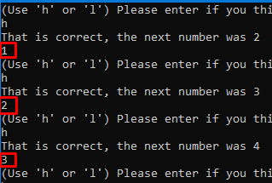 | Yes | In the red squares. Outputted the wins variable to display what’s in it.
029 | Does the output for “do you think next number is higher or lower than” pNumbers[i] | 1 | Should output the correct number. |  | Yes | Displays correctly.
030 | Does the If (wins == 6) output the winning message? | n/a | Should output the correct message. |  | Yes | Displays correctly.

Problems and problem solving
Test No #013a, Test No #013b – It reads the number and recognises it’s a decimal and then it caused the game to enter an endless loop of displaying please enter a number between 1 and 10. On closer inspection of the screenshot it accepts 10.5 as a number and moves on to the second number however it should accept it anyways as it is over 10.
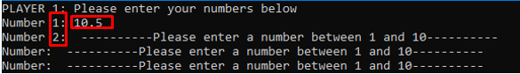
Further testing reveals that if the number is, for example, (11.5) the number isn’t accepted but still causes it to loop. The issue must be within the Numcheck function. The only solution I can think of is checking the number to ensure it’s a whole number or rounding it up to a whole number if a decimal is entered. Same issue for Test No 013b

Test No #019 - Even though the answers are technically correct, the expected result wasn’t for it to display if it was correct or not. This is because the input and the validation for it reads the ‘h’ recognises its accepted and does the same for the ‘l’ and as they are both accepted characters it allows both to be entered as opposed to giving the;

cout << "Please enter 'h' for higher and 'l' for lower... Try again!" << endl;

It doesn’t cause any major issues as this issue wouldn’t occur if the number doesn’t match as it takes each character individually and processes them individually through the function, however it is something that shouldn’t happen. Fixing this issue would require limiting the variable to accept only one character at a time.

Test No #019a, Test No #019b – In result of the bug above, it made me think about how it may not accept capitalisation of the accepted characters. To which the test proved that theory. This is something easily fixable unlike above. Where I was accepting certain characters (‘h’ and ’l’). I’ve now allowed it to accept the capitalised versions of them. With me using a case statement this caused and issue as the case statement was expecting non-capitalised forms of them. This again was an easy fix as I was able to within the newly accepted if statement rewrite the array to be ‘h’ or ‘l’. Code is below.

else if (pTwoSelction == 'H')
{
pTwoSelction = 'h';
break;
}

else if (pTwoSelction == 'L')
{
pTwoSelction = 'l';
break;
}

Exercise 2 – Hidden Treasure

Planning
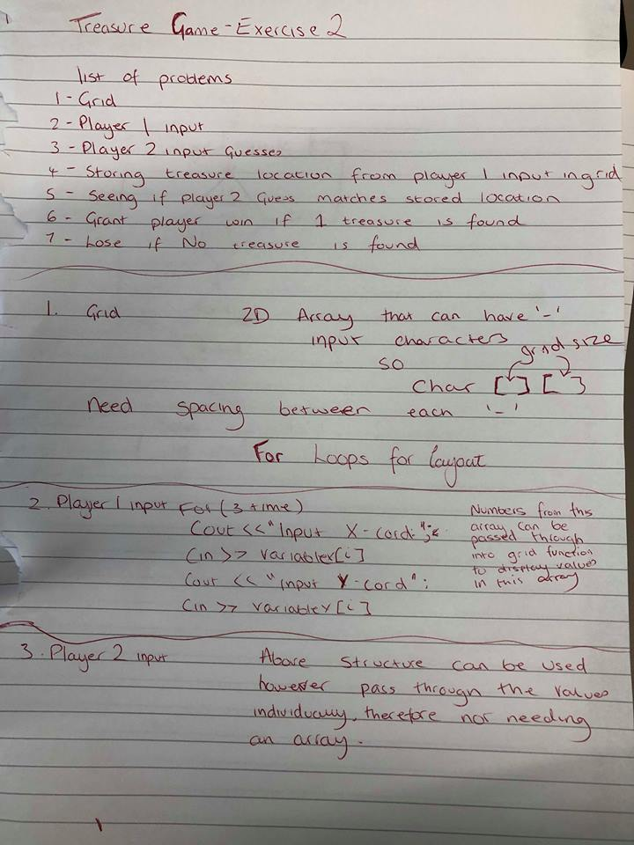
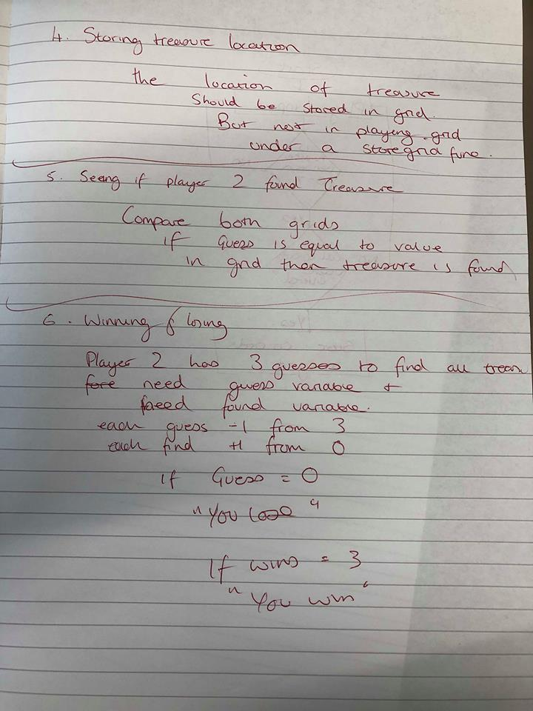
Here are the initial notes for exercise two. Like exercise one I wrote out the tasks I thought I needed to complete and how I would complete them.
I knew for the treasure I would need a grid to be able to store and display the input from players. For this I knew I wanted to use a 2D array as it acts as x and y axis which is ideal. I knew I wanted spaces between the dashes between but I wanted to view the initial grid first before formatting it.
Input just requires the console asking user for co-ordinate and saving it to an array.
Storing the data in grid is where I thought of creating a second grid not to clutter the playing grid. The idea here was to compare the both grids as a way of finding the treasure.
Winning and losing uses counters and the first one to reach the target gives the outcome.
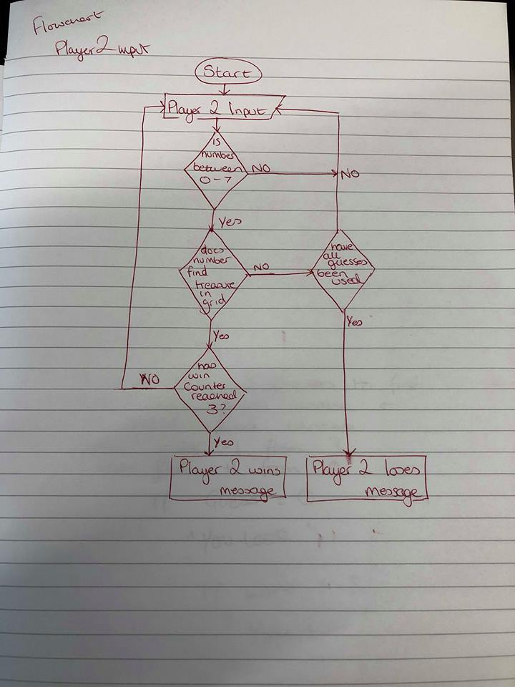
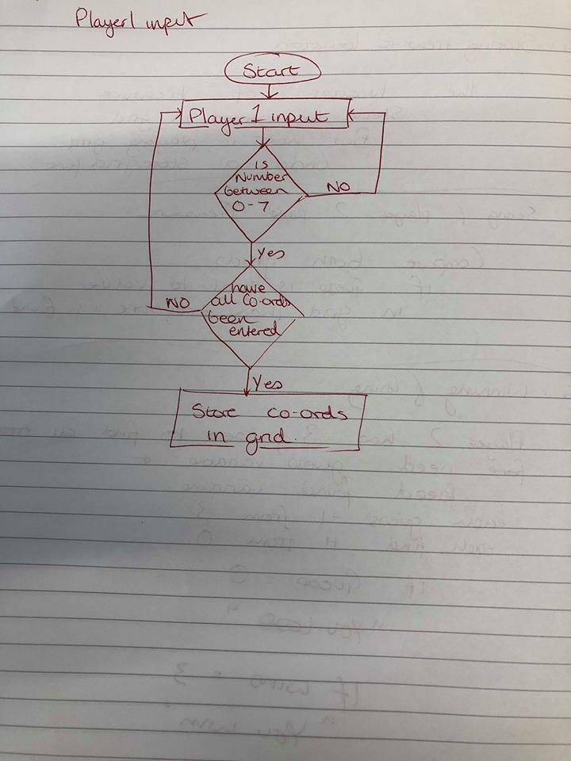
Here are my flow charts for the second exercise that describe the flow of data for the main 2 parts of the program.

Coding (Development and Patterns)
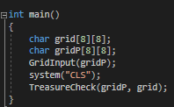
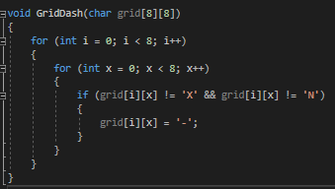
int main ()
This is my main function. The first two variables are 2d arrays and they are there to declare the grid size. The grid size is going to be a constant 8 by 8 size and I don’t want that to change so by declaring it in the main it can be called from anywhere.
The grid input function is how I put the input values into the grid. gridP is for the player to enter values on and doesn’t have a visual aspect to it, therefore it stores the values and will compare them to the main grid later to match treasure.
System(“CLS”) clears the console window which is needed to hide player one’s input answers from player 2.
TreasureCheck function is where the two grids are compared as discussed above, the function accepts the two pass through values which are the two grids for comparing.
void GridDash (char grid[8][8])
This is part of creating my visual grid. I have many issues with the grid as I didn’t draw it myself within the array, I got the computer to draw it which caused many issues. One of which is when the grid function was called it was wiping over already placed co-ordinates making the ‘X’ and ‘N’ not show. This is why I created this function. This function accepts 1 argument which is the main grid so that it can be read. The first loop acts as the searcher in the X axis, the second loop acts as the searcher in the Y axis. It then searches every aspect of the grid for anywhere it does NOT equal ‘x’ and ‘n’ and draws a ‘-‘ in there. This solved my issues of the x’s not displaying as they were no longer being overwritten.
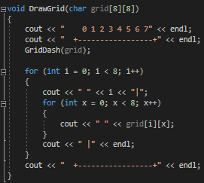

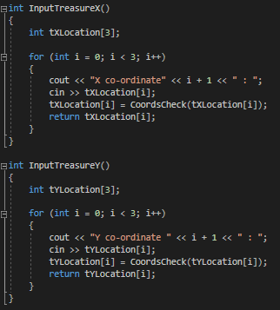
int InputTreasureX (), int InputTreasureY ()
This is for getting the user to input the treasure. I used to separate functions however they involve the same code, just one is for X and one is for Y. I use an array of 3 to store the numbers in. Then used a loop for the input to occur, the loop runs 3 times before closing as this is how many co-ordinates are required. The consoles outputs asking for the X co-ordinate plus number of the loop plus one, as the loop starts at 0, so it will display 1 to 3. The input is then saved into the array under the number of the loop. The number from that array, like in the previous exercise, goes into a check where it makes sure the number is between 0-7. The number is then returned into the array and returned to the function it was called from.

void DrawGrid (char grid[8][8])
This is the main setup for the grid. The first two lines are output lines for the rows and formatting to keep the grid simple and easy to understand. The GridDash function then comes into play and fills every available slot with dashes. The next loops are for formatting, the first loop places a space and number of the loop to give the vertical x axis co-ordinate labels and a ‘|’ to separate the numbers to the table. The nested loop goes through the individual dashes and places spaces to make it look more appealing and easier to understand. After the loop has finished it means it completed one single line of formatting and then it exits out and finishes the previous loop which ends with closing the grid with a ‘|’. The final line is to follow the same formatting as above and close the bottom of the grid off.

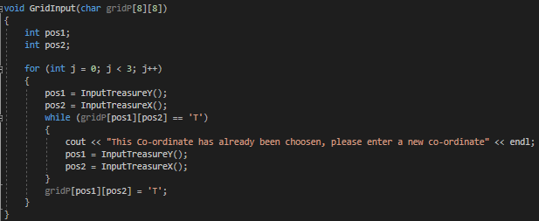
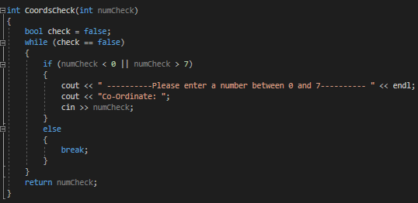
void GridInput (char gridP[8][8])
This is where the inputs from player one is dealt with and inputted into the virtual grid for comparing with the visual grid. This function has two variables, pos1 and pos2 these are to store the x and y values. The for loop then runs 3 times and each time it calls the InputTreasure function and stores the return value in the respected variable. There obviously needed to be a validation in place for choosing the same co-ordinate input again which is where the while loop comes in. the while loop checks the grid for the position stated and searches for the letter ‘T’ which is what the treasure is represented as on the virtual grid. If it is found it will say this co-ordinate has been found please re-enter. This comes before any of the grid has been entered as the first values will never have been entered before so it’s impossible to enter a duplicate co-ordinate on the first go. After the while loop is dealt with the grid plus position of the input treasure is entered into the grid as ‘T’.

int CoordsCheck(int numCheck)
See here.

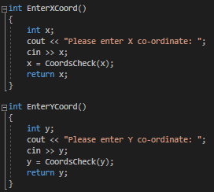
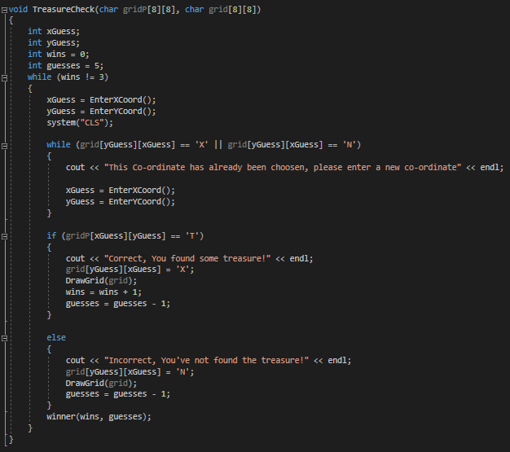
void TreasureCheck (char gridP[8][8], char grid[8][8])
This is where the two grids are compared and determines if there is a match or no match. The xGuess and yGuess are to store the return values from the EnterXCoord and Y function. The wins variable is there to count how many treasures have been found. The guesses variable starts at 5 because that’s how many guesses I’ve allowed the user to have.
The while loop will keep going until the win’s variable is equal to 3. The console clears after every loop to keep the console looking neat. The nested while loop checks, like in the GridInput function, if the co-ordinates have been entered before by checking the grid for X’s or N’s and prompts the user to re-enter a different value.
The if function checks to see if the guess provided returns a ‘T’ from the virtual grid, if it does that means the user has found a treasure. The main grid with that position is then marked with an ‘X’, the DrawGrid function gets called with the argument of the grid variable and wins gets a +1 and guesses also gets a -1. The else then does the opposite and returns an ‘N’ in the main grid and guesses gets a -1. The winner function is then called and passes through the wins and guesses variables.

int EnterXCoord (), int EnterYCoord ()
This is for player two to enter their guesses. The variable x stores the input from the user and runs the check on the number stored within that variable the number that is returned is then stored in that variable before being returned off to the function it was called from.
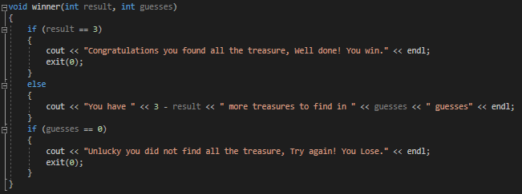
void winner (int result, int guesses)
This function is to decide if the user wins or loses. Using the pass-through values from above the first if statement when it reaches 3 will say congratulations and exit the program, giving the user the win. If the wins counter hasn’t equalled 3 it will display how many treasures left to find and how many guesses left to find them. If guesses equal 0 then a message is displayed and the program exits.

Testing
Test No. | Test Description | Input | Expected result | Actual result | Result Expected? | Comments
int InputTreasureX(), int InputTreasureY(), int EnterXCoord(), int EnterYCoord()
All input tests above would produce same results. Therefor grouped.
001 | Does it display X/Y Co-ordinate 1 and await input? | N/A | Displays message  “Y co-ordinate 1: “ | 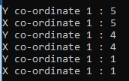 | Yes | Displays correctly.
002 | Does it display X/Y Co-ordinate 2 and await input? | N/A | Displays message  “Y co-ordinate 2: “ |  | No | See here.
003 | Does it display X/Y Co-ordinate 3 and await input? | N/A | Displays message  “Y co-ordinate 3: “ |  | No | See here.
004 | Does tXLocation save each co-ordinate?  (using cout to see if saved) | 3 | Should store the data entered into the array and be able to be called if necessary | 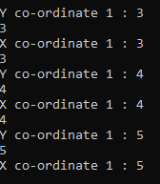 | Yes | Displays correctly.
005 | Does tYLocation save each co-ordinate?  (using cout to see if saved) | 3 | Should store the data entered into the array and be able to be called if necessary |  | Yes | Displays correctly.
006 | Does tXLocation save each co-ordinate?  (using cout to see if saved) | 4 | Should store the data entered into the array and be able to be called if necessary |  | Yes | See here. Different issue identified.
007 | Does tYLocation save each co-ordinate?  (using cout to see if saved) | 4 | Should store the data entered into the array and be able to be called if necessary |  | Yes | See here. Different issue identified.
008 | Does tXLocation save each co-ordinate?  (using cout to see if saved) | 5 | Should store the data entered into the array and be able to be called if necessary |  | Yes | See here. Different issue identified.
009 | Does tYLocation save each co-ordinate?  (using cout to see if saved) | 5 | Should store the data entered into the array and be able to be called if necessary |  | Yes | See here. Different issue identified.
010 | Does input accept characters? | a | Should cause infinite loop like in exercise 1. | 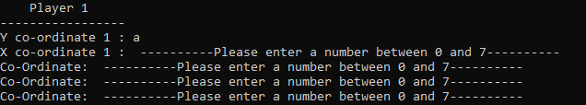 | No | See here
011 | Does input accept decimals? | 5.5 | Should cause infinite loop like in exercise 1. | 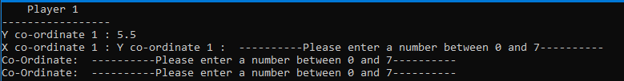 | No | See here
012 | Does input allow for input within range? (0-7) | 0 | Take input and move onto next co-ordinate | 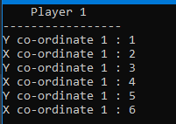 | Yes | Displays correctly.
013 | Does input allow for input within range? (0-7) | 1 | Take input and move onto next co-ordinate |  | Yes | Displays correctly.
014 | Does input allow for input within range? (0-7) | 2 | Take input and move onto next co-ordinate |  | Yes | Displays correctly.
015 | Does input allow for input within range? (0-7) | 3 | Take input and move onto next co-ordinate |  | Yes | Displays correctly.
016 | Does input allow for input within range? (0-7) | 4 | Take input and move onto next co-ordinate |  | Yes | Displays correctly.
017 | Does input allow for input within range? (0-7) | 5 | Take input and move onto next co-ordinate |  | Yes | Displays correctly.
018 | Does input allow for input within range? (0-7) | 6 | Take input and move onto next co-ordinate |  | Yes | Displays correctly.
019 | Does input allow for input within range? (0-7) | 7 | Take input and move onto next co-ordinate | 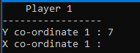 | Yes | Displays correctly.
020 | Does input allow over allowed range? (0-7) | 8 | Should reject input and ask to be re-entered. | 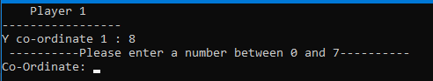 | Yes | Displays correctly.
021 | Does input allow under allowed range? (0-7) | -1 | Should reject input and ask to be re-entered. | 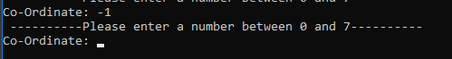 | Yes | Displays correctly.
void GridInput(char gridP[8][8])
022 | Does pos1 get returned data from InputTreasureY function? | 4 | Expecting it to return the value fine, outputting the variable to see if it does | 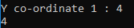 | Yes | Displays correctly.
023 | Does pos2 get returned data from InputTreasureY function? | 2 | Expecting it to return the value fine, outputting the variable to see if it does | 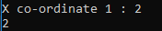 | Yes | Displays correctly.
024 | Does entered position get entered into grid under ‘T’ | 4, 2 | Outputting the grid to see if the letter T is in it | 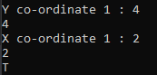 | Yes | Displays correctly.
025 | Do repeated numbers get an error message saying please enter a new coord? | 4, 2 | Should say this coord has been chosen please enter new one. | 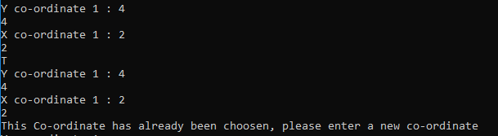 | Yes | Displays correctly.
void TreasureCheck(char gridP[8][8], char grid[8][8])
026 | Does xGuess get returned data from EnterXCoord function? | 6 | Expecting it to return the value fine, outputting the variable to see if it does | 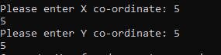 | Yes | Displays correctly.
027 | Does yGuess get returned data from EnterYCoord function? | 3 | Expecting it to return the value fine, outputting the variable to see if it does |  | Yes | Displays correctly.
028 | Does wins counter go up by 1 after a treasure find? | N/A | Expecting counter to go up. Will say how many treasures are left and that way will know If it worked. | 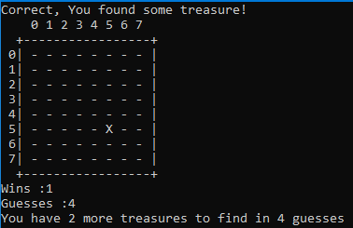 | Yes | Displays correctly.
029 | Does guesses counter go down by 1 after a correct guess? | N/A | Expecting counter to go down. Will say how many guesses are left and that way will know If it worked. |  | Yes | Displays correctly.
030 | Does guesses counter go down by 1 after an incorrect guess? | N/A | Expecting counter to go down. Will say how many treasures are left and that way will know If it worked. | 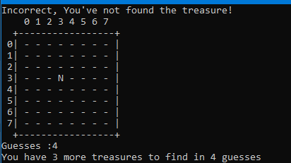 | Yes | Displays correctly.
031 | When entering correct treasure location does program display treasure is found? | 6, 3 | Should display and X in the table in console | 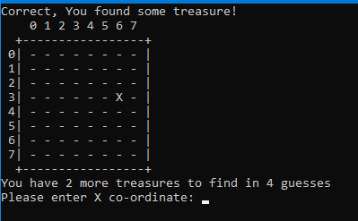 | Yes | Displays correctly.
032 | When entering incorrect treasure location does program display treasure is not found? | 5, 2 | Should display an N in the table in console | 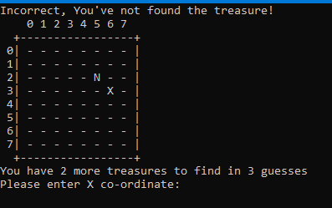 | Yes | Displays correctly.
032 | If treasure has already been guessed, does program tell user to try again? | 6, 3 | Should tell the user cords have been used please enter new ones. |  | Yes | Displays correctly.
033 | Does program call winner function successfully and pass through the variables? | N/A | It should display a message of some kind from the called function. | 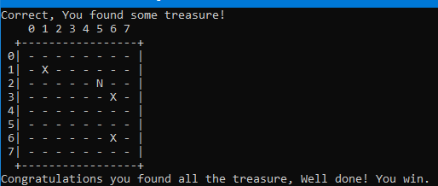 | Yes | Displays correctly.
void winner(int result, int guesses)
034 | Does program display Winner message when result = 3? | N/A | Should display congratulations… then exit program | 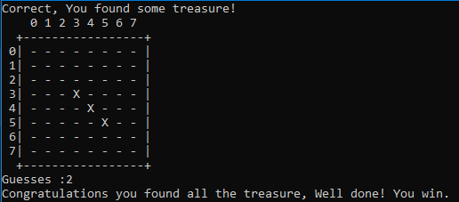 | Yes | Displays correctly.
035 | If counter doesn’t equal 3 does message saying how many treasures are left to find and how many guesses are left? | N/A | Should display how many treasures are left to find and how many guesses are left. | 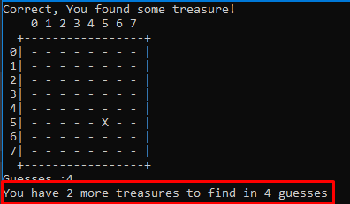 | Yes | Displays correctly.
036 | If guesses equal 0 is loser message displayed? | N/A | Should display unlucky… then exit program | 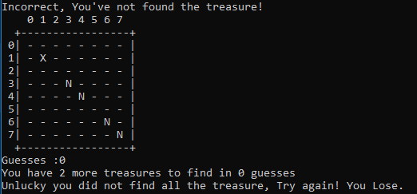 | Yes | Displays correctly.

Problems and problem solving
Test No #006 – When doing this test, I noticed that the counter for the number of co-ordinate was always repeating 1which meant the loop was reset. This was a silly mistake and makes a lot of the function obsolete as it means there is no need for the array either as the first number in the array was always being overwritten and then put into the grid. This is because the return command exits out of the loop, so although it worked it was inefficient code.
Before –
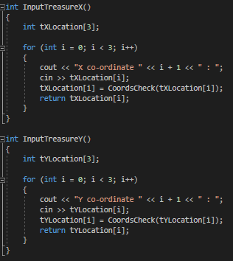
After –
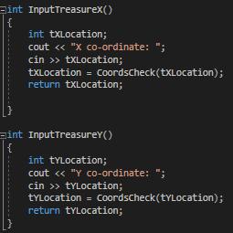

Appendix

Exercise 1 code

#include <string>
#include <iostream>
#include <sstream>
#include <stdlib.h>

using namespace std;

void pOneInput(int playerNumbers[]);
int HigherLowerCalc(int num1, int num2);
char pTwoInput();
int Numcheck(int numCheck);

int main(int argc, char *argv[])
{
int pNumbers[7];
pOneInput(pNumbers);
int wins = 0;

for (int i = 0; i < 6; i++)
{
cout << "(Use 'h' or 'l') Please enter if you think the next number will be higher or lower than " << pNumbers[i] << endl;
HigherLowerCalc(pNumbers[i], pNumbers[i + 1]);
wins = wins + 1;
if (wins == 6)
{
cout << "Congratulations, You have won the game. YOU WIN!!!!" << endl;
}
}
}

void pOneInput(int playerNumbers[])
{
cout << "PLAYER 1: Please enter your numbers below" << endl;
for (int n = 0; n < 7; n++)
{
cout << "Number " << n + 1 << ": ";
cin >> playerNumbers[n];
playerNumbers[n] = Numcheck(playerNumbers[n]);
}
system("CLS");
}

int Numcheck(int numCheck)
{
bool check = false;
while (check == false)
{
if (numCheck < 1 || numCheck > 10)
{
cout << " ----------Please enter a number between 1 and 10---------- " << endl;
cout << "Number: ";
cin >> numCheck;
}
else
{
break;
}
}
return numCheck;
}

char pTwoInput()
{
char pTwoSelction;

cin >> pTwoSelction;
while (true)
{
if (pTwoSelction == 'h')
{
break;
}
else if (pTwoSelction == 'l')
{
break;
}
else if (pTwoSelction == 'H')
{
pTwoSelction = 'h';
break;
}
else if (pTwoSelction == 'L')
{
pTwoSelction = 'l';
break;
}
else
{
cout << "Please enter 'h' for higher and 'l' for lower... Try again!" << endl;
cin >> pTwoSelction;
}
}
return pTwoSelction;
}

int HigherLowerCalc(int num1, int num2)
{
char pselect = pTwoInput();

switch (pselect)
{
case 'h':
if (num1 <= num2)
{
cout << "That is correct, the next number was " << num2 << endl;
}
else
{
cout << "That is incorrect, the next number was " << num2 << " therefore you lose" << endl;
exit(0);
}
break;
case 'l':
if (num1 >= num2)
{
cout << "That is correct, the next number was " << num2 << endl;
}
else
{
cout << "That is incorrect, the next number was " << num2 << " therefore you lose" << endl;
exit(0);
}
break;
default:

break;
}
}

Exercise 2 code
#include <string>
#include <iostream> // for cin, cout and getline()
#include <sstream>
#include <stdlib.h>

using namespace std;

void GridDash(char grid[8][8]);
void DrawGrid(char grid[8][8]);
int InputTreasureX();
int InputTreasureY();
int CoordsCheck(int numCheck);
void GridInput(char gridP[8][8]);
int EnterXCoord();
int EnterYCoord();
void TreasureCheck(char gridP[8][8], char grid[8][8]);
void winner(int result, int guesses);

void GridInput(char grid[8][8]);

int main()
{
char grid[8][8];
char gridP[8][8];
cout << " Player 1" << endl << "-----------------" << endl;
GridInput(gridP);
system("CLS");
cout << " Player 2" << endl << "-----------------" << endl;
TreasureCheck(gridP, grid);
}

void GridDash(char grid[8][8])
{
for (int i = 0; i < 8; i++)
{
for (int x = 0; x < 8; x++)
{
if (grid[i][x] != 'X' && grid[i][x] != 'N')
{
grid[i][x] = '-';
}
}
}
}

void DrawGrid(char grid[8][8])
{
cout << " 0 1 2 3 4 5 6 7" << endl;
cout << " +-----------------+" << endl;
GridDash(grid);

for (int i = 0; i < 8; i++)
{
cout << " " << i << "|";
for (int x = 0; x < 8; x++)
{
cout << " " << grid[i][x];
}
cout << " |" << endl;
}
cout << " +-----------------+" << endl;
}

int InputTreasureX()
{
int tXLocation;
cout << "X co-ordinate: ";
cin >> tXLocation;
tXLocation = CoordsCheck(tXLocation);
return tXLocation;

}

int InputTreasureY()
{
int tYLocation;
cout << "Y co-ordinate: ";
cin >> tYLocation;
tYLocation = CoordsCheck(tYLocation);
return tYLocation;
}

int CoordsCheck(int numCheck)
{
bool check = false;
while (check == false)
{
if (numCheck < 0 || numCheck > 7)
{
cout << " ----------Please enter a number between 0 and 7---------- " << endl;
cout << "Co-Ordinate: ";
cin >> numCheck;
}
else
{
break;
}
}
return numCheck;
}

void GridInput(char gridP[8][8])
{
int pos1;
int pos2;

for (int j = 0; j < 3; j++)
{
pos1 = InputTreasureY();
pos2 = InputTreasureX();

while (gridP[pos1][pos2] == 'T')
{
cout << "This Co-ordinate has already been choosen, please enter a new co-ordinate" << endl;
pos1 = InputTreasureY();
pos2 = InputTreasureX();
}
gridP[pos1][pos2] = 'T';

}
}

int EnterXCoord()
{
int x;
cout << "Please enter X co-ordinate: ";
cin >> x;
x = CoordsCheck(x);
return x;
}

int EnterYCoord()
{
int y;
cout << "Please enter Y co-ordinate: ";
cin >> y;
y = CoordsCheck(y);
return y;
}

void TreasureCheck(char gridP[8][8], char grid[8][8])
{
int xGuess;
int yGuess;
int wins = 0;
int guesses = 5;
while (wins != 3)
{
xGuess = EnterXCoord();
yGuess = EnterYCoord();
system("CLS");

while (grid[yGuess][xGuess] == 'X' || grid[yGuess][xGuess] == 'N')
{
cout << "This Co-ordinate has already been choosen, please enter a new co-ordinate" << endl;
xGuess = EnterXCoord();
yGuess = EnterYCoord();
}

if (gridP[xGuess][yGuess] == 'T')
{
cout << "Correct, You found some treasure!" << endl;
grid[yGuess][xGuess] = 'X';
DrawGrid(grid);
wins = wins + 1;
guesses = guesses - 1;
}

else
{
cout << "Incorrect, You've not found the treasure!" << endl;
grid[yGuess][xGuess] = 'N';
DrawGrid(grid);
guesses = guesses - 1;
}
winner(wins, guesses);
}
}

void winner(int result, int guesses)
{
if (result == 3)
{
cout << "Congratulations you found all the treasure, Well done! You win." << endl;
exit(0);
}
else
{
cout << "You have " << 3 - result << " more treasures to find in " << guesses << " guesses" << endl;
}
if (guesses == 0)
{
cout << "Unlucky you did not find all the treasure, Try again! You Lose." << endl;
exit(0);
}
}

