Introducing the Modern Workplace
LCBB4003
Module tutor: Nadeem Mirza

Group Assessment
TEAM 3

Student Name and ID:
Adelina Perva ​(2020310)
Galina Rais ​(2020307)
Nikola Nikolov​ (2014060)
Rositsa Mateva ​(2022688)
Svetoslav Stoianov (2023030)

Table of Contents

A Profile Of Chosen Organisation From Retail Sector In The UK -ALDI……………………………………………………………………………………........................................................4
Introduction…………………………………………………………………………………..5
Reflective Report Using Gibbs Reflective Cycle………………………………………………………………………………..6
Description………………………………………………………………………………………………………………………………………6
Feelings…………………………………………………………………………………….……………………………………………………..7
Evaluation………………………………………………………………………………………………………………………………………..7
Analysis……………………………………………………………………………………..........................................................8
Conclusion…………………………………………………………………………………........................................................8
Action Plan………………………………………………………………………………….......................................................8
Conclusion………………………………………………………………………………………………………………………………………9
References………………………………………………………………………………………………………………………………………10
Analyse the relationship between organisational structure and organisational performarnce in ALDI, UK………………………………………………………….…………………………………………………………………………………..14
Organisational Structure…………………………………………………………………...................................................15
Organisational Performance………………………………………………………………................................................16
Analysis of Organisational Structure and Performance…………………………………… ………………………………18
References………………………………………………………………………………… …………………………………………………….20
Tasks and Skills for a manager ensuring operational effectiveness in ALDI UK…………........................................................................................................................................24
Reflection on own managerial skills………………………………………………………………………………………..………..25
Employee management skills……………………………………………………………………………………………………….25
Motivational skills………………………………………………………………………………………………………………………..25
Effective communication skills………………………………………………………………………………………………..…..26
Delegation skills…………………………………………………………………………………………………………………..……..26
Stress tolerance skills……………………………………………………………………………………………………….………...26
Risk analysis and mitigation skills…………………………………………………………………………..………………...…27
Budget management skills………………………………………………………………………………………….……………...27
Organisational skills…………………………………………………………………………………………..……………………….27
Interpersonal skills…………………………………………………………………………………..…………………………………27
Skills Development Plan Using SMART Writing……………………………………………………………………..…..28
Conclusion………………………………………………………………………………………………………………………………..32
References ……………………………………………………………………………………………………………………………….33
How Leadership can inspire and motivate staff members to improve performances-ALDI……………………………………………………………………………………………………………………………………..34
Conclusion ……………………………………………………………………………………………………………………………….39
References………………………………………………………………………………………………………………………………..39
An analysis of factors influencing Group and Team Behaviours at ALDI……………………………………………………………………………………..……………………………………………..42
Action-oriented roles……………………………………………………………………………………………………………...44
People-oriented roles…………………………………………………………………………………………………………..…..44
Thought-oriented roles…………………………………………………………………………………………………………...44
Conclusion…………………………………………………………………………………………………………………………..….45
References……………………………………………………………………………………………………………………………..46

Module Title: Introducing the Modern Workplace
Module code: LCBB4003
Module tutor: Nadeem Mirza

Student Name: Adelina Camelia Perva
Student ID: 2020310

A Profile of Chosen Organisation From Retail Sector In The UK ALDI

Introduction
In this individual reflective report, I will be reflecting on my learning from the topic covered in the task presentation under this module. The task required a team activity comprising of five different points, which would have been done by individual members of the team.
I contributed by producing the profile of the chosen organisation, Aldi, which is one of the renowned retail brands in the UK. I have also covered the organisational culture and history of the organisation. Regarding the reflection on my learning and skill development from this topic, I will be using the Gibbs reflective cycle model.

Reflective Report Using Gibbs Reflective Cycle
Gibbs reflective cycle model is a six-step reflective model wherein each certain stage question is involved, and the learner reflects on specific experience by answering those questions (Tarrant, 2015).
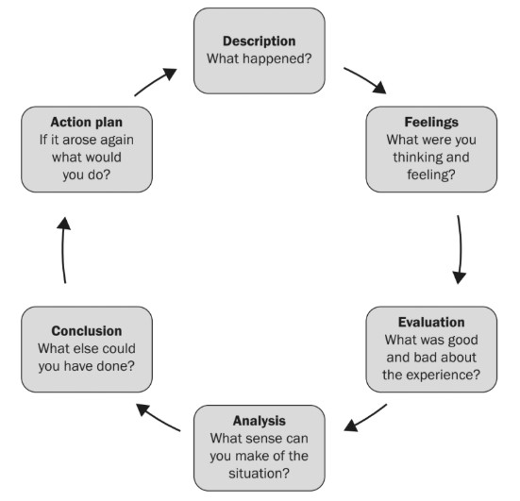
Gibbs Reflective Cycle Model
Source: (Ghaye and Ghaye, 2011)

Description
The first step of the model requires the learner to provide a summary of the experience. The learner, in the first stage, accumulates all the information regarding the experience so that the reflection can be done effectively and no event of the experience is overlooked (Roffey-Barentsen and Malthouse, 2017). As part of the team presentation, I produced the profile of the chosen organisation, Aldi, which is one of the largest retail organisations in the UK. Along with this, I have also highlighted the historical background and culture of the organisation.
Aldi was first opened in Essen, Germany, in 1913 and later in 1948 was taken over and expanded where the chain has grown including thousands of locations around the world, including more than 1,600 in the United States, so Aldi became the third-largest grocer in the United States by store count.
Aldi has a strong culture centred on cooperative leadership people. Aldi's culture consists of maintaining a focus on developing people toward common goals and ensuring that all employees are working within their specific job description to ensure ultimate productivity and efficiency.
I have included the financial and non-financial information, market growth, gross and net profit over different time periods and so on. In this regard, I gathered information from the company website, annual report, corporate governance report. Also, I have communicated with the employees of the organisation in terms of assimilating the company's information.

Feelings
In the second stage of Gibbs model of reflection, the learner outlines his feelings on different stages of his experience including before the experience, during and after the experience (Ogilvy, 2017). I was quite worried regarding the key points regarding which I should gather information about the company to develop its profile. After I started gathering the company's information, I started to understand which information should be highlighted in the profile. After accomplishing the task, I felt quite confident that I have been able to produce an effective profile of Aldi, including important and relevant information about the organisation.

Evaluation
The learner is required to evaluate his experience highlighting different portions of the experience that went well and different parts of the experience which did not go well (Taylor, 2010). This stage enables the learner to assess specific factors which contributed to the effective accomplishment of the experience and factors which created obstacles to the completion of the experience (Ghaye and Ghaye, 2011). In this experience, I was able to plan the task effectively, highlighting what tasks should I do and when should I do those tasks. Unfortunately, certain tasks of the experience were not accomplished within the planned time. The task of gathering information about the company, its corporate history and corporate culture from different secondary sources such as the company website, annual report, corporate governance report went very well, and I could find relevant information from those sources effectively. However, I faced difficulties regarding finding the quarterly information of the company and hence could not highlight the recent performance of the organisation. As long as communicating with the organisational employees is concerned, it did not go very well since I was not able to get answers to several questions since I did not know which information the employee of the organisation is authorised to answer. The employee with whom I communicated was not eager to exchange information regarding their internal workplace culture since he was not employed at the managerial level. Producing and delivering the presentation went moderately well and hence I believe I have a scope of improving my presentation skill.

Analysis
The learner, in the fourth stage of the reflective model introduced by Graham Gibbs, is required to analyse the key factors due to which certain activities went well or did not go well during the experience (Bolton and Delderfield, 2019). Thus, in this stage, the learner is able to identify the strengths and weaknesses of his key skill and hence identify the skills which he needs to develop (Bolton, 2014). I believe I was able to gather information from different secondary sources effectively since I have strong research skills and hence, I was able to search in the appropriate database to gather relevant secondary sources.
Again, I was not able to accomplish a certain task on time due to weak time management skills as I did not take notes while searching for information and did not maintain a schedule to remind me about my to-do tasks. Apart from this, I was not able to gather information from direct communication with the employee of the organisation due to weak communication skills. Lastly, I believe I have moderate presentation skills, but I have a certain scope of making improvements in this skill.

Conclusion
The learner, in this particular stage, is required to outline alternative practices which could have been undertaken by the learner to accomplish the experience (Roffey-Barentsen and Malthouse, 2017). I believe I could have taken notes while gathering company information ad also maintained a specific schedule. Thus, I would have been able to complete this task more effectively. Apart from this, I could have noted down specific information which I should ask the employee of Aldi to get relevant information from the employee. In relation to gathering internal information of the organisation, such as its culture, I could have relied on different secondary sources based on the opinion of others regarding the workplace culture of the company.

Action Plan
The learner prepares a plan of action in the last stage of the reflective model, which enables the learner to create a development plan to improve his weak skills (Bolton, 2014). To improve my skills further, I will focus on developing my communication skill, time management skills and presentation skill. With regard to developing these skills, I will attend the personal and professional development program offered by educational institutions. Apart from this, I will also consider researching for appropriate secondary resources in relation to conducting self-study with which I will be able to gather knowledge about improving those skills and apply that knowledge to improve my skills effectively.

Conclusion
Based on the above reflective analysis, it can be concluded that reflective practice is an effective learning practice that enables a learner to learn from any experience and identify the specific skill which should be focused more on to improve. By reflecting on the above experience, we have identified certain skills of our which needs to be developed such as communication, presentation and time management skill.

References
Bolton, G. and Delderfield, R., 2019. Reflective practice. London: Sage Publication.
Bolton, G., 2014. Reflective Practice. Sage Publications.
Ghaye, T. and Ghaye, T., 2011. Teaching and learning through reflective practice. London: Routledge.
Ogilvy, J., 2017. Learning from practice. St. Paul, MN: Thomson/West.
Roffey-Barentsen, J. and Malthouse, R., 2017. Reflective practice in the lifelong learning sector. Pearson Education Limited.
Tarrant, P., 2015 Reflective practice and professional development. Routledge.
Taylor, B., 2010. Reflective practice. Maidenhead: Open University Press.

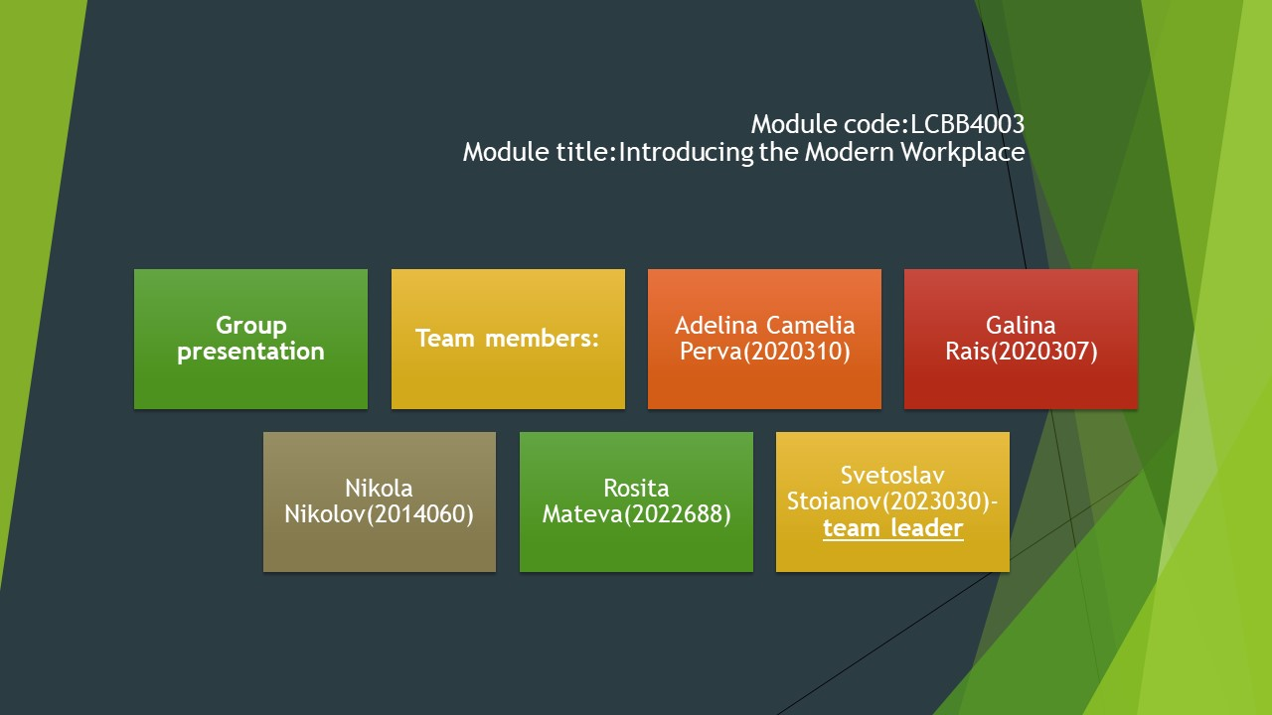
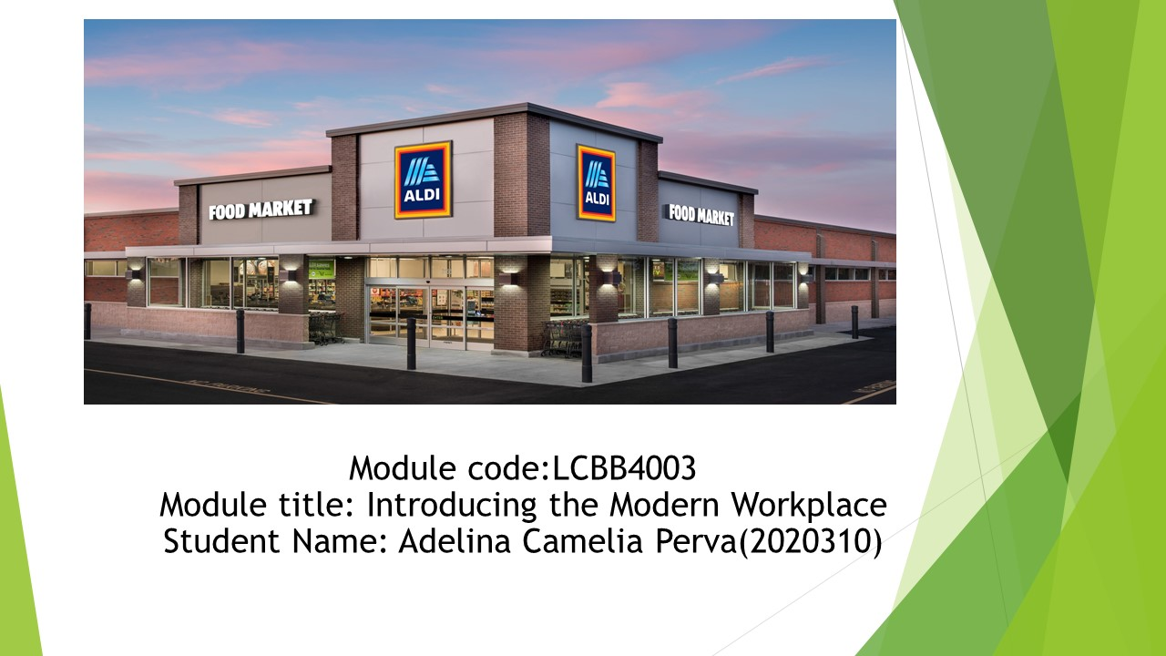
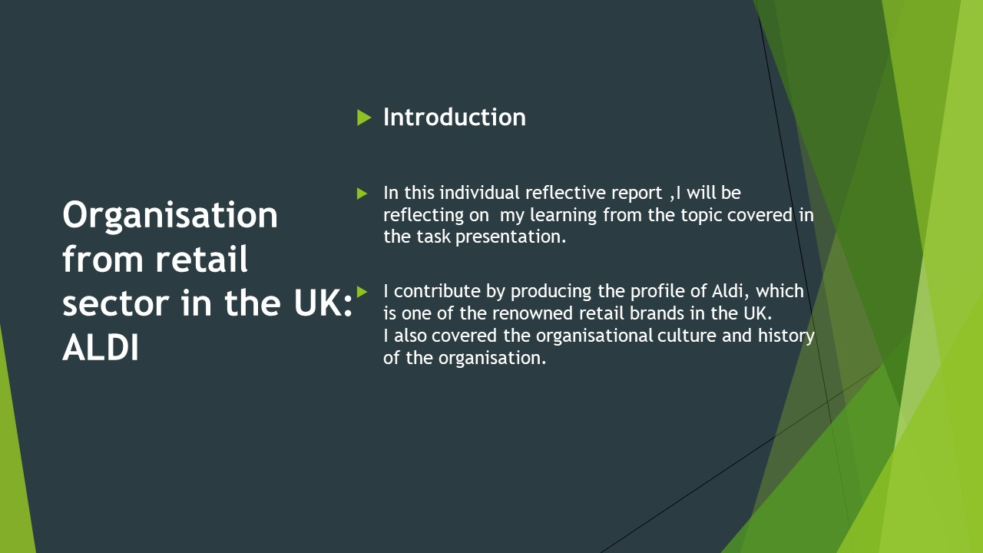
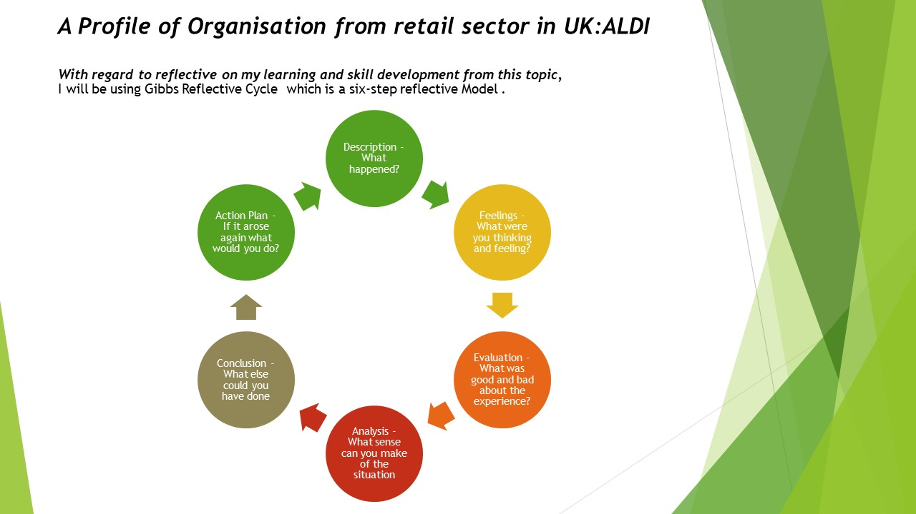
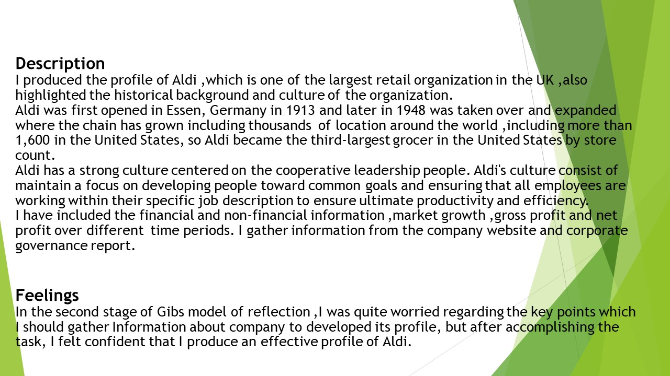
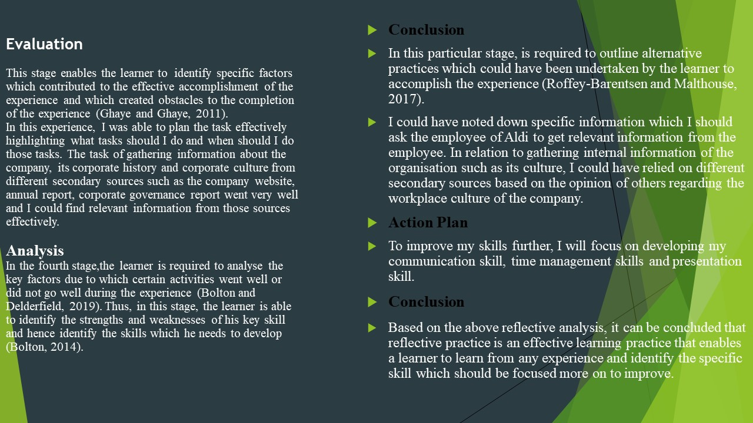
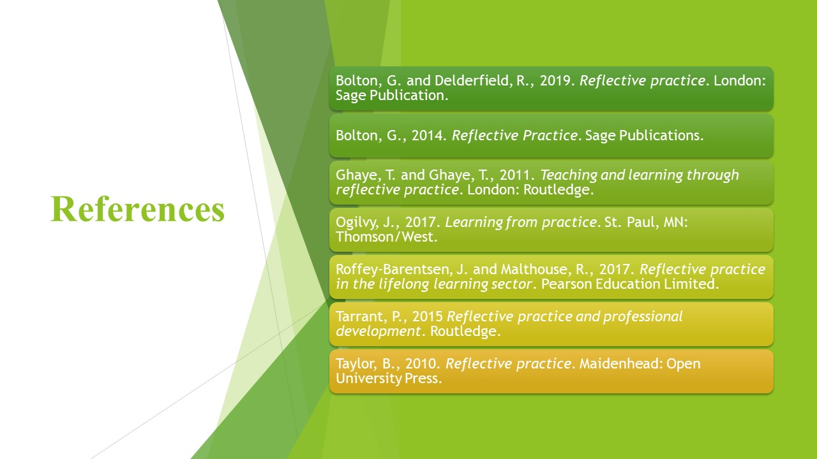

Analyse the relationship between organisational structure and organisational performance in (ALDI UK)
Galina Rais ID (2020307)

Organisational Structure: It is a system of orders which exhibit how activities should be executed in an organisation to achieve a target or goal of organisation. Duties, roles, rules & regulations and responsibilities are part of these activities (Lawler, Hall and Oldham, 1974).
Organisational structure also indicates how tasks are executed and flow of information within a company, In case of centralised structure decision is delivered from top authorities towards down to managers and working staff while in decentralised structure every one holds a specific percentage of decision power according to the levels of organisation (Tolwiński and Sosnowski, 1980).
Aldi's structure is divided based on area and geography and not too departmental. Managers in charge according their divisions are responsible of their delivery of service and product and are operating like it's their own business. Therefore Aldi follow upon the rules of decentralised structure in which managers in charge are professional enough to make their own decision at workplace. Acceptance of this structure happened when Aldi was divided into Aldi Nord and Aldi Sud in 1961. Only purchase through cash management and data processing falls into the domain of centralised structure, but decentralisation is the core structure of Aldi's corporate management. 40 to 80 stores are operated by each company of Aldi, when they become large enough that they require at least two sales managers (Aldi, 2019). When a number of operating stores reach to a limit of 60 to 80, a split between current operating companies is made and a new company is created with a new balance sheet, bookkeeping and everything which is operated in the former company (Aldi, 2019). It operates on a flat structure not a hierarchical in which managers have large range of control over operations because it does not have planning department, HR department or any marketing department all decisions are made by managers in charge.
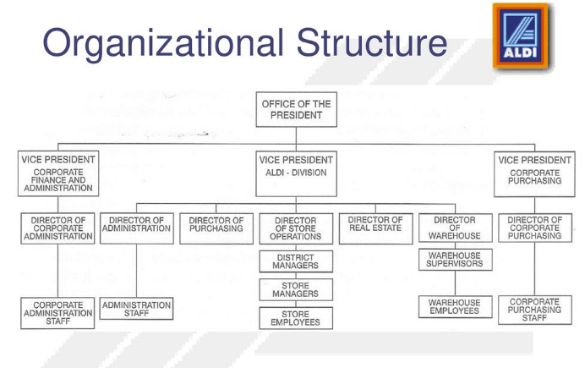
Figure 1 (Board, 2021)

Organisational Performance: It means output or result of any organisation against its executed actions which can be goals or aims (Ronan and Prien, 1973).
Performance of any organisation is based on three specific areas which are:
- Financial Performance
- Market Performance
- Return to Stakeholder
In organisational performance of Aldi we will discuss its strategy, customer service, management staff and their financial outcome.

Aldi is mostly concerned about high quality product and low pricing which keeps its customers loyal it pays its store keepers 19.20$ an hour plus industry benefits as well (Statista, 2014).

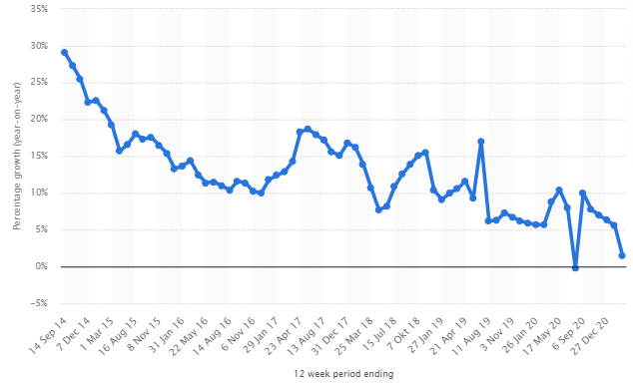
Figure 2 (Statista, 2014)

Aldi sales growth to 13% in the month of July 2020, and at the end of March 21st its online sales increased by 1.5% which is higher than last year due to covid-19 (Statista, 2014).
From January 2015 to December2020 Aldi's market share expanded upto 7.7% while other retailers lost their market share, furthermore it also received positive brand recognition award in 2019. Moreover number of stores of Aldi Sud in UK increased by 48.25% having in possession of almost 880 stores in 2020 due to its good operational performance (Statista, 2014).

Analysis of Organisational Structure and Performance
Aldi follows a decentralised structure which means managers in charge are responsible for making a decision and are responsible for the quality and service of the product. This structure gives freedom of work to working employees, and that is why most of them turned out to be entrepreneurs in future. Literature confirms that organisations that follow a centralised structure have a negative effect on their overall performance (Dalton et al., 1980). Because of the fact that their creativity is restricted and they must have to follow only orders which are given to them. Organisational structure and performance maintain a direct relationship, and it is confirmed that performance is a variable of structure that is ultimately affected by a change in the structure of the organisation (Dalton et al., 1980). Because of Aldi's structure, it has a direct effect on its performance as well. Aldi gave its managers freedom of decision which allowed the company to save their money by not investing in other departments like planning, marketing etc. This allowed the company to follow its one and foremost rule of providing low cost and high quality products with excellent customer service.
Organisational performance is indicated by the performance of its employees and results, studies show that organisation with poor structure leads to poor performance of employees (low productivity, no interest in work) which means bad wages, bad incentives and this happens in companies with centralised structure. Expansion of Aldi's store and its warehouse are clear examples of its good organisational structure and performance. Moreover, it pays its employees with an industry advantage of 15$/hr. All credit goes to the dedication and hard work of its employees earned company dedicated customers who don't go to other retailers to purchase goods.
A price comparison was made in Australia in which Aldi offered a pack of bananas worth 1.65$ while other retailers offered the same pack of bananas in 1.89$ or 1.82$ (Peter, 2015). This price comparison shows that Aldi does not compromise on quality and quantity and offer good prices to its customers rather than its competitors, having a systematic organisational structure has direct effect on implementation as well as the performance of its employees. Similarly, hard work of employees is the one which benefits the company at the end, another factor which contributes a lot in organisation having good structure and performance is employee retention. Employees who are enjoying good wages as well as industry benefits do work hard than usual and because of decentralised system every manager and store keeper work like it's his or her own business which earned company a good reputation in retail market, however there are also competitors to Aldi but it's growth simply indicates that company is doing very well in terms of performance and structure.

References
Aldi, U. (2019). Corporate Information - ALDI UK. [online] Aldi.co.uk. Available at: https://www.aldi.co.uk/corporate-information.
Board, O. (2021). Org Chart Aldi UK. [online] The Official Board. Available at: https://www.theofficialboard.com/org-chart/aldi-uk [Accessed 7 Jul. 2021].
Dalton, D.R., Todor, W.D., Spendolini, M.J., Fielding, G.J. and Porter, L.W. (1980). Organisation Structure and Performance: A Critical Review. The Academy of Management Review, 5(1), p.49.
Lawler, E.E., Hall, D.T. and Oldham, G.R. (1974). Organisational climate: Relationship to organisational structure, process and performance. Organisational Behavior and Human Performance, 11(1), pp.139–155.
Peter, G. (2015). ALDI - A German success story. [online] Technology and Operations Management. Available at: https://digital.hbs.edu/platform-rctom/submission/aldi-a-german-success-story/ [Accessed 8 Jul. 2021].
Ronan, W.W. and Prien, E.P. (1973). An analysis of organisational behavior and organisational performance. Organisational Behavior and Human Performance, 9(1), pp.78–99.
Statista (2014). Aldi sales growth in Great Britain 2014-2019 statistic | Statista. [online] Statista. Available at: https://www.statista.com/statistics/386763/aldi-sales-percentage-change-great-britain-uk/.
Tolwiński, B. and Sosnowski, J. (1980). Planning Model with Decentralised Structure of Decision Making. IFAC Proceedings Volumes, 13(5), pp.367–374.
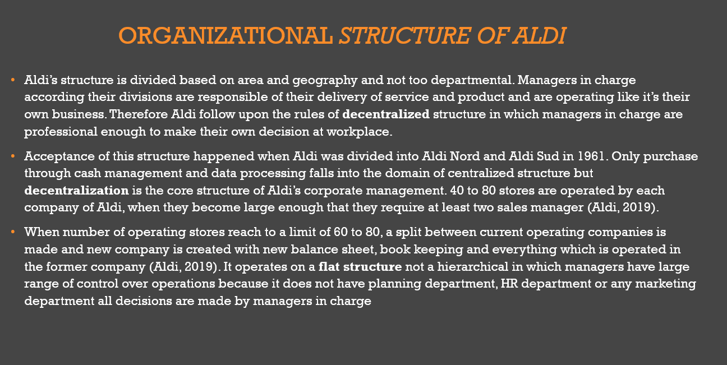
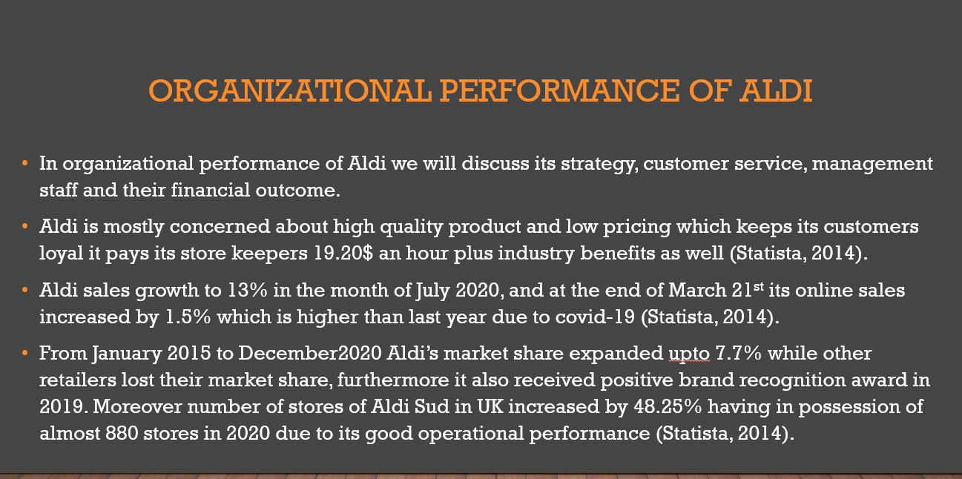
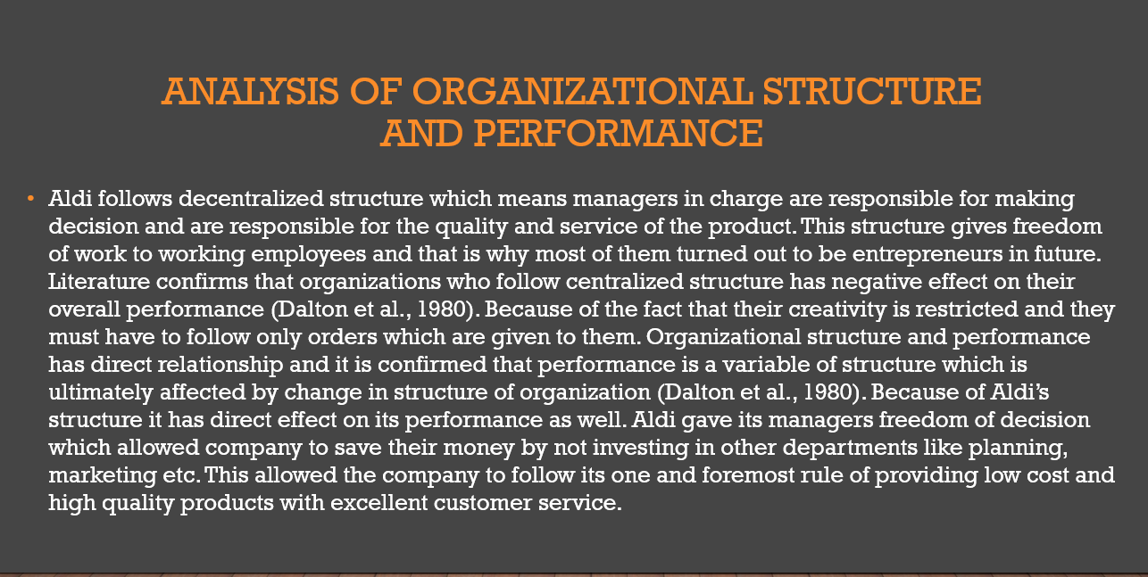

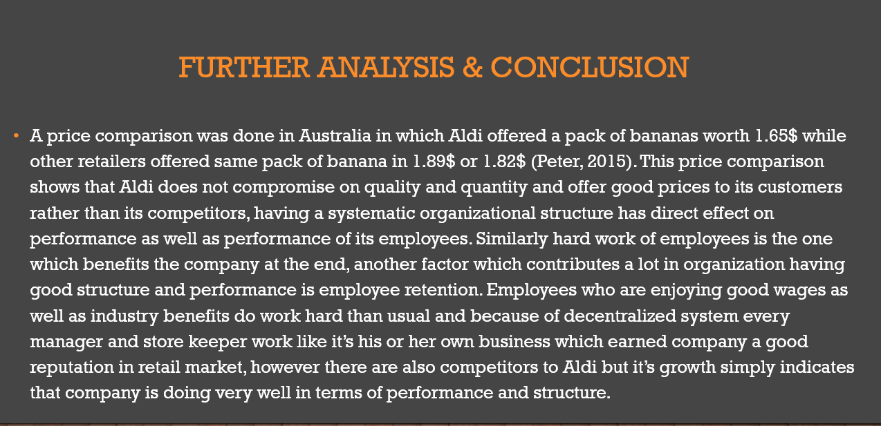

TASKS AND SKILLS FOR A MANAGER ENSURING OPERATIONAL EFFECTIVENESS IN ALDI UK.
Reflective Report

Student Name: Nikola Nikolov
ID: 2014060
Date of Submission 09/09/21

Reflection on own managerial skills
Reflective writing refers to the practice of evaluating managerial skills concerning the essential set of skills required for one manager to be able to perform given roles or tasks. In this reflective report, I examine the individual skills of strategic managers at Aldi retail stores and describe how they develop relevant skills that would be useful for an effective strategic manager.

Employee management skills
A strategic manager at Aldi is expected to track and measure employee performance using the various performance measurement tools available like 360-degree feedback, supervisors' feedback, self-evaluation, constructive communication etc.
Measuring employee performance is essential in recognising talents and therefore developing them into a form that can enhance the company achieve its goals more conveniently. However, If the employee does not have refined management skills because of a lack of experience in the field, he/she would need to develop new skills in employee management to be eligible to be an ideal strategic manager at Aldi.
Motivational skills
Motivational skills enable a manager to communicate the company's vision to the employees in an inspiring way such that they feel like part of the vision. Strategic managers at Aldi are expected to appeal to the employees' desire to work more passionately and achieve the organisational goals since they are convinced that achieving the goals is beneficial to the company and them. Having good motivational skills can influence the staff to do something extra, in order to achieve more productivity

Effective communication skills
The strategic managers at Aldi are needed to possess excellent communication skills, both written and spoken. Furthermore, they are expected to listen carefully,read and comprehend the goals that need to be accomplished. Also, they should create a plan that will guide the staff towards success. For instance, no one can be able to develop an effective plan if the goals are not understood clearly. The manager would also require excellent communication skills to deliver the tasks to the employees and clearly explain the plan on how to achieve them—for example, proficient skills in both written and spoken communication. Also, being able to listen attentively, read guides and implement instructions as required.
Delegation skills
Delegation skills refer to the ability of a manager to entrust employees with the role of making decisions within their individual capacities without having to be involved in all decision making. Delegation is essential in imparting a sense of accountability in employees and developing them into future leaders. Therefore, managers at Aldi would need to trust their employees and delegate some leadership roles to them.
As a result, such employees would feel trusted and pride themselves as being part of the decision-making team. Furthermore, this increases productivity and enhances employee retention rates, which cuts the recurrent recruitment and training costs in terms of money and time. However, suppose a trainee manager has not been entrusted with a managerial position yet where he/she would delegate roles and responsibilities. In that case, they could need practical exposure to develop practical delegation skills.
Stress tolerance skills
Management job is characterised by stress which may emanate from disappointment in employees when they fail to perform as expected. The stress can also result from failed orders or projects. Therefore, managers at Aldi are expected to possess stress tolerance skills to cope up with unpleasant situations that may arise and look for ways to go past them. Having a great sense of tolerance and being composed even when faced with a disappointing situation is essential for Aldi's managers.

Risk analysis and mitigation skills
Risk analysis and mitigation skills refer to the ability of a Aldi's manager to evaluate the business environment, identify potential risks and provide viable mitigation measures that can be effective in preventing the risk.
Being a manager in Aldi is also anout to learning various analytical tools for internal and external business environments such as PESTEL mode, SWOT analysis...Using them effectively to identify potential risks facing the business and explore ways to overcome the risk. However, to gain hands-on experience in analysing the actual business environment, identify risks and opportunities and establish strategies to utilise the opportunities while mitigating the risks before they have caused losses to the business.
Budget management skills
A strategic managers at Aldi should have the ability to position the available resources that are ever scarce and limited to capture maximum value for the organisation. So they do practical budget management skills. Also, they will need to know how to prioritise areas of expenditure and allocate less in less profitable ventures.
Organisational skills
Aldi's managers exhibit excellent organisational skills, having worked in a capacity such as strategic managers. Organisational skill is an essential skill for a strategic manager since it enables him/her to complete all intended tasks within the specified time without omitting or getting late. They learnt how to organise tasks in the order of prioritising where the more urgent tasks appear at the top of the list while the less urgent tasks are given last priority
Interpersonal skills
Being a strategic manager in Aldi requires working collaboratively with other staff and colleagues to get their opinions and make wise decisions backed with factual information. Therefore, for a strategic manager at Aldi is vital to harmonise mutually with other colleagues, whether seniors or subordinates are expected to present proficient interpersonal skills. In addition, equality and diversity are critical factors in Aldi's company policy.
The staff who worked at Aldi as an assistant manager in a team of colleagues were required to coordinate with other members to deliver expected outcomes. As a result, they learnt excellent interpersonal skills, enabling one to relate and work well with others which involves tolerating divergent opinions even when you disagree with them.

Skills Development Plan Using SMART Writing
Specifics | Measurable | Achievable | Relevant | Timebound
Employee management skills | Recommendation letter | I will attend leadership seminars and workshops to learn various employee management skills from experienced managers and scholars. I will request them to give me a recommendation letter once I have gained the prerequisite skills. | I will apply my learnt employee management skills in managing employees and getting the best from their potential. Effective management of employees will increase productivity and competitiveness of my future business thus recording the much sort success. | Two months
Delegation skills | Recommendation letter | I will look for an internship in a local company where I will seek mentorship from experienced managers. I will work under them and learn through observing and doing. Once I have attained the desirable delegation skills, I will request the company to issue me with a recommendation letter showing that I attained the desired levels. | I will need good delegation skills to be able to entrust my subordinates in my future career. This will enable me to streamline operations and improve service deliver in my future business | 3 months
Risk analysis and mitigations skills | Certification | I will enrol for an online course where I will be trained on the various ways of identifying risks and formulating effective mitigation measures to potential risks. I expect to be issued with a certificate upon completion of the online course. | I will need to be effective in identifying potential risks facing my future business and consequently come with competitive mitigation measures to curb the prevailing risks. | 5 months
Budget management skills | Certification | Enrol for short course in budget management in a local college | Will utilise the learnt skills and knowledge on budget management skills to manage my business in the future in such a way I maximise profits while cutting down production costs | 6 months

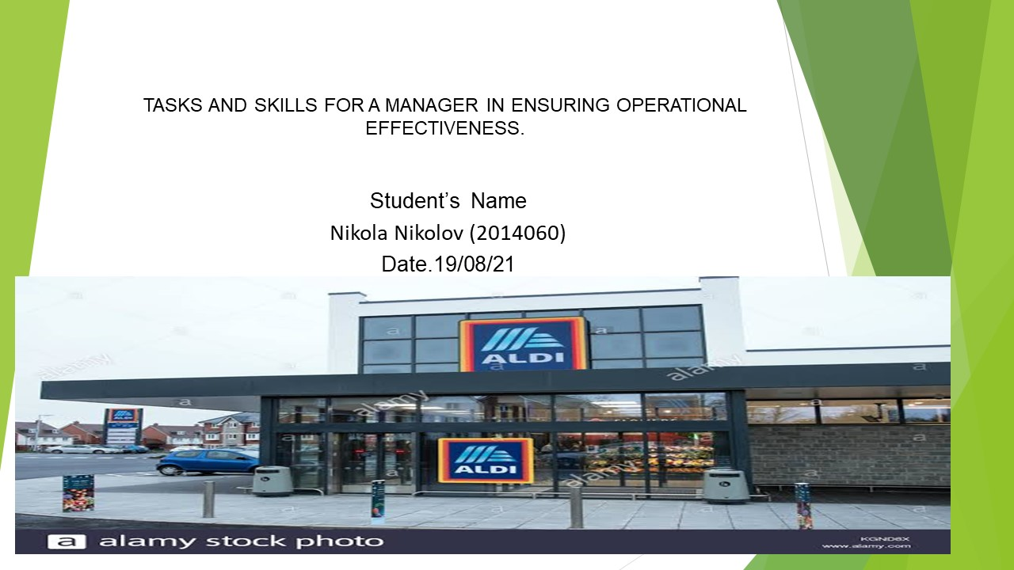
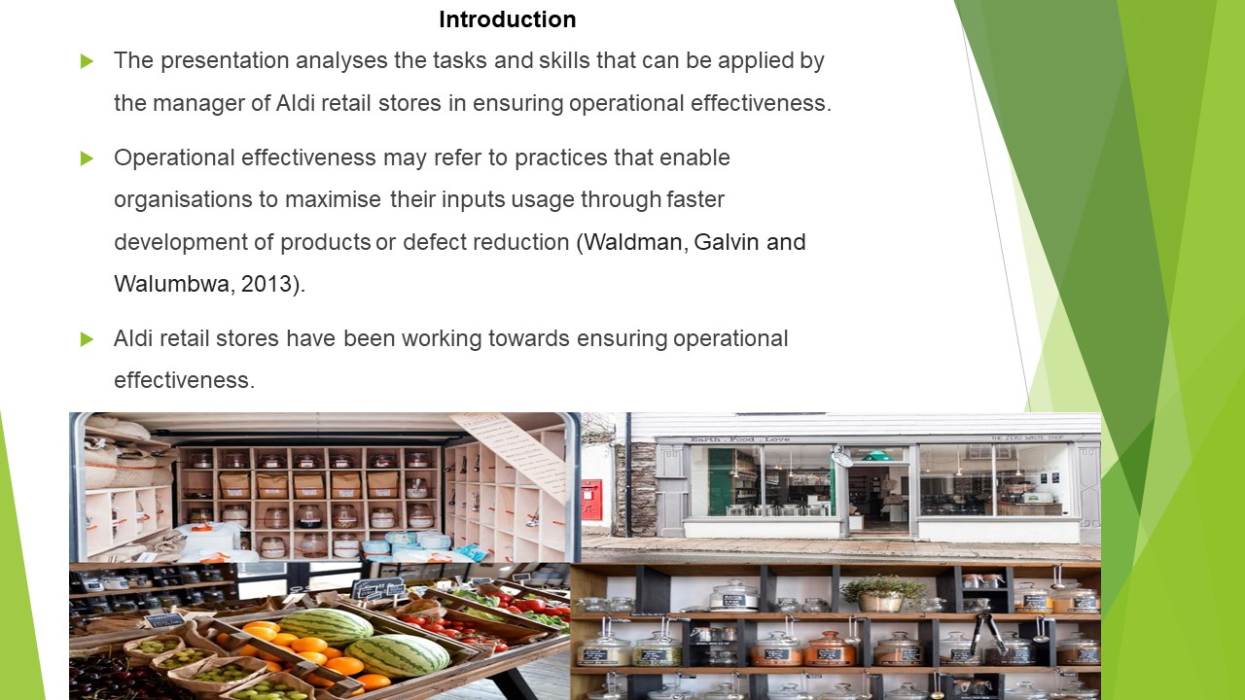
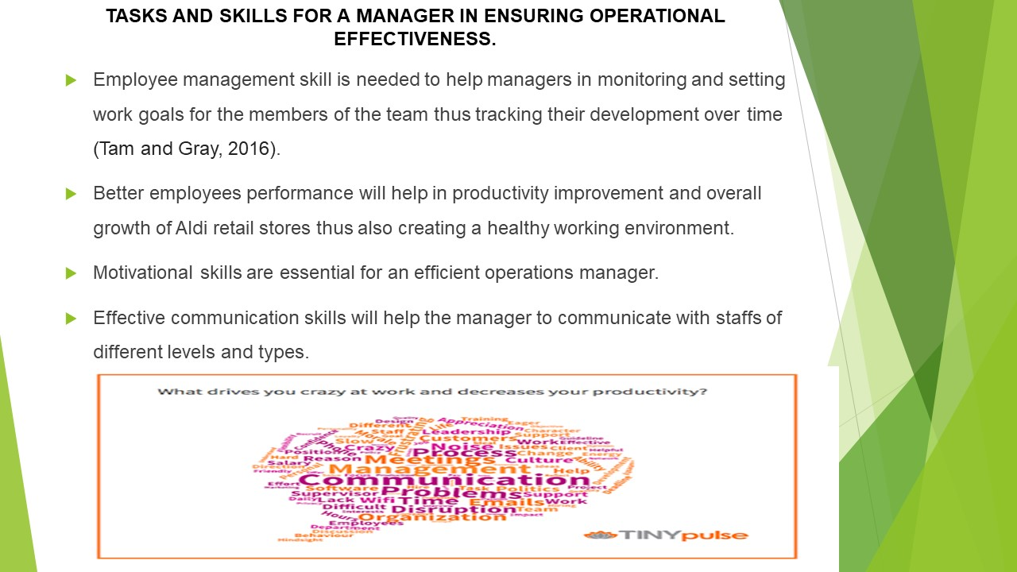
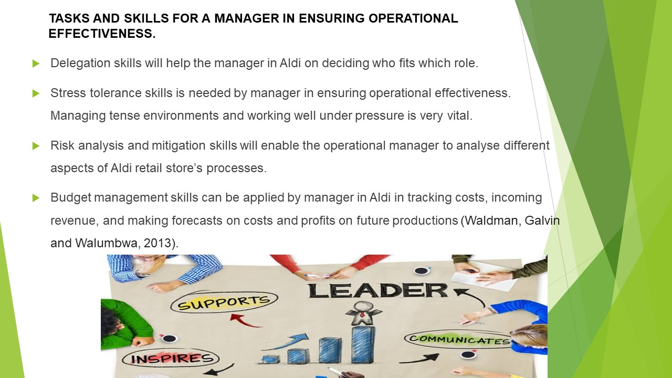
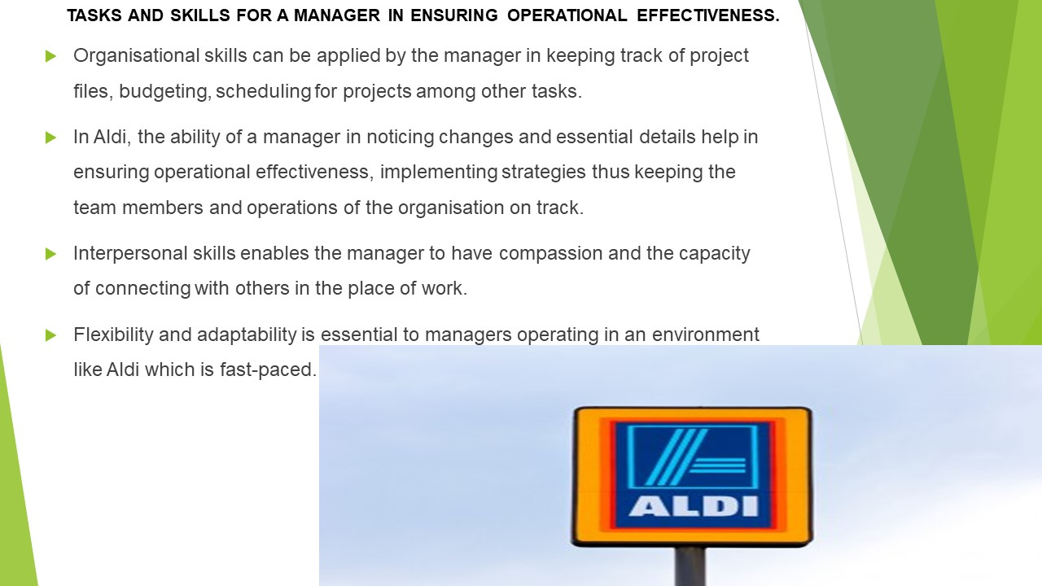
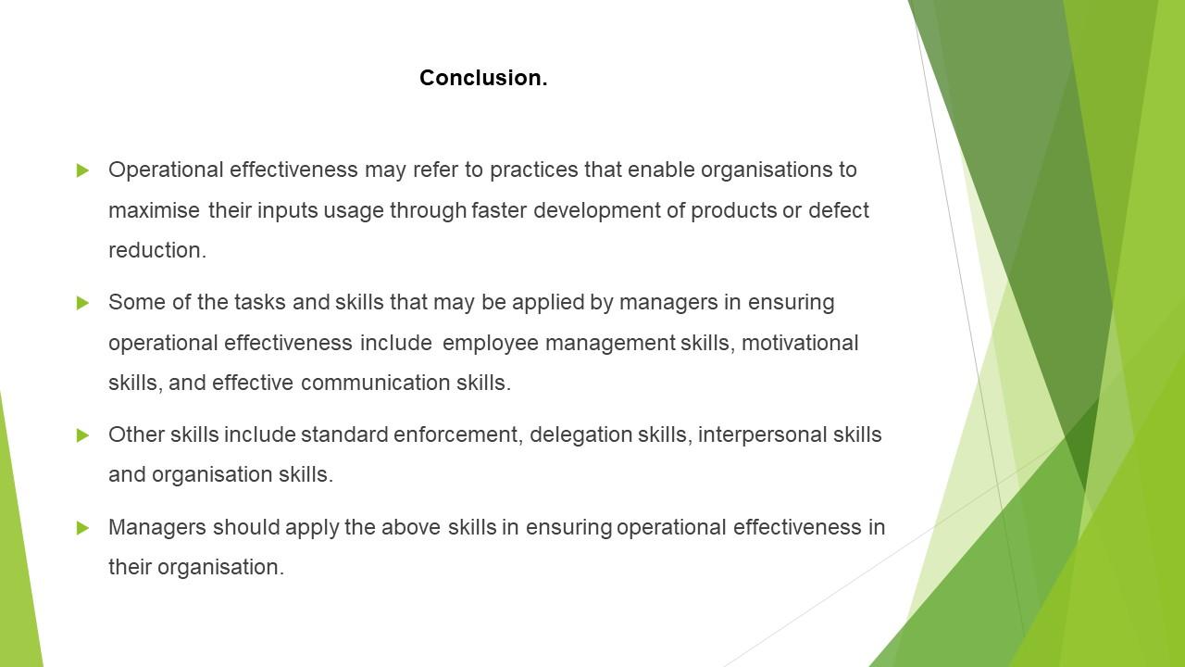
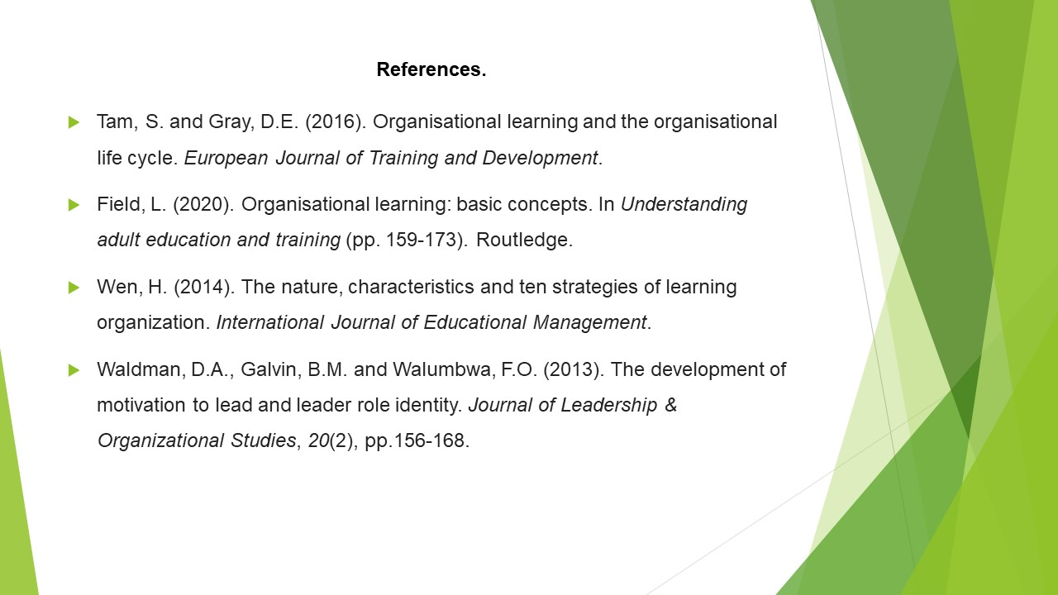


How Leadership can inspire and motivate staff members to improve performances
“ Aldi “

Mateva, Rositsa Marinova
ID (2022688)

The Aldi grocery stores were established by two brothers of German descent named Karl and Theo Albrecht on July 10, 1946. To date, the company has more than 10,000 stores in 20 countries. As the business develops very well and gains great popularity and very satisfied customers. The company is gaining a lot of popularity due to its quality products and good service from their employees. Thanks to the quality they offer on the market and the presentation of the products, they create trust in their customers, attracting more new ones and thus, supermarkets are spreading to other countries outside Germany. But in order for the business to continue to move to one of the most sought-after stores, their leaders and employees work hard to continue to maintain this position, thanks to the organised work, motivation, inspiration and right Leadership that leaders give to their employees.
In Aldi, it often happens that employees who do a good job are well rewarded with bonuses, rewards or even promotions; sometimes, the company challenges their employees to work hard and also provides the opportunity for career development and training. Employees who successfully do their job and have completed their training expect to take their new jobs, which leads to the idea that the more you work and work, the higher the reward you will receive based on your work, perseverance and hard work.

When starting any business, the owner must make sure that they have hired people who are motivated and know how to inspire and make people work together in a team so that the business can grow successfully. A good leader always knows how to approach in such a way that he can respond to any situation, have an accurate assessment of things and how to approach the case that has arisen. Good communication also plays a role in leading a team. At the same time, the redeemer must always trust his leader and listen to him.
A good leader should also always meet with his employees to discuss new proposals or solve a problem. In order for a team to work together, the leader must make sure that everyone feels vital in what they are doing, consult and find out the case. It is also essential for him to know that workers are also necessary and that they also play a very important role in the work process and business development. Although it is not something special as a job, it is still vital. Therefore, the leader should not ignore the least created problem because he can also play a role in a situation. The leader is no less engaged than the workers. He performs and represents the entire managerial position; he bears all the responsibility at the slightest mistake. Even though he is busy, he should always have time to pay attention to everyone more often if necessary. Although he is the captain of the team, he must be perceived not only as a responsible person but also as a friend. This is a sure way for him to make it much easier to win over the audience and work for him because when you have treated your employee well, he could appreciate that fact, gain even more respect and focus on performing well. In order to be able to arouse their interest, you need to challenge them to do things they have never done before, to present them with the future business plan, how after the presentation of the project, the business will accumulate higher income and rise to a reasonable level in business circles. When a leader overwhelms their employee, they have more responsibilities.
A decent leader will give them more freedom to unleash their full potential and inspiration to create a good and successful project. The more motivated and inspired a worker is, the more successful projects he can develop, thanks to the trust that his leader has given him, based on the knowledge and skills he has and with which he can contribute to the business. It is imperative in a team for people to understand each other, to work together so that they can go in the same direction because even if something small is wrong in the organisation, there is a chance to fail or cope, but not as it could to be if they are united and cohesive. The motivation they provide in Aldi is incredible. Thanks to the desire to develop and climb the stalk to success, it makes more people want to feel this sense of job satisfaction and appreciation of their abilities. It is for this reason that there are people who apply for a job and do their best to achieve something more. When there is motivation, there is more demand. Because if a worker is not motivated for something more, he will always stay in the same position, and no one can help him.

In conclusion, I can give an example with ants. They are very smart and brilliant creatures who are taught to work in a team, one to give up, everything fails. That's why we people have to learn a lot from them, because thanks to the teamwork and the cohesion of the team they could conquer many peaks because they worked together, they looked in one direction, there was someone to show them the way, their leader and they did not give up just to be able to touch success.
This also applies to the Aldi company, they inspire people by motivating and ambition them to want more than what they do for the common good, and that is why they have regular and satisfied customers who always come back and rely on them because they present the most innovative and new products on the market, which is why the company is becoming one of the most popular and sought after supermarkets in the country. Because when you work well and give your best, you are always appreciated by clients and higher employers.

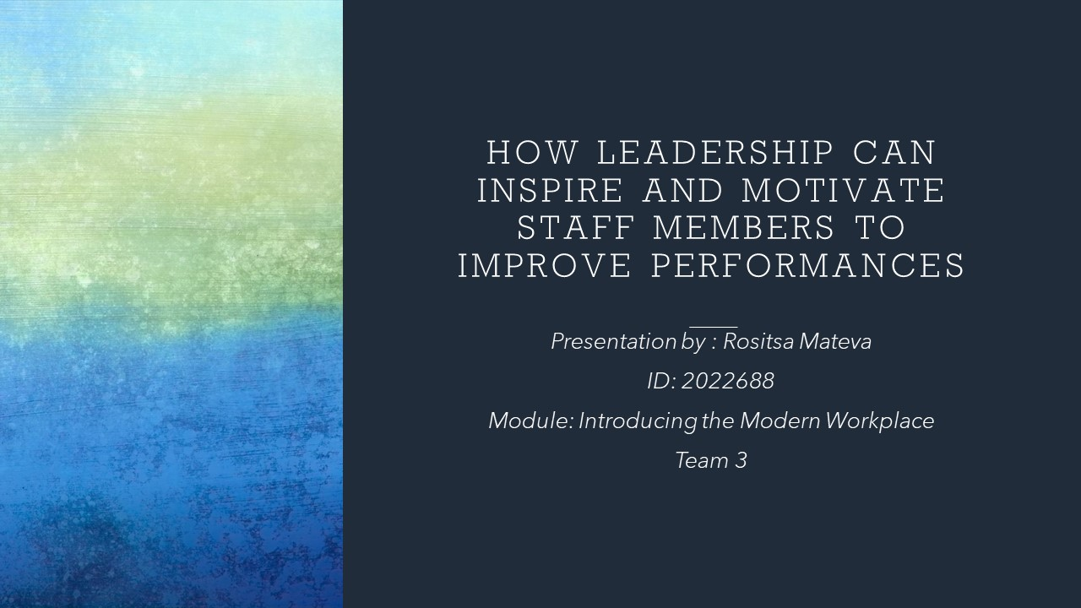
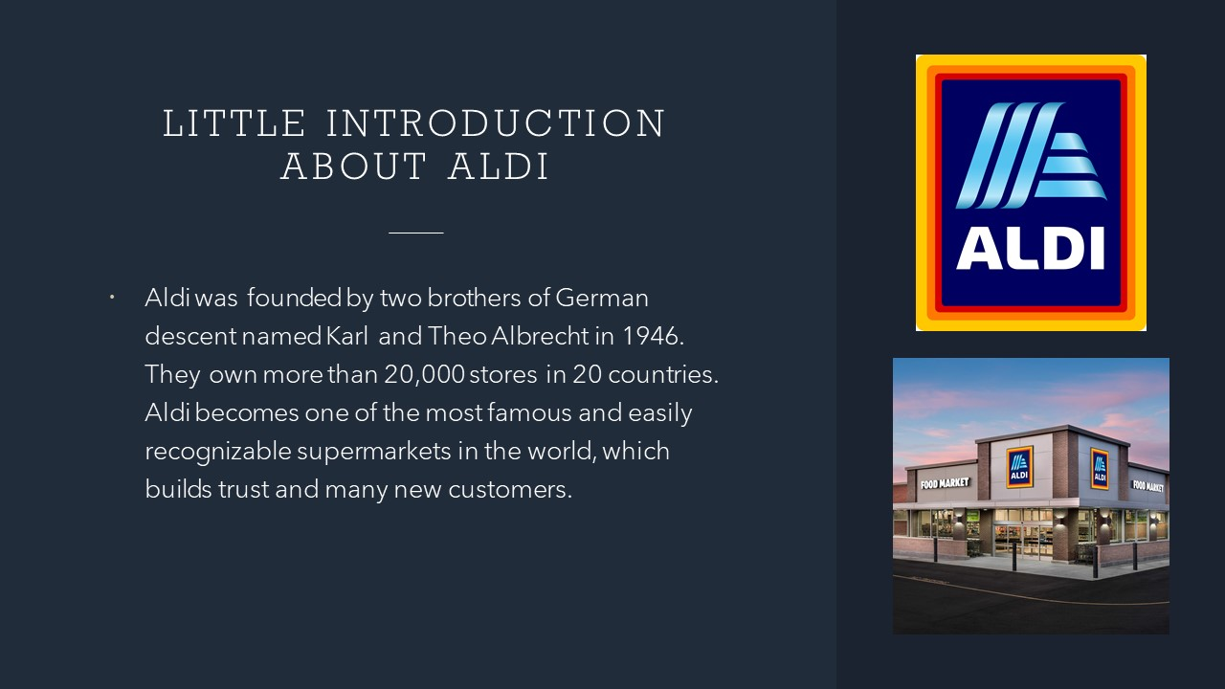
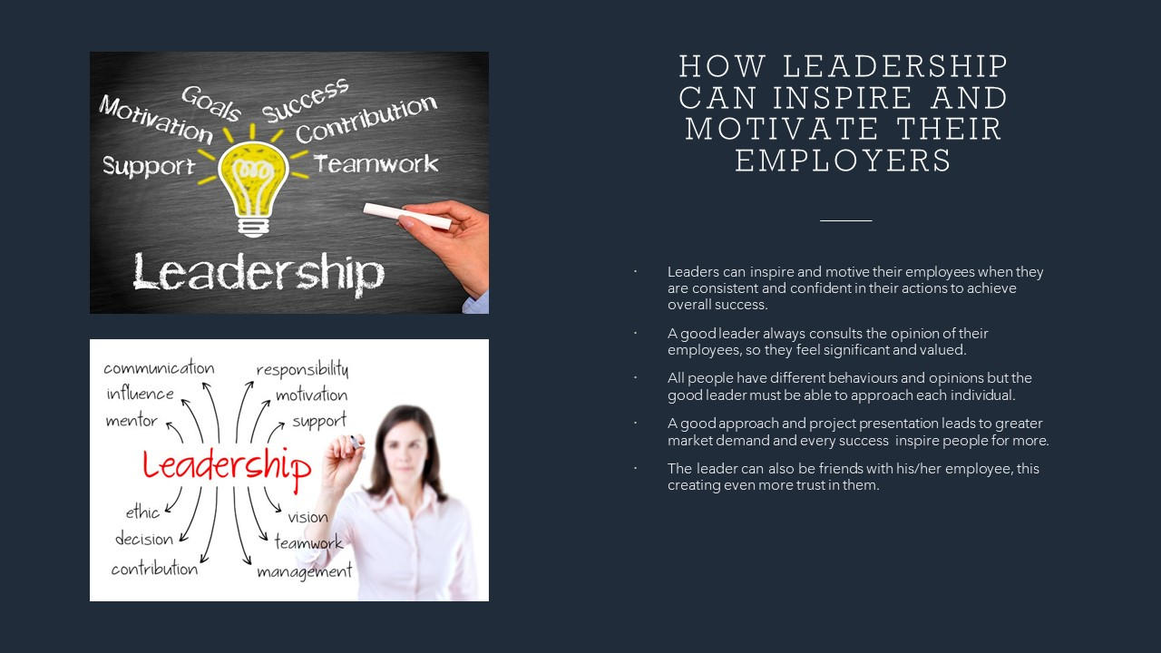
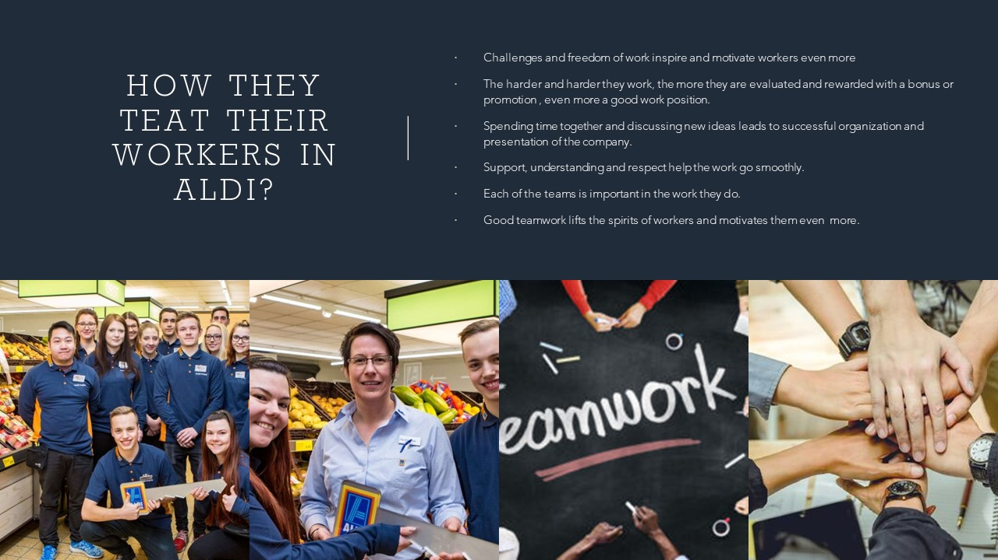
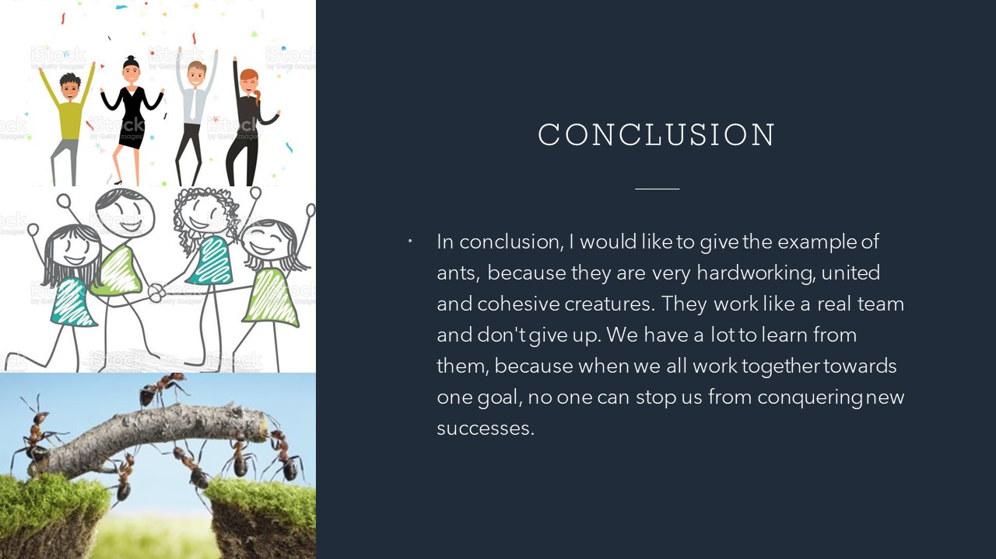
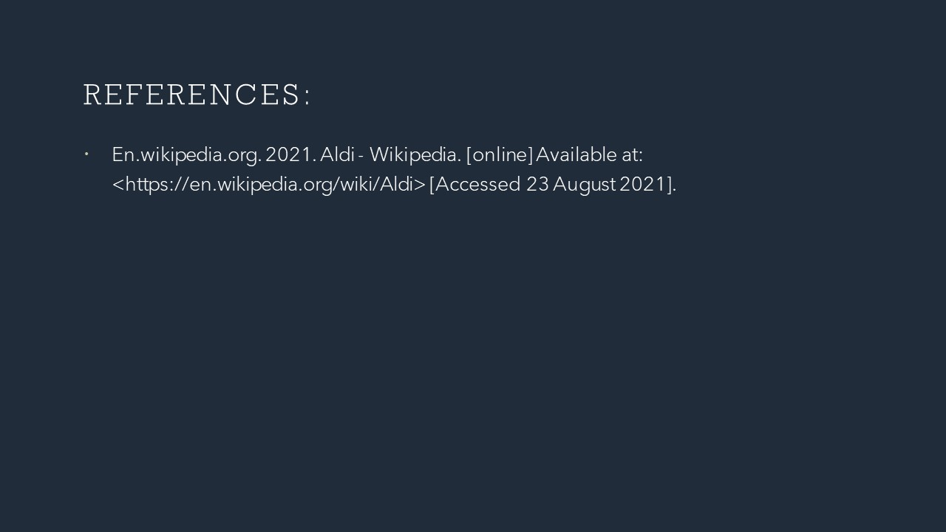


Introducing the Modern Workplace
LCBB4003

An analysis of factors influencing
Group and team behaviours at Aldi

Assessment 2

Svetoslav Stoianov
Student ID: 2023030

An analysis of factors influencing Group and team behaviours
Effective team is considered as very important of the success of an organisation. Quality of products and services is one factor that is improved by the effective team and its management. Aldi is one of the famous companies in the retail sector, and the company is focused on producing quality products. There are different kinds of reasons behind an ineffective team, and this ineffective team could have resulted in negative competition among the members, unfocused or conflict situations. Workers feel frustration and poor communication that eventually lead to absenteeism and a higher eve of turnover among members of the team.
Effective team is valuable development of team is considered as key factor of gaining success (Bell et al., 2018). In the perspective of Tuckman's model of team development, the discussion is made as below.
- Forming-orientation period of developing a team is started at this stage. There is higher level of uncertainty is present at this level. This is a stage in which members look at Leadership and authority to be performed in positive way. Background and skills are introduced at this stage to every member of team in case of Aldi. An opportunity is also giving at this stage to members of team in Aldi regarding organisation of team along with changes and responsibilities.
- Storming- in employees' perspective this stage is considered as difficult and critical because of reason of existence of competition and conflict among the members. Both ideas and innovative ways are encouraged to be shared among members. A plan is developed by leader, and they provide support to members based on which members become able to manage competition. This is done based on reducing communication gap by leader (Grubaugh and Flynn, 2018).
- Norming- feeling to perform work is developed among members at this stage and in this way the thing is made successful. Every member in team become understood to goals and responsibilities that mean at this stage competition is not existed between members. Effective way of working is started among members because at this stage everyone in team starts moving towards common goals.
- Performing- this stage is based on the practical working of members, and at this level, an increase occurs regarding trust among members. For achieving common goals, everyone starts putting in efforts. At certain points of this stage, certain kinds of issues could be faced by members, but members have the potential of solving the issues between them.
- Adjourning- in the team development process, the final stage is known as adjourning and after this stage member moves to the next project that means the current project is completed at this stage. Members conduct a review of the project, and analysis is made by members on important things so that improvement in future could be made (O'Neill and Mclarnon, 2018).
One important factor of gaining successful outcomes of the team in Aldi is to focus on developing that capability based on which common goals could be achieved with collective efforts. It is also important to ensure that tasks are performing in an effective way so that goals can be attained (Fatema and Sakib, 2017).
For smooth and successful conduct of business, one most important element is considered as co-operation. Engagement of members of the team in an open process of communication is the key element of co-operation. One important thing is that co-operation could be ineffective or effective because it is characterised by team members. It has been identified that organisations could not be helped based on the mere presence of a team. For the achievement of goals and objectives, it is noted that a team has to be effective in terms of co-cooperation. It is a fact that when an open discussion prevails in a team, then a group could be said to be effective that means one key characteristic of an effective team is to allow members to express their ideas and view freely (O'Neill and Salas, 2018). Therefore, when members are presenting their opinions and views to each other, and there is a situational style of Leadership is following, then it is said to be an effective team. In opposite to an effective team, in the context of consideration of an ineffective team, it could see that members have no environment of listening to each other and style of Leadership is authoritative and there is closed discussion. A form of consensus is considered in an effective team in respect of the decision-making process that means every member give an opinion and view, and it is valued by a leader. But in the case of an ineffective team, it could see that decisions are taken on a premature basis before solving issues on a real basis. In the perspective of making the team effective or ineffective, it is noted that there is an important role of team roles. Meredith Belbin had presented a theory known as team development theory that could be used for getting an understanding of such aspects. This theory has revealed that the effectiveness of a team could be impacted by certain kinds of roles in a team (Motycka et al., 2018). These roles are discussed below:
Action-oriented roles
- Shaper- Shaper is dynamic and extrovert because he is committed in challenging team for improvement
- Implementer- Key role is based on converting plans into action, which means he encourages members to do things
- Complete-Finisher- In the completion of the project, he is involved in ensuring that there is no mission or error (Salas, Rico and Passmore, 2017).
People Oriented Roles
- Coordinator- Members are guided by a coordinator, and he acts as a traditional team leader.
- Team worker- Effective working of team members, is ensured by team worker, and he provides support to members.
- Resource Investigator- The resources are negotiated by this individual and all available options are explored by using curious and innovative thinking.
Thought oriented roles
- Plant- New approaches and ideas are presented by this individual because he is a creative innovator.
- Monitor-Evaluator-The ideas are evaluated by a person with this role because he is an analyser. Both pros and cons are identified by him in the perspective of the process of decision making.
- Specialist- specialised knowledge and skills are retained by this individual based on which specific task is completed (Pertegal-Felices et al., 2019).
It has been identified based on applying this theory in the case of ALDI that in terms of role defining, this theory or model is using by management. Clothing, luxury food products and other home products are producing by the company, and it is operating based on various departments such as Human Resources, Logistics, Technical, Finance and Accounts and others. Effective team role management is a key factor based on which the company has developed an effective communication and coordination system (McLeod et al., 2019).

Conclusion
We have learnt about the good managerial techniques and approaches in Aldi UK. In addition, the organisation is proven to be one of the most successful retail companies in Europe and particularly in the United Kingdom

References
Bell, S.T., Brown, S.G., Colaneri, A. and Outland, N., 2018. Team composition and the ABCs of teamwork. American Psychologist, 73(4), p.349.
Fatema, I. and Sakib, K., 2017, December. Factors influencing productivity of agile software development teamwork: A qualitative system dynamics approach. In 2017 24th Asia-Pacific Software Engineering Conference (APSEC) (pp. 737-742). IEEE.
Grubaugh, M.L. and Flynn, L., 2018. Relationships among nurse manager leadership skills, conflict management, and unit teamwork. JONA: The Journal of Nursing Administration, 48(7/8), pp.383-388.
McLeod, P.L., Cunningham, Q., DiazGranados, D., Dodoiu, G., Kaplan, S., Keyton, J., Larson, N., LeNoble, C., Marsch, S.U., O'Neill, T. and Parker, S.H., 2019. Hacking Teamwork in Healthcare: Addressing Adverse Effects of Ad Hoc Team Composition in Critical Care Medicine. Health care management review.
Motycka, C., Egelund, E.F., Gannon, J., Genuardi, F., Gautam, S., Stittsworth, S., Young, A. and Simon, L., 2018. Using interprofessional medication management simulations to impact student attitudes toward teamwork to prevent medication errors. Currents in Pharmacy Teaching and Learning, 10(7), pp.982-989.
O'Neill, T.A. and Mclarnon, M.J., 2018. Optimising team conflict dynamics for high performance teamwork. Human Resource Management Review, 28(4), pp.378-394.
O'Neill, T.A. and Salas, E., 2018. Creating high performance teamwork in organisations. Human resource management review, 28(4), pp.325-331.
Pertegal-Felices, M.L., Fuster-Guilló, A., Rico-Soliveres, M.L., Azorín-López, J. and Jimeno-Morenilla, A., 2019. Practical method of improving the teamwork of engineering students using team contracts to minimise conflict situations. IEEE Access, 7, pp.65083-65092.
Salas, E., Rico, R. and Passmore, J., 2017. The psychology of teamwork and collaborative processes. In The Wiley Blackwell Handbook of the Psychology of Team Working and Collaborative Processes (p. 1). Wiley Blackwell.


