Jade Harris
P150679
Theoretical and practical justification for the use of art therapy as a tool to support mental health in children and adolescents
Submitted in partial fulfilment of the requirements for the degree of BA (Hons) University of Wales Trinity Saint David, Swansea 18th December 2018
Word Count: 5128
Supervisor: Derek Bainton

Table of Contents
List of Illustrations……………………………………………………………………………………………………..Page 3 Introduction…………………………………………………………………………………….………………….…….Page 5 Chapter 1 Approaches to Art Therapy ………………………………………………………………………Page 6
Chapter 2 Art Therapy and Children ……………………………………………………………………...…Page 9
Chapter 3 How can Art Therapy be Utilised ……………………………………………………………..Page 16
Conclusion……………………………………………………………………………………………………………….Page 23
Bibliography………………………………………………………………………………………………………….…Page 27
List of Illustrations
Figure 1: Winnicott and Child Client. Available at: https://www.psychologytoday.com/us/blog/arts-and-health/201206/1001-art-therapy-activities-really (Accessed: 18th December 2018)

Figure 2: Draw A Story Assessment w/Rawley Silver Available at: http://www.joshkale.com/apps/photos/photo?photoid=200803514 (Accessed: 18th December 2018)
Figure 3: Dale Vn Marshall’s latest exhibition, I am not a child. Available at: https://www.graffitistreet.com/dale-vn-marshall-i-am-not-a-child-raises-awareness-of-childrens-mental-health/#jp-carousel-12213 (Accessed: 18th December 2018)
Figure 4: Illustrations from Michael Rosen’s Sad Book. Available at: http://www.walker.co.uk/Michael-Rosen-s-Sad-Book-9781406317848.aspx (Accessed: 18th December 2018)
Figure 5: Tan, S. (2010) Nobody Understands [Oil, acrylic and wax pencil on paper]. Available at: http://www.shauntan.net/books/red-tree.html (Accessed: 18th December 2018)
Figure 7: Green, K. (2013) Detail from Katie Green's Lighter Than My Shadow. Available at: https://www.theguardian.com/books/2013/nov/08/lighter-than-my-shadow-katie-green-review (Accessed: 18th December 2018)
Figure 8: Harris, J (2017) ‘Hello, is that you, my friend in the dark’

Summary of Topic
This dissertation discusses the benefits of art therapy especially in relation to children with mental health issues. Looking into the history of Art Therapy and different key theorists in this field, as well the different methods and approaches that have been taken. Investigating how Art therapy should be put in place within the health care practice and schools. Looking at children’s book authors and illustrators and how it reduces the stigma around mental health and how children engage visually and its benefits.

Introduction
Art therapy is a massive field of research with many sub branches. Within this dissertation, it is not possible to explore them all in depth, and therefore this will discuss what Art therapy is and how it benefits children in relation to mental health issues. It will also look at how children are able to respond visually, when talk therapy may not be enough.
Chapter one touches upon the brief History of Art Therapy and education systems and what is currently in place for children. Introducing the key theorists Carl Jung, Donald Winnicott, Margret Naumburg and Edith Kramer, will help to explore the different methods and approaches that are currently in place and how Art Therapy is formed today.
Chapter two particularly focusses on art therapy in relation to children. Looking at current mental health statistics with children, it shows that it needs alternative therapies as the statistics of individuals with mental health issues are increasing. From looking at research it would be beneficial for early interventions to be put in place for children and this chapter will argue why Art Therapy should be implemented more. It goes further in-depth as to why it is currently needed and discusses the different methods and how they can be adapted for different mental health and situations for each individual.
Chapter three looks at how Art Therapy can be utilised, as children are natural image makers and have a lot of creative freedom when they create their work, which is a good way to express themselves and get a bigger understanding on how they feel. Looking at how art can reduce stigma and particularly how children’s books help children understand difficult feelings around what is considered to be sensitive topics. Various children’s authors and illustrators have produced works surrounding the topic of mental health, some of these will these will be further discussed.
In the conclusion it will combine the overall findings and discuss if the use of Art Therapy is a good support tool for children and adolescents and if it should be put in place in the current health care system. The last bit of the conclusion will draw parallels from own practice as an illustrator in relation to art therapy, on the art work created which is about mental health.
Chapter 1 - Approaches to Art Therapy
Art therapy first began in the 20th century primarily in Europe, as well as the USA, mainly within art education. Adrian Hill was the person who first acknowledged and used the term art therapy to describe the application of image making. He discovered therapeutic benefits of drawing and painting while he was recovering from tuberculous (Robert A. Bitonte, 2014). Hill stated that it ‘completely engrossing the mind and releasing the creative energy of the frequently inhibited patient’ (Edwards, 2014, p. 1).
In Art Therapy there are many different creative mediums that can be used, these different forms include drawing, sculpting, mosaics, painting, clay making and music. All of these different mediums have really good benefits (Brown, Psychological Benefits of Art Therapy, 2012).
Art Therapy is closely related with art education. It can help patients (in this instance specifically related to children) to express their feelings through art and creation. Focusing on the end product may interfere with the therapy. The aim of the therapy is never the end of the product but is focussed on the process itself. From a psychotherapy perspective art therapy is used to also understand inner conflicts and can further create self-awareness and initiative to start a healing process (Anderson, 1980, p. 20). Therefore building further self-awareness and build a better relationship with themselves which may help to boost their self-esteem.
The process of making art with a professional therapist can be healing and life enhancing for the client (American art therapy Association 2004). Art experiences can provide an alternative to verbal forms of assessment treatment as registered art therapists (ATRs) are mental health professionals with master degrees who are trained in both art and therapy, and use art to assess and treat individuals with disabilities in various settings including schools (Silver, 2005).
This section will discuss different approaches to Art therapy. It is a professional practice which is being increasingly recognised in the health care system, schools, hospitals and charities (Therapists, N.D.). There will be various different art therapy methods discussed, as well as some of the techniques used. Some key figures and theorists will be discussed such as Donald Winnicott, Margaret Naumburg, and Edith Kramer in order to provide context.
When discussing art therapy pioneers it is hard to talk about this without mentioning Carl Jung (1875-1961) who was an early theorist, who recognised the benefit of art therapy. He believed art making was an important way for a person to express themselves. Jung encouraged his patients to express themselves through creation. Jung considered art as a way of self-analysis and an important tool in the ‘individuation’ process. Considering Jung’s take on art therapy where he emphasises the unconscious mind, there is an inevitable link between imagination and art. Jung says: ‘’Image and meaning are identical: And as the former takes shape, so the latter becomes clear. Actually the pattern needs no interpretation: it betrays its own meaning’’ (Miller, 2004, p. 204).
Donald Winnicott (1896-1971) is also considered to be another important figure in the development of art therapy. Winnicott was a psychoanalyst and child theorist whom developed a theory emphasising the importance of play. He created the squiggle game which is one of the methods implemented within art therapy. Winnicott’s play theory explored how children’s creativity could help them become more self-aware. In his play theory it discusses how individuals can expresses themselves through the art, and become more self-aware (Winnicott, 2005, p. 90). Winnicott is considered to be one of the leading theorists behind Art Therapy particularly with his development of the ‘the squiggle game’, as will be later discussed in more detail.
Margaret Naumburg (1912-1964) was a pioneer of Art Therapy especially in America, and is well known for her approach Dynamically Orientated Art Therapy (D'Amello, 2000, p. 47). Naumburg linked her work and built from Jung’s and Freud’s approaches to art therapy. Dynamically Orientated art therapy stems from the theory that thoughts and feelings come from the unconscious mind and can be expressed through image. Naumburg later looked at the squiggle game that Donald Winnicott developed and used it later in her own practice.
This is how the therapist and the patient communicate by using pictorial projection, which could be based from the patient’s inner conflicts, dreams and fears. For those who struggle to communicate verbally are later able to express themselves better with the help from the art they have created (Naumburg, 1966, p. 1).
Edith Kramer (1916-2014) is also considered to be another pioneer of art therapy. Kramer worked alongside children that were labelled ‘disturbed’, that’s when she first got given the title of art therapist. Kramer focused on the process of art therapy as the healing factor of mental health (Malchiodi, 2014). Describing her approach to art therapy Kramer said:
My Therapeutic medium is as old as mankind. Since human society has existed the arts have helped man to reconcile the eternal conflict between the individual’s instinctual urges and the demands of society. Thus, all art is therapeutic in the broadest sense of the word (Kramer, 2000, p.17).
Kramer’s approach process does acknowledge the psychic processes, however she doesn’t analyse and interpret the unconscious meaning unlike Naumburg’s approach which is focused on the unconscious mind. Both approaches are relevant in the conversation of art therapy. For the purposes of this essay we will focus on Kramer’s approach predominantly as it focuses more on the creative process.
Chapter 2 - Art Therapy and Children
Art therapy is an important type of therapy, it helps children to express themselves when words cannot. It gives them a voice to communicate with the therapist, it is also good for crossing language barriers (Malchiodi, Child Art Therapy: How It Works , 2016). It is important to be careful with all children as some of their experiences may be very hard for them to touch upon, this is why Art Therapy is a good alternative communication (Malchiodi, Child Art Therapy: How It Works , 2016).
The relationship between art therapy and children goes back a long way. During the 1930’s to the 1940’s Friedl Dicker-Brandeis an Austrian Jew was imprisoned by Nazi’s in the concentration camp. She managed to bring art supplies within the luggage they were allowed to take; her beliefs were that in bringing the art supplies with her she could help children cope with their imprisonment through making art. She went on to teach 600 children secret art classes. Some of the work created became part of a book called ‘I never saw a butterfly’, which is about people’s experiences during the holocaust (scrapbook.com, 2018). This shows that art therapy does help those who are struggling in hard times and has continued to be used since, even in the most difficult situations.

It can be risky to look at art too closely, but in the case of children, who may not have the words to express how they are feeling, it is very beneficial to use art as a mode of expression (Tripathi, 2014, p. 83).
Once the art has been created it is important not to over analyse it, in some cases. Children may find it intimidating to speak to a therapist in a clinical setting. Art therapy is a universal way for children to communicate their feelings and help the children themselves deal with it. It is easier for some to draw their feelings rather than answer it in-depth. Children may even feel hostile talking about how they are feeling so art is a way for the child and Art Therapist to build ‘trust’. Some of the issues Art Therapy can help with are, death of a family member, mental health, learning difficulties and physical difficulties. Some of the benefits can be, it is a universal communication, it can strengthen the children’s self-awareness, and help them develop further coping skills, as well give them an emotional outlet (Art Therapy Journal, 2018).
To date, in the United Kingdom there is little information on art therapy in schools, within the research and practice there has been an improvement with the introduction of National Service Framework. This was introduced by Department of Health 2004. As a result of this there are more results of art therapists being brought into schools (Sangeeta Prasad, 2013, p. 127).
If Art therapy was practiced more in schools there is evidence to suggest that there are a multitude of benefits to aid in children’s learning as well as contributing to boosting their mental wellness. There has been a number of projects implemented within America that are both for special need students as well as mainstream students, which benefits them with socialization, self-esteem as their communication skills (Sangeeta Prasad, 2013, p. 127).
A number of studies have shown that there is an increase of pressure on young children, from the stress of school, to social media with online bullying. There is evidence to suggest that this could affect their mental health. Children’s mental health is a major issue which starts at school age and statistics show that it is on the increase at an alarming rate. Access to support is also an issue; 3 in 4 children with a diagnosable mental health condition do not get access to the support that they need (Young Minds, Mental Health Statistics, 2018).
Schools are an important factor in children’s lives for their early mental health and wellbeing (Mental Health Foundation, 2017). The number of children being treated for mental health, by the NHS is a third higher than it was two years ago. The linked reasons to these are to do with depression, anxiety, body image and eating disorders. There is increased pressure to do well in school and to follow the social norms of social media. Latest statistics from the NHS shows that there are currently 389,727 active referrals, which 50,000 of these referrals are from GPs (Campbell, 2018). Investigating the topic is Journalist Laura Donnelly she says:
We know from our research that children and young people face a huge range of pressures, including stress at school, body image issues, bullying on and offline, around-the-clock social media and uncertain job prospects (Donnelly, 2017).

Art therapy can be an effective way to cure and treat depression. This approach is beneficial for children and adolescents as it is a gentler approach to help improve their emotional state (Mansooreh Rahmania, 2016, p. 79).
Art therapy helps express emotions in a non-verbal manner that help children and adolescents who are closed off, to express themselves and communicate with others. As Picasso states: “Art washes from the soul the dust of everyday life” (Brown, 2012).
There are various forms of treatments available for children with mental health such as seeking help from teachers, school nurse, school councillor and educational psychologists. These tend to be the professionals that refer children to get further help. The most common type of therapy put in place is talk therapy where children often discuss their feelings and behaviours with a psychologist or a councillor. There is also the option of medication, which is focused on adults more so than children, however there are occasions where children often use medication as a treatment as well (MentalHealthFoundation, 2018).
A child may thrive on the ability to have a free-flow of verbal and nonverbal expressions. A child’s empowerment occurs when they are capable of expressing their troubles, concerns, and challenges in a nonthreatening, non-hostile, and non-invasive therapeutic session. When a child is empowered they are given a torch of emotional freedom. While talk therapy offers an avenue for verbal communication; Art therapy is capable of simultaneously looking at verbal and nonverbal spectrums on of life (Brown, 2012).
Talk therapy has its benefits for children and young people, but Art therapy gives the allowance to do both which could allow a bigger understanding of how they feel. Traditional methods of treatments are not accessible when needed, and therefore, there is an ever-increasing need for alternative therapies.

Barry (2009) and Sturgen (2006) argue that early intervention for children with mental health could reduce undesirable outcomes, that public health programmes have been restructured to consider promotion and prevention as the focus (Kvalsvig et al., 2014).
There are a number of different Art methods used within Art Therapy, some are there for the purpose of the drawing, which is implemented to be the creative therapy. Then there is also other methods put in place where the end result will then be further analysed. There are many different therapists and pioneers within the field of Art Therapy who have created methods which makes art therapy what it is currently, some of these methods include: The squiggle game, draw a story and birds nest drawing. These approaches will be looked at briefly as they are good examples of how different techniques can be implemented in art therapy, and can be adapted for different circumstances.
The squiggle game which is one of the most known strategies is a technique by Donald Winnicott, he developed a pre-existing drawing game to create the method ‘the squiggle game’. Winnicott would start off by drawing a squiggle then encourage the patient to engage, it was a way to communicate. It would let the patient use their interpretation to create a drawing from it. He focuses the method on how it engages the patient, as the method has no rules, it lets the patient use their own interpretation during the game, it focuses less on the end product and more how the patient interacts, with this in mind it helps the patient express themselves (Eisdell, 2005).
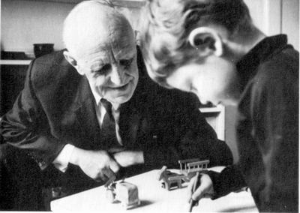
Figure 1 - Winnicott and Child Client
The Draw a story method is to encourage patients to draw a variety of drawings. Once they are done the patient has to then pick two of the drawings they created of their choice. To then create a story about the ones they have chosen. The therapist would then encourage them to go into detail and understand further meaning behind their words. Based on their description, the therapist would refer to a criteria sheet to be assessed. It is not about the ability it’s about the narrative content (Silver, 2005).
The Birds Nest Drawing was by Donna Kaiser who used Bowlby’s attachment theory to develop it. The Birds Nest Drawing is a method that is particularly suited for children to further find out about their family environment. This exercise would ask the client to draw a bird’s nest, which would be an unconscious metaphor of their family life. It looks at their home life is secure, and the nature of the clients attachment and lets the client communicate in a non-threatening way. This is a good way to get the child to communicate, as this is a sensitive topic (Kaiser, 2009).
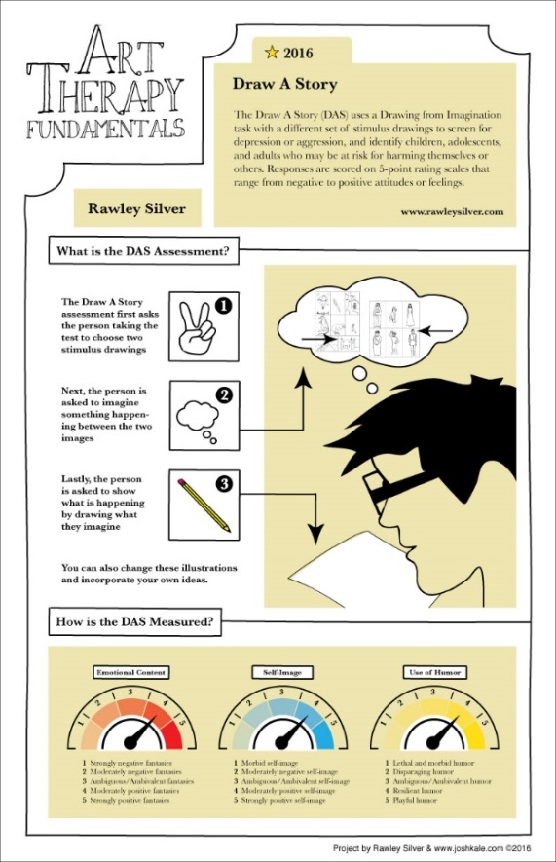

Figure 2 - Draw A Story Assessment w/Rawley Silver

Looking through these different approaches ‘The Squiggle Game’ encourages the patient to engage, the end product isn’t important part of the therapy, it is the process of creating the art. Compared to ‘Draw-A-Story’ and the ‘Birds Nest Drawing’ those get assessed and analysed based on the content produced and the meaning behind the end result.

Chapter 3 - How Art Therapy Can Be Utilised
Children are able to naturally create images as it is something that is not necessarily learnt, they just put pen to paper. In contrast, writing is something they have to learn (when children are normally learning to write they are often corrected if grammar is incorrect).
In the early years of schooling, children are constantly encouraged to produce images, and to illustrate their written work. Teachers comment on these illustrations, as much as they do on the written part of the text, though perhaps not quite in the same vein; unlike writing, illustrations are not ‘corrected’ or subjected to detailed criticism (‘this needs more work’, ‘not clear’, ‘poor expression’, and so on). They are seen as self-expression, rather than as communication: as something which the children can do already, spontaneously, rather than as something they have to be taught (Leeuwen, 1996, p. 15).
They may be advised on how to further improve the drawing, if at all. Children’s art is seen as creative self-expression rather than strictly a form of communication.
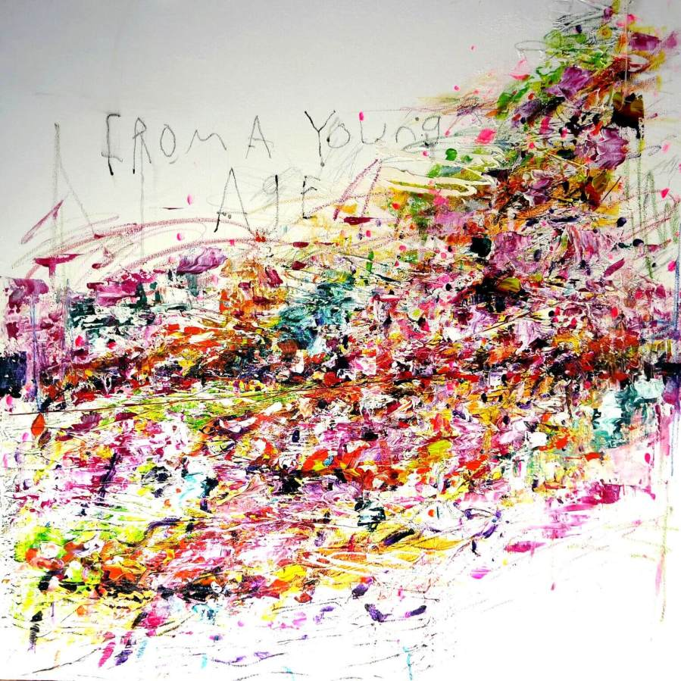
Figure 3 - Dale vN Marshall’s latest exhibition, I am not a child
Dale Vn Marshal is an artist who has produced and created art, raising awareness in order to reduce stigma around mental health, from his own experiences as well as other young people’s experiences by putting on workshops and having conversations with the young people who deal with mental health such as anxiety, ADHD and trauma. From all the shared experiences he was able to put together art pieces and do an exhibition called ‘I am not a child’. Through the pieces it shares more understanding around mental health and continues to spread awareness (Fringe, 2016) (Kuma, 2017).

Although raising awareness through art and exhibitions helps to reduce stigma and improve knowledge, there is also another form in which that can be done through children’s books. In recent times, children’s book Illustrators have created more awareness around topics such as mental health, which helps put in place the reduction in stigma. It helps to create more knowledge and understanding for children as well as young people. It helps them process these types of feelings when they sometimes don’t understand why they often feel that way (Global, 2018).
In children’s books when they are reading or listening to the children’s book being read and following along, words are sometimes not enough to grasp the children’s understanding. However, words alongside illustrations, helps them to understand more visually. Therefore children’s illustrations are a good form of communication. There are many children’s book illustrators who address these types of topics such as, Michael Rosen, Shaun Tan and Katie Green.
Michael Rosen (1946-) is a children’s book author. One of the books he has written titled ‘Sad Book’ which expresses themes about grief. This book is autobiographical as it’s based from his own personal experience when he lost his son. Illustrated by Quentin Blake, the illustrations that go alongside the writing make the meaning behind the book more powerful. It engages the readers, helps them understand the raw feelings it expresses. Rosen speaking of the illustrations Quentin Blake created says:
I wrote it at a moment of extreme feeling and it went straight down onto the page … Quentin didn’t Illustrate it, he ‘realized it’. He turned the text into a book and as a result showed me back to myself. No writer could ask and get more than that. (Rosen, n.d.)
Children’s illustration books are important as the image really communicates with them when they don’t understand words and the meaning behind them. They would be able to relate and understand how the illustration represents itself. It helps them understand more difficult feelings and that it’s normal to feel that way. There are times when illustrations express feelings when words can’t.

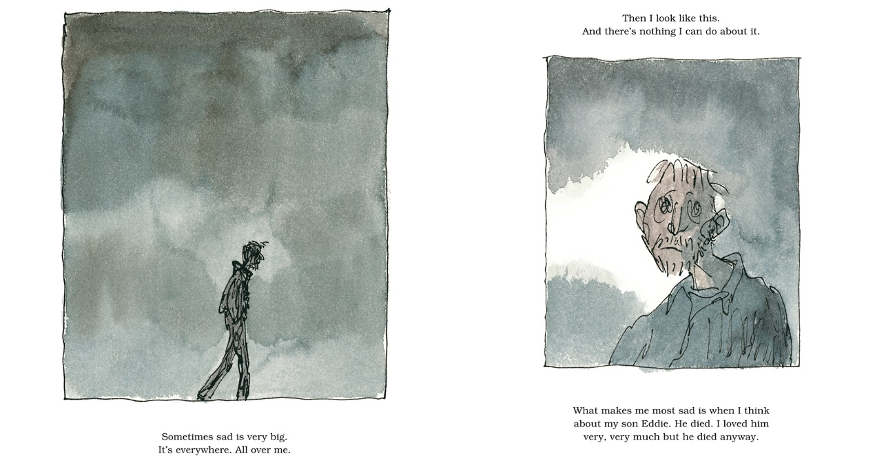Figure 4: Illustrations from Michael Rosen’s Sad Book

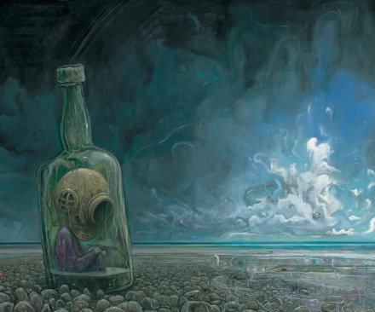
Figure 5: "Nobody Understands" by Shaun Tan from The Red Tree. Oil, acrylic, and wax on paper.
Shaun Tan’s (1974-) book ‘The Red Tree’ is about a girl who remains nameless throughout. When reading the book, you can experience the story from her perspective. Throughout the book you are increasingly aware of her isolation and how intense, dysmorphic and unsettling it is. The weight of her problems becomes apparent very quickly. The imagery reflects on her as she continues to push through and continue with day to day life, despite how over bearing her feelings may be. The illustrations would allow children to translate and understand how uncomfortable feelings can be and that it is okay to feel this way (Holdencaulfeildcampion, 2014).
‘Lighter than My Shadow’ by Katie Green (1983-) is a graphic novel which is aimed at an older audience mainly adolescents. It touches upon the topics of eating disorders, anxiety and trauma of sexual abuse. It is suggested many artists are saved by their art. It is a memoir of Greens own experiences growing up through childhood all the way to adulthood. Showing the characters experience of being a young child who is a picky eater and how it develops into an eating disorder, OCD, anxiety and depression. The books illustrations show her experiences of trauma through gripping imagery throughout the novel. You see the character go through different experiences and through the imagery. Dark grey tones are used as the character goes through her journey and struggles trying to overcome her mental health and trauma. As she gets older and begins to heal the illustration tones become lighter tones of grey till eventually they are white which gives a lighter happier mood. This shows throughout the novel how the colour begins to change it shows how the character is not letting her mental health and taking control (Smart, 2013).
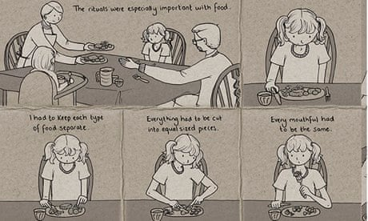
Figure 6: Detail from Katie Green's Lighter Than My Shadow
In children’s books there are more connections between children’s mental health, children’s authors and illustrators. There has been a number of studies surrounding Winnie the Pooh, analysing each of the characters surrounding psychological disorders. Following the DSM which is the diagnostic criteria that professionals use to diagnose patients. The main study was conducted by Sarah E. Shea and her team of paediatricians, who had written a paper analysing each of the characters. In the paper they summarise each of the characters and speaking about them as if they were to be diagnosed following the DSM.
The stories that are created, although not specifically about mental health, they do outline many mental health issues through forms of illustration. The topic of mental health is expressed through the characters thoughts, feelings and behaviours. None of the characters in the novels are expressed as diagnosed with mental health, although many personality traits can highlight symptoms.
How the characters interact reduces stigma as, despite all their indifferent quirks and personality traits, they accept one another for who they are and help each other in times of need. It teaches children and young people that we are all different and that’s okay despite our indifferences.
The paper suggested that each of the characters may demonstrate different types of mental health conditions. For example following these guidelines Winnie the Pooh would have ADD characteristics as well as, OCD, and binge eating as his behaviours would suggest throughout the story. Piglet would potentially have generalised anxiety disorder as you can see he is often worried and distressed. The article suggests that Eeyore may be diagnosed with Dysthymic disorder (a form of depression), Rabbit’s symptoms was described as OCD as he is constantly distressed when the other characters make mess and accidently ruin his garden as things are out of place for example. According to Smith (2015) Tigger behaviours come under the criteria of ADHD (Shea, 2000) (Smith, 2015).
Through looking at various children’s books, they each give different examples of mental health such as grief, depression, eating disorders, trauma and anxiety. These children’s books show the raw emotions that come along with these topics and circumstances. The illustrations really helps to communicate with the children, the imagery can express more than words can ever say. Nicks Sousanis scholar and cartoonist says; ‘’the visual provides expression where words fail’’. Sousanis (2015) talks about how image is an important tool, how words and images link together. Illustration books could be considered to be a useful tool for children dealing with complex emotions as well as mental health. It reduces stigmatisation by creating a conversation, raising awareness and encouraging children to share their own experiences with others- not alone.
Conclusion
From looking at the evidence, it is clear to see the benefits of Art Therapy as a whole. Art Therapy can help individuals of all ages deal with their emotions, help them work through the issues and further understand these feelings. When looking at art therapy specifically for children, Art Therapy has very good benefits. Art allows the children to work through difficult topics that they struggle to talk about, gently and at their own pace. This allows them to feel that they are in a safe place and gives them a way to express themselves in a confidential manner. In a therapy setting like this the child is able to build a relationship with their therapist and build a trust, which will encourage further benefit to their therapy session. Evidence shows that Art Therapy should be used more within schools and the health care system. Art therapy has a lot of potential and many benefits and should be considered as a therapy treatment. Some of the reasons for this is children naturally respond to images, engage with it and produce art. The approach to this essay was to focus more on the method of art making rather than how the end product turns out. From analysing all the different theorists and techniques, you can see there is a lot of potential and benefits for children to produce more art in a therapy setting. In certain instances, it may be necessary to further analyse art produced, but the therapeutic benefits for creating art should not be overlooked. Looking at different theorists and the different approaches to art therapy, Kramer’s approach was the one that applied most appropriately because creating the art is what the therapy is about. It focuses more on the process of making art as the therapy itself, in comparison to having the finished piece of art analysed. Also reflecting on Jung’s theory which shows the connection between the unconscious mind and creating art particularly from an art therapy stand point. It helps patients become more self-aware of their feelings and feel more connected with their mental health. From researching theorists, it was also important to consider different methods, each of the ones that was looked at were all creative, which shows that each have their own strengths. The elements of creating art is important for children and communicating their feelings and even just expressing themselves creatively. As discussed previously for those artists that are aware or have personal experience with mental health, it is important for them to put work out into the world as it starts conversations, which is a good example for children and shows them that it is okay to talk about mental health and difficult feelings, which allows children to be more empathetic with one another. Although children’s books are technically not art therapy, they are still very therapeutic for young children as they could be expressing the same feelings as what the book represents, which could be therapeutic to the individual. It can comfort them, even maybe help them ease how intense the feelings are knowing they are not alone. However, for the illustrator and author who have produced these books, it may be a form of art therapy, especially when creating the art and going through the process of producing the book. The illustrator and author are able to use this as a form of getting their emotions out, which is healthy and beneficial for individuals mental health. From looking at everything overall, in the essay there are parallels that stood out, which connect to my own practice. Focusing on Art Therapy in my illustration work, I create art which enforces on topics such as anxiety and depression, as well as grief which relate to the following children’s Illustration books that have been discussed previously; such as ‘The Red Tree’ and ‘Sad Book’. The illustrations produced are used as a form of therapy as well as to reduce the stigma surrounding it. 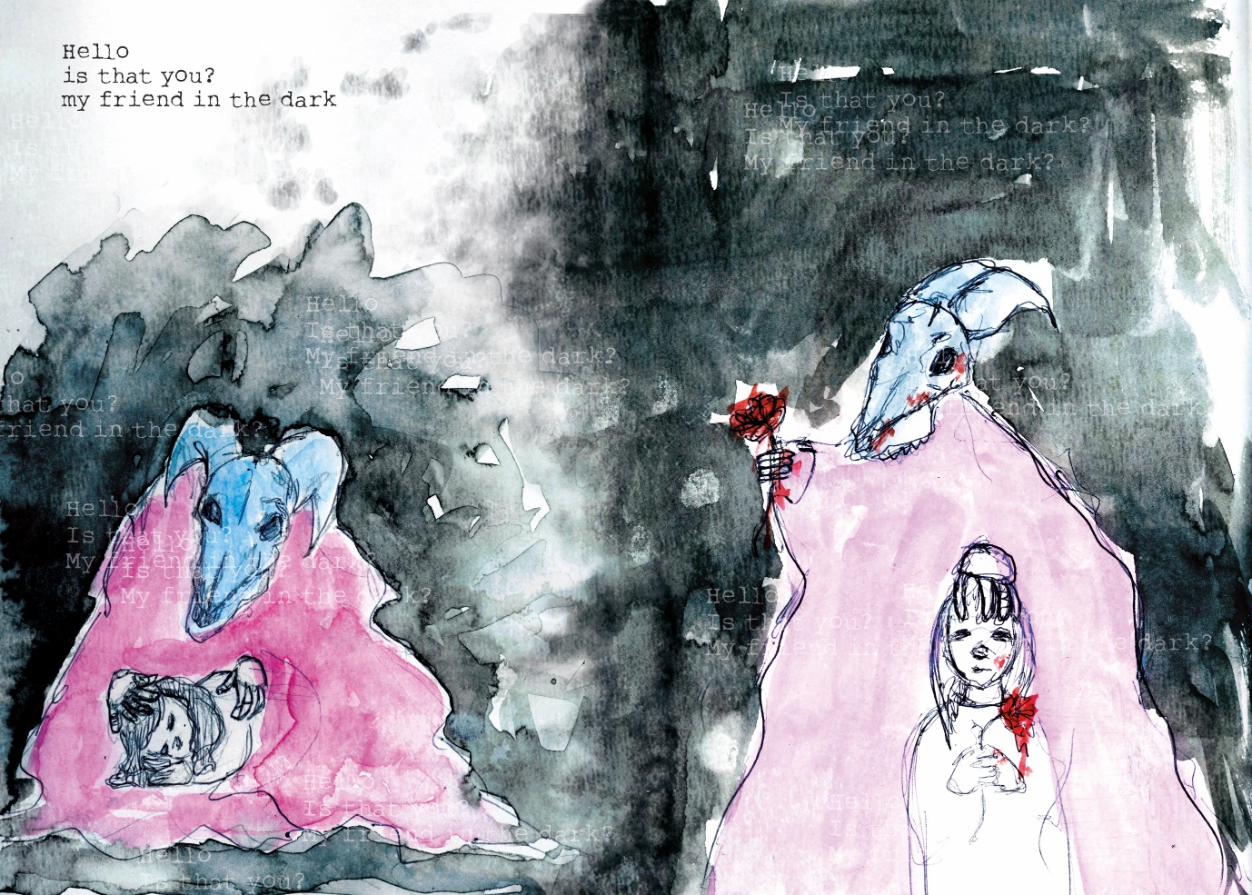
Figure 8: Jade Harris ‘Hello, is that you, my friend in the dark’
The poem accompanying the illustration above was made into a small graphic novel book ‘My Friend in the Dark’. It is about mental health and is written in such a way that the writing and the images work together so the reader interprets for themselves and can relate to their current feelings, or experiences and mental health.
Illustration books are for everyone from children to adults of all ages, art can speak a thousand words, that words can never express. Children’s illustration books are not just for those who have mental health issues, it’s for all. This is how the awareness around mental health would be raised and stigma around mental health would be reduced. It will allow children to openly talk about their difficult feelings as well as create art as a form of therapy.

Bibliography

Books
Anderson, F. E. (1980). Art Therapy: Myths and Realities. Art Education , 20.
Edwards, D. (2014). Art Therapy. London: Sage.
Leeuwen, G. K. (1996). Reading Images: The Grammar of Visual Design . London: Routledge .
Krammer, E. (2000). Art as Therapy: Collected Papers. London: Jessica Kingsley Publishers .
Miller, J. C. (2004). The Transcendent Function. New York : State University Of New York Press.
Naumburg, M. (1966). Dynamically Oriented Art Therapy: Its Princibles and Practices . New York : Grune & Stratton .
Sangeeta Prasad, P. H. (2013). Using Art Therapy with Diverse Populations: Crossing Cultures and Abilities. London: Jessica Kingsley Publications .
Silver, R. (2005). Aggression and Depression Assessed Through Art: Using Draw-A-Story to Identify Children and Adolescents at Risk. New York: Brunner-Routledge.
Sousanis, N. (2015). Unflattening . Canada: First Printing .
Winnicott, D. W. (2005). Playing and Reality . New York: Tavistock Publications Ltd.

Journals
D'Amello, P. D.-S. (2000). How Art Teachers Can Enhance Artmaking as a Therapeutic Experience: Art Therapy and Art Education . Art Education , 46-53.
Eisdell, N. (2005). A Conversational Model of Art Therapy . Psychology and Psychotherapy: Theory, Research and Practice, 1-19.
Mansooreh Rahmania, B. B. (2016). Integrating effect of art and music therapy on depression in adolescents. Journal of Educational Sciences, 78-87.
Shea, S. E. (2000). Pathology in the Hundred Acre Wood: a neurodevelopmental perspective on A.A. Milne. Canadian Medical Association , 1557-1559.
Smith, R. C. (2015). Winnie the Pooh Characters and Psychological Disorders. Indiana: Ball State University .
Therapists, B. A. (N.D.). Career Information. Retrieved from British Association of Art Therapists:
Tripathi, K. D. (2014). Art Therapy: A creative and expressive process . Indian Journal of Positive Psychology , 81-85.
Websites
Bitonte, R.A. (2014). Art Therapy: An underutilized, yet Effective Tool. Retrieved from PMC: https://www.ncbi.nlm.nih.gov/pmc/articles/pmc4253394
Bohan, H. (2017, Febuary 6). Co-producing good mental health with young people. Retrieved from Mental Health Foundation: https://www.mentalhealth.org.uk/blog/co-producing-good-mental-health-young-people (Accessed: 18th December 2018)
Brown, A. D. (2012, Febuary 28). Psychological Benefits of Art Therapy. Retrieved from Counselling Connect: https://www.ccpa-accp.ca/psychological-benefits-of-art-therapy/ (Accessed: 18th December 2018)
Brown, A. D. (n.d.). PSYCHOLOGICAL BENEFITS OF ART THERAPY. Retrieved from Councelling Collects: https://www.ccpa-accp.ca/psychological-benefits-of-art-therapy/ (Accessed: 18th December 2018)
Donnelly, L. (2017, January 22). Mental health crisis among children as selfie culture sees cases of anxiety rise by 42 per cent in five years, NHS figures show. Retrieved from Telegraph : https://www.telegraph.co.uk/health-fitness/mind/mental-health-crisis-among-children-selfie-culture-sees-cases/ (Accessed: 18th December 2018)
Fringe, T. S. (2016). The Sick Of The Fringe. Retrieved from http://thesickofthefringe.com/diagnoses/i-am-not-a-child (Accessed: 18th December 2018)
Global, T. (2018, August 13). 19 Must-Read Books to Help Kids Understand Their Emotional and Mental Health . Retrieved from Thrive : https://thriveglobal.com/stories/19-must-read-books-to-help-kids-understand-their-emotional-and-mental-health/ (Accessed: 18th December 2018)
Holdencaulfeildcampion. (2014, July 24). Shaun Tan’s ‘The Red Tree’ A picture book focussing on depression in children. Retrieved from LightLit : https://lightlit.wordpress.com/2014/07/24/shaun-tans-the-red-tree/ (Accessed: 18th December 2018)
Journal, A. T. (2018). How Art Therapy Can Help Children. Retrieved from arttherapyjournal.org: http://www.arttherapyjournal.org/art-therapy-for-children.html (Accessed: 18th December 2018)
Kaiser, D. H. (2009). Assessing Attachment with the Bird’s Nest Drawing:. Art Therapy: Journal of the American Art Therapy Association, 26-33. (Accessed: 18th December 2018)
Kuma. (2017, March 13). Kumanation. Retrieved from http://kumanation.com/stories/mental-health-awareness-using-art/ (Accessed: 18th December 2018)
Malchiodi, C. (2014, February 24). Edith Kramer: Art (Therapy) Tells the Truth . Retrieved from Psychology Today: https://www.psychologytoday.com/gb/blog/arts-and-health/201402/edith-kramer-art-therapy-tells-the-truth (Accessed: 18th December 2018)
Malchiodi, C. (2016, January 31). Child Art Therapy: How It Works . Retrieved from Psychology Today: https://www.psychologytoday.com/gb/blog/arts-and-health/201601/child-art-therapy-how-it-works (Accessed: 18th December 2018)
Mental Health Foundation. (2017, February 6th). Co-Producing Good Mental Health in Young People. Retrieved from Mental Health Foundation: https://www.mentalhealth.org.uk/blog/co-producing-good-mental-health-young-people (Accessed: 18th December 2018)
MentalHealthFoundation. (2018). Children and Young People. Retrieved from Mental Health Foundation: https://www.mentalhealth.org.uk/a-to-z/c/children-and-young-people (Accessed: 18th December 2018)
Rosen, M. (n.d.). Michael Rosen's Sad Book. Retrieved from Walker Books: http://www.walker.co.uk/Michael-Rosen-s-Sad-Book-9781406317848.aspx (Accessed: 18th December 2018)
scrapbook.com. (2018). Art Therapy Benefits and History . Retrieved from scrapbook.com: https://www.scrapbook.com/articles/art-therapy (Accessed: 18th December 2018)
Smart, J. (2013, November 8). Lighter Than My Shadow by Katie Green – review. Retrieved from The Guardian : https://www.theguardian.com/books/2013/nov/08/lighter-than-my-shadow-katie-green-review (Accessed: 18th December 2018)
Young Minds. (2018). Mental Health Statistics. Retrieved from YoungMinds: https://youngminds.org.uk/about-us/media-centre/mental-health-stats/?gclid=EAIaIQobChMIwJKDrNqA3gIVCrHtCh2dGQxnEAAYASAAEgI6QPD_BwE

