Conrod dynamic forces report
9th DECEMBER 2019
Module: Analytical Methods with Study Skills Module Code: M4X02193
Jonathan Bennett (1807541)
2019
Contents
Abstract 2
List of Figures 3
Figure 1 and 2 3
Table 1 3
Figure 3 3
Figure 4 3
Figure 5 3
1. Introduction 4
2. Background 5
2.1 Materials 5
3. Methodology 7
4. Analysis of Results 8
4.1 Table of Data 8
4.2 Analysis of Graphs 9
5. Conclusion 12
References 13

Abstract

This report highlights the operations of a Connecting Rod and the functions it must perform whilst experiencing the forces and stresses of a running engine. The engine model used in the practical assessment is a 2000 Ford Zetec.
The materials and components used to make the con rod and its construction will be analysed in detail and an evaluation will determine how different engine speeds influence the forces applied and how the parts endure the stresses.
Whatever you write as the last part of your conclusions but shortened and slightly reworded. (highlighted red for you to see where)

List of Figures
Figure 1 and 2: Measuring the centre point of the conrod. Bennett, 2019.
Table 1: A table of data accumulated during the practical assessment of the components
Figure 3: Graph illustrating the highest and lowest points the conrod travels over a period of time. Bennett, 2019
Figure 4: Graph illustrating velocity measuring metres per second over a given time period. Bennett, 2019
Figure 5: Graph illustrating the acceleration and forces over a given time period. Bennett, 2019

1. Introduction
This report illustrates the operations of a Connecting Rod (also known as a con rod) and the functions it must perform whilst experiencing the forces and stresses of a running engine. The engine model is a 2000 Ford Zetec (blacktop/ph3) produced by Ford in Bridgend, Wales, UK.
The materials and components used to make the con rod and its construction will be analysed in detail, in conjunction with the weight of the piston and its gudgeon pin and the crank radius. Further evaluation will determine how different engine speeds influence the forces applied and how the parts endure the stresses.
Any measurements needed for the report that cannot be obtained through physical inspection are to be sourced from Haynes workshop manuals, relevant websites or archives
It is expected that the data input from measuring and weighing the Conrod and piston, when used with a variance of engine speeds will show calculated data supporting the stress of forces acting on the Conrod. This should make evident why the Conrod is constructed this way and how it is able to resist the forces it is subjected to
The data will be coalesced into a graph in Excel which will present how the velocity, forces, acceleration and distance the conrod will travel.

2. Background
The Conrod is a key component in the reciprocating internal combustion engine. It converts a lateral movement into a reciprocating movement where the piston moves up and down the cylinder (Builders, 2016). It is the Conrod’s job to transmit the energy from the piston to the crankshaft (Nasa, 2019).
As the piston is forced down the cylinder the conrod will rotate on the crankshaft and the movement is skewed and linier (Instruments, 2019). In context this means the conrod is subjected to a bending force that can cause it to fracture at its most severe angle (Instruments, 2019).
Construction of the conrod is crucial to its functioning under such stresses and in most cases it is made from steel with a particular casting to provide a good tensile strength and durability (Education, 2010).
The movement of a connecting rod within a running engine is complicated as the smaller end is reciprocating whilst the bigger end rotates and the rod moves along a plane( (Myagkov, 2014). Concurrently, the intricate connecting rod forcing situation includes two parts; a gas explosion and reciprocating piston inertia (Myagkov, 2014). The inertia of the rod itself is relatively small but does include reciprocating inertial force, centrifugal force, and lateral bending moment (Liu, 2019).
When referring to the structural longevity of the Conrod, stiffness, fatigue and strength are crucial factors to obtain reliability and long-lasting components (Waseem, 2013).
The conrod is at the core of any car engine and must undergo rigorous alternating loads in not only lateral movement but in a reciprocating and rotating motion (R.C. McCune, 2001). A weak or damaged Conrod will cause the entire engine to fail and approximately 60-90% of all Conrod failures are caused by fatigue (Builders, 2016).

2.1 Materials
Steel is the most common used metal for the construction of a conrod. While it offers strong and long-lasting results it is not always the most suitable construction, most notably in the motorsport sector (Education, 2010).
As the load increases on the conrod during its oscillating around the turn of the crank shaft the chances of bending and fracture also increase. This bending is the most common failure point of any rod, rather than the compression of the rod itself (Waseem, 2013)
The compressive forces are often great. If the engine is tuned or simply doesn’t have strong enough conrods to the point the compressive and tensile forces are now exceeding that of which the rods are rated for, the rod will be under a larger great stress and at risk of fracture on each rise and fall of the conrod (Myagkov, 2014)
As the conrod begins the compression stroke the combustion process can sometimes happen slightly before the piston has achieved top dead centre. This is referred to as ignition advancing, as allowing tuners to reach a full chamber shock wave by the time the piston is fully at TDC, rather than waiting for the combustion to shock wave as the piston is already moving back down the stroke cycle (R.C. McCune, 2001).
The problem this presents is that the piston is still climbing the cylinder and suddenly the combustion has taken place and is in full swing before the piston. This means that the conrod has stopped moving, resulting in great forces compressing the conrod (Instruments, 2019).
A method of resisting this compressive force is by either changing the material used to construct the conrod, or by using alternative construction methods to make the existing steel design (Instruments, 2019)
.
Shot peening is a reliable method where metal ball bearings are fired in high pressure at the conrod during the later stages of the construction process (chris@highpowermedia.com, 2010). This compacts the steel and makes it incredibly strong (chris@highpowermedia.com, 2010). It also allows less steel to be used to construct a conrod, which transpires that the same levels of strength as if it was made of more steel but be a fraction of the weight is achievable. Something which is an important feature when trying to lower engine rotational mass, or making a car lighter (chris@highpowermedia.com, 2010).
You Can also change the materials used to aluminium or titanium. Titanium being the stronger of the of the 3 options, also lighter than steel but at a very high cost (Education, 2010).
However, for the best light weight option aluminium is the choice of many tuners, including drag racers but the cost is substantially more and the life span is too short for a road car (R.C. McCune, 2001).

3. Methodology
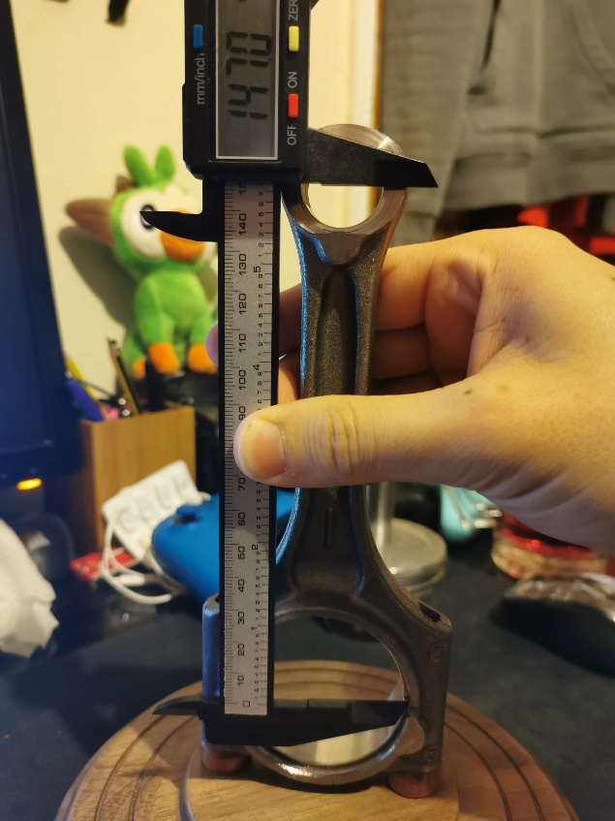
First an engine will be chosen; in this case a 2000 Ford Focus sourced 2.0 Zetec engine. The final iteration, the phase 3 “blacktop”.
Next the engine will be taken apart and its crank shaft removed. The pistons along with the connecting rods can then be pulled out from the cylinders through the bottom of the engine. Following this the crank shaft is removed and the circlip holding the gudgeon pin inside the piston and conrod small end will be removed allowing the pin to slide out from its position, allowing the rod and the piston to be separated.
From here a Digital calliper is used to measure the centre point in the big end opening of the con rod to the small end centre. This defines the con rod length. This data is recorded and input into excel to formulate graphs illustrated by Table 1 and Figures 3, 4 and 5.
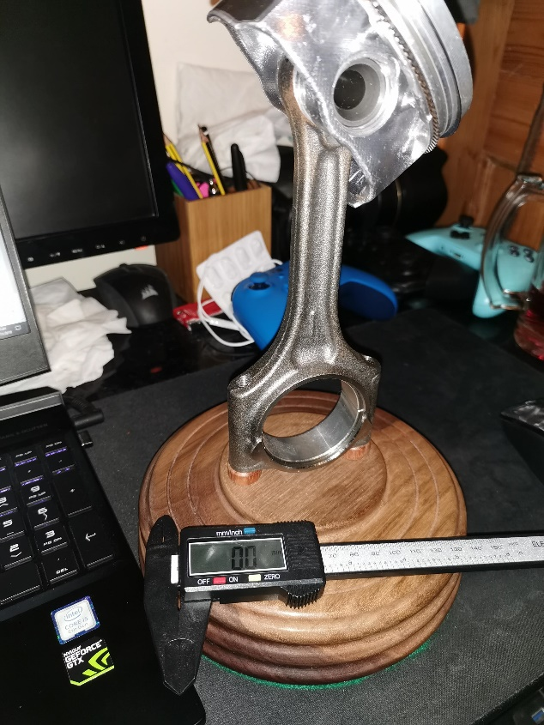
(Figure 1 and 2: Measuring the centre point of the conrod. Bennett, 2019.)
The Crank Radius was measured using a meter rule due to its larger size. Taking measurements from the cranks centre point and the centreline of where the conrod connects enables us to calculate the radius of the crank. This can be demonstrated by placing the crank on a sheet of paper and drawing straight lines along the big end centre line to the end of the crank using straight edges for reference and this then formulates the crank radius.

4. Analysis of Results

4.1 Table of Data
Crank Radius (mm) | 120 | mm
Conrod Length (mm) | 147 | mm
RPM | 1500 | rpm | ω | 157.0796
Compute Time Interval | 0.0002
Mass of Piston/gudgeon pin etc (kg) | 0.31 |  |  | Max tensile force on rod |  |  |  | 1665.766
Time (s) |  | 0 | 0.0002 | 0.0004 | 0.0006 | 0.0008 | 0.001 | 0.0012
Crank Angle (radians) |  | 0 | 0.031416 | 0.062832 | 0.094248 | 0.125664 | 0.157079633 | 0.188496
Crank Angle (degrees) |  | 0 | 1.8 | 3.6 | 5.4 | 7.2 | 9 | 10.8
Distance X |  | 0 | 3.769291 | 7.534862 | 11.293 | 15.03999 | 18.7721358 | 22.48576
inv sine phi |  | 0 | 0.025641 | 0.051258 | 0.076823 | 0.102313 | 0.127701604 | 0.152964
phi (radians) |  | 0 | 0.025644 | 0.05128 | 0.076899 | 0.102492 | 0.128051263 | 0.153567
Height (dist between top of conrod and crankshaft) |  | 267 | 266.8925 | 266.57 | 266.033 | 265.2823 | 264.319058 | 263.1445
Velocity mm/s |  | -537.729 | -1612.42 | -2684.79 | -3753.32 | -4816.45 | -5872.633369 | -6920.31
Velocity m/s |  | -0.53773 | -1.61242 | -2.68479 | -3.75332 | -4.81645 | -5.872633369 | -6.92031
Acceleration |  | -5373.44 | -5361.89 | -5342.63 | -5315.65 | -5280.92 | -5238.400191 | -5188.07
Force |  | -1665.77 | -1662.19 | -1656.22 | -1647.85 | -1637.08 | -1623.904059 | -1608.3
Below is the excel entries of the collected data to produce Table 1 and then Figures 3, 4 and 5.
(Table 1: A table of data accumulated during the practical assessment of the components)

The engine can rev to a maximum of 6800rpm and this is where the engine is prevented from accelerating any faster due to an electronic cut off limiter provided by the engine control unit (Ford Mondeo service and repair manual, 2003, p.2A.5).
For this example, the engine is now revving at 6500rpm and the results are vastly different to before. The engine speed has now brought many more factors into the conrods movement cycle.
4.2 Analysis of Graphs
When functioning at a lower rpm of 1500 the engine is moving at a lower rate and the conrod is considerably slower to run its cycle. The piston is travelling up and down the cylinder at a notably lower velocity where the piston and conrod are under far less stress and force.

(Figure 3: Graph illustrating the highest and lowest points the conrod travels over a period of time. Bennett, 2019).
The graph curve is far apart and at a gradual gradient which expresses how the engine is moving slowly. The time between the peaks in the graph can be evaluated in order to establish just how slow the engine is moving. At this reduced speed the engine is under relatively low stress and is more than capable of the forces acting on the conrod. However, as the speed rises the forces are amplified by roughly two times on the acceleration and forces graph (Figure 5).
(Figure 4: Graph illustrating velocity measuring metres per second over a given time
period. Bennett, 2019).
The stresses on the conrod and its oscillating speed means minimum and maximum forces are now lasting for a reduced time at both ends of the rod’s movements. The escalation and decline of the forces are happening rapidly which is illustrated in the steepness of the curve on the graph. The engines speed is depicted as going from 17 on the 1500rpm to 115 on the velocity graph with a reduction in the overall time.
The conrod is going through drastic changes each millisecond, expressing high levels of tensile and compression forces.
(Figure 5: Graph illustrating the acceleration and forces over a given time period. Bennett, 2019).
The double dip found on the Acceleration and Forces graph indicates the effort needed to expel the exhaust gasses out of the engine and that another cylinder will be firing at the same time.

5. Conclusion
Conclusively, the velocity of the engine increases the forces the conrod is subjected to and in a relative quantity. The more power needed from the engine, the quicker the pistons operate and the conrods along with.
In order to withstand these forces a strong and durable metal is used and with a construction that is complementary of that metal, such as H section rod, or I beam construction, these designs will ensure long lasting service and a far lower failure rate.
In the case of a high performance engine, further strengthening is required, such as titanium rods, or via the shot peening method for steel rods. Higher performance engines can not only exert more force from its combustion cycle but can also run at far higher speeds which is far more demanding on the Conrod and its design.
The assessment of this exercise points out the importance of using the right metal and construction to form the conrod, that using subpar methods and materials will only cause a premature failure of the engine.
The stresses and forces applied to the conrod are constantly testing the component and it’s this fatigue that warrants the extensive costs of the part, an example of its cost is, PEC an aftermarket Conrod constructor supply a set of 4 conrods for this particular engine at a price of £428.51 (RetroFord, 2017)

References
Builders, G. T. (2016, December 14). Inspecting & Measuring the Pistons, Pins & Connecting Rods. Retrieved from Goodson: https://goodson.com/blogs/goodson-gazette/inspecting-measuring-the-pistons-pins-connecting-rods
chris@highpowermedia.com. (2010, january 21). Con Rods: Application of Shot-peening. Retrieved from High Power Media : https://www.highpowermedia.com/Archive/con-rods-application-of-shot-peening
Education, A. S. (2010). SELECTION OF MATERIAL, SHAPE, AND MANUFACTURING PROCESS FOR A CONNECTING ROD. Retrieved from selection-of-material-shape-and-manufacturing-process-for-a-connecting-rod.pdf
Gibson, J. (2012, January). PERFORMANCE PERSPECTIVES: CONNECTING ROD INSPECTION. Retrieved from MOTOR: https://www.motor.com/magazine-summary/performance-perspectives-connecting-rod-inspection/
Instruments, N. (2019). Developing an Engine Connecting Rod Fatigue Test System Based on CompactRIO. Retrieved from National Instruments: https://www.ni.com/en-gb/innovations/case-studies/19/developing-an-engine-connecting-rod-fatigue-test-system.html
Myagkov, L. (2014). Engine Connecting Rod. Retrieved from Science Direct: https://www.sciencedirect.com/topics/engineering/engine-connecting-rod
Nasa. (2019). Bore and Stroke. Retrieved from Nasa: https://www.grc.nasa.gov/WWW/k-12/airplane/stroke.html [
R.C. McCune, G. W. (2001). Learn more about Connecting Rods. Retrieved from Science Direct: https://www.sciencedirect.com/topics/engineering/connecting-rods
RetroFord. (2017). Retroford. Retrieved from RetroFord: http://www.retro-ford.co.uk/shop/content/ford-zetec-black-top-20-16v-h-beam-pec-steel-connecting-rod-set-pr001
Waseem, M. (2013, NOVEMBER 1). manufacturing of connecting rod. Retrieved from LinkedIn: https://www.slideshare.net/sheema9/group-3-1

