- National Pride

At the beginning of my Masters’ studies I was trying to find my place in life, as a foreigner and future bride to a Welshman. In order to find stability my practice and research turned to something already known, namely being Polish – my language, culture, upbringing. That meant my work and writing would become very personal, as I would use my own life experience to understand my new roles in the society. This was the moment when I turned to autoethnography, as it recognises intricate link between personal and cultural voice in social research, while taking inspiration from our experiences and allowing non-traditional forms of research and expression (Wall, 2006). I decided to talk about my life, culture and heritage, because that is always that has always inspired my creative work and at the time of exploring my praxis I was already attempting mixing the Polish and Welsh cultures and traditions in order to create a perfect wedding. It was quite stressful time and using my heritage as creative inspiration has helped me process the events around me and settle in my new role. During this process, I decided to invent words that I believe give a better description of my current identity, Slaveltic (Slav- from Slavic, -eltic from Celtic) or Polkymraes (Polk- from Polka – in Polish: Polish woman, -ymraes from Cymraes – in Welsh: Welshwoman).
One of the inspirations to pursue this path was also Foucault’s definition of the “arts of existence” or “techniques of the self” as premeditated and independent actions taken by us in order to set the rules of our behaviour and to undergo a change of our singular being in a way that makes our life a work of art carrying “certain aesthetic values” (Foucault, 1988). Since moving to Wales I have been trying to balance the Polish-Welsh identity in my life that on the number of occasions turned out to be difficult due to the different behaviours expected in these countries on a daily basis, as every day I would feel I was not Polish or Welsh enough and lost within both societies. This daily struggle became a part of my self-analysis both in mind and practice and was a beginning point of finding the own, individual true self.
Peter Finnemore in his interview revealed he believes most powerful images are of the subject matter that is most familiar to the author (Finnemore, 2011). The family, house and garden, something most familiar to him, are the key of his snapshots. Finnemore tries to portray the relatives’ identity and their other identities enacting various scenarios by using the history of his family. He lives in a house that is about 150 years old and it contains memories, history of his family. Living in a house that is about 150 years old he tries to show the absence and presence. For example, he uses clothes of a deceased member of his family and hanging them to show the absence of that person in his life. Portrait of his grandma shown in the interview includes various clothes to show the progress of life and a few walking sticks to show hardships.

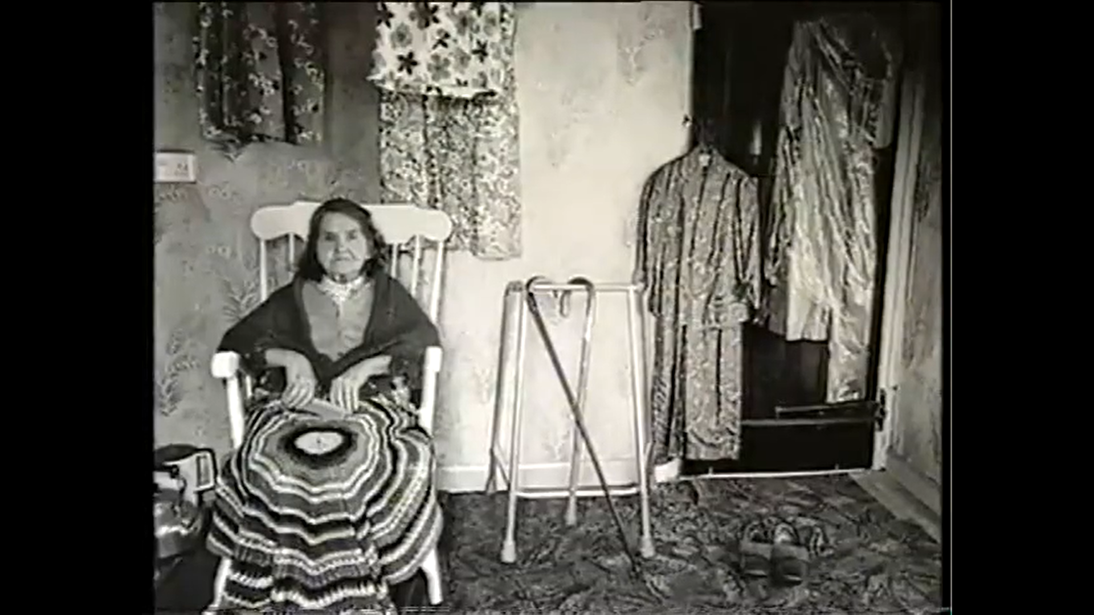
Figure 1. Snapshot from the interview with Finnemore, P. (2011) Peter Finnemore - Interview. Available at: https://vimeo.com/23031156, originally broadcast in 2000 for Gwendraeth House Catalogue, Ffotogallery, Cardiff, Wales.
Finnemore’s practice was an inspiration to investigate my own heritage in more detail. Coming from a military family I decided to look more into that story. My great-grandfathers from both sides and great-grandmother have fought for Polish independence while serving in Home Army. Home Army was an underground arm, the main Polish resistance movement in Poland during World War II while occupied by Nazi Germany and the Soviet Union (Encyklopedia PWN, 2014; Ney-Krwawicz, 2020). The Army evolved from Union of Armed Combat (Polish – Związek Walki Zbrojnej) and was loyal to the Polish government-in-exile, constituting the armed wing of Polish Underground State (Ney-Krwawicz, 2020).
My maternal great-grandfather was the commander of the Home Army platoon in Gałęzice of region Kielce, and my great-grandmother was a paramedic and caregiver for the sick, cooking their meals and feeding them. She was also a liaison, bringing reports and underground press to other villages. My paternal great-grandfather fought Schleswig-Holstein at Westerplatte. Schleswig-Holstein began the World War II by bombarding the Polish base at Westerplatte in the early morning hours of 1 September 1939 (Williamson, 2012:06).
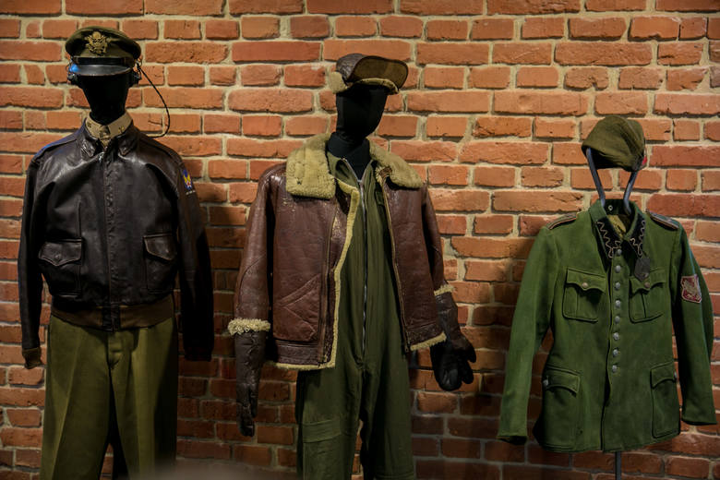
Figure 2. Home Army uniform. Source: Home Army Museum in Kraków, Poland.
Not only my great-grandparents served in the military, my maternal and paternal grandparents from both sides have also been soldiers in 1960s onwards. My great-uncle, who has been raising me and taking care of me since I remember, served as well at the same time. Therefore, I initially thought I could look at uniform worn by my elders and its meaning in the Polish culture as an inspiration.
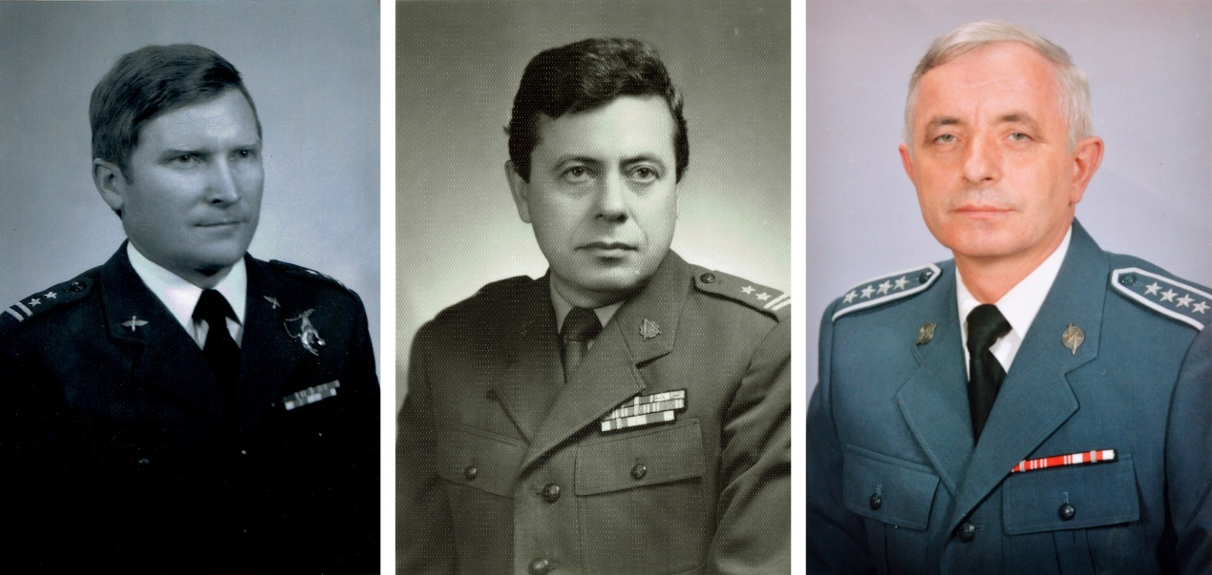
Figure 3. My maternal grandfather (left), my great-uncle (middle), and my paternal grandfather in their uniforms.
Thinking of tradition and something that could connect both Polish and Welsh cultures, I also looked into Polish regional clothing and Welsh traditional one. In Poland at the end of the 19th and at the beginning of 20th century there were 50 basic types of Polish traditional clothing, every of them having their own regional variations (Brzezińska and Tymochowicz, 2019). I had to look again back into my ancestors’ lives, as me or my parents would not wear any variations during my childhood, because there was no tradition like that in our region. My great-grandparents used to wear the clothing from regions Kraków and Kielce before their house was burnt down during the war.
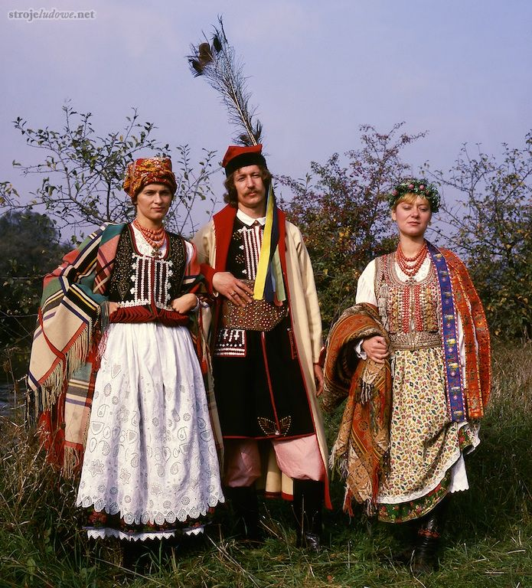
Figure 4. Gadomski, S. (2021) Stroje Krakowiaków Zachodnich. Available at: https://strojeludowe.net/#/krakowski/1/0.

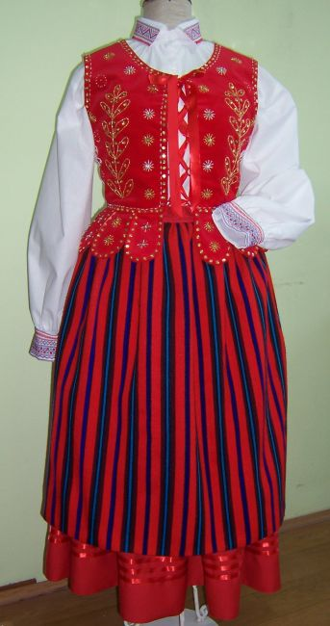
Figure 5. Photo of women’s folk outfit from Kielce. Available at: https://strojeludowe.ipr.pl/wybierz-region/kieleckie-stroje-ludowe/ (Accessed: 14 January 2021).
THEORY AND PHILOSOPHIES ON THE IMPORTANCE OF CLOTHING, FABRIC, MILITARY AND TRADITIONAL CLOTHING HERE

While researching uniforms and looking into traditional clothing I came across David Mabb’s work Selfportrait as Rodchenko, Dressed in a Rodchenko. David Mabb made a Production suit from the ‘Fruit’ William Morris fabric (Artspace, 2020; Goldsmiths, 2020). With his work Morris/Fruit, Rodchenko/Triple Peaks (2010) Mabb is contrasting Morris’s hand-printed nostalgic pattern design with Rodchenko’s machine-printed patterns of daily objects (Victoria and Albert Museum, 2007).
The artist “works with appropriated imagery to rethink the political implications of different aesthetic forms in modern art and design history” (Artspace, 2020; Goldsmiths, 2020), as he questions how Morris’ designs could be used and understood (Mabb, 2013). He contrasts Morris’s and Rodchenko’s practice and political beliefs – Morris was a socialist, yet he supported his life through selling luxury goods to the upper middle-classes, and Rodchenko produced designs cheap in labour while promoting radical socialism (Victoria and Albert Museum, 2007).

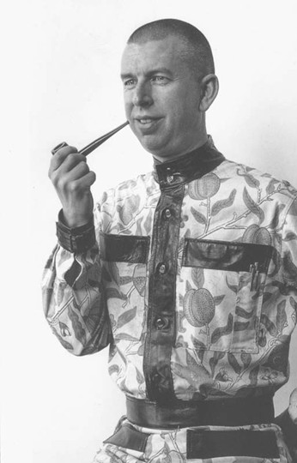
Figure 6. Mabb, D. (2006) Self-Portrait as Rodchenko. In: "John Moores 24", National Museums Liverpool, United Kingdom, 16 September - 26 November 2006. [Show/Exhibition]
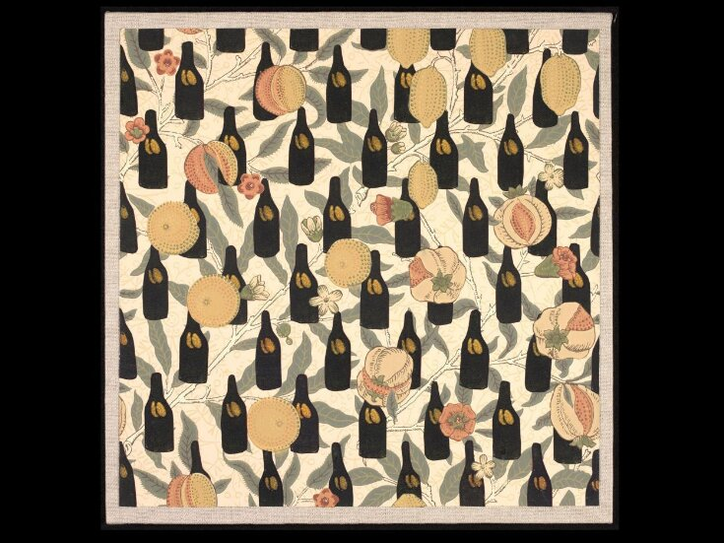
Figure 7. Mabb, D. (2010) Morris/Fruit, Rodchenko/Triple Peaks. In: Gill Saunders, ed. Walls Are Talking: Wallpaper, Art and Culture. Chicago and London: The Whitworth Art Gallery, Manchester and KWS Publishers. [Book Section]
Mabb’s work gave me the courage to play with the military uniforms and, while still discovering my project, mix its seriousness with feminine Slavic-Celtic pattern tin order to create something mine and unusual, contrasting military uniform that is culturally believed to be traditionally masculine (Koeszegi, Zedlacher and Hudribusch, 2014) with flower pattern where flowers are believed to be feminine (Reardon, 2014).
Having found the initial topic, I started dwelling on the technique and a way of portraying it. At first, I gathered all the information I could on my family, photos of my elders wearing uniforms, handwritten short biographies and recordings of interviews with them. Then I looked into fashionable outfits in Poland at the time of my birth. As it happens, I managed to find a Polish fashion magazine Przekrój that was published just two days after my birth in December 1996 showcasing fashionable outfits of the time. One of them was a jacket that immediately reminded me of my elders’ uniforms.

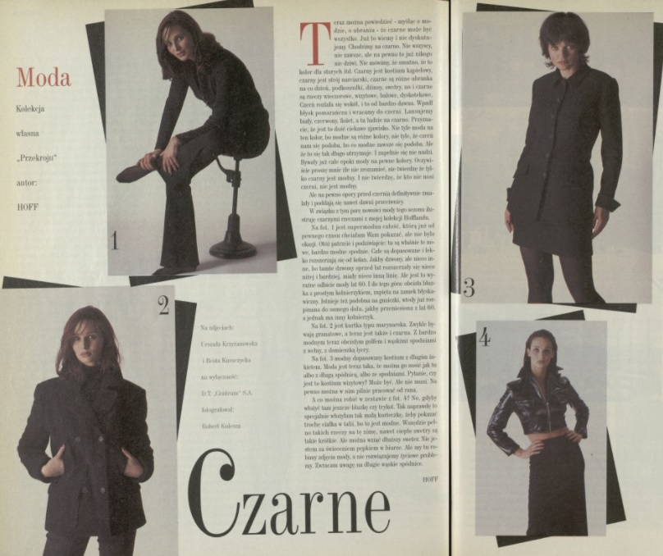
Figure 8. Przekrój (1996) Rubryka Moda - Archiwum rok 1996 - Kwartalnik Przekrój p. 53. Available at: https://przekroj.pl/archiwum/rubryki/moda (Accessed: 23 April 2020).
As I have decided to work with clothes, I got hugely inspired by Shelley Goldsmith and Tracey Emin’s work with physical objects as a way of creating and telling a story. They encouraged me to work with materials and potentially create a garment that would resemble my identity while also opening up about myself.
Shelly Goldsmith’s The Lovers (2011) was an installation made from reclaimed woman’s glove and man’s jacket showcased in the Duke of York pub. The work is inspired by stories of Frederick Augustus, Duke of York and Albany (1763–1827) and historical research into his life, namely of him having dates with his mistress in the Duke of York pub. The installation aims to focus on the layers of the intimate atmosphere of the pub that has heard and revealed many stories over the years, owing to the romantic endeavours and social interaction the pub has witnessed (Axisweb, 2020). My attention was caught particularly by the jacket presented in the installation (see below). Using single stitch Goldsmith creates layers of these stories, giving the voice to inanimate objects and allowing them sharing their wisdom through the typography work printed on a fabric, cut and stitched onto the garment. Such procedure gives two ways of experiencing this work of art, by appreciating the pattern created with the cut out and stitched layer on top of the jacket and by trying to decipher and understand what the garment can share with the audience. This way of telling the story was something I found inspiring and comfortable to use in my own practice.
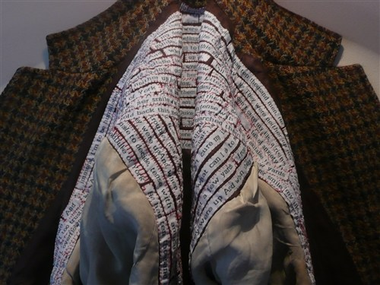
Figure 9. Goldsmith, S. (2011) The Lovers jacket interior detail [Site-specific work, Textiles] Available at: https://research.uca.ac.uk/2255/
Shelly Goldsmith has also used same stitching technique in her yet another work titled Queen of Clouds presented the ‘Drawn to Ohio’ exhibition (Goldsmith, 2015). That particular jacket has a fabric with printed sentences stitched on top of its shoulders and crossing at the back, rather than hidden inside like in The Lovers discussed above which design I found interesting in terms of controlling and shifting viewers’ attention immediately to the story told by garment.
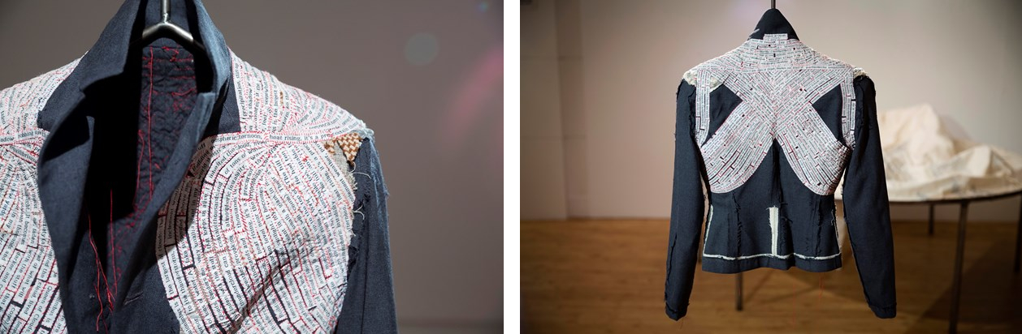
Figure 10. Goldsmith, S (2015) Queen of Clouds in installation view of 'Drawn to Ohio' exhibition [Exhibition/show, Textiles] Available at: https://research.uca.ac.uk/2964/
Locus of the Dress Publication - Introduction (printed on a head scarf) (2017) are yet another works that I visually like. Goldsmith seems to be able to convey her ideas through the medium of typography, graphics and textiles, and this is exactly what I was looking for, as they remind me of my work I did during workshops while learning how to work with textiles, giving the initial “this is me and my purpose” feeling. During the first day of the Contextile Talks 2020 live YouTube transmission at Ideias Emergentes (2020) Shelley Goldsmith presented her work for the project Locus of the Dress. The project is an exploration of the mark our lives make on the garments we wear as, wandering through the course of our lives, we share our experiences and journey with our clothes. Following the theory of Julian Rotter on internal versus external control of reinforcement, locus of control, she created Locus of the Dress taking an autoethnographic approach to embody the two poles of the theory; namely by using Cincinnati and surrounding towns in Ohio, USA, to portray the external locus, and Phoenician Coast of Margate and Ramsgate in East Kent, UK, to represent the internal side of the spectrum (Ideias Emergentes, 2020). As she explains in her presentation, her main aim was to focus on the garment as a dynamic space linking “location on the planet with location on and within a garment”, and this project has resonated strongly with my own search for answers through my practice. I wanted to portray my journey in early adulthood through the medium of clothes, as not only they were the witnesses of my life development, but also they represented uniforms and military upbringing that was something very well known to me.
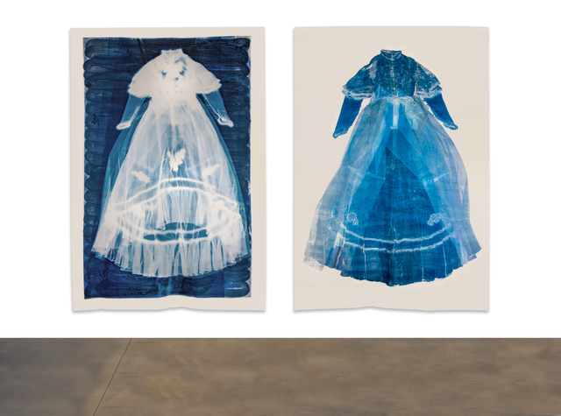
Figure 11. Goldsmith, S. (2019) Inaugural Vlieseline Fine Art Textiles Award Exhibition (from the research project Locus of the Dress: an internal and external cloth landscape). [Exhibition/show] Available at: https://research.uca.ac.uk/5209/
Coming from the down-to-earth military family, I have always been the outsider with my creative ideas, dreams, opinions or even my daily style. That is why I believe clothing and style has become a very important part of my identity, as it something that was carefully controlled during my childhood and now gives me a possibility to fully grow and present myself in my own way. At the beginning of my praxis I was very anxious towards revealing anything about my life, but seeing Tracey Emin’s work I have gained courage to show my true and vulnerable side.
Tracey Emin would discuss the events in her life through her art, for example thanks to My Bed (Emin, 1998) or Psyco Slut (Emin, 1999) we are introduced to a very intimate insight to her state of mind and life at the time. Tracey Emin’s Psyco Slut that consists of appliquéd words, phrases and patches of handwritten texts that give a very intimate insight to her life (Google Arts & Culture, 2020). What I like about this particular work of hers is that it shows her mindset at the time, her response to something that was said to her. It reminded me of my life and constant battles I had and still have to pick up to justify my decisions. It made me amazed that she was able to use these vulnerable moments as her inspiration and inspired me to do the same.
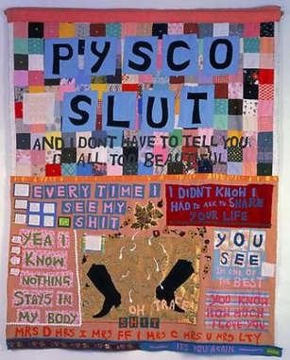
Figure 12. Emin, T. (1999) Psyco Slut. Available at: https://artsandculture.google.com/asset/psyco-slut-tracey-emin/IgFDgQ_fMwHC_w

My Bed (1998) is an autobiographic artwork that represents her state of mind, her bed and life at the time. In the video Tracey Emin - The South Bank Show (VHS Pile, 2020) she admits to had not gone out from bed for four days and eaten for even more, as she would be only drinking at the time. At the time of researching her work, I was experiencing similar moments, as due to the COVID-19 I had to call off my wedding, something that to me was a symbol of union of my both identities and both of our families. While the work created in response to the heart-break and serving as a cleansing ritual of the negative memories connected to the wedding is not used in this project, it helped me find my path to growing up and using life events as my inspiration and creating the final piece.
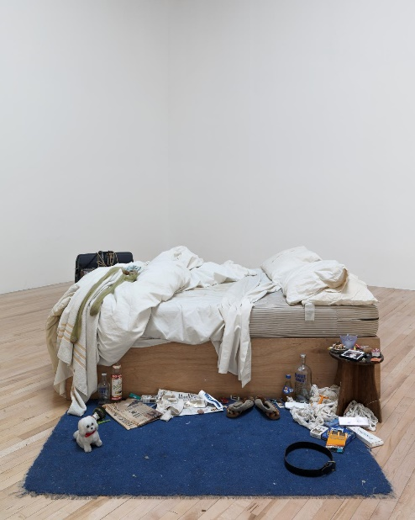
Figure 13. Emin, T. (1998) My Bed. [Installation] Available at: https://www.tate.org.uk/art/artworks/emin-my-bed-l03662.

I also have explored David Carson’s work in typography as a way of giving my ancestors a voice, by using their handwritten biographies and writing their words from a recorded interview myself. I want to show, that even though they were not fully present in my upbringing, they still played an important part in it.
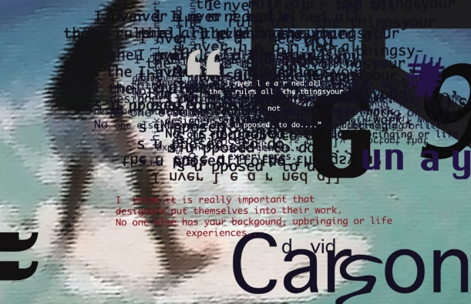
https://www.hypocritedesign.com/david-carson

In his talk titled Design and discovery (2003) Carson admitted to be enthusiastic towards emotion and message sent in the design. He presents his projects and in one of them is using quotes of Marshall McLuhan and playing with their design and portrayal to the point they are hard to read, yet still understandable if the audience takes a moment to figure them out. Another example of his work was, according to Carson, experimental, as he tried to bring the focus to the website by cutting out pieces of one photo and shifting its parts into different areas. This procedure brought an eye catching and interesting result than a regular photo advertising something we tend to ignore on a daily basis. My idea was to create a pattern from the scans of my and my great-grandfather’s handwritten stories, to make it hard to read and to draw attention to a piece of garment relevant to them. I chose the pocket of the uniform belonging to my great-grandparents while they were serving in the Home Army, as my way to pay them a tribute.

- Artist Blooms

2.1 Moving away from family

At this stage of my research I started feeling that my focus on my identity was too much in the past, so I decided to analyse most recent events: moving to Britain, becoming an artist, feeling this initial freedom as no one in the area knew me or my family. In a way, I started moving away from my heritage, discovering myself in the new setting and becoming someone that would be frowned upon in my inner circles back in Poland. This part I would call my rebellion from the tradition, and this rebellion has led me to look into something forgotten in Poland, namely Slavic mythology. My idea was to find similarities between Slavic and Celtic ones and use it as an inspiration for the pattern of my outfit as a way to portray the mixture within me. Another reason I started looking into mythology, because it was the very first thing that made me fall in love with Welsh culture and language. Looking into Polish or Slavic one I found out that there is no ancient manuscript of Slavic mythology that has survived. We have no written record of Slavic myths or their netherworld (Kalik and Uchitel, 2018). Therefore, it was difficult to me to find many similarities between mythology of Slavs and Celts. I decided then to focus on my own Slaveltic identity, the mix of the languages and cultures in daily life, while also looking into my ancestry and future as a wife of a Welshman creating my own family abroad.
Since it was very hard to find mythological similarities, I looked into the pagan rites of these two cultures. It was quite challenging, as I have not been raised as a pagan, even though Catholic events take inspiration from them. As it happens, many of Slavic and Celtic pagan rites coincide, since they are nature and season based, for example Kupala Night and Gŵyl Ifan.
Kupala Night and Gŵyl Ifan are very close to each other in terms of dates and they celebrate similar aspects - in the end, both countries also refer to these events as St. John’s Eve or St. John’s Night. Kupala Night (or Noc Kupały, and Gŵyl Ifan are a Slavic and Welsh pagan rites respectively celebrating Midsummer or Summer Solstice (Megre, 2008:231; Owen, 2016).
Kupala Night’s celebrations focus on love, foreseeing the future whether one will find their partner – the girls would use flowers blooming during that time to create the wreaths and throw them into the river, and should one of the boys fish one out, he would become the owner’s intended (Kuksenok, 2019:76). Another tradition would be to go to the forest in hopes to find the fern flower, which was believed to be the symbol of love (Kuksenok, 2019:77). Ferns would only blossom only one night a year – Kupala night – and the legend says that the one who finds it would be granted wealth and the ability to become invisible should they be in danger (Warnke, 2015) and “learn the language of glass, trees, birds, animals” and will remain happy for the rest of their life (Kuksenok, 2019:77). Therefore, the search for the fern flower by couples is the culminating point of Kupala rites.
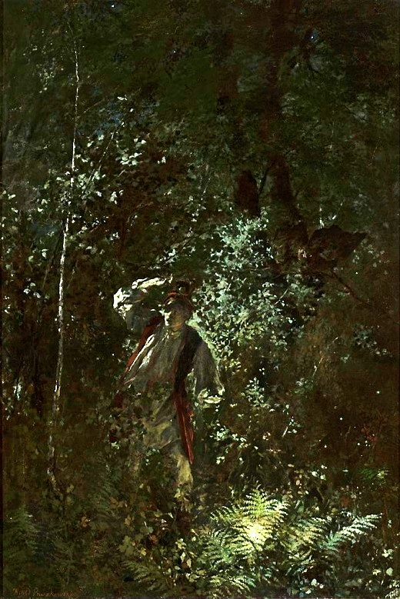
Figure 14. Pruszkowski, W. (1875) Fern flower, National Museum in Warsaw Available at: https://commons.wikimedia.org/wiki/File:Pruszkowski_Fern_flower.jpg (Accessed: 11 March 2021).
On June 24th the Welsh celebrate Gŵyl Ifan, which is their own celebration of the Midsummer Day (Society, 1893:126; Owen, 2016), as it was the day believed to have be close to the supernatural world similarly to the Halloween (Rich, 1998:2; Owen, 2016). Rich (1998:3) explains it was the day Celtic young women would try foresee the name of their future husbands through the medium of spells, one of them requiring picking 12 leaves of sage at midnight of Midsummer’s Eve in order to summon them in a form of a vision. The author also mentions the usage of rosemary bush under which, at midnight, young girls would place a plate of flour in order to reveal their future husbands’ initials in the morning. Another important spell mentioned is a song accompanied by sprinkling petals of red roses at the church.
“Rose petals, rose petals,
Rose petals I strew.
He that will love me,
Come to me soon.”

Apart from Shelly Goldsmith and Tracey Emin’s influence and inspiration on my praxis, together with Slaveltic pagan rites I have also discovered that Frida Kahlo and Yinka Shonibare are yet another artists who discuss similar ideas to mine – a mixture of cultures within them.
Frida Kahlo’s self-portraits show a silent yet powerful woman; as, wanting to be truly seen, Kahlo presented herself as a heroine while also depicting her vulnerability by creating the mythic creature invented to keep her feelings in check (Lindauer, 2011:4). This reminds me of my childhood, as I would always want to be perceived strong in order to fulfil my dreams which meant rebellion against the views of my family which, as a child and even in early adulthood, I have sometimes found difficult.
Frida Kahlo is known for wearing her traditional Tehuana traje, a trademark clothing with intricately embroidered huipils and skirts, of the most independent and proud indigenous women in all of Mexico (Lindauer, 2011:114; Haute Culture Fashion, 2018). Another reason for adopting and identifying with the Tehuana dress was Frida’s mother, Matilde, who was from Oaxaca and had been photographed wearing the dress together with her family. Kahlo’s signature appearance visible in her work titled Self Portrait as a Tehuana 1943 has encouraged me to work closer with traditional clothing from my country even more. I decided to attempt to mix the military outfits worn by my elders with folk clothing worn in Poland and Wales, in order to show this combination of cultures together with respect and rebellion towards my upbringing.
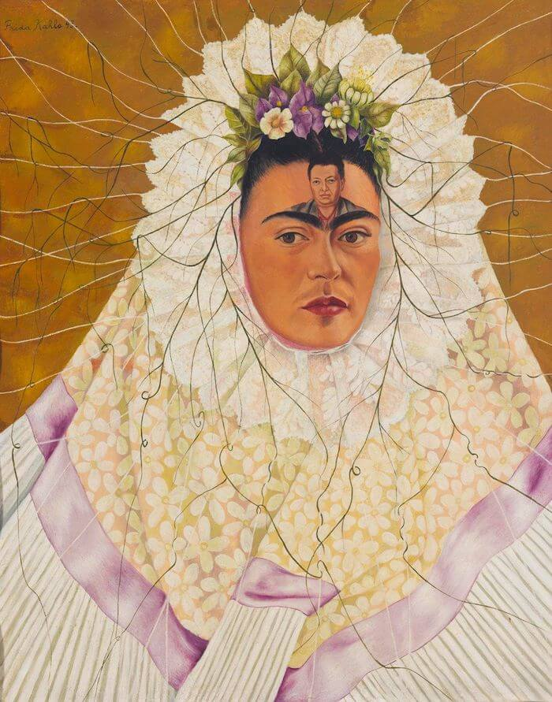
Figure 15. Kahlo, F. (1943) Self Portrait as a Tehuana Diego On My Mind. Available at: https://www.fridakahlo.org/self-portrait-as-a-tehuana.jsp (Accessed: 11 March 2021).
Yinka Shonibare CBE is well-recognised for his headless mannequins adorned in Dutch wax fabric. His garments intend to explore European decadence, the relationship between colonialism and post-colonialism within the current world (Hirsh, 2010). He references and plays with the Western art history with his paintings, photos and sculptures, using it as a medium to criticize and navigate the viewer to the complexities of colonialism and its impact (Hirsh, 2010).
Looking into his praxis, I liked how the artist works with his double identities; he is British-Nigerian born in 1962 in London, who moved to Lagos in Nigeria when he was 3 and then returned to London to study Fine Art (Hynes and Picton, 2001; Shonibare, 2020). In the mid-1990s the artist started working with Victorian style, while using African-print textiles for his designs (Hynes and Picton, 2001). This has encouraged me to work with my Polish-Welsh identity and to look more into the world of fabrics and a way to use them to create my own narrative.
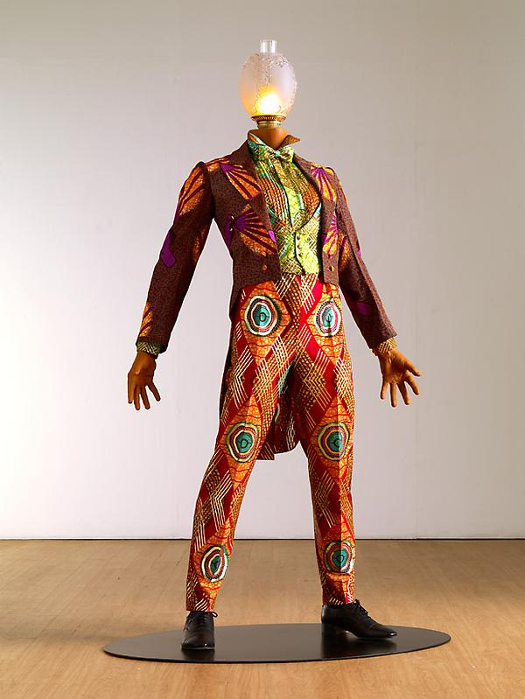
Figure 16. Shonibare, Y. (2010) FIRE. Available at: http://yinkashonibare.com/artwork/sculpture/?image_id=101 (Accessed: 11 March 2021).

2.2 Blending two worlds

My research into mythology, pagan rites and foreign artists dealing with their identity has made me decide to try to find similarities or pinpoint the mixture of identities within me. I decided to blend these two worlds and celebrate my uniqueness. At this stage I felt it was still chaotic, and I tried to organise it by creating my first pattern for fabric taking inspiration from St. John’s Night celebrated by both cultures. As it seemed, both of these rites focused on love, flowers and plants that could be used for decoration, spells and celebration these events. I decided to use them as my initial inspiration and create a pattern mixing the plants from both events into one.
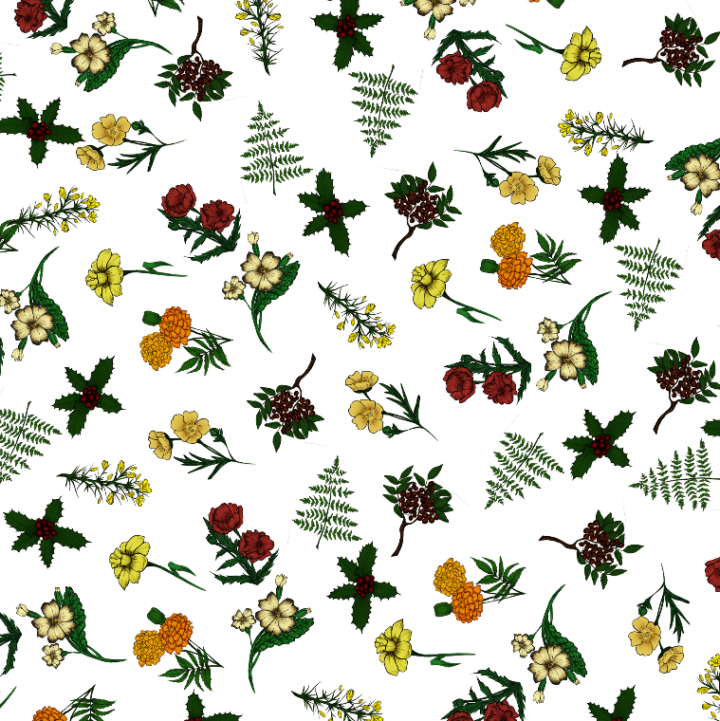
Figure 17. First plant-based pattern for my garment.
This pattern was an attempt to physically represent mixture of cultures within myself on a fabric that would be used to create a garment inspired by my own biography. I wanted to create something uncertain and visibly chaotic to represent how I felt inside. I could feel inside me that there was this visible mixture that was trying to get organised, but it was failing and leading to the more uncertain outcome in the future. Bearing that in mind, at that stage I also came back to the roots again and have gathered photos, interviews, handwritten short biographies with my great-grandfathers from both sides and created a pattern using my maternal great-grandfather’s handwritten short biography. Having David Carson’s work with typography being layered out on top of each other I scanned the biography and put the pages on top of each other as I wanted a pattern that would be hard to read, yet still visible for my family to recognise my great-grandfather’s writing, representing my state of mind at the time. What I mean by that is I felt like my identity was hard to define, but still there were obvious traits of my upbringing in the Polish military family.
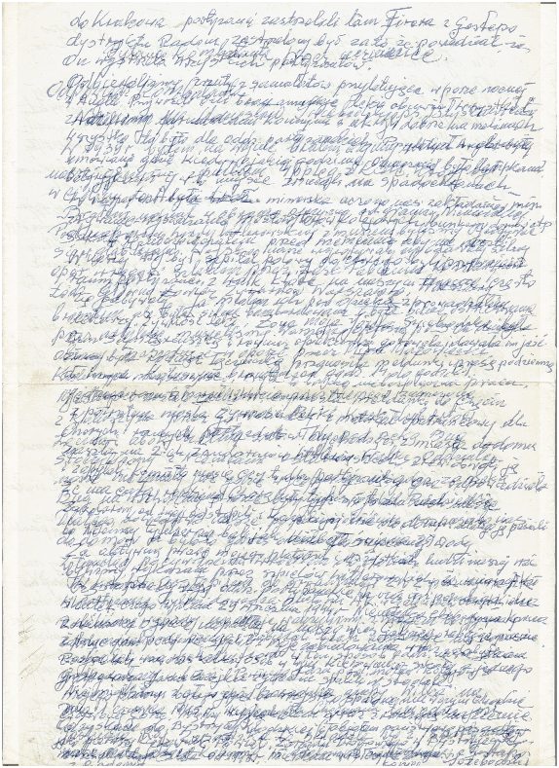
Figure 18. Fabric pattern created from my maternal grandfather’s handwritten biography.
To further help myself with gathering ideas I have created a mind map (below). I wanted to use my maternal grandfather’s uniform and the jacket that was fashionable when I was born as a base, and to represent my great-grandparents, I decided to use the pockets from the Home Army uniform. The base would be made out of the plant pattern, as I wanted to show the main mixture within me, and the pockets would be sewn together using the handwriting of my great-grandfather representing the roots and my ancestry.

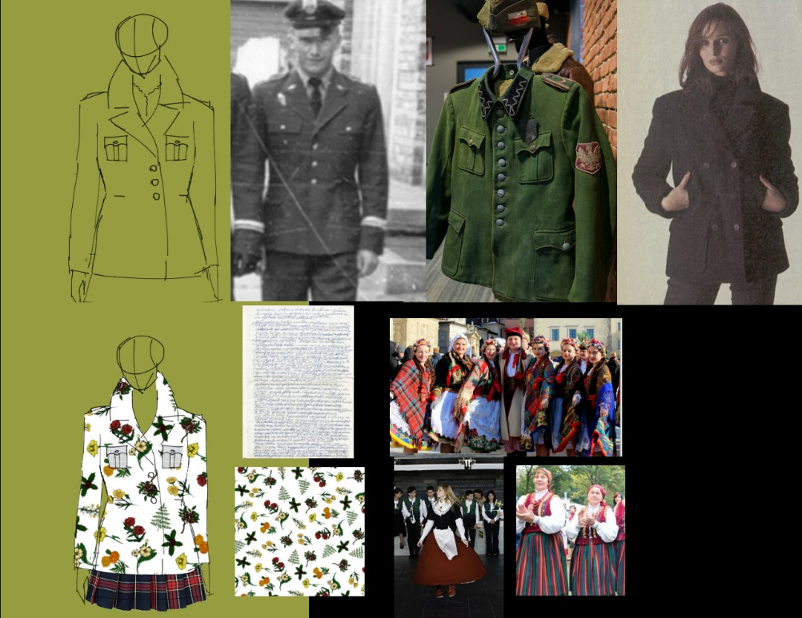
Figure 19. The mind map.
My main aim was to create something that could be worn, like I do wear my identity, so I still kept looking into folk clothing for further designs. The idea was to create a garment to show to the audience, but also photos of me wearing it as a final part of my self-search journey. Since at the time I felt more Polish than Welsh or British, I decided to represent the Polish side more by planning out my hairstyle that would be braided with the material and pattern I designed. As a nod towards Kupala Night and Polish folk clothing on top of my head I would wear a wreath that made out of the plants used by both Polish and Welsh cultures to honour the mixture.
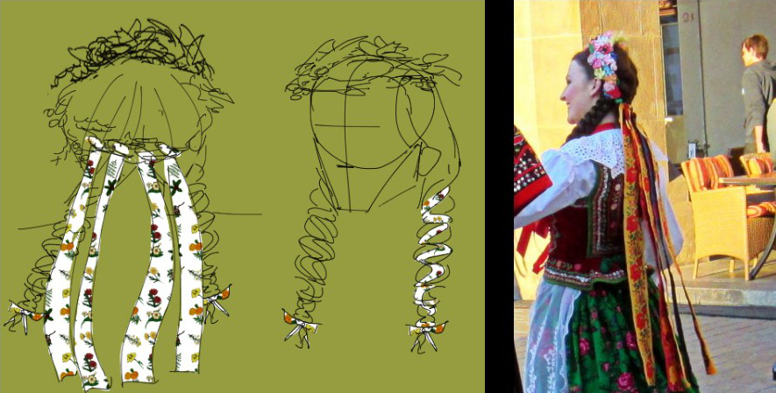
Figure 20. Hairstyle ideas and inspiration.

2.3 Moving away from Poland

After I had created my first designs, I felt like I managed to perfectly represent what I felt in terms of my mixed identity and that it only needed some polishing and potential small changes. decide Shortly after this realisation the political situation in Poland has become so difficult to me to cope and even want to celebrate this side of me. Starting from the presidential election controversy in May/June 2020, the hate speech towards LGBT+ (e.g. calling them an ideology), arguments with family supporting these events, to the abortion ban in October and the way this was performed and how Polish citizens were treated during the protests. This, combined with the issue of Brexit making my connection with my family more difficult and then and not being able to get married due to the pandemic, I started feeling like I had no home, no family and no identity, and almost gave up on this whole project all together, because I had nothing to be proud of and therefore nothing to show and talk about. Since June this whole project has had episodes of chaos, doubt and pain, but at some point I decided that with having an identity I also had a responsibility to accept that no matter how good or bad I perceived this mixture, it is still a part of me and I can still comment on that.
I decided to use protests happening in Poland as an inspiration to portray the negative side of my identity, as they were representing the general dissatisfaction with the current government represented by Law and Justice party (in Polish called Prawo i Sprawiedliwość or PiS in short). The protests have become much more aggressive and different from the ones before, as Poles would use “Fuck PiS” (Polish: “Jebać PiS” or the eight stars corresponding to these letters”) and “Get the Fuck Out!” (Polish: “Wypeirdalać!”) as their motto (Czarniawska, 2020:4). At the time, I created my own protest art and took part in artistic collaborations with other Polish women living abroad as my own contribution to this dissatisfaction. While doing so, I decided that I must somehow include this criticism towards current situation in my praxis, even though I knew my main focus of it was celebration of the unity between two cultures within me.

Figure 21. Protest poster I created after the ruling on abortion ban had been announced.
At that stage I have discovered natural dyeing and eco printing. Working with natural dyes adds more to the representation of the chaos and mixture between cultures inside me, and it always gives unexpected results, same as my journey. I am also talking about the worse side of my identity – I call it bad identity – that shows all of the conflicts of my beliefs between me and my family and, or even, a disapproval of the current situation in my home country, because living abroad does not mean I do not care about its prosperity and development. I am grateful to know about my ancestors, as not everyone my age in Poland can say so. To come from a military family and share their story is something we appreciate and honour, because we all hope the sacrifices our elders had to make will not ever go in vain. That is why I decided to honour their memory in my project while also comment on whether their fight was worth the current situation in Poland.

One of the conclusions
One of the things that could have been improved upon in this project, or I regret not to have done, is not being able to visit ethnographic museums in Poland and Wales, so that I could research in person traditional clothing of both countries.
I also wish I had discovered the natural dyeing process earlier last year, so that I could have practiced with actual poppies.

Bibliography

Anonymous (2019) ‘The bigots creating LGBT-free zones’, The Week, 3 August, p. 15.
Artspace (2020) David Mabb, Artspace. Available at: http://www.artspace.com/david-mabb (Accessed: 6 June 2020).
BBC News (2020) ‘Poland abortion: Top court bans almost all terminations’, 23 October. Available at: https://www.bbc.com/news/world-europe-54642108 (Accessed: 4 March 2021).
BBC News (2021) ‘Poland enforces controversial near-total abortion ban’, 28 January. Available at: https://www.bbc.com/news/world-europe-55838210 (Accessed: 4 March 2021).
Beswick, E. (2020) Police using ‘excessive violence’ against peaceful protesters in Poland amid abortion row | Euronews. Available at: https://www.euronews.com/2020/11/24/police-using-excessive-violence-against-peaceful-protesters-in-poland (Accessed: 4 March 2021).
Brzezińska, A. W. and Tymochowicz, M. (2019) ‘Atlas Polskich Strojów Ludowych 1949–2019. Kierunki badań nad strojami ludowymi w Polsce po 1945 rokuThe Atlas of Polish Traditional Costumes 1949–2019. Directions in Research on Traditional Costumes in Poland after 1945’. Biuro Upowszechniania i Promocji Nauki PAN. doi: 10.24425/NAUKA.2019.126182.
Carson, D. (2003) Design and discovery. Available at: https://www.ted.com/talks/david_carson_design_and_discovery (Accessed: 26 January 2021).
Czarniawska, A. (2020) ‘Cultural Clash in the Midst of Pandemic: Essay on protests in Poland’, The Interdisciplinary Journal of International Studies, 10(1), pp. 10–10. doi: 10.5278/ojs.ijis.v10i1.6357.
Dehnel, J. (2019) The struggle for LGBT equality: Pride meets prejudice in Poland, The Guardian (Online). London (UK), United Kingdom: Guardian News & Media Limited. Available at: http://search.proquest.com/docview/2267577847/citation/DB23867F7A164E3DPQ/1 (Accessed: 4 March 2021).
Emin, T. (1998) My Bed. Available at: https://www.tate.org.uk/art/artworks/emin-my-bed-l03662.
Emin, T. (1999) Psyco Slut.
Encyklopedia PWN (2014) Armia Krajowa. Available at: https://web.archive.org/web/20140512221344/http://encyklopedia.pwn.pl/haslo.php?id=3871190 (Accessed: 23 May 2020).
Finnemore, P. (2011) Peter Finnemore - Interview. Available at: https://vimeo.com/23031156 (Accessed: 27 May 2020).
Foucault, M. (1988) The history of sexuality. 1st Vintage Books ed. New York: Vintage Books.
Goldsmith, S. (2011) The Lovers. Available at: https://research.uca.ac.uk/2255/ (Accessed: 13 January 2021).
Goldsmith, S. (2015) Drawn to Ohio: textiles by Shelly Goldsmith. doi: 10/flq7z2fkkiu6mrqvkjiow_large.jpg.
Goldsmiths (2020) David Mabb, Goldsmiths, University of London. Available at: https://www.gold.ac.uk/art/research/staff/dm/01/ (Accessed: 6 June 2020).
Google Arts & Culture (2020) Psyco Slut - Tracey Emin, Google Arts & Culture. Available at: https://artsandculture.google.com/asset/psyco-slut-tracey-emin/IgFDgQ_fMwHC_w (Accessed: 15 May 2020).
Grzymala-Busse, A. (2020) ‘Analysis | Poland’s presidential election just got more complicated’, Washington Post. Available at: https://www.washingtonpost.com/politics/2020/05/08/polands-presidential-election-just-got-more-complicated/ (Accessed: 4 March 2021).
Haute Culture Fashion (2018) ‘The Tehuana & Their Showstopping Traditional Dress’, Haute Culture Textile Tours, 16 July. Available at: https://hauteculturefashion.com/tehuana/ (Accessed: 6 June 2020).
Hirsh, J. (2010) ‘Yinka Shonibare Mbe’, Nka: Journal of Contemporary African Art, (27), pp. 122–125. doi: 10.1215/10757163-2010-27-122.
Hussein, J., Cottingham, J., Nowicka, W. and Kismodi, E. (2018) ‘Abortion in Poland: politics, progression and regression’, Reproductive Health Matters. Taylor & Francis, Ltd., 26(52), pp. 11–14.
Hynes, N. and Picton, J. (2001) ‘Re-Dressing History’, African Arts. MIT Press, 34(3), p. 60.
Ideias Emergentes (2020) Contextile Talks 2020 - Day 1 Afternoon. Available at: https://www.youtube.com/watch?v=2cvtNWwTh3M (Accessed: 4 March 2021).
Kahlo, F. (1943) Self Portrait as a Tehuana Diego On My Mind. Available at: https://www.fridakahlo.org/self-portrait-as-a-tehuana.jsp (Accessed: 11 March 2021).
Kalik, J. and Uchitel, A. (2018) Slavic Gods and Heroes. Routledge.
Kieleckie - Stroje ludowe - POLSKIE STROJE LUDOWE - Regionalne stroje ludowe: damskie, męskie, dziewczęce, chłopięce (no date). Available at: https://strojeludowe.ipr.pl/wybierz-region/kieleckie-stroje-ludowe/ (Accessed: 14 January 2021).
Koeszegi, S. T., Zedlacher, E. and Hudribusch, R. (2014) ‘The War against the Female Soldier? The Effects of Masculine Culture on Workplace Aggression’, Armed Forces & Society. SAGE Publications Inc, 40(2), pp. 226–251. doi: 10.1177/0095327X12460019.
Kuksenok, O. (2019) ‘HISTORICAL DYNAMICS AND SPIRITUAL CULTURE OF THE SOCIETY: REGIONAL AND GLOBAL CONTEXTS’, p. 3.
Lindauer, M. A. (2011) Devouring Frida: The Art History and Popular Celebrity of Frida Kahlo. Wesleyan University Press.
Mabb, D. (2013) ‘Commodity as comrade: Luibov Popova - Untitled textile design on William Morris wallpaper for Historical Materialism’, Ephemera. Leicester, United Kingdom: Nick Butler (On Behalf of the Editorial Collective of Ephemera), 13(2), pp. 445–448.
Megre, V. (2008) Rites of Love. Ringing Cedars Press LLC.
Ney-Krwawicz, M. (2020) The Polish Underground State and Home Army. Translated by A. Bohdanowicz. Available at: http://www.polishresistance-ak.org/2%20Article.htm (Accessed: 23 May 2020).
Owen, T. M. (2016) The Customs and Traditions of Wales: With an Introduction by Emma Lile. University of Wales Press.
Pruszkowski, W. (1875) Saint John’s Eve label QS:Lru,"В ночь на Ивана Купала (Цветок папоротника)". Available at: https://commons.wikimedia.org/wiki/File:Pruszkowski_Fern_flower.jpg (Accessed: 11 March 2021).
Reardon, K. H. (2014) ‘“A Flora Specific to Modern Wars”: The Rhizomatic Feminine Rhetoric of Flowers’, Space Between: Literature & Culture, 1914-1945, 10, pp. 1–1.
Rich, V. (1998) Cursing the Basil and Other Folklore of the Garden. TouchWood Editions.
Rotter, J. B. (1990) ‘Internal versus external control of reinforcement: A case history of a variable’, American Psychologist. American Psychological Association, 45(4), pp. 489–493. doi: 10.1037/0003-066X.45.4.489.
Shonibare, Y. (2010) FIRE. Available at: http://yinkashonibare.com/artwork/sculpture/?image_id=101 (Accessed: 11 March 2021).
Shonibare, Y. (2020) Yinka Shonibare, CBE (RA) | Biography. Available at: http://yinkashonibare.com/biography/ (Accessed: 8 June 2020).
Society, C. (1893) The Transactions of the Honourable Society of Cymmrodorion. The Society.
The Independent (2019) Polish cities and provinces declare ‘LGBT-free zones’, The Independent. Available at: https://www.independent.co.uk/news/world/europe/poland-lgbt-free-zones-homophobia-hate-speech-law-justice-party-a9013551.html (Accessed: 4 March 2021).
VHS Pile (2020) Tracey Emin - The South Bank Show. Available at: https://www.youtube.com/watch?v=OxaoAy9oNtY (Accessed: 15 May 2020).
Victoria and Albert Museum (2007) Morris/Fruit, Rodchenko/Triple Peaks | Mabb, David | V&A Explore The Collections, Victoria and Albert Museum: Explore the Collections. Available at: /item/O1/O13/O135/O1353/O13533/O135338/ (Accessed: 4 March 2021).
Wall, S. (2006) ‘An Autoethnography on Learning About Autoethnography’, International Journal of Qualitative Methods. SAGE Publications Inc, 5(2), pp. 146–160. doi: 10.1177/160940690600500205.
Warnke, A. (2015) 9 Slavic Rituals & Customs of Ye Olden Days | Article | Culture.pl. Available at: https://culture.pl/en/article/9-slavic-rituals-customs-of-ye-olden-days (Accessed: 28 January 2021).
Williamson, G. (2012) German Battleships 1939–45. Bloomsbury Publishing.
Żuk, Piotr and Żuk, Paweł (2017) ‘Women’s health as an ideological and political issue: Restricting the right to abortion, access to in vitro fertilization procedures, and prenatal testing in Poland’, Health Care for Women International. Routledge, 38(7), pp. 689–704. doi: 10.1080/07399332.2017.1322595.

Locus of Control (Rotter, 1990) – locus, Latin ‘place or location’ – is a theory referring to the degree to which people believe that an outcome of their lives is unpredictable, outside of their control, and determined by luck, fate (External Locus); or that the outcome of their lives are attributed to effort, decision making and hard work leading to positive results (Internal Locus).
The date when Kupala happens varies, some sources say it starts on 20th and last for the four following days (Warnke, 2015), while some say it happens on the 24th, which is the 7th July in Russia after they have adopted the Georgian calendar, (Megre, 2008:231).
On June 24th the Welsh celebrate Gŵyl Ifan, which is their own celebration of the Midsummer Day (Society, 1893:126; Owen, 2016), as it was the day believed to have be close to the supernatural world similarly to the Halloween (Owen, 2016).
According to Rich (1998:3) there was no clear reason as to why sage was used in these rituals. The author speculates it could have been due to its medicinal advantages and longevity; and therefore symbolising long-lasting marriage, or that in the 19th century sage represented the ideal wife, and the number twelve could have been referring to the Christian apostles.
Rich (1998:3) argues rosemary’s symbolism of virginity due to its association with the Virgin Mary, and therefore being used by bridal bouquets; and fidelity as its fragrance is long-lasting for a plant.
Rich (1998:4) explains symbolism of roses as they symbolise love, being associated with pagan goddesses Aphrodite and Venus, and then Virgin Mary; moreover, there was a belief (from the Middle Ages to 19th century) that red roses appearing in dreams were foretelling a marriage of a young woman to a handsome man.
Polish presidential election was first supposed to happen on 10th May 2020 and, despite the social-distancing orders, it would require in-person balloting (Grzymala-Busse, 2020). Opposition called for the elections to be delayed yet at first the government refused and tried to keep the date without doing anything at first, but then through introduction of the postal vote, although preparations were made too late for it to happen (Grzymala-Busse, 2020). The first round happened on 28th June 2020 and second on 12th July 2020 with Duda winning by 2.4%.
The leader of the currently ruling Law and Justice party, Kaczyński, has called LGBT an ideology and described them as a threat to Polish values in response to Warsaw’s mayor appeal to incorporate sex education and LGBT+ issues into curriculums for schoolchildren (Dehnel, 2019; The Independent, 2019). In 2019 in a right-wing city called Białystok there was organised a Pride march (and opposed by right-wing “family picnic”), which resulted in violence, blood, and insults towards those who happened to be in the area (Dehnel, 2019). After that event thirty cities administrated by the ruling party declared their land as “LGBT-free zones”, and Gazeta Polska (Polish Newspaper) attempted to include “LGBT-free zones” stickers (Anonymous, 2019).
The issue of the abortion ban started in October 2016 when thousands of women protested the bill on abortion ban, starting “women’s strike”; as the ban was expected to also cover rape or fetal damage (Żuk and Żuk, 2017). On 23rd March 2018 when tens of thousands of Poles gathered wearing black to protest the “stop Abortion” bill, marking it the beginning of the Black Protest movement (Hussein, Cottingham, Nowicka, Kismodi, 2018). At the time it was still legal to undergo abortion if there was danger to the life or health of the woman or in cases of incest or rape, but on 23rd October 2020 Polish Constitutional Tribunal has ruled out fetal defects as legitimate reason for abortion (BBC News, 2020). The law was enforced on 27th January 2021 and therefore imposed a near-total ban, as in 2019 fetal defects were the reason for 98% of the abortions (BBC News, 2021).
The police were using violence against peaceful protesters, mostly consisting of women, over abortion ban; hitting them with telescopic batons, throwing them on the ground (Beswick, 2020).

