Leading and Implementing Workplace Change (BMSW6103_LON)
Student name: Ignacio Perez Blanco
Student ID: 2129210
Lecturer name: Nadeem Mirza


Context Table

Front Pg…………………………………………………………………………………. Pg 1

Context Table……………………………………………………………………………. Pg 2

Executive Summary and Introduction of Easy Jet………………………………. Pg 3

Pestel analysis of Easy Jet………………………………………………………. Pg 5

Porter’s 5 Forces: …………………………………………………………………..Pg 7

Swot Analysis: ………………………………………………………………………..Pg 9

Digital Disruption and current economic uncertainty ……………………………. Pg 11

Evaluation of change management model and leadership styles in EasyJet. …Pg 14

Impact of EasyJet’s Organizational Culture on Change Management and Developing a Future-Proof Change Management Plan…………………………………………Pg 15

Develop a suitable change management plan for Easy Jet ……………………Pg 16

Conclusion……………………………………………………………………………. Pg 20

Reference ……………………………………………………………………………Pg 21

Executive summary
Nowadays, the companies are changing the ways of ensuring the objectives of it. This is because businesses are unpredictable, and new businesses emerge in the market, and this creates competition. This means that the companies should change because it is a natural process which happens and in which we can see if the company evolves and achieves its objectives or on the contrary it does not change and most of the time fails. This is not always the case. This changes that triggers them are external and internal factors. They can create a trigger that can affect positive or negatively the companies.
This report focuses on analysing the impacts of these changes will be used a change management plan to explain the changes that the company have had. Also, we are going to explore on this report how the technologies generate an impact in the companies, also the external triggers, and the change management that the companies can have:
1.Changes in the external environment, the digital disruption, and the economic impact on the company.
2.Internal and external triggers and Internal and external environment.
To continue with this report, a company will be chosen to see its triggers and environment. The objective is to explain those elements that can affect the company. To expelling these elements first, I going to explaining the current state of the company which in this case is Easy Jet.

Introduction of Esay Jet Air
As of the first half of 2024, easyJet demonstrates robust financial health and growth. EasyJet's organizational culture, characterized by its Orange Spirit. The airline’s balance sheet is strong, underlined by a net cash position of £146 million as of March 2024, following the repayment of a €500 million Eurobond in October 2023 and the issuance of an €850 million bond in March 2024. This stability, validated by its Baa2 and BBB credit ratings from Moody’s and S&P respectively, is poised to support fleet expansion and shareholder returns. (Easy Jet, 2024)

Revenue has surged by 22% year-over-year to £3,268 million, fuelled by a 5% increase in revenue per seat and strong growth in easyJet Holidays, which boosted ancillary revenue by 30% to £1,222 million. Enhanced capacity and optimized pricing have also driven passenger revenue up 17% to £2,046 million. Meanwhile, headline costs rose by 17% to £3,618 million, primarily due to fuel expenses and expanded operations. However, easyJet effectively managed non-fuel unit costs, which remained flat despite inflationary pressures, through increased productivity and operational efficiencies.
Driving its competitive low-cost model, easyJet leverages network optimization, yield management, and a robust ancillary product portfolio. Recent initiatives support this model, including the acquisition of a maintenance facility in Malta, increased digitalization of customer service, and the strategic up gauging of its fleet. These efforts are expected to sustain cost advantages and operational resilience as easyJet continues to build on its low-cost leadership across Europe. (Easy Jet, 2024)
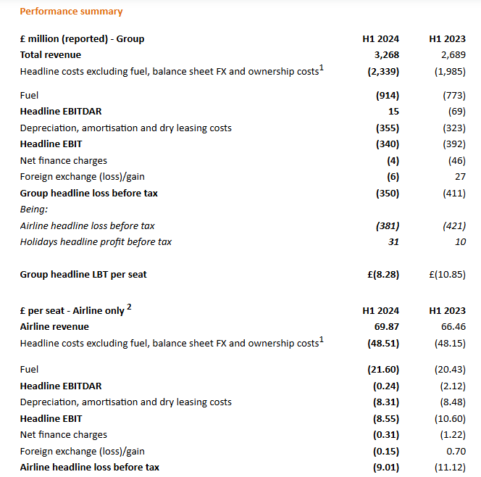
(Easy Jet, 2024)

Analysis of external Environment (A)
Now, there will be an explanation of how external factors have advantages, disadvantages for the company, such as disruption technologies and the variability of the companies. To analyse the external factors PESTEL analysis, Porters’ 5 forces and SWOT analysis will be used.

Pestel analysis of Easy Jet.
Political: In this case Easy Jet can have political changes, including shifts in leadership and international relations, can influence EasyJet’s operations. Conflicts between countries may disrupt flight schedules or restrict routes, while Brexit has imposed regulatory changes that may limit EasyJet’s access to EU markets. Regulatory shifts in areas such as safety, environmental standards, and labour laws can affect operational costs. Additionally, terrorism concerns can lead to increase security measures, impacting expenses and potentially reducing demand in certain areas. Lastly, increased government support for national airlines could create competitive disadvantages for EasyJet.
Economical: Operating internationally, EasyJet faces risks from currency fluctuations, which affect costs and revenues. Operating internationally, EasyJet faces risks from currency fluctuations, which affect costs and revenues. Fuel costs, a significant expense, fluctuate with oil prices, impacting profitability. Inflation and interest rates also influence costs, as higher rates increase borrowing expenses for investments like aircraft. Consumer spending confidence and employment levels further affect demand: high confidence and low unemployment encourage travel, while low confidence and high unemployment reduce it. Inflation and interest rates also influence costs, as higher rates increase borrowing expenses for investments like aircraft. Consumer spending confidence and employment levels further affect demand: high confidence and low unemployment encourage travel, while low confidence and high unemployment reduce it.
Social: Sociocultural shifts are altering travel patterns, as trends like eco-tourism, adventure travel, and remote work drive changes in destination demand. Growing environmental awareness has led some travellers to consider lower-impact options, affecting flight demand. Demographic trends, including an aging population, influence preferences for specific services and destinations, while cultural differences across markets impact EasyJet's approach to marketing and customer service. Health and wellness concerns, especially post-pandemic, have created lasting changes in consumer behaviour, such as a preference for less crowded locations.
Technological: Advances in technology shape EasyJet’s operations in various ways. Online booking systems and mobile features like digital boarding passes have become essential for meeting customer expectations, while in-flight services require a balance between cost and benefit. With increased digitalization, cybersecurity is crucial to protect customer data.
Environment: Changing weather patterns can disrupt flight schedules and raise costs for EasyJet, while also affecting travel preferences. Increased pressure to cut emissions could lead to higher expenses, especially with the need for carbon credits. The shift toward more sustainable fuels, though costlier, may become necessary with stricter rules. Noise restrictions near airports could limit operations, especially in residential areas, while growing waste reduction demands require changes in EasyJet’s practices. Additionally, environmental concerns about airport expansions may hinder the airline’s ability to grow or establish new routes.
Law: EasyJet must comply with various regulations, including safety standards, flight rules, and policies on overbooking and compensation, all of which can impact operations and costs. Labor laws also affect hiring, benefits, and wages, influencing labour expenses. As digital platforms are widely used, data protection and privacy laws are essential for the airline to follow. Environmental regulations, covering emissions, noise, and waste, also affect its operations. Brexit introduces legal challenges, such as potential restrictions on EU operations and changes to compensation rules. Additionally, strict health and safety regulations ensure the safety of passengers and crew during flights. (Professional academy, 2024)
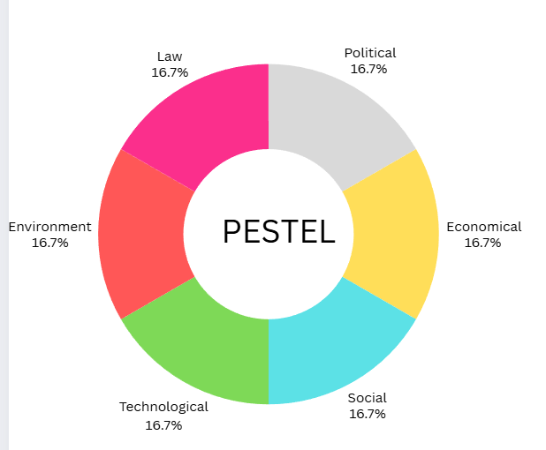(ignacio,2024)

After having used the the pestle above, there will be analysis by using Porter 5 forces, since this tool will help us to externally analyse our competitors.

Porter 5 forces of Easy Jet
The competitive environment for easyJet in the low-cost airline market is intense, primarily due to the similarity in pricing strategies, high fixed costs, and limited differentiation among airlines. With low switching costs, customers can easily move between airlines, which pressures easyJet and its competitors to lower prices, especially when demand dips. EasyJet can benefit by emphasizing its brand differentiation through unique add-ons, quality service, and an expanding flight network, as these factors can help build customer loyalty. Looking forward, easyJet should consider fleet expansion to meet potential market growth and to maintain its competitive edge among other low-cost carriers.
- Industry Rivalry:
High. Competition in the airline industry is intense for easyJet, driven by high fixed costs, low customer switching costs, and minimal differentiation between airlines. While some competitors have exited the market, others like Jet2 are expanding, increasing rivalry. Slowed market growth. With high exit barriers due to significant investments, airlines often lower prices to maintain market presence. EasyJet can differentiate by focusing on fleet expansion, service quality, and unique add-ons, which may strengthen its competitive position in the low-cost sector.
- Threat of New Entrants:
Low. The threat of new entrants in the airline industry is low due to high initial capital needs for fleet acquisition, licensing, and regulatory compliance, along with an already competitive market. Established brands like easyJet benefit from customer loyalty, as passengers prefer recognized, trusted airlines. Regulatory and environmental demands further raise entry barriers, discouraging new competitors. Thus, easyJet is relatively insulated from new entrants, allowing it to focus on market growth and customer retention without immediate risk from newcomers seeking market share.
- Threat of Substitutes:
Medium. The threat of substitutes, such as trains and car-sharing, is moderate for easyJet. While environmentally friendly options appeal to some, they are generally slower and less practical for long-distance travel. Technological advancements in sustainable transportation and rising environmental awareness could drive some interest in alternatives, but air travel remains preferable for its speed and convenience. easyJet can counter this by promoting flight benefits and exploring sustainable practices that align with customer preferences, reducing the appeal of substitutes.
- Threat from Suppliers:
High. Supplier power is high due to easyJet’s dependence on Airbus and fuel providers, with limited alternative suppliers. Rising fuel costs and sustainability requirements also increase supplier leverage. This dependence allows suppliers to influence pricing and terms, impacting easyJet’s cost structure. To manage this, easyJet could diversify suppliers, strengthen existing partnerships, and consider alternative fuel options, helping to reduce dependency on key suppliers and mitigate rising costs driven by supplier power.
- Threat from Customers:
High. Customers have significant bargaining power, as they prioritize low fares and can easily switch between airlines using comparison tools. Environmental concerns also pressure airlines like easyJet to adopt sustainable practices. Low switching costs intensify this threat, forcing airlines to keep prices competitive. easyJet can mitigate customer power by building brand loyalty through unique service offerings and focusing on quality. Expanding loyalty programs and service options may help retain customers, reducing their inclination to switch to other airlines. (Professional academy, 2024)
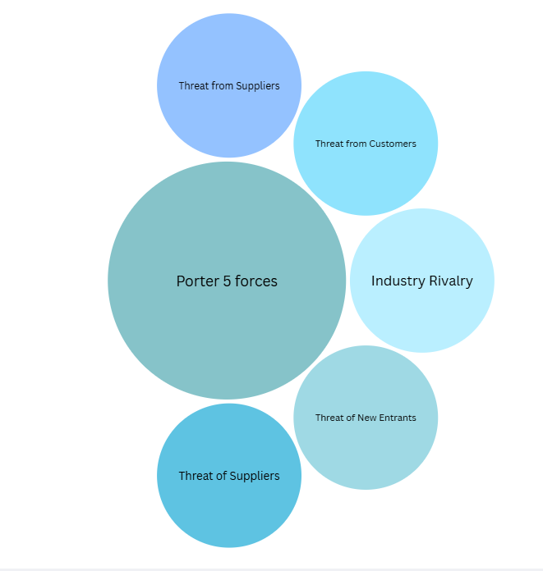(ignacio,2024)

Now, to the next part of this report, which is use the SWOT Analysis to explain the strengths, weakness, opportunities and threats of Easy Jet. Echa of them will briefly comment each one.

SWOT Analysis EasyJet
- Strengths
Low-cost business model: EasyJet's affordable pricing attracts a large base of budget-conscious travellers. Strong brand recognition: Known for its iconic orange and white livery and sustainability efforts, EasyJet enjoys high brand loyalty. Wide network: Operating in 150+ destinations across 36 countries, it offers extensive options for leisure and business travel. Customer service focus: With a dedicated team and a user-friendly mobile app, EasyJet prioritizes positive customer experiences. Sustainability commitment: Initiatives like fuel-efficient aircraft and net-zero carbon goals appeal to eco-conscious customers.
- Weaknesses
Limited premium services: Lacks offerings like business class or enhanced comfort features, reducing appeal to luxury travellers. European market dependency: Heavy reliance on Europe increases vulnerability to regional economic or political instability. External risk exposure: Fluctuations in fuel prices, currency rates, and weather events pose significant operational risks. Brand similarity: Branding overlaps with other low-cost carriers, making market differentiation challenging. Customer complaints: Issues like strict baggage policies and delays can harm reputation and deter potential customers.

- Opportunities
Market expansion: Exploring regions like Asia and the Americas to diversify operations beyond Europe. Sustainability demand: Capitalizing on consumer increasing interest in environmentally friendly travel. Digital innovation: Investments in technologies to streamline operations, enhance customer experience, and increase efficiency. Strategic alliances: Partnerships with airlines or travel providers to expand offerings, such as bundled packages.
Emerging technologies: Adopting electric or hydrogen-powered aircraft and leveraging AI for cost reductions and efficiency gains.

- Threats
Economic challenges: Recessions or reduced travel spending can negatively impact revenues. High competition: Pressures from traditional airlines and other low-cost carriers can erode market share. Political instability: Events like Brexit disrupt operations and financial performance, especially within Europe. Changing preferences: A shift towards premium or sustainable travel could reduce EasyJet’s appeal in key segments. External risks: Natural disasters, currency volatility, and fuel price fluctuations could impair profitability and efficiency.
(Kenton, 2024)
Since the external factors have been analysed with the PESTEL analysis, Porter's 5 forces and finally the SWOT analysis, now the next external factor that may be important is digital disruption and current economic uncertainty. (Raeburn, 2024)
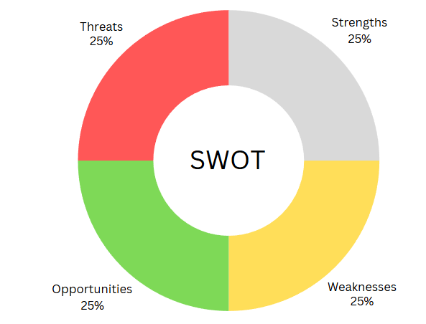 (ignacio,2024)

Digital Disruption and Current Economic Uncertainty (B)
Technology has been crucial to the development of most organizations. The world is changing, and companies must follow those changes to avoid any problems. We are in times of economic uncertainty, so companies must create a good change management plan. Knowing this, the next step will be to evaluate the change management approach that this company has had. Easy Jet is a company that has had the vision to use technology so that this disruption can be both an advantage and a disadvantage for this company.
This emerging innovation requires adaptation to integrate it effectively. Such advancements are referred to as disruptive innovations, and the aviation sector has experienced several of them in recent years. Although implementing disruptive innovations can be expensive, their potential long-term advantages are significant. In recent times, certain technologies have enabled the aviation industry to lower maintenance expenses while enhancing safety protocols for both staff and passengers. Here we can see how changes can be an advantage or disadvantage, but do the people involved in a business really want a change? In any organization we will find a group of people who will resist any type of change. For these cases the organization should have a good leader when it comes to making decisions, change and most importantly, the leader must influence the people who resist that change.
(Nation Thailand, 2024)

- Leadership Styles and Their Relevance to EasyJet
Among the four key leadership styles democratic, autocratic, transactional, and laissez-faire the democratic style aligns most effectively with EasyJet’s strategic change initiatives. A democratic leadership approach emphasizes collaboration, participation, and empowerment, which are essential when navigating complex, organization-wide transformations. By engaging employees at all levels and valuing their input, EasyJet was able to mitigate resistance and foster a sense of ownership in the change process.
The autocratic style, characterized by top-down decision-making, may have been effective for rapid decision-making during crises but lacks the flexibility and engagement necessary for sustained change in a customer-facing, service-driven industry like aviation. EasyJet's reliance on employee cooperation and innovation would have clashed with an overly directive approach.
The transformational leadership style is vital for organizations as it encourages innovation, teamwork, and adaptability. By motivating employees with a shared vision and fostering a sense of purpose, leaders can navigate change effectively. This style builds trust, promotes open communication, and empowers teams to embrace new strategies, ensuring that organizations remain agile and competitive in an ever-changing business environment.
The transactional style, which focuses on structured goals and rewards, likely played a role in certain aspects of EasyJet’s changes, such as incentivizing employees to achieve efficiency targets. However, its emphasis on short-term objectives makes it less suitable for fostering the cultural and behavioural shifts required for long-term strategic transformation.
The laissez-faire style, marked by minimal intervention, would have been unsuitable for EasyJet during periods of significant change, as it requires active leadership to navigate complex challenges and resistance. Given the scale of EasyJet’s digital transformation and sustainability goals, this style would have risked a lack of direction and accountability.
(IMD, 2022)

- The Role of Transformational Leadership in EasyJet’s Success
Transformational leadership is particularly suited to EasyJet because it aligns with the company's goals of innovation and adaptability in a highly competitive market. This approach encourages collaboration and motivates employees by connecting them to the organization's broader vision, such as sustainability and digital transformation. By fostering trust and inclusivity, transformational leaders help EasyJet address challenges like operational efficiency and customer satisfaction while ensuring employee engagement and long-term success.
The next step is analysing the 3 model of change management and take the best one for EasyJet.

Change management model analysis (C)

- Change Management Models and Plans for EasyJet
Organizational change is vital for adapting to evolving environments. EasyJet’s transformation efforts can be evaluated using Lewin’s Three-Step Model, Kotter’s Eight-Step Plan, and the Pettigrew Model, each offering distinct frameworks for managing change effectively.
Lewin's Three-Step Model: This model emphasizes preparation, implementation, and reinforcement of change. The Unfreeze stage creates awareness and readiness for change through transparency and communication, crucial for addressing resistance. The Change stage involves agile implementation, continuous feedback, and visible progress to maintain motivation. Lastly, the Refreeze stage stabilizes the change by embedding it into organizational culture, ensuring long-term adoption. This structured and simple approach makes Lewin's model ideal for EasyJet's need to implement focused changes like fleet optimization or digital transformation.
Kotter’s Eight-Step Plan: This comprehensive model breaks down change into eight sequential steps, from creating urgency to institutionalizing change. While its detailed steps ensure robust execution, its linearity may be challenging for organizations like EasyJet that operate in a dynamic environment. However, Kotter's emphasis on vision-building, leadership coalitions, and short-term wins could provide significant benefits for large-scale initiatives, such as sustainability projects or global market expansion.
Pettigrew Model: This model’s strength lies in its holistic perspective, integrating the content, process, and context of change. It considers both internal factors (culture and structure) and external factors (competition and regulation) to guide change implementation. This adaptability aligns with EasyJet’s multifaceted challenges, such as regulatory shifts and market competition. However, its theoretical complexity may require significant management expertise to execute effectively.
- Choosing the Best Model for EasyJet
Among these models, Lewin's Three-Step Model emerges as the most suitable for EasyJet. Its simplicity, focus on stakeholder engagement, and reinforcement mechanisms align well with EasyJet’s culture and operational needs. The iterative nature of its Change stage supports continuous improvement and employee feedback, essential for fostering the

collaborative Orange Spirit culture. Additionally, its emphasis on embedding changes into daily operations during the Refreeze stage ensures sustainability and minimizes reversion risks.
Having analysed the different models and found the most suitable one, the next step would be addressing issues related to strategic change within the organization, including the approach to managing the change and the leadership style adopted.

Addressing issues related to strategic change, management and leadership style.

EasyJet, one of Europe’s leading low-cost airlines, has navigated significant strategic changes to remain competitive amidst evolving market dynamics. The organization faced challenges such as rising fuel prices, growing competition from other low-cost carriers, and increasing demands for sustainability in aviation. To address these, EasyJet implemented strategic initiatives aimed at enhancing customer experience, operational efficiency, and environmental responsibility.
A key strategic change involved the introduction of more digitalized services, including online booking platforms, mobile apps, and automated check-in systems. This shift not only streamlined operations but also aligned with changing customer preferences for convenience and technology integration. Another transformative initiative was EasyJet’s commitment to environmental sustainability, which included adopting more fuel-efficient aircraft and investing in carbon offsetting programs.
The management of these changes required a structured and proactive approach. EasyJet emphasized clear communication to ensure employees and stakeholders understood the rationale behind these transformations. Regular updates and training sessions were provided to equip the workforce with the necessary skills for adapting to new systems and processes. The company also fostered collaboration across departments to ensure alignment with its strategic goals.
The leadership style that drove these changes was transformational and participative. For instance, under the leadership of Carolyn McCall, EasyJet adopted a people-focused approach. McCall emphasized transparency and inclusivity, ensuring that employees were actively involved in the change process. Her ability to inspire and motivate teams created a culture of innovation and adaptability. By empowering employees and encouraging feedback, she built trust and minimized resistance to change.

Overall, EasyJet’s strategic transformation demonstrates the importance of visionary leadership, effective communication, and employee engagement in successfully managing change. These initiatives have enabled EasyJet to strengthen its market position while responding to environmental and technological challenges. Once again, we see how EasyJet has been able to face the problems, that is why the following point of this report is important, and it will talk about its culture which are the values ​​and pillars of this company.

Impact of EasyJet’s Organizational Culture on Change
Management (D)
Organizational culture plays a crucial role in the success of change management programs, as it shapes employee attitudes, behaviours, and the overall response to change. EasyJet's organizational culture, characterized by its Orange Spirit, emphasizes boldness, passion, unity, and ethical behaviour. This inclusive culture, with a commitment to diversity and opportunity, has profoundly impacted its change management strategies, both positively and negatively. Understanding this culture and leveraging it effectively is essential for EasyJet to successfully implement change while remaining competitive in the dynamic airline industry.

- Impact of EasyJet’s Culture on Change Management
EasyJet's culture fosters innovation and collaboration, making it well-suited to adapt to the fast-paced nature of the airline industry. The emphasis on teamwork and inclusivity aligns with the company’s efforts to introduce transformative changes such as sustainability initiatives, digital innovation, and fleet optimization. Employees are motivated to embrace these changes because they are part of a shared vision that resonates with the company's core values. For example, EasyJet's commitment to sustainability aligns with its cultural ethos of “doing the right thing,” which has likely increased employee buy-in for environmentally friendly practices like investing in fuel-efficient aircraft.
However, the organization's culture also poses challenges to change management. While the Orange Spirit promotes unity and passion, the same characteristics could lead to resistance if changes are perceived as undermining the strong bonds and established practices among

employees. For example, the move toward increased automation in customer service might create apprehensions about job security or alienation from the company's traditionally people-centric approach. Additionally, EasyJet’s diverse workforce, while a strength, may require tailored communication and training strategies to ensure uniform understanding and acceptance of change across all levels. (EasyJet, 2023)
At this point, knowing the external factors, leadership styles and which Change Management Models are best for easy jet, the next step would be to develop a suitable change management plan for the future.

Develop a suitable change management plan for Easy Jet

In the rapidly evolving aviation industry, adaptability is crucial for maintaining a competitive edge. EasyJet recognizes the need to implement strategic changes to streamline operations, enhance customer satisfaction, and align with sustainability goals. This change management plan outlines the steps to introduce a new integrated digital booking and customer management system, accompanied by a financial and evaluation plan.

- Proposed Change
Description of Change: The initiative involves adopting an advanced, integrated digital platform for booking, customer relationship management (CRM), and analytics. This system aims to centralize customer data, automate key processes, and deliver a seamless experience for customers while enhancing internal workflows. EasyJet’s current systems are fragmented, leading to inefficiencies and inconsistent service delivery. By replacing these outdated systems with a modern platform, the airline will improve data-driven decision-making, streamline operations, and better meet customer expectations. This change also supports EasyJet’s broader strategic objectives of innovation and operational excellence.
The new system will affect key departments, including customer service, IT, sales, and marketing. Employees will require training to adapt to the new platform, and existing processes must be redefined to leverage the system’s capabilities effectively. Additionally, the platform's sustainability features will reduce paper usage and energy consumption.

- Change management plan

Step 1: Align Stakeholders Around a Cohesive Vision
The first step involves engaging executive sponsors and stakeholders from all relevant business areas. This team will align on the vision, emphasizing how the proposed system aligns with EasyJet’s strategic goals. Key benefits such as cost reduction, enhanced communication, improved productivity, and increased employee engagement must be clearly communicated to secure stakeholder buy-in and advocacy.
Step 2: Craft a Blueprint for Success
With the vision established, EasyJet will develop a comprehensive governance and project management plan. This blueprint will include detailed timelines, key milestones, resource allocation, decision-making processes, and communication strategies. Regular updates will be provided to all stakeholders and employees to build readiness and foster transparency.
Step 3: Conduct Change Readiness Sessions
To prepare employees, EasyJet will organize readiness sessions to highlight the differences between the current and proposed systems. These sessions will address key questions, such as what improvements the new platform offers and how employees will be supported during the transition. Additionally, the "Change Valley of Despair" model will be used to normalize employee concerns and identify training needs.
Step 4: Launch an Early Adopters Program
A group of influential employees will be identified to pilot the system as early adopters. Their feedback will inform adjustments to training materials, UX design, and communication strategies. These advocates will also champion the change within their teams, promoting adoption and addressing resistance.

Step 5: Roll Out Training and Communication
Comprehensive training programs will be launched to ensure employees are well-equipped to use the new platform. Training methods will include eLearning modules, workshops, videos, FAQs, and guides. The focus will shift from explaining the "why" to detailing the "how." Simultaneously, go-live communications will be tailored to reach employees through multiple channels, ensuring engagement and clarity.

Step 6: Motivate Employees and Recognize Achievements
To foster motivation, EasyJet will implement gamification elements and recognition programs. Employees who demonstrate outstanding adaptability and contributions during the transition will be rewarded. This approach will create a positive atmosphere and encourage a culture of continuous improvement.
Now in order to continue, we must develop the financial plan, the communication plan and finally the evaluation plan.

- Financial Plan
Implementing the digital platform will require significant investment, but the long-term benefits outweigh the costs. The financial plan includes:
Budget Allocation: Platform development and licensing: £20 million.
Training programs: £3 million.
Stakeholder and employee engagement activities: £2 million.
Projected Savings: Improved efficiency in operations and customer management is expected to save £8 million annually. Enhanced sustainability measures, such as reduced paper and energy use, will lower operational costs by £1 million annually.
Funding Sources: The initiative will be funded through EasyJet’s operational budget and potential partnerships with technology providers.

- Communication Plan
Communicating a change plan is crucial to ensure transparency, alignment, and active participation from all stakeholders. An effective communication plan establishes clear guidelines on who communicates, what is communicated, and through which channels, minimizing confusion and fostering collaboration. For EasyJet, the process begins with defining communication methods, such as using email for external updates to create an effective communication is essential for change success at EasyJet. The plan includes:
Methods: Use email for external communication, Slack for quick updates, and Asana for tracking progress. Meetings via Zoom will address team-wide updates.
Cadence: Weekly status updates for stakeholders, monthly team meetings, and milestone notifications.
Stakeholder Management: Tailored updates for various stakeholders, focusing on progress, risks, and benefits to ensure alignment.
Accessibility: Make the plan accessible on EasyJet’s central information platform and update it as needed.
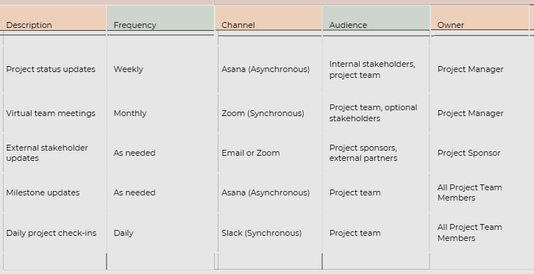
Here is a table, this clearly reflects the points of the communication plan.
(Ignacio 2024)
- Evaluation Plan
To ensure the success of the change initiative, EasyJet will implement a robust evaluation framework:
Feedback Mechanisms: Conduct surveys and focus groups to gather employee and customer feedback. Analyse help desk tickets and system usage data to identify areas for improvement.
Timeline for Evaluation: initial surveys and performance reviews will be conducted within the first three months post-implementation. Follow-up assessments will occur at 30, 60, and 90 days, with additional reviews at six months and one year.
Continuous Improvement: Insights from evaluations will guide adjustments to training, communication, and system features. A dedicated team will oversee ongoing refinements to ensure sustained success.
By following this structured change management plan, EasyJet can successfully implement its new digital platform, delivering enhanced customer experiences and operational efficiency. Aligning stakeholders, crafting a robust strategy, preparing employees, and evaluating progress will ensure the change is both effective and sustainable. This initiative underscores EasyJet’s commitment to innovation and adaptability in a competitive industry.

Benefits of the Proposed Change for EasyJet
The proposed change offers significant benefits for EasyJet. By adopting an integrated digital booking and customer management system, the airline enhances operational efficiency, centralizes customer data, and streamlines workflows. This transformation improves customer experiences through faster and more seamless interactions while reducing operational costs. Furthermore, the system's sustainability features align with EasyJet's environmental goals, promoting reduced paper and energy usage and supporting the company's broader commitment to innovation and sustainability.

Conclusion
The report highlights the essential role of effective leadership and structured planning in driving successful workplace changes. It emphasizes the need for clear communication, trust-building, and collaboration to foster a culture that embraces change. Leaders must understand stakeholders’ concerns, align change initiatives with organizational goals, and anticipate potential resistance. The change management process involves three critical phases: planning, execution, and evaluation. Planning requires identifying risks and preparing strategies to address them. During execution, transparent communication, employee support, and inclusivity are key to overcoming resistance and ensuring buy-in. Evaluation allows organizations to measure the impact of the changes and make necessary adjustments. Leadership qualities such as emotional intelligence, active listening, and empathy are highlighted as vital for inspiring teams and addressing uncertainty. Additionally, frameworks like Kotter's 8-Step Process and Lewin's Change Management Model provide structured approaches for managing transitions effectively. Key learnings include the importance of strategic thinking, adaptability, and continuous feedback. Engaging employees, fostering inclusivity, and creating an environment of trust are crucial for long-term success.
In summary, the report stresses that successful change management is about more than processes—it is about empowering people and enabling them to navigate and embrace transformation with confidence.

References

- Barhite, B. (2024). Crafting a winning change management plan: The 6 essential steps. Available at: https://firstup.io/uk/blog/crafting-a-winning-change-management-plan-the-6-essential-steps/ [Accessed 11 Dec. 2024].

- Curryer, E. (2022). How EasyJet is scaling to new highs with AI. Available at: https://techinformed.com/how-easyjet-is-scaling-to-new-highs-with-ai/ [Accessed 2 Dec. 2024]

.
- Danao, M. (2024). Porter’s Five forces: Definition & How to Use the Model. www.forbes.com. Available at: https://www.forbes.com/advisor/business/porters-five-forces/ [Accessed 14 Nov. 2024].

- Director, M., and, T., and, A.-P., Leader, R. and Partner, (2024). How the airlines industry is bracing for an uncertain recovery. Available at: https://www.ey.com/en_no/insights/strategy/how-the-airlines-industry-is-bracing-for-an-uncertain-recovery [Accessed 5 Dec. 2024].

- Easy Jet (2024). EasyJet PLC - Half-year Report. Available at: https://corporate.easyjet.com/investors/regulatory-news/news-details/2024/easyJet-PLC---Half-year-Report/default.aspx [Accessed 11 Nov. 2024].

- EasyJet (2022). Home. Available at: https://mediacentre.easyjet.com/story/15431/-nextgen-easyjet-is-ready-for-take-off-as-new-marketing-campaign-signals-a-new-era-for-the-brand [Accessed 9 Dec. 2024].

- EasyJet (2023). Inclusion and Diversity | Life at easyJet. [online] careers.easyjet.com. Available at: https://careers.easyjet.com/en/life-at-easyjet/inclusion-and-diversity [Accessed 5 Dec. 2024].

- Gordon, J. (2022). Culture Types Model - Explained. Available at: https://thebusinessprofessor.com/en_US/management-leadership-organizational-behavior/culture-types-model-explained [Accessed 5 Dec. 2024].

- IMD (2022). The 6 Most Common Leadership Styles & How to Find Yours. Available at: https://www.imd.org/blog/leadership/leadership-styles/ [Accessed 1 Dec. 2024].

- Jones, R. and Clark, J. (2023). Budget airlines: which is the best – and what about the worst? Available at: https://www.theguardian.com/travel/2023/apr/01/budget-airlines-best-worst-jet2-uk-travel-rules-extras.

- Kenton, W. (2024). How to perform a SWOT analysis. Available at: https://www.investopedia.com/terms/s/swot.asp [Accessed 1 Dec. 2024].

- Liedloff, D. (2023). Spotlight: easyJet Strategic Analysis | Resources | Get Lucidity. Available at: https://getlucidity.com/strategy-resources/spotlight-easyjet-strategic-analysis/ [Accessed 1 Dec. 2024].

- Malik, P. (2024). Lewin’s 3-Stage Model of Change Theory: Overview. Available at: https://whatfix.com/blog/lewins-change-model/ [Accessed 1 Dec. 2024].

- Marklew, P. (2017). The five most disruptive technologies for aviation - AGN. Available at: https://aerospaceglobalnews.com/news/the-five-most-disruptive-technologies-for-aviation/ [Accessed 2 Dec. 2024].

- Martins, J. (2024). How to write an effective communication plan. Available at: https://asana.com/resources/communication-plan [Accessed 7 Dec. 2024].

- Nationthailand (2024). Digital transformation key to surviving economic uncertainty. [online] nationthailand. Available at: https://www.nationthailand.com/business/economy/40043471 [Accessed 1 Dec. 2024].

- Olmstead, L. (2019). Applying the enhanced kotter’s 8 step change model. Available at: https://whatfix.com/blog/kotters-8-step-change-model/ [Accessed 9 Dec. 2024].

- Professional academy (2024). Marketing Theories – PESTEL Analysis. Available at: https://www.professionalacademy.com/blogs/marketing-theories-pestel-analysis/ [Accessed 19 Nov. 2024].

- Raeburn, A. (2024). SWOT Analysis: What Is it and How Do You Use It. Available at: https://asana.com/resources/swot-analysis [Accessed 15 Dec. 2024].

- Supremetech (2023). What is Digital Disruption and Why is it Changing The Game?. Available at: https://www.supremetech.vn/what-is-digital-disruption-and-why-is-it-changing-the-game/ [Accessed 1 Dec. 2024].

- Whatfix (2024). What is Change Management? A Brief Guide. Available at: https://whatfix.com/change-management/ [Accessed 3 Dec. 2024].

- Wong, K. (2023). Organizational Culture: Definition, Importance, and Development. Available at: https://www.achievers.com/blog/organizational-culture-definition/ [Accessed 5 Dec. 2024].

