Mind the Gap
Construction play a vital role across the world, delivering the infrastructure and buildings which supports and shapes our way of life. It designs, constructs and maintains the homes we live in, the buildings we work in, the schools we learn in and the infrastructure which delivers the services that society needs. However, an ageing workforce, lack of diversity and a shrinking talent pool has resulted in a slip in productivity that currently sees the UK languish behind a host of other world economies (Office for National Statistics, 2018).
In 2017, the construction industry contributed £113 billion to the UK economy and provided 2.4m jobs (Rhodes, 2018) and this is set to grow further. As detailed in the National Infrastructure Delivery Plan, a £483 billion investment to improve the UK’s ageing infrastructure is proposed by 2021. It is hoped that this investment will address the UK’s lagging productivity rates.
It is encouraging that this investment is already resulting in high quality infrastructure projects commencing across the UK:
- The £80bn HS2 and £18bn Crossrail are two of the biggest rail transport infrastructure projects that has ever been undertaken in the UK.
- The £1.5bn A14 Cambridge to Huntingdon improvement scheme is one of many large highway investments
- The £20bn construction of the UK’s first new nuclear power plant will offset 9 million tonnes of carbon dioxide emissions a year over its 60-year lifespan (www.edfenergy.com, 2019).
A grand challenge
As well as opportunities, such investment and pipeline of large-scale infrastructure projects brings grand challenges. To successfully deliver the infrastructure pipeline a high quality, productive and skilled workforce is required. However, the Infrastructure and Projects Authority estimates a demand for over 250,000 construction and over 150,000 engineering construction workers by 2020. This means the industry must attract, develop and retain nearly 100,000 additional workers (HM Treasury, 2015).
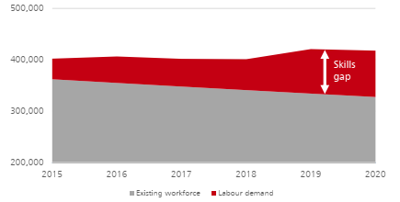
The last Employer Skills Survey, undertaken in 2017, highlighted that construction employers are now struggling to fill two in every five vacancies, up from one in three in 2015. The reason construction employers cited was that it was difficult to find applicants with the appropriate skills, qualifications or experience (Department for Education, 2017). This could see the wages of the existing work force double as construction firms battle for the skills the so desperately need. Brexit also has the potential to exacerbate the scale of the challenge. Many construction employers rely on resource drawn from across the European Union to fill shortages in skills. A no-deal Brexit with tight regulation on migration could constrain construction and infrastructure delivery across the UK.
The issues
In addition to the impact of Brexit, retiring workers and the sheer numbers required to replace them, the construction industry has a list of issues that get in the way of attracting, recruiting and retaining bright, new, resource:
- An unattractive industry
Students, parents, teachers and careers advisors perceive careers in construction to be hard, dirty, manual jobs for boys. Although slightly out of date, the Educating the educators report states 35% of teachers say careers in construction are ‘unattractive’ (CITB, 2014). Little has changed over the past five years to suggest this perception is any different. This misconception will also be contributing to only 13% of the UK construction workforce being female.
- Technology and engineering undervalued
As well as the misconception of being “cold and dirty”, the construction industry is also perceived as being low skilled and most suited to people who do not get into college or university. Despite the number of A-level students choosing STEM related degrees increasing (UKCES, 2015), the number choosing engineering and technology subjects are stagnating (HESA, 2019). This is despite unmet demand from construction employers and higher median working salaries on offer (Department for Education, 2019).
- Project pipelines are not aligned with demand for skills
Numerous strategies and reports which detail planned projects across the country are readily available. What’s missing is the commercial details to help construction companies effectively plan and increase resources which will be required during delivery. For example, in 2017 Angela Hepworth, Corporate Policy and Regulation Director at EDF, said: “At the peak of the construction of Hinkley Point, we are going to need 1,400 steel fixers. At the moment, the total population of certified steel fixers in the UK is 2,700 so we would need more than half of the total steel-fixing population in the UK in order to meet the peak requirement for Hinkley Point.”
Consequences
The skills gap is already having a detrimental impact on the delivery of large-scale projects across the UK. Budgets and, ultimately, the profitability of construction firms is being hit. For example, according to the The Economics of High Speed 2 report undertaken by the House of Lords, the many delays to HS2 are caused, in part, by the lack of resources and experience (House of Lords, 2015).
Furthermore, the Transport Infrastructure Skills Strategy estimates that the consequences of a lack of investment in talent will cost the transport and rail industry over £300M by 2024 and could escalate to over £1bn ten years later (Department for Transport, 2016).
The solution
There is both a monetary incentive and operational need for construction employers to identify initiatives and actions to increase the talent pool available to them. So, what needs to be done?

Engaging with the next generation
The construction industry has an ageing workforce. This means that the number of employees above 60 is increasing more than any other age group. In 2011, the Office for National Statistics found that one in every five UK-born construction workers were aged over 55, meaning that in the next two years, those people will nearly have reached retirement age. The same report identified that the 16 – 24 year old age group was the smallest (Gerrard, 2018). In 2019, with more workers retiring than what are entering the industry, the construction workforce is decreasing at a time when output is rising.
Construction firms need to take a proactive approach to engaging with younger generations. Offering a week’s work experience during year six is not enough. Engagement needs to start in primary schools and should focus on inspiring pupils and educating teachers.

School engagement should start early
Activities such as the Institution of Civil Engineers’ (ICE) Bridge to School programme, which gives primary school pupils the opportunity to build a 40ft model cable stayed bridge, is just one example. Business in the Community’s (BitC) “Business Class” initiative is a formal relationship between school and business which could provide opportunities for teachers to learn more about the wide range of careers in construction and engineering and help change the outdated perception of an unskilled, dirty and tough industry.

Activities need to inspire the next generation
However, getting out on site and witnessing construction activities first-hand is surely the best way of inspiring future construction workers? Site visits can demonstrate the size and scale of projects. Talks from construction professionals can introduce a wide range of potential careers from Environmentalists to Town Planners. It’s not just plant operatives and groundworkers we need.

Site visits allow pupils to get a first-hand experience
Apprenticeships
In 2015, the Government committed delivering 3,000,000 apprenticeship starts across all industries in England by 2020. The objectives were clear: apprenticeships would boost productivity, develop vocational skills and increase the quantity and quality of apprenticeships. In the light of this commitment, the road and rail sector has set an ambition to create 30,000 new apprenticeships by 2020 through the Transport Infrastructure Skills Strategy (Department for Transport, 2016).
The Go Construct website (https://www.goconstruct.org/), which showcases the many career opportunities available in construction and the built environment states 80% of employers say that apprentices have made their business more productive. The Centre for Economic Research estimates that apprentices can boost a company’s productivity by an average of £214 per week, generating £3.4 billion for the UK economy by 2022.
By employing apprentices, construction firms will be improving their own productivity rates whilst supporting the economic growth of the UK. But the benefits don’t end there, young apprentices are often tech-savvy and will help utilise new technology, such as Building Information Modelling, GPS Controlled Construction Equipment to its full extent. Apprentice training can be bespoke to business needs, company values instilled and staff retention rates improved. National Apprenticeship Service data shows 80% of companies who invest in apprentices have reported a significant increase in employee retention and therefore reduced recruitment costs.
Construction business should make long term commitments to apprentice recruitment. The 5% Club is one way. Member organisations commit to employing 5% of their workforce on “earn as you learn” contracts which enable them to build and develop the workforce they need as part of a socially mobile, prosperous and cohesive nation.
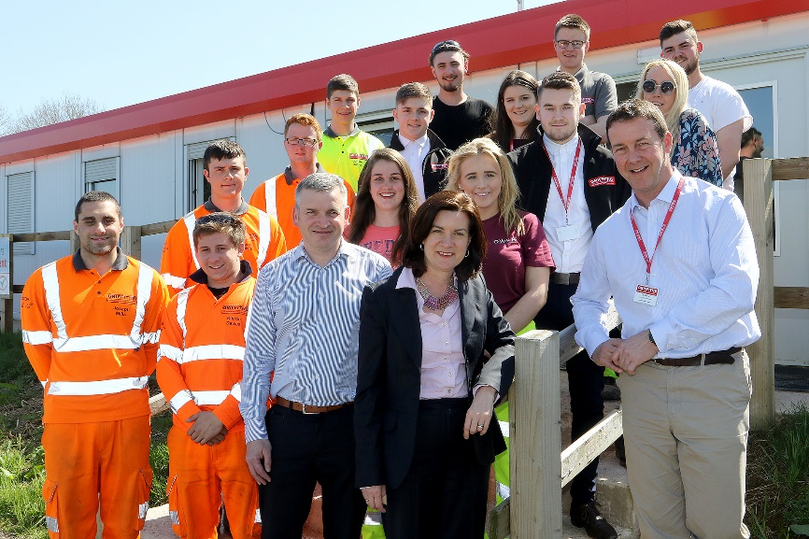
Diversifying the workforce
To truly address the construction skills gap, the industry must also address its lack of diversity. Currently, only 14% of construction jobs are held by women (Powell, 2019) with less than 2% of workers in manual trades (https://wamt.org.uk/, 2019). Having so few females in construction is an issue that needs addressing urgently – highlighted by the United Nations Sustainable Development Goal 5: Gender equality.
Programmes and initiatives to attract more females into the industry, such as the Government’s #NotJustForBoys campaign and Women and Manual Trades, are working. Go Construct report that 37% of new entrants into the industry that came from higher education are women.
In 2017, mandatory gender pay gap reporting highlighted another clear issue for construction businesses. Second only to Financial and insurance activities, the construction industry has a 22.1% median pay gap (Gale, 2018). The pay gap is also diluted by the fact that so few females work in construction and those that do are often in more senior positions. By forcing all businesses to clearly publish their gender pay gap on their websites means this information is readily available and will only deter females applying for jobs in an unfair industry.
Diversifying the workforce, doesn’t stop at increasing the female workforce. Businesses with a healthy balance of men and women are 15% more likely to outperform their competitors, while those with employees from a good mix of ethnic backgrounds are 35% more likely (Hunt Et al, 2015). Therefore, diversifying the workforce needs to take account of all nine protected characteristics:
- age
- disability
- gender reassignment
- marriage and civil partnership
- pregnancy and maternity
- race
- religion or belief
- sex
- sexual orientation
Clients are also driving the equality, diversity and inclusion (EDI) agenda and have developed their own strategies to address a lack of representation from people with protected characteristics. Network Rail’s Everyone Strategy sets out how they will deliver a safer, more accessible and improved service for our customers and passengers, and they’ll make Network Rail a better place to work for everyone. Delivery of strategic outcomes are also passed on to contractors through social value plans and commitments. EDI also forms an integral part of Highways England Strategic Alignment Assessments which is used to measure the performance of contractors against their own vision and values. The scores achieved in this assessment has the potential to impact the amount of work allocated.
There is no doubt that the skills gap presents a grand challenge to the construction industry. However, it also presents the opportunity to target previously underrepresented groups, widen the talent pool and become more creativity, innovation, efficient and representative of the communities in which we work.
Developing the existing workforce
Perhaps just as important as the three points above, construction employers need to make better use of their existing workforce. It’s clear that new, young apprentices will help to deliver much sought after that tech and digital skills, however a more immediate solution could be to identify existing employees to be retrained to fill these positions. The benefits of this approach would mirror the benefits of apprentice recruitment. By offering development opportunities to existing staff, construction employers will create a more engaged workforce with higher staff retention rates.
Conclusions
Identifying, recruiting and training new resource to create a sustainable pipeline of new talent is of utmost importance if we are to deliver the planned pipeline of infrastructure projects over the coming years. Construction businesses must work with schools, colleges and charities to widen the talent pool. Government can help by providing clear pipelines of work with sufficient financial detail to allow construction employers to plan their resources effectively.
Taking a coordinated approach will be the only way to finally close the construction skills gap.

References
CITB, 2014 | https://www.citb.co.uk/documents/research/citb%20educating%20the%20educators%20key%20messaging.pdf
Department for Education, 2017 | https://assets.publishing.service.gov.uk/government/uploads/system/uploads/attachment_data/file/746493/ESS_2017_UK_Report_Controlled_v06.00.pdf
Department for Education, 2019 | https://assets.publishing.service.gov.uk/government/uploads/system/uploads/attachment_data/file/797308/GLMS_2018_publication_main_text.pdf
Department for Transport, 2016 | https://assets.publishing.service.gov.uk/government/uploads/system/uploads/attachment_data/file/495900/transport-infrastructure-strategy-building-sustainable-skills.pdf
Gale, 2018 | https://www.managementtoday.co.uk/sector-worst-gender-pay-gap/women-in-business/article/1461200
Gerrard, 2018 | http://www.constructionmanagermagazine.com/news/revealed-how-uks-construction-workforce-ageing/
HESA, 2019 | https://www.hesa.ac.uk/news/17-01-2019/sb252-higher-education-student-statistics/subjects
HM Treasury, 2015 | https://assets.publishing.service.gov.uk/government/uploads/system/uploads/attachment_data/file/464354/NIP_for_skills_final_web.pdf
House of Lords, 2015 | https://publications.parliament.uk/pa/ld201415/ldselect/ldeconaf/134/134.pdf
https://wamt.org.uk/, 2019 | https://wamt.org.uk/
Hunt Et al, 2015 | https://www.mckinsey.com/business-functions/organization/our-insights/why-diversity-matters
Office for National Statistics, 2018 | https://www.ons.gov.uk/economy/economicoutputandproductivity/productivitymeasures/bulletins/internationalcomparisonsofproductivityfinalestimates/2016
Rhodes, 2018 | http://researchbriefings.files.parliament.uk/documents/SN01432/SN01432.pdf
UKCES, 2015 | https://www.gov.uk/government/publications/ukcesemployer-skills-survey-2015-uk-report
www.edfenergy.com, 2019 | https://www.edfenergy.com/energy/nuclear-new-build-projects/hinkley-point-c

