ECEY6010- Early Years Curricula
Portfolio

This portfolio investigates critical understanding of the Early Years Curricula linking values and approaches to learning, complexities of interpretation and implementation of early years curricula guidance, linking to the mindset of the practitioners, assessment, and progress tracking. This portfolio also studies the importance in how the enabling adult supports children’s learning through loose parts play.

Section1

This section investigates the implementation of the new Welsh Curriculum and looking into how difficult it is to make changes, complexities produced from Covid and what are the challenges practitioners face putting changes into place and attitudes towards the implementation.

In accordance with Welsh Government (2021a) “education is our national mission” and in many schools, change has already begun. Schools and other educational settings in Wales were given the option to start teaching their new curriculum from September 2022. As of now, schools, teachers and other experts have started working together to create the new Curriculum for Wales commencing in the Autumn Term (Welsh Government 2022a).

In agreement with Lewis (2022) and Welsh Government (2020b), the proposal for the curriculum was labelled ‘the biggest change to Welsh education in a generation’. It will now be founded on six areas of learning and experience, aiming to empower learners to progress towards the new four purposes of the curriculum - to become ambitious, capable learners; enterprising and creative contributors to society; ethical, informed citizens; and healthy and confident individuals. They will contribute to our goals as a nation to promote the Well-being of Future Generations (Wales) Act 2015 and an important apparatus for putting into practice the United Nations Convention on the Rights of the Child (UNCRC) in the experience of learning and teaching for children and young people, giving them an understanding of their rights.
What is more, according to Power et al., (2020) the new Curriculum for Wales is based on the Successful Futures for All review by Graham Donaldson (2015), who credits although the current school curriculum was becoming out of date, the Foundation Phase was one of the best entities to come out of Welsh education. This curriculum encompasses a radical move away from traditional subject-based approach to one whereby the curriculum is delivered through six ‘areas of learning and experience’. (Donaldson, 2015:15-17). These six areas are now known as:
- Expressive Arts.
- Health and Well-being.
- Humanities.
- Languages, Literacy and Communication.
- Mathematics and Numeracy.
- Science and Technology.
(Welsh Government, 2022a)

Professor Donaldson strongly believed there should be a ‘straightforward, enduring statement of curriculum purposes for Wales’. Deprived of ‘clear and agreed purposes’, the implied argument is if we don’t know why we are doing this, how can we know what to do and how to do it? (Dauncey, 2021a). While the Curriculum for Wales sets a framework, schools are encouraged to develop their own curricula tailored for their pupils and communities (Welsh Government, 2020b). there have been many concerns about how to essentially implement them in educational settings.

Educators are apprehensive it does not provide enough structure for teachers and could lead to too much variation in standards. As stated by reporter Wightwick (2022a), although teachers and teaching unions are broadly supportive of the changes, many say they had been left without enough time to prepare due to the pandemic. Secondly, Wightwick (2022a) further exclaims, due to traditional boundaries between subjects being scrapped, in their place will be six “areas of learning and experience” (AoLEs). There has been criticism of this with warnings that this could lead to “dumbing down” and schools no longer having heads of subjects.

While the new curriculum is rolling out, many have critiqued there has been frequent warnings from teachers, that not all schools are able to plan appropriately for the massive change due to Covid disruption and numerous Welsh Government commissioned reports have warned preparation is too variable as said by Wightwick (2022b). Conversely, Covid is known to have knocked preparations and school life off course since March 2020, which no one foresaw. This created challenges for schools working towards the reform de-railed by the massive impact of Covid. Welsh Government (2021a) believes this challenge will continue, and schools and settings will face the challenge of recovery as they make decisions on prioritising learning to ensure learners are able to progress. However, according to Welsh Government (2022b) the interference that schools and learners have encountered over the last two years, have responded by ensuring that the philosophy of the new curriculum (wellbeing and learner progression) were at the core of their response to the pandemic. In light of the pandemic, Curriculum reform remains ambitious but achievable. Welsh Government (2021a) ensures the opportunities for schools and settings regarding curriculum reform set out in Curriculum for Wales: The journey to 2022 are realistic, and that they provide flexibility in their specific contexts. They recognise that schools and settings will be in different places, and the pace and focus of activity will vary. Education expert and school governor Professor Chris Taylor (cited by Wightwick, (2022c) blatantly warned: “There’s going to be little ‘transformation’ in Welsh education and the new curriculum without a significant uplift in funding, and whilst also dealing with the aftermath of the pandemic, which perpetuates the first point.” As a result of this being recognised by many, Welsh Government (2022b) declares the government responded swiftly and positively to those needs, and have since increased funding to schools, therefore current spending is at the higher end of pre-pandemic projections.

Another challenge this section investigates is how educators feel about the learning areas. In a previous article mentioned by Wightwick (2022a) exclaiming, AoLEs could lead to “dumbing down” subjects have conducted a follow up article talking to Crickhowell High, who feel the curriculum does not dumb down education as they state, “students now feel they have better relationships with their teachers and are more interactive with their learning… its raised aspirations and expectations” (Wightwick, 2022b). The new Curriculum for Wales is a step up above the Foundation Phase which was a developmental curriculum set up for three to seven-year-olds in Wales and encouraged children to be creative, imaginative and to have fun while making learning more effective. Within the Foundation Phase, children should be given opportunities to explore the world around them, understanding how things work by taking part in practical activities relevant to their developmental stage (Welsh Government 2018).

Contrarywise, the New Curriculum for Wales aims higher, setting out legislation for all learners aged three to sixteen years old in Wales, ensuring schools cover the same core learning to secure a consistency of approach for learners across the country. Their vision is to improve education and their experiences, knowledge, and skills that the young people need for lifelong learning, employment and citizenship as stated by Welsh Government (2020). However, according to James (2021) this ‘dumbed-down’ curriculum ‘sets up Wales’s children to fail – if not in the grades they get, then in their life chances’ as pupils will have to compete for places in the future, such as universities and in the workplace, with peers who have greater and wider subject knowledge of core subjects, and who have grades determined through public examinations. Nevertheless, how these changes are going to be made will be down to the educators, they will need to design learning that supports an increasingly high-level understanding and application of the AoLEs (Welsh Government, 2020). This curriculum is about finding links between subjects and giving teachers and children more choice about what they learn and teach. This gives teachers more freedom and does not set out a detailed plan for exactly what should be taught, which as cited by Wightwick (2022b) the Welsh Government expressed: “specific subjects will still be taught, but schools can decide to combine them, so learners understand the links between them. In humanities for example a topic like climate change can be looked at holistically through geography, history, and impact on society”

Recently, due to these changes, and schools across Wales implementing the new curriculum this term, a local head teacher at Redhill High School located in Pembrokeshire, has explained why his pupils won’t be. In a news article on behalf of the school, Wightwick (2022a) states how they will not be following the new curriculum as their core curriculum is different to the new in terms of maintaining subjects discreetly. They want their students to love individual subjects taught by people who love those subjects. This means, private provisions, known as ‘independent schools’, are non-maintained schools who charge fees to attend instead of being funded by the government meaning pupils don’t have to follow the curriculum, but educators will have to provide a broad balanced teaching programme that incorporates the six areas of learning set out in the new curriculum, stated by The School Run (2022) and Gov (date unknown).

To summarise, although the new curriculum for Wales does not set out a detailed plan for exactly what educators should be teaching their students, it aims to help schools develop their own curriculum, supporting their learners to develop towards the four purposes of the curriculum. It will also support funded non-maintained nursery settings, pupil referral units, and those responsible for the provision of education other than at school in other settings, aiding them to develop an understanding of the Curriculum for Wales Framework.

Section 2

Respecting individuality of each child is recognised and indorsed within the United Nations Convention of the Rights of the Child (UNCRC), the Equality Act 2010 and the Early Years Foundation Stage (EYFS) curriculum (Ayling, 2022).

Oxford Learner’s Dictionaries (2022) defines ‘unique’ as “being the only one of its kind” which in terms of the unique child, suggests every child is different and rare, The Early Years Foundation Stage (2007) explains babies and children develop in individual ways at varying rates. Each area of their development- physical, cognitive, linguistic, social, emotional, and spiritual, are all equally important. Development is a continuous, complex interaction of the environmental and genetic factors in which the brain, body and behaviour become more complex. This section will be looking into what uniqueness means to practitioners, cultures, and how children’s individualism shapes their development with links to the new and improved Progression Steps for child development and how different this is to the previous Foundation Phase Profile.

Mithila (2015) implies tailored teaching is probably the most challenging, yet an essential part teaching-learning responsibilities promoting equality and inclusion. In every classroom, children from different experiences bring their own unique traits and needs. Practitioners should pan to meet the needs of both genders, children with special educational needs, disabilities, complex health needs, children from all social, family, cultural and religious backgrounds, ethnic groups, traveller communities, refugees, asylum seekers and children from diverse linguistic backgrounds (Basford et al., 2011:51). The practitioner’s profession ensures an inclusive environment provides attention to the individual needs of each child. The first step is recognising the child’s interests, needs and abilities. The teacher must be diligent about identifying each child’s unique traits and needs, utilizing those for creating learning opportunities that would create engaging effectual learning experiences for every child (Mithila, 2015).

Culture is a complex phenomenon with several layers that must be taken into consideration when conducting observations and assessments. No child should be discriminated against (Early Years Foundation Stage, 2007). General knowledge of different beliefs is superficial, often perceived to relate to food, dress, language, celebrations, and festivals (Devarakonda, 2013:52). For multicultural education to be efficient, it must begin in the early years and reinforced throughout the school years. It is important for teachers to be prepared with the appropriate knowledge, skills, and positive attitudes to promote multiculturalism in their classrooms (Karuppiah and Berthelsen, 2011). Children whose home language is not English should have occasions to engage in activities in the security of their home language. Children from different cultural backgrounds will demonstrate their abilities not only through what they have been taught but also when activities such as role play, cookery, or celebrations and events linked to their cultural experience (Department for Education, 2022).

The starting point is always with the child, observations are vital and take place on a regular basis as part of daily routines. It is the practice of looking at children’s abilities in their development, interests, and what they are learning through their play. All children have unique abilities, therefore observations in different situations capture first hand experiences (Early Years Matters, 2022). Observing what children choose to do and resources they enjoy playing with, provides adults reliable information about children as individuals. Adults should take observations into consideration to inform current and future planning. Observations can be planned, specific, or a spontaneous occurrence (Welsh Government, 2022c:37).

Developmental assessments are the process of recording a child’s performance compared with children of similar age (Bellman et al., 2013). When conducting assessments, practitioners need awareness of the general diversity in children’s needs and backgrounds, to appropiately assess their development and outcomes. This includes children with a special educational need or disability (SEND), who may demonstrate their attainment in different ways (Department for Education, 2022). Assessments must accentuate on ‘moving learning forward’ by understanding the learning which has already happened and using this to challenge and support children, according to their individual learning needs (Wightwick, 2022b).

During children’s time in the Foundation Phase, a key aspect of the Welsh Government’s Early Years Development and Assessment Framework, practitioners were encouraged to observe and assess children using the Foundation Phase Profile (FPP). The purpose of the profile is to provide a baseline assessment following children’s expected phase outcomes, using observations and formative assessments, helping practitioners to anticipate a developmentally appropriate holistic curriculum for all children (Welsh Government, 2017).

In line with Evans (2015) FPP’s are statutory assessments for the Foundation Phase aligned with the Revised Areas of Learning and the Revised Outcomes. Comprising children’s four Areas of Learning: Personal and Social Development; Language, Literacy and Communication; Mathematical Development; and Physical Development (Welsh Government (2017). The profile is proposed to work alongside assessments conducted by health professionals and supports early identification of possible developmental delay, special educational needs (SEN), or additional learning needs (ALN) to children who need it. Dauncey (2021b) asserts, learners study the curriculum in three key stages (Key Stages 2, 3 and 4) following from the Foundation Phase, which itself has been familiarised since devolution to merge Early Years and Key Stage 1, founding a new way of learning in early years.

However, according to Dauncey (2021b), Professor Donaldson acclaims ending the current system of key stages, will build a ‘learning continuum’ for pupils. He cites this will ‘increase potential for higher attainment’ during a young person’s school life. Learning and progression go hand in hand, delivering a purposeful approach to sequencing learning. Wightwick (2022c) states, as Foundation Phase Learning will no longer exist, assessments under those stages have finished. The Welsh Government states a new approach to assessments, focus on individual learner progression known as “progression steps” linking to broad expectations of a child’s development at age 5, 8, 11, 14 and 16. Twinkl (2022) further clarifies, in line with ‘Successful Futures’, the Curriculum and its assessment arrangements are now constructed on progression, so each AoLE includes progression steps. Attached below is an example image of what the progression steps look like:
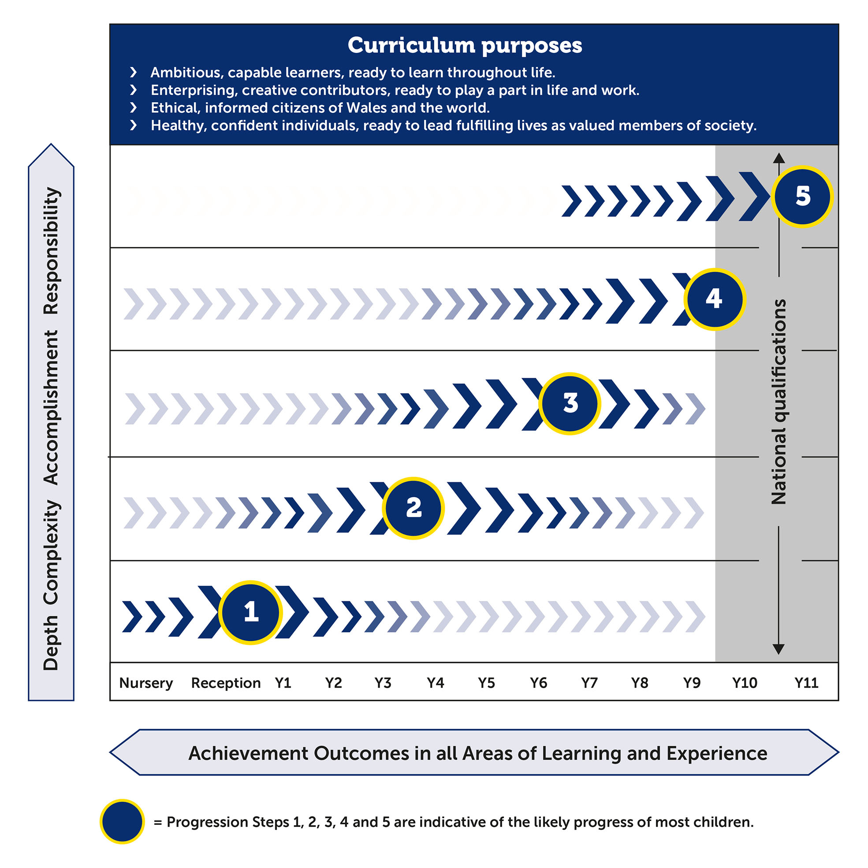
[source: Dauncey, 2021b]
This is a move away from the current system where decisions are made on the overall ability of a learner in a specific area and age across the allocation on a ‘best fit’ basis. The new achievement outcomes for each progression step will not be used to make ‘best fit’ judgements. In its place, they will be used on an ongoing basis to help adults decide is learners are ‘on track’ with their learning progression (Welsh Government, 2019).

In the new curriculum, interaction amongst children, adults, experiences, and environments are articulated in each developmental pathway throughout the statements and are purposely inextricably linked, making opportunities holistic and achievable for all children to reach their potential (Welsh Government, 2022c:26).

Achievement Outcomes for each of the six Areas of Learning and Experience will be used to define a pupil’s progress. These Achievement Outcomes will be portrayed from the learner’s own point of view, using phrases such as ‘I need to…’ ‘I am learning to…’ and ‘my… is enhanced by…’ for experiences and for outcomes (Dauncey, 2021b; and Welsh Government 2022c:26).

The ‘I need to ...’ are inclusive statements that apply to children of all abilities and should be used to support provision planning. These statements scaffold the fundamental opportunities children require to thrive and is the responsibility of the adult to recognise and understand these ambitions, so that positive play opportunities for children arise to fulfil their needs (Welsh Government 2022c:26).

The ‘I am learning to ...’ statements determine the skills children are building in their learning journey. If the adult recognise what children are learning to do, they will be able to deliver better learning experiences that can develop greater understanding, and chances to apply new skills in familiar environments. It is therefore vital that adults use their observations to provide support, guidance, and challenge when necessary (Welsh Government 2022c:27).

The ‘My ... is enhanced by ...’ statements portray the ideal conditions that can have a positive impact on the child’s social, emotional, cognitive, and physical development. How well adults respond to and plan for these developing needs will be the underpinning of success (Welsh Government 2022c:27).

Contrarywise, B-Squared (2021) states there is minimal guidance of implementation in the Curriculum for Wales, for pupils with Additional Learning Needs (ALN). While, the Government has taken into consideration children with ALN progress at individual rates, they state educators should use their own professional judgement about their pace of progression. As stated by Developing A Vision For Curriculum Design, cited by B-Squared (2021) children with additional needs progress at a rate individual to the learner and this may not correlate with the expected broad two-to-three-year progression step. However, in accordance with Welsh Government (2022d), children and young people with ALN, regardless of the severity of their learning difficulty or disability, are entitled to a statutory support plan called an Individual Development Plan (IDP). The National Deaf Society (2022) affirms IDPs portray a learner’s ALN and specify what support will be given to help them learn and are for children with ALN aged 0-16, as well as young people with ALN who attend sixth form or college aged 16-25. The IDPs must be available to learners with all levels of ALN, not just those with a high level of support needed.

To summarise, all children have unique talents. All babies, children and young people grow in every area of development at their own pace and in their own individual ways. By observing children supports adults to learn about and enjoy the unique qualities of each individual child. These observations portray the process of watching the children in our care, listening to them, recording what we see and hear, and should take place across a wide range of scenarios in an enhanced, continuous, and focused provision. These observation aid assessments by tracking progress, planning next steps, reporting, and involving parents, children, and young people in learning.

Section three- Blog
How can the enabling adult support children’s learning through loose parts play?

The term ‘loose parts play’ is being used more regularly in the previous years within the childcare education sector, especially within the introduction of the new curriculum for Wales. However, the theory has been around for a lot longer. Loose parts play theory was first introduced in the 1970s (NDNA, 2022). This report will be looking into the theory how the enabling adult can positively implement loose parts in the early years setting to effectively reach its full potential.

In accordance with Fox and Wirth (2016) architect Simon Nicholson used the term ‘loose parts’ to describe materials with varied properties that can be manipulated and moved in many ways. Nicholson theorised the richness of an environment depends on the opportunity it allows for children to interact and make connections with. He proposed that if educators wanted to develop children in a way to motivate creativity and innovation, we need to offer a variety of materials that can be moved, lined, stacked up, taken apart and put back together again with no specific way or instructions of playing with them. Children’s toys often have a fixed outcome and limited flexibility, whereas loose parts aren’t prescriptive and can become anything a child wants it to be, they offer limitless possibilities! (NDNA, 2022; Fox and Wirth, 2016; and Casey and Robertson, 2016)

While children engage in loose parts play, it is essential the enable adults support children’s skills development through varied opportunities and engaging experiences. In a nutshell, an enabling adult is someone who sets the expectation for learning by creating an environment that is emotionally safe and allows children to regulate and express their feelings. (Welsh Government, 2021b; and Welsh Government, 2020a). They are consistent in their care and model compassion, support learners to cope with uncertainty and changes in their daily routine and refine planning and the quality of the environment, making conscious adaptations to meet the needs for all children (Welsh Government, 2022c:8).

According to Welsh Government (2022c:12) multi-sensory experiences should provide opportunities for children to be inspired by the creativity of others and support them to communicate and express themselves. This can be achieved by adults providing a range of materials to choose from with different properties, encouraging children to develop their creativity, critical thinking and problem solving, all of which are vital to children’s overall development. Thorough their experiences, Welsh Government (2022b) continues to express, children should be able to explore how they and objects move in space and experience language that describes and can direct movement. This outdoors is most beneficial for this. As said by Williams (2022) learning outdoors can lead to high-levels of well-being, engagement, and confidence, whilst supporting children’s social, emotional, spiritual, and physical development, as well as providing authentic opportunities for learners to develop and consolidate cross-curricula skills.

Durant (2018) insists for children to thrive in the outdoors, settings need an environment that is safe, inviting, challenging, and stimulating, regardless of its space. It can be made interesting even if the equipment must be set up and stored away each day. It is important to remember the outdoor play setting may be the only place where children can independently orchestrate their own negotiations with the physical and social environment as some children and families may have little or no access to an outside area (Garrick, 2009:21; and Durant, 2018). Moorhouse (2019:23) also takes into consideration the settings who have little to no access to a rich outdoor environment affirms ‘how we set up the indoors and outdoors will have an impact on where children learn’.

Early childhood theorists and pioneers over several centuries have been staunch advocates of the benefits of children and young people playing outside spending frequent time in nature, as stated by Casey and Robertson (2016). Who also believes many education approaches such as Steiner and Montessori advocate the need for real experiences to acquire life skills and playing with various loose part materials assist with these approaches as there is a long-standing tradition of using household items for play. However, according to NDNA (2022) the idea of what resources constitute to ‘loose parts’ can sometimes lead to confusion. For instance, many see loose parts being represented by natural or found materials only, but loose parts can be a collection of natural, or even man-made materials which can be used to build upon children’s play experiences. Loose parts can be natural or synthetic. The picture table diagram below gives educators examples of materials.
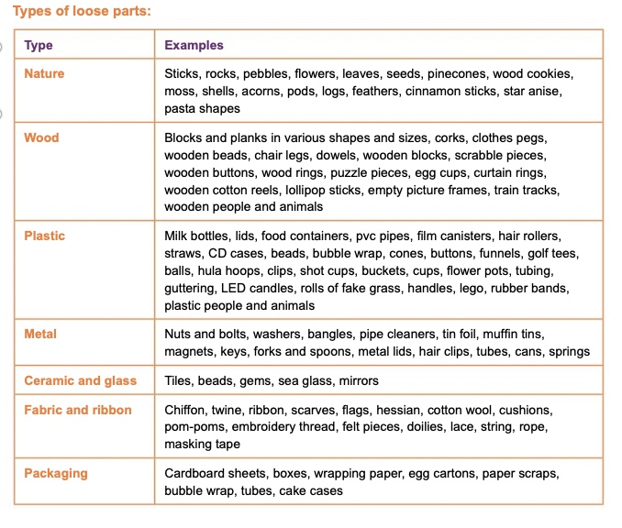

[source: Play Wales, 2020]

Sustained and focused learning is regularly observed as children engage in loose parts play and the action of the child is clear, claims Nature Play SA (date unknown). Although the learning is often child-led and self-directed, educators play a vital role in facilitating these experiences often knowing when to watch, wait and support. Adults need to model, support, and nurture a child to see beyond the literal and into the world of possibilities. Moorhouse (2019:23) believes the role adults play in creating a rich resourceful environment actively extends and reflects on children’s learning. Adults must show a genuine interest and sensitively interact, when appropriate, to extend their thinking by supporting them to develop their ideas, find solutions and make new connections. Their role is to show joy in their environment, expressing awe and wonder in the remarkable connection’s children embark through loose-parts play, as emphasised by Kingston-Hughes (2020), because if the practitioner is uninterested or limits exploration and experimentation, then the child’s relationship with the same environment can stagnate.

Buchan (2017:19) believes the role of the adult is also to remove or eliminate risks posed by bad hazards while encouraging the risks and challenges when playing outdoors. Buchan (2017:19) believes having a risk-taking disposition is a great advantage in life as she states research has shown that children who are risk-takers in the outdoors are also risk-takers indoors as they are more likely to attempt a difficult question or try a new book or activity. Casey and Robertson (2016) recommend promoting an equalised approach which involves a balanced and proportionate approach to the risk assessment process. Buchan (2017:19) advises adults to look at hazards children may encounter ‘good or bad’ and urges the duty of the adult is to remove or eliminate the risks posed by bad hazards while encouraging the risks and challenges from good hazards that the children can negotiate by themselves.

To conclude, loose parts play essentially is all about exploration, discovery, tinkering and experimenting, children may play for the sake of playing, but soon they will be beginning to explore how the items work by combining them in different ways. It is very important, as educators, to see the value in children and young people exploring materials and items. It is by repeating patterns of behaviour during play with many different objects that children and young people can construct knowledge and meaning about the world. So next time, you see a child or young person transporting items from one place to another, stacking objects on one another or pulling and putting objects together, remember that they need to tinker before they can create!

References

Ayling, P (2022) Respecting the values and individuality: the rights of the child. Available at: http://oars.uos.ac.uk/2586/ [Accessed: 21 October 2022]

B-Squared (2021) Curriculum for Wales 2022, B Squared Assessment Overview. Available at: https://www.bsquared.co.uk/wp-content/uploads/2021/08/B-Squared-Curriculum-for-Wales-Assessment-Overview.pdf [Accessed: 23 October 2022]

Basford. et al., (2011) Successful Placements in Early Years Settings. Exeter: Learning Matters

Bellman, M. et al., (2013) ‘Developmental assessments of children’ Bmj, p.346, available at: https://doi.org/10.1136/bmj.e8687 [Accessed: 21 October 2022]

Buchan, N (2017) ‘Putting the ‘natural’ back into play and provision’ Early Years Educator. 19(2), pp.18-20

Casey, T., and Robertson, J (2016) Loose Parts Play. Edinburgh: Inspiring Scotland

Dauncey, M. (2021a) Donaldson Review: The ‘purposes’ and content of a Curriculum for Wales. Available at: https://research.senedd.wales/research-articles/donaldson-review-the-purposes-and-content-of-a-curriculum-for-wales/ [Accessed: 21 October]

Dauncey, M (2021b) Donaldson Review: An end to Key Stages and a change to the way we structure pupils' progression? [image] Available at: https://research.senedd.wales/research-articles/donaldson-review-an-end-to-key-stages-and-a-change-to-the-way-we-structure-pupils-progression/ [Accessed: 23 October 2022]

Department for Education (2022) Early Years foundation Stage profile 2023 handbook. Available at: https://assets.publishing.service.gov.uk/government/uploads/system/uploads/attachment_data/file/1109972/Early_Years_Foundation_Stage_profile_2023_handbook.pdf [Accessed: 21 October 2022]

Devarakonda, C. (2013) Diversity & Inclusion in Early Childhood: An Introduction. London: Sage Publications Ltd.

Donaldson, G. (2015) Successful Futures: Independent Review of Curriculum and Assessment Arrangements in Wales. Available at: http://dera.ioe.ac.uk/22165/2/150225-successful-futures-en_Redacted.pdf [Accessed: 14 October 2022]

Durant, S (2015) The value of outdoor play. Available at: https://www.communityplaythings.co.uk/learning-library/articles/the-value-of-outdoor-play [Accessed: 16 October 2022]

Early Years Matters (2022) Observation, Assessment and Planning. Available at: https://www.earlyyearsmatters.co.uk/eyfs/a-unique-child/planning/ [Accessed: 21 October 2022]

Evans, G (2015) What is the Foundation phase Profile? A teachers guide to Wales’ new tool Wales Online. Available at: https://www.walesonline.co.uk/news/education/what-foundation-phase-profile-teachers-9984664assessment [Accessed: 23 October 2022]

Fox, H., and Wirth, S (2016) The learning in loose parts. Available at: https://www.communityplaythings.co.uk/learning-library/articles/the-learning-in-loose-parts [Accessed: 16 October 2022]

Garrick, R (2009) Playing outdoors in the early years. London: Continuum International Publishing Group

Gov (date unknown) Types of school, Private schools. Available at: https://www.gov.uk/types-of-school/private-schools [Accessed: 14 October 2022]

James, D (2021) Welsh GCSE reforms amount to educational vandalism on an epic scale. Available at: https://capx.co/dumbed-down-schools-will-set-welsh-children-up-to-fail/ [Accessed: 16 October 2022]

Karuppiah, N., and Berthelsen, D. (2011) ‘Multicultural education: The understandings of preschool teachers in Singapore’ Australasian Journal of Early Childhood, 36(4), pp.38-42 https://doi.org/10.1177/183693911103600406 Available at: [Accessed: 21 October 2022]

Kingston-Hughes, B (2020) Loose Parts Play- Think out of the box. Available at: https://www.nurseryworld.co.uk/features/article/loose-parts-play-think-out-of-the-box [Accessed: 16 October 2022]

Lewis, B. (2022) ‘Wales schools: New lessons ‘exciting but a challenge’’ BBC News. Available at: https://www.bbc.co.uk/news/uk-wales-61787090 [Accessed: 13 October 2022]

Mithila, R.R (2015) ECD, individuality during Early Years. Available at: https://bdeduarticle.com/appreciating-individuality-during-early-years-a-case-study/?amp [Accessed: 21 October 2022]

Moorhouse, P (2019) Outdoor environments, Developing outdoor learning spaces. Community Playthings

National Deaf Society (2022) Additional learning needs (ALN) in Wales. Available at: https://www.ndcs.org.uk/ALN-Wales#IDPs [Accessed: 12 October 2022]

Nature Play SA (date unknown) The power of loose parts play. Available at: https://www.education.sa.gov.au/sites/default/files/npsa-familyday-care-loose-parts.pdf [Accessed: 16 October 2022]

NDNA (2022) A Brief Introduction to ‘Loose Parts Play’ Wales. Huddersfield: National Early Years Enterprise Centre

Oxford Learners Dictionaries (2022) Unique. Available at: https://www.oxfordlearnersdictionaries.com/definition/english/unique?q=unique [Accessed: 21 October 2022]

Play Wales (2020) Thinking about loose parts in school. [image]. Available at: https://issuu.com/playwales/docs/thinking_about_loose_parts_in_school [Accessed: 16 October 2022]

Power, S. et al (2020) Curriculum reform and inequality: The challenges facing Wales. Available at: https://www.bera.ac.uk/blog/curriculum-reform-and-inequality-the-challenges-facing-wales [Accessed: 14 October 2022]

The Early Years Foundation Stage (2007) A Unique Child, Child Development. Available at: https://www.earlyyearsmatters.co.uk/wp-content/uploads/2011/03/eyfs_card_unique_child_dev1.pdf [Accessed: 21 October 2022]

The School Run (2022) The Curriculum for Wales 2022: what parents need to know. [blog] Available at: https://www.theschoolrun.com/curriculum-wales-2022-what-parents-need-know [Accessed: 14 October 2022]

Twinkl (2022) Progression Steps. Available at: https://www.twinkl.co.uk/teaching-wiki/progression-steps [Accessed: 23 October 2022]

Welsh Government (2017) Foundation Phase Profile Handbook. Available at: https://hwb.gov.wales/storage/f9d85dba-85a4-4e87-bb58-a24730ad7e57/foundation-phase-profile-handbook-revised-september-2017.pdf [Accessed: 23 October 2022]

Welsh Government (2018) How is my child doing in the Foundation Phase? Available at: https://gov.wales/sites/default/files/publications/2018-06/how-is-my-child-doing-in-the-foundation-phase-a-guide-for-parents-and-carers.pdf [Accessed: 16 October 2022]

Welsh Government (2019) Assessment and new curriculum. Available at: https://curriculumforwales.gov.wales/2019/04/26/assessment-and-the-new-curriculum/ [Accessed: 12 October 2022]

Welsh Government (2020a) Implementation and practical considerations. Available at: https://hwb.gov.wales/curriculum-for-wales/designing-your-curriculum/implementation-and-practical-considerations [Accessed: 18 October 2022]

Welsh Government (2020b) Introduction to Curriculum for Wales guidance. Available at: https://hwb.gov.wales/curriculum-for-wales/introduction/ [Accessed: 13 October 2022]

Welsh Government (2021a) Curriculum for Wales: Implementation plan. Available at: https://hwb.gov.wales/curriculum-for-wales/curriculum-for-wales-implementation-plan [Accessed: 13 October 2022]

Welsh Government (2021b) Enabling Pathways. Available at: https://gov.wales/sites/default/files/consultations/2021-05/enabling-pathways-consultation-document_0.pdf [Accessed: 18 October 2022]

Welsh Government (2022a) Six things you may not know about the new Curriculum for Wales. Available at: https://gov.wales/six-things-you-may-not-know-about-new-curriculum-wales [Accessed: 13 October 2022]

Welsh Government (2022b) Audit Wales report on the new Curriculum for Wales. Available at: https://gov.wales/audit-wales-report-new-curriculum-wales-html [Accessed: 14 October 2022]

Welsh Government (2022c) A curriculum for funded non-maintained nursery settings. Cardiff: Welsh Assembly Government

Welsh Government (2022d) The additional learning needs transformation programme: frequently asked questions. Available at: https://gov.wales/additional-learning-needs-transformation-programme-frequently-asked-questions-html [Accessed: 25 October 2022]

Wightwick, A (2022a) ‘The teacher who started his own school but won’t be teaching the new curriculum’ Wales Online. Available at: https://www.walesonline.co.uk/news/education/teacher-who-started-school-wont-25145124 [Accessed: 13 October 2022]

Wightwick, A (2022b) ‘The huge changes to how schools will teach in Wales next term’ Wales Online. Available at: https://www.walesonline.co.uk/news/education/huge-changes-how-schools-teach-24869472 [Accessed: 13 October 2022]

Wightwick, A. (2022c) ‘What teachers in Wales make of the controversial changes set to completely change how and what pupils learn’ Wales Online. Available at: https://www.walesonline.co.uk/news/education/wales-education-news-exams-curriculum-23769446 [Accessed: 14 October 2022]

Wightwick, A. (2022c) ‘What teachers in Wales make of the controversial changes set to completely change how and what pupils learn’ Wales Online. Available at: https://www.walesonline.co.uk/news/education/wales-education-news-exams-curriculum-23769446 [Accessed: 14 October 2022]

Williams, S. (2022) Increased role for outdoor learning and natural environment in new school curriculum. Available at: https://naturalresources.wales/about-us/news-and-events/blog/increased-role-for-outdoor-learning-and-natural-environment-in-new-school-curriculum/?lang=en [Accessed: 10 October 2022]

