
Skills for the Workplace
Module Assignment Submission
Student Name: | AYODEJI MATHEW AJIBOYE
Student Number: | 1813316
Module No: | BMSK4003_LON
Assessment Title | A report evaluating the effectiveness of the use of modern technologies within the workplace and explore social media as a tool for marketing, information gathering and communication within the workplace.
Module Title | DIGITAL SKILLS AND RESEARCH METHODS
Lecturer: | JOY BOTU.

Table of Contents
Introduction.............................................................................................3
Evaluating Morden technology ...............................................................4
1.Time and Attendance System
2. Excel Application
Social Media ............................................................................................7
1.Facebook
2. Instagram
3. LinkedIn
Online presence ......................................................................11
Conclusions...............................................................................14
References................................................................................15

Introduction
Technology is putting together skills and techniques for the production of goods and services .We use technology for our daily activities. It has Impacted our lives in both positive and negative ways .According to Duck and McMahan ,(2015,p.106),“when a new technology is introduced in a society it is generally framed both as something that will save the world and something that intrusive and threatening.” Television, video games, mobile phones and internet are some of the examples of Technology.
Our addiction to technology has lead to creation of more advanced technologies, and this is really having an affect on our life most especially our relationship with others. “People are essentially viewed as powerless against the force of Technology”(Duck and Mcmahan, 2017,p.107).For example ,playing video games is a very serious addiction for children. And also People’s habit of spending most of there time on their mobile phones. In other words the positive impacts of Technology can not be under emphasised, most importantly in the work place .Modern Technologies are very useful in every organization sectors, such as Education and Medical Sectors, For training, as well as for marketing.
This report will focus on two Morden technologies used in my workplace, which are Time and Attendance system and Excel Application. Also the importance of social media as tools for marketing, Information and communication within the workplace will be discussed.

TIME AND ATTEDANCE SYSTEM.
This is a device that is used to record accurately every employees working hours. Tracking employee start and finishing time is a serious challenge . Before the invention of Time and Attendances system, self report or manual time sheet method were been used. The use of self report or manual time sheet give rooms for administrative irregularities. Employee Punctuality and absent can not be monitored. It encourages lateness to work and leaving work earlier than the end of the shift. But the Introduction of modern technology like Time and Attendance system changes everything .It changes employee attitudes towards work just as Duck and McMahan,(2016,p 106) claimed, that our world is influenced by Technology.
Time and Attendance system functions in different ways. Employee can either Access it using an Application, Fobs, mobile phones or Biometric .
TYPES OF TIME AND ATTEDANCE SYSTEM. Time and Attendance system using a time card: This requires employee to use a credit card looking time card to swipe the machine, and data is automatically transferred to produce computer generated time sheet . one of the disadvantages of this is that it encourages employee clocking in and out for each other.
Time and Attendance system using proximity cards ,badges and key fobs : This does not involve swiping, it requires the employee to pass the identity card, badges or fob in front of the reader machine, this type can also be used to track the movements of employee within the working facility.
Time and Attendance system using web-based login station: In this type, employee is digitally clocked in immediately they log in to the computer because a static IP address is triggered. It is used mostly for employees working from there personal computers .
Time and Attendance system using Biometric : This is the type used within my workplace. This eliminates the use of manual time sheet and also the habits of employee clocking in or out for another employee. Each employee is identify using a unique finger print or the use of eye scanning equipments, in some cases using facial recognition. This allows the employer to ensure that wages appropriately match the hours employee worked .Employees biometric is collected and stored in the Time and Attendance system using a software .This software identifies employees identity when they clock in or out of there shifts .It saves time and money. As stated by Rees-Pullman(2019)“Emerging technologies, such as biometrics, offers the best of both worlds, making the internet more secure in one click or less”.
Morden Time and Attendance system does more than monitoring employee punctuality, it can also be programmed to serve other work related purposes like ,Booking of holidays, report absent from work, and also describing to employees which task they are meant to undertake .

Excel. Excel is a Microsoft software program that uses spreadsheet to manage data and numbers using functions, shortcuts and formulas. It is a very important tool used by most Business organisations for their financial Analysis .It is used to manage any input data and these can be made into charts or graphs by using Excel software. The Organisation am working with has a very large number of employees, They rely on Excel Microsoft application to manage their employees data .In addition, they use Excel Microsoft spreadsheets to manage the Stocks of Cleaning materials been used monthly within the company. There is also disadvantages to using Excel, The spreadsheets vulnerability to viruses and its limited ability to store large number of data are disadvantages of using excel Microsoft.

Social Media .
This is a platform where people create, share or exchange information and ideas using technologies. Media and Technology are known to be working hand in hand. People usually rely on media and technology for specific relational reasons to connect with each other (Duck and McMahan,2016,p.109).
Social media connects people together, using various online communication Channels dedicated to community-based input, interaction, content-sharing and collaboration(Class notes) using technologies and media. “Especially when people are not at the same location, a sense of connection is created through shared experience with technology and media”( Duck & McMahan,2016,p. 109). This characteristic makes social media very important in Business and Education. Examples of social media sites are Facbook,Twitter,Istagram,google+ and LinkedIn. “This sites are constructed in ways that enable connection to take place. Intimacy, security, entertainment, knowledge, self-worth, and also other needs generated from relationships are also provided through their use”(Duck and McMahan,2016,p.127).
Social Media as a Marketing tools . The use of social media for marketing has been very important in Businesses due to its large number of social media users. Companies create a very strong online presence by interacting directly with customers online for brands promotions, product marketing ,foster new business, as well as brands competition. Most popular social media use for marketing is Facebook.
Facebook : is a social media website, where you can create a personal profile with information about yourself .It has a lot of users, therefor you can request friends, like pages and also share articles with your friends. It enhances online communication .This “online communication enables people to maintain and enhance existing relationship, reinvigorate previous relationship and create new relationships”(Duck & McMahan 2016).Employees can form a group chat within themselves at workplace on Facebook, discussing work related topics that can boost the image of their company. This enhances good relationship and good communication between employees within the work place. In addition, Facebook is a good social media tools for marketing. As a business owner, you can create a Facebook personal profile which can be used to create a Facebook business page. With your business page, you can book advertisement for your product on Facebook. Facebook will make your product advertisement visible to wider audience, it will promote your brands by making your business appear to all your friends list as well as people who are not on your friends list .You can have direct online interaction with your customers on Facebook, to expand the online community to win new followers and potential customers. Using Facebook for your business gives you a chance to get feedback from your customers. Customers can directly comments on your product Which can help grow your business. With customers review, you can evaluate your product and services For future production.
Instagram : This is another social network service, where you can’t create a personal profile to share photos and videos. Just like Facebook, information sharing, news and business marketing are also activities that are been exhibited on Instagram.
Facebook and Instagram are very useful and easy to use for advertisements and marketing. You can determine your audience and also track your campaigns. But the comparison between them can not be overlooked. Facebook has more daily user than Instagram and this means your product advertisement and marketing is more likely to reach more people on Facebook than on Instagram. Both social media platforms are very important tools to enhance your business growth, by targeting customers and also Engaging customers.
Social media and Employability. The use of social media for employability is a growing area for career services (Racheal,2014).people looking to join the labour market use social media to search for their desirable jobs .you can join groups that are related to your job search on Facebook, post comments and participate in group discussions regarding what is needed to get your desirable job. On Twitter, you can follow employers related to your career. One social media network that dedicated to Employability is LinkedIn.
LinkedIn. This is a social media site for business community, where a professional profile is created, containing your educational background, past working experiences. It keeps you connected with other LinkedIn users. With LinkedIn you can keep in touch with your colleagues at your work place. If potential employers search on Google, seeking for employee, your professional profile will appear on the search, this gives you a good chance of employment. Having LinkedIn professional account gives you access to companies information, you can demonstrate your interest by joining and participating in group discussions. You will be able to identify the skills that employees need to have in your career sector.
Social media as a tool for information. All social media website are tools for spreading information and news because they quick and easily accessible. Owing to large number daily users , information from all over the world can be accessed anywhere at any time because of fast growing technologies such as internet and mobile phones. Twitter is a good example of social media networking site that is good in disseminating information. Information about politics, sports, education and Entertainment published on Twitter is visible to all Twitter users.
Technology and Social media in turn has so many disadvantages. According to Ress-pullman(2019) “As we look at the future of the web, we’ll see technology move towards recreating these human, physical interactions”. Face to face communication is becoming less common. Lack of security is another disadvantage. Cyber attack is becoming imminent while using the internet. In addition, social media is been deemed not save because of the anti social activities on the social media websites, like Bullying and radicalisation. It is becoming a key source of information on disaster and crises, which can have negative impacts on some individuals. Bentham(2019) wrote that social media chiefs were blasted by MPs for their failure to remove terror posts from their sites to prevent people from seeing them.
Also in Business marketing, a negative review or comment from one customer on one of your products on social media can have a negative influence on other customers regarding your products or brand.

Online presence.
I have created an online presence using Facebook .“we need to create an online presence for recognition, providing opportunities and also collaboration and shared learning to build connection and also to show case our scholarly activity” (Beckingham,2014). Bellow is my Facebook personal profile page and also my Facebook business page . As a restaurant owner, am using Facebook as a tool to advertise my restaurant business and also to connect with my potential customers.
Links to my profiles:
https://www.facebook.com/ajiboyeayodeji.mathew
https://www.facebook.com/Maths-P-NigerianPortuguese-Restaurant-2191294947867447/

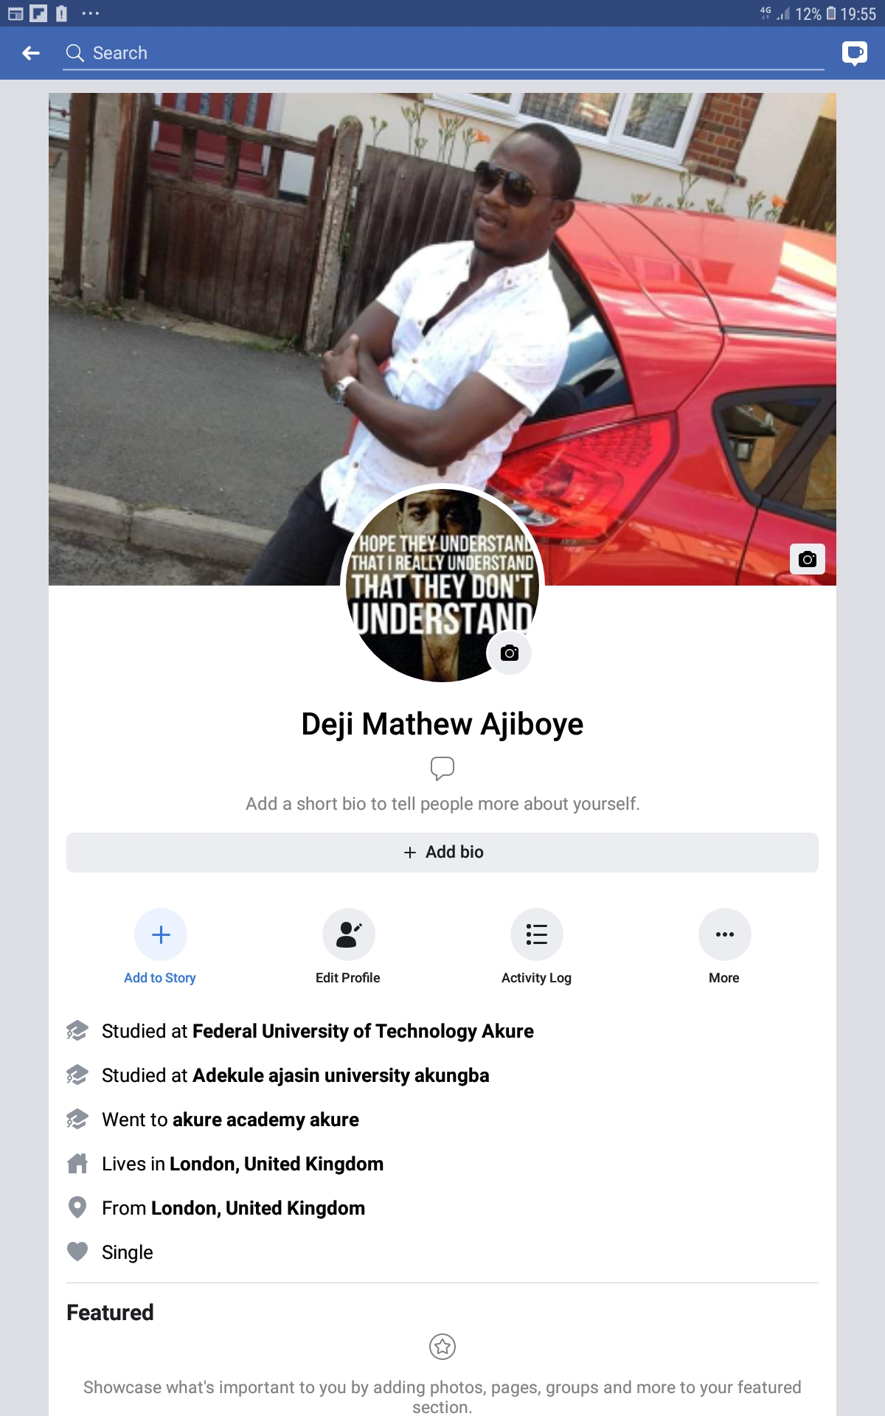
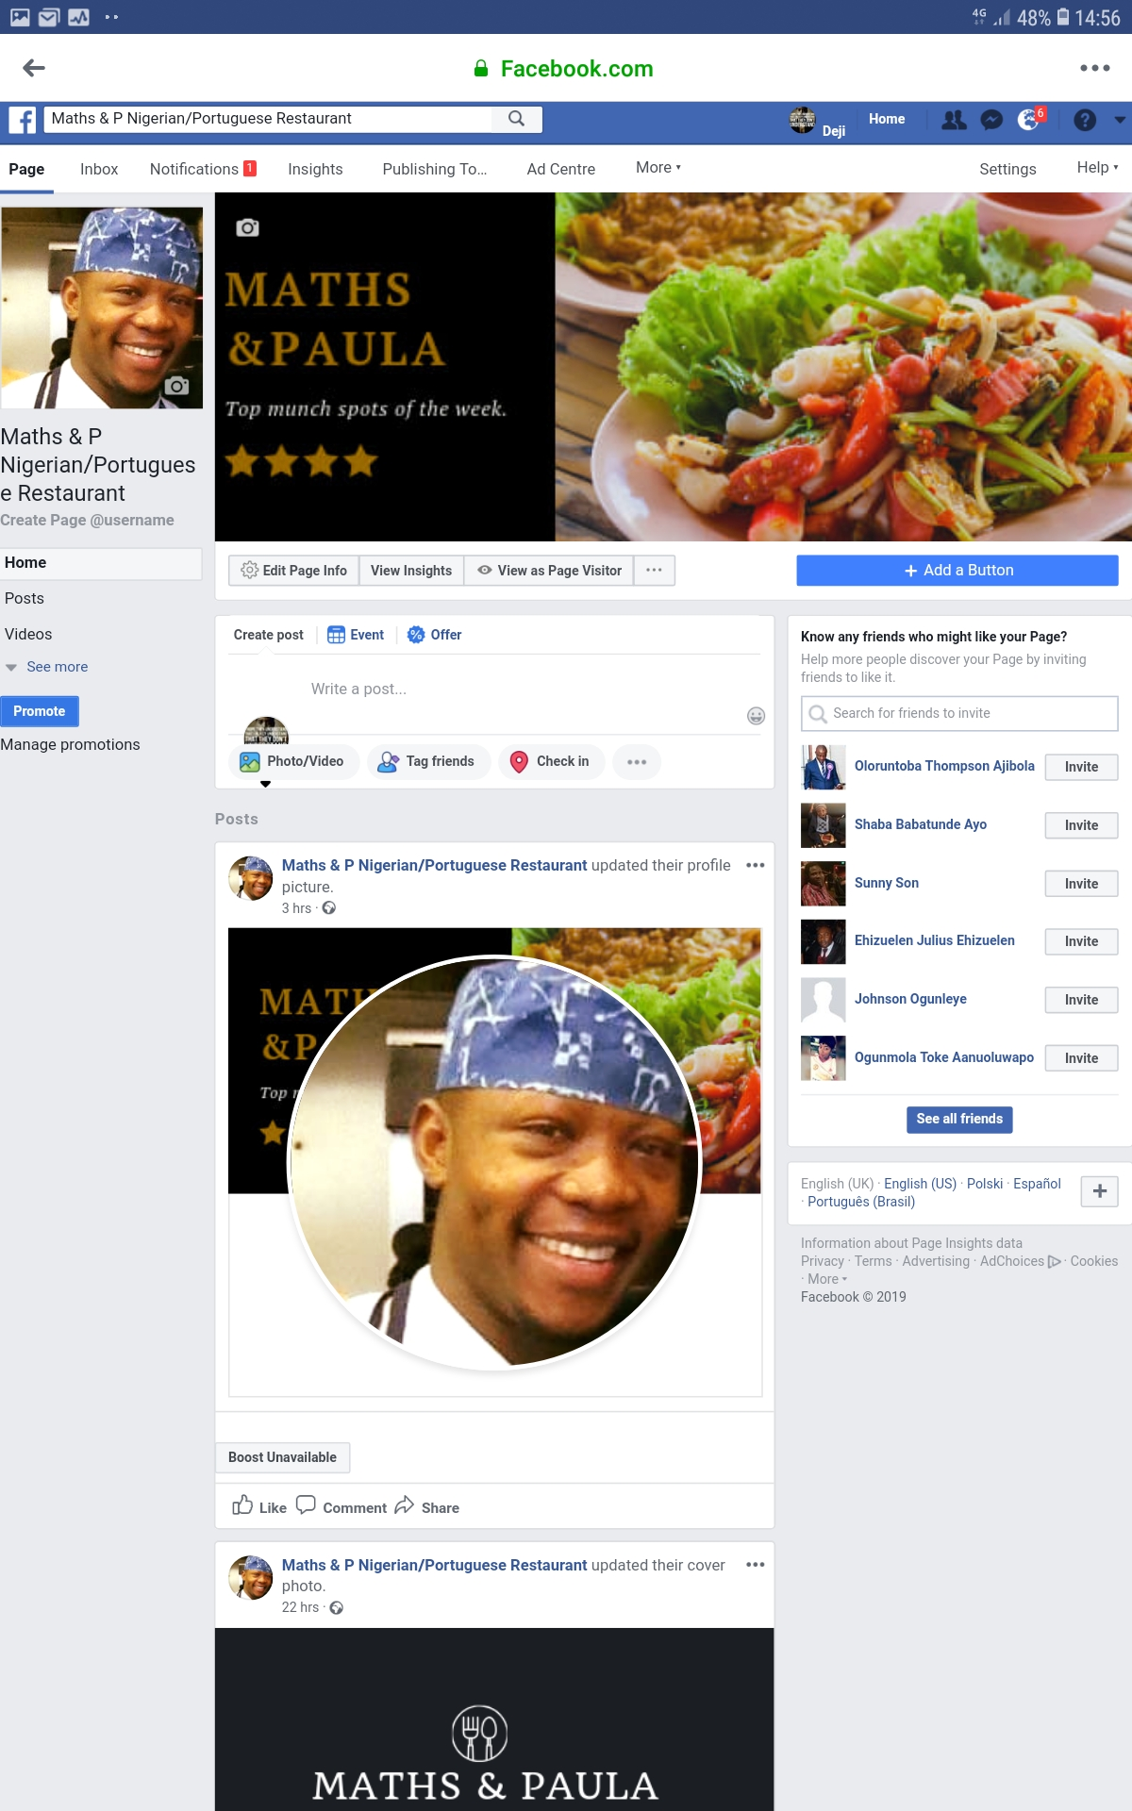

Conclusions

In Conclusion, Technology evolves with time and this is making our dependence on it inevitable while we ignore the danger it poses on our world. Our digital identity is fast replacing our physical identity. But there is no doubt that Technology is a wonderful thing, because it has brought developments to our world.

References

Duck,S and Mcmaha,D.T.(2016) ‘Technology and Media', in Mound, A, Shriek,M and Tinker,P.T (ed.) certificate in higher education:Skils for the workplace student yearbook. London: Sage .
Beckingham,S.(2014) why you need professional online presence. Available at: https://www.slideshare.net/mobile/suebeckingham/why-you-need-a-professional-online-presence-and-how-to-do-it-rscon5 (Accessed :29th April 2019).
Sheffield Hallam University (2014) Social media and employability. Available at : https://sites.google.com/a/my.shu.ac.uk/shusome/employability (Accessed: 29th April 2019).
Rees-Pullman,S.(2019) ‘The world wide web has come of age, now it’s time for digital identity to grow up too’, City Am,23rd April,p.20.
Bentham,M.(2019) ‘MPs blast Facebook and YouTube on terror footage’, Evening standard, 24th April,p.8.

