

School of Graphic and Digital Arts

Creative Practice 1
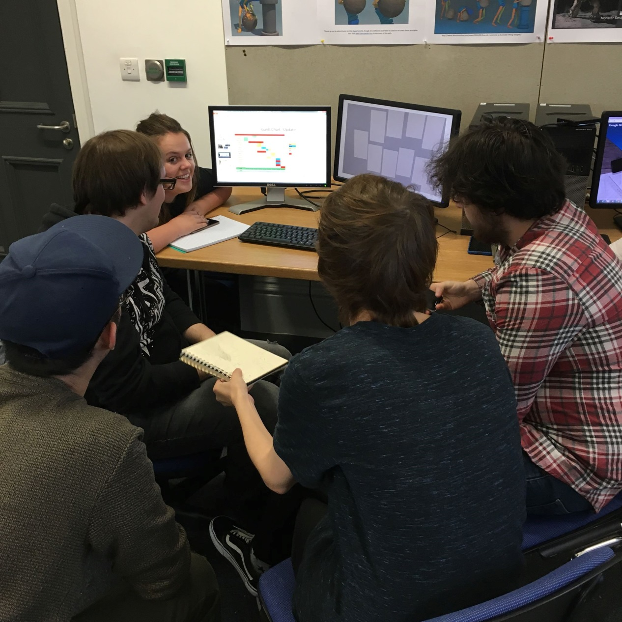

Module Code: M4X01557 2017-18

Creative Practice 1
20 Credits [48 hours Scheduled Learning; 152 hours Independent Learning]
Room: AA108a
Thursday: 10am – 12pm
Tutor: Scott Smith
Scott.L.Smith@uwtsd.ac.uk
SYLLABUS
In this module students will identify and develop ideas for subject-relevant media objects and, working in small, bring these ideas to fruition.
Teaching will initially relate to the production process itself but will then need to adapt to the needs of the students and the nature of the projects they are doing. This will inevitably require flexibility by the academic staff, and free interchange between groups.
Methodologies will be adapted to facilitate the flow of ideas across groups, to keep track of group progress, and to provide formative feedback .

AIM(S)
The aim of this module is to immerse the student in industry-relevant production processes.

LEARNING OUTCOMES
Upon the successful completion of this module, the student should be able to demonstrate the ability to:
- Understand and describe the production pipeline.
- Develop and produce simple new media objects within the context of a production team.

TIMETABLE
The course is taught over a twelve week period, starting in week one of Semester one. Sessions will primarily be student-led, being a mixture of seminar style group discussion, individual tutorials, and presentations.

BIBLIOGRAPHY
Essential
Cottrell, S. (2008) The Study Skills Handbook. Palgrave Macmillan.

Tharp, T. (2007) The Creative Habit: Learn It and Use It for Life. Simon and Schuster.

Recommended
Belsky, S. (2011) Making Ideas Happen: Overcoming the Obstacles Between Vision and
Reality. Penguin.

de Bono, E. (2007) How to Have Creative Ideas: 62 Exercises to Develop the Mind.
Vermilion.

Duarte, N. (2008) slide:ology: The Art and Science of Creating Great Presentations.
O'Reilly.

Johnson, S. (2011) Where Good Ideas Come From: The Seven Patterns of Innovation.
Penguin.

Graham, N. (2010) Project Management for Dummies. Wiley.

Nokes, S. (2007) The Definitive Guide to Project Management. FT/Prentice Hall.

Websites
www.acm.org

ASSESSMENT
Assessment Component 1 – Coursework 50%
Create a simple new media object from an idea and externalize and evidence the production process of the new media object. This is to be delivered as a Production Team presentation. In the presentations each student will be allocated 5 minutes (a team of 4 should take 20 minutes, a team of 5 should take 25 minutes etc.) with a possible 10 minutes for questions from teaching staff afterwards.

Given a scripted idea suitable for animation, develop and articulate an overall group ‘style’ from which is derived 1. Character concept design, 2. Environment concept design and 3. Prop concept design. Develop the story into 1. a storyboard sequence, 2. A colour script and 3. An animatic/animation with an audio track. The work from the storyboard and the colour script can be purposed into the animatic.
Hand-out: 19/10/2017 | Submission: 14.12.18

Assessment Component 2 – Analysis 50%
Externalise and evidence the group planning and development work by producing a 1000 word critical reflective analysis of the production process, include pictures of your work and documents used to advance the process (meeting minutes-appendix, not affecting word count, design items, team communication, etc)
Hand-out: 19/10/2017 | Submission: 14.12.18
Submit paper by uploading On Turnitin

FEEDBACK
Feedback is an essential part of all education and training programmes. It helps learners to maximize their potential at different stages of their development. It raises awareness of strengths and areas for improvement, and helps identify actions that can be taken to improve performance.

Feedback can be seen as informal (for example in day-to-day encounters between teachers and students or trainees, between peers or between colleagues) or formal (for example as part of a written assessment or presentation). However, there is no sharp dividing line between assessment and teaching in the area of giving feedback on learning. Feedback is part of the overall dialogue or interaction between teacher and learner, not a one-way communication.

