  Component One:  What are the key skills required when working in the housekeeping team? 750 words (+/- 10%)  Contribution to Overall Module Assessment: 25% | Student No: | 2128048
 | Module Title: | Operating Hotel Facilities
 | Module Code: | BMIH4006
 | Lecturer: | Lola Villard
The housekeeping team plays a vital part in maintaining the cleanliness and hygiene of public and private facilities. An effective and successful member of the housekeeping team has several important skills, including An eye for detail and organisation skills.
Housekeeping skills are essential skills that allow a housekeeper to be effective at their job. These skills can range from customer service, to being detail-oriented, and they may vary based on a housekeeper’s specific duties and place of employment. However, regardless of a housekeeper’s duties and place of work, they should possess several housekeeping skills to be successful at their job.
Among such skills, time management skills are paramount. Housekeepers most likely have to complete a set number of cleanings each day. Being able to properly manage time and a set schedule is a key skill needed by the housekeeping team to ensure they complete all cleanings on time. They must also be punctual and finish their tasks within the time frame expected.
Furthermore, a housekeeper must be extremely detail-oriented to be effective at their job. From organising various household items to ensuring that floors and windows are clean and everything is spic and span, these cleaning professionals need a keen eye for detail to successfully perform their duties. The more thorough a housekeeper is at completing their tasks, the better they will be at their job.
The members of a housekeeping team need also to regularly communicate with co-workers, supervisors and even guests in order to make sure that the expectations for each task are thoroughly understood. Without good communication skills, a housekeeper may not meet the needs of the company, or overlook important components required to complete a particular job.
The housekeeping staff will most likely pass guests or interact with them. Poor interaction or lack of etiquette will greatly affect this. Thus, common interpersonal skills needed by housekeepers in the performance of their job include dependability, teamwork and responsibility.
More often than not, housekeeping staff will be required to work different hours each day, based on the company’s needs. Being flexible and adaptable can help a housekeeper be available for more jobs and potentially make more money.
Housekeeping staff must also have strong customer service skills to be successful at what they do. Their work is based on the approval of the guests and of the company, so ensuring they are satisfied is key to being effective in this career.
Moreover, housekeepers need to develop several hard skills to be effective in performing their jobs. Hard skills are specific skills required to perform a certain task. Common hard skills needed to be a good member of a housekeeping team include: sweeping, vacuuming, mopping, carpet cleaning, deep cleaning, window treatment cleaning, dusting, polishing, bathroom and bedroom cleaning, touch points’ cleaning and disinfecting, infection control.
Steps must be continually taken to continue developing, refining and improving housekeeping skills, to become an overall more efficient member of a housekeeping team. Being organised is a key component of being a good housekeeper. One can improve their organisation skills by practicing in your own home and focusing on organisation each time one completes a specific project. All hotels offer training programs for new housekeepers, as well as training classes to help the housekeeping team improve their housekeeping skills.
The housekeeping team must also familiarise themselves with the cleaning equipment. Different types of equipment can be used for housekeeping. Common equipment includes laundry supplies, vacuum cleaners, mops and other machinery that can help housekeepers to effectively complete their jobs. Becoming familiar with housekeeping equipment and developing those necessary hard skills will help the housekeeping team complete their work more quickly and effectively.
Given that communication and punctuality are important components to being a good member of the housekeeping team, keeping a planner with all the details and requirements can ensure one does not forget or mix up anything. Such a planner might also be used to record any special notes for particular rooms. Consistency and attention to detail are key skills that housekeepers often need to be good at their jobs. The housekeeping team should also take pride in their work by knowing they have done the best job possible. This not only helps ensure your guests and your hotel are satisfied, but keeps one motivated in one’s work. For the housekeeping team to take pride in their job also encourages them to keep honing their skills so that they become more and more effective and successful.
The skills that a housekeeping team learn and hone can be the difference between the success and failure of a hotel. It is not just about having a clean and tidy room. The finishing touches through to the guest interactions all play a major part.

Word Count

Component Two:
Contribution to Overall Module Assessment: 25%
In this scenario – You have just been promoted to team leader for a floor within the hotel. A guest complains that on their arrival, their room had not been properly cleaned. Create an action plan and answer the following questions.

Problem | Why did it happen? | What are you going to do? | How will you prevent this from happening in the future? | What measures would you introduce to improve team effectiveness?
Room not properly cleaned | Identify all the causes. Go to the root of the problem. For the problem to be solved and with a view to ensure that such an issue is prevented from happening again in the future, all possible causes must be identified and analysed. Then, an action plan will be drawn up and implemented. | Sit down with the team and discuss what happened. Hear everybody out and ask their opinion a bout why this happened. Tigether with the team, create and put into practice an action plan meant to prevent this occurring in the future. | Depending on the causes of the problem, various actions and measures will be identified and put into place to prevent such an occurrence in the future. Going to the very root of the problem, customised measures will be implemented for each possible cause. | Bearing in mind that housekeeping and guest loyalty are directly proportional, first and foremost the causes of the problem must be identified and analysed thoroughly. Afterwards, specific measures meant to increase the housekeeping team efficiency will be implemented such as: use of detailed checklists for the cleaning of each room. Include all the points that need to be cleaned and/or checked, and a list of everything that needs replacing. Training: the training offered during onboarding is essential for the person to learn how to perform their duties and know how to comply with hygiene and safety standards. Furthermore, offering more training allows staff to become increasingly efficient. A team should be always kept motivated. People who are satisfied with their workplace and working conditions are less likely to leave and are also more productive. Increased productivity is the result of a union of people (your team), processes (the way housekeeping is organised), and technology. The benefits of a strong housekeeping team range far and wide. Not only does it impact reputation management, it can also affect a company’s ability to keep staff members and hotel guests safe. In conclusion, by performing regular housekeeping audits, creating a cleaning checklist, offering regular job training and keeping the staff motivated, it can be ensured that the brand quality standards are maintained, productivity and efficiency are increased, and, ultimately the guests are happy and come back to the hotel time and time again.

Component Three:
Contribution to Overall Module Assessment: 50%
Your task is to create and prepare a presentation following the detailed scenario provided below.

As the floor housekeeping manager and given the recent guest complaints you need to put together a basic training presentation for your colleagues within the housekeeping team to get the best out of them, ensure that brand standard is being achieved and that Health and Safety procedures are also being followed.

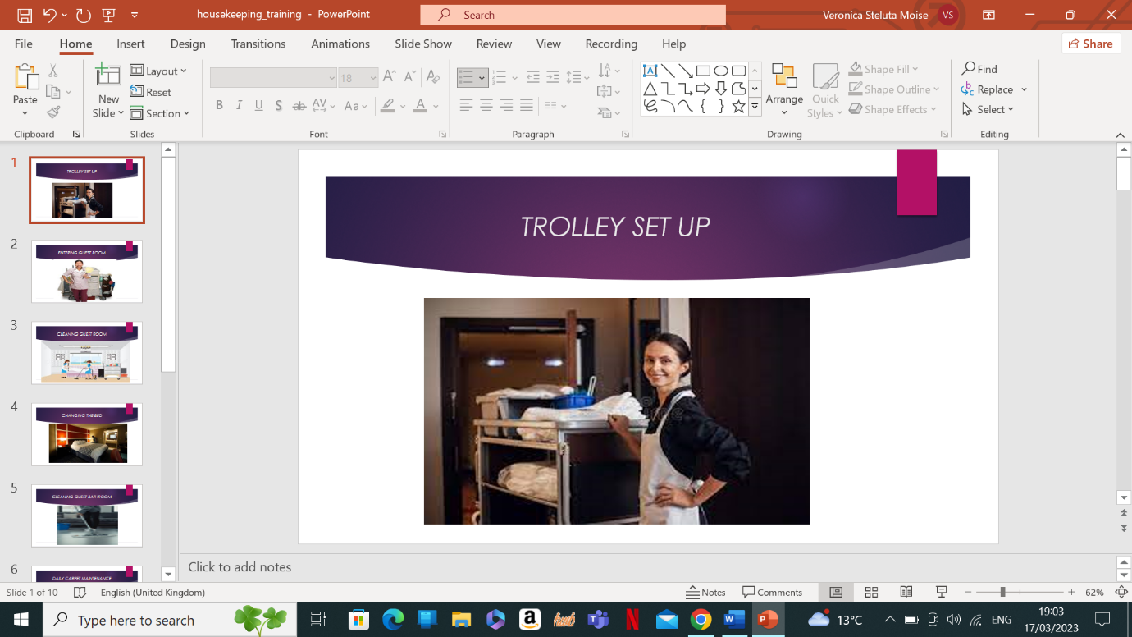

Training Notes: This is perhaps the most significant piece of equipment in the housekeeping department. It is like a giant toolbox, stocked with everything necessary to service a guest room effectively. The trolley should be well organised, so that the housekeeper does not have to waste valuable time in searching for supplies or make frequent trips back to the supply room.
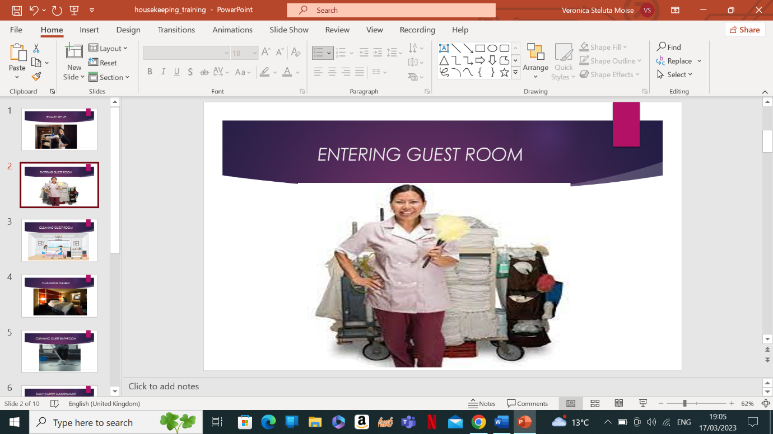

Training Notes: Respect for a guest’s privacy is the primary consideration when entering a room. Where there is a “Do not disturb!” sign on the door, obviously do not disturb the guest. Otherwise, knock on the door lightly and identify yourself as the “Housekeeping!”. If the guest is still in the room, ask for a convenient time when you could service the room. If not, start the housekeeping normal operation.

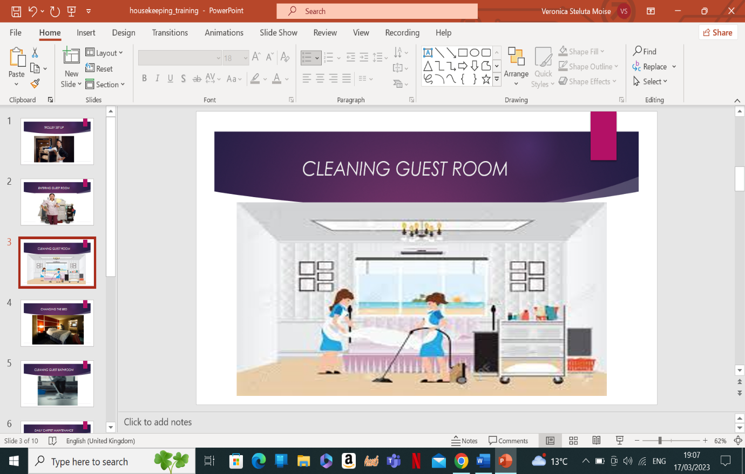

Training Notes: Follow the steps below when cleaning a room: prepare your cleaning material, chemicals and equipment; knock and enter the room; put on your gloves; prepare the room for cleaning; open the window; remove trash and linen and spray the bathroom; make the bed; dust, damp wipe and polish; replenish items; clean the floor; vacuum the carpet.

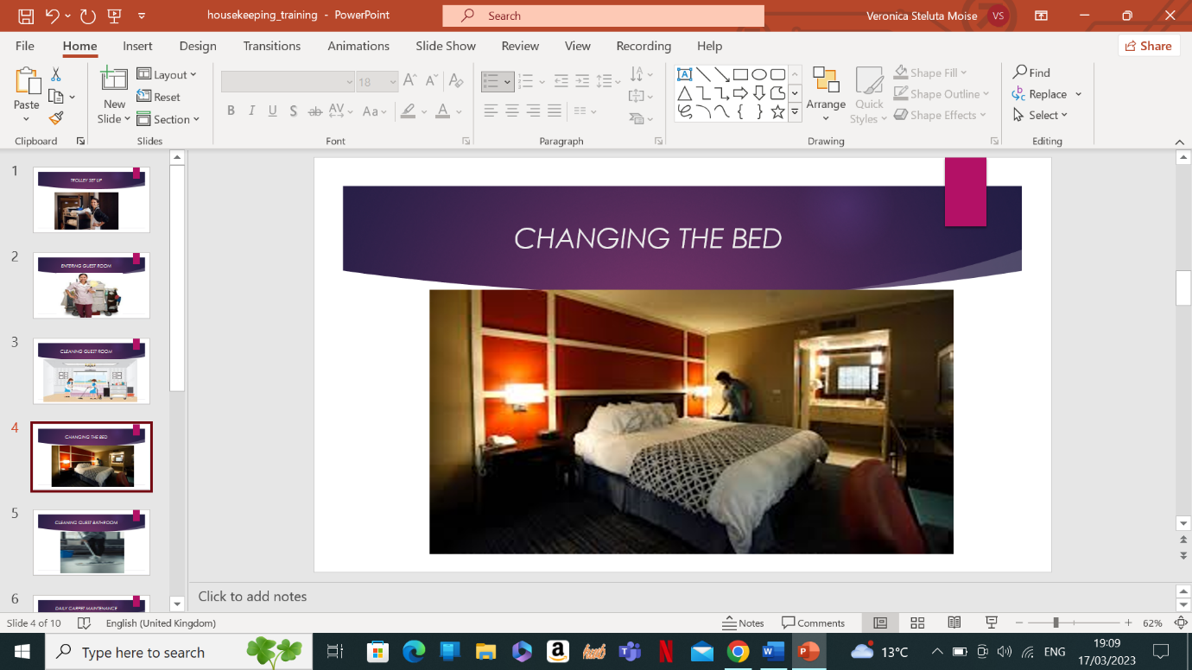

Training Notes: Remove bed linen and place it in the laundry bin in the housekeeping trolley. If the room is occupied by the same guest for more than one night, they do not necessarily need a change of sheets, in which case the housekeeper should just neatly remake the bed and get the room ready for their return (turndown service). Some hotels leave a card that the guest can place on the bed or doorknob to request a full linen change. Make the bed as per the hotel’s brand standards.

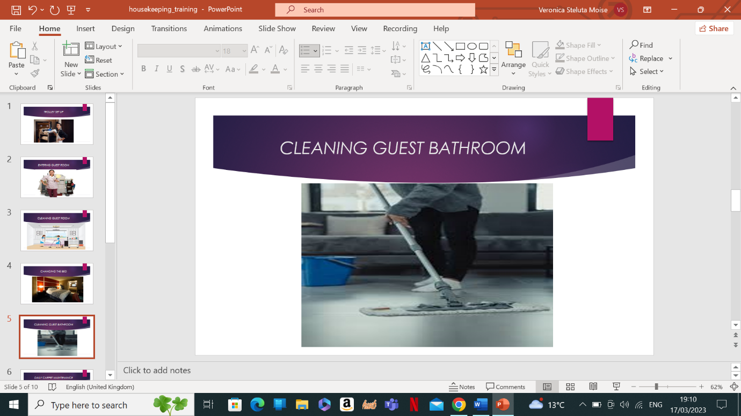

Training Notes: Remove all trash and dirty linen from the bathroom. Clean all surfaces with a disinfectant or antibacterial cleaner. Scrub the toilet, sink and shower. Rinse all surfaces with clean water. Dry all surfaces with a clean towel or cloth.

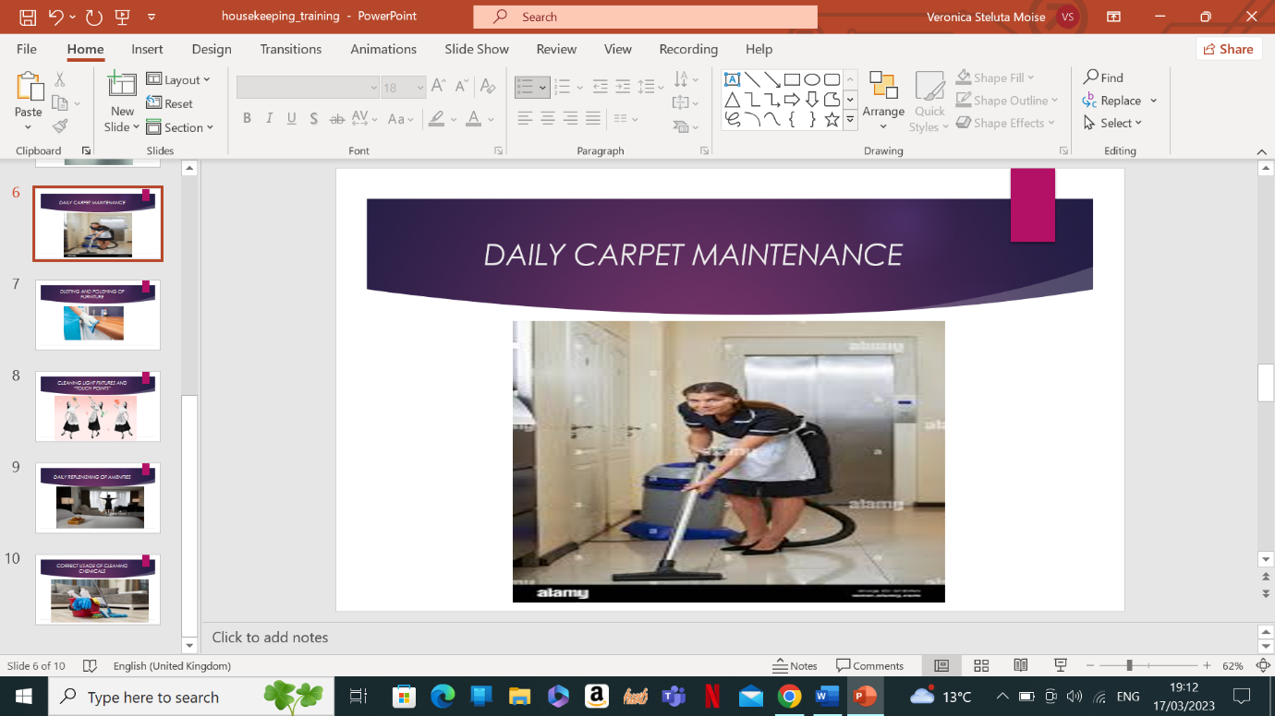
Training Notes: If possible, vacuum the carpets every day to remove surface dirt and dust. Use a vacuum with a HEPA filter and change the filter every six months, so you do not blow pollutants back into the air.

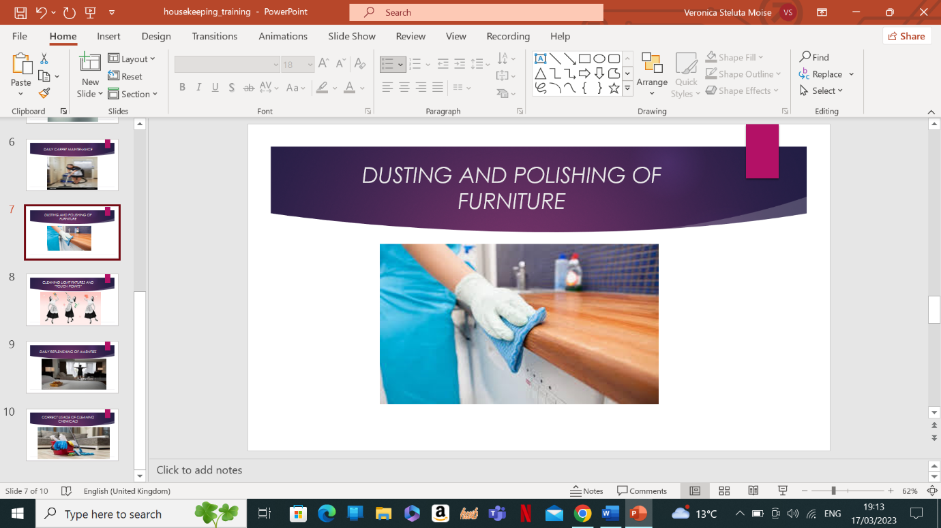

Training Notes: Start by wiping down the wood furniture with a barely damp microfiber cloth to remove dust and grime. One never wants water to sit on the wood, so quickly wipe it down with another dry microfiber cloth. For regular dusting, a quick wipe-down with a microfiber cloth will do the trick.

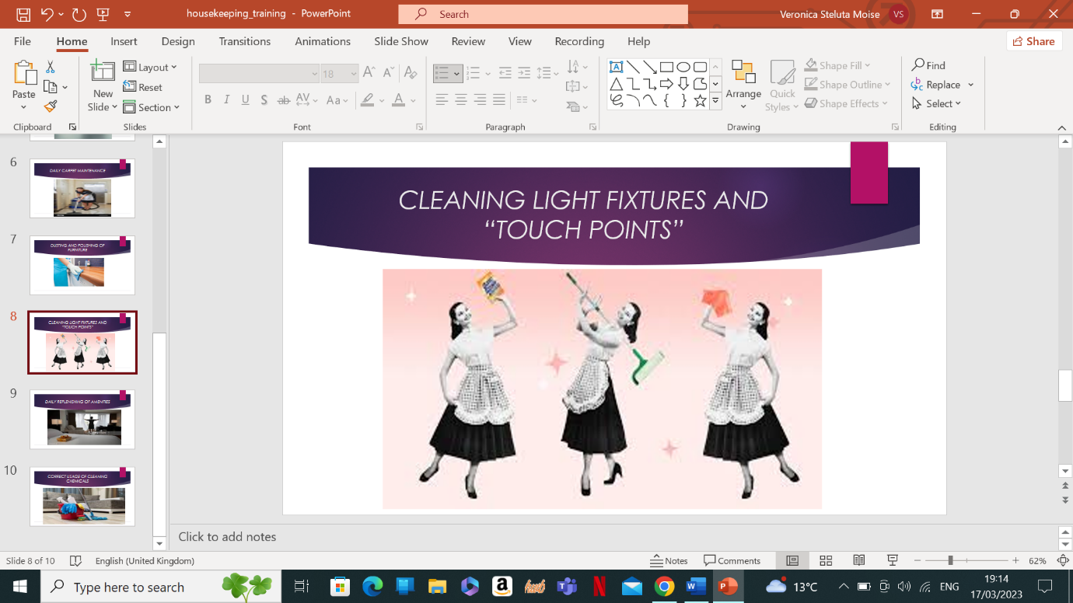

Training Notes: Clean the interior walls and around the bulb using a feather duster. Dust the exterior with a cloth, and then wipe it down with a damp cloth. For stubborn grime, spray a clean microfiber clothe with all-purpose cleaner and wipe the surface thoroughly. Touch point cleaning ensures those parts of your workplace which most often come into contact with people are thoroughly and individually cleaned and disinfected.
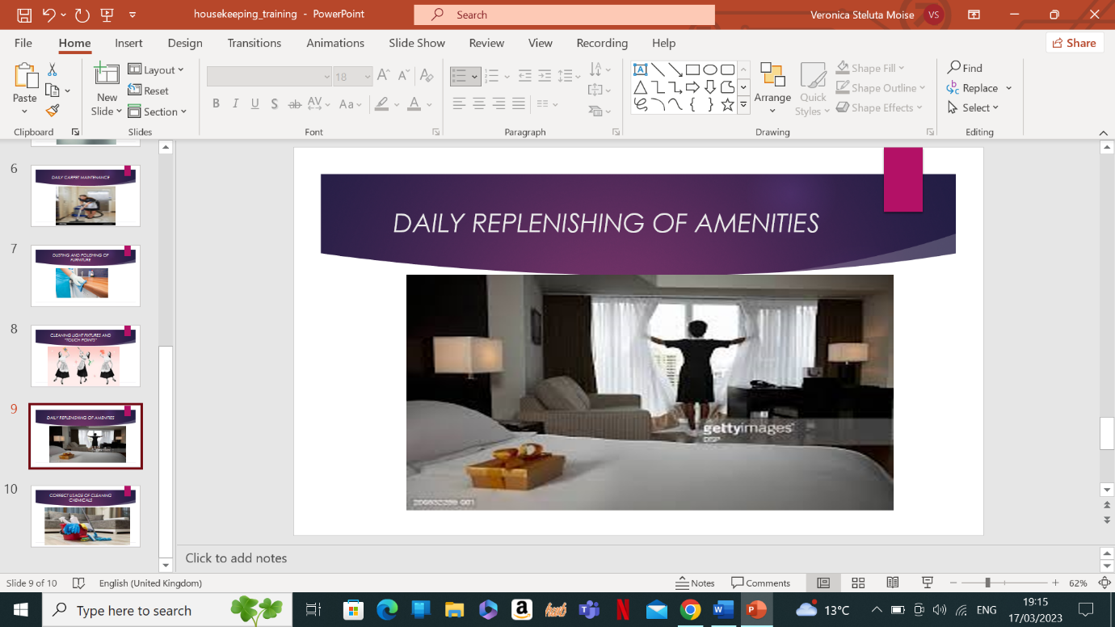

Training Notes: Amenities are things provided at no additional charge to make a guest’s stay more convenient and comfortable. Most hotels provide things like toiletries, hair dryers, shaving supplies, sewing kits etc. The guest rooms might be also supplied with tea, coffee, milk, sugar, sweetener. Restock all of these on a daily basis.

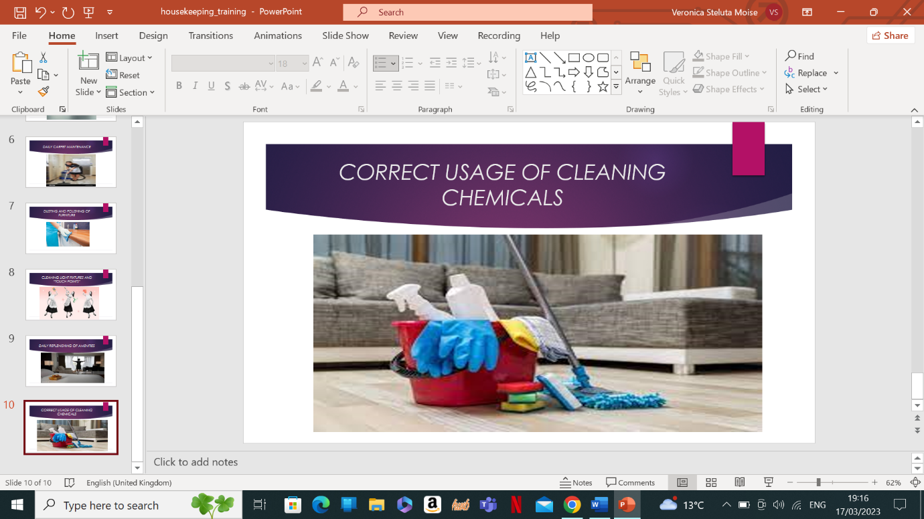

Training Notes: Several chemical products that are used as a part of the hotel operation pose potential hazards to human health and the environment, therefore they must be handled, stored and disposed of carefully. As safety procedure of using cleaning chemicals, ensure that the following steps are being complied with: sufficient ventilation when using cleaning chemicals; protective clothing, gloves and safety goggles when needed; labels on containers of cleaning chemicals; training on the hazards of cleaninc chemicals that are being used, and safe work practices.

References

Leiter, Michael P.; Bakker, Arnold B. (2010) Work engagement: a handbook of essential theory and research, New York: Psychology Press.
Mullins, Laurie J.,, Dossor, Penny (2013), Hospitality management and organisational behaviour, Harlow, England: Pearson.
Bridger, Emma (2018), Employee engagement: a practical introduction, 2nd edition, London: KoganPage.
Hotel housekeeping: operations and management (2015), 3rd edition, Oxford University Press.
Casado, Matt A. (2012), Housekeeping Management, 2nd edition, Hoboken, N.J: Wiley.
Jones, Thomas J. A. (2008), 5th edition, Hoboken, N. J.: John Wiley&Sons.
www.hospitality.com, (Accessed: 05 March 2023);
www.hilton.com (Accessed:10 March 2023);
www.premierinn.com (Accessed 05.03.2023);
Tesone, Dana (2010) Principles of management for the hospitality industry, 1st edition, Oxford: Butterworth-Heinemann an imprint of Elsevier.
Bardi, James A., Hoboken, N. J., Wiley, (2011) Hotel front office management, 5th ed., p. 100 – 290;
William S., Grey; Salvatore C. Liguori, Hotel and Motel Management and Operations;
www.hotelexecutive.com, (Accessed: 01 March 2023);
Verma, Rohit; Corgel, Jack B.,; Sturman, Michael C., Wiley, (2011), The Cornell School of Hotel Administration on Hospitality: cutting edge thinking and practice;
Tewari, Jatashankar R., (2009), Hotel front office: operations and management, Oxford University Press;
www.hospitality.net, (Accessed: 28 February 2023);
Vallen, Gary K., Vallen, Jerome J., (2014), Check-in check-out: managing hotel operations, 9th edition, Harlow, Essex;
Rutherford, Denney G.,; O’Fallon, Michael J., (2011), Hotel management and operations, 5th edition, Hoboken, N. J.; Wiley;
Wood, Roy C., (2013), Key concepts in hospitality management, London;
Walker, John R., (2021), Introduction to Hospitality, 8th edition, Harlow, England.

