Author: | Charles Gill | Student Number: | 0250767
Module: | Network Operating Systems and Services | Programme: | BSc (Hons) Software Engineering
Reference: | ACCA5023 - Worksheet 1 | Lecturer: | Nitheesh Murugan Kaliyamurthy
Date: | 12/03/21

Network Operating Systems and Services

A Report on how to Build, Deploy, Configure and Manage a Type 2 Hypervisor Platform Based Virtualised Network

Contents
Contents 2
Section 1. Overview 3
1.1 General 3
1.2 Purpose 3
Section 2. VirtualBox and Virtual Machines 4
2.1 Installation of VirtualBox 4
2.2 Creating Virtual Machines 5
2.2.1 Server VMs 6
2.2.2 Client VMs 8
2.3 Virtual Machine Settings 10
2.3.1 Install ISO location 10
2.3.2 Optimisation 11
2.4 Installation 13
2.4.1 Server installation 13
2.4.2 Client Installation 17
2.4.3 Issues encountered 29
Section 3. Virtual Network Configuration (Task2) 32
3.1 Server1 Network Settings 33
3.2 Client1 Configuration 36
3.3 Server2 and Client2 38
3.4 Firewall 40
3.5 Testing 42
Section 4. Observational Tasks (Q3) 44
4.1 Type 1 and Type 2 Hypervisors 44
4.2 Subnet Mask in IPv4 addressing 44
4.3 Cloud computing 44
4.4 Differing terminologies 45
References 46

Overview

General
The task is set in two parts, instructed by two worksheets. The aim is to build, deploy, configure and manage a Type 2 Hypervisor platform-based Virtualised network. Applying a systematic understanding of network operating system environments to then deploy, manage and maintain critical network services and resources. This report details the outcomes of creating the virtual machines on a virtual network and check connectivity.

Purpose
Use the following resources:
- Type 2 Hypervisor Management Software
Task 1 requests that the following is developed:
- Build a virtual network configuration, (Worksheet 1)
The above tasks comprise of Practical work and Observational tasks.
This document is laid out with the following structure:
- Section 1: is this overview.
- Section 2: Covers the installation of VirtualBox and the creation of the virtual machines.
- Section 3: Configuring the network
- Section 4: Observational Tasks * Some of these observations are made during the recording of the exercise as the terms were met.

VirtualBox and Virtual Machines
This section covers the installation of VirtualBox and the creation of four virtual machines, two servers and two clients. There are various technologies at play here to be able to provide this functionality and these are discussed in the report.

Installation of VirtualBox
VirtualBox is a program for creating virtual Machines implementing Hypervisor technology. VirtualBox allows the creation of Virtual Machines (VMs) within a Type 2 Hypervisor environment. Type 2 Hypervisors are described by Matthew Portnoy as
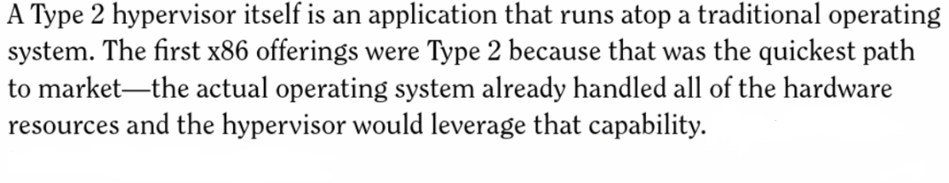 [1, p. 25]
This method of virtualisation utilises the host’s OS as this has already made the connections and built the driver sets to make use of the computer’s hardware. The Type 2 Hypervisor then utilises an API layer to access the hardware via the software and OS. This means that the Type 2 hypervisor can support a large range of hardware and they are easy to install and deploy.
However, they are not quite as efficient as Type 1 hypervisors as discussed by Matthew Portnoy below:
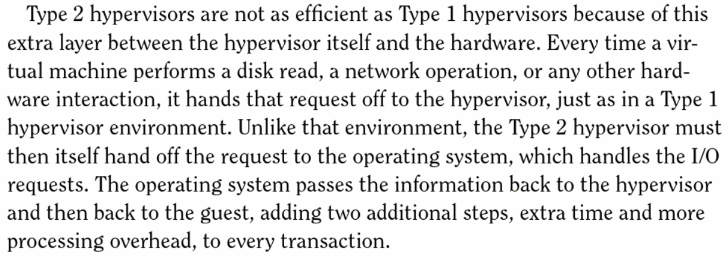 [1, p. 25]
The screenshots below detail the installation of VirtualBox.

Standard settings were used throughout the install.
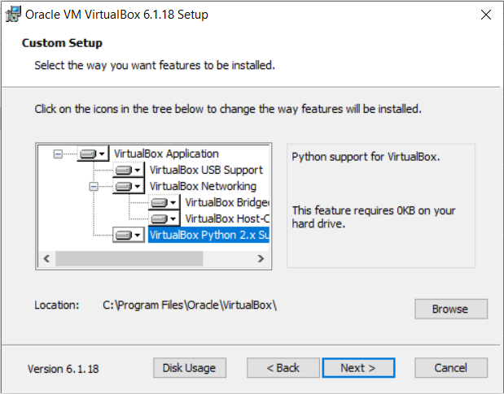
Presenting the user with the following main menu from which to start creating VMs.
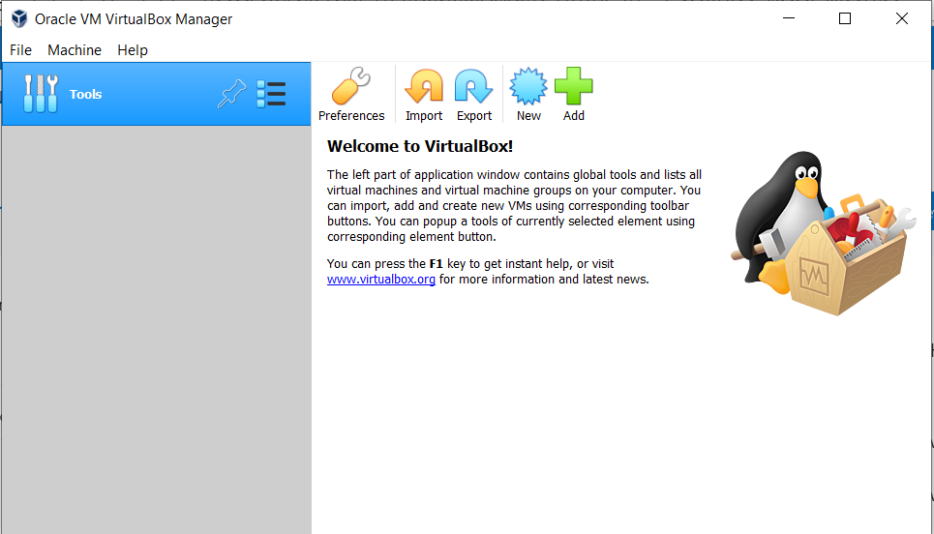

Creating Virtual Machines

The virtual machines were created by selecting New and completing the details as per the worksheet instructions:

Server VMs

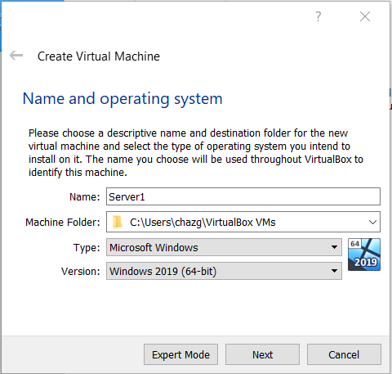

The name Server1
of type MS Windows
and version of
Windows 2019 (64-bit) were selected:

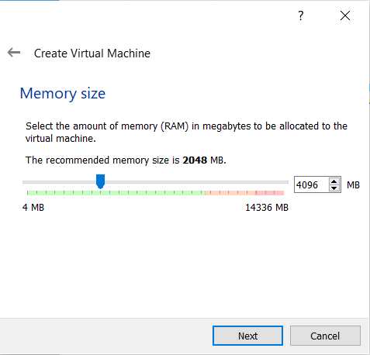

The memory of the virtual machine was set to 4GB or 4096MB.

The virtual machine requires a hard disk to be available to run. The following steps provide a virtual hard disk for the VM to access. The VM’s OS will be installed onto this virtual Hard disk.
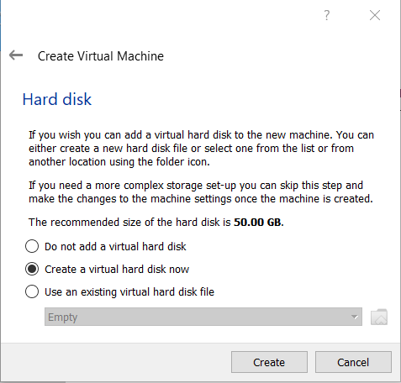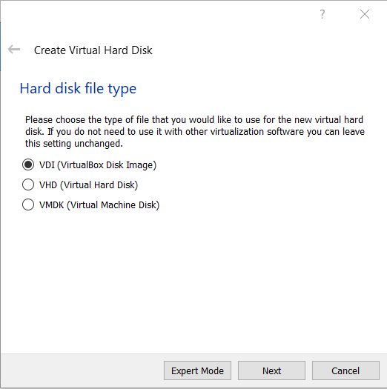
The types of hard disk file are described on VirtualBox’s website as below:
‘Oracle VM VirtualBox supports the following types of disk image files:
- VDI. Normally, Oracle VM VirtualBox uses its own container format for guest hard disks. This is called a Virtual Disk Image (VDI) file. This format is used when you create a new virtual machine with a new disk.
- VMDK. Oracle VM VirtualBox also fully supports the popular and open VMDK container format that is used by many other virtualization products, such as VMware.
- VHD. Oracle VM VirtualBox also fully supports the VHD format used by Microsoft.
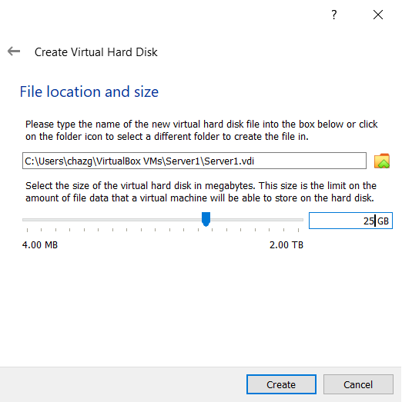
- HDD. Image files of Parallels version 2 (HDD format) are also supported.’ [2]

The size of which was then set to 25GB

The above steps were then repeated to setup a VM named Server2 with the same specifications.

Client VMs
The Client VMs were created in the same way but by altering the options, created the client machines that will attach to the servers ultimately.
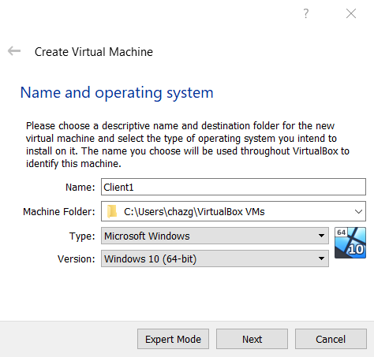

The name Server1
of type MS Windows
and version of
Windows 10 (64-bit) were selected:

The memory of the virtual machine was set to 4GB or 4096MB.

The virtual machine requires a hard disk to be available to run. The following steps provide a virtual hard disk for the VM to access. The VM’s OS will be installed onto this virtual Hard disk.
The size of which was then set to 20GB as opposed to the 25GB set for the Server VMs.
The above steps were then repeated to setup a VM named Client2 with the same specifications.
The screenshot below shows all four VMs having been created and available to run from the main/manager screen of VirtualBox:
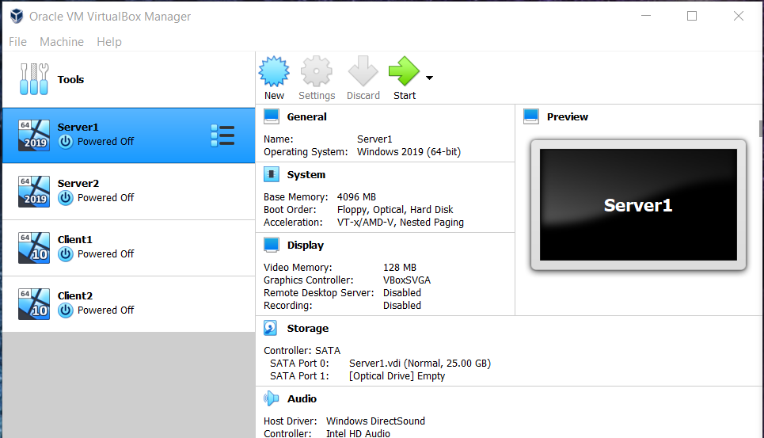

Virtual Machine Settings
The VMs require certain settings to be configured for a variety of reasons, some for the initial installation and some to increase the performance of the VM.

Install ISO location
An ISO file is defined by FilExt.com as
‘The ISO file type is primarily associated with ISO-9660 CD Disc Image. A literal dump of the data on the CD, byte-for-byte. The data is stored in the ISO-9660 format. IsoBuster can interpret these files directly.’ [3]
Two ISO files were downloaded containing the Microsoft Operating systems for Windows Server 2019 and Windows 10.
These were mapped to the CD drives of the virtual machines as below:

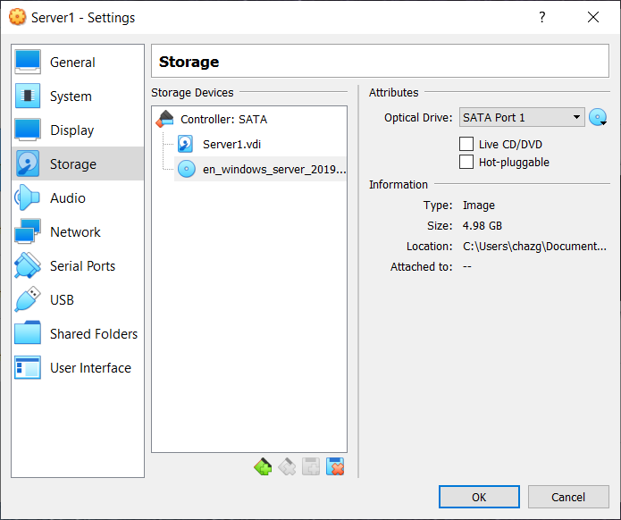

Windows Server_2019 for Server1 and Server 2.

And for the clients.

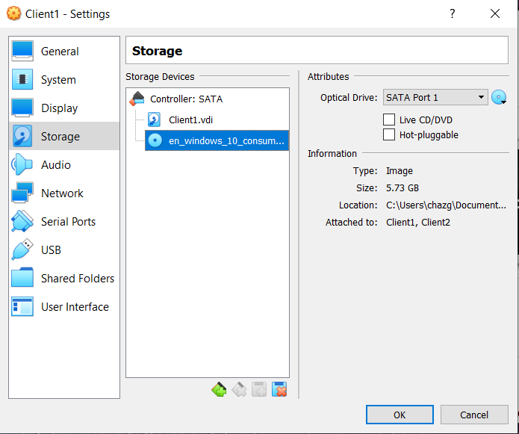

And Windows 10 for Client 1 and Client 2.

Optimisation
The VMs have a number of settings that can be modified to enhance the performance of them during running.
The worksheets describe these, and provide a link to a webpage that provides suggestions. The only ones that needed changing are shown below:
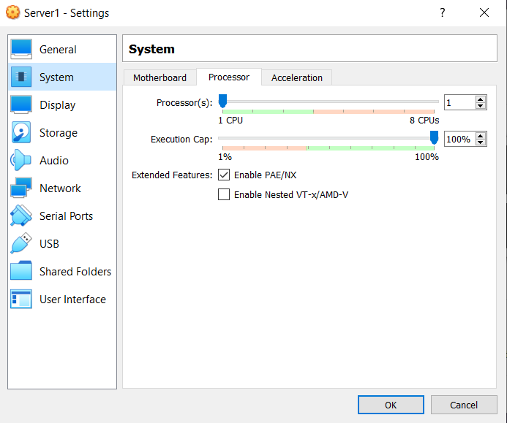

Enable PAE/NX.

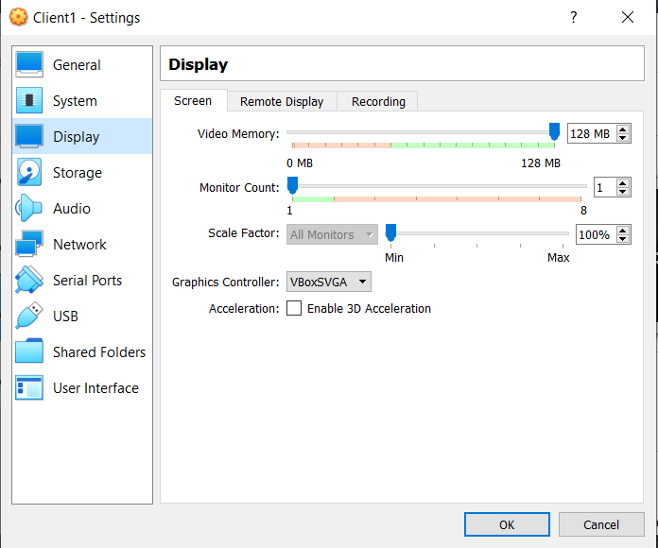

Set Video RAM to 128MB.

The PAE/NX setting relates to two technologies available within Windows. The Microsoft website describes PAE as
‘Physical Address Extension (PAE) is a processor feature that enables x86 processors to access more than 4 GB of physical memory on capable versions of Windows.’ [4]
Going on to mention that it also provides advanced features as below:
‘In 32-bit Windows running on x64-based systems, PAE also enables several advanced system and processor features, including hardware-enabled Data Execution Prevention (DEP), non-uniform memory access (NUMA), and the ability to add memory to a system while it is running (hot-add memory).’ [4]
Although the system running these VMs and the VMs themselves are all 64 bit and the RAM selected does not exceed 4GB, the NX section of the abbreviation stands for Non Executable. This is a flag that is set against certain memory locations to prevent execution of the contents. This links with the DEP above and is described by Microsoft below:
‘This option is also referred to as Data Execution Prevention (DEP) or No-Execute (NX). When this option is enabled, it works with the processor to help prevent buffer overflow attacks by blocking code execution from memory that is marked as non-executable.’ [5]
The above can help with security of a system and is set in line with the worksheets.
The Video RAM settings are to help the host system not be overloaded with the demands of the VMs video requirements. The VMs will not be graphically intensive in their use so the setting of 128MB is adequate.

Installation
Upon ‘starting’ the VMs there is no installed OS on the VDI, therefore the system looks to the CD drive to find the ISO that had been setup in section 2.3.1 above. Oddly, when the system started up VirtualBox provided a select start-up disk dialog box defaulting to the Windows 10 ISO instead of the Windows 2019 server ISO as setup above. Selecting the correct ISO here made sure that the correct OS was installed onto the server. The screenshots below detail the installation of the OSs.

Server installation
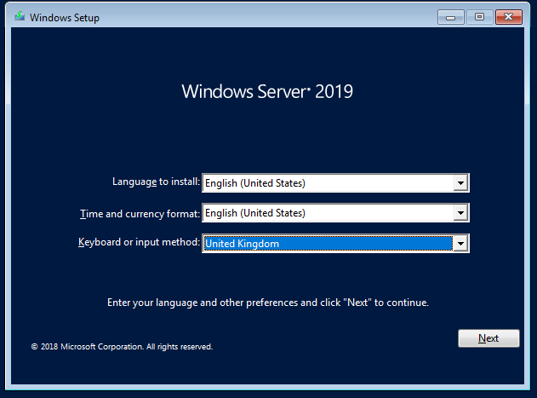

Install:

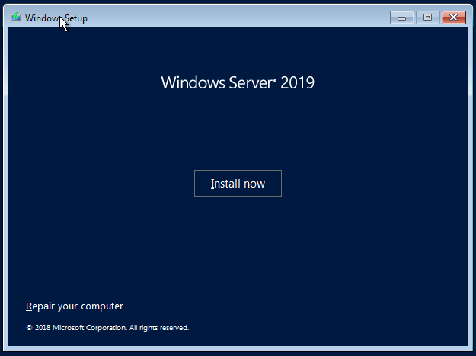
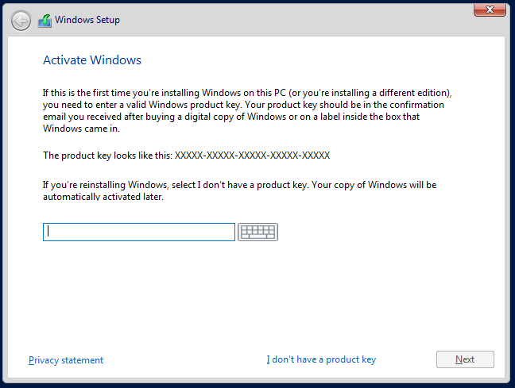

Windows activation –
No product key option selected.

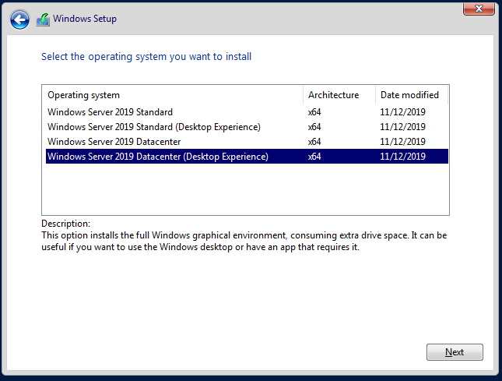

Windows Server 2019 DataCentre (Desktop Experience) selected

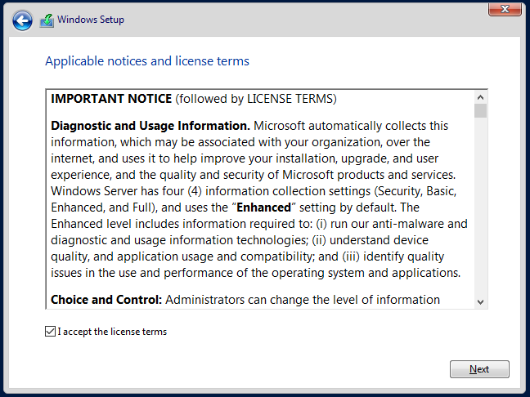

Accept terms.

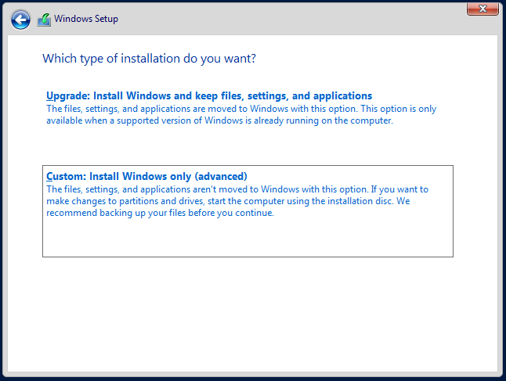

Custom installation selected as no previous OS to upgrade.

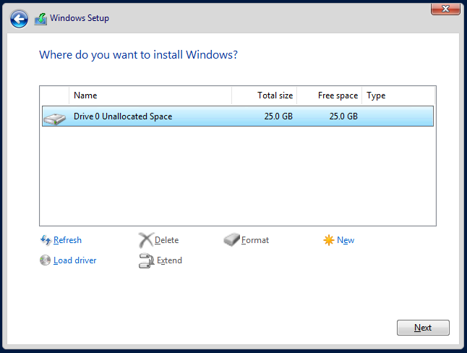

The drive listed as available for install is the 25GB VDI created in section 2.2.1.

Within the screen above it is possible to partition the drive further, format the partitions extend them. The ‘Load driver’ option is usually required if hardware RAID is being used. In this instance the above can be left as standard and the installer partitions and formats the drive ready for install.

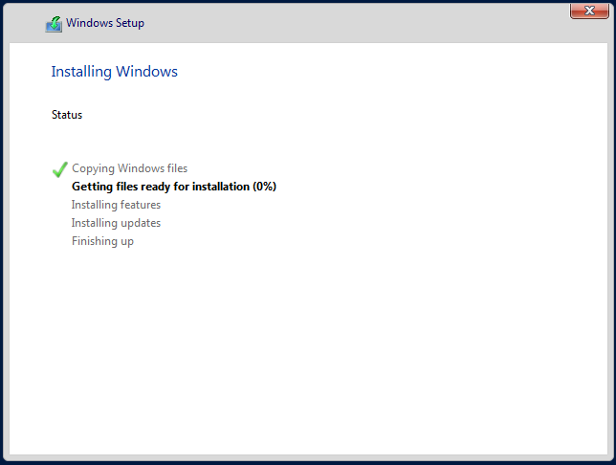

The following screen is displayed as the OS install files are copied and a bootable OS is created.

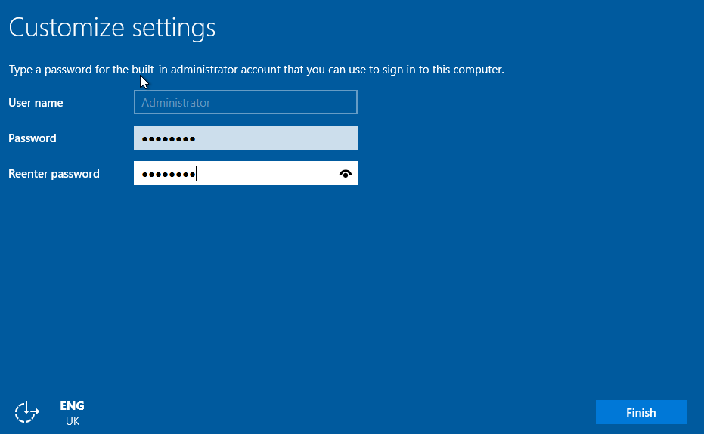

Set username and password as per the worksheet instructions.

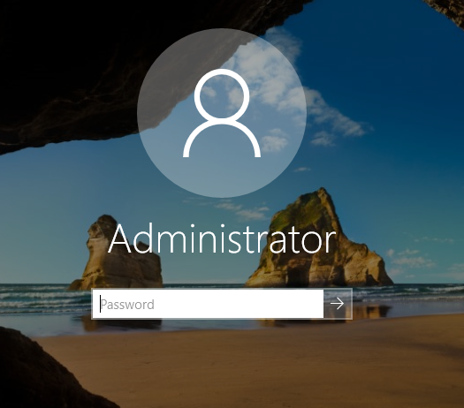

Windows 2019 Server Login screen available.

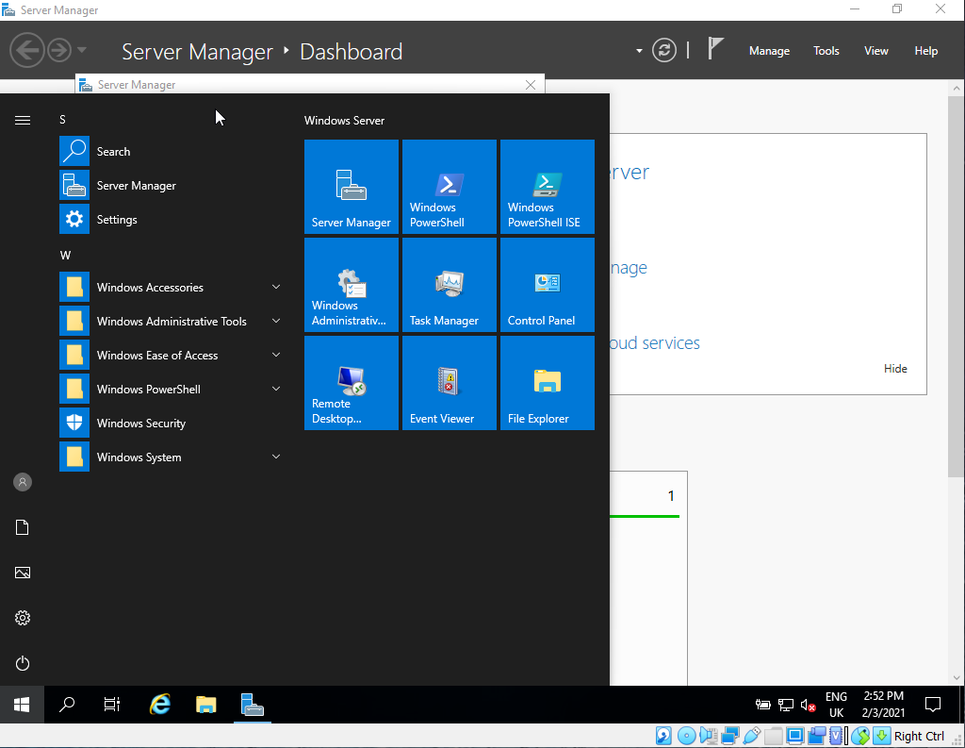

Server logged in as administrator.

Shutdown and repeat for Server 2.

Client Installation

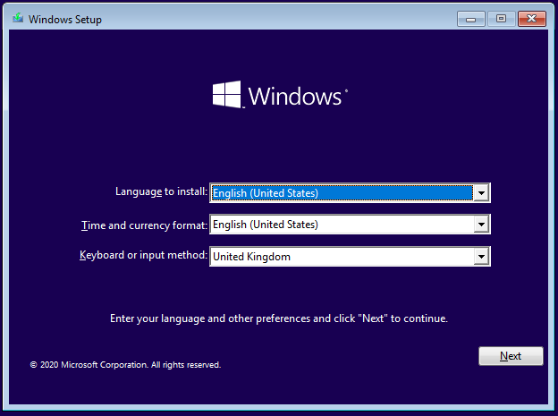

Install Windows 10 Pro on Client from Windows 10 ISO.

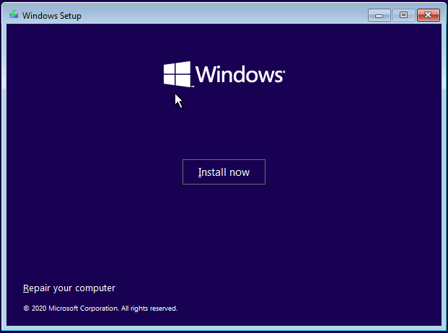

Install screen.

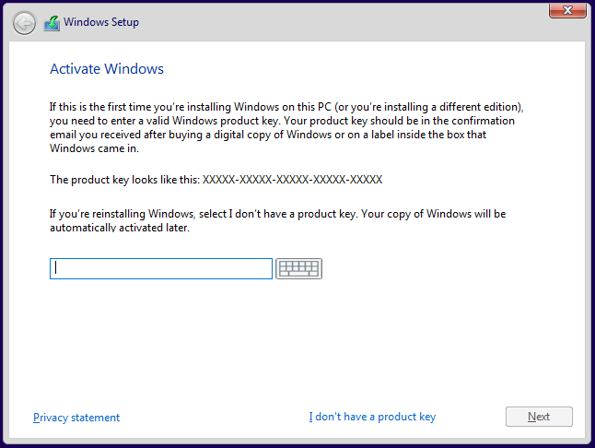

Activate Windows – Select no product key.

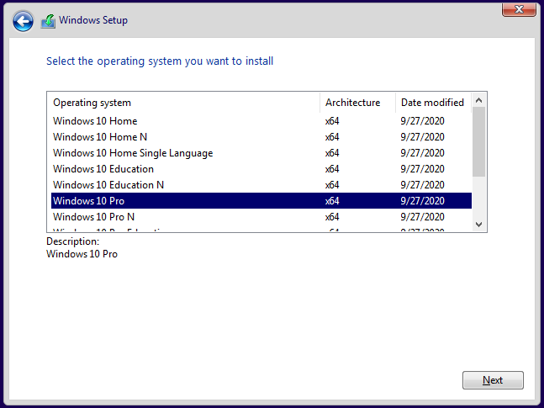

Windows 10 Pro selected, Not specified in worksheet.

There are further networking capabilities within Windows 10 Pro. As this exercise involves setting up domains and attaching to them, it may be advantageous to select Windows 10 Pro at this point.

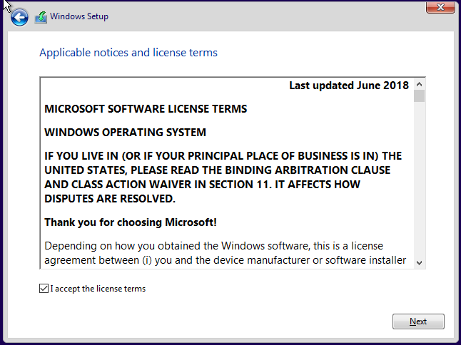

Accept licence.

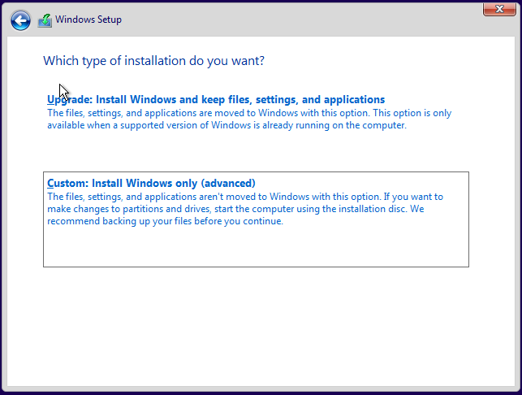

Select Custom as there is no existing OS to upgrade.

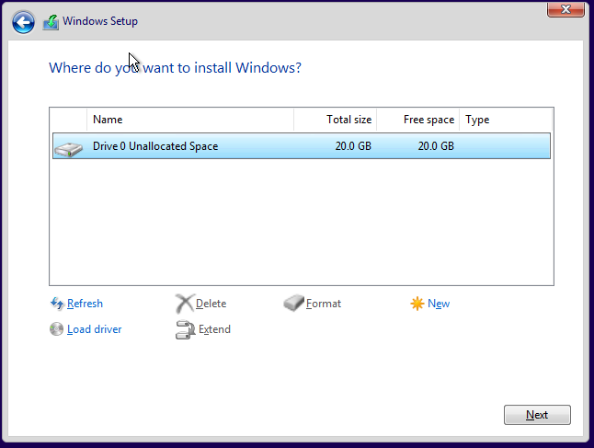

Select (VDI) drive to install to:

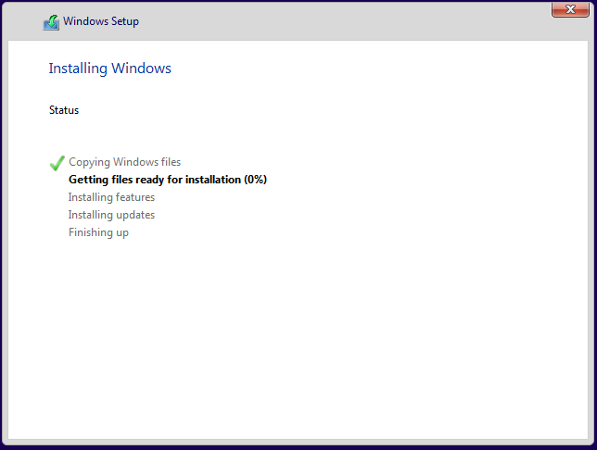

Install Windows OS onto drive:

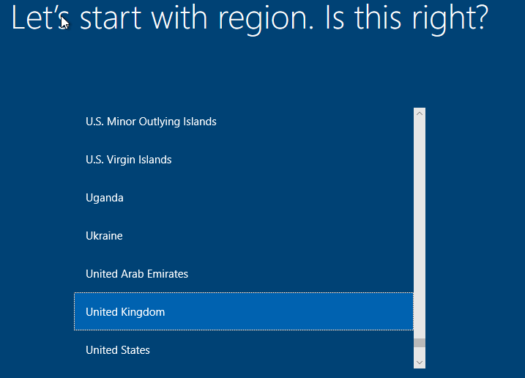

Select Region:

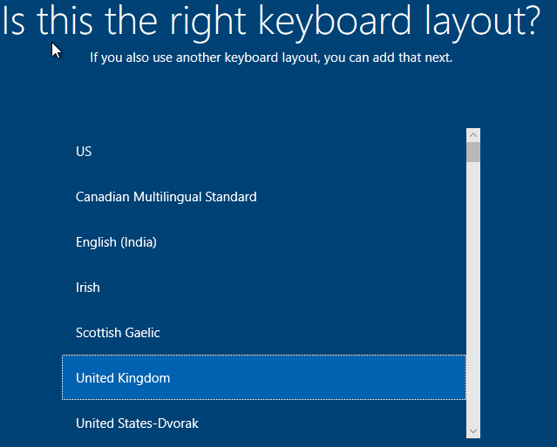

Select Keyboard layout:

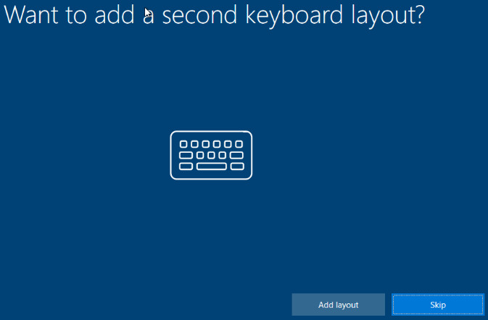

Skip second keyboard layout:

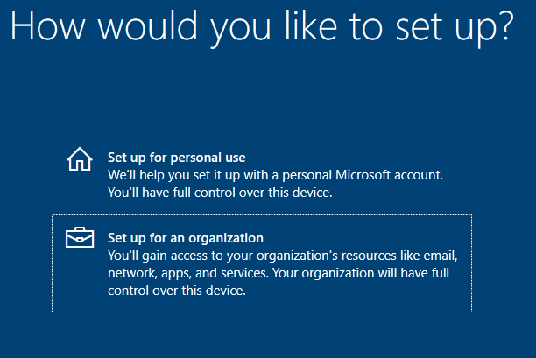

Setup for organisation selected – exercise includes creating a domain.

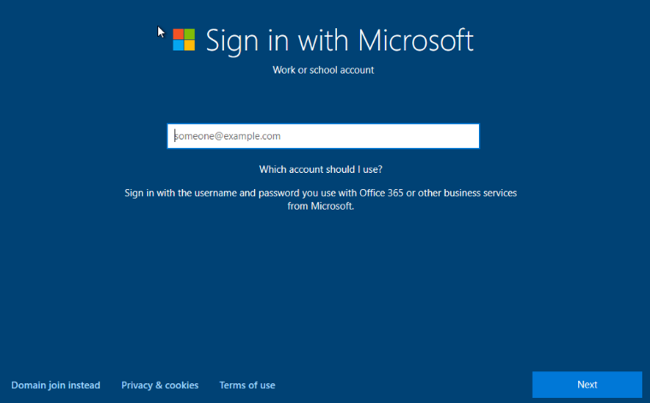
However, no work or school account created as yet and no domain to join as yet either. Select back and select Setup for personal use on above screen.

Select Offline account. Microsoft tend to lead the user/installer away from creating local accounts as can be seen from these account setup screens. The above screen, even though setup for an organisation, initially requests a sign-in with Microsoft option. The screen above also includes the option to sign in with the user’s Office365 account or other Microsoft business service. Then as will be seen below, selecting personal use account, still requests the user to use their Microsoft account to sign in, with Offline account tucked in the lower left-hand corner. This forms the basis of where OOBE (Out Of Box Experience) is initialised, discussed below:
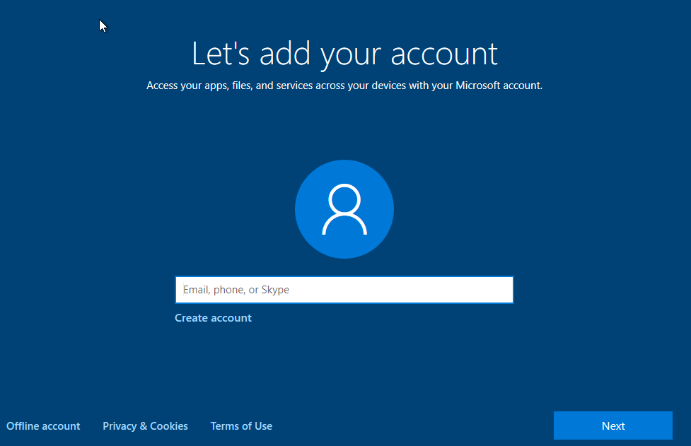

Select Offline account:

To be prompted with yet another screen extolling the virtues of Microsoft account sign-in…

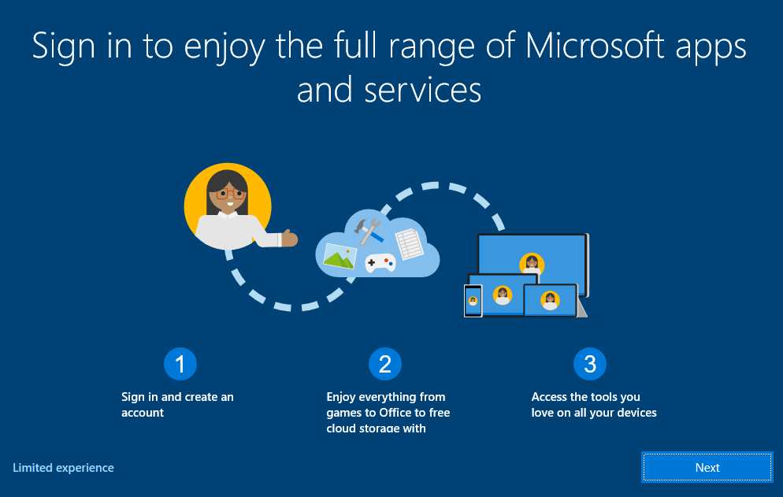

Select ‘Limited Experience’:

‘Next’ actually returns user to previous MS account sign-in screen.

Create Offline (limited experience) account named Client1, this creates a User folder within the path ‘C:\Users\’ folder, named Client1.

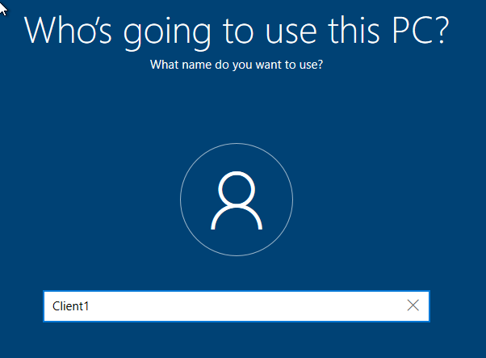

Setup local user ‘Client1’:

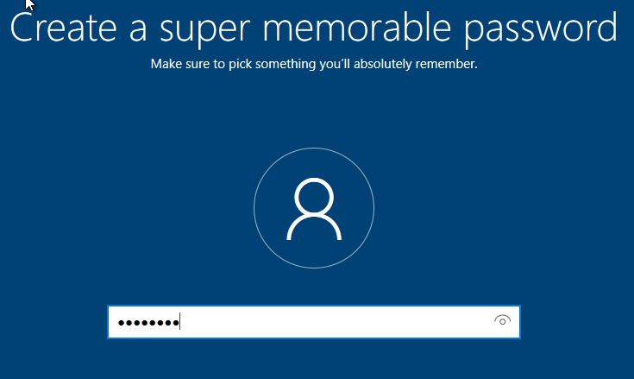

Setup password as P@ssw0rd:

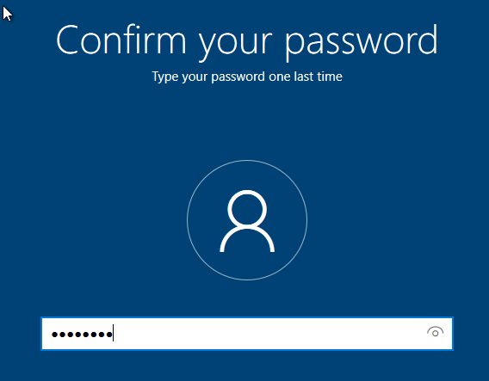

And confirm password.

Due to the account not being linked to an online Microsoft account or Domain, a series of security questions then follow, which are used in the event that the user forgets their password. The following screens show the security questions linked against an offline account.
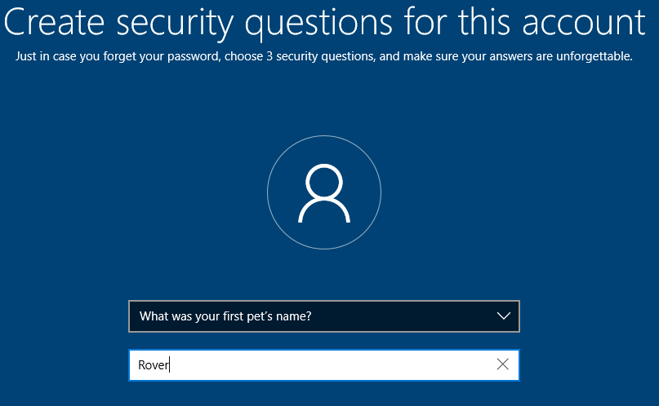

Security Question 1:

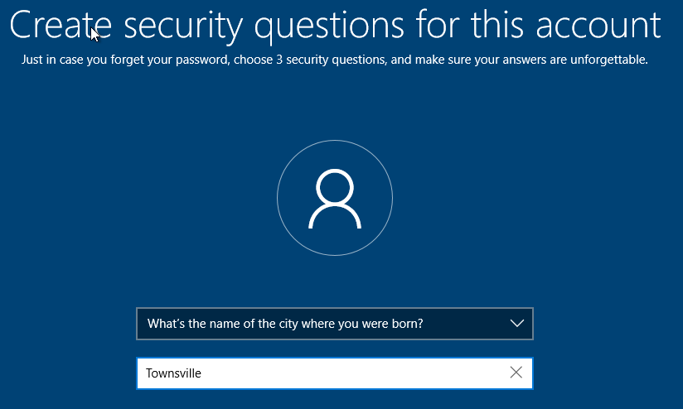

Security Question 2:

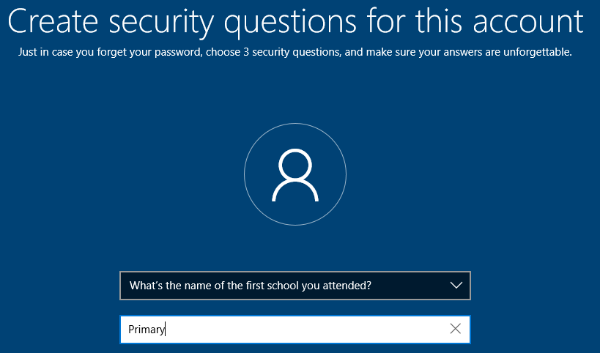

Security Question 3:

The following screens continue requesting the user to start implementing or configuring their OOBE.
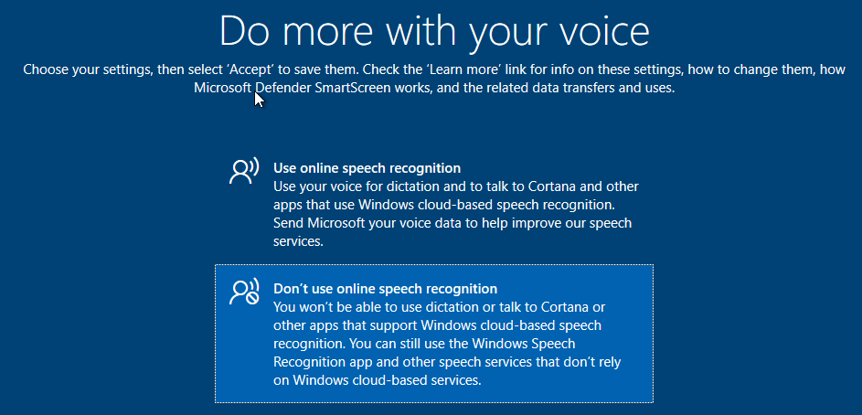

Setup Voice recognition for Cortana or Speech to Text.
Not required.

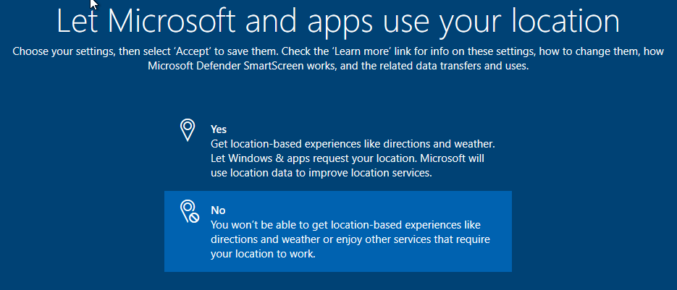
Setup Location Data for location services such as tailored weather.
Not required.

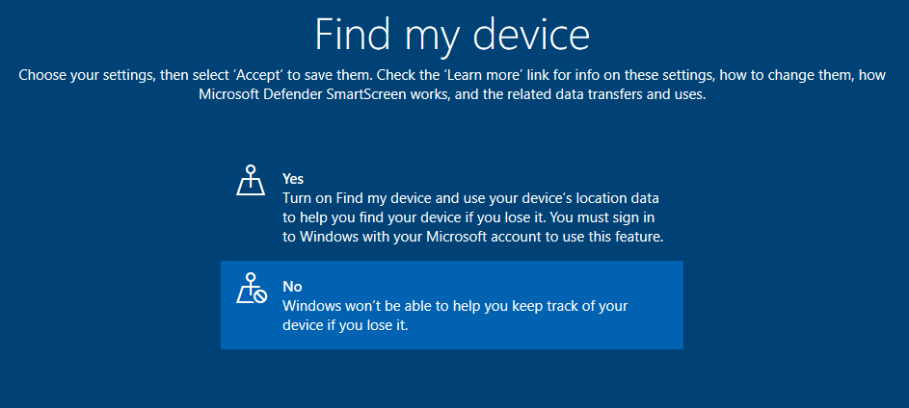

Linked to the above and for security reasons.
Not required.

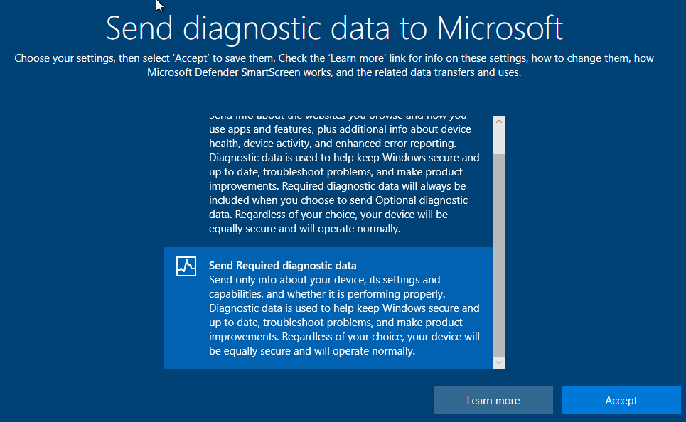

Determine what data is sent to Microsoft to improve software.
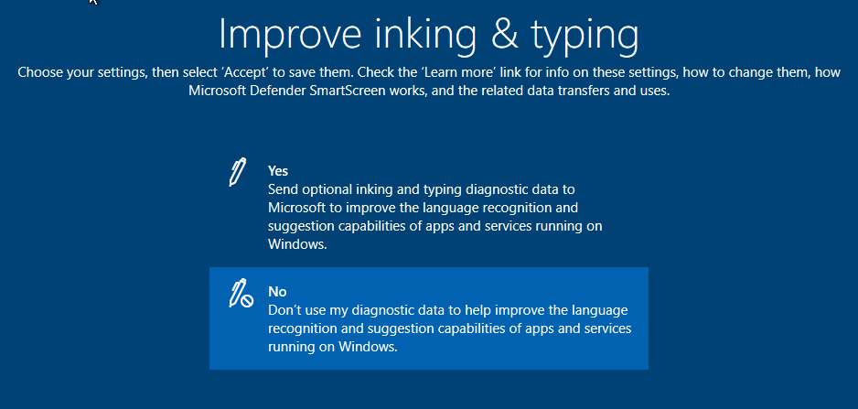
Setup Inking and Typing for language recognition and suggestion capabilities. Not required.

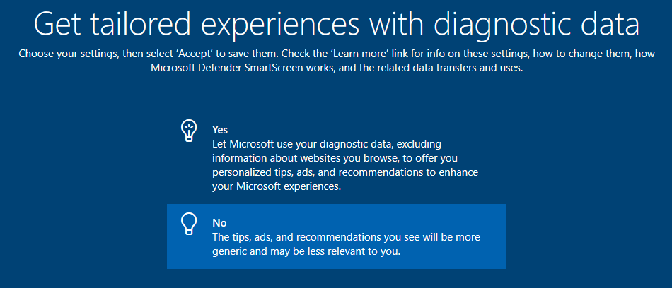
Use diagnostic data to create personalised ads and recommendations. Not required.

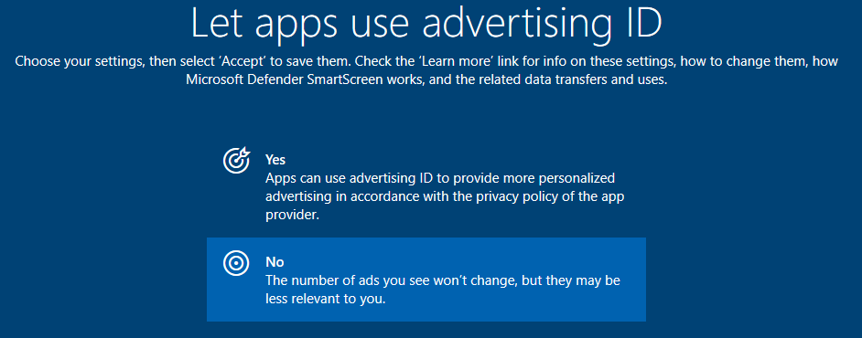
Personalised Adverts setting. Not required.

Once the above have been selected, Cortana is the final option for setting up.
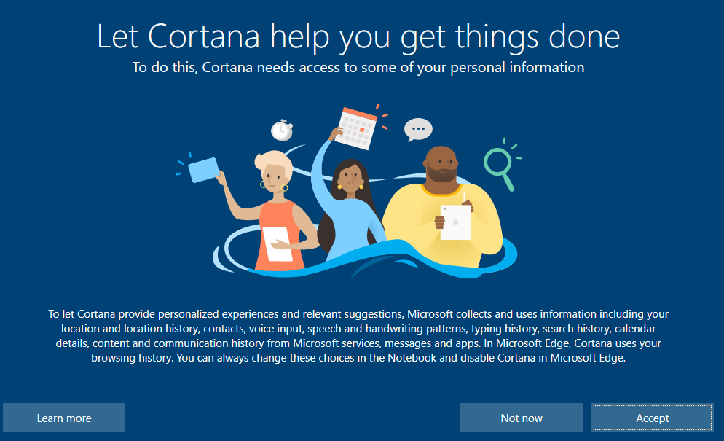

Cortana is Windows in-buuilt assistant.
Clicking accept and the installation finalises providing the user with the login screen for Client1. Entering the password displays the Desktop for Client1(running within Oracle VM VirtualBox as below:
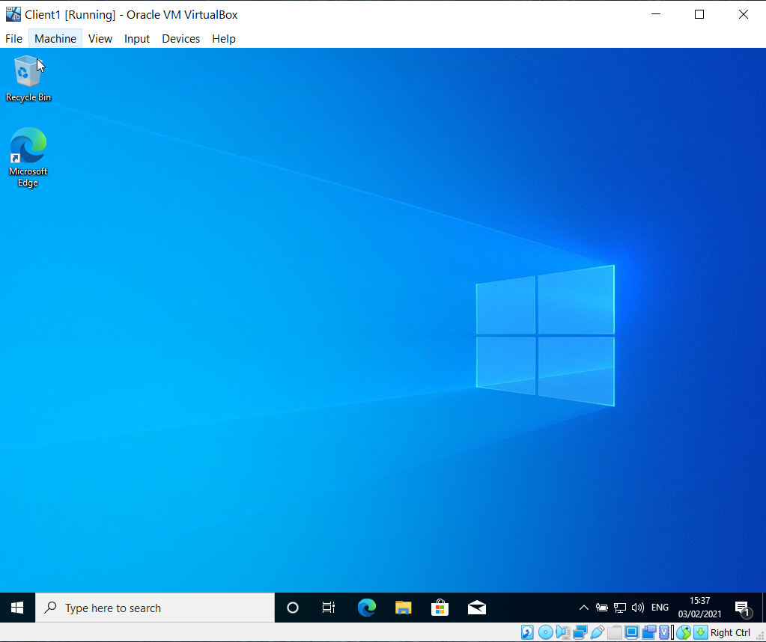
Shut down Client1 and perform the same steps (within section 2.4.2) to setup Client2 VM.

Issues encountered
The initial computer that these VMs were created on had 16GB of RAM, however, upon running multiple instances of the VMs (as required to run the Server and the Client simultaneously) VirtualBox became unstable. It provided the following error:
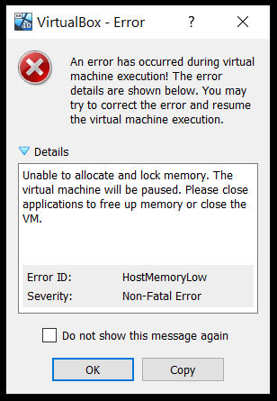
I tried running the other Server and Client VMs but they also showed the same error.
Subsequently, neither Server1 or Server2 will boot correctly and provides the following message.
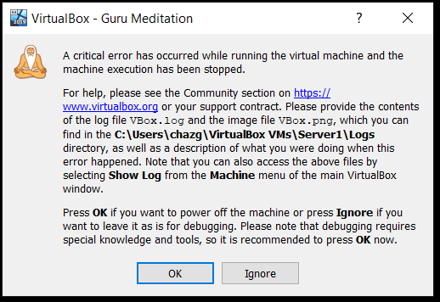

Client1 just continually re-boots and does not load the OS. Client2 did boot correctly, but then Blue-screened when shutting down.
I deleted all of the VMs and re-created new VMs as above, but reducing the RAM required by each system due to the ‘HostMemoryLow’ error report displayed earlier.
However, VirtualBox, although starts the new VM, as soon as the installation of the OS starts the following error message is displayed:
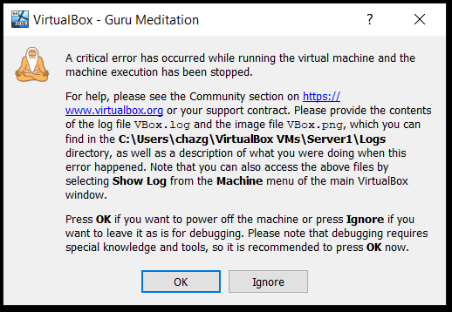
This happens for the Server install or the client install. This indicates that remnants of the previous builds has possibly corrupted some VirtualBox files and therefore VirtualBox may need re-installing.
Upon instruction, another PC was made available and the VMs successfully created and boot into working environments on that machine.
It is these installs that will be used for the remainder of the exercise.

Virtual Network Configuration (Task2)
The below section includes the screenshots of the virtual network adapters being configured on the server and client machines that were virtualised in the previous section. The servers have two network adapters configured, one to attach to the PublicNet network and one to attach to a private network. This means that in essence, 3 networks are created, one that the servers can communicate across and two private networks that allow each client to communicate with their respective server. The network diagram is shown below:
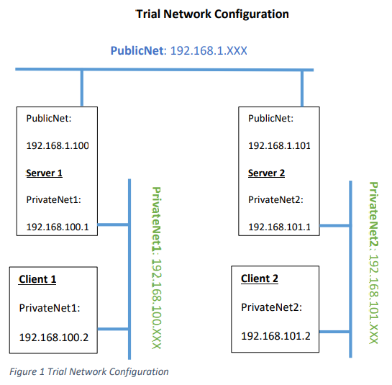
It can be seen that:
- PublicNet has an IP range of 192.168.1.xxx
- PrivateNet1 has an IP range of 192.168.100.xxx
- PrivateNet2 has an IP range of 192.168.101.xxx
The following screenshots show this configuration being created virtually.

Server1 Network Settings
Click on settings for Server1 and select the Network option
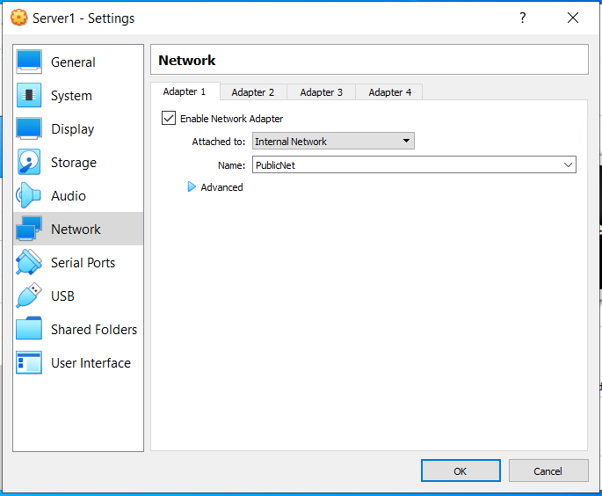

Set Network adapter to internal Network and name the network ‘PublicNet’

Once the above has been set this effectively creates a virtual switch that the adapter will connect to.
Once the above is configured, the Server1 machine has to be booted and the network configuration entered against the Network adapter. This involves navigating to the network adapter as below:
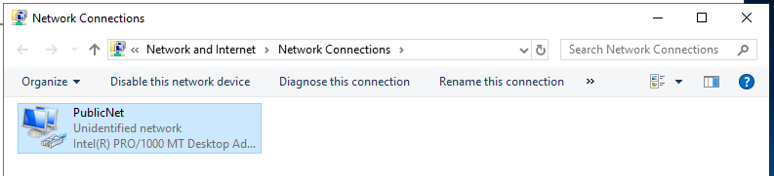
The adapter has been renamed to PublicNet.

Once this has been done, the v4 IP address is changed to 192.168.1.100 and the subnet mask to 255.255.255.0. as detailed in the network diagram at the start of this section.

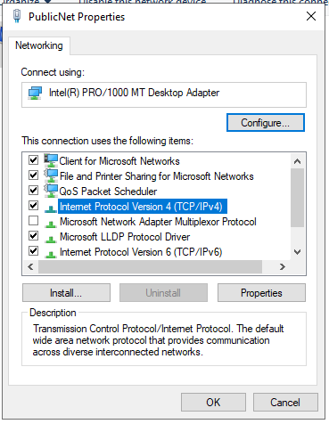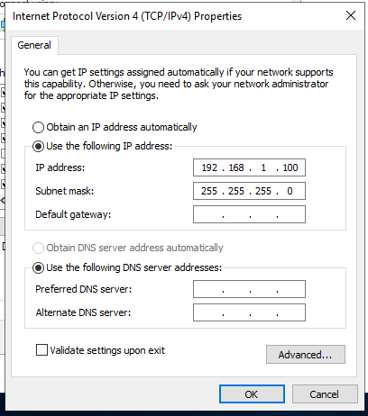
Clicking properties on the Internet Protocol Version 4 (TCP/IPv4) provides the dialog box to alter the IP addresses accordingly. There is no DHCP server at this time and so the IP addresses are manually set, along with the subnet mask. The IP address is the unique address on the network that allows packets of network data to be successfully sent and received between network devices. The subnet mask is defined within ‘A Dictionary of Computer Science (7 Ed) as:
‘A specification of which part of an IP address (see TCP/IP) represents the network identity. It is a 32-bit bitmap where ‘1’ means that bit position is part of the network identity and ‘0’ that it is part of the host address. This bitmap always take the form of a single block of ‘1’s (the network identity part) followed by a single block of ‘0’s (the host address part). It is important that routers can distinguish efficiently between those packets originating on its network whose destination is on the same network and those that that require routing over an inter-network. This operation requires isolating the network identity part of the IPA address, and an AND operation with the subnet mask is a very efficient way to do this. For convenience, subnet masks are usually represented either as the decimal form of four 8-bit numbers or as an integer representing the network identity. Thus, 255.255.255.0 and /24 both indicate a 24-bit network identity and an 8-bit host address.’ [6]
In essence the bitmap isolates the network identity aspect of the IP address so the router can distinguish efficiently which packets have a destination on the same network and which require routing to another network. This is done by using the logical AND operator over the IP address and the subnet mask. In the example above the subnet mask is 255.255.255.0 and the IP address is 192.168.1.100, which translates into the following:
 | Binary form | Dot-decimal notation
IP address | 11000000.10101000.00000001.01100100 | 192.168.1.100
Subnet mask | 11111111.11111111.11111111.00000000 | 255.255.255.0
Network prefix | 11000000.10101000.00000001.00000000 | 192.168.1.0
Host identifier | 00000000.00000000.00000000.01100100 | 0.0.0.100
The shorthand for 255.255.255.0 is /24 which essentially means the mask is the first 24 bits of the IP address.
Once the IP address and Subnet mask have been correctly configured, the Server1 was shut down and the second network adapter is configured as below:
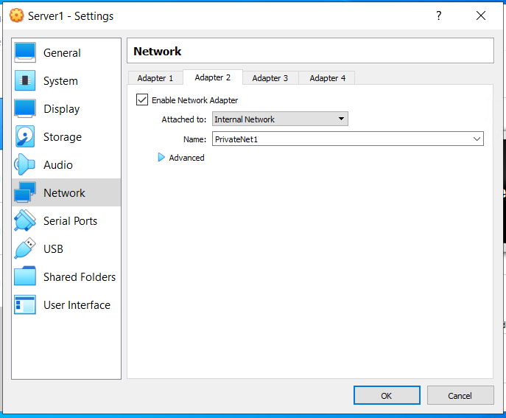

Adapter 2 again set to Internal network but the name of this network is PrivateNet1:

Re-start Server2 and navigate to the Network adapters. On this occasion rename Adapter 2 to PrivateNet1 as below:

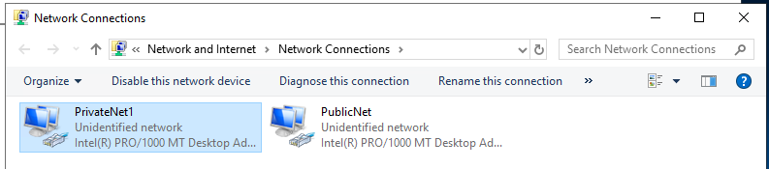
Within the same dialog box as before set IP address for PrivateNet1 to 192.168.100.1. Instructions do not mention subnet mask but state that the subnet mask is 255.255.255.0 for Class C IPv4 address. Pressing Tab automatically completes this form.
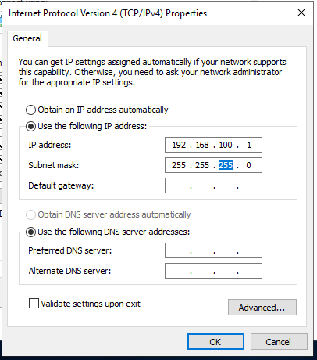
Shut server down now that both network adapters have been configured.

Client1 Configuration
Change settings for Client1. It can be seen below that PublicNet and PrivateNet1 are available for selection.

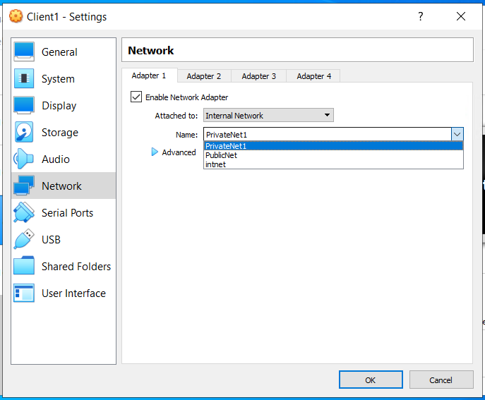

PrivateNet1 Selected:

Started ClientPC1 and located network adapters and renamed adapter 1 to PrivateNet1:
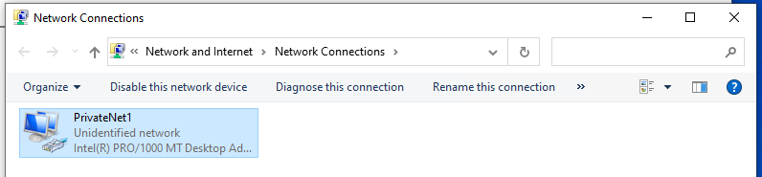
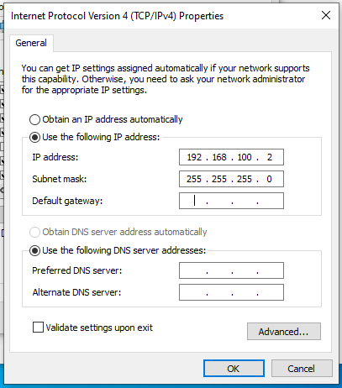

Assigned IPV4 address to 192.168.100.2 and the subnet mask as above:

Shut Client 1 down.

Server2 and Client2
The steps above were repeated for Server 2 and Client 2 but with their respective settings, the below screenshots confirm these actions but are listed with less explanation as it would be a replication of the above text:
Server 2 has 2 adapters, 1 is PublicNet
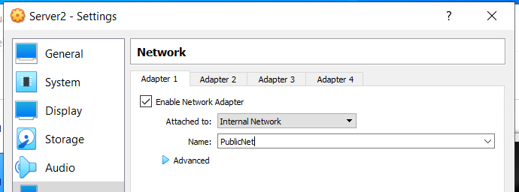
and the 2nd is PrivateNet2
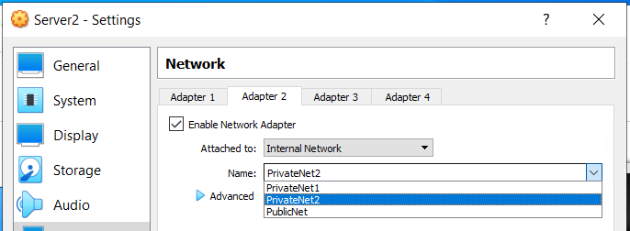

Providing network adapters:
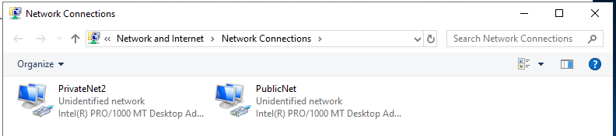

The IP addresses are 192.168.1.101 and 192.168.101.1 as below:
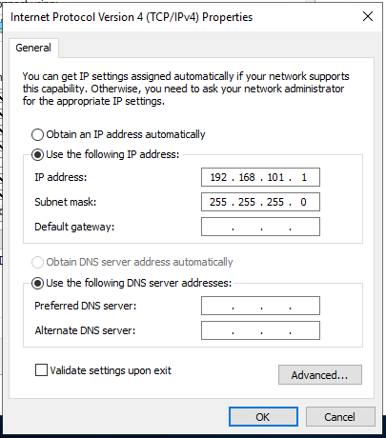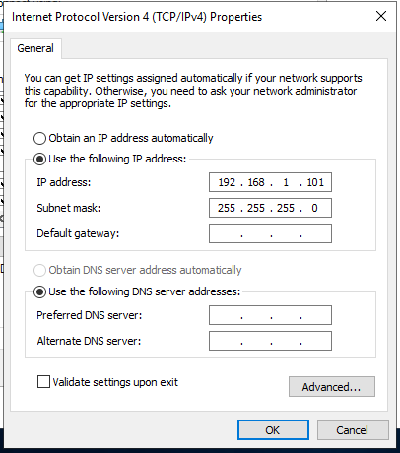
Server2 can be shutdown.

Client 2 should be connected to PrivateNet2 and its IP address set to: 192.168.101.2
Screenshots below of above settings:
Client 2 Network Adapters:
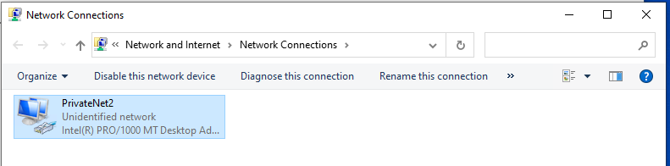

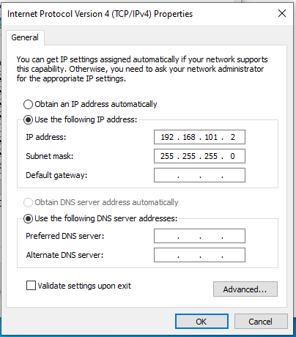

and IP address:
Shutdown Client2.

Firewall
Firewalls are defined by Chris Benton in his book ‘Mastering Network Security’ in the following way:
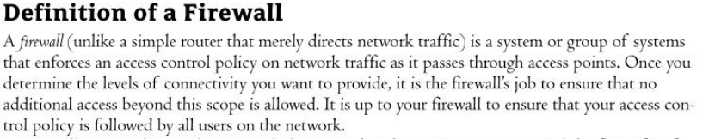 [7, p. 113]
A firewall then, protects a network by controlling the flow of traffic but with the added task of making sure that the traffic is authentic and authorised.
The most common functions that firewalls employ are listed below:
- Static Packet Filtering
- Dynamic Packet Filtering
- Stateful filtering
- Proxy.
MS Windows has a software firewall in-built. However, in the instance of our simple virtualised network there is no security risk and a firewall can add complications when testing a network. For this reason, the firewall has to be switched off for the purpose of this task.
The screenshots below confirm the firewall being switched off on the Servers and Clients.
Turn Firewall off on Server1 for Public and Private Networks:
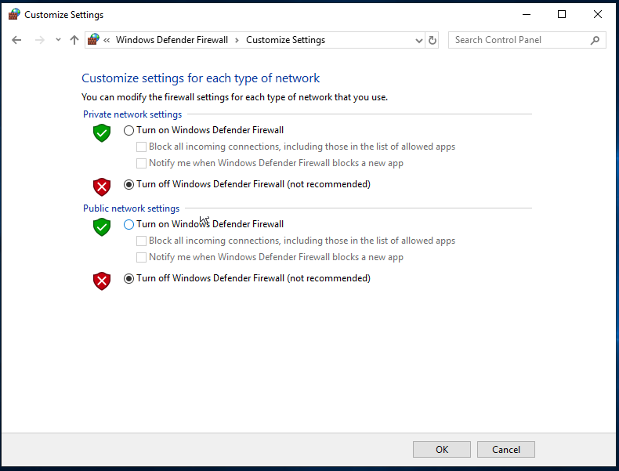
Resulting in Firewall Page displaying:
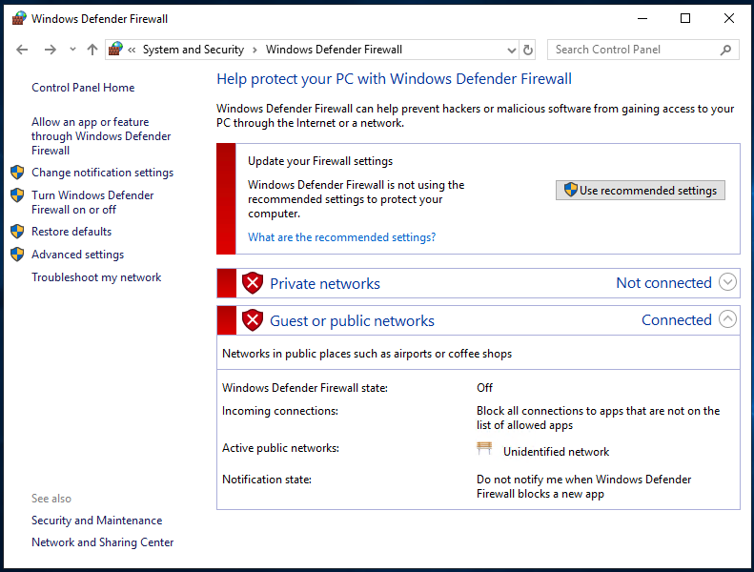

And for the Clients:
Turn firewall off on Client 1 also:
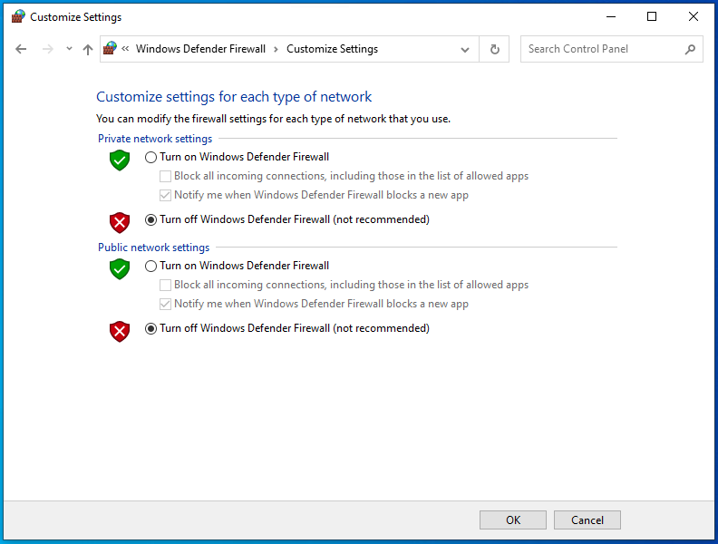
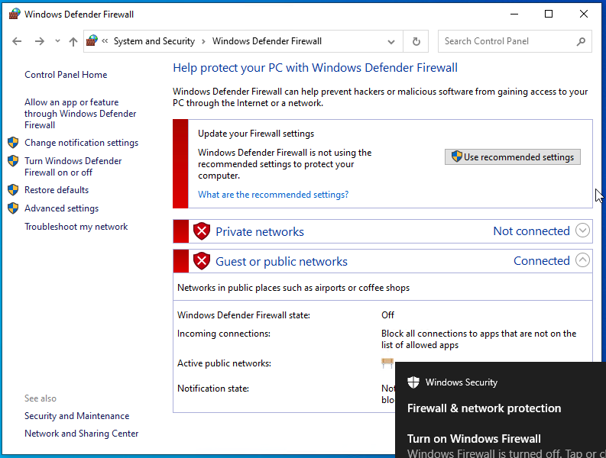

Testing
Now that the virtual machines and the virtual network have been successfully configured, it is imperative that the network is now tested to make sure that the VMs can communicate with each other across the network. This is done by utilising the PING command from the Command Line Interface.
PING is described by Microsoft as
‘Verifies IP-level connectivity to another TCP/IP computer by sending Internet Control Message Protocol (ICMP) echo Request messages. The receipt of corresponding echo Reply messages are displayed, along with round-trip times. ping is the primary TCP/IP command used to troubleshoot connectivity, reachability, and name resolution.’ [8]
It is this command that is used in the screenshots below to check connectivity.
Check connectivity over the network from Server 1 to Client 1 issuing the PING 192.168.100.2 command:
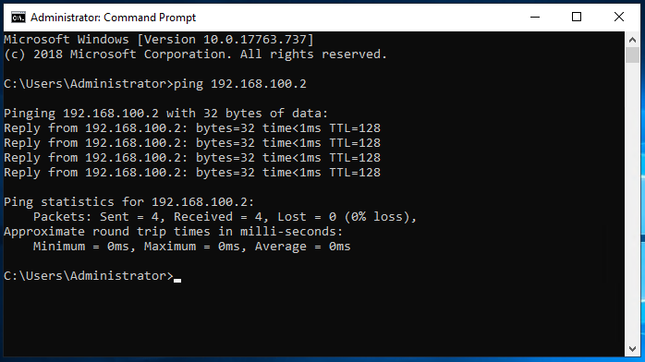

Success:

Check connectivity over the network from Server 2 to Client 2 issuing the PING 192.168.101.2 command:
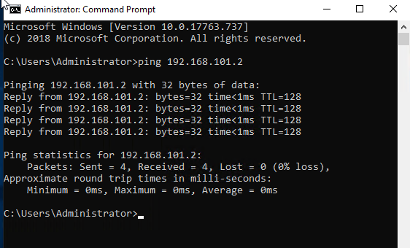

Success:

Both networks successfully configured.

Observational Tasks (Q3)

Type 1 and Type 2 Hypervisors
Question 3a has been answered as part of the text above, as that aspect of the exercise was addressed. Please see section 2.1

Subnet Mask in IPv4 addressing
Question 3b has been answered as part of the text above, as that aspect of the exercise was addressed. Please see section 3.1

Cloud computing
Many Enterprises are global in scale, cloud computing has made a massive impact on the way that different aspects of a business can communicate with one another. Different plants, factories, distribution centres, finance centres or retail outlets can all communicate with each other without the company having to front the cost of the infrastructure required to provide this functionality. Information can be relayed, and instructions given at almost real-time speeds. This feeds in to such manufacturing models as Just In Time, where stock is not kept within warehouses as such, but the exact part required for a process arrives Just In Time to be implemented.
Although some of these features are for large corporations, some of these advantages have filtered down to smaller businesses and they too can implement wider reaching projects with the use of Cloud Computing.
Cloud computing can also refer to accessing virtual machines via web browsers or remote sessions, helping the business with the costs of hardware. This also leads on to workforce access being easier especially with the advent of Bring Your Own Device or Working From Home.
Some of the main drawbacks are expense and security. Hosting large data servers or virtual machines is resource intensive for the suppliers and any time an organisation is putting gateways onto their networks at different levels, there is the risk of attack.
Example providers of cloud computing are IBM, AWS (Amazon Web Services), Microsoft Azure and Google Cloud.

Differing terminologies
Question 3d has been answered as part of the text above, as that aspect of the exercise was addressed. Please see sections below:
Terminology | Section
Virtual Disk Types | 2.2.1,
PAE/NX | 2.3.1
OOBE | 2.4.2 (pages 24 - 29),
Firewall | 3.4,
Ping | 3.5

References

[1] | M. Portnoy, Virtualisation Essentials, Indianapolis: John Wiley & Sons Inc., 2016.
[2] | VirtualBox, “Chapter 5. Virtual Storage,” VirtualBox, [Online]. Available: https://www.virtualbox.org/manual/ch05.html#vdidetails. [Accessed 07 March 2021].
[3] | FilExt.com, “Opening an ISO File,” FilExt.com, [Online]. Available: https://filext.com/file-extension/ISO. [Accessed 7 March 2021].
[4] | Microsoft, “Physical Address Extension,” Microsoft, 31 May 2018. [Online]. Available: https://docs.microsoft.com/en-us/windows/win32/memory/physical-address-extension. [Accessed 07 Mar 2021].
[5] | Microsoft, “DEP/NX Protection,” Microsoft, 31 May 2018. [Online]. Available: https://docs.microsoft.com/en-us/windows/win32/win7appqual/dep-nx-protection. [Accessed 07 Mar 2021].
[6] | G. E. N. a. A. K. Andrew Butterfield, A Dictionary of Computer Science (7 Ed.), Oxford: Oxford University Press, 2016.
[7] | C. Brenton, Mastering Network Security, New York: Sybex, 2006.
[8] | Microsoft, “Ping,” MS, 11 07 2018. [Online]. Available: https://docs.microsoft.com/en-us/windows-server/administration/windows-commands/ping. [Accessed 09 03 2021].

