

MODULE CODE: LCBB6000
TITLE: DISSERTATION
LEVEL: 6
CREDITS: 40
MODULE LEADER: MUSHFIQUR RAHMAN

Factors for employee motivation among UK small and medium enterprises’ employees

STUDENT NAME: PAVEL BODUSHKI
NUMBER: 2023711
WORD COUNT: 6,578
SUBMISSION DATE: 22.12.2023

Abstract
The research paper explored the case of small and medium enterprises. Their importance for the economy was recognised together with the limitations faced by the lack of resources. Given the dependence on human resources, the study explored the ways of boosting employee motivation and satisfaction at work as factors determining retention and organisational performance in general. The discussion of the available literature clearly demonstrated the importance of motivated employees for achieving productivity gains, greater innovativeness, cost control and competitiveness. The theory analysed the models of fostering employee motivation. The main determinants of motivation were then discussed as a series of interviews five different employees from small and medium sized enterprises. The collected new information from the interviews revealed important contemporary trends in the field of human resource management, as well as specific in-depth evidence from each employee. In general, the results from the interviews demonstrated different policies and practices in the field of human resource management. Respectively, the levels of employee motivation, satisfaction and retention were quite different. The performance in those key areas largely depended on meeting the determinants of employee motivation, as suggested by the theoretical models. Thus, the theory was validated in the case of small and medium sized enterprises. Respectively, the recommendation for future improvement addressed the currently observed performance gaps and the existing methodological limitations requiring additional research in the field.

Table of Contents
Abstract 2
List of figures 5
List of tables 6
Chapter 1: Introduction 7
1.1 Background of the research 7
1.2 Aim and objectives 8
1.3 Research Questions 8
1.4 Background of the organisation 8
1.5 Rationale for the study 8
1.6 Outline of research 9
Chapter 2: Literature review 10
2.1 Importance of employee motivation 10
2.2 Link between motivation and employee turnover 11
2.3 Models of employee motivation 13
Chapter 3: Methodology 17
3.1 Philosophy 17
3.2 Paradigm 18
3.3 Approach 18
3.4 Strategy 19
3.5 Choices and time horizon 20
3.6 Data collection and analysis 20
3.7 Ethical considerations 21
3.8 Limitations 22
Chapter 4: Results and analysis 23
4.1 Findings 23
4.1.1 Sample characteristics 23
4.1.2 Levels of motivation, satisfaction and retention 24
4.1.3 Performance analysis 25
4.2 Discussion 28
Chapter 5: Conclusions and recommendations 30
5.1 Key conclusions 30
5.2 Recommendations 30
References 32
Appendix A – Interview questionnaire 37
Appendix B – Interview transcripts 39
Appendix C – Ethics form 46

List of figures
Figure 1 - Relationship between employee satisfaction and turnover intentions 11
Figure 2 - Impact of job satisfaction on key firm performance indicators 12
Figure 3 – Models of employee motivation 14
Figure 4 - Two-Factor model of motivation 15
Figure 5 - Maslow’s Hierarchy of Needs model 16
Figure 6 - Research onion model 17
Figure 7 - Inductive reasoning 19

List of tables
Table 1 - Background characteristics of employees 23
Table 2 - Reported levels of motivation, satisfaction and retention 24
Table 3 - A summary of the reporter problems 29

Chapter 1: Introduction

1.1 Background of the research
Small and medium-sized enterprises (SMEs) in the UK account for more than 99% of all for-profit business organisations (Hutton, 2022). Their importance for the economy is also seen from the fact that they generate 51.1% of national output and 60.7% of overall employment (Hutton, 2022). Considering these key findings, the performance of SMEs largely determines the general health of the national economic.
The most recent data suggests that SMEs experience difficult times. The mix of stagnating gross domestic product (GDP) growth and high inflation, which has fuelled the costs of doing business, has created a toxic environment for business development. This is seen by the rapid increase in the number of insolvencies across the UK (Trading Economics, 2023). As of July 2023, there are more than 6,000 business insolvencies per month in the UK – more than twice the average in the recent years and comparable to the period of the financial crisis of 2008-09 (Trading Economics, 2023).
Since more than 99% of business organisations are classified as SMEs, the insolvency wave has mainly affected these types of business organisations (Hutton, 2022). Moreover, SMEs tend to have more limited capital resources than large companies. This fact alone makes them more vulnerable to macroeconomic shocks. In such a challenging situation, SMEs must find ways of fostering their resilience and competitiveness.
The resource-based view model proposes that an organisation can attain a competitive advantage in the marketplace by leveraging a range of elements of production, such as capital, labour, technologies, and other relevant resources (Barney, 1991). Therefore, worker productivity and workplace motivation can be regarded as crucial elements in optimising the management of a fundamental aspect of market competitiveness. The significance of employee motivation is particularly elevated within the framework of SMEs given the limited access to capital in comparison to large business entities.

1.2 Aim and objectives
The main aim of the study is to improve the level of employee motivation of employees from small and medium-sized (SME) businesses.
The objectives of the study include:
- To explore the role of employee motivation on individual and organisational performance.
- To analyse the models of employee motivation.
- To assess the specific case of UK’s SMEs in terms of employee motivation level and its determinants.
- To propose focused recommendations for future improvement based on the primary data evidence.

1.3 Research Questions
How do employee motivation level affect performance?
What are the ways of improving employee motivation in the future?

1.4 Background of the organisation
This study examines individuals employed in various SMEs. The focus of consideration does not pertain to a particular company, but rather encompasses SMEs from the UK.

1.5 Rationale for the study
The scarcity and increased cost of manpower pose challenges for SMEs due to the relatively low unemployment rate at a level of 4.3% (ONS, 2023). Thus, the issue of effectively motivating and retaining top-performing individuals assumes significant strategic significance, particularly in view of the notable annual staff attrition rate of 15% (Monster, 2023). SMEs cannot afford losing employees in an environment of scarcity; however, this remains a main issue of considerable financial losses for companies. In the light of high employee turnover and labour scarcity, the prospects of boosting human resource management (HRM) provides a rationale for the study.
The examination of strategies to enhance employee motivation might provide advantages not only for firms, but also for the broader economy. The research is driven by the relatively low level of productivity growth in the period after the recession of 2008-2009, and the potential for enhancing productivity through improved HRM, as highlighted by Harari (2023).
Moreover, SMEs exhibit distinct characteristics in terms of their management practises, organisational size, resource allocation, and other relevant criteria. Hence, the examination of the unique circumstances surrounding these individuals might prove to be highly intriguing to provide more targeted strategies for enhancing both employee motivation and performance.
Moreover, the author has personal drive to investigate SMEs. This is a key factor for exploring the selected problem, as well.

1.6 Outline of research
This study examines pertinent studies in the domain of employee motivation, drawing on theoretical frameworks and empirical evidence. In addition, the collection and analysis of primary data are undertaken to get insights into the current and pertinent perspectives of employees inside SMEs, as well as to identify areas that warrant additional improvements in the future.

Chapter 2: Literature review
The next section reviews SMEs throughout the UK by using specialised reports and literature. This would be the foundation for assessing their business experience within the economy and would involve statistics, journals and articles from verified sources.

2.1 Importance of employee motivation
Employee motivation has many manifestations. For example, Rina (2023) states that motivation is the degree to which employees are inclined to act to achieve the organisation’s goals. Dubin (1970) takes the organisational environment as context and analyses the variables which drive an individual to be interested in it. For Koontz and O’Donnel (1978), motivation can be broadly defined by considering the subjective experience of individuals manifesting itself in the form of goals and desires to be productive. Finally, Scott (1962) relates individual actions of employees to achieve company objectives as motivation.
While either definition can be taken, the commonality between them implies that motivation is linked to employee and thus company performance. According to Hook and Jenkins (2019), even though motivation is often subjective, HR practitioners can resort to a variety of techniques to boost it. Therefore, it is a subject which can be studied, and competency can be developed to keep the employees engaged and aligned with the business’ goals. This concept forms the basis for the analysis.
Motivation boosts self-confidence and job satisfaction, benefiting both the company and the employees, according to Thompson and McHugh (2002). Sorge and Warner (1997) agree and explain that motivated workers have common traits like higher dedication to organisational goals. According to Kreitner and Kinicki (2002), motivated workers are most satisfied with their jobs and perform better.
Martin and Dowson (2009) state that the more motivated an employee is, the likelier it gets that they would be self-driven to initiate solutions within the company environment. Such staff members would generally see a problem through to its completion, as well. Analoui (1999) demonstrates that businesses, which are profitable, boast the highest proportion of motivated employees, giving credence to the statement that motivation indeed plays a large role in overall success. Sekhar et al. (2013) relates creativity and consistence with motivation similarly. Sheikh et al. (2016) state that motivated staff members would guarantee that organisational goals are met efficiently, while productivity skyrockets when employee motivation is high.
Motivated staff help service-sector SMEs succeed. Due to its importance in services, Kotler et al. (2020) place motivation in the “people” element of the marketing mix. The authors argue that “people” can help organisations differentiate and position themselves (Kotler and Keller, 2012). Normally, businesses examine product, pricing, place, and promotion. Thus, it is not unexpected that more SMEs are prioritising employee satisfaction and helping them thrive in retailing.

2.2 Link between motivation and employee turnover
As high employee turnover could be deleterious to a business’ reputation and performance, managers are highly concerned about motivation. In Alhaji’s opinion (2012), engaged employees tend to be highly committed and emotionally attached to their company, making it unlikely that they would switch jobs. Imran et al. (2016) has noted the opposite relation as well – unmotivated employees often leave their job, leading to high turnover. Skelton et al. (2020) explore turnover against job satisfaction. As evident, lower job satisfaction leads people to consider leaving the companies which they work for in pursuit of more fulfilling employment (Skelton et al., 2020).
Figure 1 - Relationship between employee satisfaction and turnover intentions
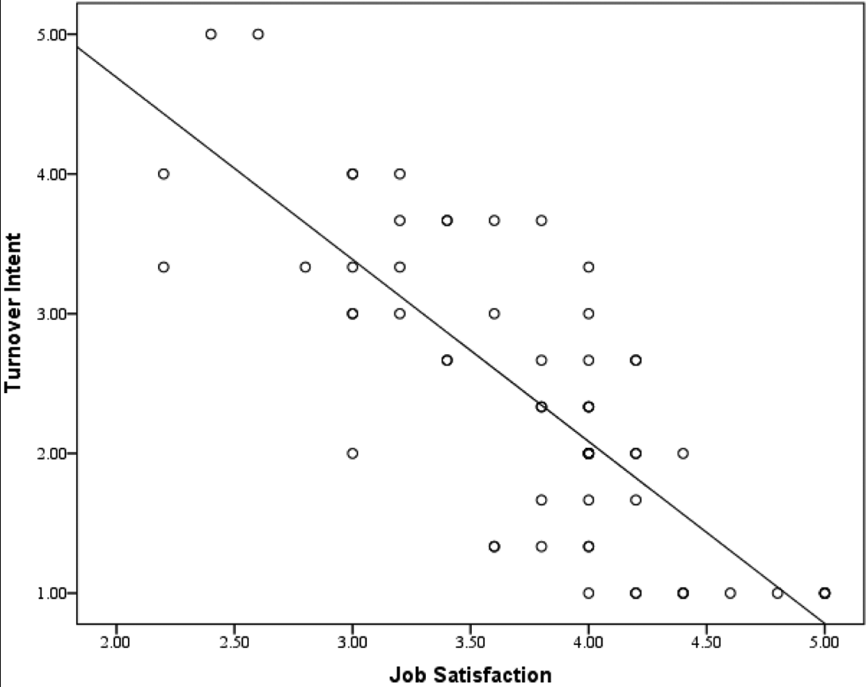
Source: Skelton et al. (2020)
According to a meta-analysis study performed by Krekel et al. (2019) by aggregating the results of 339 independently conducted studies, job satisfaction is indeed related to productivity. The meta-analysis is rendered more valid given the large study sample of over 1,880,000 workers across more than 82,000 businesses (Krekel et al., 2019). Figure 2 clearly shows the varying correlation between customer loyalty, employee productivity, profitability and staff turnover when compared to the employee satisfaction and firm performance (Krekel et al., 2019). The results are highly supportive of the findings presented earlier and could be used to conclude that employee turnover is a complex issue which can be analysed within a framework where multiple factors are considered.
Figure 2 - Impact of job satisfaction on key firm performance indicators
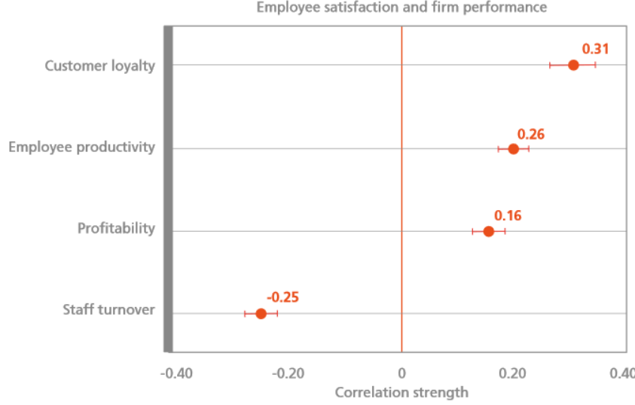
Source: Krekel et al. (2019)
According to Hook and Jenkins (2019), the departure of talented and experienced people can be particularly harmful for businesses with high employee turnover. Barney (1991) also suggests that this equates to decreased value and production capacity as labour is decreased. As companies invest specifically in developing their workforce to increase output and gain differentiation, ensuring employee loyalty prevents losing a key asset within the competitive environment. If people leave, a business can often find itself unable to deliver on market demand and see its logistical and production processes interrupted. Furthermore, finding and recruiting new qualified employees is a costly process. Elliott (2023) thus argues that in today’s tight labour market in the UK with an unemployment rate of just 3.9% this task can become even more difficult.
Even if new employees are found, the business still needs to go through educational and practical courses to bring its new employees up to speed. According to Enrich (2023), this may cost as much as over half the annual pay for an existing employee. Imran et al. (2016) suggests that even after all the in-house training, new employees still need time to reach their full potential and match the people who were there before them. In the service sector this would mean decreased profits and disrupted schedules. The quality of services would also temporarily decrease, increasing the risk of consumers preferring a competitor instead (Imran et al., 2016).
Research suggests that not every instance of employee turnover is due to company policy. Sometimes workers need to decide for personal reasons, relocate to another city or take on less responsibility (Aslam et al., 2013). In these cases, management cannot be held responsible as they have no control over these circumstances. Regardless, it should be within their responsibilities to monitor the employees and apply HRM techniques to maintain the quality of the relationships. Galletta et al. (2011) argue that these pre-emptive efforts are intended to keep employee motivation above a healthy level and alleviate any doubts which the workers might have.
Research by Krekel et al. (2019) and Skelton et al. (2020) suggests that considering the examples discussed so far, HRM professionals are generally able to predict when employees are starting to have doubts about staying with their current employer. Thus, the literature review further deals with the methods and techniques applicable for increasing satisfaction at the workplace and preventing such incidents.

2.3 Models of employee motivation
Discovering the circumstances influencing motivation on the job is discussed in the following section. Theoretical analysis is used to examine some of the primary models reflecting the phenomenon.
Ramlall (2004) classifies frameworks dealing with motivation into content theories and process ones. Due to the complexity of process models and the broad application of content ones, only the latter are analysed in this case. Ramlall (2004) states that content theories are more straightforward to implement due to the presence of a clearly defined structure and definitions on the variables to be considered. It is easier to instruct HRM specialists within this framework and apply the rules outlined when researching people’s needs. Consequently, avoiding bias and ensuring completeness of results lead to strategies which are more easily put to work for the benefits of the organisation.
Figure 3 – Models of employee motivation
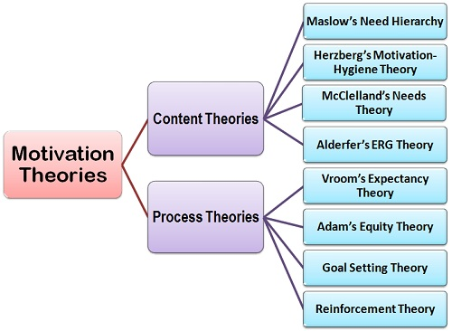
Source: BJ (2019)
Herzberg (1987) proposes a Two-factor model based on content theory to boost motivation. Hygiene variables and satisfiers are examined within the model and said to be responsible for motivation at work according to Kunchala (2017). Identifying and addressing these factors would thus be the primary purpose of the practitioners until the employees are feeling content. Herzberg (1987) states that the hygiene factors make the basis for employee performance. They are of crucial importance and represent the minimum requirements which must be satisfied for people to work. They do not necessarily lead to higher profitability; however, their absence would undermine the entire effort. Satisfiers are secondary; however, observing them leads to increased quality of service and job satisfaction. They encompass fulfilment criteria, such as recognition, responsibility and growth (Herzberg, 1987).
Figure 4 - Two-Factor model of motivation
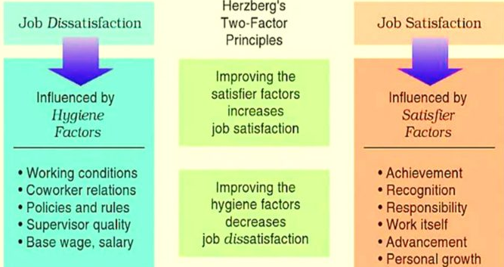
Source: Kunchala (2017)
Maslow’s Hierarchy of Needs is well-known and applied within the organisational theory framework. Mintz (2017) explains that the model was constructed in 1943 and can be applied to a variety of situations due to its large scope. Practitioners use it to understand human demands, from the most basic to the elevated ones. At the top of the pyramid resides the self-actualisation category of needs which arise as consequences of meeting the more basic needs (Maslow, 1943). For HR practitioners, this implies that people should be expected to perform at their respective levels only after they have been provided for. Thus, the needs for shelter, food and adequate pay precede the building of professional relationships, self-development and setting new challenges (Mintz, 2017).

Figure 5 - Maslow’s Hierarchy of Needs model
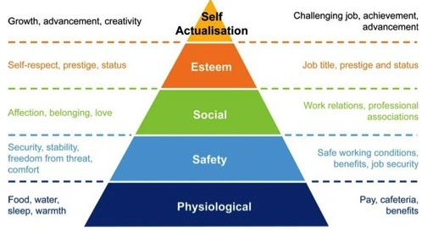
Source: Mintz (2017)
Maslow and Herzberg’s models, both of which are content based, can be found to share a lot of common ground and can be applied to numerous situations within a corporate setting and in the outside world alike. As they both rely on fulfilling a hierarchy of needs, they posit that an individual cannot be expected to perform well if their needs have not been provided for (Macpherson, 2013).
In conclusion, it is important to note that according to the body of research, motivation is complex, relates to organisational theory and is guided by a multitude of variables which are often difficult to follow. This is why HRM strategy should involve a continuous process in line with the dynamic environment outside of the organisation.
As workers and SMEs were interviewed, the discussion continues with an explanation of primary data collection processes.

Chapter 3: Methodology
This part of the dissertation explains the key methodological considerations related to the collection and analysis of primary data from SME employees. The methodological framework is intended to deliver a detailed explanation regarding the ways of creating new knowledge. In accordance with the research onion model, it is important to consider a set of areas, such as research philosophy, approach, strategies, methods, time horizon, as well as data collection and analysis tools (Saunders et al., 2019).
Figure 6 - Research onion model
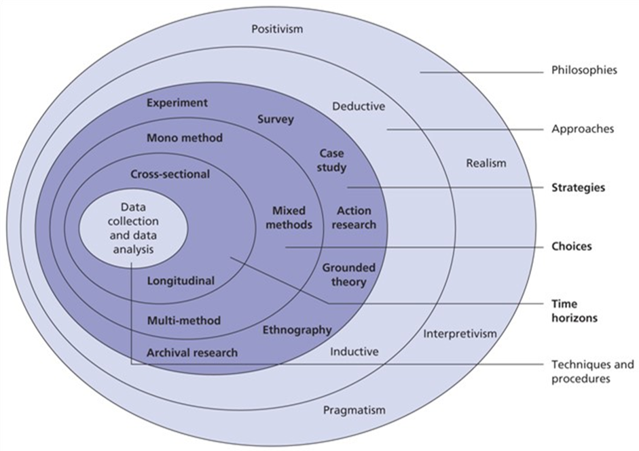
Source: Saunders et al. (2009)
Therefore, the chapter follows the structure suggested by the research onion model by also discussing some relevant ethical considerations in research and the limitations of the proposed methodological framework.

3.1 Philosophy
The present study has chosen an interpretivist approach. Within this study paradigm, the generation of knowledge, commonly referred to as epistemology, is rooted in an individual's experiences, hence emphasising the importance of phenomenology (Weber, 2004). The significance of comprehending each individual case can be of considerable value (Pizam and Mansfield, 2009). Interpretivism is a theoretical perspective that places emphasis on the analysis and understanding of specific settings and experiences. In this light, the focus is intentionally placed on individual persons, rather than depending on extensive samples (Pizam and Mansfield, 2009). Interpretive studies prioritise the utilisation of qualitative data as their focus. This encompasses the utilisation of various research techniques, such as interviews, focus groups and others (Myers, 2008).

3.2 Paradigm
When considering the study paradigm, it is crucial to acknowledge the presence of numerous potential interpretations. Weber (2004) posits that interpretive investigations lack a distinct demarcation between the person conducting the study and the specific reality being researched. The acknowledgment of the social construction of reality allows for the recognition of the existence of various types of realities (Pizam and Mansfield, 2009).

3.3 Approach
Interpretivism is frequently employed in conjunction with inductive thinking, as suggested by the research onion model (Adams, 2014; O’Gorman, 2015). Induction is distinguished by the lack of a clearly defined theoretical framework, as demonstrated by the research methodology that centres on the examination of specific examples to generate new facts and knowledge (Dudovskiy, 2023). Therefore, induction suggests the existence of a "bottom-up" approach of knowledge creation (Lodico et al., 2010). From a practical point of view, this means exploring the case of SME to outline the most important determinants of employee motivation - knowledge creation from the specific to the general.

Figure 7 - Inductive reasoning
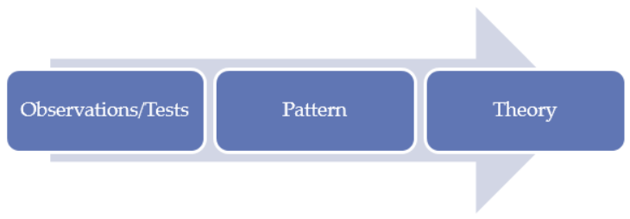
Source: Dudovskiy (2023)
As discussed in the literature review, there are popular and proven theories of employee motivation which can be of value in studying the current case of SMEs. The knowledge from these conceptual frameworks is used just as guidance when exploring the actual experience of SMEs in the UK. Eventually, the evidence from the conducted interviews will be used to build new models of employee motivation in alignment with the chosen inductive reasoning.

3.4 Strategy
The data collection strategy is based on interviews. In general, interviews serve as a valuable method for gathering primary data from personnel working in SME enterprises. Interviews possess numerous noteworthy advantages worthy of discussion. Interviews are a valuable method for gathering qualitative data, since they provide a comprehensive understanding of each interviewee through the acquisition of in-depth information (Adams, 2014: Saunders et al., 2015). Therefore, interviews seem to be highly efficacious in acquiring a comprehensive knowledge regarding the individual job experiences and the determinants of motivation.
Furthermore, it is worth noting that interviews tend to possess a lower degree of structure compared to surveys. Consequently, this characteristic affords the interviewer the chance to pose supplementary questions and alter the trajectory of the discourse in response to new insights. The acquisition of novel and unanticipated insights pertaining to individual experiences has significant importance (Saunders et al., 2015). Moreover, it is worth noting that interviews have proven to be useful in generating data, even when conducted with small sample sizes (Saunders et al., 2015). This can be of key advantage given the limited resources for conducting the current study among SME firms in the UK.

3.5 Choices and time horizon
A mono method is used in the current study. This means that new knowledge is entirely based on qualitative data from interviews. A mono method prevents the achievement of data triangulation where multiple methods of data collection are utilised (Saunders et al., 2019). Despite this limitation, the use of interviews is still useful for recognising the current trends in the field of employee motivation.
Given the constraints of the research project, the time horizon is limited to the contemporary situation. As a result, this study is suggested to be a cross-sectional one.

3.6 Data collection and analysis
The main objective of the data collection procedure is to carry out a sequence of interviews with personnel working in SME firms located across many areas of the UK. Digital communication platforms, such as the widely utilised Zoom, are employed to effectively connect with employees who are in different geographical regions, hence optimising cost and time management.
The data collection process is based on a set of predetermined questions – a structured questionnaire. The actual questionnaire, which guides the interviews, is shown in the appendix of the study. The questionnaire consists of 15 items separated into three main sections focused on personal/organisational background, level of motivation and an exploration of the determinants of employee motivation. Questionnaire items are not random. Instead, they are derived from the key findings from the literature review. Nevertheless, there are some modifications based on the specific requirements of the data collection process.
The data collection process took place in October 2023 for a period of two weeks. It was according to the initial schedule.
The sample finally reached five employees of SMEs. As discussed, interviews predispose smaller sample sizes to reach valuable findings (Saunders et al., 2019). Regardless of the small sample, the selected participants were quite diverse in terms of geographic location, type of firm, industry of operations and personal professional background. Considering this, the results from the interviews can be considered indicative for the established trends and practices among SMEs.
In terms of data analysis, it is worth noting that the processing of the collected interview-based qualitative data is unstructured. The full transcripts of the interviews are presented in the appendix of the study. The research process examines the semantic interpretations and contextual nuances conveyed through the content of the interviews. Thus, the potential for subjective interpretations is inherent in this approach, which is a prevalent characteristic of qualitative data analysis.

3.7 Ethical considerations
Ethical standards must be high given the participation of humans. There are several principles guiding the current data collection process. First, participation is completely voluntary and based on informed consent (O’Gorman, 2015). In general, recruiting motivated participants on a voluntary basis ensures more extensive and high-quality research findings. Second, the data collection process prioritises safety, as harm avoidance is essential in research ethics (Saunders et al., 2009). In this context, there are no sensitive questions in the interviews. The interview environment is also safe. Participants have the right to leave the interview or skip questions if considered inappropriate. Third, the principle of anonymity and confidentiality is also maintained by avoiding personal information and keeping the results of the interviews for research purposes only. Confidentiality and anonymity are important, as interviewees share information regarding their professional work experience which may expose their employers. Last, under-aged interviewees, as well as the ones lacking capacity are purposefully excluded from participation.
While these key principles ensure ethical primary data collection, it is also important to maintain ethical principles in relation to the used literature. For instance, appropriate conduct requires accurate citation of all sources under the form of in-text citations and a list of references (Sekaran and Bougie, 2016). Thus, the research contribution of others is recognised. In addition, it is important to maintain the principle of justice by selection of sources of information based on a certain search criterion and avoiding a selective, and respectively subjective, choice of certain information sources only (Saunders et al., 2009).

3.8 Limitations
The earlier mentioned limitations in terms of time horizon and types of data pose a threat to the ability to achieve valid results. Nevertheless, these methodological limitations are inherited given the university requirements to complete the research project.
The lack of large-scale survey-based data may lead to some bias; thereby, jeopardising the reliability of the acquired primary data. The focus on SMEs is also a limitation, as it restricts the scope of analysis of employee motivation. The exclusion of large company eliminates the opportunity to compare the trends between SMEs and large organisations.
The above-mentioned limitations must be explored as a part of future research in the field.

Chapter 4: Results and analysis
This part of the dissertation explores the results from the interviews with five employees of SMEs.

4.1 Findings

4.1.1 Sample characteristics
The starting point of the discussion focuses on the demographic features of the small sample of five interviewees. Table 1 summarises the key findings. The sample is quite diverse in terms of job experience at the currently occupied position. The interviewees have accumulated job experience ranging from just several months up to ten years. Thus, they are suggested to have sufficient knowledge about their employers to deliver evidence-based opinions. The sample is also quite diverse in terms of job positions. There are two regular employees, an entry level professional, a manager and a specialist. These are diverse perspectives which enrich the understanding about the HRM process at SMEs.
Table 1 - Background characteristics of employees
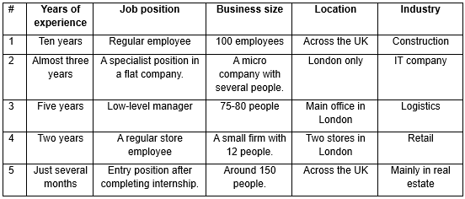
Despite the small sample size, the sample also managed to include companies with quite different background. There are two medium-sized companies, followed by two small firms and a micro one. The organisations are primarily located in London, but some of them have a nationwide exposure, as well. The industries of operation are also quite different by including organisations in construction, IT, logistics, retail and real estate.
Considering these key background findings, it is expected to collect quite diverse opinions reflecting different professional and organisational perspectives. Thus, the research findings can be quite valid and supporting the understanding of the HRM process among the SMEs.

4.1.2 Levels of motivation, satisfaction and retention
The next part of the analysis explores the levels of motivation, job satisfaction and retention among the interviewed five employees. These are key manifestations of the HRM effectiveness, as discussed in the literature review. The findings are presented in table 2 below by including quotes from the interviews.
In terms of motivation level, quite diverse opinions are expressed. The IT and real estate employees are very motivated; however, the retail sector representative expresses quite low level of motivation. Thus, there are considerable variations in the reported levels of motivation. It is important to note that job satisfaction significantly correlated with the expressed levels of motivation. In general, motivated employees are also satisfied and the vice versa, as explained in more detail in table 2.
Table 2 - Reported levels of motivation, satisfaction and retention
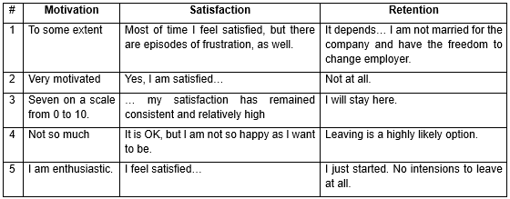
The level of retention is also quite diverse. In general, motivated and satisfied employees demonstrate strong retentions to stay at the current employer. In contrast, dissatisfaction at work, as observed in employee #4, leads to strong intentions to leave the company.
The diversity of opinions shows that SMEs have quite different HRM policies and practices, yielding different outcomes. This motivates the exploration of the determinants of employee motivation, as they affect the quality of the entire HRM process. Therefore, the analysis of interview findings continues with a thorough exploration of the key factors, as selected in the literature review discussion.

4.1.3 Performance analysis
The actual performance analysis first explores the priorities of employees by asking them about the most important factors to be motivated and satisfied at work. The construction sector employee appreciates a good pay level and a balance between work and life. Growth and dynamism are considered important by the IT sector employees. Professional development is also mentioned as important by the real estate employee. The retail employee wants to meet the basic need of good treatment. A quite different opinion is expressed by the interviewee from the logistics sector. The comment demonstrates gradually evolving priorities over time: “At the beginning, I focused on safety and good pay level. Now, I appreciate being a part of a team and growing professionally. I also want to be challenged at work. As you can see, it is different, and my needs have changed over time.”
The expressed opinions are different, and they recognise the existence of many needs in a work context. Among all, professional growth and development appears to be quite important three out of five employees. This demonstrates the role of motivators and the highest order needs from the analysed theoretical model of Maslow and Herzberg. The analysis continues with an analysis of organisational performance by groups of factors.
The physiological and especially safety needs are initially analysed, as they occupy the foundation of the pyramid model (Maslow, 1943). The construction employee reports safety issues at work: “Safety is sometimes an issue in our sector due to the specifics of the construction process. My tensions at work are often associated with safety problems.” As seen, safety can be a major problem effecting the levels of job motivation and satisfaction. Safety of the work environment is not a problem in the remaining four interviewees.
In addition to a safe environment, safety at work also depends on the level of financial compensation. The construction employee states that the pay level aligns with the industry averages. In the case of the IT employee, the pay level is described as “quite attractive”. In logistics, there are variations worth noting: “…pay level is quite reasonable. It is high but tends to fluctuate, since a part of the payment depends on the size of a quarterly performance bonus.” The real estate employee receives low pay, but this is not a problem given the entry position and expectations for future increases. Based on the interview findings, payment appears to be a major problem for the retail sector employee: “The payment is close to the minimum for such a position. This is not a motivating factor for me to stay there.” Low pay level is a major factor for demotivation and frustration in the workplace.
The nature and quality of organisational policies is also a key element of work safety and transparency of management. There are variations in this domain. The two medium-sized organisations have formal and written policies, as reported by the employees in the construction and real estate firms. In a similar fashion, the logistics organisation also adopts written and clearly determined policies. In the micro-IT firm, policies and procedures are informal and oral. A similar practice is also observed in the small-sized retail firm. Thus, it can be suggested that organisational size and implemented communication processes largely determine the degree of policy formality and the ways of solving work-related conflicts. In general, organisational policies are not a factor which may cause low motivation and satisfaction at work, as reported in the interviews.
The analysis proceeds along the pyramid model and evaluates the satisfaction of the belonging needs of the interviewed employees. At the construction company, belonging needs are overlooked, as reported by the employee: “There are no efforts to deliver any celebrations and team-based activities. It is simply not the priority of the company. They assume that working together is equal to team-based activities.” Respectively, this is considered a major HRM problem. In contrast, the belonging needs are well-met at the IT firm: “We are a coherent team in every aspect of the work. We do many things together, including team-based activities and celebrations.” In a similar manner, the logistic firm also adopts a range of policies stimulating the team spirit: “There is good spirit and many activities involving many people as a team.” Celebrations and team-based activities are also present in the retail firm. Acceptance and being a part of the team is also reported by the real estate employee. Considering these results, belong needs are generally well-addressed except for the construction company.
Esteem needs are also analysed accordingly. There are special rewards in the IT firm once a project is completed. In the logistics company, esteem needs are well-addressed: “Recognition is reflected in the size of the quarterly bonus. The employer also engages in public recognition in front of all colleagues. Private recognition also exists. I feel high status.” The real estate employee occupies an entry position and there is no information regarding the applied rewards and forms of recognition. Problems are reported in the construction and retail firms. The former has no policies for recognising employees’ achievements. The retail job is seen as a low-status one and recognition is not present, as well. The findings demonstrate quite diverse policies and practices in the field of recognition and rewards with major effect on employee motivation and job satisfaction.
The final area refers to self-actualisation where themes, such as professional development, promotion, work-related challenges and job design are discussed. Regrading training and development, this is a priority area for the construction company: “There are many training and development initiatives…because there are many technical aspects of working in the sector.” In the IT company, training and development is also a priority: “…many online seminars and specialised courses based on the individual needs…The boss is also quite helpful and delivers real-time on-the-job assistance and support, if necessary.” In the logistics firm, there is a mixed performance, as reported by the employee: “To some extent. I ask for extra activities, such as access to specialised courses. But the reaction has been quite slow so far. This is definitely a key performance gap…” In the real estate firm, training and development are critically important; hence, periodic support and learning activities are delivered. In the retail firm, training and development is limited to some on-the-job training at the beginning of the occupation. Considering all, the nature of training and development tends to largely affects the quality of the HRM process.
Regarding promotion, the real estate employee cannot answer because of the limited work experience. In the IT firm, promotion does not exist, as the company is flat, and all employees are autonomous and highly specialised. Promotion is evident in the construction and logistics firms, as reported by the interviewees. In the retail firm, the nature of the job position does not allow for promotion at all. Findings show that promotional opportunities largely depend on the size of the respective organisation and the structural complexity.
Job challenges are common and have a positive impact on the construction employee: “There are many cases on daily basis. Creativity, flexibility and problem-solving skills must be demonstrated to cope with the problems. This is to some extent stimulating for me.” In a similar fashion, work-related challenges strongly contribute to employee motivation in the IT firm: “…solving challenges and applying creative solutions is quite important for keeping me motivated at work.” In the field of logistics, there are “…many challenge.... I like challenges and this explains my professional choice…This is challenging and stimulation, but at some point, it may be a main stressor if crossing a certain level.” In the field of retail: “There are many challenges at work. Sometimes, it is necessary to cope with a high workload. We also participate in some of the operational decisions which boosts engagement and creativity due to the feeling of being a part of the company.” In the real estate firm: “There are challenges every day due to the dynamism of the work…challenges and solving problems considerably motivate me to grow.” As demonstrated by interview findings, challenges are common and have a positive impact on motivation and engagement, if the doze is appropriate.
The analysis of findings concludes with the performance in job design. Except for the logistics firm, the work process can be altered based on individual preferences. In the construction firm, this is manifested by changes in the work time, whereas the retail employee receives extra days-off, if necessary. In the IT firm, all work processes are modified based on individual needs and preferences. Flexibility are responsiveness are reported in the real estate firm, as well. In general, the performance in job design is appropriate, but there is room for future improvements.
The analysis continues with a discussion of findings.

4.2 Discussion
The study explored in detail the experience of five SME employees and there is evidence to improve HRM process – a key goal of the research paper. The analysis shows performance gaps in all five cases, as summarised below. HRM performance is unique and may be affected by organisational specifics, such as size, structure and resource availability. The information from table 3 clearly shows the differences in the range of reported problems. The construction and retail employees face problems at the more basic safety needs, and this has a quite negative impact on their work motivation, satisfaction and retention (see table 2). This validates the theoretical propositions by Herzberg (1987) regarding the importance of meeting the hygiene factors first prior to proceeding to motivators. The validity of the Maslow’s model is also confirmed, as gaps in the more basic safety and belonging needs prevent the achievement of high motivation and progress along the pyramid (Maslow, 1943). Considering all, the lack of a systematic HRM policy, as evident in the cases of the construction and retail employees, delivered motivational and retention issues.
Table 3 - A summary of the reporter problems
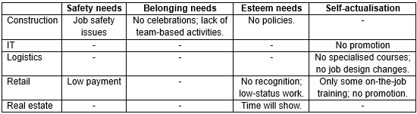
The results from table 2 also confirm the earlier-mentioned link between motivation and satisfaction at work, as well as their effect on retention and engagement. Thus, the empirical findings by Imran et al. (2016), Krekel et al. (2019) and Skelton et al. (2020) are confirmed by the results of the current study.
In general, findings indicate differences in the reported levels of employee motivation, satisfaction and retention at work. The performance results largely depend on the quality and extensiveness of the applied HRM policies and practices. The results from table 3 indicate not only the specific performance gaps to be addressed by the respective SMEs, but also the positive link between performance gaps and instances of employee dissatisfaction and intentions to leave. Considering this, research findings largely validate the applied theoretical models and deliver guidelines for future improvements. Specific recommendations are suggested in the next chapter.

Chapter 5: Conclusions and recommendations

5.1 Key conclusions
Research findings demonstrates the existing fluctuations of employee motivation, satisfaction and retention aming the interviewed five employees. The observed fluctuations are mainly explained with the nature of the applied HRM process, rather specific background factors of employees. Therefore, future improvement largely depends on the quality of the HRM process and the ability of firms to address all factors affecting motivation at work. Since employee motivation significantly influences organisational productivity, creativity and overall performance, investments in a more extensive HRM process are worth considering. SMEs strongly depend on the quality of employee management; hence, the proposed evidence-based recommendations must be applied to achieve sustainable improvements in the future.

5.2 Recommendations
The first recommendation recognises the lack of consistent HRM policies in some companies. Therefore, firms are advised to regularly monitor the levels of motivation and satisfaction among employees. Such knowledge can show the performance gaps and the respective policies for improvement.
Second, organisations must also prioritise the HRM process in general. This includes more resources, as well as better understanding of the HRM process. Owners and managers are advised to apply some of the proven models (Maslow, Herzberg or other) to have a road map guiding performance.
Third, all HRM policies and procedures must be adapted to the specifics of each firm. While the analysed employee needs and factors for motivation appear to be quite relevant and valid, each firm is different. Therefore, some factors may be more or less important depending on the specifics of the occupation and company. For example, while promotion is theoretically suggested to be a major motivator, it is of no relevance for the IT firm in this study where a flat structure and autonomy of employee make promotion of little value. Considering this example, HRM policies must be adapted.
Fourth, organisations should also consider the usefulness of job design changes. Given the case of SMEs, it is easier to know the specific preferences of every employee due to the low number of employees and personal communication. This in turn makes it easier to adapt the job process, work time and other elements to achieve improved motivation and satisfaction.
Last, but not the least, recommendations also address the existing methodological weaknesses. Future research is necessary to explore the main HRM trends among the group of SMEs. In this light, longitudinal studies are quite valuable. Validation of current results is also needed by considering studies with larger samples, as well as other methods of analysis, such as focus groups and specifically surveys. Future research may also consider the applicability of other theoretical models, as well. The topic of employee motivation is relevant and important; hence, it must be a priority in future research.

References
Adams, J. 2014. Research Methods for Business and Social Science Students. New Delhi: SAGE Publications.
Alhaji, I. 2012. Does motivational factor influence organizational commitment and effectiveness? A review of literature. E3 Journal of Business Management and Economics. 3(1): 1-9.
Analoui, F. 1999. Eight parameters of managerial effectiveness. Journal of Management Development. 18(4):362–390. DOI: 10.1108/02621719910265568.
Balogh, L. 2015. Sport – Culture – Sports Culture, [online] Available at: https://www.researchgate.net/publication/288835900_Sport_-_Culture_-_Sports_Culture [Accessed 31 July 2023].
Barney, J. 1991. Firm Resources and Sustained Competitive Advantage. Journal of Management. 17(1):99–120. DOI: 10.1177/014920639101700108.
Business Jargon (BJ) 2019. Theories of Motivation, [online] Available at: https://businessjargons.com/theories-of-motivation.html [Accessed 31 July 2023].
Dubin, R. 1970. Human Relations in Administration. Prentice Hall.
Dudovskiy, J. 2023. Inductive Approach (Inductive Reasoning), [online] Available: https://research-methodology.net/research-methodology/research-approach/inductive-approach-2/ [Accessed 1 August 2023].
Elliott, L. 2023. UK payroll numbers fall as unemployment rate rises to 3.9%, [online] Available: https://www.theguardian.com/business/2023/may/16/uk-payroll-fall-unemployment-rate-rises#:~:text=The%20official%20figures%20showed%20employment,to%203.9%25%20from%203.8%25 [Accessed 20 October 2023].
Enrich 2023. The Cost of Replacing an Employee and the Role of Financial Wellness, [online] Available: https://www.enrich.org/blog/The-true-cost-of-employee-turnover-financial-wellness-enrich#:~:text=Research%20by%20SHRM%20suggests%20that,overall%20losses%20to%20the%20company [Accessed 22 October 2023].
Galletta, M., Portoghese, I. & Battistelli, A. 2011. Intrinsic motivation, job autonomy and turnover intention in the Italian healthcare: the mediating role of affective commitment. Journal of Management Research. 3(2), 1-19.
Harari, D. 2023. Productivity: Key Economic Indicators, [online] Available at: https://commonslibrary.parliament.uk/research-briefings/sn02791/ [Accessed 5 July 2023].
Herzberg, F. 1987. One more time: how do you motivate employees? Boston: Harvard Business School.
Hook, C. & Jenkins, A. 2019. Introducing Human Resource Management. 8th edition, Pearson: UK.
Hutton, G. (2022) Business statistics, [online] Available: https://researchbriefings.files.parliament.uk/documents/SN06152/SN06152.pdf [Accessed 5 July 2023].
Imran, R., Allil, K. & Mahmoud, A. 2016. Teacher’s Turnover Intentions: Examining the Impact of Motivation and Organizational Commitment. International Journal of Educational Management. 31: 828-842.
Koontz, H. & O’Donnell, C. 1978. Essentials of Management. McGraw Hill.
Kreitner, R. & Kinicki, A. 2002. Organizational Behaviour. 2nd edition, McGraw Hill, London.
Krekel, C., Ward, G. & de Neve, J-E. 2019. Happy employees and their impact on firm performance, [online] Available: https://blogs.lse.ac.uk/businessreview/2019/07/15/happy-employees-and-their-impact-on-firm-performance/ [Accessed 22 October 2023].
Kunchala, R. 2017. Herzberg’s Two-Factor Theory of Motivation, [online] Available: https://www.mbahelp24.com/herzbergs-two-factor-theory-motivation-hygiene-satisfier/ [Accessed 22 October 2023].
Lodico, M., Spaulding, D. & Voegtle, K. 2010. Methods in Educational Research: From Theory to Practice. John Wiley & Sons.
Macpherson, W. 2013. An Examination of Kaizen Drift in Japanese Genba: Implications for Business in the Anglosphere, [online] Available: https://www.researchgate.net/publication/264861381_An_Examination_of_Kaizen_Drift_in_Japanese_Genba_Implications_for_Business_in_the_Anglosphere [Accessed 22 October 2023].
Martin, A. & Dowson, M. 2009. Interpersonal relationships, motivation, engagement, and achievement: yields for theory, current issues, and educational practice. Review of Educational Research. 79(1): 327-365.
Maslow, A. 1943. A theory of human motivation, Psychological Review, July, 370-396.
Mintz, S. 2017. Meeting Millennials’ Needs in the Workplace, [online] Available: http://www.workplaceethicsadvice.com/2017/04/meeting-millennials-needs-in-the-workplace.html [Accessed 22 October 2023].
Monster (2023) What is the ideal employee turnover rate? [online] Available at: https://www.monster.co.uk/advertise-a-job/resources/workforce-management-planning/employee-retention-strategies/what-is-the-ideal-employee-turnover-rate/ [Accessed 5 July 2023].
Myers, M. 2008. Qualitative Research in Business & Management. SAGE Publications.
O’Gorman, K. 2015. Research methods for business & management: a guide to writing your dissertation. 2nd edition, Oxford, England: Goodfellow Publishers Ltd.
Office for National Statistics (ONS) (2023) Employment in the UK: September 2023, [online] Available: https://www.ons.gov.uk/employmentandlabourmarket/peopleinwork/employmentandemployeetypes/bulletins/employmentintheuk/september2023#:~:text=The%20UK%20unemployment%20rate%20was,(COVID%2D19)%20pandemic [Accessed 11 October 2023].
Pizam, A. & Mansfield Y. 2009. Consumer Behaviour in Travel and Tourism. New York: Howarth Hospitality Press.
Ramlall, S. 2004. A review of employee motivation theories and their implications for employee retention within organizations, Journal of American Academy of Business, Cambridge. 5(1): 52-63.
Rina, H. 2023. Employee Motivation, [online] Available: https://www.economicsdiscussion.net/human-resource-management/employee-motivation/employee-motivation/32360 [Accessed 23 October 2023].
Saunders, M. 2019. Research methods for business students. 8th edition, Harlow: Pearson.
Saunders, M., Lewis, P. & Thornhill, A. 2009. Research methods for business students. 5th edition, London: Pearson.
Saunders, M., Lewis, P. & Thornhill, A. 2015. Research methods for business students. 7th edition, London: Pearson.
Scott, W. 1962. Human Relations in Management: A Behavioral Science Approach: Philosophy, Analysis, and Issues. Irwin.
Sekaran, U. & Bougie, R. 2016. Research Methods for Business: A Skill Building Approach. 7th edition, United Kingdom: Wiley.
Sekhar, C., Patwardhan, M. & Singh, R. 2013. A literature review on motivation. Global Business Perspective. 1:471-487.
Sheikh, A., Dahie, A. & Ali, A. 2016. Teacher Motivation and School Performance, the Mediating Effect of Job Satisfaction: Survey from Secondary Schools in Mogadishu. International Journal of Education and Social Science. 3(1): 24-38.
Skelton, A., Nattress, D. & Dwyer, R. 2020. Predicting manufacturing employee turnover intentions. Journal of Economics, Finance and Administrative Science. Vol. 25(49): 101-117. https://doi.org/10.1108/JEFAS-07-2018-0069.
Sorge, A. & Warner, M. 1997. The IEBM handbook of Organisational Behaviour. Amazon: Ca.
Thompson, P. & McHugh, D. 2002. Work Organisations. 3rd edition, Basingstoke: Palgrave.
Trading Economics (2023) United Kingdom Bankruptcies, [online] Available: https://tradingeconomics.com/united-kingdom/bankruptcies [Accessed 8 October 2023].
Weber, R. 2004. Editor’s comments: the rhetoric of positivism versus interpretivism: a personal view. MIS Quarterly. 3-12.

Appendix A – Interview questionnaire
Background information
1. Can you provide some basic details regarding the years of professional experience and the occupied position in the current company?
2. Can you describe basic facts about your employer, such as size, location and industry of operations?
Employee management
3. Are you motivated in the workplace and to what extent?
4. Do you feel professionally satisfied at work?
5. Do you have intensions to stay with the company and plan to leave in the foreseeable future?
Determinants of employee motivation
6. Can you explain the most important factors which you consider as essential to be motivated in the workplace?
7. Does your employer deliver a safe work environment and secure employment? Is this important for your motivation?
8. Is your current employer offering effective and transparent organisational policies which support you at the workplace?
9. Is the current payment in terms of salary and bonuses attractive enough to maintain high motivation in the workplace?
10. What is the role of teamwork and sense of belonging? Does your employer support team-based activities and celebrations?
11. Do you receive recognition of achievement at work and status?
12. Is your current employer dedicated to training and development?
13. Is promotion well-met by the current organisational policies?
14. Are you challenged at work in terms of solving challenges and bearing responsibility for key decisions and activities?
15. Is the job design adapted to your personal specifics and needs?

Appendix B – Interview transcripts
1. Can you provide some basic details regarding the years of professional experience and the occupied position in the current company?
Employee 1: Ten years of professional experience. I am a regular employee.
E2: In this company, I think almost three years. We don’t have hierarchy, as I am just a part of the team of IT specialists working together.
E3: Five years ago, I became a part of the company. I am a low-level manager.
E4: Two years. A regular store employee behind the cash desk.
E5: I am newly hired with just several months of experience. This is an entry position after a successful internship.
2. Can you describe basic facts about your employer, such as size, location and industry of operations?
E1: It is a medium-sized company of approximately 100 employees. Located in London, but also having offices around the UK. In the field of construction.
E2: It is a micro company of just seven people in the IT sector with a single office in London.
E3: It is a small company with 75-80 people in the field of logistics. The main office is in London.
E4: It is a small business of around 12 people. In the retail sector. Two stores only.
E5: The company predominantly operates with real estate. It provides consultancy services and serves as intermediary between buyers and sellers. As far as I know, there are offices across the UK. The number of people varies. It is something around 150 people as far as I know.
3. Are you motivated in the workplace and to what extent?
E1: To some extent.
E2: I am very motivated.
E3: Yes, I am motived. On a scale from 0 to 10, it is seven.
E4: Not so much.
E5: I am enthusiastic with my first real job.
4. Do you feel professionally satisfied at work?
E1: Most of time I feel satisfied, but there are episodes of frustration, as well.
E2: Yes, I am satisfied because I do what I want to do. It is creative and challenging. The work contributes to my professional and personal growth.
E3: Yes, I feel satisfied in general. There are difficult periods, but my satisfaction has remained consistent and relatively high.
E4: It is OK, but I am not so happy as I want to be.
E5: I feel satisfied with the fact that they recognised my capabilities and hired me on a full-time basis.
5. Do you have intensions to stay with the company and plan to leave in the foreseeable future?
E1: It depends. I have been with the company for a long time. But I am not married for the company and have the freedom to change employer, if necessary.
E2: Not at all.
E3: At the current stage of development, I will stay here. The unemployment is increasing again, and I expect difficult periods in the future. Hence, I think it is better to stay safe here.
E4: Leaving is a highly likely option.
E5: I just started. No intensions to leave at all.
6. Can you explain the most important factors which you consider as essential to be motivated in the workplace?
E1: The pay level and the balance between work and life.
E2: Growth and dynamism.
E3: This is a difficult question. At the beginning, I focused on safety and good pay level. Now, I appreciate being a part of a team and growing professionally. I also want to be challenged at work. As you can see, it is different, and my needs have changed over time.
E4: To treat me better. In all aspects of the word.
E5: The opportunity to grow as a professional and fulfil worthy goals.
7. Does your employer deliver a safe work environment and secure employment? Is this important for your motivation?
E1: Safety is sometimes an issue in our sector due to the specifics of the construction process. My tensions at work are often associated with safety problems.
E2: Yes, the work environment is safe. It is an IT firm eventually.
E3: The work environment is safe. Everything complies with the safety standards. The employment is also relatively safe. Safety is not an issue.
E4: The work environment is safe. No complaints about that.
E5: The work environment is perfect. The office is well-equipped. Really a fancy place to be. Regarding the job security, my contract is for one year. I have some security.
8. Is your current employer offering effective and transparent organisational policies which support you at the workplace?
E1: There are written policies, but I have never read them. Most of the time, there are oral instructions.
E2: It is a micro business. We are a few people only. There is no need for formal policies, as we can openly discuss everything.
E3: I cannot determine. All past conflicts were solved according to organisational rules which are clear and written. Therefore, I can confirm to you that there are policies and rules guiding the employee management process.
E4: The work is simple. There is no need for formality and complex policies. I don’t really care so much about it.
E5: Yes, the organisation has written policies and guidelines.
9. Is the current payment in terms of salary and bonuses attractive enough to maintain high motivation in the workplace?
E1: The pay level is OK. It is like the other companies in the sector.
E2: The financial rewards are quite attractive. But they are not the main factor of being a part of the company.
E3: The pay level is quite reasonable. It is high but tends to fluctuate, since a part of the payment depends on the size of a quarterly performance bonus.
E4: The payment is close to the minimum for such a position. This is not a motivating factor for me to stay there.
E5: The pay level is quite low, as I am an entry level employee. The salary must grow over time. Currently, this pay level is not a problem for me, but I have expectations which must be met in the future. Otherwise, I will become dissatisfied at work.
10. What is the role of teamwork and sense of belonging? Does your employer support team-based activities and celebrations?
E1: This is a major problem. There are no efforts to deliver any celebrations and team-based activities. It is simply not the priority of the company. They assume that working together is equal to team-based activities.
E2: We are a coherent team in every aspect of the work. We do many things together, including team-based activities and celebrations.
E3: This is important for me and one of the key needs which are satisfied at work. There is good spirit and many activities involving many people as a team. The environment is really quite positive, and I appreciate it.
E4: There are celebrations and team-based activities and rewards. In this area, I have no complaints at all.
E5: I have a sense of being a part of the team. The accepted me and this is a sign that everything works well.
11. Do you receive recognition of achievement at work and status?
E1: No.
E2: Yes. There are special rewards when competing a project on time.
E3: Yes. Recognition is reflected in the size of the quarterly bonus. The employer also engages in public recognition in front of all colleagues. Private recognition also exists. I feel high status.
E4: Far from receiving recognition. I consider the work as a low status one.
E5: Time will show. Being hired is a recognition for my achievement. The future will show what other rewards are provided.
12. Is your current employer dedicated to training and development?
E1: There are many training and development initiatives. This is important because there are many technical aspects of working in the sector.
E2: Yes. We attend many online seminars and specialised courses based on the individual needs for learning and preferences. The boss is also quite helpful and delivers real-time on-the-job assistance and support, if necessary.
E3: To some extent. I ask for extra activities, such as access to specialised courses. But the reaction has been quite slow so far. This is definitely a key performance gap to be addressed in the future.
E4: I don’t think so. I received an on-the-job training at the beginning and nothing after that.
E5: Quite a lot. As an intern here I learnt a lot. They are flexible, ready to help and provide support if necessary. Learning and growth are keys for success in this company. This is perhaps because of the dynamic external environment and the high level of competition in the sector.
13. Is promotion well-met by the current organisational policies?
E1: To some extent, but I am not interested in getting promoted and having more responsibilities at work.
E2: No, because it is a small flat organisation with no hierarchical structure.
E3: Yes, I began as an ordinary employee. Now, I am a manager and have plans to grow in the future.
E4: The job does not allow for promotion at all.
E5: I cannot answer. I am an entry level employee eventually.
14. Are you challenged at work in terms of solving challenges and bearing responsibility for key decisions and activities?
E1: Oh, yeah. There are many cases on daily basis. Creativity, flexibility and problem-solving skills must be demonstrated to cope with the problems. This is to some extent stimulating for me.
E2: The IT job is quite challenging, as there are many issues to be solved daily. As earlier mentioned, solving challenges and applying creative solutions is quite important for keeping me motivated at work. This is perhaps the main differences between the current company and the large IT organisations.
E3: There are many challenges as logistics is dynamic by nature. I like challenges and this explains my professional choice. As a part of the work process, we must monitor many vehicles across Europe in real time and make instantaneous decisions. This is challenging and stimulation, but at some point, it may be a main stressor if crossing a certain level.
E4: There are many challenges at work. Sometimes, it is necessary to cope with a high workload. We also participate in some of the operational decisions which boosts engagement and creativity due to the feeling of being a part of the company.
E5: There are challenges every day due to the dynamism of the work. As a young professional, challenges and solving problems considerably motivate me to grow.
15. Is the job design adapted to your personal specifics and needs?
E1: On Wednesdays, I come later at work because of family reasons. The employer allows me to do so which is a form of job design change.
E2: Absolutely. Everything is adapted to individual tastes and preferences. This approach creates comfort and supports productivity at work. I find it quite important.
E3: Not really, I have never asked for job changes. The work process suits me well and I am not aware of the possible job design changes available to me.
E4: The boss is flexible and responsive when I have personal problems. I can ask for several days-off, if necessary. But the actual job stays the same.
E5: I don’t think so. If I have a problem, they are ready to help. My boss is quite flexible to be honest.

Appendix C – Ethics form
APPLICATION FOR ETHICAL APPROVAL

In order for research to result in benefit and minimise risk of harm, it must be conducted ethically. A researcher may not be covered by the University’s insurance if ethical approval has not been obtained prior to commencement.

The University follows the OECD Frascati manual definition of research activity: “creative work undertaken on a systematic basis in order to increase the stock of knowledge, including knowledge of man, culture and society, and the use of this stock of knowledge to devise new applications”. As such this covers activities undertaken by members of staff, postgraduate research students, and both taught postgraduate and undergraduate students working on dissertations/projects.

The individual undertaking the research activity is known as the “principal researcher”.

Ethical approval is not required for routine audits, performance reviews, quality assurance studies, testing within normal educational requirements, and literary or artistic criticism.

Please read the notes for guidance before completing ALL sections of the form.

This form must be completed and approved prior to undertaking any research activity. Please see Checklist for details of process for different categories of application.

SECTION A: About You (Principal Researcher)
1 | Full Name: |  | PAVEL MILKOV BODUSHKI
2 | Tick all boxes that apply: |  | Member of staff: | ☐ | Honorary research fellow: | ☐
 | Undergraduate Student | ☒ | Taught Postgraduate Student | ☐ | Postgraduate Research Student | ☐

3 | Institute/Academic Discipline/Centre: | University of Wales Trinity Saint David - London
4 | Campus: | London
5 | E-mail address: | pavelbodushki@mail.bg
6 | Contact Telephone Number: | 07550333442
 | For students:
7 | Student Number: | 2023711
8 | Programme of Study: | Ba - Business Management
9 | Director of Studies/Supervisor: | Mushfiqur Rahman

SECTION B: Approval for Research Activity
1 | Has the research activity received approval in principle?  (please check the Guidance Notes as to the appropriate approval process for different levels of research by different categories of individual) |  | YES | ☐ | NO | ☒
 |  |  |  |  | Date
2 | If Yes, please indicate source of approval (and date where known): Approval in principle must be obtained from the relevant source prior to seeking ethical approval | Research Degrees Committee |  | ☐
2 |  | Institute Research Committee |  | ☐
2 |  | Other (write in) |  | ☐

SECTION C: Internal and External Ethical Guidance Materials
 | Please list the core ethical guidance documents that have been referred to during the completion of this form (including any discipline-specific codes of research ethics, location-specific codes of research ethics, and also any specific ethical guidance relating to the proposed methodology). Please tick to confirm that your research proposal adheres to these codes and guidelines. You may add rows to this table if needed.
1 | UWTSD Research Ethics & Integrity Code of Practice | ☒
2 | UWTSD Research Data Management Policy | ☒
3 | [List any other relevant documents here] | ☐

SECTION D: External Collaborative Research Activity
If there are external collaborators then you should gain consent from the contact persons to share their personal data with the university. If there are no external collaborators then leave this section blank and continue to section E.
1 | Institution
2 | Contact person name
3 | Contact person e-mail address
4 | Is your research externally funded? |  | YES | ☐ | NO |  | ☐
5 | Are you in receipt of a KESS scholarship? |  | YES | ☐ | NO |  | ☐
6 | Are you specifically employed to undertake this research in either a paid or voluntary capacity? | Voluntary | YES | ☐ | NO | ☐
7 |  | Employed | YES | ☐ | NO | ☐
8 | Is the research being undertaken within an existing UWTSD Athrofa Professional Learning Partnership (APLP)? | If YES then the permission question below does not need to be answered. | YES | ☐ | NO |  | ☐
9 | Has permission to undertake the research has been provided by the partner organisation? | (If YES attach copy)  If NO the application cannot continue | YES | ☐ | NO |  | ☐

Where research activity is carried out in collaboration with an external organisation
10 | Does this organisation have its own ethics approval system? | YES | ☐ | NO |  | ☒
 | If Yes, please attach a copy of any final approval (or interim approval) from the organisation (this may be a copy of an email if appropriate).

SECTION E: Details of Research Activity
1 | Indicative title: | Factors for employee motivation among UK small and medium enterprises’ employees
2 | Proposed start date: | 20 September 2023 | Proposed end date: | 15 December 2023
Introduction to the Research (maximum 300 words per section)
Ensure that you write for a Non-Specialist Audience when outlining your response to the points below:
- Purpose of Research Activity
- Proposed Research Question
- Aims of Research Activity
- Objectives of Research Activity
Demonstrate, briefly, how Existing Research has informed the proposed activity and explain
- What the research activity will add to the body of knowledge
- How it addresses an area of importance.
3 | Purpose of Research Activity  The research activity is purposefully intended to collect and analyse contemporary data from small and medium-sized businesses. The evidence from employees is then used to analyse the human resource management process of small and medium-sized companies. Findings are expected to deliver relevant areas for improvements, so that the important human capital is better managed. This is important for enhancing the competitiveness of companies and benefit their employees.
4 | Research Question  How do employee motivation level affect performance?  What are the ways of improving employee motivation in the future?
5 | Aims of Research Activity  The main aim of the study is to improve the level of employee motivation of employees from small and medium-sized businesses.
6 | Objectives of Research Activity  - To explore the role of employee motivation on individual and organisational performance.  - To analyse the models of employee motivation.  - To assess the specific case of UK’s SMEs in terms of employee motivation level and its determinants.  - To propose focused recommendations for future improvement based on the primary data evidence.
Proposed methods (maximum 600 words)
Provide a brief summary of all the methods that may be used in the research activity, making it clear what specific techniques may be used. If methods other than those listed in this section are deemed appropriate later, additional ethical approval for those methods will be needed. You do not need to justify the methods here, but should instead describe how you intend to collect the data necessary for you to complete your project.
7 | The research activity includes different methods of data collection. The literature review – an important part of the research activity – is based on secondary data. Secondary data are necessary to build the context of the research and identify important themes in studying the process of human resource management by small and medium-sized organisations. The secondary data analysis includes secondary data sources, such as industry reports, statistical releases, books, academic publications and some online-based articles. The focus is placed on data reliability and accuracy.  The research activity also includes interviews. They contribute with primary information which is also quite specific in understanding the individual context. Thus, the access to high-quality in-depth qualitative data is essential for properly understanding the experience of employees from small and medium sized companies in the UK.
Location of research activity
Identify all locations where research activity will take place.
8 | The location is the UK.
Research activity outside of the UK
If research activity will take place overseas, you are responsible for ensuring that local ethical considerations are complied with and that the relevant permissions are sought. Specify any local guidelines (e.g. from local professional associations/learned societies/universities) that exist and whether these involve any ethical stipulations beyond those usual in the UK (provide details of any licenses or permissions required). Also specify whether there are any specific ethical issues raised by the local context in which the research activity is taking place, for example, particular cultural and/or legal sensitivities or vulnerabilities of participants. If you live in the country where you will do the research then please state this.
9 | (this box should expand as you type)

10 | Use of documentation not in the public domain: Are any documents NOT publicly available? | NO | ☒
10 |  | YES | ☐
11 | If Yes, please provide details here of how you will gain access to specific documentation that is not in the public domain and that this is in accordance with the current data protection law of the country in question and that of England and Wales.  (this box should expand as you type)

 | Does your research relate to one or more of the seven aims of the Well-being of Future Generations (Wales) Act 2015? | YES | NO
12 | A prosperous Wales | ☐ | ☒
13 | A resilient Wales | ☐ | ☒
14 | A healthier Wales | ☐ | ☒
15 | A more equal Wales | ☐ | ☒
16 | A Wales of cohesive communities | ☐ | ☒
17 | A Wales of vibrant culture and thriving Welsh language | ☐ | ☒
18 | A globally responsible Wales | ☐ | ☒
19 | If YES to any of the above, please give details:
 | (this box should expand as you type)

SECTION F: Scope of Research Activity
 | Will the research activity include: | YES | NO
1 | Use of a questionnaire or similar research instrument? | ☐ | ☒
2 | Use of interviews? | ☒ | ☐
3 | Use of focus groups? | ☐ | ☒
4 | Use of participant diaries? | ☐ | ☒
5 | Use of video or audio recording? | ☐ | ☒
6 | Use of computer-generated log files? | ☐ | ☒
7 | Participant observation with their knowledge? | ☐ | ☒
8 | Participant observation without their knowledge? | ☐ | ☒
9 | Access to personal or confidential information without the participants’ specific consent? | ☐ | ☒
10 | Administration of any questions, test stimuli, presentation that may be experienced as physically, mentally or emotionally harmful / offensive? | ☐ | ☒
11 | Performance of any acts which may cause embarrassment or affect self-esteem? | ☐ | ☒
12 | Investigation of participants involved in illegal activities? | ☐ | ☒
13 | Use of procedures that involve deception? | ☐ | ☒
14 | Administration of any substance, agent or placebo? | ☐ | ☒
15 | Working with live vertebrate animals? | ☐ | ☒
16 | Procedures that may have a negative impact on the environment? | ☐ | ☒
17 | Other primary data collection methods. Please indicate the type of data collection method(s) below. | ☐ | ☒
 | Details of any other primary data collection method:  (this box should expand as you type) | ☐ | ☒
If NO to every question, then the research activity is (ethically) low risk and may be exempt from some of the following sections (please refer to Guidance Notes).

If YES to any question, then no research activity should be undertaken until full ethical approval has been obtained.

SECTION G: Intended Participants
If there are no participants then do not complete this section, but go directly to section H.

 | Who are the intended participants: | YES | NO
1 | Students or staff at the University? | ☐ | ☒
2 | Adults (over the age of 18 and competent to give consent)? | ☒ | ☐
3 | Vulnerable adults? | ☐ | ☒
4 | Children and Young People under the age of 18? (Consent from Parent, Carer or Guardian will be required) | ☐ | ☒
5 | Prisoners? | ☐ | ☒
6 | Young offenders? | ☐ | ☒
7 | Those who could be considered to have a particularly dependent relationship with the investigator or a gatekeeper? | ☐ | ☒
8 | People engaged in illegal activities? | ☐ | ☒
9 | Others. Please indicate the participants below, and specifically any group who may be unable to give consent. | ☐ | ☒
 | Details of any other participant groups:  (this box should expand as you type) | ☐ | ☒

Participant numbers and source
Provide an estimate of the expected number of participants. How will you identify participants and how will they be recruited?
10 | How many participants are expected? | Five participants.
11 | Who will the participants be? | Employees of small and medium sized organisations in the UK.
12 | How will you identify the participants? | Participants are friends and colleagues of the researcher.

 | Information for participants: | YES | NO | N/A
13 | Will you describe the main research procedures to participants in advance, so that they are informed about what to expect? | ☒ | ☐ | ☐
14 | Will you tell participants that their participation is voluntary? | ☒ | ☐ | ☐
15 | Will you obtain written consent for participation? | ☒ | ☐ | ☐
16 | Will you explain to participants that refusal to participate in the research will not affect their treatment or education (if relevant)? | ☒ | ☐ | ☐
17 | If the research is observational, will you ask participants for their consent to being observed? | ☐ | ☐ | ☒
18 | Will you tell participants that they may withdraw from the research at any time and for any reason? | ☒ | ☐ | ☐
19 | With questionnaires, will you give participants the option of omitting questions they do not want to answer? | ☒ | ☐ | ☐
20 | Will you tell participants that their data will be treated with full confidentiality and that, if published, it will not be identifiable as theirs? | ☒ | ☐ | ☐
21 | Will you debrief participants at the end of their participation, in a way appropriate to the type of research undertaken? | ☒ | ☐ | ☐
22 | If NO to any of above questions, please give an explanation
 | (this box should expand as you type)

 | Information for participants: | YES | NO | N/A
24 | Will participants be paid? | ☐ | ☒ | ☐
25 | Is specialist electrical or other equipment to be used with participants? | ☐ | ☒ | ☐
26 | Are there any financial or other interests to the investigator or University arising from this study? | ☐ | ☒ | ☐
27 | Will the research activity involve deliberately misleading participants in any way, or the partial or full concealment of the specific study aims? | ☐ | ☒ | ☐
28 | If YES to any question, please provide full details
 | (this box should expand as you type)

SECTION H: Anticipated Risks

Outline any anticipated risks that may adversely affect any of the participants, the researchers and/or the University, and the steps that will be taken to address them.

If you have completed a full risk assessment (for example as required by a laboratory, or external research collaborator) you may append that to this form.
1 | Full risk assessment completed and appended? |  | Yes | ☐
1 |  |  | No | ☒
2 | Risks to participants  For example: sector-specific health & safety, emotional distress, financial disclosure, physical harm, transfer of personal data, sensitive organisational information
 | Risk to participants:  Emotional distress from sensitive questions. | How you will mitigate the risk to participants:  Purposeful avoidance of sensitive questions. Participants are allowed to skip a question if they wish to do so.
3 | If research activity may include sensitive, embarrassing or upsetting topics (e.g. sexual activity, drug use) or issues likely to disclose information requiring further action (e.g. criminal activity), give details of the procedures to deal with these issues, including any support/advice (e.g. helpline numbers) to be offered to participants. Note that where applicable, consent procedures should make it clear that if something potentially or actually illegal is discovered in the course of a project, it may need to be disclosed to the proper authorities
 | (this box should expand as you type)
4 | Risks to the investigator  For example: personal health & safety, physical harm, emotional distress, risk of accusation of harm/impropriety, conflict of interest
 | Risk to the investigator: Conflict of interest  (this box should expand as you type) | How you will mitigate the risk to the investigator:  The researcher must openly disclose any possible conflicts of interest among the involved stakeholders and successfully address them to maintain the integrity of the study process.  (this box should expand as you type)
5 | University/institutional risks  For example: adverse publicity, financial loss, data protection
 | Risk to the University: Adverse publicity  (this box should expand as you type) | How you will mitigate the risk to the University:  The research should have a policy of openness by freely disclosing its aims and methods, addressing disputes in a forthright manner, and giving priority to integrity to safeguard the university's image.  (this box should expand as you type)
6 | Environmental risks  For example: accidental spillage of pollutants, damage to local ecosystems
 | Risk to the environment: Data privacy and security  (this box should expand as you type) | How you will mitigate the risk to environment:  The researcher should implement resilient data security strategies to mitigate breaches and choose environmentally conscious and safe data storage techniques.  (this box should expand as you type)

 | Disclosure and Barring Service
 | If the research activity involves children or vulnerable adults, a Disclosure and Barring Service (DBS) certificate must be obtained before any contact with such participants. | YES | NO | N/A
7 | Does your research require you to hold a current DBS Certificate? | ☐ | ☒ | ☐
8 | If YES, please give the certificate number. If the certificate number is not available please write “Pending”; in this case any ethical approval will be subject to providing the appropriate certificate number.

SECTION I: Feedback, Consent and Confidentiality

1 | Feedback  What de-briefing and feedback will be provided to participants, how will this be done and when?
 | Prior to the interviews, all participants are informed about the purpose of the research and the specifics of the interviews. The individual rights of participants are also clarified. Feedback is also provided at the end of the data collection process.
2 | Informed consent  Describe the arrangements to inform potential participants, before providing consent, of what is involved in participating. Describe the arrangements for participants to provide full consent before data collection begins. If gaining consent in this way is inappropriate, explain how consent will be obtained and recorded in accordance with prevailing data protection legislation.
 | Informed consent is gained prior to interviews. This is a result of an informed consent sheet sent to all participants prior to the interview. The informed consent sheet clarifies the rights of participants, their role as source of data, purpose of the research and other relevant aspects of the interviews and the study. The informed consent also informs participants regarding the ethical standards an practices employed in the study.
3 | Confidentiality / Anonymity  Set out how anonymity of participants and confidentiality will be ensured in any outputs. If anonymity is not being offered, explain why this is the case.
 | Anonymity and confidentiality are protected by not asking any sensitive questions which may reveal any personal information. Interviews are also organised in a way, so that only the interviewer and the respective interviewee take part. Thus, privacy is ensured.

SECTION J: Data Protection and Storage

 | Does the research activity involve personal data (as defined by the General Data Protection Regulation 2016 “GDPR” and the Data Protection Act 2018 “DPA”)? | YES | NO
1 | “Personal data” means any information relating to an identified or identifiable natural person (‘data subject’). An identifiable natural person is one who can be identified, directly or indirectly, in particular by reference to an identifier such as a name, an identification number, location data, an online identifier or to one or more factors specific to the physical, physiological, genetic, mental, economic, cultural or social identity of that natural person. Any video or audio recordings of participants is considered to be personal data. | ☐ | ☐X
 | If YES, provide a description of the data and explain why this data needs to be collected:
2 | (this box should expand as you type)
 | Does it involve special category data (as defined by the GDPR)? | YES | NO
3 | “Special category data” means sensitive personal data consisting of information as to the data subjects’ –  (a) racial or ethnic origin,  (b) political opinions,  (c ) religious beliefs or other beliefs of a similar nature,  (d) membership of a trade union (within the meaning of the Trade Union and Labour Relations (Consolidation) Act 1992),  (e) physical or mental health or condition,  (f) sexual life,  (g) genetics,  (h) biometric data (as used for ID purposes), | ☐ | ☐X
 | If YES, provide a description of the special category data and explain why this data needs to be collected:
4 | (this box should expand as you type)

 | Will data from the research activity (collected data, drafts of the thesis, or materials for publication) be stored in any of the following ways? | YES | NO
5 | Manual files (i.e. in paper form)? | ☐ | ☒
6 | University computers? | ☐ | ☒
7 | Private company computers? | ☐ | ☒
8 | Home or other personal computers? | ☒ | ☐
9 | Laptop computers/ CDs/ Portable disk-drives/ memory sticks? | ☐ | ☒
10 | “Cloud” storage or websites? | ☐ | ☒
11 | Other – specify: | ☐ | ☒
12 | For all stored data, explain the measures in place to ensure the security of the data collected, data confidentiality, including details of backup procedures, password protection, encryption, anonymisation and pseudonymisation:
 | The interviews are protected with a password. The interviews are also anonymous.

 | Data Protection
 | Will the research activity involve any of the following activities: | YES | NO
13 | Electronic transfer of data in any form? | ☐ | ☒
14 | Sharing of data with others at the University outside of the immediate research team? | ☐ | ☒
15 | Sharing of data with other organisations? | ☐ | ☒
16 | Export of data outside the UK or importing of data from outside the UK? | ☐ | ☒
17 | Use of personal addresses, postcodes, faxes, emails or telephone numbers? | ☐ | ☒
18 | Publication of data that might allow identification of individuals? | ☐ | ☒
19 | Use of data management system? | ☐ | ☒
20 | Data archiving? | ☐ | ☒
21 | If YES to any question, please provide full details, explaining how this will be conducted in accordance with the GDPR and Data Protection Act (2018) (and any international equivalents, where appropriate):
 | (this box should expand as you type)
22 | List all who will have access to the data generated by the research activity:
 | (this box should expand as you type)
23 | List who will have control of, and act as custodian(s) for, data generated by the research activity:
 | (this box should expand as you type)
24 | Give details of data storage arrangements, including security measures in place to protect the data, where data will be stored, how long for, and in what form. Will data be archived – if so how and if not why not.
 | (this box should expand as you type)
25 | Please indicate if your data will be stored in the UWTSD Research Data Repository (see https://researchdata.uwtsd.ac.uk/ ). If so please explain. (Most relevant to academic staff)
 | (this box should expand as you type)
26 | Confirm that you have read the UWTSD guidance on data management (see https://www.uwtsd.ac.uk/library/research-data-management/) | YES | ☒
27 | Confirm that you are aware that you need to keep all data until after your research has completed or the end of your funding | YES | ☒

SECTION K: Declaration
The information which I have provided is correct and complete to the best of my knowledge. I have attempted to identify any risks and issues related to the research activity and acknowledge my obligations and the rights of the participants.

In submitting this application I hereby confirm that I undertake to ensure that the above named research activity will meet the University’s Research Ethics and Integrity Code of Practice which is published on the website: https://www.uwtsd.ac.uk/research/research-ethics/
1 | Signature of applicant: | Pavel Milkov Bodushki | Date:  22/12/23

For STUDENT Submissions:
2 | Director of Studies/Supervisor: | Mushfiqur Rahman | Date:  22/12/23
3 | Signature: | Mushfiqur Rahman | Date:  22/12/23

For STAFF Submissions:
4 | Academic Director/ Assistant Dean: |  | Date:
5 | Signature: |  | Date:

Checklist: Please complete the checklist below to ensure that you have completed the form according to the guidelines and attached any required documentation:
☒ | I have read the guidance notes supplied before completing the form.
☒ | I have completed ALL RELEVANT sections of the form in full.
☒ | I confirm that the research activity has received approval in principle
☐ | I have attached a copy of final/interim approval from external organisation (where appropriate)
☐ | I have attached a full risk assessment (where appropriate) ONLY TICK IF YOU HAVE ATTACHED A FULL RISK ASSESSMENT
☒ | I understand that it is my responsibility to ensure that the above named research activity will meet the University’s Research Ethics and Integrity Code of Practice.
☒ | I understand that before commencing data collection all documents aimed at respondents (including information sheets, consent forms, questionnaires, interview schedules etc.) must be confirmed by the DoS/Supervisor, module tutor or Academic Director.

RESEARCH STUDENTS AND STAFF ONLY
All communications relating to this application during its processing must be in writing and emailed to pgresearch@uwtsd.ac.uk , with the title ‘Ethical Approval’ followed by your name.
You will be informed of the outcome of your claim by email; therefore it is important that you check your University and personal email accounts regularly.
STUDENTS ON UNDERGRADUATE OR TAUGHT MASTERS PROGRAMMES should submit this form (and receive the outcome) via systems explained to you by the supervisor/module leader.

This form is available electronically from the Academic Office web pages: https://www.uwtsd.ac.uk/academic-office/appendices-and-forms/

