Transcription Exercise

Almost more than three decades after the devastating disaster that took place in the Soviet Union in 1986 contemporary historians are still researching and debating the effects of the catastrophe that took place that fateful day as well as how it happened. This letter was found within the State Archival Service of Ukraine and stands as just one document that builds up the Chornobyl: 35 years of memory exhibition. Created in 2021 this exhibition showcases life from the Exclusion Zone from those offering aid to those affected by the disaster.
The letter I have chosen to both translate and transcribe was written by a long-standing Russian family suggesting that the creation of a nationwide fund will help with fixing the fallout of Chornobyl. Unfortunately, there is no English translation therefore my transcription may not be 100% accurate however I used a rather simple methodology. Using a simple template of the Russian alphabet I was able to identify key vowels making words such as “and” and “nuclear” easy to identify, then to make the job slightly easier I used Sergey Levchin’s 2013 book Easy Russian Phrase Book to find small phrases. Going line by line I was able to place most of the words in comprehendible order.
To provide some brief historical context, the Chornobyl Nuclear disaster began on April 26, 1986, at the No. 4 reactor of the Chornobyl Nuclear Power Plant, near the city of Pripyat towards the Soviet Union's northern Ukrainian SSR. It is one of only two nuclear energy disasters with a rating of seven on the International Nuclear Event Scale, the other being Japan's Fukushima nuclear accident in 2011. The planned test of the plant was preceded by a series of operator actions, as well as the bypassing of automated shutdown systems. By the point the operator decided to shut down the reactor was in a severely unstable state. A design error in the control rods triggered a massive power surge as they were inserted into the reactor. The combination of highly hot fuel and cooling liquid incited fuel fragmentation, rapid steam generation, and a pressure increase. The reactor's design specifications were such that severe damage to even a handful of fuel assemblies would - and did - give rise to the reactor's destruction. During the first response, 237 workers were rushed to the hospital, with 134 suffering from severe radiation illness. Within 90 days, 28 of those hospitalised died, all of who were being treated for ARS. In the decade that followed, 14 more employees died from reasons other than radiation exposure 9 of whom had been hospitalised with ARS.
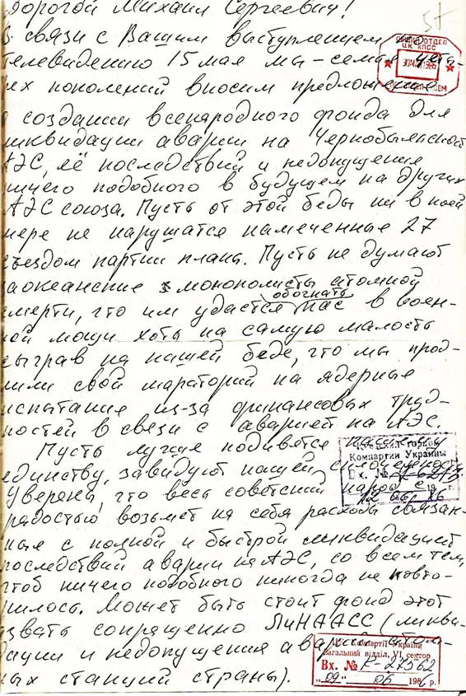

Letter from 4 generations of the family (Kononenko, Foya, Tronda) on the creation of a fund for the elimination of the consequences of the accident at the Chernobyl nuclear power plant. September 1986

Transcription-
Dear Mikhail Gorbachev!
In connection with your performance tour televised on May 15th, we ourselves of four generations are making a proposal to create a nationwide fund to eliminate the accident at Chornobyl and its consequences and to prevent something similar from occurring in the future. Let this trouble in no way disrupt the great plans outlined by the 27th congress of the party, let them not think that the monopolists of the atomic nuclear industry that they will succeed in overtaking our great military. What power we have, even the smallest of amounts should be used to manage our grave misfortune.
Let there be a set of moratoriums on nuclear tests. Testing of radiation on bones has been stopped due to financial trade with the west being halted, let us fix this. Let them marvel at our ways of unity and envy our ways of communism. We are sure that the western soviet people will take the weight of the cost itself with complete and rapid liquidation and bearing the consequences of the accident to ensure that nothing like this will ever happen again.
It may be worth calling this fund LINAASS.
Although this document is not an extremely long one there are a lot of key historical points that can be drawn from the contents the first point being the person that the letter is addressed to Mikhail Gorbachev. Gorbachev served as the eighth and also the final leader of the Soviet Union, Gorbachev held his position in office between 1985 and 1991. Unfortunately for Gorbachev and the rest of the Soviet Union, this would place his run as head of the Union right at the beginning of the nuclear disaster and its consequences, placing the unforeseen weight of the catastrophe on their shoulders.
The televised tour on May 15th was the first instance of Gorbachev publicly discussing the disaster after a period of an 18-day silence, the speech lasted around 25 minutes in which he defended the Soviet Union’s handling of the incident and outlined a suggested four-point plan in order to open communication and make information surrounding the accident and any future accidents easier to access.
There are many plans that the 27th Congress Party put forward upon Gorbachev taking his position as General Secretary in 1985 however there are three main ones that can be identified. The first being that “Soviet citizens must work in a new way in order to promote renewal”, and the second one was the “shift to intensive growth, and a drastic increase in efficiency was to be accomplished by the scientific and technical updating of production”. And finally, the “improvement of economic relations.”
Within the scope of a wider historical context, this letter can tell us a lot, the first major point to be drawn from this letter is that the faith of the Russian people in their government at this point after the disaster did not waiver and that their pride of the communist party and the Russian way of life was stronger than ever. The second major point that could be taken from this letter is that considering the fact that the disaster happened on the 26th of April 1986 and less than 5 years later in 1991 saw the fall of the Soviet Union it has been suggested by many modern historians such as Harvard historian Serhii Plokhy in his book The Last Empire that Chornobyl was one of the major inciting incidents that lead to the collapse of the Soviet Union. The country was heavily indebted both before and after the tragedy, but Chornobyl had already increased the Union's demise due to the damages it inflicted on an already dysfunctional economic structure.

ЦДЕА України (2021). State Archival Service of Ukraine. [online] Archives.gov.ua. Available at: https://archives.gov.ua/en/chernobyl-35-years-of-memory/ [Accessed 9 Jan. 2023].
Levchin, S. (2013). Easy Russian Phrase Book NEW EDITION: Over 700 Phrases for Everyday Use. United Kingdom: Dover Publications.
Mara, W. (2010). The Chernobyl Disaster: Legacy and Impact on the Future of Nuclear Energy. Ukraine: Marshall Cavendish Benchmark.
World-nuclear.org. (2022). Chernobyl | Chernobyl Accident | Chernobyl Disaster - World Nuclear Association. [online] Available at: https://world-nuclear.org/information-library/safety-and-security/safety-of-plants/chernobyl-accident. [Accessed 10 Jan. 2023].
(ЦДЕА України, 2021)
Gorbachev, M. S. (2011). Mikhail Gorbachev: Prophet of Change: from the Cold War to a Sustainable World. United Kingdom: Clearview.
GORBACHEV, ON TV, DEFENDS HANDLING OF ATOM DISASTER (Published 1986). (2023). The New York Times. [online] Available at: https://www.nytimes.com/1986/05/15/world/gorbachev-on-tv-defends-handling-of-atom-disaster.html [Accessed 10 Jan. 2023].
Chow, S., Herrera, N., Di, T., Moderator, V. and Haugen, D. (1986). TWENTY-SEVENTH CONGRESS OF THE COMMUNIST PARTY OF THE SOVIET UNION COMITTEEE DIRECTOR VICE DIRECTORS. [online] Available at: https://static1.squarespace.com/static/533e6b7de4b0d84a3bd7c4be/t/5c394261758d4640ed668422/1547256420130/Soviet.pdf [Accessed 10 Jan. 2023].
(Chow et al., 1986)
(Chow et al., 1986)
Plokhy, S. (2015). The Last Empire: The Final Days of the Soviet Union. United Kingdom: Oneworld Publications.

