Financial plan for WORLD OF CAKE shop

Executive Summery

Financial plan always helps us to know where our business stands and then let us to make better informed decisions about our business for resource allocation. It also gives a broad picture to set and truck progress towards our business goals. Any small business needs more cautious about their finance as it’s got very limited source of finance. A well-planned financial plan can help us to establish a successful business with greater confidence. It is also an important tool for all share holder or partners to know and consider our business because its give clear idea where we can see our business expenses and generate revenues. Ultimately every business survives when it makes enough profit then it’s expenses. This plan can give more confident and build better unity within the shareholders or partners to invest more to continue the business. Here I am going to explain our ‘World of Cake’ shop’s financial plan step by step to get a clear view of our business plan. It will cover our Sources of finance, Cash flow forecast, Sales forecast, Cost of production forecast and Break-Even analysis for our cake shop.

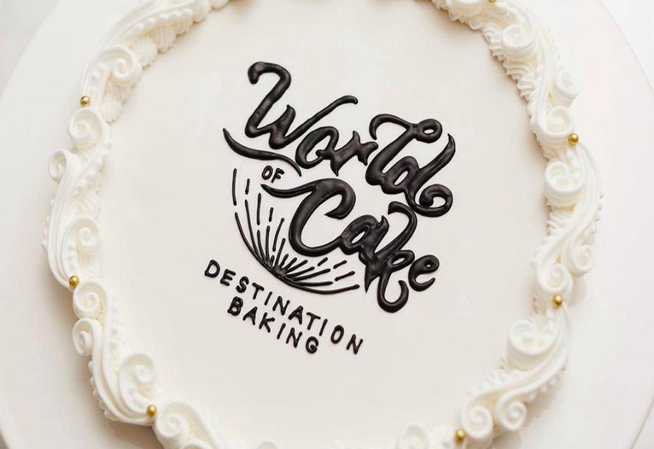
Source of Finance

Finance is the key element to start business. It is not easy to sources of finance at the beginning especially for a start-up small business. It is mostly by shareholders or partners savings who make up their hard earning cash to deposit to start their dream business. The source can mainly divide in to two key areas one is Internal Sources other is External sources. Under these two major sources there could be few other classified sources to get finance like:
  - Friends and family
  - Bank Loan
  - Credit Union
  - Government-Back schemes
  - Local Authorities like Councils
  - Crowd Funding
  - Asset Finance and Leasing

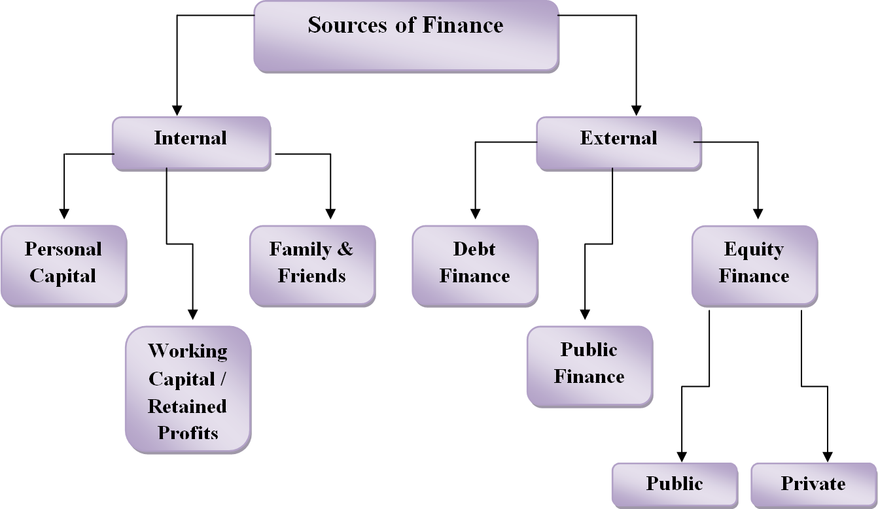

In our cake shop business we got 5 shareholders each of us got 20% shares which is equally distribute with personal £8000 cash deposit each. We got total £40000 cash investment to start our cake shop.

Cash Flow Forecast

Cash flow forecast is an important part of financial planning for our business. It is got brief explanation of money in business brought in and how much money paid out and the ending cash balance. Generally, Cash flow forecast statement make for monthly where we can see our business situation every month. It counts all kind of cash in for business as well as all money out for business. It is basically help us to understand the difference between what our profit and loss statement reports as income, our profit and what our actual cash position is. To run a healthy business, it is very important to understand where and when we can get Cash inflow in our business and to run as cash outflow to survive the business. It gives us a clear look at what cash are left of each month, help us to plan a possible business expansion or re investments. It also helps us to make our budget smarter such as take control of other expenses one month for the anticipated cash needs of another month. In a small business like our cake shop There is only two option to Cash inflow.
- Shareholder’s cash contribution
- Cash receive from sales
Cash out flow for our business such as:
- Premises Rent
- Business rate and Insurance
- Raw materials
- Utility and Transport bill
- Marketing and advertising
- Cleaning materials
- Uniform
- Salary
- Repair and maintenance
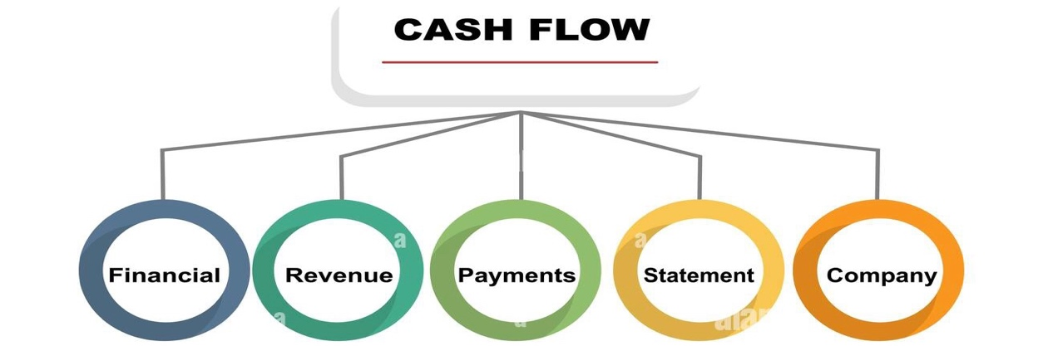
Sales forecast

Sales forecast gives us an accurate representation of our projected revenue and growth for our cake shop. It is determining our estimates sales, customer head count within in a period say for example in a month. Normally a sales forecast is comparing with present and previous data about our sales from similar items and to compare with our competitor for better market analysis. In the present competitive market to grow the revenue and reduce expenses it is a very vital tool to have a healthy sales forecast. We know its not easy as a new business our sales could hit our target but altogether, we have to give push to it more than our Break Even point to survive the business. The more quickly we can increase our sales the batter time we can generate our profit and reduce our loss. As a Cake shop, we might think about the seasons while we make our sales forecast. Usually in summer people spend a lot compared to winter or say for example after Christmas in January is always quite so we have to consider it when we create our sales forecast. As we discussed Weather and Economic situation also, we need to consider like at present there is high recession in economy with makes people to spend less. Sales forecast help us to make a better planning and marketing purposes. It is a on going process of our business plan. As sales is the main source to generate the profit, we have to be very cautious about it.

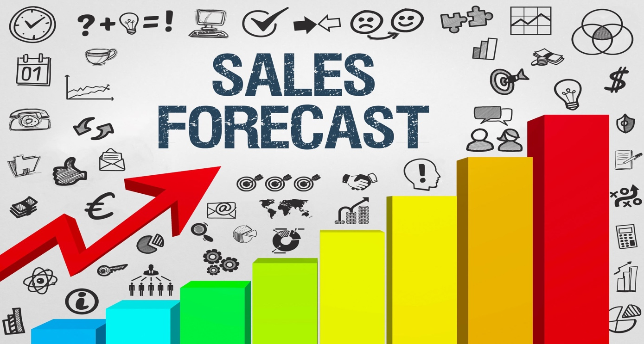
Cost of Production Forecast

Production is one of the major expensive areas in our cake shop business. We need different kind of raw materials for different kind of cakes, bakery and pastry. We have to be very realistic with current market price of raw materials. All most everything price gone up with high transport cost. Before we set the Cost of production, we need to do the physical market or raw material resource price check which will give us real time price trucker. We have to estimate per unit cost of manufactured good like Cake and pastry in our shop. As it is a food shop, we cannot afford to produce too many foods in one go then unless we sell them, we will end up waste eventually which lead our business down. When we think for cost forecast, we have to remember that it always two types of cost one is Fixed Cost other is Variable Cost.
- Fixed Cost: The cost that do change or vary with any amount of goods produced. It is something always fixed even we sell one item or hundred items. In a business revenue and output level do not affect fixed cost. In depth asset depreciation is also a fixed cost. There are some fixed costs we have to consider for our cake shop:
- Rent
- Business Rate
- Utility bills and Transport
- Advertising and Online account
- Cleaning Materials and Uniform
- Salary

- Variable cost: The cost that changes with the proportion of production output or sales. When our cake shop’s sales increase the variable cost also increase. It is something goes up and down through our sales forecast. Variable cost is a constant amount per unit items we produced. There are some fixed costs we have to consider for our cake shop:
- Raw Materials
- Labour cost
- Repair and Maintenance

Initial Administration Budget for Our Cake shop
Items | (Assets) Cost | Monthly Fixed Expenses | Other Expenses
Rent |  | £2000
Business rate |  | £500
Legal Expenses |  |  | £1000
Machinery | £7000
Shop Decoration | £6000
Raw Materials | £3000
Utility Bills & Transport |  | £1500
Advertising & Web develop |  | £2000 | £2000
Cleaning Materials & Uniform |  | £1000
Salary |  | £5000
TOTAL | £16000.00 | £12000.00 | £3000

•Our Initial Investment for first Month: £31000.00
•Our Total Fixed Cost: £12000.00
•Our Total Variable Cost: £10 per unit Cake
•Our Total Cost = Total Fixed Cost + Total Variable Cost
•Our Assets = Our Liabilities + Shareholder’s Capital
•Our Profit = Total Revenue − Total Cost
•Total Revenue = Quantity of Cake sale × Unit Sales Price (£40)

Break-Even Analysis

Break-Even point in an important calculation for any business financial plan. This is the point where Total Cost and Total Revenue are equal. That means in this point there is no loss or profit for a business. We can say other way like the it is the level of production at which the cost of production equals the revenues for a product. Simply how much we need to sell in order to cover all our expenses is our Cake shop Break-Even point. Break-Even analysis is a great tool to determine our product pricing. So, we should aim to fix a price per cake that gives us a comfortable margin over our expenses while allowing our business to remain compositable.

•Break Even Point = Total Fixed Cost ÷ (Sales Revenue −Variable Cost)
•Break Even Point = Profit zero

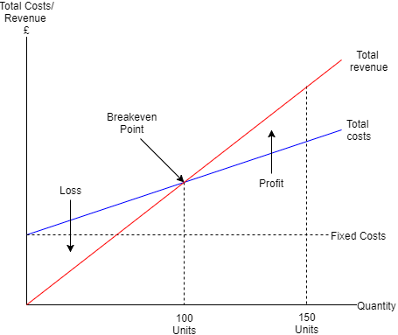
Break Even Analysis for next 6 months

 | Unit Sales | Fixed Cost  £ | Variable Cost  £ | Total Cost  £ | Sales Revenue  £ | Profit/Loss  £
January | 100 | 12000 | (100×10)=1000  Others=1000 | 14000 | (100×40)=4000  Others=6000 | ( −£4000 )
February | 150 | 12000 | (150×10)=1500  Others=1500 | 15000 | (150×40)=6000  Others=8000 | ( −£1000 )
March | 200 | 12000 | (200×10)=2000  Others=1500 | 15500 | (200×40)=8000  Others=8000 | £500
April | 250 | 12000 | (250×10)=2500  Others=2000 | 16500 | (250×40)=10000  Others=10000 | £3500
May | 300 | 12000 | (300×10)=3000  Others=2000 | 17000 | (300×40)=12000  Others=10000 | £5000
June | 350 | 12000 | (350×10)=3500  Others=2000 | 17500 | (350×40)=14000  Others=10000 | £6500

From the above table we can see that our Fixed Cost each month are £12000. Our Variable Cost per unit cake are £10. As it is a cake shop, we will also selling Hot drinks, soft drink, cold drinks, pastry, sandwiches, crisps, dry fruits and nuts, fresh fruits and traditional sweets. Here we are focusing cake unit price and rest of them in Others item price/cost. We can see in January when we will first open our “World of Cake” shop we hope we will sell 100 Unit of Cakes and their variable cost will be £1000 and in the same time Others items Variable costs £1000 also. So in January our Total Variable cost £2000. When we add up Fixed cost + Variable cost our Total Cost is £14000. This £14000 is our first month total expenses. Now if we look our Sales, we can see each cake unit we will sell £40. So, from 100 Unit of cake generate us £4000. From Others items we will sell £6000. Our Total Sales Revenue in January £10000. It looks like first month in January we are in loss -£4000. In second month, our shop get little bit busy hopefully and more customer start heading in to our shop also online order will increased we start increase our Cake production from 100 to 150 in February. We also increase our Others items stocks. In February our Cake Variable Cost £1500 for 150 units and Others items Variable Cost increase £1500. This month our Total Cost also increase to £15000. End of February our Sales Revenue will be £14000. This February we will be still in Loss position -£1000 which is better than previous month January. Third month which is March we will increase the cake unit sale to 200 unit which will increase our Total Cost to £15500 but our Sales Revenue will be £16000. In this third month we can see first time we will be in profit of £500. We can say this our Break-Even point for our Cake shop that mean we need to sell at least 200 Unit of Cake which generate £8000 and Others items Sales Revenue £8000. Total if we can make our Sales Revenue £16000 only then we can cover all our expenses with £500 profit. Here we can clearly see that it will take three months to make this shop to hit it’s Break-Even point. Our Initial Investment was £31000. Whereas out total capital was £40000. We keep £9000 in our hand to reinvest for first three months to make sure we can survive in the competitive market. From April we can see our profit increase £3500, May £5000 and June £6500 respectively. Over the next six months our Fixed Cost always keep £12000. By the passage of time when we increase our production our Variable Cost gone up from £14000 in January to £17500 in June. We belive it is great opportunity if we can continue our business like these way we can expand our new branch in next one year time.

References

- Battista, G. L., & Crowningshield, G. R. (1966). Cost behavior and breakeven analysis—a different approach. National Association of Accountants NAA Management Accounting, 48(2), 3–16.
- Bazerman, M. H. (2006). Judgment in managerial decision making. 6th edition. New York: John Wiley & Sons.
- Bell, A. L. (1969). Break-even charts versus marginal graphs. Management Accounting, 59(6), 32–35, 48.
- Brealey, R. A., Myers, S. C., and Marcus, A. J. (2008) Fundamentals of Corporate Finance. 6th edition. McGraw-Hill, NY.
- Wentworth, J., and Cafferky, M. E. (2010) Breakeven Analysis: The definitive guide to cost-volume-profit analysis. 1st edition. Business Expert Press, USA.

