A Critical Review of Three Primary Source Documents
Word Count 1156

The purpose of this essay is to compare and critically review three primary sources that reference the Pleiades, a star cluster located in the vicinity of the constellation Taurus. Specifically, each source will reflect the time that they were written in. Firstly, an ancient work from around 700 BCE, Hesiod’s (c. 750-650 BCE) Works and Days. The second, from 1531, Heinrich Cornelius Agrippa (1486-1535) Three Books of Occult Philosophy (De Occulta Philosophia libri III) and finally the third source will be Vivian E. Robson (1890-1942) 1923 book Fixed Stars and Constellations in Astrology. The relationship between how each source piece assigns a role to the constellation will be addressed and the different interpretations will be discussed as they have changed over the three time periods of Antiquity, the Renaissance, and the modern commentator. This essay will also discuss the overall material and the context that the Pleiades are presented within each source. That is, as part of Greek literature and epic poetry in Works and Days, in Renaissance philosophic interpretation by Agrippa, and as an astrological tool by Robson.

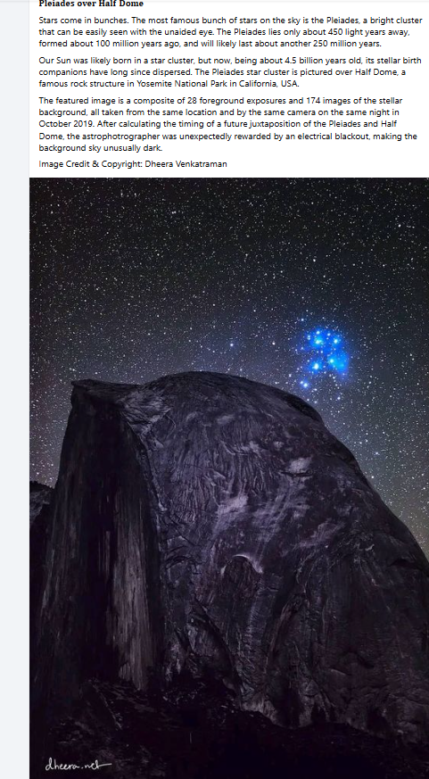

(Stellarium stills)

The Astronomy and Astrology of the Pleiades:

The Pleiades are a collection of approximately one thousand stars, known as a cluster, found in the constellation of Taurus. Because seven of the stars are clearly visible to the naked eye, the Pleiades are also known by the name “the Seven Sisters” and have various folkloric allegories regarding the seven stars in different cultures. According to astronomer Brian Koberlein, the cluster is about one hundred and twenty million years old and may have been ‘a stellar nursery, [like] the Orion Nebula’, in its younger phase.

A traditional interpretation of the Pleiades in astrology is as being harbingers of periods of creativity and spirituality, and because of their shared similarities to the seven “Muses” from Greco-Roman mythos they are often present in connection to art, literature and music too. This corresponds to the characterization of the Pleiades as manifestations of inspiration and creativeness.

History of the Pleiades in Human Understanding:

The relationship between the Pleiades and human societies has been observable for millennia, with two of the earliest artistic representations of the star cluster being found in the Palaeolithic wall paintings in the Hall of the Bulls, Lascaux Caves in France (French: La Salle des Taureaux, Grotte de Lascaux) dated between fifteen and seventeen thousand years ago; and inset in gold on the Nebra Sky Disc (German: Himmelsscheibe von Nebra), estimated to be from approximately 1800BCE.

The suggestion that in the Hall of the Bulls, the Pleiades have been represented in cave art has been put forward by several researchers, for example German ethnoastronomer Michael Rappenglück, and particularly French archaeo-astronomer Chantal Jegues-Wolkiewiez who identified the Pleiades above a cave painting of an aurochs bull, an extinct wild, bovine species, (pictograph No. 18), and reasoned that ‘[if] the sun passed through all of the constellations […and…] if the Hall of the Bulls was in glass, you would see the constellations behind them.’. UNESCO also recognises the painted dots above the pictograph and corresponding points at Lascaux Cave as being, ‘Representations of asterisms (a pattern or group of stars smaller than a constellation), particularly the Pleiades and Hyades.

Using the Pleiades on the Nebra Sky Disc as a feature of an astronomical calendar, would not have been possible ‘without decades of intensive observation, […because…] no one thought prehistoric people capable of such precise astronomical knowledge.’ The utilisation of the Pleiades as an indicator for cyclical farming and agricultural practices were prevalent in early agrarian cultures in parts of Eurasia, with the heliacal rising, the first visible appearance of the constellation on the horizon before the sunrise, heralding the beginning of the planting season. Hesiod, (ancient Greek Ἡσίοδος) believed that the Pleiades were crucial markers for the agricultural and naval year, advising his audience to plant forty days after the helical rising and as the setting of the Pleiades saw the end of the sailing season and the time to harvest.
When the Pleiades, daughters of Atlas, are rising,
begin your harvest,
and your ploughing when they are going to set.
Forty nights and days they are hidden and appear again as the year moves round,
when first you sharpen your sickle.
This is the law of the plains, and of those who live near the sea

Hesiod uses the mythos of the Pleiades in Works and Days as a celestial calendar to advise when to plant, harvest and sail. From an ancient Greek farming family, and as an epic poet, Hesiod describes the practical significance of the Pleiades while alluding to their cosmic divinity ‘the Pleiades, daughters of Atlas’. In Greek mythology, the Pleiades get their name from their mother, the Oceanid Pleione, oceanids being akin to a water nymph, as well as the Greek word meaning to sail plein (πλέω) they were viewed as seven mortal women (maidens) who were altered into the asterism by the transformative power of Zeus, who pitied them for being pursued by the hunter Orion, who in turn was pursued by a plague of scorpions, according to some lore, the inference being the Pleiades being followed by the constellation Orion, and Orion being followed by the constellation Scorpio. Hard expressed the opinion that ‘in ancient […] folklore […] stars gathered together in conspicuous clusters are commonly identified either as maidens or animals of one kind or another [with Greeks believing] they were the daughters of [the Titan] Atlas (citing Hesiod) while the Romans called them Septentriones […] seven plough-oxen.’

Hesiod’s two main surviving works are the Theogony and Works and Days, with the Theogony being the source of much of our knowledge about the mythological origins of the world and deities, while Works and Days is an instructional and ethical poem that espouses the Greek archetypal principles. Hesiod claimed to be similarly inspired in his poetry by the Muses and this is a secondary link between the Muses and the Pleiades as ‘divine sisters’.

Trans. Hugh G. Evelyn-White, The Homeric Hymns, and Homerica by Homer and Hesiod (1914).
https://briankoberlein.com/blog/seven-sisters
Blah blah
Blah blah
Landesmuseum für Vorgesschichte: Himmelsscheibe von Nebra [online].
Michael Rappenglück, 1997, The Pleiades in the "Salle des Taureaux", grotte de Lascaux. Does a rock picture in the cave of Lascaux show the open star cluster of the Pleiades at the Magdalénien era (ca 15.300 BC?" pp. 217-25
National Geographic, Stone Age Zodiac, 9 December 2009 [video] YouTube [online].
United Nations Educational Scientific and Cultural Organisation (UNESCO), The Astronomical Rock Panels in the Lascaux Cave, France [online].
Harald Meller quoted by Jarrett A. Lobell in Archaeology Magazine, Mapping the Past May/June 2019
Blah blah
Early May
November
Trans. Hugh G. Evelyn-White, The Homeric Hymns, and Homerica by Homer and Hesiod (1914) lines 383-389.
Robin Hard The Routledge Handbook of Greek Mythology (2004) p. 518

