

CertHE in Business Skills

Student Name: Leticia Mota
Student Number: 2544839
Course Name: Digital Skills LCLM4002
Lecturer Name: Nishi Ramsurrun
Session: June 2026 Term

Word Study key information

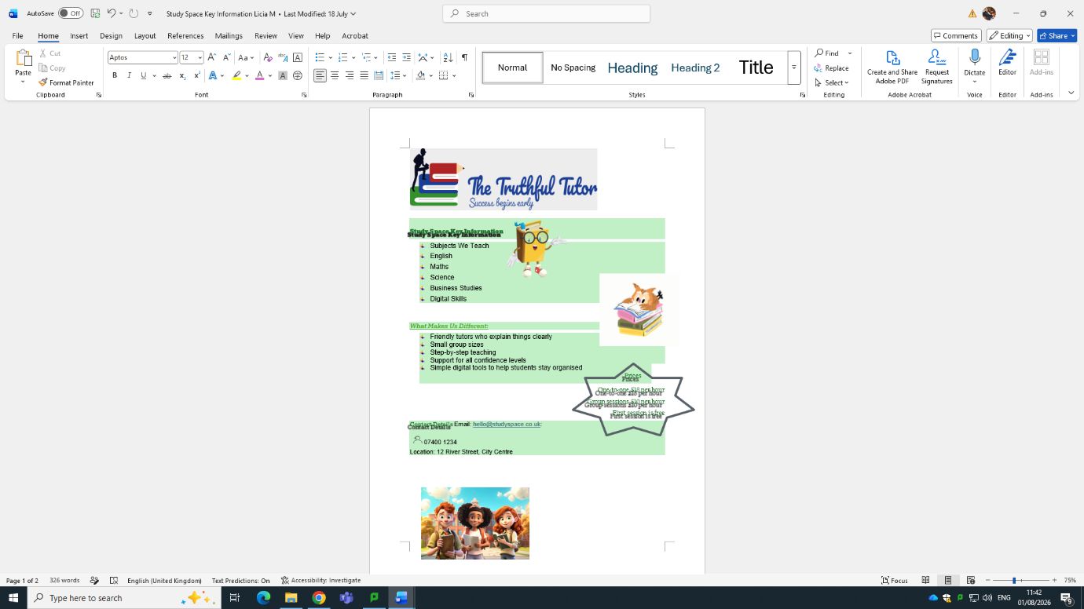

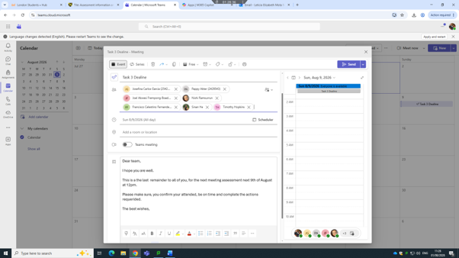
TEAMS MEETING

POWERPOINT HISTORY



