

Module Name: Marketing Management
Module Code: LCMB7024
Term 1

Student Name: Mangukiya Heet
Student ID: 2336342
Lecturer’s Name: Laila maazouz
Work Count: 2516

Table of Contents
1. Introduction 3
2. Brand Extension 3
2.1 Sainsbury’s Plant Kitchen Fresh Meals 3
2.2 Alignment with Brand Values 4
2.3 Market Value and Gap Analysis 5
3. STP for the New Brand Extension 5
3.1 Segmentation 5
3.2 Targeting 6
3.3 Positioning 6
4. Customer Personal Profile 7
5. Marketing Mix Strategy 9
6. Conclusion 13
Reference List 14

1. Introduction
Sainsbury’s, one of the United Kingdom’s largest supermarket chains, has built its reputation on providing high-quality, affordable food to a wide demographic. Over the years, it has successfully diversified into various product categories including groceries, clothing, and banking services (About.sainsburys.co.uk, 2025). With the increasing shift toward health-conscious and sustainable eating habits, Sainsbury’s will need to continue evolving its brand to meet emerging consumer demands. A strategic brand extension into the fresh plant-based ready meals segment will enable Sainsbury’s to tap into a growing market while reinforcing its commitment to sustainability, health, and innovation (About.sainsburys.co.uk, 2025). This portfolio will present a new brand extension titled Sainsbury’s Plant Kitchen Fresh Meals, outlining how it aligns with the brand’s values, addresses market gaps, and will be positioned successfully through effective segmentation, targeting, and positioning strategies.

2. Brand Extension

2.1 Sainsbury’s Plant Kitchen Fresh Meals
The proposed brand extension, Sainsbury’s Plant Kitchen Fresh Meals, will introduce a premium range of freshly prepared, refrigerated plant-based ready meals. Unlike frozen or shelf-stable offerings, this line will focus on fresh ingredients and minimal processing, catering to consumers seeking convenience without compromising on nutrition or taste (About.sainsburys.co.uk, 2025). The range will include products such as vegan pasta dishes, superfood grain bowls, Mediterranean wraps, fresh plant-based curries, and seasonal salads.
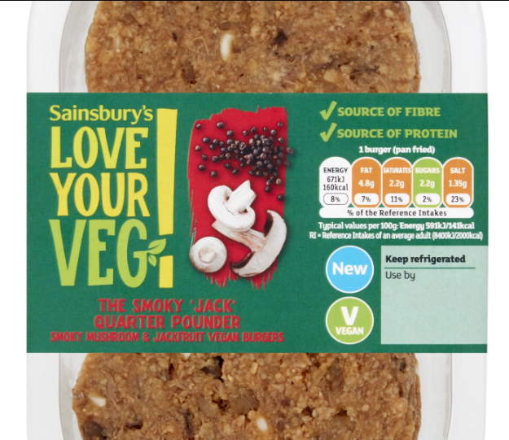
Figure 1: Sainsbury’s Vegan Food
(Source: About.sainsburys.co.uk, 2025)
The meals will be designed to meet the needs of busy, health-conscious individuals who prefer quick dining options but are also mindful of their dietary choices and environmental impact (About.sainsburys.co.uk, 2025). Sainsbury’s will differentiate itself in a crowded cheap convenience food arena while appealing to an even wider audience who are interested in plant-based options when it launches these fresh meals range.

2.2 Alignment with Brand Values
The values that Sainsbury’s has put forward continually have been quality, sustainability, innovation, and customers wellbeing. These brand values are a perfect fit for these brand values, the introduction of Plant Kitchen Fresh Meals will perfectly align with these values. Sainsbury’s is instead focusing on plant-based ingredients because it will provide products having a reduced carbon footprint than those from meat-based meals (Xiao et al. 2021). The brand promises freshness and nutritional balance while representing the commitment to quality and healthy living. There will be demonstrated unique recipe development and safe packaging to maintain freshness, keeping plastic down. On top of that, it will help Sainsbury’s’ mission of helping customers live well for less (Ciobotaru et al. 2024) by providing customers with accessible plant-based meal options. The extension of this brand will not only target the existing loyal customers but also appeal to new demographic groups that focus on ethical consumption and healthy eating.

2.3 Market Value and Gap Analysis
Consequently, demands for plant-based food have skyrocketed in the UK as the population become more flexitarian, vegetarian or vegan. Industry reports indicate that the UK’s plant-based food market has only begun to grow with significant momentum in the coming years (Jones 2023). While it has grown, there is still a large hole in the market for fresh plant based ready meal at an affordable price point. Frozen, highly processed, or price gouged by specialist brands, existing options are rarely available. Filling this gap would be uniquely possible for Sainsbury’s who already has existing supply chain and customer base and can offer freshly prepared nutritious plant-based meals to be both priced for and available. (Beacom et al. 2024) Launching Plant Kitchen Fresh Meals will give Sainsbury’s the opportunity to profit from the university between the gaps and build on its status as a market leading food retailer between the unhealthy and sustainable space.

3. STP for the New Brand Extension

3.1 Segmentation
The demographic, psychographic and behavioural factors will be used to segment the market for the Plant Kitchen Fresh Meals by Sainsbury’s. The target primary segments, and in particular, the target demographics in which we strive to address, will be adults between 18 and 45 years of age, urban dwellers whose life is very busy but they are the ones taking considerable interest in healthy eating (Lindberg et al. 2025). The target audience will be composed of health conscientious people, ethically thinking audience, those connected to trends and the purchases of those in their early twenties (millennials and Gen Z consumers) who dislike what they see and who buy because they are looking for innovation and sustainability.
Behavioural segmentation will centre around consumers that continuously purchase ready meals, lean towards quick solutions in meal, be loyal to the options that are plant-based or vegetarian (Aceves-Martins et al. 2023). This multi-dimensional segmentation approach ensures that marketing strategies targeted towards the most promising arriving and retaining customers.

3.2 Targeting
A differentiated targeting strategy will be adopted for the Plant Kitchen Fresh Meals by Sainsbury’s. The health-conscious city professionals, young consumers looking for clean nutrition in a convenient package will be the brand’s primary target. Such consumers are likely to be socially aware, if not shaped by his tendencies in sustainability and wellness trends (Nguyen, 2021).
Secondary targeting will also be flexitarians, those that are not categorically vegetarian or vegan, but who are eating more and more plant-based meals. Sainsbury’s can maximise relevance and appeal of their products and communication by tailoring them to these specific groups. The targeted marketing campaigns will focus on the freshness, health benefit, ethical sourcing as well as the convenience of the meals to appeal to these audiences based on their values and lifestyles.

3.3 Positioning
Sainsbury’s Plant Kitchen Fresh Meals will be the easy to choose as the premium, yet affordable fresh plant-based convenience meal within the aisle. Freshness, healthiness, sustainability and superior taste will be the tone of the brand positioning statement (Beacom et al. 2022). It will send the message that selecting Plant Kitchen Fresh Meals is not just the smart decision for personal wellness, but also one for planetary health. Vibrant, appetizing visuals of the meals, testimonials about quality and taste, and educational content about the environmental benefits of plant-based eating will be highlighted in advertising, in store promotions.
Through quality ingredients, modern packaging and affordable pricing strategy the pricing strategy will ensure that the product will be accessible to all while conveying premium value. In general, positioning will employ an emotional connection with consumers through appealing consumers' everyday meal decisions to their broader lifestyle values of healthy, convenient and environmentally friendly living.

4. Customer Personal Profile
Primary Customer Persona: Sophie Turner
Category | Details
DEMOGRAPHIC PROFILE
Age | 29 years
Gender | Female
Location | London (Zone 3, urban apartment)
Occupation | Graphic Designer at an advertising firm
Education | Bachelor’s degree in Graphic Design
Income | £42,000 per annum
Household Status | Single, lives with one flatmate
Housing | Rents a 2-bedroom modern flat
Transportation | Uses public transport (Underground and bicycle)
Health Insurance | Relies on NHS, considers private GP for emergencies
PSYCHOGRAPHIC PROFILE
Core Values | Sustainability, wellness, creativity, convenience
Health Attitudes | Prefers plant-based and organic food, proactive about gut health, mindful eater
Digital Comfort | Highly tech-savvy; shops online, uses health and fitness apps daily
Decision Factors | Product freshness, ethical sourcing, taste innovation, quick preparation time
Pain Points | Limited time to cook, finds healthy fresh meals overpriced or unavailable, dislikes food waste
Information Sources | Instagram food influencers, eco-lifestyle blogs, brand websites, peer reviews
BEHAVIORS & LIFESTYLE
Shopping Patterns | Shops at Sainsbury’s Local 2–3 times per week, orders groceries online monthly
Health Management | Focuses on preventive health through diet and exercise, practices mindfulness
Time Pressures | Balances demanding work hours with freelance side projects and social life
Wellness Activities | Attends yoga classes, goes to weekend farmers' markets, practices "Meat-Free Mondays"
Technology Usage | Heavy smartphone user, prefers brands offering mobile ordering, delivery tracking, and loyalty rewards
GOALS & ASPIRATIONS
Health Goals | Maintain plant-based lifestyle, manage energy levels, reduce environmental footprint
Service Expectations | Freshness guarantee, clear labelling (vegan, allergen info), affordable premium quality
Future Concerns | Climate change impact on food supply, rising grocery costs, maintaining personal wellness with a busy schedule
Value Proposition | Saves time without compromising on health, supports sustainable living, offers exciting new plant-based flavours
Table 1: Consumer persona
(Source: Self-created)

5. Marketing Mix Strategy
Product
The new Sainsbury’s Plant Kitchen Fresh Meals will provide a ready to eat, 100% plant based range, designed to offer a diverse range of flavour delivered without brands, and still be convenient. Sourcing fresh, responsibly produced ingredients to make the meals we will craft, we will focus on global cuisines, from Thai curries to Mediterranean salads and Indian inspired dishes for a range of consumer palates (CHO, 2021).
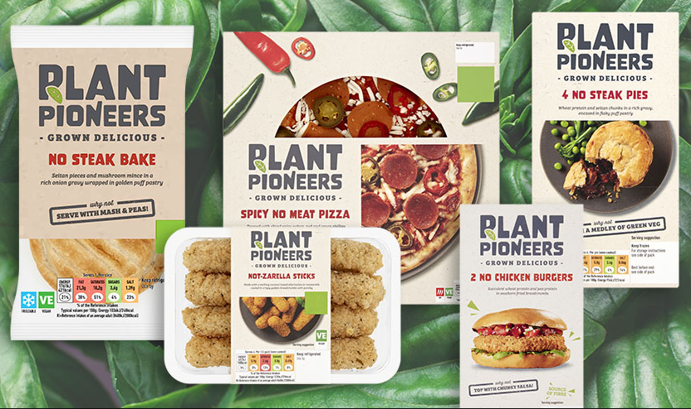
Figure 2: Different vegan products of Sainsbury
(Source: About.sainsburys.co.uk, 2025)
High-protein plant alternatives like lentils, chickpeas, tofu and quinoa and meals will be free of artificial preservatives and additives for each meal. In addition to the labelling of the allergens, the nutritional benefits, the ethical credentials such as a vegan certified and sustainably sourced ingredient label will also be clear. It will also use eco-friendly packaging such as biodegradable or recyclable materials to align with Sainsbury’s continued approach to environmental responsibility (Solanki et al. 2024).
Price
The pricing strategy for the Plant Kitchen Fresh Meals will strike a balance between affordability and perceived value. The meals will be marketed at the mid-to-premium ranges as the target audience of health-conscious people ready to pay for quality and sustainability (Miller et al. 2025). The tiered pricing will be implemented with small food at prices of £3,50 – £4,00 for salads and other light options such as soups and similar and slightly more expensive but full meal at £5,50 – £7,00. The retailer will introduce multi-buy promotions, loyalty discounts to Nectar card holders as well as one-offs bundling offers, in order to increase customer value and get them to buy more often (Shams et al. 2025). The online platform will also offer pre-order weekly meal bundles at a discounted rate, thereby improving customer loyalty, and Sainsbury’s will also offer products through subscription.
Promotion
It will be vital that Sainsbury’s Plant Kitchen Fresh Meals successfully launches and grows by way of a strong, targeted promotional strategy. The first phase of the campaign will have multiple channel marketing tactics that will leverage television, online video ads, social media platform, email newsletters and influencer partnerships. Freshness, taste innovation, convenience and ethical sourcing will be the key messaging for it (Xiao et al. 2021). Indisputably, partnerships with health and sustainability advocates on Instagram, TikTok, and YouTube will be a big role here. To inform current Sainsbury’s shoppers about the brand awareness, in store promotions like tasting booths, limited time launch discounts and featuring end cap displays will be used.
Place
Firstly, at more than 1,200 Sainsbury’s stores nationwide, and then rolling out at Sainsbury’s Local stores, particular in urban and suburban areas where time poor, health-conscious consumers are more likely to be seeking convenient meal solutions, Sainsbury’s Plant Kitchen Fresh Meals will be available. In addition, Sainsbury’s will list the meals on its online grocery platform for home delivery and click and collect options (Jones, 2023). To cope with the increasing demand for fast meal delivery in large cities, partnerships with delivery services such as Uber Eats and Deliveroo will be studied. Plant Kitchen meals will be placed in strategic locations within stores in dedicated refrigerated zones, which features clear signage that the foods are vegan appropriate and together with other health-related products, will appeal to consumers to buy up other products. The product range could also expand into Sainsbury’s partner stores or featured within subscription meal kit services to levels of accessibility to a greater demographic target.
Process
Sainsbury’s Plant Kitchen Fresh Meals will have an operational process that will highlight efficiency, freshness and quality control. A just in time manufacturing model will be employed at Sainsbury partner production facilities to prepare meals daily for service using fresh ingredients in order to minimize food waste (Beacom et al. 2024). The supply chain management system will be so advanced that it can track the sourcing of ingredients, the levels of inventory and the forecasts for demand in real time to enable swift replenishment and stock rotation. Online and in-store, there will be clear product categorization, filter options like “high-protein” or “gluten-free,” etc., and quick checkout system. Nevertheless, the focus will still be to reduce the friction at every touchpoint, so customers can select, purchase, receive meals without delay or inconvenience.
People
Success will depend hugely on the people: the back of house people (product developers, sourcing and so on) who make it and the on-house people (instore staff, delivery drivers) who sell it. Employees of the stores will be trained on different ways to sell the new range and its key characters including product contents, health benefits and ethical activities. Trained staff will be able to confidently answer customer queries as well as personalise recommendations for meals according to a customer's dietary needs (Aceves-Martins et al. 2024). There will be dedicated customer service teams online and offline who would attend to inquiries, feedback, and complaint quickly and build trust and loyalty. Innovation and customer centricity will be fostered internally by Sainsbury’s to encourage feedback from staff as well as customers to continuously improve the product range and service standards. Sainsbury’s could also get involved with dietitians and plant-based chefs in future phases to propel the brand’s reputation and stood as thought leaders in the plant-based food market.
Physical Evidence
Visual branding, packaging, and store environment will constitute the physical evidences of the Plant Kitchen Fresh Meals range. It will package in fresh, lively and natural colour schemes of green and white suggestive of health, youth and endurance. The brand will use biodegradable containers and recyclable sleeves which will be clearly marked to fulfil environmental commitment. Consistent branding should take place in point-of-sale materials like signage, shelf talkers and promotional stands in order to deliver a cohesive in-store experience (Nguyen, 2021).
High quality images, nutritional breakdowns, sourcing stories and customer reviews will be features of product pages on the Internet, in order to create transparency and trust among customers online. Real life customer testimonials, behind the scenes footage of meal preparation and creative recipe ideas using the fresh meals will all come to life across social media ensuring that the promise of quality and authenticity remain pulled by the brand (Aceves-Martins et al. 2024). With every touch point real and imaginary, customers will once again be at ease that Sainsbury is one committed to offering wholesome, convenient, and sustainable meals.

6. Conclusion
Launched as Sainsbury’s Plant Kitchen Fresh Meals, the company will meet a growing market demand for the convenient, healthy, and ethically sourced plant-based food offerings that the company plans to provide. Through careful product development of Sainsbury’s, which employs health, sustainability and convenience values, the company will be in a good position to continue being an innovative and responsible retailer. To support the brand extension a well formed STP strategy, will be followed up with a holistic marketing mix covering all possible customer touch points such as product quality and pricing, promotional efforts and physical evidence. With busy, health-conscious customers continuing to shop for easy, delicious plant-based meals, the Plant Kitchen Fresh Meals range will be well positioned as a trusted and loved choice. In the future, Sainsbury’s will continue to innovate in the range and bring new recipes, seasonal varieties and extended service ranges to ensure the range remains at the vanguard of the fast-changing plant-based food market.

Reference List
About.sainsburys.co.uk, (2025). About Us, Available at: https://www.about.sainsburys.co.uk/about-us
Ciobotaru, R., Tas, A.A. and Khan, T.A., 2024. Healthiness of meat-based products in comparison to their plant-based alternatives in the UK market: a packaging evaluation. Foods, 13(21), p.3346.
Jones, P., 2023. UK retailers and plant-based alternatives to meat and dairy products. Athens journal of business & economics, 9(2), pp.207-220.
Dimbleby, H., 2021. National Food Strategy: The Plan.
Beacom, E., McLaughlin, C. and Furey, S., 2024. Household food consumption typologies: Examining population adherence to healthy eating guidelines for evidence-informed policy making. Journal of Consumer Policy, 47(2), pp.297-315.
Lindberg, L., Woodside, J.V., Fitzgerald, H., Campbell, N., Vogan, H., Kelly, C., Robinson, M. and Nugent, A.P., 2025. Plant-Based Meat Alternatives on the Island of Ireland: Changes in the Market and Comparisons with Conventional Meat. Foods, 14(5), p.903.
Aceves-Martins, M., Denton, P. and de Roos, B., 2023. Ready meals, especially those that are animal-based and cooked in an oven, have lower nutritional quality and higher greenhouse gas emissions and are more expensive than equivalent home-cooked meals. Public Health Nutrition, 26(3), pp.531-539.
Nguyen, L., 2021. Developing sustainable marketing plan for plant-based products.
Beacom, E., Repar, L. and Bogue, J., 2022. Consumer motivations and desired product attributes for 2.0 plant-based products: a conceptual model of consumer insight for market-oriented product development and marketing. SN Business & Economics, 2(8), p.115.
Riedl, M., Němec, M., Jarský, V. and Zahradník, D., 2024. Unveiling game meat: an analysis of marketing mix and consumer preferences for a forest ecosystem product. Frontiers in Sustainable Food Systems, 8, p.1463806.
CHO, Y.S., 2021. How have retailers led the HMR industry in Japan and UK?. The Journal of Economics, Marketing and Management, 9(6), pp.25-38.
Miller, O., Scarlett, C.J. and Akanbi, T.O., 2024. Plant-based meat analogues and consumer interest in 3D-printed products: A mini-review. Foods, 13(15), p.2314.
Shams, S.R., Brown, D.M. and Hardcastle, K., 2025. Marketing Dynamics and Stakeholder Value Creation for People, Planet, and Profit. In Sustainable Marketing: Strategic Marketing for People, Planet and Profit (pp. 1-101). Cham: Springer Nature Switzerland.
Xiao, B., Chen, Q. and Yu, Z., 2021, April. Research on the Investment Value of Sainsbury’s. In 2021 6th International Conference on Social Sciences and Economic Development (ICSSED 2021) (pp. 108-115). Atlantis Press.
Solanki, S., Shah, S. and Hasan, S., 2024, November. The Resilience of UK's Food Retail Supply Chains and Business Strategies. In 2024 IEEE International Conference on Technology Management, Operations and Decisions (ICTMOD) (pp. 1-5). IEEE.

