
Programme: BA Business Management
Module: Management Economics
Module code: LCBB5008
Assignment Title: Component 1: Coursework: Essay
Student Name: Cristian Lupu
Student ID: 2112677

Case Study
The impact of the Covid pandemic globally on business

Introduction
Management economics uses economic concepts and quantitative analysis to guide managers in decision-making, resource allocation, market dynamics, and company activities, enhancing efficiency and strategic planning in corporate settings (Cigliano, 1980).
Managerial economics, also known as management economics, is a specialised field of economics that utilises economic principles and quantitative analysis to address management issues. Economic theories and approaches are used to aid managers and decision-makers in making logical and well-informed decisions inside an organisation. Also, management economics facilitates the efficient allocation of resources, examines cost frameworks, comprehends market dynamics, and assesses the influence of different aspects on company activities (ons.gov.uk, 2023). It is of extreme importance in making strategic decisions, determining pricing strategies, predicting demand, and enhancing management performance, especially when resources are limited, and corporate conditions are always changing.
Main Body
The COVID-19 epidemic, an incomparable worldwide problem, has brought up several economic difficulties that have had far-extensive effects on international, national, and organisational levels. Each of these issues has contributed to a complex web of economic implications (Andreyeva, Long and Brownell, 2010). Also, the epidemic significantly disturbs corporate operations, causing one of the most prominent economic issues. The case study emphasises the impact of extensive lockdowns, travel restrictions, and social distancing measures used to control the rapid transmission of the virus, which resulted in the rapid cessation or reduction of corporate operations worldwide. As a consequence, several organisations, regardless of their size, saw a decline in output, a sharp decrease in earnings, and severe financial repercussions (Institute for Government, 2021). The abrupt and substantial reduction in economic activity was a huge obstacle, compelling businesses to reconsider their strategy and adjust to the changing environment. Also, the supply-and-demand gaps caused by the epidemic represent a significant economic challenge. The case study highlights consumer behaviour fluctuations that have caused shortages of products and services. During the course of the pandemic, there was a significant increase in the need for personal protective equipment (PPE), cleaning supplies, and other commodities. This spike in demand resulted in a shortage of these products and a sharp rise in pricing (Aigner-Walder, 2015). Concurrently, several industries, including travel and hospitality, saw a significant decrease in demand, resulting in enterprises struggling with reduced income and the possibility of economic failure (Griffith, 2003). Therefore, the occurrence of Brexit, which happened concurrently with the epidemic, exacerbated supply chain difficulties, consequently exacerbating economic hardships. The implementation of new customs laws and trade barriers between the United Kingdom and the European Union caused disruptions in the smooth movement of products, leading to delays, higher expenses, and administrative obstacles for enterprises involved in cross-border commerce (Foot and Gomez, 2006). The introduction of this additional layer of complexity further exacerbated the already delicate supply chain environment. A distinct and problematic economic phenomenon during the early phases of the epidemic was panic purchasing. During prevailing uncertainty, customers engaged in the practice of hoarding vital commodities such as canned food, and hand sanitizers. The rapid accumulation of these commodities resulted in artificial shortages and strained supply systems, resulting in both depleted shop tables and price inflation (Cigliano, 1980). Also, the case study identified fuel supply difficulties and the resulting price volatility as additional economic issues. Fuel deliveries experienced significant disruptions as a result of the notable driver scarcity resulting from the departure of EU drivers from the UK, perhaps as a result of Brexit and pandemic-related reasons (Bagwell, 2005). As a result of this interruption, there were severe shortages and significant increases in gasoline prices, affecting both consumers and businesses. However, the case study highlights the challenges that firms encounter as a result of rising operational expenses and reduced sources of income. Following the termination of furlough plans and the implementation of redundancies, firms experienced significant financial strain, resulting in bankruptcies and closures (OECD, 2015). So, the closures had economic ramifications that included unemployment and increased economic instability. The epidemic caused a change in consumer preferences, introducing an additional layer of complexity to the economic environment.
According to the case study, customers shifted their preferences from services to commodities during the epidemic. The transition had heterogeneous effects on various businesses, with some sectors seeing a rise in demand while others struggled with diminished customer interest (Aigner-Walder, 2015). However, the COVID-19 epidemic has exposed several underlying economic issues that have significant and widespread consequences. These problems, which include interrupted corporate operations, imbalances in supply and demand, obstacles caused by Brexit, panic purchasing, shortages in fuel supply, financial difficulties, and changing consumer tastes, all demonstrate the intricate and interconnected nature of the global economy. It is crucial to have efficient policymaking and management choices in order to tackle these issues, promote economic recovery, and establish resilience in the face of future uncertainty.
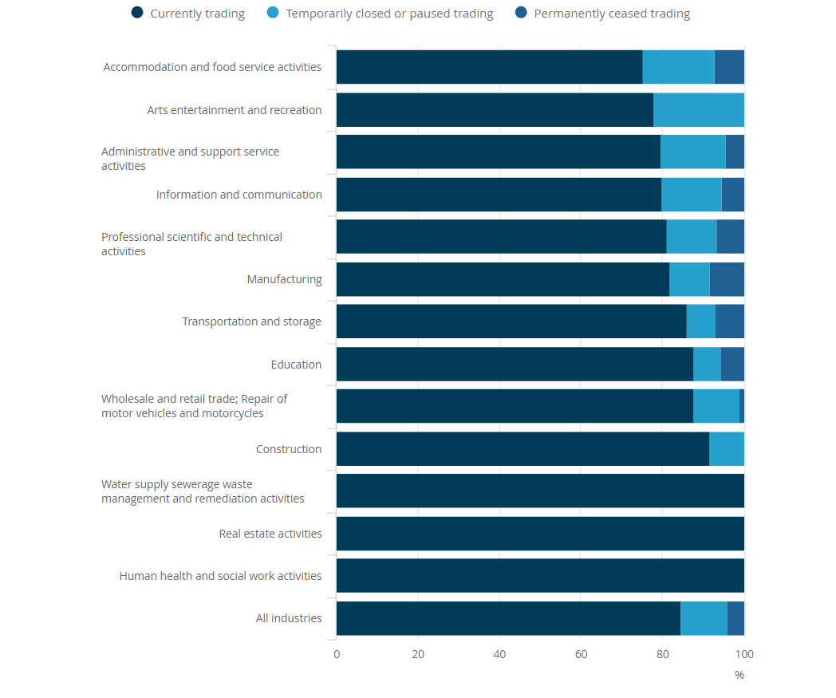
Fig. 1: The accommodation and food services industry had the lowest percentage of businesses currently trading. ( Sources: Office for National Statistics – Business Impact of Coronavirus (COVID-19) Survey
The Covid-19 epidemic has exposed a variety of economic difficulties, including interruptions in supply chains and financial hardships, at both the national and organisational levels. Addressing these complex issues requires a coordinated endeavour including governmental interventions, smart corporate endeavours, and efficient stakeholder cooperation.
Government Intervention: Governments may have a crucial impact in mitigating economic burdens resulting from the epidemic. The Institute for Government (2021) states that impacted enterprises may get financial assistance in the form of grants, loans, and tax relief measures. Through this approach, governments may assist firms in sustaining their operations and preserving their staff, therefore fostering economic stability. Furthermore, governments might contemplate legislative modifications and incentives to promote the continuity of corporate operations and the stability of employment. Implementing these steps may stimulate economic recovery (OECD, 2015).
Loosening epidemic-Related laws: Governments may contemplate easing some strict laws implemented during the epidemic, especially if the situation becomes more stable. Although safety precautions were essential during the peak of the crisis, relaxing these requirements might expedite the restoration of regular economic operations. Implementing this measure may expedite the recovery of enterprises, resulting in heightened productivity and the generation of employment opportunities. Striking a careful equilibrium, strategic modifications to policies may promote economic expansion (Rauch and Schleicher, 2015).
Strategic Shortage Management: Organisations may take proactive measures to solve shortages by establishing specialised teams and implementing strategies to effectively manage and alleviate them. These teams have the ability to carefully oversee supply chains, anticipate any obstructions, and take proactive actions to guarantee a steady stream of vital products and services (Rauch and Schleicher, 2015). By using this strategy, organisations may effectively reduce interruptions and maintain customer trust in the dependability of their supply networks.
Enhancing Supplier Collaborations: Establishing more robust collaboration networks with suppliers helps bolster the resilience of the supply chain. Collaborating with important suppliers may result in improved coordination, adaptability, and the implementation of joint strategies for managing risks (Ellickson, 2013). By cultivating stronger alliances with suppliers, organisations may enhance their ability to address supply chain obstacles and mitigate the consequences of interruptions.
Businesses might investigate alternate approaches to minimise waste in their operations, therefore promoting sustainability. Incorporating sustainable practices, such as the implementation of recycling, reusing resources, and adopting eco-friendly manufacturing techniques, may effectively save expenses and enhance resource efficiency (Shapiro, 1987). These approaches not only result in cost savings but also meet the increasing customer expectations for ecologically sustainable goods and activities. Continuous evaluation of supply chains may aid in the identification of risks and inefficiencies. It is essential for organisations to consistently assess and develop their supply chain strategies in order to increase adaptability and promptness (Bagwell, 2005). This involves examining possible disturbances and formulating prompt strategies to tackle them.

Collaborative price negotiations include working together with suppliers to achieve cost savings, which may then be transferred to customers. Implementing this strategy may effectively reduce the negative effects of increasing costs and promote trust and assurance among consumers (Baker, 2003). Organisations may preserve their competitiveness in the market by collaborating closely with suppliers to identify solutions that are advantageous for both parties.
Efficient Stakeholder Communication: Open and regular communication with stakeholders, including consumers, workers, and investors, is crucial throughout times of economic turmoil. This facilitates the management of expectations, fosters trust, and guarantees synchronised reactions to difficulties. Organisations may retain their support and loyalty by effectively communicating with stakeholders on their initiatives to tackle economic issues.
Investing in innovation and digital transformation may improve corporate agility. Companies that swiftly adjust to changing market circumstances by using technical breakthroughs are more likely to succeed in dynamic situations (Osadiya, 2023). Through the use of digital technologies, organisations may optimise their operations, boost consumer interaction, and bolster their overall competitiveness.
However, addressing the economic challenges caused by the Covid-19 epidemic requires a comprehensive strategy that integrates government involvement, industrial ingenuity, and productive cooperation among all parties involved. By employing these tactics, companies and governments may reduce the effect of economic issues and strive towards a more robust and adaptable economic future (OECD, 2015). These actions not only tackle the current difficulties, but also strategically position organisations and economies to prosper in a constantly evolving global environment.
The assessment of the economic impacts of the COVID-19 pandemic in the case study relies heavily on the dynamics of demand and supply. Within this context, the interplay between demand and supply has a significant influence on several economic determinations and market dynamics.
Employing Pricing Strategies to Equilibrate Demand and Supply: The case study illustrates the impact of demand and supply on pricing in situations when supply is limited. Companies sometimes adjust pricing in reaction to increasing demand for vital items, in order to mitigate supply constraints. Dynamic pricing, often known as surge pricing, enables businesses to optimise the distribution of their resources by increasing prices when demand is strong (Shapiro, 1987).
Amidst the epidemic, the presence of rivalry among companies leads to a decrease in pricing. As commodity demand increases, several providers may join the market, offering reduced rates to attract clients. Competition reduces expenses, which is advantageous for consumers and limits the ability to set high prices (Aigner-Walder, 2015).
Enhancing Business Productivity: Business growth is influenced by the interplay between demand and supply. Companies that efficiently align their production with customer demand may improve their operations. Amazon employs sophisticated demand forecasting algorithms to effectively control inventory and guarantee timely delivery to consumers (Cigliano, 1980). Also, this approach has significantly facilitated the quick expansion of Amazon.
Marketing Strategy and Promotion: Marketing methods are influenced by the interplay between demand and supply. Companies may intentionally advertise popular items by aligning their promotions with current market trends. This enhances the firm's idea and optimises marketing outcomes (Bagwell, 2005).
Enhancing Inventory Management: Inventory management systems are based on the principles of demand and supply. The Just-In-Time (JIT) system aligns production with consumer demand. This strategy allows firms to reduce inventory and storage expenses without compromising product availability (Heien and Pompelli, 1989).
Capital investment: Companies must have a thorough understanding of supply and demand when seeking funding. IPOs have the potential to enhance investment by attracting substantial sums of capital. Investors are attracted to firms that have a high level of demand for their shares, since this usually results in successful initial public offerings (IPOs) (Foot and Gomez, 2006).
In order to address the growing need for workers, enhancing wages and offering appealing compensation packages might enhance worker retention and satisfaction. When there is a limited supply of workers with certain skills or qualities owing to high demand, offering higher pay helps to keep and please employees, guaranteeing the ongoing success of the company (OECD, 2015).
Effective Risk Management for Equilibrium: It is vital to proficiently handle risks associated with supply and demand. Businesses must proactively forecast and mitigate any interruptions in order to ensure stability. In order to provide a reliable and resilient system, it is necessary to increase the number of suppliers, allocate resources for backup plans, and establish robust supply chains (Griffith, 2003).
Managing Shortages and Fulfilling Market Demand: It is essential to maintain equilibrium between supply and demand in times of scarcity. Businesses must promptly adjust to market and customer fluctuations. By comprehending demand patterns and using adaptable supply chain strategies, organisations may effectively handle shortages and adapt to fluctuations in the market (Ellickson, 2013).
Therefore, the Covid-19 pandemic case study emphasises the importance of demand and supply dynamics. They have an impact on pricing strategies, competitiveness, productivity, marketing, inventory management, financial recruitment, labour retention, risk management, and the capacity to handle shortages and changing market demand. However, these considerations emphasise the significance of demand and supply in exerting influence on management and policymaking during times of economic instability.
Economics relies on demand elasticity and inelasticity describe how price changes affect consumer behaviour. In cost analysis, understanding these ideas is essential for studying customer reactions to petrol price increases (Mankiw and Taylor, 2014).
Elasticity of Demand, or elasticity, measures how much a product's demand responds to market conditions like price and income. Also, when demand is elastic, small price changes cause large changes in quantity needed. Divide the percentage change in quantity requested by the percentage change in price to calculate elasticity.
Inelasticity occurs when demand for a product or service remains consistent despite price changes. Inelastic demand occurs when consumers' buying behaviour is unaffected by price fluctuations (Perloff, 2018). Additionally, inelastic items are generally necessities or have few alternatives. Electricity, water, prescription drugs, and tobacco are inelastic.
Existing few differences between elastic and inelastic demand. Products with elastic demand are more price responsive. Minor price changes affect requested amounts greatly. Also, for products with low price elasticity, price changes have minimal effect on customer demand. Consumer spending is seldom affected by price changes. Therefore, products with elastic demand may struggle during market volatility because buyers are more price sensitive. Businesses may need to adjust prices to maintain demand. On the other hand, goods with inelastic demand resist market changes and consumers purchase these items regardless of price, maintaining stable stability.
Between disadvantages could be mentioned elastic demand which means that new competitors may face challenges due to elasticity. Also, new entrants struggle because established enterprises may decrease prices to attract customers. Another aspect is that the market entry is easier for products with inelastic demand since demand is steady. Also, established companies can maintain their market position since consumers are less likely to switch brands or suppliers. (Case, Fair and Oster, 2016).
As advantages elasticity research helps organisations determine the best price for revenue. Also, since consumer reactions to pricing changes affect tax calculations, a reduction in elasticity may lower corporate tax responsibilities. Therefore, increasing Sales is another advantage. Understanding elasticity allows companies to adjust prices to boost sales across certain durations.
According to Perloff, (2018) flexible products companies must check their competitors' prices to remain competitive and is a disadvantage. Furthermore, time Restriction could be a disadvantage. Environmental factors like customer preferences and market conditions affect elasticity.
Regarding the inelasticity of demand a benefit is that increasing prices may generate income by taking advantage of inelastic demand, allowing for price increases without a significant decrease in demand. This may boost profitability (Cigliano, 1980).
But price sensitivity is a drawback. However, businesses with poor price elasticity must be careful when raising prices since consumers may notice more.
Understanding demand elasticity and inelasticity is crucial to assessing how petrol price changes affect consumer behaviour. Elasticity is price reactivity and adaptation, whereas inelasticity is stability and insensitivity. In shifting market conditions, these concepts help enterprises and governments make educated decisions.
Supply and demand govern market activity and product prices in economics. Some call these regulations laws. Company executives must grasp these rules to make production and price decisions. Also, supply, demand, and pricing are defined by these laws.
Additionally, demand increases while supply remains fixed, raising prices and volumes. This boosts the market. Increased demand for the goods makes buyers willing to pay more, according to Mankiw and Taylor (2014). This encourages vendors to produce more merchandise to meet demand. Therefore, when product demand drops but supply remains the same, prices drop, and volumes drop. The law of demand asserts that decreasing demand equals unchanged supply. Merchant’s lower prices to boost sales when consumers are less interested in buying. According to Samuelson and Nordhaus (2010), this reduces the possibility of profit, causing suppliers to curtail production.
The Law of Supply states that when supply increases but demand remains the same, prices fall, and quantities rise. Merchants must lower costs to attract consumers and stay competitive due to a wide range of goods and services from many suppliers (Perloff, 2018). Also, if product supply drops but demand remains constant, prices will rise, and quantities will fall. This is opposite what occurs when product supply falls for the same cause. When goods are scarcer than demand, consumers are willing to pay more to ensure the supply (Case, Fair, and Oster, 2016).Companies must consider these rules while pricing, producing, and marketing. Understanding how supply and demand affect price and quantities is crucial to market participation.
Conclusion
However, having a comprehensive grasp of the basic economic issues, the significance of supply and demand interactions, and the concepts of elasticity and inelasticity are essential for making well-informed decisions when confronted with intricate economic difficulties. These notions provide significant perspectives for both corporate management and policymakers as they negotiate the complexities of ever evolving marketplaces.

References
Aigner-Walder, B. (2015) Effects of the Demographic Changes on Private Consumption: An Almost Ideal Demand System Analysis for Austria. Journal of Economic and Social Studies, 5, 1, 33-57
Andreyeva, T., Long, M. and Brownell, K. (2010) The Impact of Food Prices on Consumption: A Systematic Review of Research on the Price Elasticity of Demand for Food. American Journal of Public Health, 100, 2, 216-222.
Bagwell, K. (2005) The Economic Analysis of Advertising. Columbia University Discussion Papers No. : 050601
Baker, J. (2003). Competitive Price Discrimination: The Exercise of Market Power Without Anticompetitive Effects (Comment on Klein and Wiley). Articles in Law Reviews & Other Academic Journals. Paper 278.
Cigliano, J. (1980). Price and Income Elasticities for Airline Travel: The North Atlantic Market. Business Economics, pp. 17–21.
Case, K. E., Fair, R. C., & Oster, S. M. (2016). Principles of Economics (12th ed.). Pearson.
Ellickson, P. (2013). Market Structure and Performance. International Encyclopedia of the Social & Behavioral Sciences, Forthcoming; Simon School Working Paper No. 13-21.
Foot, D., & Gomez, R. (2006). Population aging and sectorial growth: the case study of the UK, 2006-2026. OJBE, 5(1).
Griffith, G. (2003). The Impact of Supermarkets on Farm Suppliers. The Australian Economic Review, 37(3), 329–336.
Heien, D. and Pompelli, G. (1989) The Demand for Alcoholic Beverages: Economic and Demographic Effects, Southern Economic Journal, pp. 759–769.
Institute for Government. (2021). Institute for Government analysis of ONS, Business Impact of COVID-19 Survey (BICS). Available at: https://www.ons.gov.uk/economy/economicoutputandproductivity/output/datasets/businessinsightsandimpactontheukeconomy ( Accessed 16/12/2023).
Mankiw, N. G., & Taylor, M. P. (2014). Economics (3rd ed.). Cengage Learning.
Online:https://www.ons.gov.uk/businessindustryandtrade/business/businessservices/bulletins/coronavirusandtheeconomicimpactsontheuk/5november2020 ( Accessed 16/12/2023).
OECD (2015). OECD Employment Outlook 2015. OECD Publishing, Paris. Available at: https://www.oecd-ilibrary.org/employment/oecd-employment-outlook-2015_empl_outlook-2015-en ( Accessed 16/12/2023).
OECD (2015), OECD Employment Outlook 2015, OECD Publishing, Paris.
Available at: http://ifuturo.org/documentacion/Employment%20outlook%202015.pdf
Osadiya T. (2023). Introduction to Economics. Amazon.
Perloff, J. M. (2018). Microeconomics (8th ed.). Pearson.
Rauch, D. and Schleicher, D. (2015) Like Uber, But for Local Governmental Policy: The Future of Local Regulation of the 'Sharing Economy'. George Mason Law & Economics Research Paper No. 15-01. Available at: http://ssrn.com/abstract=2549919 (Accessed 16/12/2023).
Samuelson, P. A., & Nordhaus, W. D. (2010). Economics (19th ed.). McGraw-Hill/Irwin.
Shapiro, M. (1987) Measuring Market Power in U.S. Industry, NBER Working Paper, No. 2212.

