Corporate Reporting and Social Responsibility

Assignment 1 – Earnings Management and Patisserie Valerie



Name: Rhodri Shepherd
Student Number: 1702359
Module Name: Corporate Reporting and Social Responsibility
Module Code: BMBM6004
Table of Contents

Table of Contents
1. Executive Summary 3
2. Introduction 4
2.1. Report Remit 4
2.2. Background of the organisation (Patisserie Valerie) 4
3. Earnings Management 4
3.1. Definition of Earnings Management 4
4. Incentives and pressures that drive managers to earnings management 5
4.1. Internal Targets 5
4.2. External Expectations 5
4.3. Income Smoothing 5
5. Earnings Management and Patisserie Valerie. 6
5.1. Earnings Management issues that were prevalent in the case of Patisserie Valerie 6
5.2. Ways in which Patisserie Valerie could have used earnings management 7
6. UK corporate governance structure in constraining earnings management 8
7. Conclusion 8
7.1. Conclusion 8
7.2. Recommendations 8
8. References 8

Executive Summary

The aim of this report is to look at earnings management and the incentives and pressures that can end up driving managers to engage in this fraud. This report also aims to look at the high-profile case of Patisserie Valerie and how they misleadingly misstated their accounts to their potential investors and shareholders.

This report has found that there can be many reasons that drive managers and directors to use earnings management techniques, ranging from internal targets, which is when they inflate earnings to meet their targets, external expectations, which is when they misstate their accounts in order to appear more successful than they actually are, and lastly, income smoothing, which is when they move money from one accounting period to another in order to keep a more consistent growth pattern.

With regards to Patisserie Valerie, it was found that they had overstated their accounts by £94 million, and that they had failed to disclose overdrafts of nearly £10m amongst other accounting errors. This had therefore ultimately led to the company’s collapse. Patisserie Valerie could have had a few pressures that led them to misstate their accounts, and the reasons could be in order to look more successful to potential investors, or in order for the financial manager to meet their targets.

Many agencies and the corporate governance code operate in order to fight against potential fraud, but ultimately more needs to be done in order to tackle earnings management.

The recommendations offered is to involve auditors in fraud detection, in order to detect fraudulent entries into financial statements sooner, and for the FRC to improve their systems with regards to tackling earnings management.

Introduction

Report Remit
The aim of this report is to look at Earnings Management within the accounting industry, with particular emphasis on Patisserie Valerie, as they are one of the most recent high-profile Earnings Management cases in recent times. This report will also look at the incentives and pressures that can drive managers to earnings management. Also, this report will discuss the role of the UK Corporate Governance Structure in constraining earnings management. Lastly, there will be some recommendations offered with regards to how the Corporate governance code could improve with tackling earnings management.

Background of the organisation (Patisserie Valerie)
Patisserie Valerie was founded by Madame Valerie in 1926 when she came to London in order to introduce fine Continental Patisserie to the English. They first opened with a store in Frith Street in London’s Soho. They are a chain of café’s that operate throughout the United Kingdom, and they specialise in cakes, breakfasts, lunch, teas and coffees. Previously, Patisserie Valerie operated throughout many locations in the United Kingdom, with 406 stores all over the country, but following the company going into administration in early 2019, they suffered huge losses, and nowadays only have 96 stores (Patisserie Valerie, 2019).

Earnings Management

Definition of Earnings Management
Earnings management is when companies try to mislead stakeholders by altering the financial records with regards to the performance of the company. Some businesses try to smooth out discrepancies in their earnings so that the profit in the financial statements show to be more consistent each month (Finch, 2012). It may be normal for a company to have large fluctuations in their income and expenses, but this could end up putting off investors who prefer to see a company’s accounts to be stable. After an earnings management announcement, the stock prices of said company could rise or fall, but this depends on whether the earnings are met or if they are not reached the expectations of an analyst. Forms of earnings management include capitalising costs, making changes to an accounting policy that leads to the company having greater earnings and many more (Fok & Franses, 2013).

Incentives and pressures that drive managers to earnings management

Internal Targets
Internal targets are an incentive for managers to use earnings management, as companies often set out their own internal targets and goals, e.g. department budgets, and all managers want to meet those goals. No department wants to be the one to go over the initial budget, so managers can use earnings management techniques in order to balance this out (Higson, 2003).

External Expectations
Managers can be pressured into using earnings management techniques when they have already made profit projections and forecasts to their stakeholders. Stakeholders will be expecting the company’s profits to be at least the figure they projected or more, and if the company has not reached this figure, they may be inclined to shift revenue from one accounting period to another, in order to reach the goal they set out to their investors (Gordon, et al., 2008)

Income Smoothing
Investors like to invest in companies who have a steady continuous growth pattern, therefore in order to appeal to this, companies shift revenues and expenses into different accounting periods in order to give a false impression that they have steady earnings. Managers use income smoothing in order to increase their earnings in a period that have typical low earnings in order to appeal more to potential investors and shareholders (Elliot & Elliot, 2015).

Earnings Management and Patisserie Valerie.

Earnings Management issues that were prevalent in the case of Patisserie Valerie
Upon investigation KPMG had declared that Patisserie Valerie were eventually found to have overstated their accounts by £94m, which was much more than the £40m originally thought (Partington, 2019). Patisserie Valerie’s cash position was found to be larger than they had originally declared at £30m and that they had overdrafts of nearly £10m which they had not declared. Furthermore, they also claimed to have £54m in cash, and had overstated the amount their assets were worth by £23m more than in reality (Reuters, 2019). Therefore, Patisserie Valerie’s financial directors had been using methods of earnings management in order to inflate the financial position of the business, which can be misleading to potential investors as well as auditors and other important parties (BBC News, 2019). As a result of the investigation, at least five people were arrested who were involved in the fraud (Caterer (2055-7817), 2019).

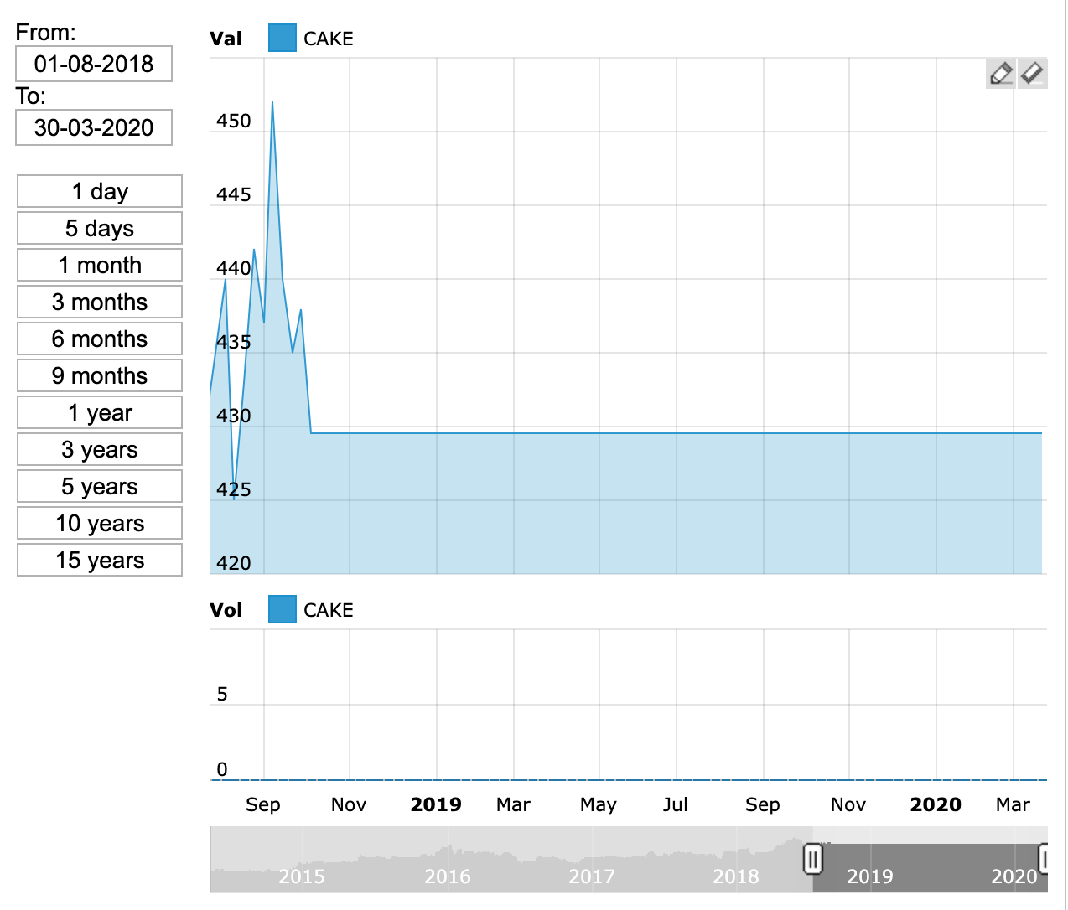
Figure 1 - (This is Money, 2020)

Above is a diagram which shows the share price of Patisserie Valerie from August 2018 to its insolvency in 2019. The share price had spiked slightly before the fraud had been discovered, but as soon as it was, the share price dropped from 452p per share to 429.5p per share showing that the discrepancies had a major effect on its investors and shareholders (BPP Learning Media, 2017).

Ways in which Patisserie Valerie could have used earnings management

Lack of Visibility – Having an increased Visibility is a massive safeguard against errors. If auditors and finance professionals have access to real time company data, they can then recognise anomalies and fraud as it appears, and not only at month end or year end. In the case of Patisserie Valerie, if they had an increased visibility, the professionals could have detected fraud earlier than they did, and therefore could have recognised it before potential investors and stakeholders are affected (Skoulding, 2018).

According to Simon Bonney an insolvency expert, he suggested two possible ways in which Patisserie Valerie could have ‘secretly’ conducted fraud:

Removal of money – They could have removed money from the accounts of the company in order to hide it.

Misstatement – They could have tried to make un unsuccessful business appear to look more successful by overstating their financial statements (AccountancyAge, 2019).

As mentioned above in 5.1., Patisserie Valerie had been seen to have overstated their accounts by £94m, and their cash by £30m, which therefore could have meant that the finance director at that time could have felt pressured as his job was on the line, and therefore overstated the figures in order to make the company look like it was at a better financial position than it actually was (Fadilah, et al., 2019). This would then lead to more investors potentially giving the company more cash injections and more shareholders buying shares (Jones, 2010).

UK corporate governance structure in constraining earnings management

Earnings management is decreased, and management opportunistic behaviour is reduced when the use of monitoring systems is introduced (Dechow, et al., 1996). The stock market has regulators that look out for fraud, as well as agencies who protect investors, both of these operate to fight earnings management due to the high number of high-profile companies who have gone into administration due to creative accounting in the last decade, such as Patisserie Valerie, Carillion, and BHS. Therefore, corporate governance has been improved as well as auditors being given more independence. One of the main objectives of the corporate governance code is to resolve potential problems by matching managers aims and objectives with the aims and objectives of the shareholders (Demsetz & Lehn, 1985).

Conclusion

Conclusion
To conclude, earnings management has played a part in many high-profile companies going into liquidation. Companies use earnings management in order to make their business look more successful than it actually is in order to gain more investments, and this was the case with Patisserie Valerie, which ultimately led to their failure, with their business being worth £450m and being sold for £5m. The corporate governance code’s role needs revising as they need to concentrate more on looking out for potential fraud.

Recommendations
The first recommendation is that Auditors could be given the training in order to detect fraud in financial statements. This could then mean that auditors can pick up potential fraud that could lead the company into insolvency, and if this was picked up early enough, something could be done about it. Patisserie Valerie’s ex-auditor for Grant Thornton argued that it is not the auditor’s job to pick up on fraud, and if it was, audit firms would have to charge much more for their audit services (The Guardian, 2019).

The second recommendation is to speed up investigations of auditors. The UK’S accounting regulator is expanding its enforcement powers and speed up their investigation process of auditors, in order to help to detect fraud faster. Some argue that the FRC has been to slow in investigating earnings management within a few high-profile collapses, and therefore they need to invest more money into procedures in order to tackle fraud cases (Financial Times, 2019).

References

AccountancyAge, 2019. How did fraud come about in the Patisserie Valerie case?. AccountancyAge.

BBC News, 2019. Patisserie Valerie black hole grows to £94m. [Online]
Available at: https://www.bbc.co.uk/news/business-47591082

BPP Learning Media, 2017. ACCA P2 Corporate Reporting (International & UK). s.l.:BPP Learning Media.

Caterer (2055-7817), 2019. Five arrested in investigation into alleged Patisserie Valerie fraud.. 207(5079), p. 5.

Dechow, P., Sloan, R. & Sweeney, A., 1996. Causes and Consequences of Earnings Manipulation: An Analysis of Firms Subject to Enforcement Actions by the SEC.
Contemporary Accounting Research, Volume 13, pp. 1-36.

Demsetz, H. & Lehn, K., 1985. The Structure of Corporate Ownership: Causes and Consequences. The Journal of Political Economy, Volume 93, pp. 1155-1177.

Elliot, B. & Elliot, J., 2015. Financial Accounting and Reporting,. 17th ed. London: Financial Times - Prentice Hall.

Fadilah, S., Lim, T. N. & Maemunah, M., 2019. Forensic accounting: fraud detection skills for external auditors. Polish Journal of Management Studies, Volume 20.

Financial Times, 2019. Corporate scandals prompt shake-up at UK accounting watchdog. [Online]
Available at: https://www.ft.com/content/0abe6718-47ed-11ea-aee2-9ddbdc86190d
[Accessed 25th March 2020].

Finch, C., 2012. A Student’s Guide to International Reporting Standard. s.l.:Kaplan.
Fok, D. & Franses, P. H., 2013. Testing earnings management. Statistica Neerlandica, 67(3), pp. 281-292.

Gordon, P., Roberts, C. & Weetman, P., 2008. International Corporate Reporting: a comparative approach. 4th ed. Harlow: Pearson Education Limited.

Higson, A., 2003. Corporate Financial Reporting: Theory and Practice. 1st ed. London: SAGE Publications Ltd.

Jones, M. J., 2010. Creative accounting, fraud and international accounting scandals. s.l.:John Wiley & Sons.

Partington, R., 2019. Police arrest five in Patisserie Valerie investigation. [Online]
Available at: https://www.theguardian.com/business/2019/jun/23/sfo-arrests-five-in-patisserie-valerie-investigation
[Accessed 20th March 2020].

Patisserie Valerie, 2019. About Us. [Online]
Available at: https://www.patisserie-valerie.co.uk/about.aspx
[Accessed 16th March 2020].

Reuters, 2019. Five arrested in investigation into Patisserie Valerie. [Online]
Available at: https://uk.reuters.com/article/uk-patisserie-hldg-arrests/five-arrested-in-investigation-into-patisserie-valerie-idUKKCN1TO0K6
[Accessed 21st March 2020].

Skoulding, L., 2018. Was lack of visibility to blame for Patisserie Valerie fraud?. AccountancyAge.

The Guardian, 2019. Ex-Patisserie Valerie auditor says 'not his role to uncover fraud'. [Online]
Available at: https://www.theguardian.com/business/2019/jan/30/ex-patisserie-valerie-auditor-says-not-his-role-to-uncover
[Accessed 24th March 2020].

This is Money, 2020. Patisserie Holdings. [Online]
Available at: https://investing.thisismoney.co.uk/charts/CAKE/Patisserie-Holdings.html
[Accessed 20th March 2020].

