Assignment: Building Survey
Student Name: Michael Nugent | Student Number: 2520530

P1 Planning the Survey
The purpose of the survey was to accurately measure, gather and capture information on the condition of Dylan Thomas centre using digital surveying methods. The survey was carried out using 3D laser scanning, which then allowed high precision spatial data to be collected efficiently with a high level of detail. The primary focus was the internal layout of the centre including key structural and circulation elements so that any future refurbishment or development can be designed, planned then carried out accordingly the use of 3D laser scanning supports safe and efficient construction by providing accurate built information ultimately reducing the risk of design errors, misalignment as well as reducing costly errors. In addition, the survey established the dimensions and overall area of the centre providing forms of clarity on the centre's spatial extent. This digital record also assists to reduce lay out disputes by clearly defining survey areas overall the survey provides reliable comprehensive data set that can be used.

The parts of the building being captured during the survey were the centre corridors, walls and fire exit doors as these elements are crucial to circulation safety and compliance also using digital surveying techniques, 3D laser scanning (accurate dimensions) were obtained for the width of the corridors, wall thickness, celling heights and door sizes. The precise location of the walls, doors and staircases were also recorded to provide reliable positional data needed to ensure accuracy and accurate drawings and spatial coordination as well as future design work. Fire safety feature such as fire doors, designated fire exits and fire extinguishers were carefully considered and documented due to their importance in emergency and regulatory compliance. A high level of detail was required as these elements directly affect the building functionality, user safety and compliance with fire and accessibility regulations' use of 3D laser scanning ensure that the centre was recorded accurately and reliably, producing a comprehensive built digital record suitable for safe use, assessment and future development.
The site assessment for the centre identified that the access to the building was sufficient with clear defining exits and entry points that allowed safe passage for people and surveying equipment throughout the centre. Internal circulation routes including corridors providing suitable locations for the placement of scanning equipment. Suitable scanning points were visible throughout the corridors, open areas and fire exit doors enabling adequate coverage as well as minimising obstruction and blind spots. The conditioning of the lighting in the centre was overall suitable due to the correct balance of artificial and natural lighting this provided adequate visibility for surveying activities and supported good data capture quality. however, the enclosed fire door exits were identified as having reduced lighting levels indicating that more artificial lighting could potentially be beneficial to improve the data accuracy in the centre. Safety conditions were evaluated and deemed acceptable with potential hazards such as public movement within the centre which was identified and directed through careful planning ad awareness. Emergency escape routes and fire exits were maintained, and the survey was to evaluate the conditioning of the centre. overall, the site assessment confirmed that the centre was suitable for surveying and the conditioning allowed for safe and effective evaluation.
Since the centre is an occupied public space one of the primary operational risks that could be identified was the interaction of visitors and staff which could possibly lead to congestion, collisions, disruptions or unsafe working conditions these risks can be mitigated by conducting scheduled surveying during quite periods of the day using clear warning signs. Obstructions such as narrow corridors and fixed fitted can be presented as a risk due to both equipment stability and data quality it can be mitigated using smaller equipment that can operate safely within limited space, pre planning a schedule to identify suitable scanning positions. Environmental risks could include poor lighting conditions around enclosed corridors and fire exit staircases which can potentially affect data capture quality this can be mitigated by selecting suitable scanning positions and allowing additional coverage where required. Fire safety can be considered also with specific attention is given when ensuring that all emergency escape routes and fire exit remain unobstructed all the time while also making sure that surveying activities complies with centre emergency policies. The identification and mitigation ensure surveying can be carried out in a safe manner and efficiently while complying with heath safety requirements.
P2 Practical:
The survey was executed as panned with access into Dylan Thomas centre granted and surveying activities carried within the allocated time. the planned use of digital surveying techniques such as 3D laser scanning was proven effective allowing large internal areas to be captured efficiently during the first visit. Scanning points positioned along corridors, open areas and fire exit staircases sufficient coverage was provided resulting in data with minimal blind spots. The equipment used performed to expectations and the survey strategy accurately allowed recording of key elements such as the corridor dimensions and floor to ceiling height.
In this case some adjustments were necessary during the survey responding to the conditioning. There was more movement than anticipated so additional care of the equipment placement was needed. In some cases, the minor repositioning of the scanning points occurred to maintain data and safety quality. The lighting condition in the enclose fire exit staircases were lower than expected which required different scanning positions to ensure sufficient data capture. In general, the survey was competed successfully with necessary changes occurred to ensure safety, accuracy and completeness of the collected data.
During the survey multiple issues occurred that required adjustment to the planned approach one of main challenges that was encountered was more movement than anticipated which restricted some scanning points and increased safety consideration this was manage by temporarily repositioning scanning equipment and moving until movement had ceased. Narrow corridors also put limitations on ideal scanning placement creating a risk factor of incomplete coverage within the data improve this additional scanning points were introduced to reduce blind spots and enhance coverage. Lighting in fire exit staircases were lower than anticipated and influenced visibility and data quality; this was addressed by carefully selecting scanning locations ensuring sufficient detail was captured. All these issues reflect on challenges encountered in the real word surveying and the ability to adapt surveying plans or strategy ensured that the survey was accurate and safe to a high standard.
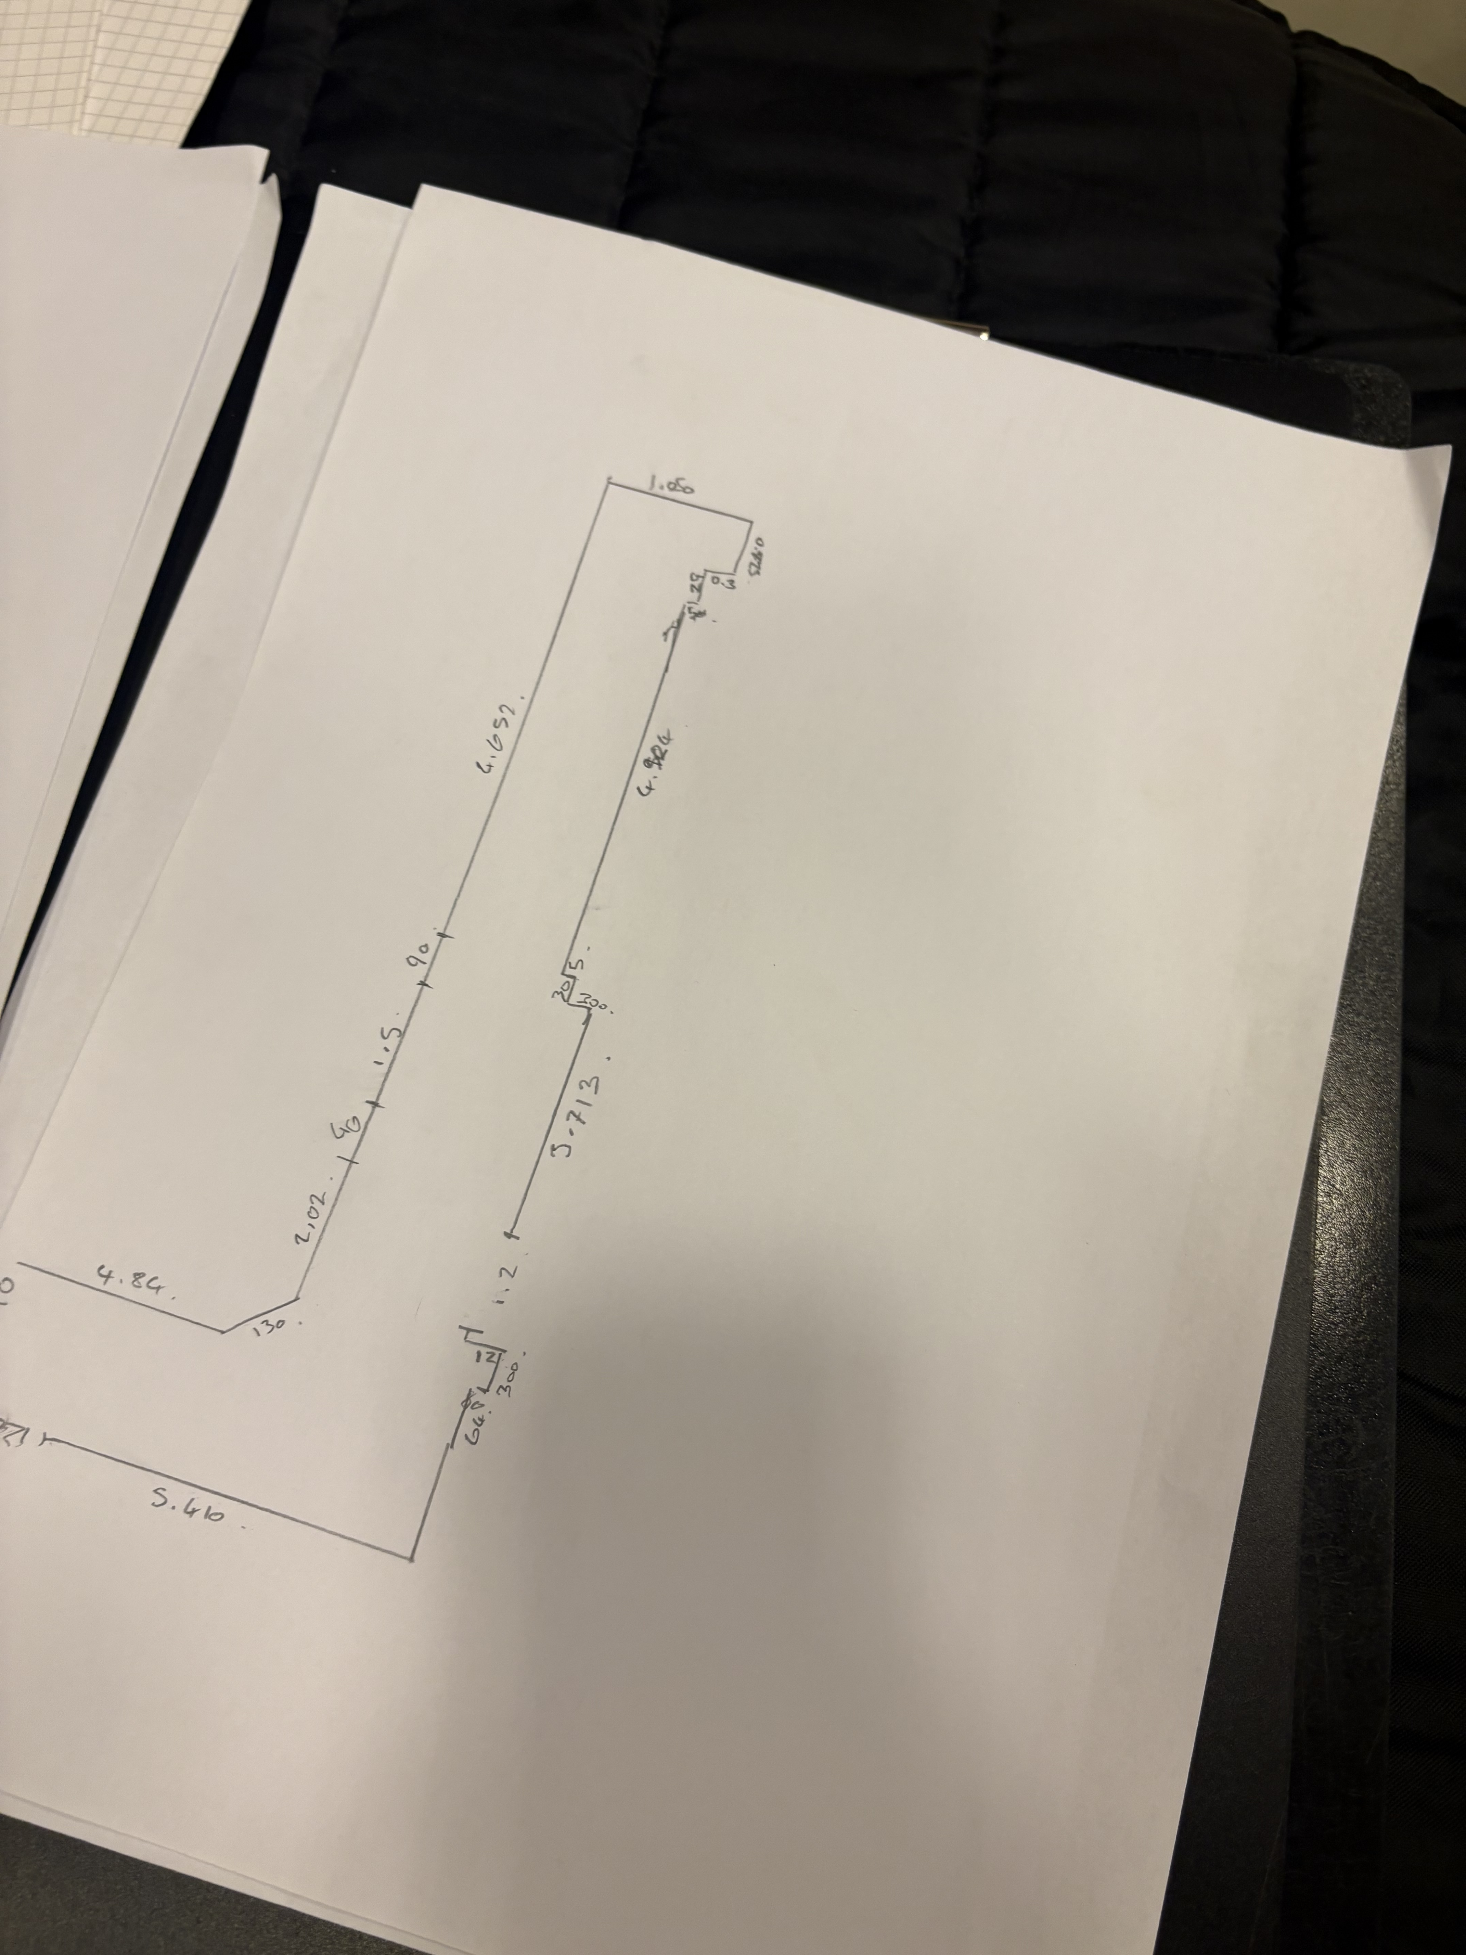
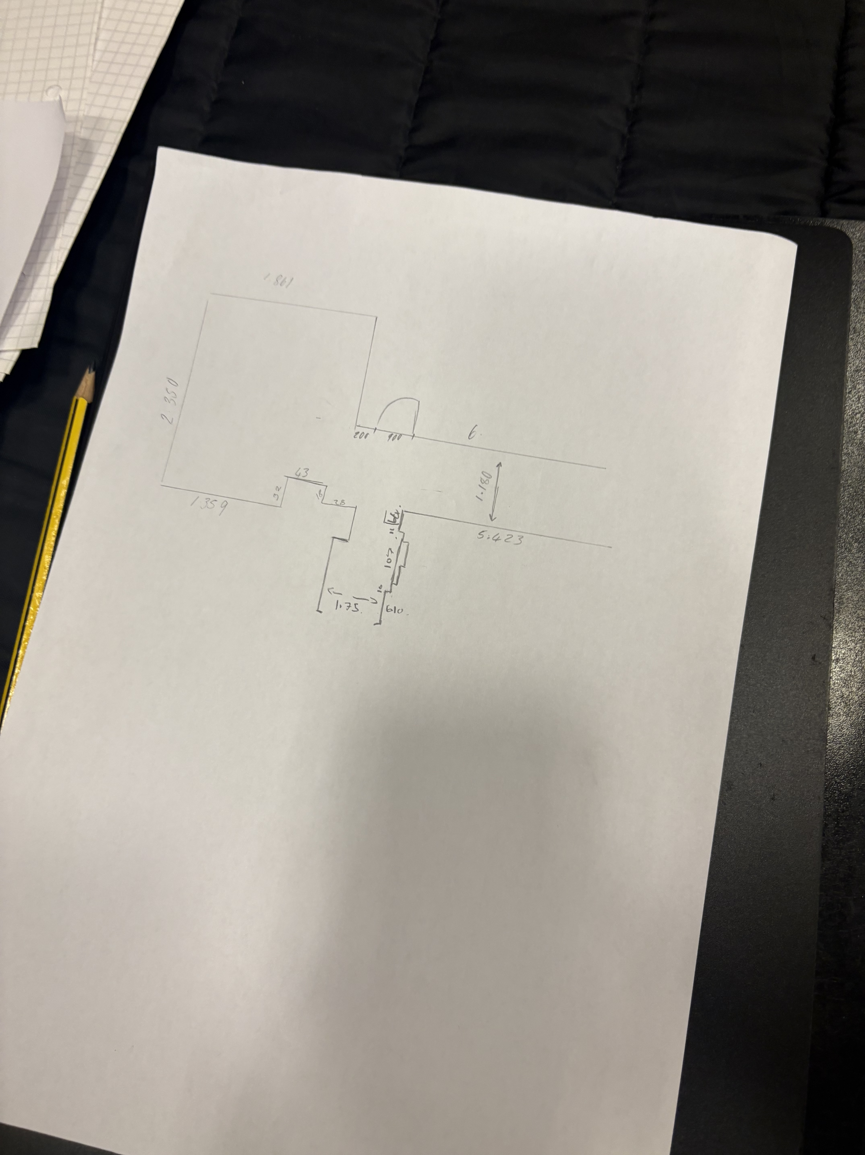
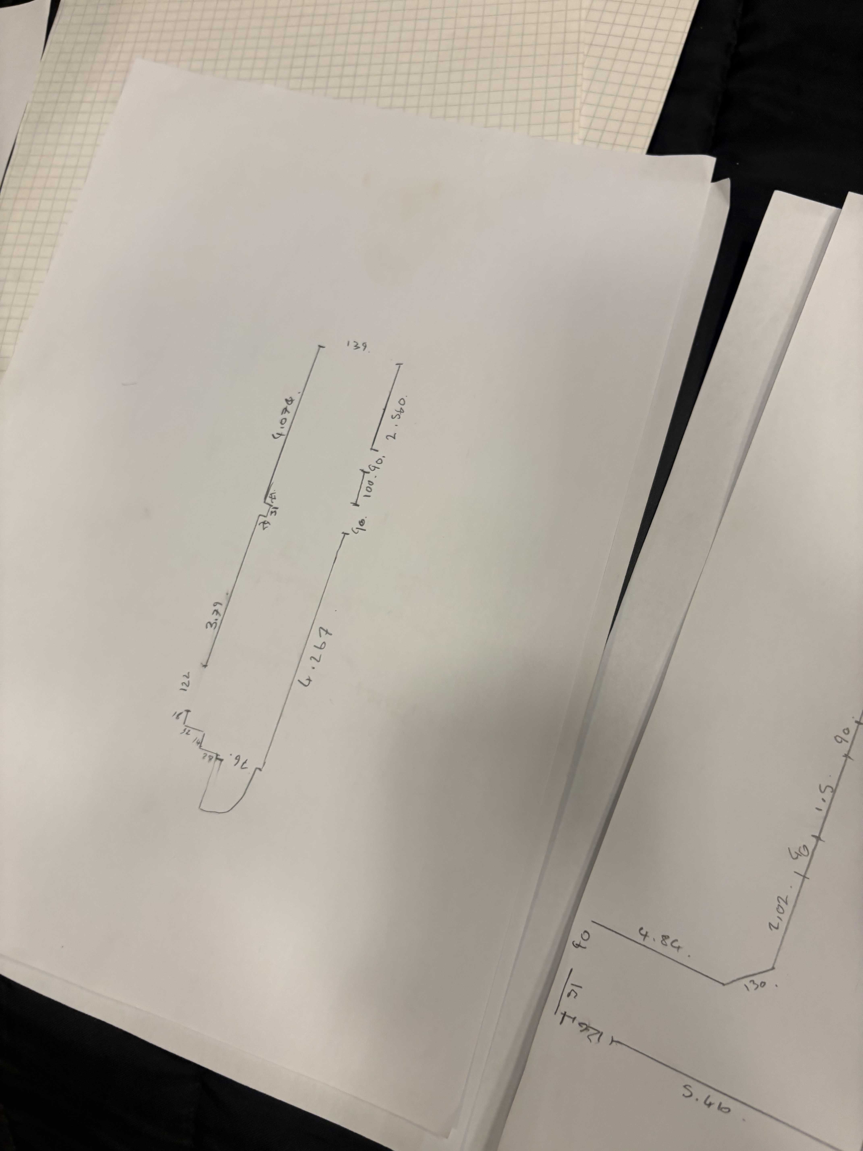

P3 Measurement and Analysis
The overall room dimension is approximately 40.1 m with the corridor width ranging between 1.20m and 1.80m this was calculated by combining the measured corridor segments of 5.423m + 6.65m + 4.80m + 5.713m + 5.40m + 12.12m. The window dimensions within the centre were recorded to provide accurate information on opening sizes the recorded values were 1.359m (width), 2.350m (height) and 1.981m (width). Based on the measurements recorded during the survey the floor to ceiling height were typical height 2.50m and maximum height 2.80m these hights were measured throughout the surveyed areas so accurate vertical clearness and understanding of the internal geometry could be established in certain areas these measurements were captured using manual methods and surveying techniques
The use of digital surveying techniques especially 3D laser scanning offers significant advantages over traditional manual measurement methods in terms of both time efficacy and completeness and accuracy. Manual measures rely on tape measurements and handheld devices which requires multiple readings and, in some cases, often repeated site devices which inevitably increases the time required as well as the risk for human error in contrast 3D laser scanning captures millions of precise spatial data within a short time frame which allows large complexed areas of the centre to be recorded during one visit. This notably improves completeness due to all surfaces and features becoming visible and being able to be captured including areas that area that aren't considered critical. Accuracy is also enhanced since measurements are derived from a high-resolution point cloud, this reduces the chances of transcript errors and allows consistent repeatable measurements to be removed digitally. Overall 3D laser scanning is much faster and more accurate compared to manual methods in digital building surveying and complex environments.
References:
RICS
https://www.rics.org › ... › documents › join-rics · PDF file

mod_view.php
mod_view.php

