

Student Name :- Vedang Bhaskarbhai Trivedi
Student ID :- 2220026
Programme :- MBA (General Management)
Module :- Marketing Management
Module Code :- LCMB7001
Lecturer Name:- Tushara Balendran
Submitted On :-

Table of Contents
1. Introduction 1
2. PESTLE Analysis of Gucci 2
3. Porter’s five forces for Gucci 6
4. SWOT Analysis for GUCCI 10
4.1. Advantages of SWOT analyses 13
4.2. Disadvantages of SWOT analyses 14
5. Segmentation, Targeting and Positioning ( STP ) of Gucci:- 15
5.1. Segmentation 15
5.2. Targeting 16
5.3. Positioning 17
6. Marketing mix strategies for Gucci 18
7. Recommendations 23
Conclusion 25
References 26

Introduction

In1921 Guccio Gucci established Gucci company when he started small luggage shop and leather goods firm in his home town of Florence. It is now a part of the design multinational Kering, which is run by Francois Pinault. In 2010, Gucci added a toddler’s brand to its assortment of apparel and leather items for men and women. Alessandro Michele's unused design for Gucci has been resurrected. Gucci sales increased by 33% in 2018 and by 42% in 2017 as Chinese purchasers' demand increased. With 57% of total sales, The largest market segment is still goods made of leather. 44% of the Gucci's income was derived from Japan and the Asia-Pacific region in the previous year. In January 2015, Marco Bizzarri assumed the role of president and CEO. The company's headquarters are in Florence, Italy. ( Available at :- Gucci | Company Overview & News (forbes.com) )

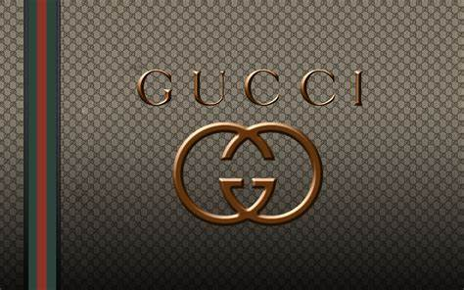
Source :- Gucci 1080P, 2K, 4K, 5K HD wallpapers free download | Wallpaper Flare
According to Forbes Gucci was America’s best employers for new grads in year 2018. In 2020 company was awarded as best employer for diversity. Gucci was ranked at 31st in year 2020 for world’s most valuable brand. Gucci was ranked at 158st for best brand for social impact in year 2023. ( Available at :- Gucci | Company Overview & News (forbes.com) )

PESTLE Analysis of Gucci

“ PESTLE represents an acronym of political, economic, social, technology, legal and environmental factors whose influence on decision making cannot be control by the organization.”
( Okyere Bismark, Obeng Acheampong Kofi, Adjei-Gyabaah Frank, Hope Eric (2018), Utilizing Mckinsey 7s Model, SWOT Analysis, PESTLE and Balance Scorecard to Foster Efficient Implementation of Organizational Strategy. Evidence from The Community Hospital Group- Ghana Limited., International Journal of Research in Business, Economics and Management Vol.2 Issue 3, pg. 97 )
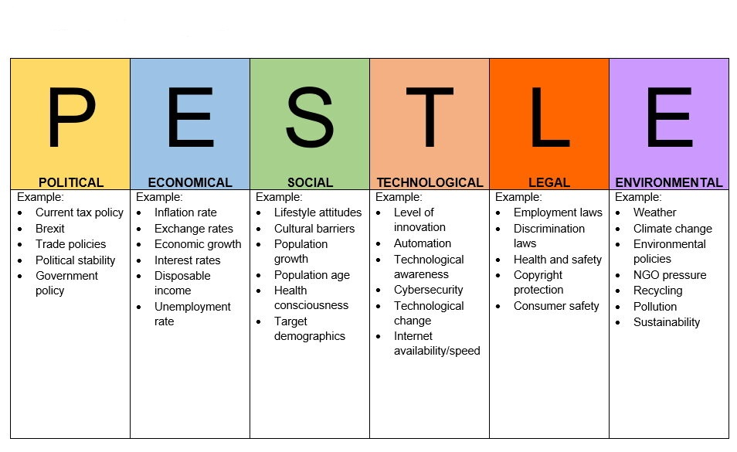

- Political factors:-

Political factors are favourable and unfavourable for Gucci.

Gucci must first comprehend the political atmosphere in the UK and any other nations where Gucci developed before making any judgements since it has an impact on the profitability level of a country. The political environment takes into account things like a country's taxation structure, political turbulence, governmental rules, corruption, etc.

Britain has a very low amount of corruption, yet Gucci operates there. The UK's most notable characteristics are its democracy and commitment to the rule of law. Given that the British government continuously promotes commercial enterprises, Gucci may profit from an especially advantageous political environment there.

Despite the BREXIT issue and the unpredictable political environment in the UK, the country is still a terrific place to do business, especially for high-end companies like Gucci. Gucci must sacrifice their profits for this because to the high tax rates in the UK.

- Economical factors:-

Economical factors are unfavourable for Gucci.

The economic climate in the UK should be considered by Gucci, as well as market dynamics, interest rates, inflation, foreign exchange rates, GDP, employment rate, and other aspects. Any firm is welcome to enter and establish a presence in the UK thanks to its open economy.

Gucci sells clothing, luxury goods, and accessories. Given that the UK economy is growing and the country has low rates of inflation, it is a great place for organisations like Gucci to do business.

Because the government in the UK consistently supports commercial organisations, the bank interest rate there is fairly low. Gucci may readily borrow money when needed and only has to pay relatively little interest because to the low interest rate.

- Social factors:-

Social factors are favourable for Gucci.

Culture, religion, social class, public opinion, and social values are a few social environmental aspects that have an impact on Gucci's business. In the UK, the vast majority of individuals take their social class and status very seriously. Gucci will have a robust market in the UK because the majority of Britons buy premium items. The fact that most of Gucci's UK customers are educated and employed in the corporate sector is a sign of success for the brand.

- Technological factors:-

Technological factors are favourable for Gucci.

Without technology, not a single company can carry out its tasks efficiently. Technology brings about a revolutionary transformation in the commercial sector. Gucci sells luxury goods in stores and online. Gucci must also use technology to sell products online, advertise, innovate, and more. In the UK, they can enjoy most modern technological instruments.

- Legal factors:-

Legal factors are favourable and unfavourable for Gucci.

The UK government is quite stringent about its laws and regulations, so if Gucci wants to operate there, it must abide by all of them.

- Environmental factors:-

Environmental factors are unfavourable for Gucci.

Environmental issues are now more important than ever to both governments and consumers. Tom Crawford claims that luxury In conclusion, the luxury business is undergoing a long-lasting change (LuxuryBriefing, 2010). If Gucci wants to conduct business, they must abide by all environmental regulations put forth by the UK government. The majority of UK customers are also extremely environmentally aware; they steer clear of businesses that contribute to pollution or otherwise hurt the environment.
( Available at:- Factors Affecting the Gucci business in UK - CIRCLE OF BUSINESS (circlebizz.com) )

Porter’s five forces for Gucci

Harvard Business School professor Michael E. Porter (Porter, 2008) has created a thorough method for analysing the industry structure in order to create competitive strategies. According to Porter's model, industry competition is deeply ingrained in its underlying economic structure and extends well beyond the actions of current market rivals. (Azhar, 2008)

( Asmita Basu Chatterjee Assistant Professor (Finance) ( 2020), Strategic Analysis- Understanding the Global Luxury Brand A case study on LVMH, Army Institute of Management, Kolkata, ISSN: 2321-8819 (Online) 2348-7186 (Print) Impact Factor: 1.498 Vol. 8, Issue 5, pg. 90)

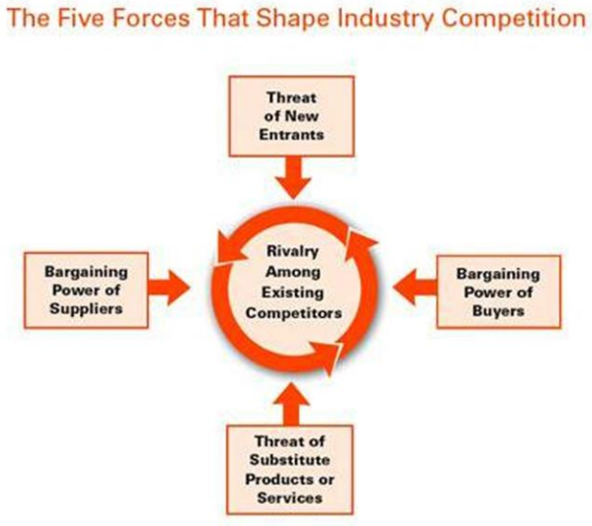

Source :- Five competitive forces that shape strategy by Michael E Porter, Harvard business review, January 2008

- Threat of new entries:-

Threat of new entries is medium for Gucci.

Threat of entrance into an industry for mature markets causes the level of competition to rise. When suggesting a new product in its developmental stage, it may go in the direction of market expansion. The scope, diversity, and complexity of the global luxury market are growing, and as a result, so is the client base. In new markets, there are more opportunities, which attracts more customers. One of GUCCI's primary strategic challenges is coming up with a suitable strategy that incorporates the developing market while maintaining the company's true heritage and experience while concentrating on the shifting clientele. Some of the most well-known and respected luxury product brands in the world are owned by Gucci. company at all.
( Asmita Basu Chatterjee Assistant Professor (Finance) ( 2020), Strategic Analysis- Understanding the Global Luxury Brand A case study on LVMH, Army Institute of Management, Kolkata, ISSN: 2321-8819 (Online) 2348-7186 (Print) Impact Factor: 1.498 Vol. 8, Issue 5, pg. 90)

- Threat of substitute product:-

Threat of substitute product is high for Gucci.

Here are the threats of substitutes from Porter's Five Forces Analysis for Gucci:

Gucci's major competition in the luxury market is the replacement of well-known names like Prada, Chanel, Christian Dior, Louis Vuitton, and Armani. When the Gucci logo was applied to the product with a small adjustment to the logo design, the business had to contend with phoney and inexpensive imitations. Since many individuals purchase these things as a status symbol, it can be challenging for the typical person to distinguish between a fake and a real product. However, people with a keen sense of style or familiarity with the industry may tell them different right away.

- Supplier’s bargaining power:-

Supplier’s bargaining power is medium for Gucci.

In a seller's market, when producers can set prices and influence consumer spending, they can increase their profits. This happens when there are surpluses and shortfalls in a certain product category's total supply. Given its dominant market share in premium goods, GUCCI has negotiation power with suppliers.
Italy is home to the bulk of Gucci's manufacturers. For a very long time, the House has trusted and remained loyal to certain vendors. To maintain Gucci's high standards across the world, they must adhere to all rules and regulations. Suppliers can swiftly boost output or raise labour costs, giving them significant bargaining leverage. They are also governed by the same political rules and have the option to join a union to voice their discontent with pay and benefits in the same location. At the same time, the entire provider side of the supply chain system will fight it if the entire world is shut down, as was the case with the Covid-19 outbreak.

( Available at:- Gucci Porter Five Forces Analysis | MBA Skool )

- Rivalry among competitors:-

Rivalry among competitors are high for Gucci.

The number of competitors, industry growth, product substitution and differentiation, assets intensity, and exit barriers all affect how fiercely various companies compete with one another. The expansion of the industry, the number of rivals, and technical advancement are the three most important drivers.

( Asmita Basu Chatterjee Assistant Professor (Finance) ( 2020), Strategic Analysis- Understanding the Global Luxury Brand A case study on LVMH, Army Institute of Management, Kolkata, ISSN: 2321-8819 (Online) 2348-7186 (Print) Impact Factor: 1.498 Vol. 8, Issue 5, pg. 91 )
Gucci sells ready-to-wear apparel, jewellery, watches, home products, handbags, shoes, accessories, children's clothing, and ready-to-wear things. Brands like Hermes, Chanel, Fendi, Louis Vuitton, Marc Jacobs, and Yves Saint Laurent are fierce rivals of Gucci in the handbag business. Jimmy Choo, Givenchy, Yves Saint Laurent, Prada, and Dolce Gabbana are the top shoe industry competitors. Some of the brands in the accessories area are Prada, Yves Saint Laurent, Louis Vuitton, and Tom Ford. Cartier, Tiffany & Co., Bvlgari, and Chopard are a few of the leading jewellery manufacturers that compete in the luxury jewellery industry. Rolex, Patek Philippe, Audemars Piguet, and A.Lange & Söhne are the leading competitors in the watch industry.

( Available at:- Gucci Porter Five Forces Analysis | MBA Skool )

- Bargaining power of buyers:-

Bargaining power of buyers is low for Gucci.

When there are more products available than people want to buy, the people who want to buy things have more power to negotiate. This is especially true when there are different places where people can buy the same thing. When new companies start selling similar products, people have even more choices, and the profits for the people making or selling the products might change a lot.
( Asmita Basu Chatterjee Assistant Professor (Finance) ( 2020), Strategic Analysis- Understanding the Global Luxury Brand A case study on LVMH, Army Institute of Management, Kolkata, ISSN: 2321-8819 (Online) 2348-7186 (Print) Impact Factor: 1.498 Vol. 8, Issue 5, pg. 91 )
This prestigious house's clientele is both widely spread and extremely concentrated. Despite being a luxury brand, Gucci is comparable to many other brands, therefore switching costs are quite cheap among this exclusive group of customers. Because the products in this sector are so steady, consumers have very little negotiating leverage. Seasonal Gucci products are still being produced in limited quantities at the facility; these things are chopped and destroyed. There is no stock clearance discount given to the business.

( Gucci Porter Five Forces Analysis | MBA Skool )

SWOT Analysis for GUCCI

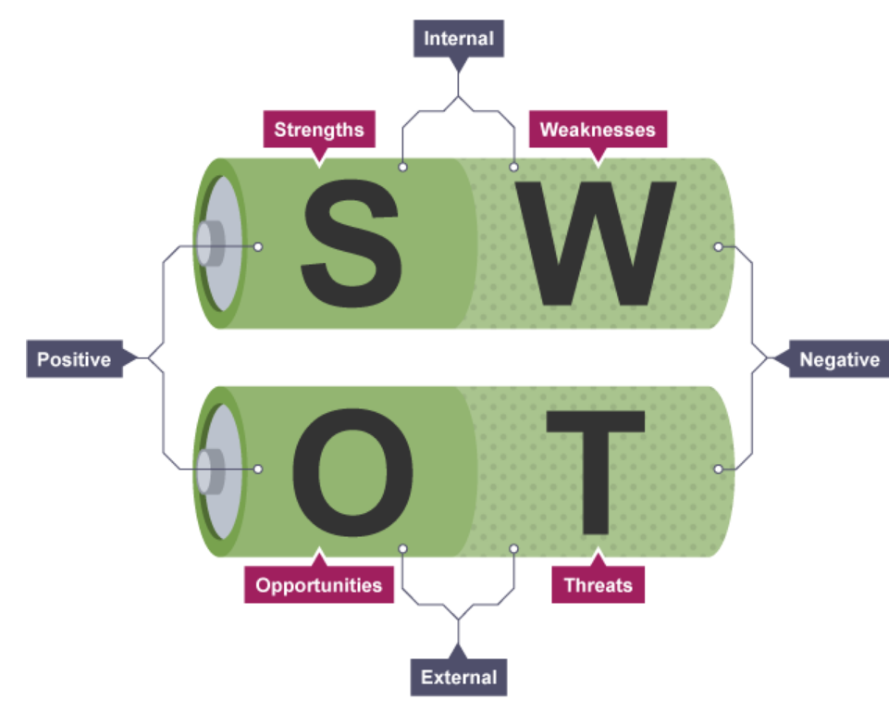
Fig. from Strengths, Weaknesses, Opportunities, and Threats (SWOT) analysis - Decision making - Higher Business management Revision - BBC Bitesize

- Strengths of GUCCI:-

- Gucci's digital marketing strategies have lessened the effects of the pandemic on the company, adjusted to how the environment has changed, and given the brand new life.
- Gucci has an established online presence thanks to social media marketing and accessibility on top e-commerce platforms.

- Gucci has also launched a number of cooperative ventures with other fashion houses and cartoon characters in an effort to pioneer sustainable fashion and appeal to young people.
( Yuxin Chen1, a, *, †, Yiming Ma2, b, *, † and Jingtong Xu3, c, *, †, ( 2022), Research on the Marketing Strategy of the Fashion Luxury Industry in the Post epidemic ERA – Taking GUCCI as acase, 5th International Conference on Financial Management, Education and Social Science (FMESS 2022), pg. 574 )

- In December 2020, GUCCI collaborated with UNICEF USA which makes brand more stronger than ever.

( Gucci and UNICEF USA’s Partnership to Save and Protect Children | UNICEF USA )

- Weaknesses of GUCCI:-

- Gucci will first start to lose some of its original masterpieces, and then slowly start to lose the real aura of luxury products. Gucci has started reviving, which goes against the present trend of people purchasing luxury items as they choose more expensive terminal products.

- Second, Gucci's immature marketing approach is prone to aesthetic and visual fatigue in the face of the epidemic and is unable to retain consumer attractiveness. Additionally, many luxury businesses are currently benefiting from millennial and Gen Z customers.
( Yuxin Chen1, a, *, †, Yiming Ma2, b, *, † and Jingtong Xu3, c, *, †, ( 2022), Research on the Marketing Strategy of the Fashion Luxury Industry in the Post epidemic ERA – Taking GUCCI as acase, 5th International Conference on Financial Management, Education and Social Science (FMESS 2022), pg. 574 )

- Opportunities of GUCCI:-

- Capturing the market by using various strategies, such as making the items available in shopping centres.
( Asmita Basu Chatterjee Assistant Professor (Finance) ( 2020), Strategic Analysis- Understanding the Global Luxury Brand A case study on LVMH, Army Institute of Management, Kolkata, ISSN: 2321-8819 (Online) 2348-7186 (Print) Impact Factor: 1.498 Vol. 8, Issue 5, pg. 91 )

- It is possible to achieve sustainable fashion development.

- Gucci may take advantage of developing luxury markets in emerging market such as India and China. Due to rising economic thresholds and the desire of the populace to imitate the West, European and American brands are increasingly much sought after in India and China.

- Threats of GUCCI:-

- Government rules and legislation are subject to change at any time. These might directly or indirectly result in decreased sales or brand harm for Gucci, especially in light of growing customer knowledge of ethical business practises.

( Available at :- SWOT Analysis of Gucci | Gucci Strengths & Weaknesses 2021 (swotanalysistemplate.com) )

- The fashion sector deals with intense rivalry. Christian Dior, Burberry, and Ralph Lauren have directly threatened Gucci on multiple occasions, and this competition might be harmful to the business if they do not keep inventing.

( Yuxin Chen1, a, *, †, Yiming Ma2, b, *, † and Jingtong Xu3, c, *, †, ( 2022), Research on the Marketing Strategy of the Fashion Luxury Industry in the Post epidemic ERA – Taking GUCCI as acase, 5th International Conference on Financial Management, Education and Social Science (FMESS 2022), pg. 574 )

Advantages of SWOT analyses

- Identify opportunities for improvement of the organisation.

- recognise areas where organisation can prepare for potential future situations.

- Identify potential areas for future growth.

- SWOT analysis is a strategy for analysis that takes a broad view and offers extensive solutions. SWOT Analysis functions as a road map that leads one from the general to the specific in this manner.

- The interactional analysis method known as SWOT analysis makes macro evaluations possible. The SWOT analysis method gives you the chance to concentrate on the positive and bad aspects of the organization's internal and external environment, or the components of this environment that supply plus and minus value, all from one integrated viewpoint. This makes the SWOT analysis also known as a "Two-by-Two Matrix."

- Business leadership may use SWOT analysis to identify opportunities for profit. Understanding vulnerabilities can help control and eliminate threats. By doing a SWOT Analysis to evaluate an organisation and its competitors, strategies to differentiate a company from rivals may be established.

Disadvantages of SWOT analyses

- SWOT is replaced by TOWS. Risks and opportunities are the optimum location to start an assessment, according to Weihrich (1982). Since they are external to the organisation and ultimately beyond of its control, they must be managed using its strengths and weaknesses. An organization's current competitive position and development potential are assessed by a methodical and in-depth analysis of internal and external factors.

- SWOT analysis is an all-encompassing approach and offers all-encompassing answers. When the environmental conditions were stable, SWOT analysis was established. This makes it invalid in the world of change and competition we live in today. The validity of entries in a SWOT Matrix is impacted by dynamic and structural changes at the system, sub-system, and supersystem levels.

- We now live in a changing and fiercely competitive world. At the system, sub-system, and supersystem levels, dynamic and structural changes have an influence on the use of components in a SWOT matrix.

- Multiple research studies illustrate how poorly prepared SWOT analyses are. It needs experience and education to be built and used methodically. According to Mintzberg (1990), the picture that comes to mind is that of executives discussing the benefits, drawbacks, and distinctive capabilities of an organisation while seated around a table, much like students in a case study class.

- The SWOT analysis is based on the current strengths, weaknesses, opportunities, and threats. To develop successful strategies for that time, SWOT must alter its inventory to arrive at one that accurately reflects the anticipated organization's strengths, weaknesses, opportunities, and threats. Otherwise, creating plans will be based more on the past or the present than the future.
( Emet GÜREL• Merba TAT ( 2017), SWOT ANALYSIS: A THEORETICAL REVIEW, The Journal of International Social Research, Volume: 10 Issue: 51, Issn: 1307-9581 )

Segmentation, Targeting and Positioning ( STP ) of Gucci:-

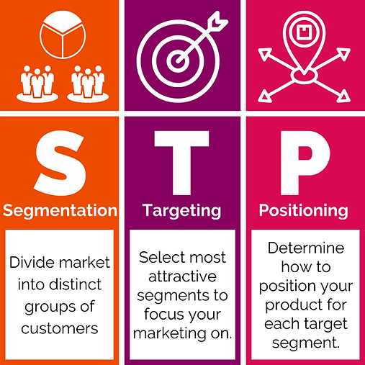
Source :- STP Model (advancewithava.com)

Segmentation

Segmentation can be divided into various parts such as Demographic segmentation, Geographic segmentation, Psychographics segmentation etc.

- Demographic segmentation:-

Companies segment the market based on factors including age, gender, race, marital status, income, education, and occupation, according to demographic segmentation.

Gucci makes products for various age groups such as children, teens and adults of both genders.

Gucci products are for the group of men and women that like making an influence over other individuals. Gucci makes various products for men such as men's shoes, men's bag, men's wallet, men's belt, men's watch, men's eye wear and jewellery etc. Gucci also makes number of women's products such as women's handbag, women's clothing, women's shoes, women's purses etc.

Gucci products are categorised as a luxurious products so they are expensive and people from lower income can not afford the products from Gucci. The Gucci brand disregards those in the middle class and lower income groups, which results in an inadequate utilisation of the market's consumer base.

- Geographic segmentation:-

Almost all of Gucci's buyers reside in wealthy nations. As a result, they have riches and high standards. The brand's regional segmentation, however, is poorly planned since it ignored underdeveloped and developing nations.

Gucci operates in a number of nations, including Australia, Austria, Belgium, Canada, the Chinese mainland, Denmark, Finland, France, Germany, Hong Kong, Hungary, Ireland, Italy, Japan, Korea, Kuwait, Luxembourg, Mexico, the Netherlands, New Zealand, Norway, Poland, and many others.

( Available at :- Gucci Market Segmentation - An Analysis (ukessays.com) )

Targeting

Targeting strategies can be divide in to three parts such as 1) Undifferentiated marketing, 2) Differentiated marketing, 3) Concentrated marketing.

Below mention targeting strategies utilised by GUCCI.
- Differentiated marketing :- Gucci uses differentiated marketing strategies by offering various luxurious fashion brand for various age groups and differentiated according to gender for instance, Clothing, Shoes, Belts for men, women and youngsters.

- Concentrated marketing :- Gucci adopted concentrated marketing strategy by focusing on a specific segment that align perfectly with its brand identity. For instance, they target the high net worth person, celebrities and influencers.

( Available at :- GUCCI® UK Official Site | Redefining Luxury Fashion )

Positioning

The goal of positioning is to establish a unique position in the eyes of those who are one's customers (Kotler, P. 2012). In the luxury market area, Gucci already has an unique and superior brand image. They are well known for their high standards of quality, retail environment, luxury pricing, and effective distribution strategies. The majority of Gucci stores have elegant decor.

Gucci can provide its customers the highest-quality products because of its distinctive characteristics and excellent customer service. Even though Gucci has expensive costs, most affluent people like shopping there. Gucci is a well-known brand among famous people and other members of high society.
( Available at :- Marketing Strategy of GUCCI in UK - CIRCLE OF BUSINESS (circlebizz.com) )

Marketing mix strategies for Gucci

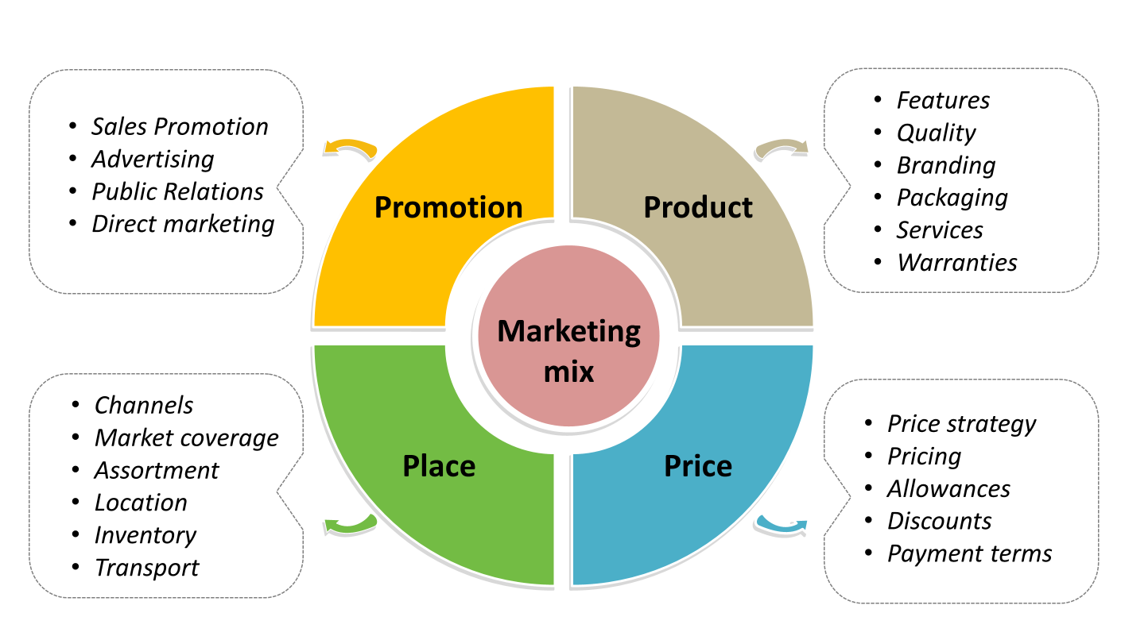
Source :- Marketing mix template - Free PowerPoint Template (yourfreetemplates.com)

Gucci's marketing strategy uses the 4Ps such as Product, Price, Place, and Promotion framework to analyse the brand.

- Product:-

Gucci is one of the most prominent and well-known names in premium apparel. The business is currently acknowledged as a premier fashion firm. A vast variety of long, wide, and deep items are part of Gucci's marketing mix. The Gucci product range consists of handbags, shoes, ready-to-wear clothes, jewellery, watches, and other accessories. It provides products for men, women, and children. The list of product categories is fairly extensive. There are many different styles of handbags, including totes, crossbody bags, backpacks, and shoulder bags. Every bag is offered in a variety of hues. Gucci offers duffel bags, briefcases, portfolios, totes, and backpacks for men. In their ready to wear segment they have jackets and coats, denims, leather and fur, skirts, tops and shirts, pants and shorts and many more products.

Shoes

Bag
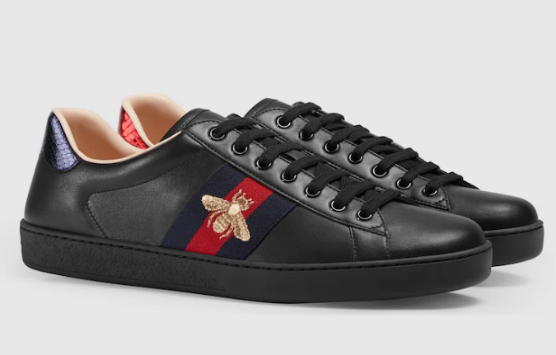
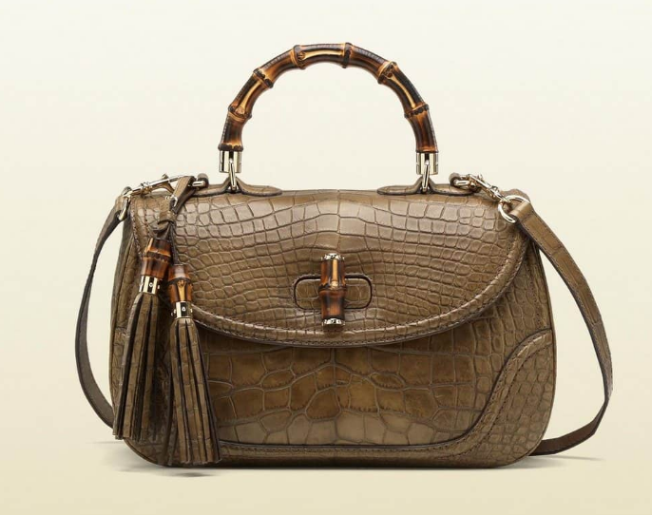

Jewellery Jeans

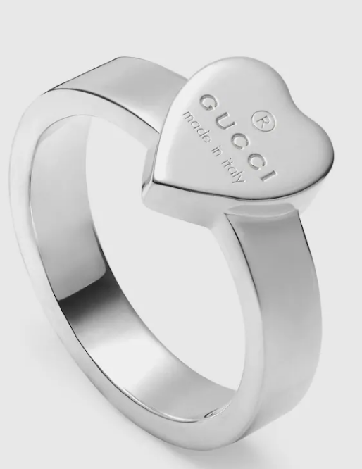
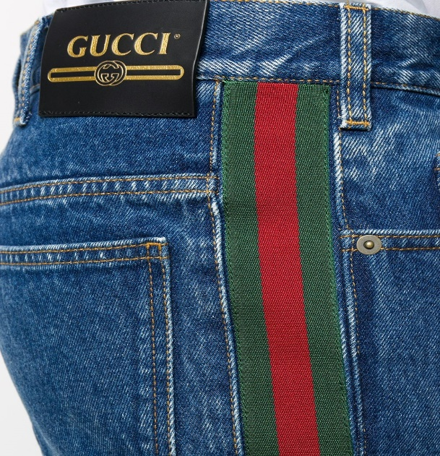

Source :- GUCCI® UK Official Site | Redefining Luxury Fashion

- Price:-

Gucci mostly sells luxury products. The quality of the fabric and the garment's construction affect the price of the apparel. Any expenses incurred are factored into the pricing strategy for the marketing mix. Products' prices rise as a result of different taxes levied against them when they are exported. Gucci products are pricey because they are manufactured using premium materials, which also raises the price of the goods. Their finished goods are marked with the made in Italy label. The product's high price functions as a status signal. Gucci charges a premium for each and every product.

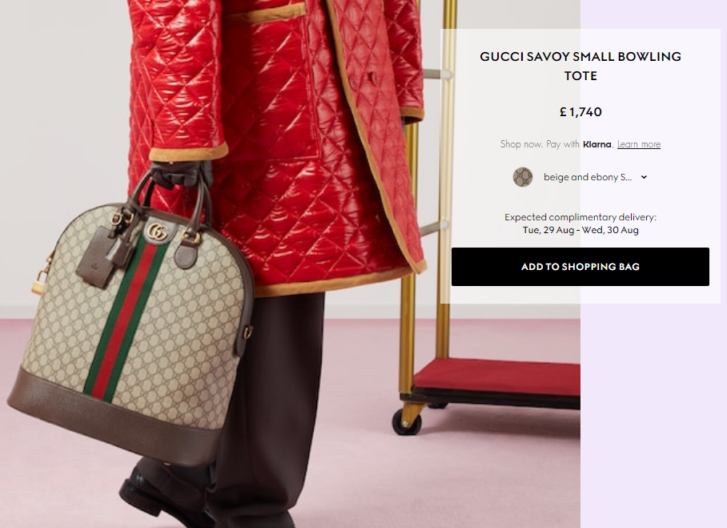
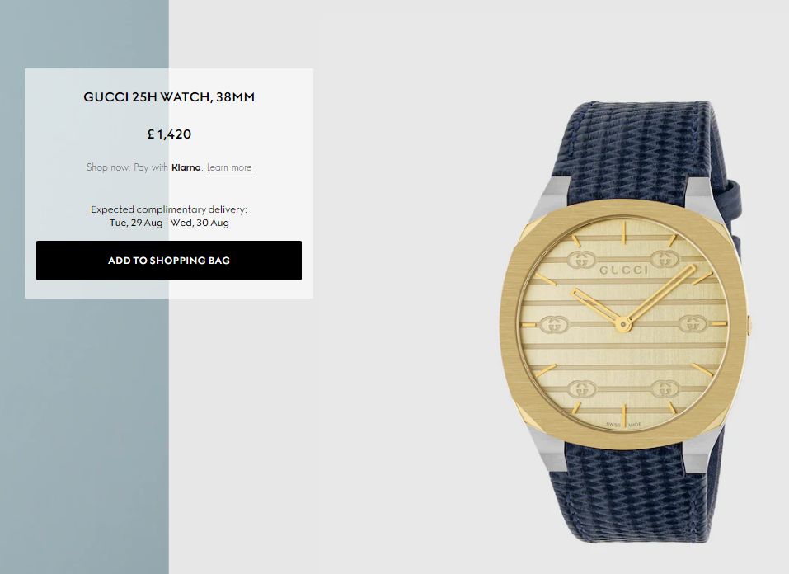

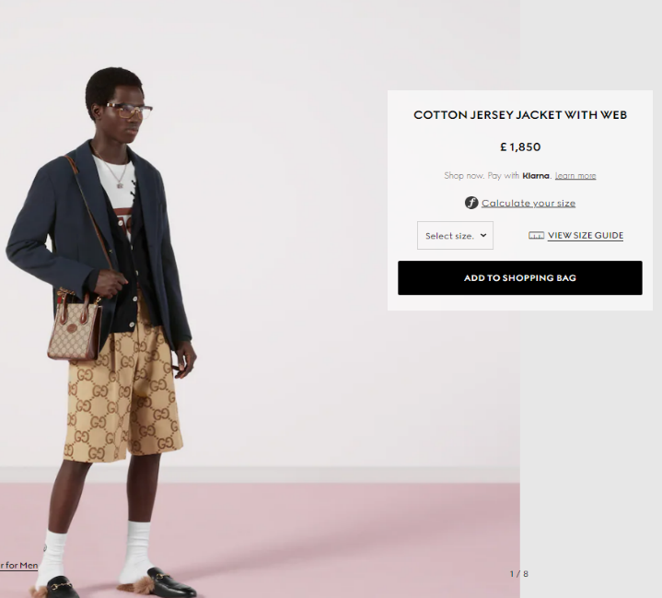

Source :- GUCCI® UK Official Site | Redefining Luxury Fashion

- Place :-

Gucci is making the most of its current network to boost sales and earnings naturally. Gucci has operations throughout Australia, Asia, the Middle East, Europe, and the United States. Merchandising, marketing, and communication, as well as retail planning, are its three main commercial operations. Support staff activities including human resources, finance, corporate social responsibility, legal, and corporate affairs look to the ancillary components of the Gucci company. Gucci's supply chain is incredibly effective and assists in producing items with cutting edge innovation from product creation to the technical sector. It has more than 500 directly run retail locations and a directly run internet business that serves more than 25 regions. Gucci sells its goods through a small number of franchisees, carefully chosen department stores, and specialised shops. Their stores are located in pricey uptown areas.

- Promotion :-

Gucci advertises itself through banners, fashion books, social media, print media, and advertisements as part of its marketing mix. Their marketing endeavours are highlighted on a number of social media platforms, including Facebook, Pinterest, YouTube, Instagram, and Tumblr. They have used a number of bloggers to promote their content on social media. In addition, Gucci provides the Gucci style app, which is offered in eight different languages. It offers articles about geolocation, fashion, interactive videos, and other topics and works as a magazine.

( Available at :-Gucci Marketing Strategy & Marketing Mix (4Ps) | MBA Skool )

Recommendations

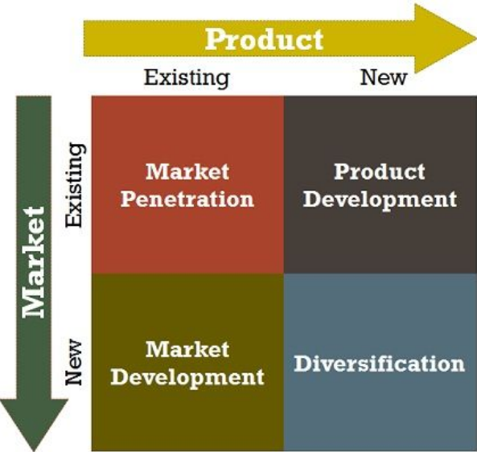
Source :- What is Ansoff Matrix? definition and meaning - Business Jargons

- Market Development :-

By introducing current items in new markets, Gucci might hasten the growth of its company through market development strategies. Spending money on R&D can help Gucci uncover possible new markets and clientele for its products. Finding and understanding diverse market cultures, trends, and consumer behaviours—and how they differ from those of already-existing markets—should be the focus of R&D. Gucci may expand locally.
This will entail local or regional expansion within the same region or to different cities. Additionally, The Gucci may profit from business expansion by becoming global. Gucci's expansion internationally will help it reach additional client demographics and increase its market share. Gucci, for instance, might increase its market share in developing nations like India.

- Market penetration :-

The market penetration strategy is used by companies who seek to expand their current product lines in markets where their brands are already well-known and in use. Due to expanded production capacity, Gucci could be able to reach more consumers in the same market. Gucci may potentially increase spending on marketing and advertising operations in order to increase market penetration. The Gucci might also consider new possibilities for introducing their products to the market.

(Available at :- Ansoff Matrix of Gucci (essay48.com) )

Conclusion

This Marketing Management report prepared by taking Gucci as brand and provides brief introduction of Gucci, PESTLE analysis of Gucci, relate the porter’s five forces with Gucci, SWOT analysis of Gucci including advantages and disadvantages of SWOT analysis. This report also includes the segmentation, targeting and positioning of Gucci and describe the marketing mix strategies ( 4Ps ) of Gucci, Ansoff matrix for Gucci which suggest new strategies should Gucci adopt for it’s growth.

References

Asmita Basu Chatterjee Assistant Professor (Finance) ( 2020), Strategic Analysis- Understanding the Global Luxury Brand A case study on LVMH, Army Institute of Management, Kolkata, ISSN: 2321-8819 (Online) 2348-7186 (Print) Impact Factor: 1.498 Vol. 8, Issue 5, pg. 90 - 91, Accessed on 02nd August 2023

Emet GÜREL• Merba TAT ( 2017), SWOT ANALYSIS: A THEORETICAL REVIEW, The Journal of International Social Research, Volume: 10 Issue: 51, Issn: 1307-9581, Accessed date 04th August 2023

Factors Affecting the Gucci business in UK - CIRCLE OF BUSINESS (circlebizz.com), Accessed on 02nd August 2023
GUCCI® UK Official Site | Redefining Luxury Fashion, Accessed date :- 25th August 2023

Gucci Marketing Strategy & Marketing Mix (4Ps) | MBA Skool, Accessed date :- 25th August 2023

Gucci Market Segmentation - An Analysis (ukessays.com), Accessed date :- 06th August 2023

Gucci | Company Overview & News (forbes.com), Accessed date 02nd August 2023

Gucci Porter Five Forces Analysis | MBA Skool ), Accessed on 02nd August 2023

Gucci and UNICEF USA’s Partnership to Save and Protect Children | UNICEF USA, Accessed date 03rd August 2023
Marketing Strategy of GUCCI in UK - CIRCLE OF BUSINESS (circlebizz.com) , Accessed date :-25th August 2023

Okyere Bismark, Obeng Acheampong Kofi, Adjei-Gyabaah Frank, Hope Eric (2018), Utilizing Mckinsey 7s Model, SWOT Analysis, PESTLE and Balance Scorecard to Foster Efficient Implementation of Organizational Strategy. Evidence from The Community Hospital Group- Ghana Limited., International Journal of Research in Business, Economics and Management Vol.2 Issue 3, pg. 97, Accessed date 02nd August 2023

SWOT Analysis of Gucci | Gucci Strengths & Weaknesses 2021 (swotanalysistemplate.com), Accessed date on 03rd August 2023

Yuxin Chen1, a, *, †, Yiming Ma2, b, *, † and Jingtong Xu3, c, *, †, ( 2022), Research on the Marketing Strategy of the Fashion Luxury Industry in the Post epidemic ERA – Taking GUCCI as acase, 5th International Conference on Financial Management, Education and Social Science (FMESS 2022), pg. 574, Accessed date 03RD August 2023

