
Quality Assurance and Service Improvements (LCHS7006)
Component 2: Service Improvement Report: Analysis of the Shrewsbury and Telford Maternity Scandal


Nazreen Akhtar
(2128933)

MSc Public Health and Social Care in Practice
Student Name: Nazreen Akhtar
Student ID: 2128933
Lecturer’s Name: Dr Fahad Khan

Table of Contents
Introduction 2
Background of the Issue 2
Contextualising the Problem 2
Purpose of the Report 3
Main Body 3
Fishbone (Ishikawa) Diagram / Root Cause Analysis 3
Donabedian Model (Structure–Process–Outcome) 5
Swot Analysis 7
Theoretical Integration 8
PDSA Cycle 9
Quality Improvement Tools and Implementation Strategy 9
Kurt Lewin’s 3-Stage Model of Change 10
Root Cause-Based Recommendations 11
Implementation Strategy 13
Benchmark 15
Conclusion 16
References 17

Introduction

Background of the Issue
The case of the Shrewsbury and Telford Hospital NHS Trust Maternity Scandal is among the most dangerous risks to the health and safety of the United Kingdom population. More than 200 mothers and babies were harmed due to avoidable maternity care, such as stillbirth, death, and long-term injury of the neonatal cases in the 1970s-2019 (Ockenden, 2022). The Trust that was supervising maternity and acute healthcare services in Shropshire and Telford failed to meet the national standards of care, which can be regarded as evidence of persistent inefficiencies in governance, leadership, and clinical practice. A study established that missed fetal health observations, increased complications, and attentiveness to the interests of the families were repeated (Dyer, 2020). It is one of the most significant health issues in the population as it undermines the trust of patients, institutional carelessness in quality, and unnecessary, preventable deaths. It was a scandal that resulted in the national improvements in NHS maternity safety in which ensured that quality assurance mechanisms and a culture of accountability were very evident.

Contextualizing the Problem
The mishaps at the Shrewsbury and Telford Hospital NHS Trust had catastrophic effects on the organization and the service users. In the case of families, such failures led to a deep emotional trauma, life loss, and an erosion of the trust they had in the maternity care system (BBC, 2022). The organization was severely scrutinized by the public, regulatory reviews, and reputational losses, as it led to national discussion regarding patient safety and accountability in the NHS (Dyer, 2022). The Care Quality Commission (CQC) found that clinical governance, leadership, as well as incidence learning were continually weak, and showed a culture of prioritising institutional reputation over patient well-being (CQC, 2023). This scandal was associated with the wider NHS health reform on transparency, safety culture, and continuous quality improvement, which are major assumptions in the NHS Long Term Plan (The Lancet, 2025) and the National Maternity Safety Strategy. These reforms focus on safer childbirth services by strengthening reporting mechanisms, training of staff, and involving the families.

Purpose of the Report
This report aims at a critical analysis of the underlying causes of the maternity care failures in Shrewsbury and Telford Hospital NHS Trust and identification of the evidence-based service improvement strategies. This analysis will be structured in the report by applying the existing quality assurance and improvement frameworks. In particular, the Fishbone Diagram will be employed to define systemic and human determinants of poor outcomes, the Donabedian Model will be used to evaluate the weaknesses of the structure, the process, and the outcomes, and the SWOT analysis will examine the internal and external environment of the organization. It will be these structures that will inform practical guidance based on the PDSA (Plan–Do–Study–Act) model to achieve sustainability in quality improvements.

Main Body

Fishbone (Ishikawa) Diagram / Root Cause Analysis
The Fishbone (Ishikawa) Diagram provides a logical approach to defining the root causes of unfavourable results in the Shrewsbury and Telford Hospital NHS Trust maternity scandal. This framework allows identifying how several system failures have contributed to avoidable harm by classifying failures according to major areas, namely leadership and governance, staffing and training, policy adherence, communication, organizational culture, and resource allocation (Ockenden, 2022).
Leadership and Governance:
Disease-wide failure in clinical governance and accountability was pointed out by the Ockenden Report (2022). The management never took warning signals and external audit seriously and acted to rectify them. The leadership was not clear but defensive as it focused on the reputation of the Trust as opposed to patient safety (Dyer, 2022). Another reason why organizational learning could not be derived to prevent repeating mistakes was the absence of strong audit and incident reporting systems.
Staffing and Training:
Low staffing, effective supervision, and a lack of clinical training played key roles. Midwives were not provided with suitable help because they were frequently left to deal with complicated cases without escalation to obstetricians (BBC, 2022). The culture of encouraging the Trust to offer normal births at all costs resulted in opposition to caesarean sections at the expense of maternal and neonatal safety (Bright, 2025).
Policy Non-Compliance:
Constant neglect of the national guidelines, including the ones provided by NICE (2022) on the process of fetal monitoring and escalation, led to improper management of labour complications. Audit procedures were poor, and adherence to the standards of national maternity safety was not uniform.
Communication Failures:
Communication problems between staff and families were everywhere. The issues of families were casually disregarded, and negative results were not presented openly, which is a sign of the absence of compassion and an open mind (O’Dowd, 2025). The interaction between midwives and obstetricians was also not effective, as it took time before getting the right treatment.
Organisational Culture:
A culture of blame and denial did not allow employees to report errors and prevented learning and growth (CQC, 2023). Lack of psychological safety did not encourage transparency and teamwork.
Resource Allocation:
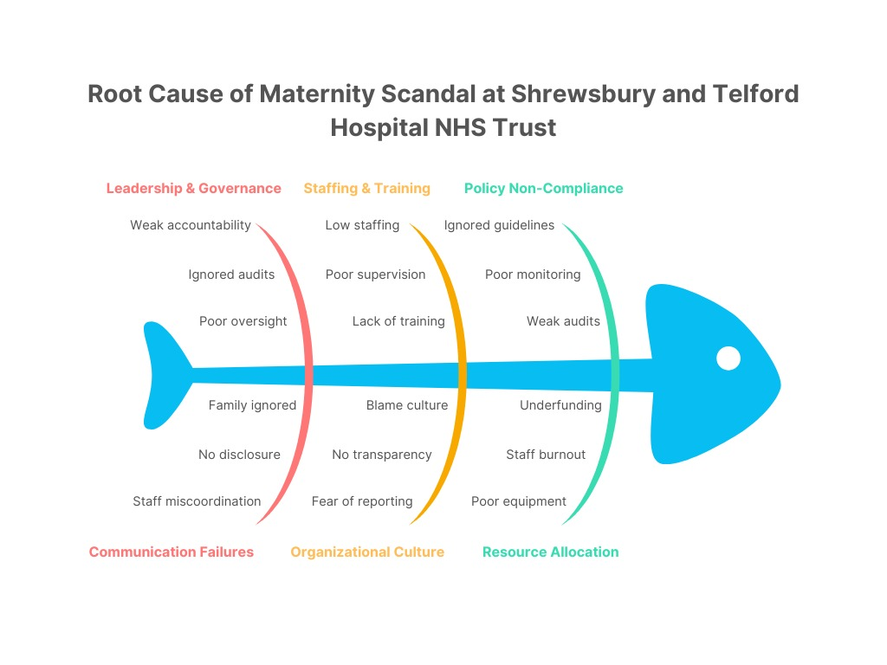
The crisis was worsened by long-term underinvestment in maternity infrastructure, staffing, and technology. Low resources were a cause of high workloads, staff burnout, and poor quality of care (Lintern, 2019). Altogether, these aspects formed a systemic trend of unsafe practice that justified the relevance of the Fishbone analysis as a powerful instrument in determining the diagnosis of multi-layered quality assurance failures in the Trust. (Figure 1 Self-Created).

Donabedian Model (Structure–Process–Outcome)
A systematic model of analysing the impact of failures in healthcare systems on patient outcomes is presented in the Donabedian Model. It applies to the case of the Shrewsbury and Telford Hospital NHS Trust to demonstrate how failure at structural, procedural, and outcome levels of the organization contributed to disastrous outcomes in maternity care (McCullough et al., 2023).
Structure:
Poor staffing ratios, a deficiency number of obstetric consultants, and poorly furnished maternity units were the structural weaknesses of the Trust (Finch, 2022). There were also training gaps, and midwives did not have current clinical competencies in fetal monitoring and emergency escalation. A vulnerable background of safe care delivery was established due to weak governance structures and weak policy implementation (Lethbridge, 2022).
Process:
The nature of operational processes was described by the low level of compliance with the clinical guidelines, e.g., NICE NG229 on fetal monitoring, and resistance to escalation of care in case of labour complications (NICE, 2022). Communication between different disciplines was also disjointed, where midwives and obstetricians could be in isolated units, causing delays in interventions (BBC, 2022). In addition, the issues that families raised were habitually disregarded, which lacked empathy and a patient-centred approach to communication (Dobson, 2022).
Outcome:
All these failures led to avoiding more than 200 preventable deaths and permanent injuries in many mothers and infants (Jones, 2025). The rate of patient safety (like maternal mortality and stillbirth) was more than the national average. The reputation of the Trust among the populace was undermined, and families lost their confidence in the NHS to provide safe maternity care (CQC, 2023).

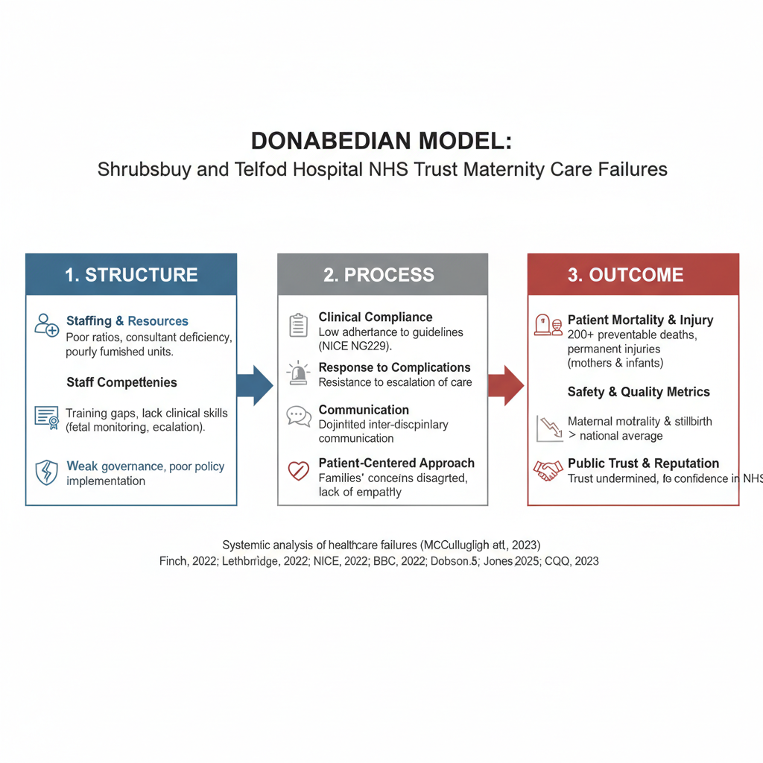
Figure 2 self-created
On the whole, the Donabedian Model reveals the fact that the lack of structure and process directly leads to the negative health outcomes, and the system needs to be reformed and provided with effective mechanisms of quality assurance.

Swot Analysis
The SWOT analysis provides a strategy of the internal and external conditions affecting the Quality Assurance (QA) system of the Shrewsbury and Telford Hospital NHS Trust. It shows the weaknesses that were present and led to failures, as well as the opportunities to improve in the long term.

Strengths:
The Trust had a committed maternity workforce despite systemic shortcomings that were devoted to the care of patients. The release of the Ockenden Report (2022) offered an excellent basis to make a reform because it stated the spheres in which the improvements could be made. The Trust is nationally based in the broader NHS framework, which allows it to access standardized QA frameworks, clinical guidelines, as well as national safety initiatives, including the NHS Maternity Transformation Program (McDonagh Hull et al., 2025).
Weaknesses:
The main weaknesses were the lack of strong clinical governance, the failure to report the incidents, and the inability to apply the lessons learned during the previous reviews. The management was protective and authoritarian, not allowing free communication and employee feedback (Sattar, 2020). The scarcity of staff, insufficient training, and irregular compliance with the principles of maternity care provided by NICE (2022) also undermined the quality of assurance. There were no effective audit mechanisms and data-based assessments of services to improve them.
Opportunities:
Ockenden's recommendations established a countrywide impetus to enhance the safety of maternity care, such as family engagement, staff education, and digital maternity outcomes monitoring (Supple, 2022). This might require building up multidisciplinary teamwork and the PDSA (Plan-Do-Study-Act) cycle, which would help to nurture the culture of continual improvement. The opportunity to benchmark and share learning will be provided through collaboration with other NHS trusts and professional bodies (Dixon-Woods, 2024).
Threats:
Constant workforce stress, financially limited circumstances, and increasing demand on maternity services are significant threats to sustainability (Tingle, 2023). The morale and recruitment of the staff are also endangered by negative media coverage and distrust of the staff by the population. Moreover, the time lag in policy execution will be prone to sustaining the vulnerabilities within the system.
To conclude, the lack of leadership and governance abilities caused severe damage, but with the assistance of national reforms, technology, and training programs, a solid and transparent QA system can be restored at the Trust.

Theoretical Integration
The Shrewsbury and Telford Hospital NHS Trust maternity scandal highlights the paramount importance of the existing theories and models in healthcare quality assurance and improvement. The Structure-Process-Outcome Model, created by Donabedian (1988), is still considered pivotal in assessing the impact of organizational structures and clinical processes on patient outcomes, providing a framework for identifying weaknesses within the system (Brazier et al., 2023).
According to Ahmed (2019), Quality Improvement (QI) theories given by Deming (1986) and Juran (1995) emphasize the roles of continuous improvement, leadership involvement, and empowerment of employees in the establishment of a sustainable culture of safety. They are mainly applied, especially within NHS contexts, where complex systems require iterative learning. The Transformational Leadership Theory (Busse, 2019) also helps understand the impact of strong and empathetic leadership as an incentive to a culture of safety in response to the defensive management practices revealed by the Ockenden Report (2022).
Moreover, balancing accountability and learning as the Just Culture model promotes is mandatory to restore trust in the company following systemic failure through reporting of incidents without fear of being blamed. Evidence-based strategies to improve care reliability, efficiency, and process variation reduction have evidence-based approaches to lean and Six Sigma (Berwick, 2019).
Empirical studies confirm that through the incorporation of these frameworks, especially PDSA cycles and robust governance structures, patient safety and clinical outcomes can be improved measurably (Rimmer, 2023). Therefore, the ability to utilize the theoretical and evidence-based models in the NHS maternity services is essential in creating resilient, open, and patient-centred systems.

PDSA Cycle

Quality Improvement Tools and Implementation Strategy
The PDSA (Plan, Do, Study, Act) and the Lean Six Sigma approach provide practical frameworks of continuous improvement in the Shrewsbury and Telford Hospital NHS Trust to translate the recommendations into a sustainable practice.
Plan:
Start by taking a clear evaluation of modern maternity practice and quality disruptions unveiled in the Ockenden Report (2022). Prostate-specific goals, which can be measured, i.e., lowering the number of avoidable maternity events by 30 percent in a year. Create a multidisciplinary enhancement team of includes clinical leaders, midwives, patient representatives, and quality assurance personnel (Rimmer, 2023).

Do:
Pilot key interventions such as better training of the staff in fetal monitoring, standardized communication procedures (SBAR framework), and better incident reporting systems. Use leadership coaching classes that allow the company to adopt an open and educational culture (Rimmer, 2023).
Study:
Monitor and assess results by means of frequent audits, a safety dashboard, and feedback from staff/family. Use the DMAIC (Define-Measure-Analyze-Improve-Control) of Six Sigma to examine the performance measures and detect the variations of processes (Wise, 2019).
Act:
Normalize best practices in interventions in every maternity unit. Cycle continuous learning by incorporating QA metrics in organizational policy and employee appraisals. Enhance growth by means of persistent training and meeting quarterly reviews (Dyer, 2020).
This is aided by the Lean approach that minimizes inefficiencies, simplifies care pathways, and redistributes resources in the most efficient way (Supple, 2022). The integration of PDSA and Lean Six Sigma allows for making change data-driven and iterative and gives staff ownership and accountability. This combined method will make sure that maternity safety reforms are not short-term reactions to a particular issue, but rather a long-term commitment to a quality culture that is evidence-based.

Kurt Lewin’s 3-Stage Model of Change
The Three-Stage Change Model offered by Kurt Lewin (1951) can be used as a practical tool to facilitate organizational change in the Shrewsbury and Telford Hospital NHS Trust, especially after the maternity care failures. The model comprises Unfreeze, Change, and Freeze, which are critical steps required to transform behaviours, structures, and culture to safer and more accountable maternity care practices.
Unfreeze:
In order to establish change preparedness, one will have to accept the seriousness and emotional effects of failures in the Ockenden Report (2022). The organization needs to create a collective feeling of urgency among personnel, leadership, and stakeholders by providing clear information on preventable harm and patient experiences (CQC, 2023). This step implies difficult work in terms of questioning the existing defensive culture by encouraging emotional awareness, open communication, and psychological security so that the staff can realize that they need new practices (Dobson, 2022).
Change:
When evidence-based interventions are in place, better multidisciplinary teamwork, competency-based maternity training, and better escalation procedures could transform once preparedness can be achieved. The implementation should be led by a guiding coalition of senior clinical leaders, midwifery supervisors, champions of safety, and patient representatives (Busse et al., 2019). The ownership is shared and resistance mitigated through consistent communication through staff briefings, safety huddles, and open learning forums (Dyer, 2022). The PDSA cycle is capable of supporting the ongoing learning process during the change process (Berwick, 2019).
Refreeze:
The new practices have to be institutionalized into organizational policy, staff appraisal systems, and continuing audit systems to maintain the momentum. Some of the reinforcement strategies are ongoing professional growth, family feedback systems, and open reporting of safety outcomes (Rimmer, 2023). An encouraging and fair culture would provide accountability and allow the staff to learn from their mistakes without being afraid of blame (Smith, 2022). Incorporation of these aspects stabilizes safe maternity practices and restores the trust of the people.

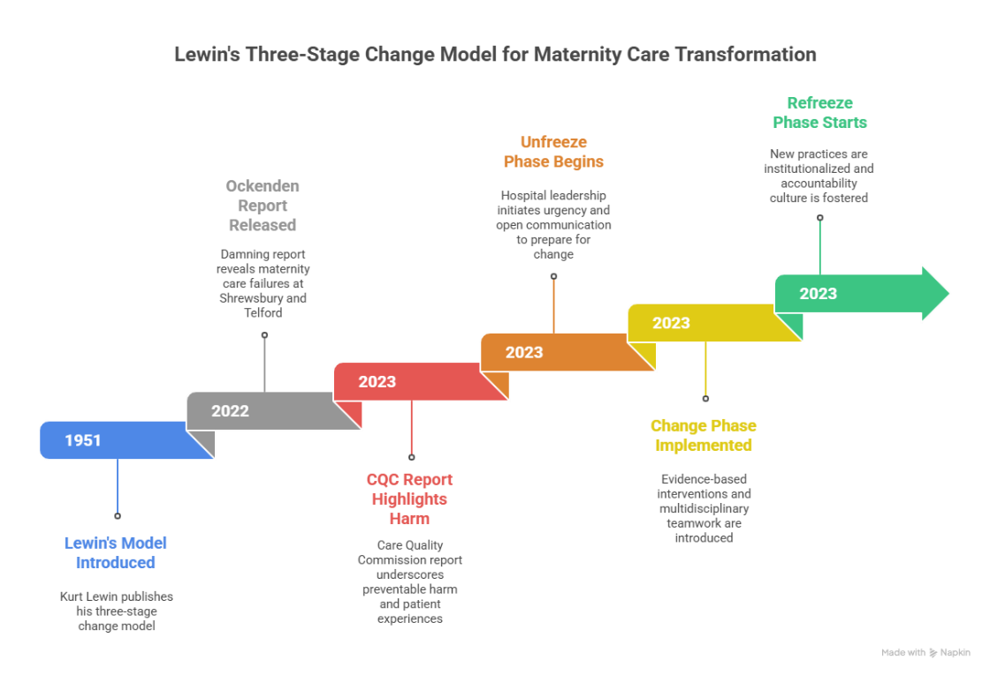
Figure 3 self-created

Root Cause-Based Recommendations
Using the recognised root causes, specific and evidence-based suggestions are necessary to enhance the quality and governance of maternity care in the Shrewsbury and Telford Hospital NHS Trust.
Enhance leadership and governance:
Establish a clear and responsible governance structure that prioritizes patient safety over reputation. Open communication and collective responsibility may be promoted through the application of the principles of Transformational Leadership (Busse et al, 2019). As advised by Ringer (2020), visibility and trust may be improved through regular safety briefings and leadership walks around.
Increase Staffing and Clinical Training:
Hire and develop qualified midwives and obstetricians, and offer ongoing professional growth via maternity safety training, which uses simulation. Training in fetal monitoring and emergency response based on a structured program proves to be beneficial in reducing adverse outcomes (Ringer, 2020).

Empower Incident Reporting and Learning Systems:
A Just Culture approach should be adopted to promote reporting without the fear of being blamed (Smith, 2022). Implement digital audit and feedback systems according to the National Patient Safety Strategy to permit learning in real time and improvement throughout the system.
Enhance Communication and Family Participation:
Inculcate patient-centred communication practices, in which families have listened to and have taken part in care decisions. Family liaison officers and open complaints procedures are useful in restoring trust (CQC, 2023).
Institute Continuous Quality Improvement:
PDSA (Plan-Do-Study-Act) will assist in testing, monitoring, and sustaining the improvements in the maternity services (Berwick, 2019). Introduction of the Lean principles will enable the reduction of inefficiencies, as well as the standardization of safe practices. All such measures combined concern leadership, cultural, and procedural gaps and inculcate learning and responsibility into practice, which are the main principles of rebuilding safety and confidence in the population.

Implementation Strategy
Evidence-based plan on quality enhancement at the Shrewsbury and Telford Hospital NHS Trust will require a systematic method of leading, and also involve the workforce, as well as long-term monitoring systems.
Alignment of Leadership and Governance:
Effective leadership that is visible and strong is core to implementing change. Maternity safety is a strategic priority that senior leaders need to champion as part of the Quality Improvement (QI) agenda of the Trust. An accountable system can be achieved through the creation of a Maternity Safety Oversight Committee, which would keep up with progress and coordinate the efforts with national standards, like the NHS Maternity Transformation Program (Shakespeare et al., 2022). Open disclosure and management by the board will continue the momentum and social confidence.

Resource Allocation:
It is necessary to obtain sufficient funds to hire qualified personnel, modernize maternity facilities, and assist in the further professional growth. Digital tools, including electronic patient records and audit dashboards, will be invested in to enhance the accuracy of data and make real-time decisions (CQC, 2023). The planned time during which staff training and interprofessional learning will be conducted will be a guarantee of uniform practice throughout maternity units.
Employee Engagement and Cultural Transformation:
The involvement of frontline staff is essential for sustainable improvement. Transformational Leadership can be applied to enhance empowerment, teamwork, and open communication (Busse et al., 2019). It will involve the implementation of a Just Culture (Dobson, 2022) that will help the staff report and engage in solution-building without the fear of blame. Trust and inclusion can be reinforced by continuous feedback loops, in the form of staff surveys and patient listening sessions.
Monitoring and Evaluation:
Recurrent improvement of the implemented strategies will be possible due to constant monitoring, depending on the PDSA cycles (Lakasing, 2025). Regular audits, performance metrics, and trends of incident analysis should be taken to conduct quarterly reviews of the safety. The success indicators, such as the reduction of the rates of stillbirths, the family satisfaction, and the adherence to NICE standards, should be properly published.
The maternity services in the Trust can be driven towards a guide of quality, compassion, and safety with the help of an investment in resources and a culture of learning via the currently existing leadership strategies.

Benchmark

Conclusion
The Shrewsbury and Telford Hospital NHS Trust maternity scandal analysis showed that there were weaknesses in the leadership, governance, staff training, and quality assurance systems. The report revealed problems in the deep-rooted cultural and structural defects that undermined patient safety and trust, using the Fishbone, Donabedian, and SWOT models. Strong leadership, the continuous development of the staff, transparent reporting, and patient-centred care were the areas of recommendation. By applying them in forms of PDSA and Lean Six Sigma, one can create an environment and culture of accountability, learning, and long-term improvement. Finally, it is necessary to incorporate evidence-based quality assurance systems to stop the repetition and restore confidence in NHS maternity care.

References
- Ahmed, S., 2019. Integrating the DMAIC approach of Lean Six Sigma and the theory of constraints toward quality improvement in healthcare. Reviews on environmental health, 34(4), pp.427-434.
- Badshah, N., 2022. Shropshire maternity scandal: 300 babies died or were left brain-damaged, says report, The Guardian. Available at: https://www.theguardian.com/society/2022/mar/26/shropshire-maternity-scandal-300-babies-died-or-left-brain-damaged-says-report.
- BBC, 2022. ‘Shrewsbury maternity scandal: Repeated failures led to deaths’, www.bbc.com, 30 March. Available at: https://www.bbc.com/news/uk-england-shropshire-60925959.
Bright, M. (2025) ‘Whistleblowing in an empty room’, Index on Censorship, 54(1), pp. 52–57. Available at: https://doi.org/10.1177/03064220251332627a.
- Berwick, D.M., 2019. Sounding board: Continuous improvement as an ideal in health care. In Management of Healthcare (pp. 183-186). Routledge.
- Brazier, M., Cave, E. and Heywood, R., 2023. Contraception, pregnancy, and childbirth. In Medicine, patients and the law (pp. 339-376). Manchester University Press.
- Busse, R., Klazinga, N., Panteli, D. and Quentin, W., 2019. Improving healthcare quality in Europe: characteristics, effectiveness and implementation of different strategies (2019) (p. 20203170674).
- Care Quality Commission, 2023. Reviewing how well we listen to whistleblowing concerns. London: CQC. Available at: https://www.cqc.org.uk/publications/listening-learning-responding-concerns/1-reviewing-how-well-we-listen-whistleblowing-concerns
Dixon-Woods, M. et al., 2022. ‘Culture and Behaviour in the English National Health Service: Overview of Lessons from a Large Multimethod Study’, BMJ Quality & Safety, 23(2), pp. 106–115. Available at: https://qualitysafety.bmj.com/content/23/2/106.
- Dixon-Woods, M., 2024. Report to the Thirlwall Inquiry: addressing Part C of the Terms of Reference. Expert report, 28.
- Dobson, J., 2022. ‘Ignoring women’s experience led to the NHS’s biggest maternity scandal’, BMJ, 22(125), p. o899. Available at: https://doi.org/10.1136/bmj.o899.
- Dyer, C., 2020. ‘Police launch investigation into maternity services at scandal-hit Midlands trust’, BMJ, 23(12), p. m2653. Available at: https://doi.org/10.1136/bmj.m2653.
- Dyer, C., 2022. ‘Failure to Work Collaboratively and Learn from Incidents Led to Deaths of Babies and Mothers at Shrewsbury and Telford trust, Review Finds’, BMJ, 376(25), p. o858. Available at: https://doi.org/10.1136/bmj.o858.
- Finch, J., 2022. The whistleblower and the bully. British Journal of Neuroscience Nursing, 18(3), pp.155-156.
- Jones, R., 2025. Delivering Babies or Delivering Justice? Reforming Clinical Negligence Law for Obstetric Claims. Manchester Rev. L. Crime & Ethics, 13, p.107.
- Lakasing, L., 2025. Delivering the Truth: Why NHS maternity care is broken and how we can fix it together. Right Book Press.
- Lethbridge, J., 2022. What are the barriers to improving public value–the case of maternity services in England?.
- Lintern, S., 2019. 'Largest maternity scandal in NHS history': Dozens of mothers and babies died on wards of hospital trust, leaked report reveals.
- McCullough, K., Andrew, L., Genoni, A., Dunham, M., Whitehead, L., and Porock, D., 2023. An examination of primary health care nursing service evaluation using the Donabedian model: A systematic review. Research in nursing & health, 46(1), pp.159-176.
- McDonagh Hull, P., Boulton, T. and Lashewicz, B., 2025. Recurring red flags: a retrospective study of MBRRACE-UK Perinatal Mortality Surveillance (2015–21) to identify maternity services most consistently reporting higher-than-average deaths. Journal of Public Health, p.fdaf019.
- NICE, 2022. Fetal monitoring in labour (NG229). London: National Institute for Health and Care Excellence. Available at: https://www.nice.org.uk/guidance/ng229/resources/fetal-monitoring-in-labour-pdf-66143844065221.
- O’Dowd, A., 2025. ‘Maternity care: 14 NHS trusts at centre of investigation named’, BMJ, 390(11), pp. r1941 r1941. Available at: https://doi.org/10.1136/bmj.r1941.
- Ockenden, D., 2022. Final report of the Ockenden review, GOV.UK. Available at: https://www.gov.uk/government/publications/final-report-of-the-ockenden-review.
- Rimmer, A., 2023. Maternity services are still failing women and babies despite reviews, says ombudsman.
- Ringer, A 2020). The Shrewsbury Maternity Scandal – the report’s findings and what all maternity services can learn from it | RWK Goodman, RWK Goodman, viewed 20 October 2025, <https://www.rwkgoodman.com/info-hub/shrewsbury-maternity-scandal-findings-maternity-services/>.
- Sattar, R., 2020. Communication, well-being, and adverse events in healthcare: How can we support maternity healthcare professionals disclosing news to patients that an adverse event has occurred? (Doctoral dissertation, University of Leeds).
- Shakespeare, J., Duff, E. and Bick, D., 2022. How many more reviews are needed? Joined-up policy and investment in England's maternity units are needed now to improve postnatal and inter-pregnancy care. Midwifery, 113.
- Smith, D. 2022, Shrewsbury maternity scandal: The babies who died in the UK’s worst hospital childbirth scandal, Sky News.
- Supple, B., 2022. Maternity scandal implications for antenatal teachers: A view from ground zero. International Journal of Birth & Parent Education, 10(1).
- Supple, B., 2022. Maternity scandal implications for antenatal teachers: A view from ground zero. International Journal of Birth & Parent Education, 10(1).
- The Lancet 2025, ‘NHS reforms need to prioritise maternal health’, The Lancet, vol. 405, Elsevier BV, no. 10481, p. 755.
- Tingle, J., 2023. Reflecting on patient safety in 2022. British Journal of Nursing, 32(1), pp.40-41.
- Wise, J., 2019. Maternity care failings in Shropshire stretch back four decades.

