BMIH4005
MARKETING ESSENTIALS

Gilpin Hotel and Lake hous
Cristian Fazecas
ID:2107706

Executive Summary
Marketing planning helps in the successful accomplishment of marketing operations. A proper plan assists the business organization in coordinating all of its marketing activities aligned with organizational objectives. In this report, a marketing plan for Gilpin Hotel and Lake house has been presented by highlighting its marketing mix components, along with the micro and macro-environmental factors.

Table of Contents
Introduction 4
1. “Marketing Mix” 4
2. The marketing environment (Micro- SWOT Analysis) 5
3. “The marketing environment” (Macro - PESTEL Analysis) 6
4. “Creating customer value and engagement” 7
5. “Effective use of digital marketing channels” 8
Conclusion 8
Reference List 10
Appendix 13

Introduction
The hotel and hospitality industry in the entire world heavily suffered from the Covid-19 pandemic. During the coronavirus outbreak, the primary focus of the business organizations and government was for people's safety. The continuous lockdown scenario and public fear resulted in the rapid revenue decrease of the hotel and hospitality sectors across the world. The business of Gilpin Hotel and Lakehouse also suffered from the said crisis. Gilpin Hotel and Lakehouse is situated in Windermere, United Kingdom, and is a member of the “Relais & Châteaux” group of hotels. The report aims to demonstrate a marketing plan which is formulated for Gilpin hotel for its future business progression. The purpose of formulating this marketing plan is to elucidate the macro and micro environmental factors of the organisation, and the way Gilpin can capitalize on its strength for making business progress.

1. “Marketing Mix”
Product: The current offering of the Gilpin hotel includes 28 bedrooms, 5 Spa Lodges, 5 Spa Lodges, 6 Garden Suites, 3 bigger Spa Suites, a cocktail bar, and luxurious bathrooms. Customers can enjoy the beautiful view of the mountain and lake from the hotel. Weddings, birthday parties, minimoons, anniversaries, honeymoon packages are also offered by Gilpins for its targeted customer's group (Thegilpin, 2021). The Gilpin hotel and the Gilpin lake house are two separate estates under one ownership. In Gilpin lake house, visitors can enjoy hot tubs, swimming pools, boathouses, and saunas on hundreds of acres of private grounds. On the other hand, in Gilpin hotels, visitors are offered free wifi-facilities, " double walk-in showers", "circular stone baths", "spa room with steam room", and "a floating bedroom over the pond " (Thegilpin, 2021).
Price: The Gilpin hotel follows a premium-pricing strategy. A classic room in Gilpin (with one double bed, garden facilities, En-suite Bathroom, and free Wifi) costs around 337.13 US Dollars. On the other hand, a Master room in Gilpin hotel (with two twin beds, Garden view, free WiFi, minibar, and luxurious toiletries costs around 403.24 US dollars (Relaischateaux, 2021). The junior suits cost approximately 509 US dollars, garden suits cost 561.89 US dollars, Spa lodge costs 813.08 US dollars, and the “Lake House Room” cost approximately 575.11 US dollars (Relaischateaux, 2021). A variety in the pricing is seen in specific seasons under specific offers. Gilpin will incorporate a proper seasonal pricing strategy to attract the customers of the UK.
Place: Gilpin is located in Crook Road, Windermere, The English Lake District, in the United Kingdom (Thegilpin, 2021). Customers will easily find it on Google-map. The location of the organization is also mentioned on the company's website.
Promotion: Gilpin will use digital marketing technologies to advertise its services to customers. The company will also spend money on television media for promoting their business.

2. The marketing environment (Micro- SWOT Analysis)
Strength | Weakness
- The major strength of Gilpin is its passionate and highly dedicated workforce.  - The location of the hotel and its pleasant environment.  - Quality services and special packages for customers (Thegilpin, 2021). | - Gilpin is not present in the international market.  - The price of the products and services are very high, and lower-middle-class groups can not afford it (Thegilpin, 2021).
Opportunity | Threat
- The organisation needs to invest capital in digital marketing technologies.  - The scope of facilitating the IT infrastructure and Artificial Intelligence is also present in front of the organization. | - Gilpin hotel has many strong competitors in the market, for example, "Conghan hall hotel", "Hand-picked hotels limited", "Coconut beach resort", "Bayshore resort" (Zoominfo, 2021).  - The competitors possess the capacity to outthrow Gilpin from the marketplace with their aggressive marketing strategy.  - Brexit and the high inflation rate is another threat for the company.
Table 1: SWOT Analysis of Gilpin
(Source: Self-developed)

3. “The marketing environment” (Macro - PESTEL Analysis)
Political Factor: The hospitality sector in the United Kingdom heavily relied on EU migrants before the Brexit decision. Due to the Covid-19 pandemic, and political decision of Brexit, most of the workforce of the hospitality sector returned to their home country [Refer to Appendix]. Gilpin can address this negative impact by recruiting more staff from the United Kingdom.
Economic Factor: In August 2021, 0.4% amplification in the UK's monthly GDP has been seen (ONS, 2021). Average annual GDP growth of 1.9% is seen. It can make the country the “fastest-growing G7 economy" within 2050 (PWC, 2021). Gilpin can capitalize on this positive impact by spending money on market expansion strategies.
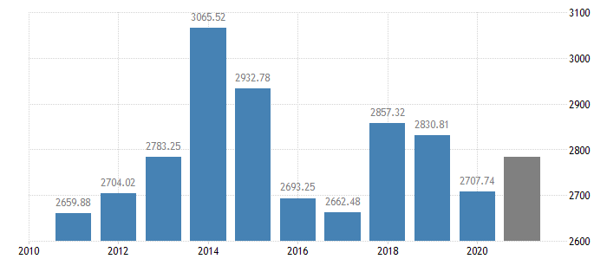
Figure 1: GDP rate of the United Kingdom
(Source: Tradingeconomics, 2021a)
Social Factor: The overall average unemployment rate in the UK has decreased by 4.5% in 2021 (in the month of August) (Tradingeconomics, 2021b). In the country, there are 53 million active social media users in 2021 (January) and the overall social media penetration of the UK is 77.9% (Statista, 2021). Therefore, it can be said that the social factor may impose a positive impact on Gilpin's business, and the organization can capitalize on that factor by integrating digital marketing technologies.
Technological Factor: The UK is a technologically advanced nation, and the government has spent more than £2.3 billion in money on AI implementation (GOV, 2021a). The technological factor is positive for the marketing plan of Gilpin, and the organization can capitalize on it by incorporating machine learning, big data analysis, and AI in its operations.
Environmental Factor: Gilpin can employ its marketing plan in a sustainable and ethical manner by following the environmental policies of the UK. Some of the most important policies are "Environmental Protection Act 1974" , "Control of Pollution Act 1974", "Energy Act 2020", "Climate Change Act 2008", (Field, 2021).
Legal Factor: The set average minimum wage in the UK is £8.91 for those employees who are twenty-three years old or more (GOV, 2021b). The rate of Value-added Tax is 20% (GOV, 2021c). Gilpin can easily operate its business in the UK by following this “National Minimum Wage” policy, and VAT rate. Legal factor is positive for the company’s business, and Gilpin can capitalise on this factor by integrating employee-centric policies abiding by all the Employment Legislation present in the UK (Cole, 2020).
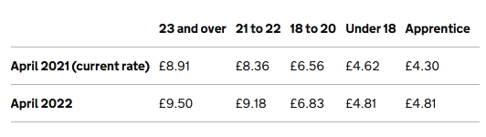
Figure 2: “National Minimum Wage” in the UK
(Source: GOV, 2021b)

4. “Creating customer value and engagement”
The term “Customer Value” refers to the customer's relative preference for certain goods or service attributes of an organisation. According to Kwon et al. (2020) it is the perception of what a good and service are worth to the consumer versus its possible alternatives. Customer engagement, on the other hand, indicates the emotional connection between an organization and its consumers (de Oliveira Santini et al. 2020). In order to generate customer value and customer engagement, Gilpin provides personalized services to its customers. The company takes care of the individual requirements of the visitors and offers them attractive services as per their needs. Apart from that Gilpin also gives personalized monetary ventures to its customers for their convenience (Gilpinhotel, 2021).
In the future, Gilpin may conduct online surveys or polls on social media sites to know the exact demand of the customers. Integration of an MIS (Management information systems)will be helpful in maintaining a good interaction with the visitors. Customer engagement will be amplified by ensuring that the customer services department is always present to provide quick solutions to the visitors.

5. “Effective use of digital marketing channels”
Digital marketing or online marketing channels help in widening the customer base of a business organisation. It also helps in tracking customer feedback and monitoring promotional campaigns (Bala and Verma 2018). Gilpin may use email marketing, social media marketing, and google ads for promoting their services.
Google ads: Google ads allows organizations to focus on the targeted customers who are specifically searching for their products and services (Balça and Casais, 2021). Gilpin can easily identify its target customers by using Google ads.
Email marketing: Gilpin can amplify its sales growth and revenue generation by sending a promotional email to the targeted customers.
Social media marketing: Facebook and Instagram can be used as marketing media for promoting the product and services of the company.

Conclusion
In conclusion, a marketing plan facilitates the scope of business growth by identifying its opportunities, core competencies, resource utilization capacity and potential target market. The aforementioned marketing plan has elucidated the micro and macro business environmental situation of Gilpin so that the organization can focus on its strengths and revive from the damage caused by Covid 19 pandemic. Effective use of marketing mix, digital marketing techniques has been demonstrated as well. Customer value creation and amplifying customer engagement with the organisation have also been highlighted in this report.
The aforementioned marketing plan highlighted that Gilpin uses a premium pricing strategy and its integration of digital promotional activities are not very effective. In order to improve that scenario, some recommendations are provided for Gilpin.
- Gilpin is recommended to incorporate a cost-leadership pricing strategy to attract visitors in the post-pandemic phase.
- The organization needs to focus on personalized advertisements and influential marketing techniques as part of its digital marketing activities.

Reference List
Bala, M. and Verma, D., 2018. A critical review of digital marketing. M. Bala, D. Verma (2018). A Critical Review of Digital Marketing. International Journal of Management, IT & Engineering, 8(10), pp.321-339.
Balça, J. and Casais, B., 2021. Return on Investment of Display Advertising: Google Ads vs. Facebook Ads. In Handbook of Research on New Media Applications in Public Relations and Advertising (pp. 1-13). IGI Global.
Cole, M., 2020. List of Employment Laws in the UK | Croner. [online] Croner. Available at: <https://croner.co.uk/resources/employment-law/legislation-list/> [Accessed 5 December 2021].
de Oliveira Santini, F., Ladeira, W.J., Pinto, D.C., Herter, M.M., Sampaio, C.H. and Babin, B.J., 2020. Customer engagement in social media: a framework and meta-analysis. Journal of the Academy of Marketing Science, 48, pp.1211-1228.
Deloitte, 2021. Brexit: Travel, Hospitality and Services companies rethink their operational strategies. [online] Deloitte United Kingdom. Available at: <https://www2.deloitte.com/uk/en/pages/consumer-business/articles/brexit-travel-hospitality-and-services.html> [Accessed 8 December 2021].
Field, 2021. List Of Environmental Laws | Field. [online] Field | Working towards a cleaner and healthier environment. Available at: <http://www.field.org.uk/list-of-environmental-laws/> [Accessed 30 November 2021].
Gilpinhotel, 2021. MONETARY VOUCHER. [online] Gilpinhotel.wearegifted.co.uk. Available at: <https://gilpinhotel.wearegifted.co.uk/monetary-vouch> [Accessed 10 December 2021].
GOV, 2021a. New ten-year plan to make the UK a global AI superpower. [online] GOV.UK. Available at: <https://www.gov.uk/government/news/new-ten-year-plan-to-make-britain-a-global-ai-superpower#:~:text=The%20government%20has%20invested%20more,Intelligence%20in%20health%20and%20care> [Accessed 27 November 2021].
GOV, 2021b. National Minimum Wage and National Living Wage rates. [online] GOV.UK. Available at: <https://www.gov.uk/national-minimum-wage-rates> [Accessed 30 November 2021].
GOV, 2021c. VAT rates. [online] GOV.UK. Available at: <https://www.gov.uk/vat-rates> [Accessed 29 November 2021].
Kwon, W., Lee, M. and Back, K.J., 2020. Exploring the underlying factors of customer value in restaurants: A machine learning approach. International Journal of Hospitality Management, 91, p.102643.
ONS, 2021. GDP monthly estimate, UK - Office for National Statistics. [online] Ons.gov.uk. Available at: <https://www.ons.gov.uk/economy/grossdomesticproductgdp/bulletins/gdpmonthlyestimateuk/august2021> [Accessed 28 November 2021].
PWC, 2021. UK could remain a top-10 global economy in 2050 - despite Brexit. [online] www.pwc.co.uk. Available at: <https://www.pwc.co.uk/who-we-are/regional-sites/northern-ireland/press-releases/world-in-2050.html> [Accessed 29 November 2021].
Relaischateaux, 2021. Gilpin Hotel & Lake House, Boutique Hotel in Windermere, United kingdom – Relais & Châteaux. [online] Relaischateaux.com. Available at: <https://www.relaischateaux.com/us/united-kingdom/gilpin-cumbria-windermere> [Accessed 5 December 2021].
Statista, 2021. UK: social media usage 2019 | Statista. [online] Statista. Available at: <https://www.statista.com/statistics/507405/uk-active-social-media-and-mobile-social-media-users/> [Accessed 7 December 2021].
Thegilpin, 2021. Gilpin Hotel and Lake House - Luxury Lake District Hotels, Windermere Hotels, Country House Hotel, Cumbria. [online] Gilpin Hotel & Lake House | Luxury Lake District Hotel | Windermere Hotels. Available at: <https://www.thegilpin.co.uk/> [Accessed 6 December 2021].
Tradingeconomics, 2021a. United Kingdom GDP | 2021 Data | 2022 Forecast | 1960-2020 Historical | Chart | News. [online] Tradingeconomics.com. Available at: <https://tradingeconomics.com/united-kingdom/gdp#:~:text=GDP%20in%20the%20United%20Kingdom%20is%20expected%20to%20reach%202860.00,macro%20models%20and%20analysts%20expectations.> [Accessed 24 November 2021].
Tradingeconomics, 2021b. United Kingdom Unemployment Rate | 2021 Data | 2022 Forecast | 1971-2020 Historical. [online] Tradingeconomics.com. Available at: <https://tradingeconomics.com/united-kingdom/unemployment-rate> [Accessed 27 November 2021].
Zoominfo, 2021. Gilpin Hotel. [online] www.zoominfo.com. Available at: <https://www.zoominfo.com/c/gilpin-hotel/114230555> [Accessed 9 December 2021].

Appendix
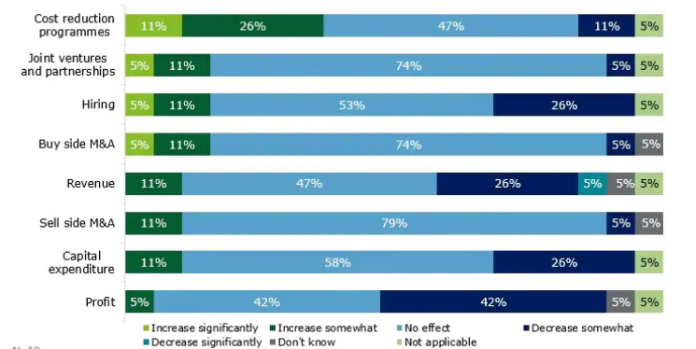
Figure 1: Impact of the Brexit decision on hotel and hospitality sector
(Source: Deloitte, 2021)

